Individual Presentation on Training and Development needs for a HR officer

Vasilka Nikolova
Lecturer Modak Koushik
University of Wales Trinity Saint David
Developing Relationships and Workplace Achievements

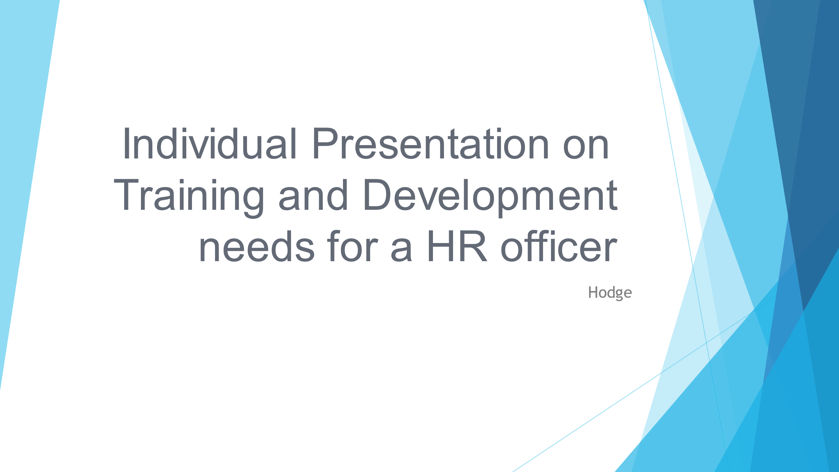

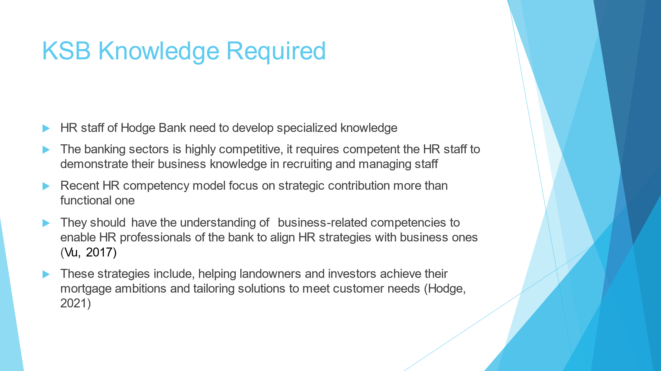
Slide 1
The dynamic business environment of the banking industry requires HR professionals of Hodge Bank. The staff needs to demonstrate its prowess in recruiting and managing staff to accomplish its strategic plans. This means that they should articulate themselves with customer’s needs and preferences, foreseeable direction and staff potentials necessary to adjust to the business environment. They must embark on strategic contributions more than functional ones as recommended by the recent competency model. HR competencies include astute business knowledge of industry and business, strategic decision-making, and organizational change (Vu, 2017). The bank would use the HR knowledge to satisfy their mortgage needs and tailor them (Hodge, 2021).

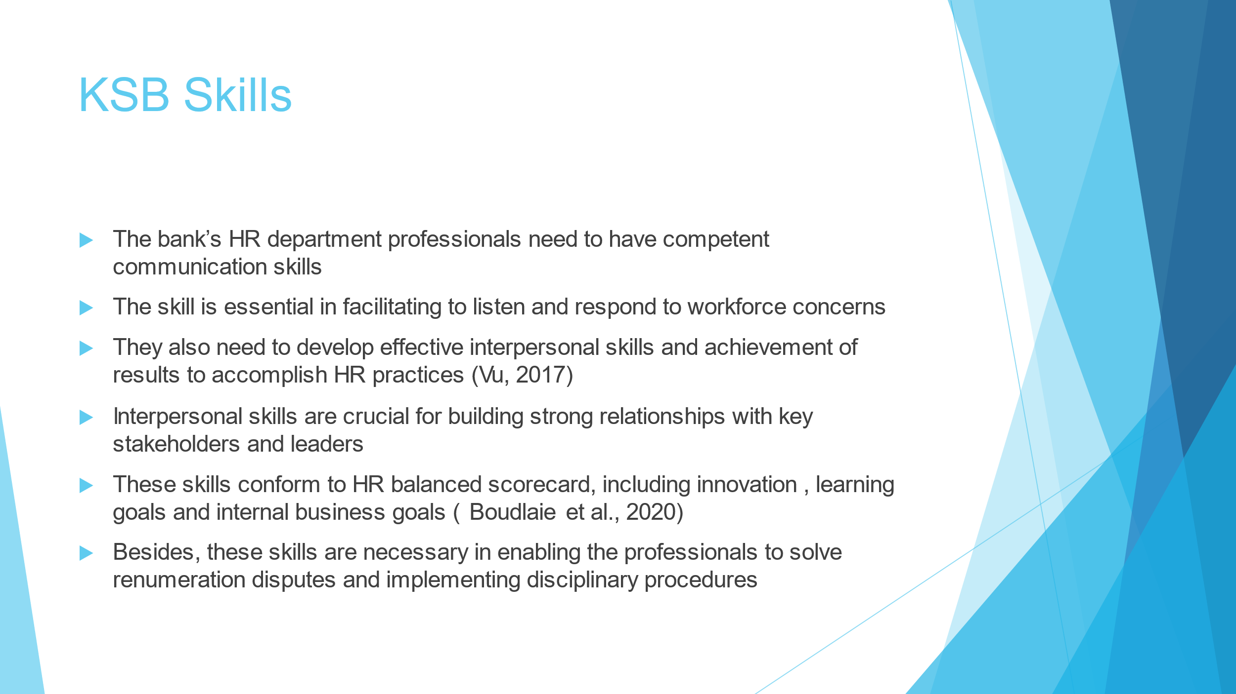
Slide 2
Hodge Bank can use HR professionals who have excellent communication skills to convey institutions to the workforce and listen to their concerns attentively. Besides, the department staff needs to acquire effective interpersonal skills and demonstrate achievement of results competency to accomplish critical HR practices (Vu, 2017). For instance, interpersonal skills will enable the professionals to build strong relationships with leaders and key stakeholders such s investors. These skills are congruent to the HR balanced scorecard that measures success based on innovation, learning goals and accomplishing internal business goals. Moreover, they can use the skills to guide the staff to solve remuneration disputes amicably and implement disciplinary procedures

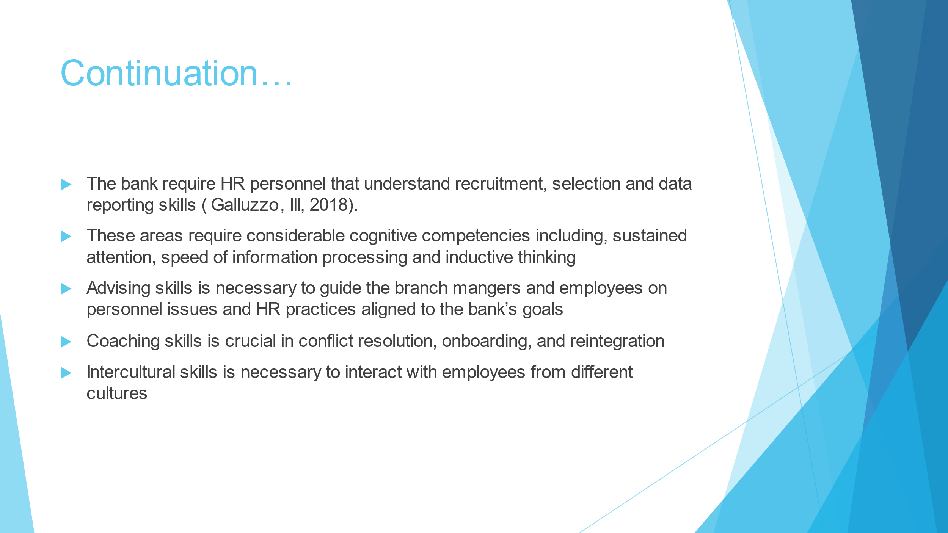
Slide 3
Hodge Bank requires HR personnel whose skills offer an adequate understanding of recruitment, selection and data reporting skills. Regarding data reporting skills, they need to familiarize themselves with qualitative and quantitative tools to analyse, interpret and facilitate the decision-making process (Galluzzo, III, 2018). It is critical for the department to have staff with cognitive skills by portraying proficiency in processing information, apply inductive thinking and sustained attention. Other critical skills necessary for employee empowerment and engagement include advising, coaching, and intercultural communication.

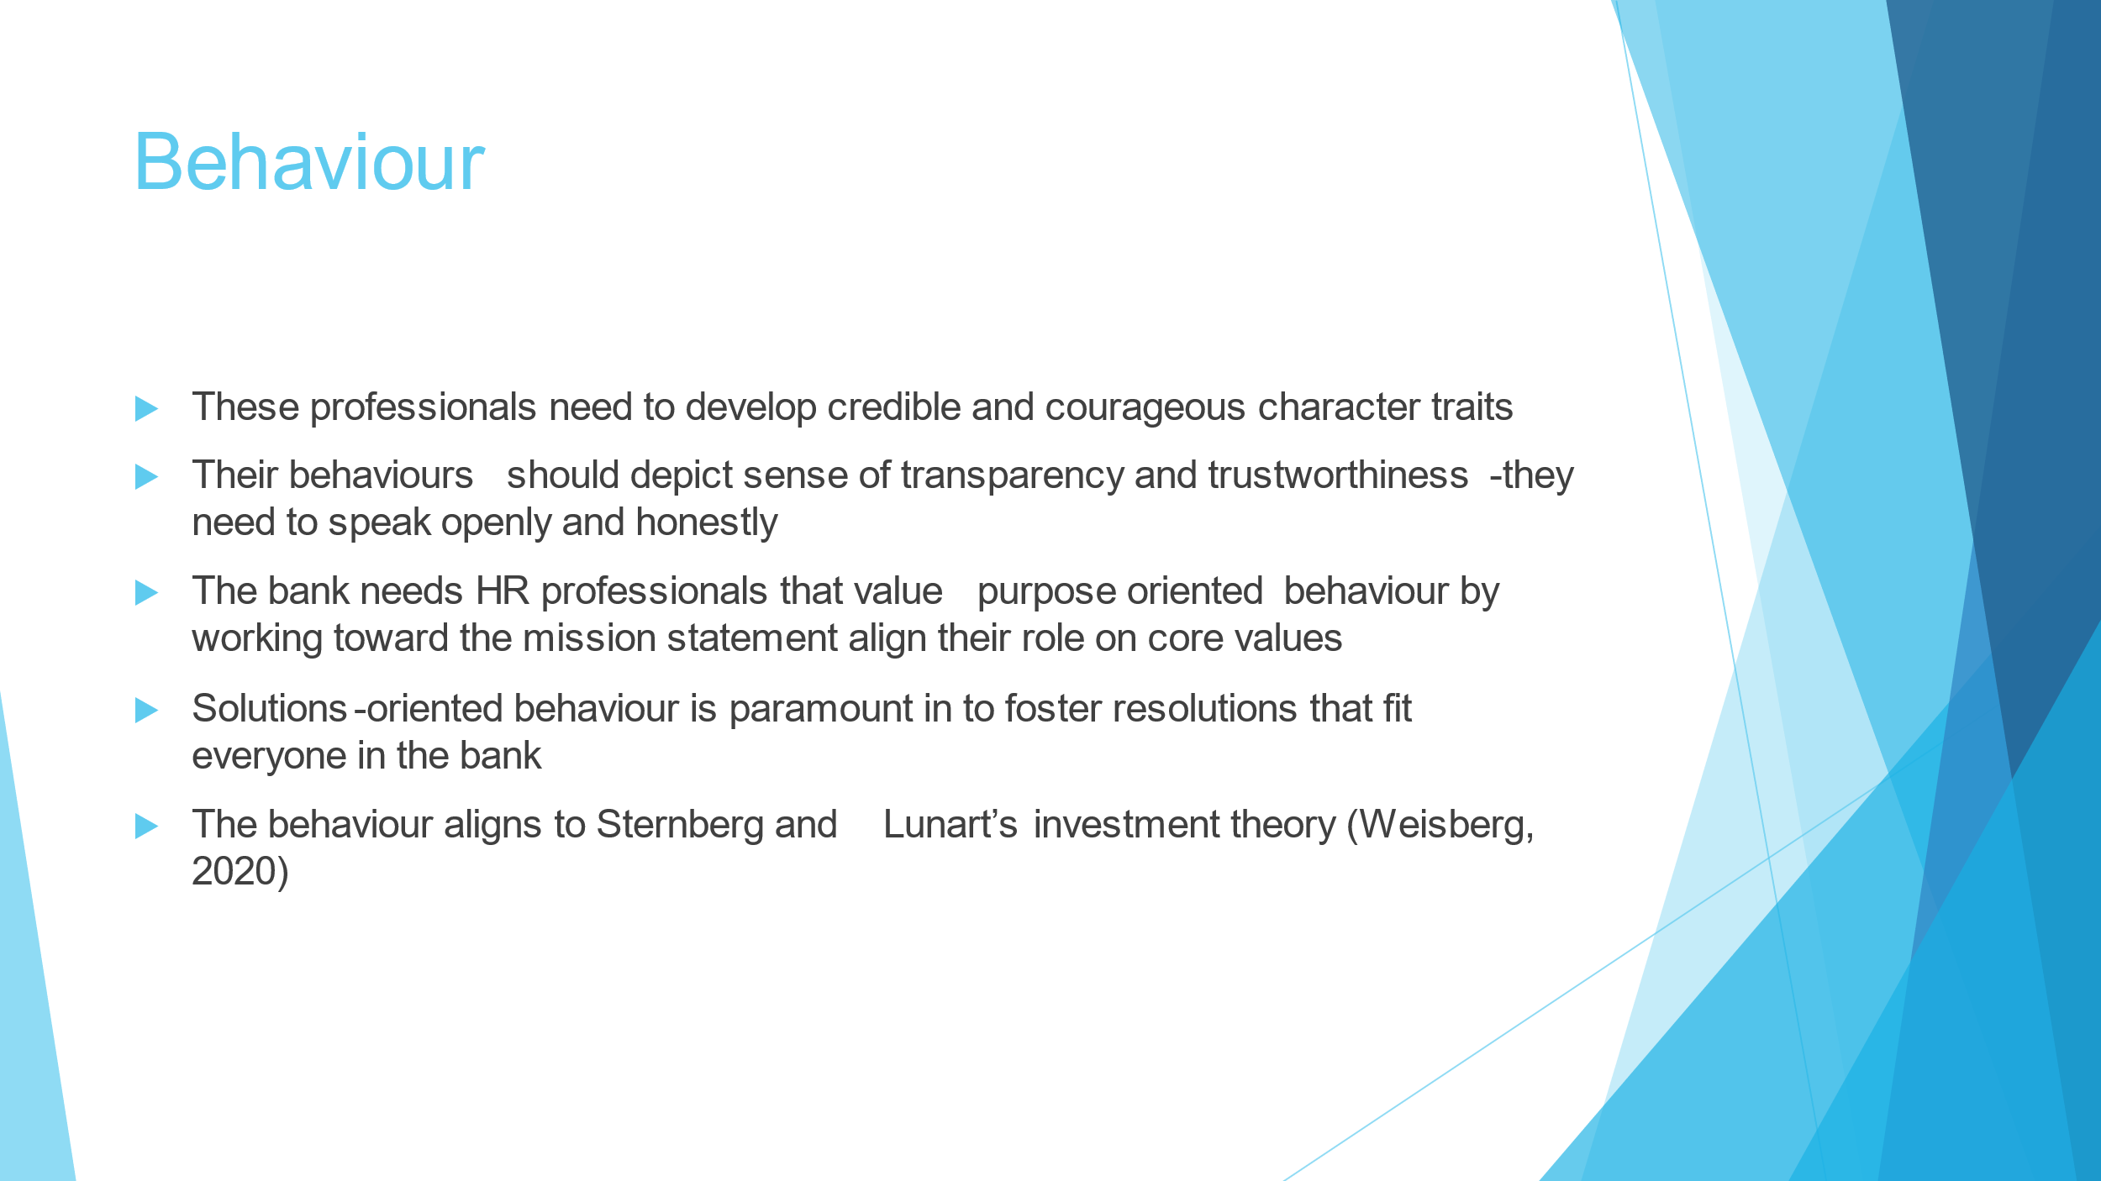
Slide 4
Hodge requires its HR staff to portray desirable traits, including credibility and courage, that would foster organisational values. Being transparent and trustworthy that depict fairness and honesty is necessary to manage tensions between departments. Purpose-oriented behaviour is necessary to ensure supervisors and employees understand and work towards the bank’s mission of protecting customer’s money. Solution-oriented, rather than problem-focused, is a desirable behaviour as the HR professionals will seek a resolution that satisfies everyone. The behaviour needs to align with the concept of Sternberg and Lunart’s investment theory, including generating underrated ideas and convincing others of their merits (Weisberg, 2020).

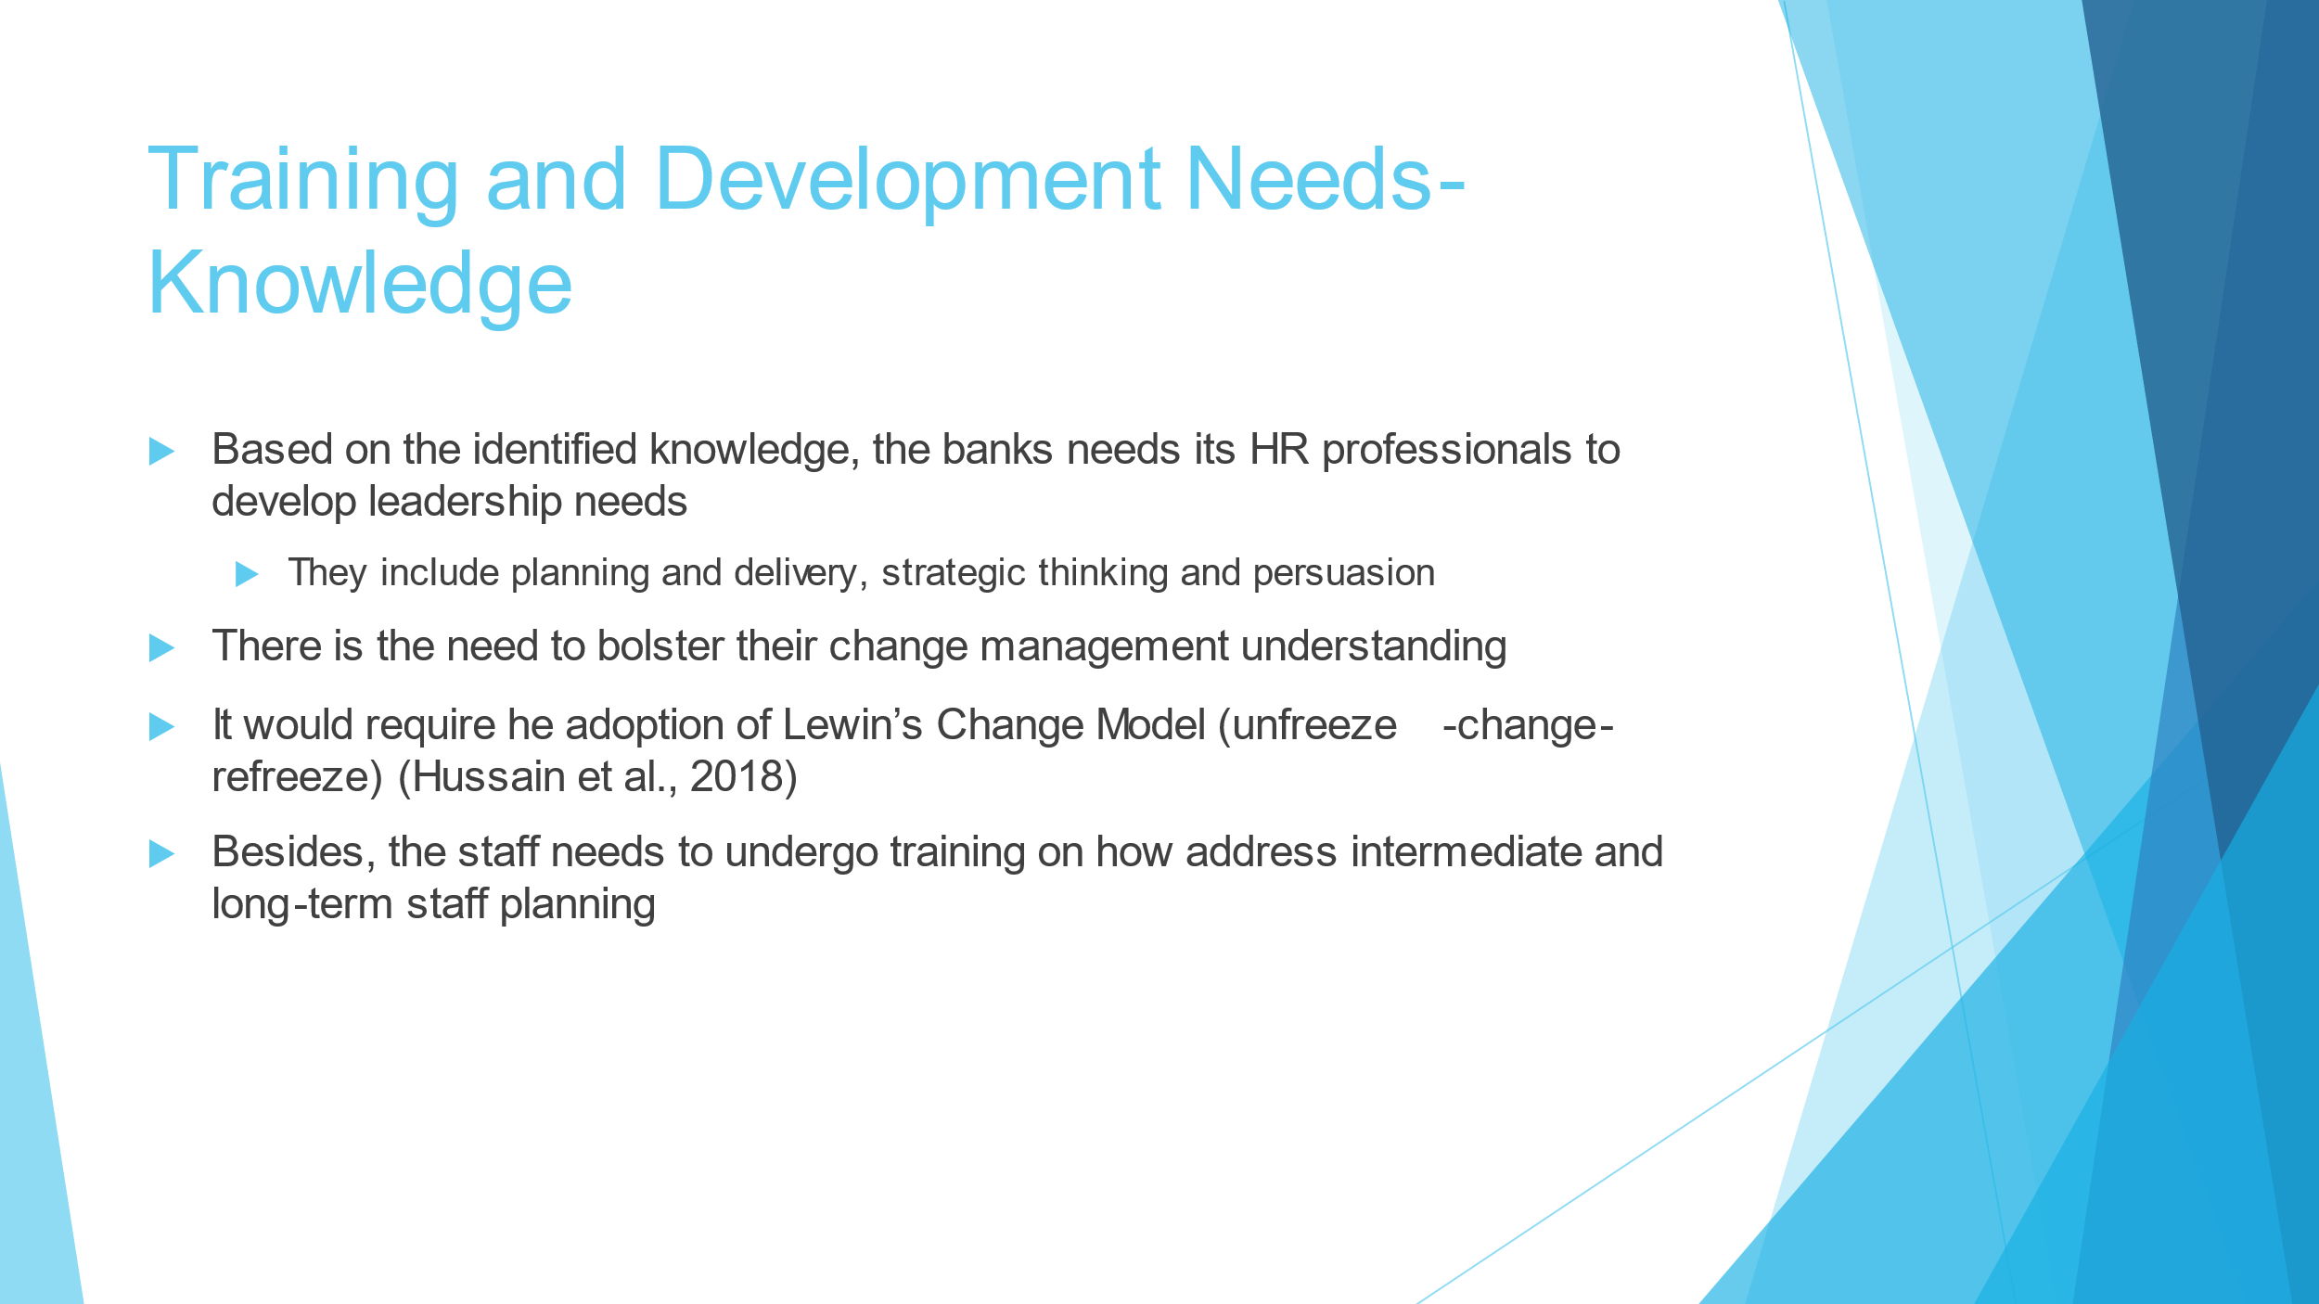
Slide 5
Based on the personal skill audit outcomes, the knowledge assessment indicates that training and development needs require the bank to emphasise developing leadership needs. The HR professionals need to understand concepts of planning and delivery, persuasions and strategic thinking. Besides, change management is crucial for accomplishing the mission of the entity. The training can adopt Lewin’s Change model of unfreezing, change, and refreezing (Hussain et al., 2018). the HR could implement necessary strategic changes by preparing employees to change through compelling messages, address personal transition, and developing a stable job description. Staff needs to develop knowledge on conceptualising intermediate and long-term staff planning, including hiring the right people that understand organisation operations.

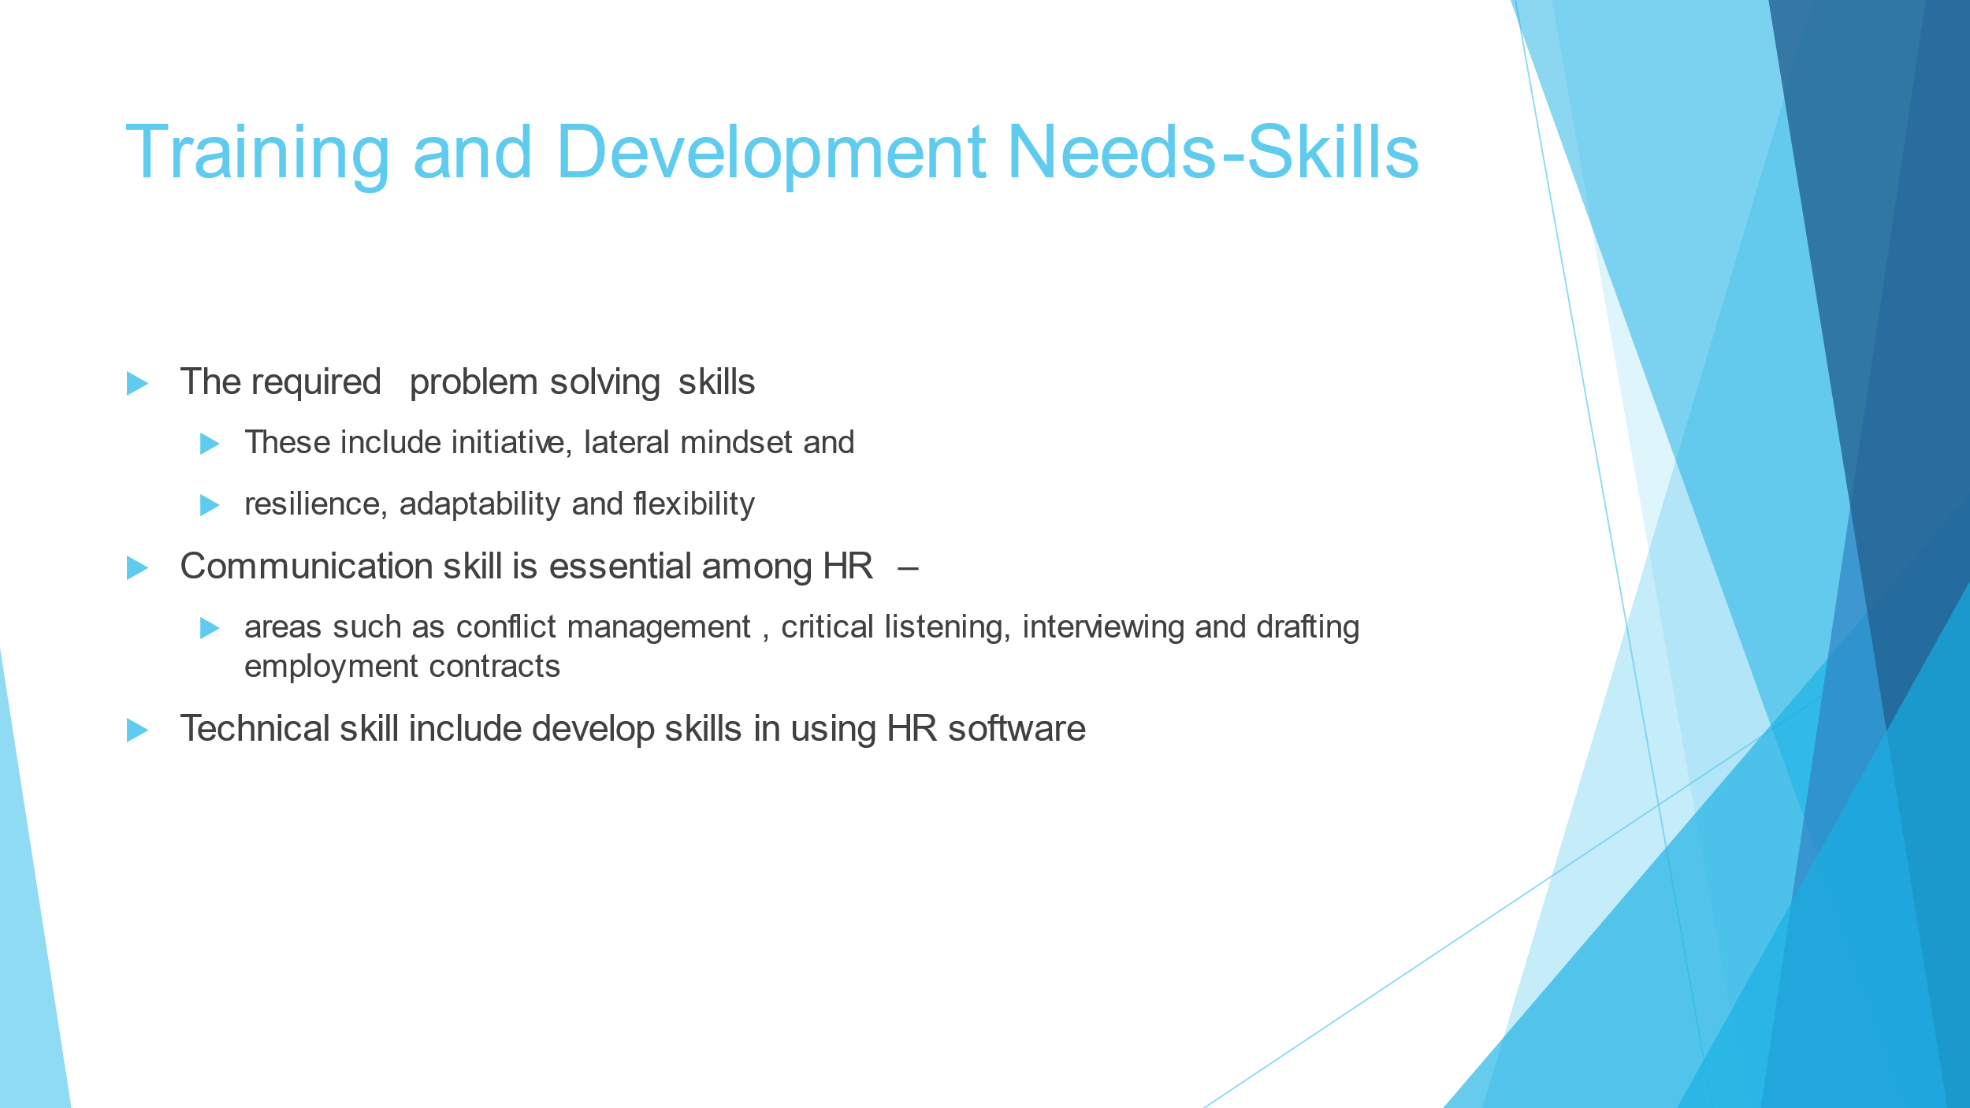
Slide 6
The audit reveals the need to develop and trains HR staff on problem-solving needs. The training can focus on engaging the staff’s initiative, lateral mind, resilience and adaptability. The training session can delve into hypothetical situations and various tests and exercise that requires the conceptual mind to solve problems. The bank would benefit from HR professionals with communication skills. The training needs to emphasize developing capability in critical listening, conflict management, interviewing, and drafting employment contracts. These are critical in conveying policy changes and necessary strategic information that can help the bank improve its performance. In addition, HR software training needs should focus on technical skills in applying HR software to complete necessary computations and add necessary employee data (e Silva, M. S., and da Silva Lima, 2018).

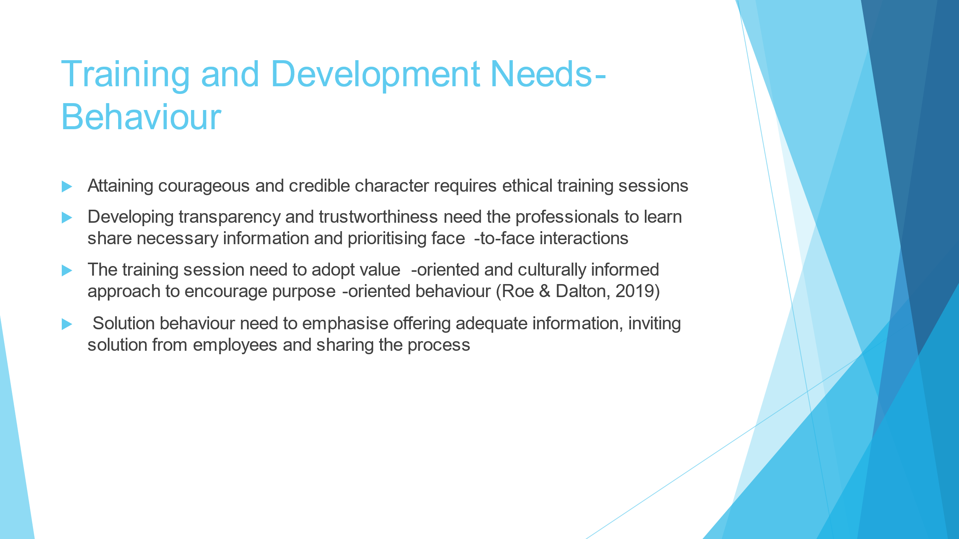
Slide 7
Development needs to have credible and courageous character traits that require the firm to invest in ethical training. The HR manager should also organise a workshop to train staff on sharing information and embarking on face-to-face interactions to bolster their sense of transparency and trustworthiness. Formal training sessions of purpose-oriented behaviour should be guided by the culture of delving into why the bank offers banking services. Purpose-oriented behaviour is guided by why the organisation exists (Roe and Dalton, 2019). The professions can foster their understanding of solution-oriented behaviour by acknowledging the essence of sharing information, encouraging employees to suggest solutions to problems in their departments, and HR leaders sharing the organization's process.

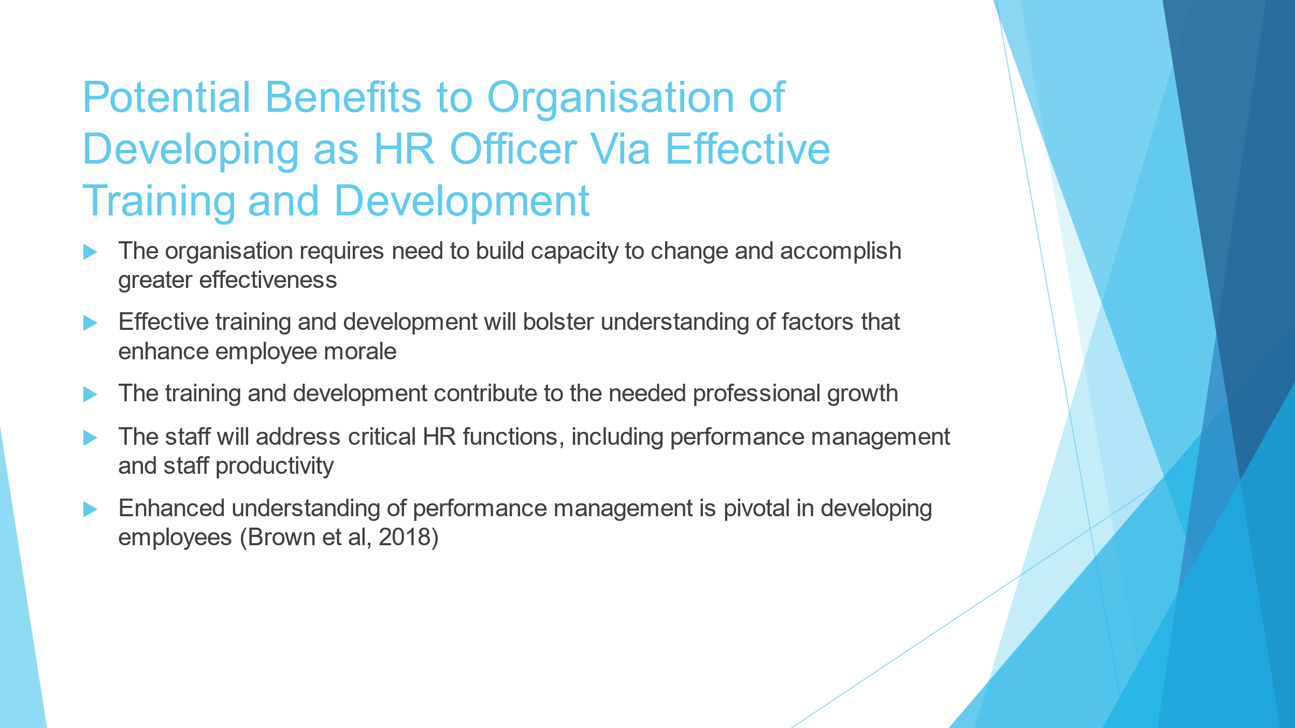
Slide 8
Effective training and development of the organisation of development will mainly benefit employees. It can benefit from professionally grown HR professionals that understand approaches to enhance employee morale and guide them to enhance their professional ambitions. Addressing the needs would also contribute to the needed comprehension of performance management and staff productivity. Regarding performance management, the organisation would develop the skills and competencies necessary to evaluate employees’ growth (Brown et al., 2018). Competent HR officials will gain effective coaching skills to train managers.

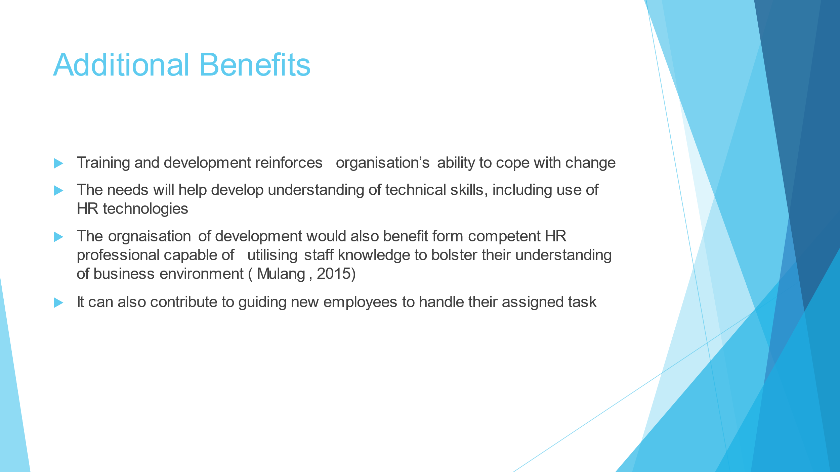
Slide 9
The organisation of development can rely on trained and developed HR professionals to cope with change. They could implement the change through technologies or enhanced strategic approaches such as new products and new markets (Mulang, 2015). Effective training and development can enhance their competency in developing staff knowledge to understand the dynamic business environment and guide new employees to complete their assigned tasks efficiently.

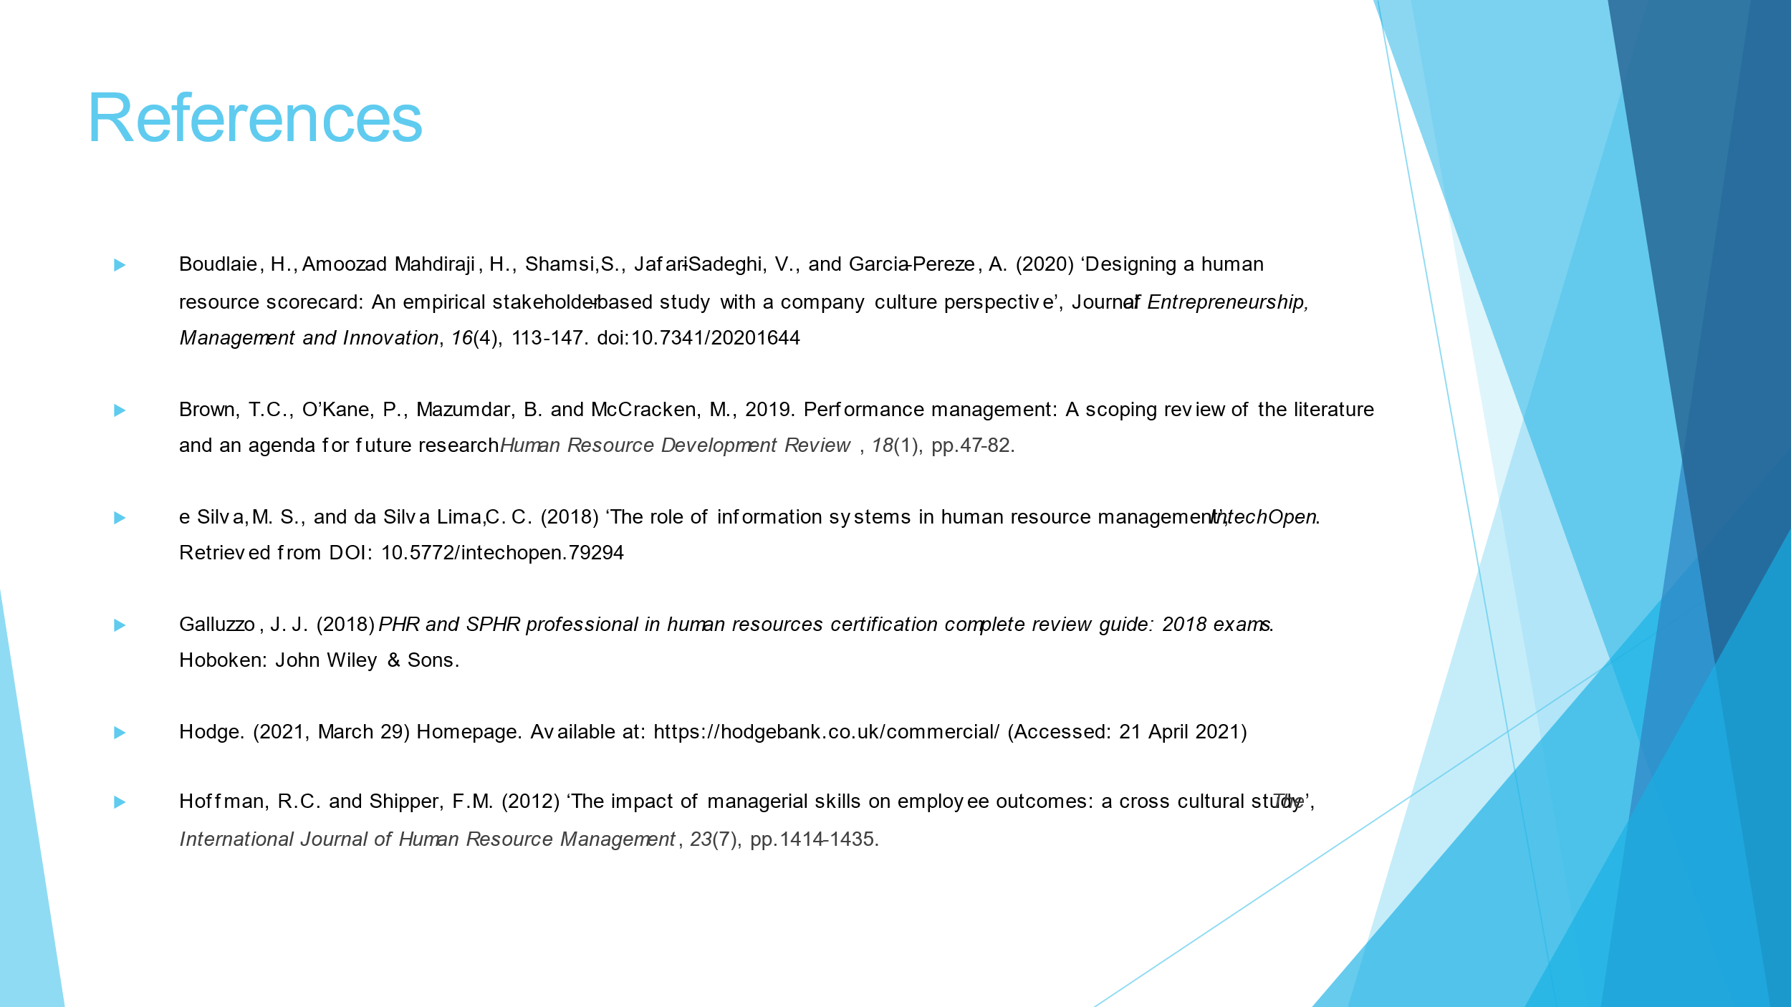
Slide 10

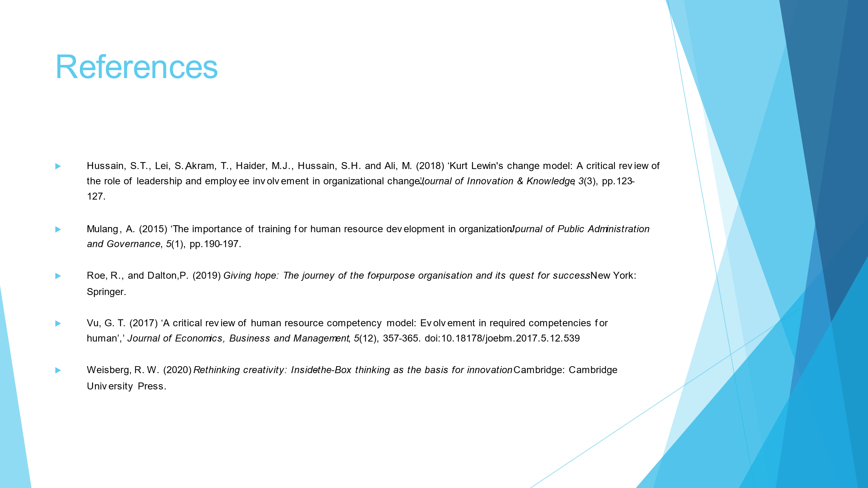
Slide 11

Appendix B

Personal Skills Audit

Name Vasilka Nikolova
Job role: Human Resource Officer

Please tick as appropriate to indicate how you would rate your skills in relation to the following work / functional areas.
 | Very good | Good | Adequate | Little or no experience
Information Technology
Use Microsoft Office Word
Use Excel spreadsheet
Use a Database
Use specialist HR software
Use the internet
Use e-mail
Use PowerPoint
 | Very good | Good | Adequate | Little or no experience
Communication Skills
Drafting contracts of employment
Taking notes of disciplinary
hearingsWrite reports
Produce material to support presentations
Delivering a training session

Resolving disputes/complaints
Interviewing
Advising on HR issues

 | Very good | Good | Adequate | Little or no experience
Problem solving skills
Make good use of verbal reasoning skills, able to handle complex data and make selective use of information
Explore more than one solution in order to solve a problem
Consider the ideas of others to help solve problems

Supervisory Management
How much experience have you had in your role? |  |  | < 1 month | 1-3 months | > 3 months
How many people have you managed at any one time? | None |  |  | 1-5 | Above 5

I declare that the information given in this form is true
Signed | 
Date | 15/04/2021

