Within a given time period, select examples of what could be considered high and low cultural artefacts. Discuss these, taking into consideration the surrounding social, political and historical context.

Student: Faith Jenkins

Student Number: 147668

BA Course Title: Illustration

Word Count: 2176

Tutors: Sarah Tombs & Louise Burston

The High and Low Cultural Art of Millais and Morris

What is the definition of ‘High’ and ‘Low’ culture? How can you establish the differences between them? How does a cultural artefact become categorized as being High art, or Low art? These are some of the questions which will be explored within this essay; particularly in the context of art and design during the Victorian era (1837-1901). The main Victorian artists and their artworks which will be considered are John Everett Millais and William Morris, two of the most influential artists during that time period. Millais’ painterly artworks will be compared with the tapestry and wallpaper designs of William Morris, to define whether and which could be considered as high or low cultural artefacts. The definition of ‘High culture’ is typically associated with the fine arts and literature, it is characteristically appreciated by the ‘elite’ or those with a more ‘cultivated taste’ (William, 2006). Whereas ‘Low’ or ‘Popular culture’ is usually related to the mass-produced, widely consumed art, which is easy to interpret, such as advertisements and poster design (William, 2006). To fully understand how to differentiate between high and low Victorian artefacts, the cultural contexts of Millais’ and Morris’ artworks must be considered.

Prior to the Victorian era, the Industrial Revolution of the mid to late eighteenth century heavily impacted on the lives of working men and women throughout Britain. The revolution drastically altered the structure of the previously handicraft and agricultural based economy, to one of mechanical production and engineering (The Editors of Encyclopaedia Britannica, 2017). In the Victorian society where, utilitarian views and mass-produced goods had become part of the everyday, a group of young artists – the Pre-Raphaelites – sought to redefine the perception of aesthetic beauty in art and design. They looked back to the Old Masters and sought inspiration from the natural world around them (Roe, 2014).

Formed in 1848 by Dante Gabriel Rossetti, William Holman Hunt, and John Everett Millais, the Pre-Raphaelite Brotherhood sought to defy the contrived artistic techniques taught by the Royal Academy (Roe, 2014). Through the modernisation of painterly methods executed by medieval and early Renaissance artists, they attempted to express Ruskin’s ethos of ‘Truth to Nature’ through the intricate detail, bright colours and symbolic realism of their art (Treuherz, 1993).

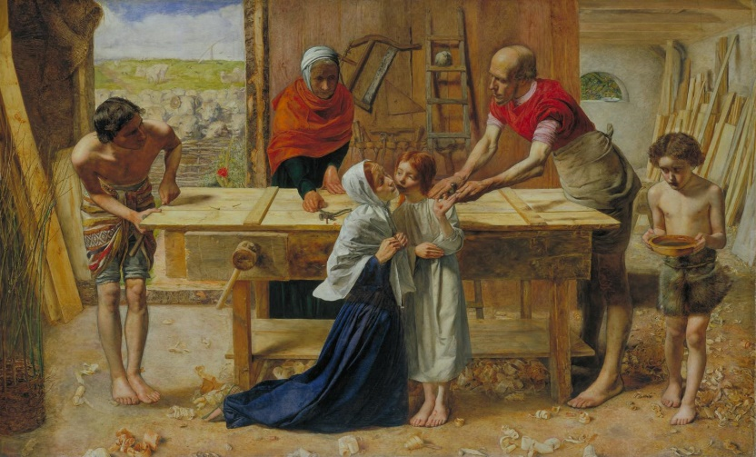
Figure 1
The first cultural artefact which will be considered is Millais’ painting in Figure 1 above titled ‘Christ in the House of his Parents’ (1849-50), which was first displayed in the 1850 Royal Academy exhibition (Roe, 2014). Each of the figures and objects within the scene contain an intricate level of detail, from the creased garments to the grain of the woodwork. Upon initial consideration, one might assume that this painting is a form of ‘High Cultural’ art, for it was displayed within a prestigious art academy, and the painterly fine art techniques are usually associated with high culture in the realm of art (William, 2006). To try to define this, the social and political contexts must be researched, therefore the views and opinions of those who saw the artwork within its cultural context – during the Victorian era – must also be evaluated to determine whether this painting is a form of high or low culture.

Millais’ ‘Christ in the House of his Parents’ received much negative criticism during its initial exhibition (Treuherz, 1993). An incredible attention to detail, and the symbolic narrative within it, was what provoked art critics to view it as a ‘revolting… nameless atrocity’ for the subject it portrayed within was that of the every-day (Mancoff, 2001:80). Millais’ artwork challenged the traditional religious painting methods, of portraying the Holy Family in a picturesque and beautified manner, in contrast he attempted to convey them in reverent yet realistic circumstances (Mancoff, 2001:72). There is a deep level of symbolism within this painting, that may often be lost on the viewer at first – the blood dripping from the child Christ’s hand onto his foot, a young John the Baptist bringing water, signifying his later work – however upon closer inspection many figurative religious references can be found (Mancoff, 2001:73). Even though this painting received much negative criticism, it does not affect its status as a ‘high cultural’ artefact, for the fine artwork techniques, religious symbolism, and literacy elements, all aid in elevating this artwork to a standard of high art and culture.
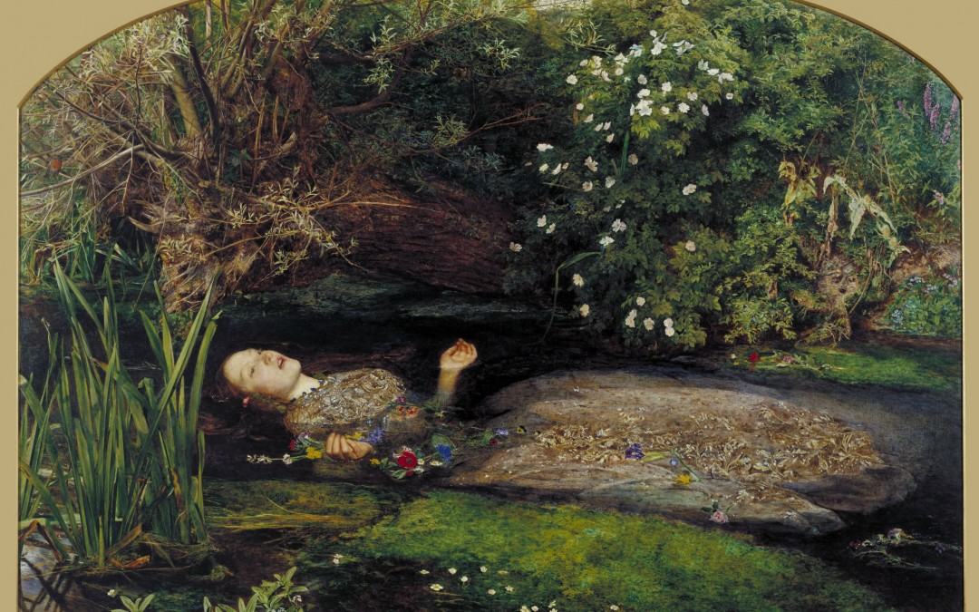
Figure 2
Another one of Millais’ artworks, which could also be considered a high cultural artefact, is in Figure 2, Ophelia (1851-52), which was exhibited in the Royal Academy during a time when a lot of paintings on display portrayed Shakespearean subjects. Although the narrative from Gertrude’s words in Shakespeare’s ‘Hamlet’ is implied within this painting, unlike many Victorian paintings during that time, it does not have to be ‘read’ in order to interpret it, due to the clear visual elements expressing the scene (Mancoff, 2001:25). Once again Millais used extensive symbolism within this painting, to portray a significant narrative element, for example, the bird and poppy both signify her approaching death. Whilst painting Ophelia, Millais would go outside and paint the foliage and flowers directly from life, before adding Elizabeth Siddal’s figure to the composition, in his studio, for he wanted ‘to capture an ethical and visual truth in paint’ (Rosenfeld, 2001:46).
Traditionally in Victorian art Ophelia was perceived as an innocent young damsel, who in tragic despair and heartbreak drowned herself, however, in Millais’ painting a far darker theme is implied.
Within many Victorian performances of ‘Hamlet’ several alterations to the script would be made, removing any suggestive or evocative connotations from Ophelia’s script, to depict her as a silent virtuous woman rather than one of transgression. Millais sought to remain true to the original Shakespearean text, but in doing so he strove against the traditional views and perceptions of Ophelia, by remaining true to the original rather than the edited script (Mancoff, 2001:43-45,63).
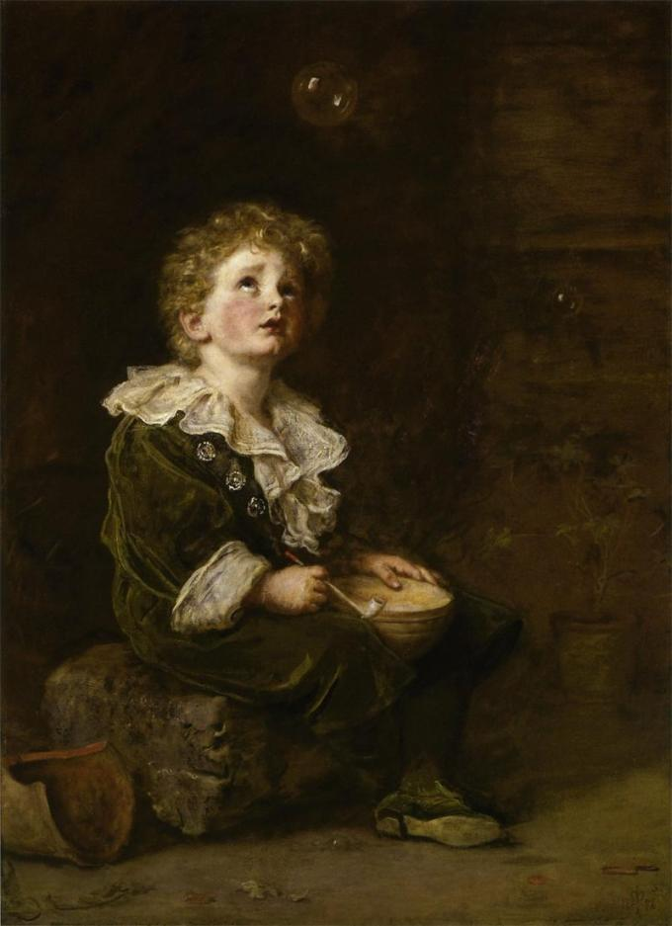
Figure 3
Millais’ later work became heavily influenced by public taste and aesthetic opinions; he became a member of the Royal Academy, which influenced the disbanding of the Pre-Raphaelite Brotherhood in the early 1950’s (Roe, 2014). As his popularity grew Millais began to sell printed reproductions of his work, which caused many art critics to question his use of mass production to promote his art, for they believed that it was ‘diffusing the purifying and softening influence of art’ (Mancoff, 2001:199). His ‘Bubbles’ (1886/Figure 3) painting caused a great deal of controversy, when the artwork was used to promote Pear soap on their posters and packaging (William, 2006). Ferdinand de Rothschild in ‘The Expansion of Art’ (1885) had already expressed his concern, with the negative affects of mass producing art and stated that they…

‘have undoubtedly served to diffuse the knowledge of art; but art itself is degraded into merchandise, and the artist is tempted to produce compositions for the factory, instead of loftily expressing his sense of the ideal.’ (Rothschild cited by Mancoff, 2001:200)

This form of combining high culture fine art, which was supposed to only be appreciated by those with a cultivated taste, with low cultural advertising provides an interesting issue when trying to define the artwork as high or popular art. As technology progressed and improved, art prints became part of mass media production, and therefore lost its high cultural appeal (Mancoff, 2001:201). Since the painting was included on promotional packaging, does that make it low cultural art?

Although the terms high and low culture suggest a contrast and difference in quality this is not the case, for this view automatically connotates a notion that defines art as being good or bad (Fisher, 2013). Nevertheless, Jeremy Maas (cited by Mancoff, 2001:5) states that a viewer’s perception of Millais’ work ‘will depend to some extent on one’s attitude to Pre-Raphaelitism’. This implies that each viewer would have a different perception on what could be defined as high or low art because it would depend on their aesthetic view and opinion of Millais’ art. The definition of high and low culture in the 1700’s, was defined as the difference between work that was ‘purely aesthetic’ and that which had a ‘function or utility’ (Plescher, 2013). Therefore, the difference between high and low art can not be defined by the quality of a painting, but by either it’s aesthetic or functional purpose within its cultural context. Taking these thoughts into consideration implies that Millais’ ‘Bubble’ artwork is a form of ‘Low cultural’ art, because it was produced for commercial purposes, and distributed to a wide audience through advertisement.

Even though the Pre-Raphaelite Brotherhood had ended, the essence and ethos it professed lived on and inspired many other Victorian artists, such as William Morris. The reviving of Pre-Raphaelitism initially began when Morris, inspired by Dante Gabriel Rosetti, collaborated with many other artists in 1857, to paint a mural in an Oxford debating chamber. Subsequently a decorative firm was established by Morris, Rosetti and Edward Burne-Jones, that eventually became ‘Morris and Co’ which promoted and sold their wallpaper, tapestry designs, and hand-crafted wares. Their ethos and emphasis on handmade artistic crafts and design was expressed through their art, as opposing the taste-less designs of mass produced wares, which were a result of the Industrial Revolution. Morris and Co also adopted the Pre-Raphaelite notion, as professed by Ruskin, to express true natural beauty within their artistic endeavours (Roe, 2014).

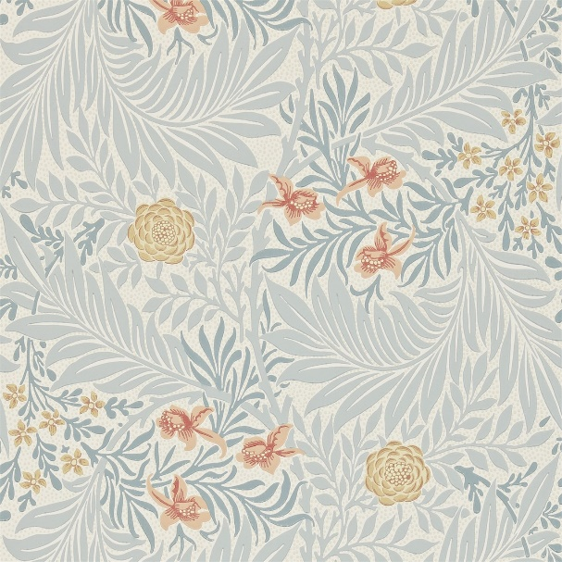
Figure 4
The Larkspur Wallpaper (Figure 4) was one of Morris’ initial wallpaper designs of the mid 1870’s, many of those designs became some of his finest achievements in the medium of wallpaper art. Inspired by English orchards and countryside the interwoven stylised leaves and flowers, reflect nature, as Morris attempted to include ‘unmistakable suggestions of gardens and fields and strange trees, boughs and tendrils’ within this design (Morris cited by Zaczek, 1999:226). One of Morris’ main goals was to produce art that was affordable for everyone, rather than just the elite few; thus implementing the medieval religious ideals concerned with the welfare of both the rich and poor (Naylor, 1988:7-8, 207). Therefore considering the context and the purpose this wallpaper design was created for, it would be considered low cultural art, because it has a function and utility, despite the wallpaper also being a decorative art form.

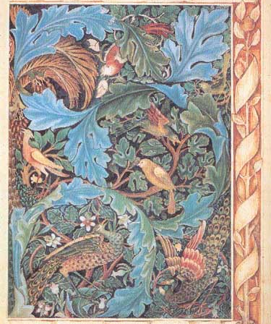
Figure 5
Morris was heavily influenced by 15th century tapestry and medieval arts, which inspired him to create many tapestry designs, one of which is displayed above in Figure 5. The ‘Acanthus and Peacocks’ design of 1881, was inspired by Morris’ first tapestry the ‘Acanthus and Vine’. Within many of his designs, such as the ‘Acanthus and Peacocks’, Morris would create a complex visual intricacy, which would cause the viewer to take a moment to differentiate the peacock’s feathers from the swirling leaves. During this time Morris strove against the industrial and commerical view of tapestry – of simply copying fine artworks onto tapsetry – by creating original artworks inspired by the tapestry art of the Middle ages (Zaczek, 1999:173). Before considering whether or not the ‘Acanthus and Peacocks’ tapetsry design is a form of High or Low cultural art, another one of Morris’ later tapestries will be considered.

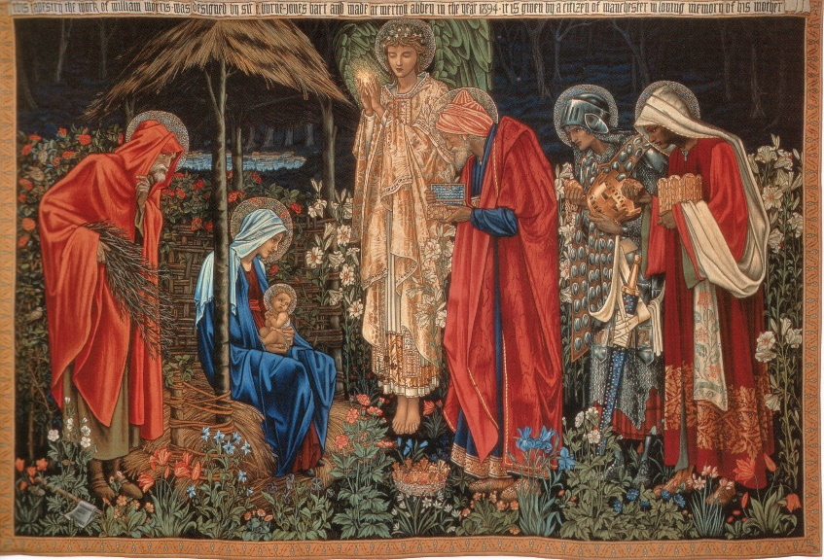
Figure 6
In Figure 6, ‘The Adoration of the Magi’ was designed by Edward Burne Jones, for a chapel in Exeter College. The Morris and Co tapestry depicts the Biblical narrative of the Wise men bestowing gifts to the newborn Christ. Although Burne-Jones designed the incredibly detailed figures and scene composition, Morris suggested applying a bold colour pallet, so the tapestry would not be overwhelmed by the chapel’s bright stain-glass windows (Richards, 2012).

In the following years Morris and Co made several repoducions of these two tapestries, for Morris believed that, ‘What business have we with art unless all can share it?’ (Morris cited by Naylor, 1988:7). Although they were associated with a form of craft, traditionally the art of tapesty design was thought of as the highest form of textile craft, for Morris describes it as ‘the noblest of weaving arts, in which there is nothing mechanical’ (Morris cited by Zackzek, 1999:173). Upon contemplating the historical and political context of these two tapestry designs, it becomes apparent that in contrast to the Morris and Co wallpaper designs, these tapestries could be considered a high cultural art form. Despite the tapestries being replicated, they were still created for decorative, fine art purposes rather than purely for a utility.

In conclusion, by looking at the historical, social and political context of Millais’ and Morris’ work – why, how and when it was produced – a better understanding of the artworks’ purpose and cultural definition can be determined. Millais’ work was predominately classed as ‘High Culture’, because initially he created his fine art paintings as purely asthetic responses inspired by literature. Whereas Morris’ wallpaper designs were defined as ‘Low Culture’, because he produced art with a function that was affordable and available to the masses. Finally it can be deduced that whether an artwork is produced for asthetic fine art purposes, or as a functional craft, it’s cultural context is what defines whether the artwork is a high or low/popular artifact.

Bibliography

Fisher, J.A. (2013) ‘High Art Versus Low Art’ in Gaut, B. and Lopes, D. The Routledge Companion to Aesthetics. Cornwall: Routledge: 527 – 540

Greenhalgh, P. (ed.) (2000) Art Nouveau. London: V&A Publications

Mancoff, N. (ed.) (2001) John Everett Millais, Beyond the Pre-Raphaelite Brotherhood. Great Britain: Studies in British Art

Naylor, G., ed., 1988. William Morris by himself. London: Little, Brown and Company.

Plescher, M. (2013) Is it useful to think of art in terms of high and low? Available at: http://www.therapidian.org/high-and-low-art (Accessed: 07 December 2017)

Richards, T. (2012) Adoration of the Magi tapestry by Edward Burne-Jones (Morris & Co). Available at: http://fourtoes.co.uk/iblog/adoration-of-the-magi-tapestry-by-edward-burne-jones-morris-co/ (Accessed: 29 November 2017)

Roe, D. (2014) The Pre-Raphaelites. Available at: https://www.bl.uk/romantics-and-victorians/articles/the-pre-raphaelites (Accessed: 23 November 2017)

Rosenfeld, J. (ed.) (2003) ‘John Everett Millais’ in the Andrew Lloyd Webber Collection. Pre-Raphaelite and Other Masters. London: Royal Academy of Arts: 44 – 60

The Editors of Encyclopaedia Britannica. (2017) Industrial Revolution. Available at: https://www.britannica.com/event/Industrial-Revolution (Accessed: 02 December 2017)

Treuherz, J. (1993) Victorian Painting. London: Thames and Hudson Ltd

William, M. (2006) ‘High Culture/Low Culture: Advertising in Literature, Art, Film, and Popular Culture’, Advertising & Society Review, 7(1), Project Muse [Online]. Available at: https://muse-jhu-edu.ezproxy.uwtsd.ac.uk/ (Accessed: 23 November 2017)

Zaczek, I., 1999. Essential William Morris. London: Parragon.

Images

Figure 1: John Everett Millais. (1849-1850) Christ in the House of His Parents [Oil on canvas]. Tate Britain, London.

Figure 2: John Everett Millais. (1851-1852) Ophelia [Oil on canvas]. Tate Britain, London.

Figure 3: John Everett Millais. (1885-1886) Bubbles [Oil on canvas]. Lady Lever Art Gallery, Liverpool.

Figure 4: William Morris. (circa 1875) Larkspur Wallpaper [Wallpaper]. Victoria and Albert Museum, London.

Figure 5: William Morris. (1879-1881) Acanthus and Peacocks [Tapestry] Victoria and Albert Museum, London.

Figure 6: Edward Burne-Jones. (1890) Adoration of the Magi [Tapestry]. Exeter College, Oxford.

Additional Reading

Browne, R.B. (1992) ‘Book Reviews - Modern Art and Popular Culture: Readings in High & Low’, Journal of Popular Culture, 26(1) : 191 – 192, ProQuest [Online]. Available at: https://search-proquest-com.ezproxy.uwtsd.ac.uk/ (Accessed: 23 November 2017)

Cormack, P. (2003) ‘Decorative and Applied Arts’ in the Andrew Lloyd Webber Collection. Pre-Raphaelite and Other Masters. London: Royal Academy of Arts: 228 – 274

Greenhalgh, P. (ed.) (2000) Art Nouveau. London: V&A Publications

michealcmichaelo (2009) high art : low art. Available at: https://www.youtube.com/watch?v=lz_UVfNdUV4 (Accessed: 30 November 2017)

Patton, P. (1990) ‘High and Low: Modern Art meets Popular Culture’, Smithsonian, 21(8): 138 Academic Search Premier, EBSCOhost (Accessed: 23 November 2017)

Smith, A. (2012) Were the Pre-Raphaelites Britain’s first modern artists? Available at: http://www.tate.org.uk/context-comment/blogs/were-pre-raphaelites-britains-first-modern-artists (Accessed: 23 November 2017)

Urasaki, A. (2017) High vs. Low Art | Alex Urasaki | TEDxCardinalNewmanHS. Available at: https://www.youtube.com/watch?v=TlhLQ57oUdg (Accessed: 30 November 2017)

Vernon, M. (2017) Tag Archives: William Morris tapestries. Available at: https://www.thetapestryhouse.com/blog/tag/william-morris-tapestries-3/ (Accessed: 29 November 2017)

Worldwide Tapestries. (2017) William Morris tapestries. Available at: http://www.worldwidetapestries.com/category/william-morris/ (Accessed: 29 November 2017)

