Student name: Samuel Riley Student ID number: 1807467

Programme: BA (Hons) Games Design

Module: Advanced Character Animation

Module code: M6X02056

Lecturer: Phil Organ, Nabeel Masih

Date: 09/12/2021

Table of contents
Production Diary/Blog:
Walk
Run
Idle
Jump
Running Jump
Environment:
Rationale:
Research:
Walk Research
Run Research
Idle Research
Jump Research
Running Jump Research
Reference list:
Bibliography:

Production Diary/Blog:
My first idea:
A game character sees a doorway from the fantasy world into the real world
The character walks up to the doorway and puts his hand through it, he pulls it back and inspects it for damage, his hand is fine, so he decides to walk through the doorway.
Second idea:
My second idea was to have a girl (Mery rig) walking through a park at night and being scared by a creature.
Story flow:
She is walking through the park at night, the path is well lit
she takes a turn onto a darker path going through a patch of woods
there is a Scary Monster lurking in the darkness
She hears something move in the bushes
The streetlight goes out
She starts walking faster towards the next streetlight
Switch to creature first person
The creature starts running towards her
She starts running
The creature speeds up and gets close to her and the camera goes black
All you get to see of the creature is some eyes in the bushes
Scary for children
Walk cycle
Cross arms and Shiver
Stop and look around
Turn down the side path
Scared when streetlight goes out
Look around and quicken pace.

Camera shots:

Shot 1:
Establishing shot
Overhead view showing, the girl walking on the path, turning into the dark wooded area,
A dark shape in the bushes near the dork wooded area.
Shot 2:
Front view of her walking towards the turning.

Shot 3:
Close up of the top half of her body, she looks around nervously crosses her arms and shivers.

Shot 4:
Behind view, she is walking down the path and taking the turning towards the dark wooded area.
Shot 5:
View from the creature looking at her as she approaches the wooded area
Shot 6:
Side view, she gets to the first streetlight, it flickers and goes out
Shot 7:
front view, she hears something rustling and looks towards the location the sound is coming from and catches a glimpse of a dark form moving in the shadow, the light flashes and goes out.
Shot 8:
Back view, she starts walking faster towards the light of the next streetlamp
Shot 9:
Creature view
The creature approaches from behind and to the left, staying in the shadows, she hears something behind her and looks around at the creature, she turns her head back and starts to run towards the light of the next streetlamp, the creature catches up and the camera goes black
Table of content
Animations:
Walk
Run
Chat on phone 10/5 sec
Put the phone away 2 Sec
Dark creature.

Test animation:
Link to 1-second facial rig animation I made; the sound is from Bee Movie [1]
Talking to a bee: Clip07
https://www.youtube.com/watch?v=zjJX2uPUuts&list=PLPjbBP7GspahCq1xNuPHUpnyxi7aPvAku
I concentrated on posture and facial expression.
I added the audio to the timeline and animated Merys lips using the audio for the timing.
She has a worried perplexed expression; she is thinking maybe she is going crazy or dreaming.

I started making the walking while talking on the phone animation.
Walking with phone: Clip06
https://www.youtube.com/watch?v=p2ig2IV9TOU

At this point I decided to change my project idea for the following reasons,
I have been making the main character for our major game project and using animations from Mixamo
I have made the animation blueprints and character functionality, but the Mixamo character and all the animations will need to be replaced.
In the coming months I will need to rig and animate the main character so I decided making character animations would better prepare me for these upcoming tasks.
I also realised that my planned animation sequence was probable beyond the scope of this project.
At this point I had only made a 1-second practice animation to learn how to use the facial rig and I had started working on the Walking while talking on the phone animation.
I used the walking while talking on the phone animation (See link above) as a starting point for my walk cycle animation.

Clip01, Walk Cycle:
Figure 1 [2] shows examples of different timings (Beats) that can be used to animate a walk cycle.
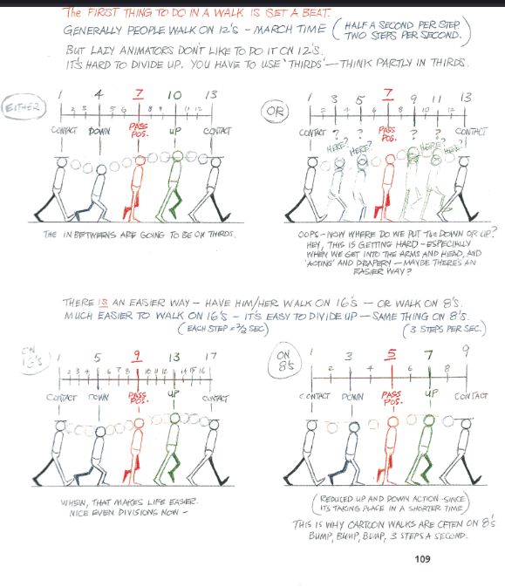
fig01
I set the beat to 12, making a full walk cycle 24 frames, my playback rate is 24 frames per second.
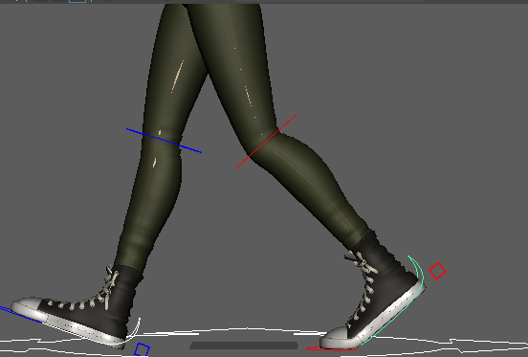
Fig02
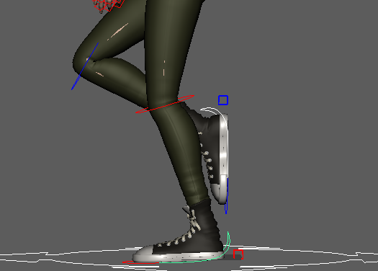
Fig03

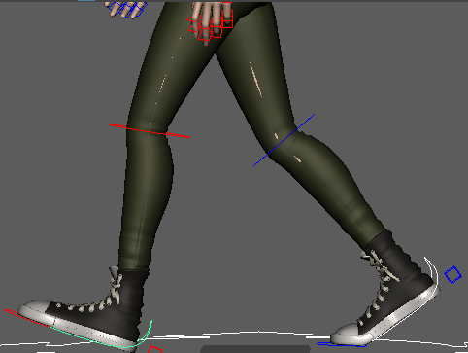
Fig04
- I set the the down keys and adjusted the inbetween.
- I added hip rotation and adjusted the up and down tangents to add weight to the characters walk.
- I added side to side movement, making sure to place the characters weight over the correct leg on the down poses of the cycle.
- I added arm movement and shoulder rotation.
- I added head and neck movement.
- I offset movements to make them look more lifelike using the loop tangent function.

Walk: Clip01
https://www.youtube.com/watch?v=wJEXc3L_d80&list=PLPjbBP7GspahCq1xNuPHUpnyxi7aPvAku&index=4
Table of content
Clip02, Run Cycle:
I set the beat to 10, making a full Run cycle 20 frames, my playback rate is 24 frames per second.
I made my run cycle animation in layers.
- I added the main key frames for the legs.
- I adjusted the feet using the heal ball roll function, to get the contact pose correct.
- I adjusted the height using the hip controller making sure the knees were slightly bent.
- I adjusted the passing pose.
- I adjusted the feet to make them lift off the ground in a more natural way.
- I adjusted the down poses to make sure the feet impacted correctly
- I added rotation and sideways movement to the feet.
- I added hip rotation.
- I added up and down movements and adjusted the up and down tangents, See fig04.
- I added arm movement, clavicle rotation, and shoulder rotation.
- I added spine and neck rotation.
- I added head movement and rotation.
I added polish by adjusting tangents and offsetting movement using loop function, pre/post infinity loop.

Run: Clip02
https://www.youtube.com/watch?v=aWEXxqrdgPk&list=PLPjbBP7GspahCq1xNuPHUpnyxi7aPvAku&index=5
Table of content
Clip03, Idle:
- I posed the character in a natural pose ensuring the hands were in a comfortable position.
- I adjusted the position of the feet and moved the waist down so the legs were not fully extended.
- I placed the weight of the character over the right leg by adjusting hip rotation and waist position.
- I added rotation to the spine, neck, and clavicles to simulate breathing.
- I added a blink and posed the face in an appropriate expression.
- I added the idle clip to the maya timeline and adjusted its speed.

Idle: Clip03
https://www.youtube.com/watch?v=INfQ5Z35ZBk&list=PLPjbBP7GspahCq1xNuPHUpnyxi7aPvAku&index=6
Table of content
Clip04, Jump:
- I used a layered workflow to animate the jump
- I set key poses, stand, squat, up, and squat with arms out
- I worked on timing and spacing.
- I added anticipation pose before jump.
- I added curvature to the spine.
- I adjusted the up and down tangents to simulate weight and impact with the ground.
- I adjusted elbow and knee vectors.
- I adjusted tangents to smooth arm movement.

Jump: Clip04
https://www.youtube.com/watch?v=lRykeJEAPxM&list=PLPjbBP7GspahCq1xNuPHUpnyxi7aPvAku&index=7
Table of content

Clip05, Running jump:
I used a straightforward animation workflow to create the running jump.
I downloaded a reference video and converted it to an image sequence using adobe After effects, I loaded the image sequence into maya and applied it to a plane using a material.
I set keys on the extreme poses and posed the character to match the reference video
I adjusted the in-betweens and smoothed out the tangents
Running jump: Clip05
https://www.youtube.com/watch?v=3Co06YzXtwI&list=PLPjbBP7GspahCq1xNuPHUpnyxi7aPvAku&index=8
Table of content
Environment:
I made an environment to place my animations into, I was planning on rendering the animation clips and using UE4’s composite futures to add them to the scene, I got as far as making a fly through of the environment, so I have included it with my project. All assets are from the UE4 marketplace, and the character is from Mixamo.
Environment for animation: clip08
https://www.youtube.com/watch?v=9Wywz-Pa60s&list=PLPjbBP7GspahCq1xNuPHUpnyxi7aPvAku&index=1
Rationale:
I decided to make character animations to use when controlling a player character because I am rigging and animating the main character in our major project game.
Making these animations will help me gain the experience I need to design and animate a believable player character.
Research:
Methods of animating:
I experimented with straight forward animation using a reference video.
I can see this approach working well for longer animations, but it did not really suit the animation I was doing.
I used a layered approach for most of my animations, this worked well and gave me a more polished result

Adding weight:
An object can be given the appearance of weight by exponentially increasing the speed which it is moving at.
This can be achieved by adjusting the tangents in the maya graph editor
Facial animation research:
Using blend spaces:
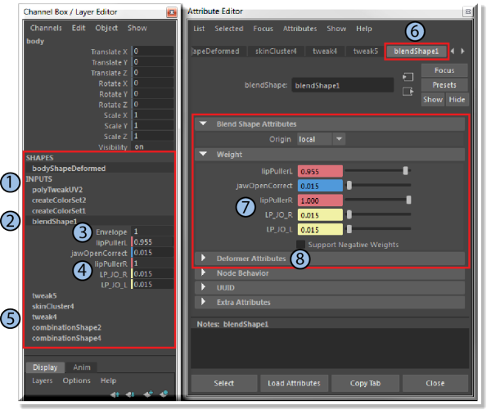
Fig05 image from [3]
Blend spaces allow a user to take one shape and blend it into another shape, these shapes are called Blend Shape Deformers.
Blend spaces can be used to animate facial expressions by blending multiple 3d models
Example:
You can manipulate a 3d shape, like the face into another expression and save this change as a blend shape, you can then blend this shape with the original at what ever amount you want, you can do this with multiple deformers
According to [3] the order which the deformers are stacked determine the order Maya evaluates them, the deformers are evaluated starting from the bottom of the stack.
Multiple deformer nodes can be used, deformer nodes are calculated in an additive fashion
Table of content
Clip01, Walk cycle Research:
I started by reading [2] Pages 102 to 163 walks.
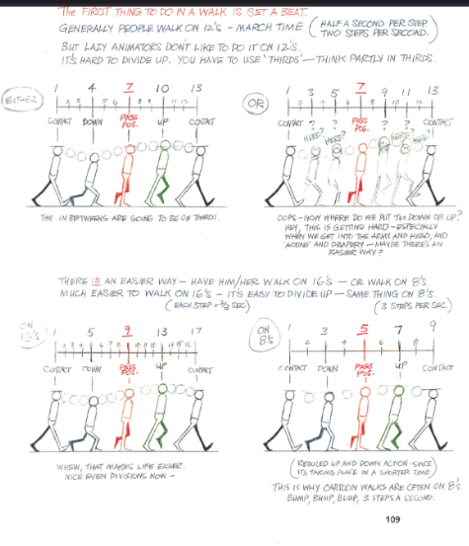
[1] p109 Fig01
Reference used:
[5]
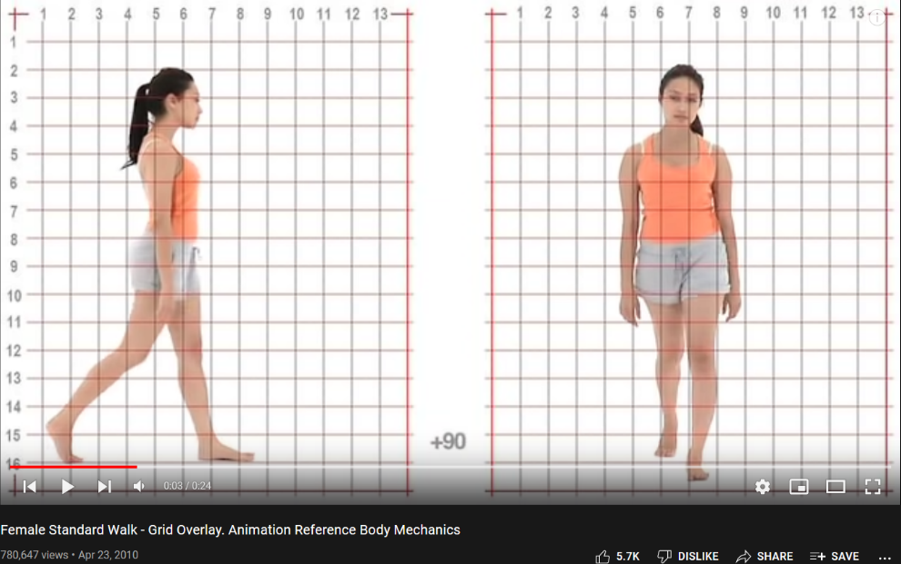
Fig06
Walk cycle reference [3]
https://www.youtube.com/watch?v=xRl7m9yTVIM
Walk cycle, Tutorial [4]
https://www.youtube.com/watch?v=ynXadXE9UjU&list=PLPjbBP7GspagNkqIoYF0d8HbWqEOvDWMt&index=3
Clip02, Run cycle Research:
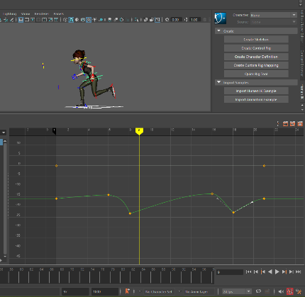
Fig07
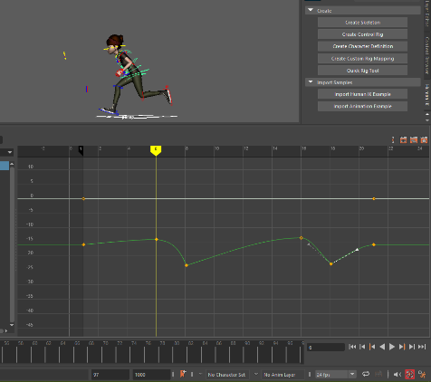
Fig08
Adding impact
When something impacts a static object, it bounces back at roughly the same speed as it impacted
(Minus, the kinetic energy which gets converted to internal energy)
According to [5] macroscopic object collisions are never completely elastic, although the swinging ball apparatus is nearly elastic.
Inelastic collisions are where some of the kinetic energy is converted to internal energy,
Completely inelastic collisions occur when all the kinetic energy is converted.
You can simulate elastic collisions in Maya by using the Maya graph editor and splitting a tangent then adjusting it. See fig 07
Movement arcs:
As stated by D. Leventhal [6] p29 Avoid straight lines, most things in nature move in arcs
Movement in nature generally forms arcs, paying attention to the arcs of movement in your animation can help make your animation seem more lifelike and believable.
Spacing/Timing Table of content
Clip03, Idle Research:
[7]
[8]

Clip04, Jump Research:
I watched tutorials and studied reference videos of different kinds of jumps.
Tutorials: [9], [10]
Reference Videos: [11], [12]
Reading pages 212-216 [2], helped me to find the best timing for my jump.
As stated in [13] a common mistake made by some 3d animators is to have their character stop moving.
Although a still shot of a 2d drawing can look attractive, a still shot of a 3d character can lose its life.
I have followed this advice and been careful to not let my character die, at the end of the jump I added breathing to the character.
Anticipation is important, D Leventhal states in [6] page 17 that an action has three parts:
Anticipation, action, and reaction, muscles must extend before they can contract.
Anticipation helps prepare the audience for the action to come and can direct their attention to where you want it to be.
Clip05, Running jump research:
Straight-ahead animation is a technique that is used in stop go or go motion Animation, this is where an animator takes a picture of a model, moves, or adjusts the model to the next pose, and take another picture then continues doing this until they have an animation sequence.
This process can also be done in maya using a character rig.
I used a straight-ahead workflow for my running jump animation.

Table of content

Research evaluation:
I watched tutorials to learn new animation techniques as I find visual learning to be a more effective way to learn hands on skills.
a lot of journals and books about animation tend to be more focused on 2d animation, it helps to see people putting theory to practice in a 3d environment.
Sir wade Neistadt has done some informative YouTube tutorials, he talks fast and clear and squeeze’s a lot of information into a small amount of time.
The animator’s survival kit has been a lot of help, Richard Williams does a really good job at breaching the gap between 2d and 3d animation

Table of content

Reference list
[1]
[2]
[5]
[6]
[13]

Table of content

Bibliography
[1]Bee Movie. United States: Dreamwork Animation, 2007.
[2]R. Williams, The animator's survival kit. .
[3]"Blend shape nodes and attributes | Maya | Autodesk Knowledge Network", Knowledge.autodesk.com, 2021. [Online]. Available: https://knowledge.autodesk.com/support/maya/learn-explore/caas/CloudHelp/cloudhelp/2018/ENU/Maya-CharacterAnimation/files/GUID-D3068F27-E96E-40AD-9BD0-54C31E0FCF4D-htm.html. [Accessed: 29- Oct- 2021].
[4]Female Standard Walk - Grid Overlay. Animation Reference Body Mechanics. 2019.
[5]"Elastic and Inelastic Collisions", Hyperphysics.phy-astr.gsu.edu, 2021. [Online]. Available: http://hyperphysics.phy-astr.gsu.edu/hbase/elacol.html. [Accessed: 20- Nov- 2021].
[6]D. Leventhal, Animation principles
[7]C. Ashley, GB Introduction to 3D Animation in Maya 2018: Idle Cycle - Lesson 1. 2018.
[8]S. Neistadt, Don't Let Your Character Die! Keep Alive Workflow. 2020.
[9]3d Animation Hub, GB How To Animate A Jump Animation (Episode 15) | How To Be A 3D Animator 2020. 2019.
[10]Maya Vertical Jump - Animation Tutorials | A Step by Step Guide. 2021.
[11]S. Neistadt, 9 Maya Scripts to Animate WAY Faster. 2019.
[12]Testosterone Nation, Vertical Jump. 2018.
[13]A. Williams, "How to Keep Your CG Characters Alive", Animationapprentice.blogspot.com, 2021. [Online]. Available: http://animationapprentice.blogspot.com/2018/10/how-to-keep-your-cg-characters-alive.html. [Accessed: 05- Nov- 2021].
[14]A. Camporota, how to animate a walk cycle (100% polish). 2018.
[15]S. Neistadt, The Secret Animation Workflow You Should Be Using. 2019.
[16]S. Neistadt, How to Animate with the Graph Editor. 2018.
[17]S. Neistadt, Tips for Polishing Animation from a Disney Animator. 2018.
[18]GB Vertical Jump Test - University of Miami. 2021.
[19]Gazyelle, Mery Walk Cycles. 2019.
Table of content

