Owen Evans (2011680)

Factory Control 2
ACMA6001 - Control Technology
Contents
Introduction 2
Factory IO 3
Ladder Logic Program 8
Network 1: Primary Program 8
Network 2: On/Off Control 8
Network 3: Conveyor Start Up Sequence 8
Network 4: Start-up Notification Sequence 9
Network 5: Emitter Control 9
Network 6: Machine Centre Activation 9
Network 7: Assembly Station Clamp Control 9
Network 8: Start-up Reset Signals to Moveable Equipment 9
Network 9: Assembler Clamp Control 9
Network 10: Packing Cycle 10
Network 11: Assembler Control 10
Network 12: Roller Conveyor Control 10
Network 13: Counters 10
Network 14: Warning Check 11
Network 15: Alarm Master Control 11
Network 16: All Warnings and Alarms Control 11
Network 17: Machine Centre Digital Displays 11
HMI Screens 12
Main Screen 12
Warning Screen 13
Engineers Screen 14
Alarm & Warning Strategy 16

Introduction

The purpose of this report is to examine a potential factory design to solve a manufacturing requirement through digital simulation. This approach can lead to shortened system development times, enhanced system design capabilities and reduction of waste materials testing the system. The developed system could be physically recreated using real pieces of equipment, programmed using the script developed for the simulation.

This report comprises of the following sections:
- Factory IO floorplan – a full system with all components required to ensure the correct operation of the system
- Ladder Logic program – a working script to drive the Factory IO digital simulation, replicating the operational parameters the system will be subjected to
- HMI Screens – this section provides the interface for the operator to interact with the system and set the control requirements that govern the system operation
- Alarm and Warning Strategy – provisions for the automatic control of the system, based on certain stipulated conditions being met. This step also provides feedback to the operator about the performance of the system, as well as providing automatic shutdown when a threshold condition is met.

Factory IO

For this assignment, a brief was provided to create a digital factory, using ‘Machine Centres’ to manufacture both ‘Lids’ and ‘Bases’ from raw materials. Once the piece parts are manufactured, a ‘Pick & Place’ machine is used to assemble the ‘Lids’ onto the ‘Bases’. The completed assemblies must then be placed into shipping boxes, two at a time, until the order is fulfilled. The completed factory design is shown in Figure 1.

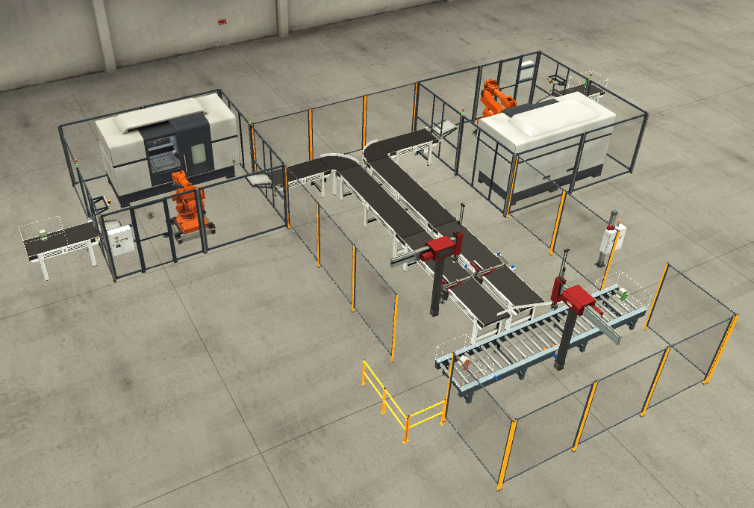
Figure 1: Completed Factory IO layout

The final factory is composed of the following components:
6 x Diffuse Sensors
4 x 2m Conveyors
4 x 4m Conveyors
3 x Emitters
2 x Curved Conveyors
2 x Machine Centres (also comprising of 2 x beam sensors and 1 x digital display)
2 x Positioners
2 x Two-Axis Pick & Place Devices
1 x Remover
1 x Roller Conveyor

Once the components and the layout are decided, the components are attached to a position on the PLC in Factory IO, with Inputs on the left and Outputs on the right. This assigns an address on the PLC to each component, allowing the PLC location to be used in the program to run the Factory IO model. The PLC layout for the factory in this report is shown in Figure 2.

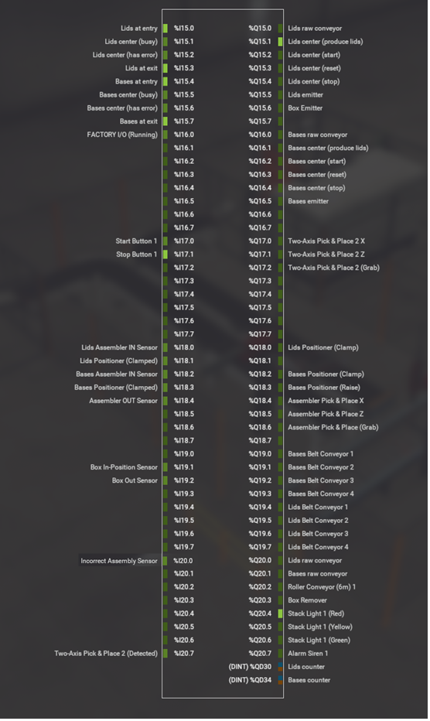
Figure 2: Factory IO screenshot displaying Programmable Logic Controller (PLC) layout. Sensors are shown on the left hand side, actuators on the right.

As an aide to creating the PLC program, an ‘Operational Flow Diagram’ can be created to map the passage of each box type through the system. The ‘Operational Flow Diagram’ for the system above is shown in Figure 3.

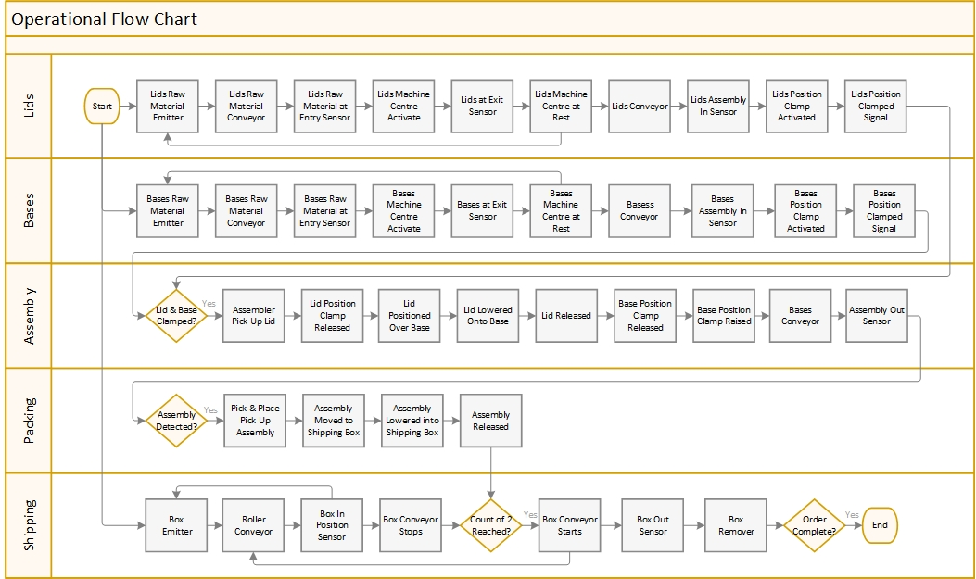
Figure 3: Operational Flow Diagram of the Factory IO intended operation

Ladder Logic Program

Once the Factory IO has been created and the inputs/outputs assigned positions on the PLC, a program is required to control the behaviour of the outputs based on the received input signals. This process can be supplemented with additional computational methods, such as timer circuits, calculations and signal pulses.

The Ladder Logic Program for the Factory IO design in this report is shown below. The nomenclature of the components has been kept the same as those used in Factory IO to aid program writing and troubleshooting activities. The comments for each step have also been added to the comments section in the Ladder program to aid development and troubleshooting for people unfamiliar with the original program.

A summary of each of the networks is detailed below, however, a full copy of the Ladder Logic program can be viewed in the embedded file below.

Network 1: Primary Program

Initial step to assign drivers for the PLC system.

Network 2: On/Off Control

Provides the Start/Stop control of the system, with an additional "Emergency Stop" button function to override all other inputs. Once the system has been triggered by the 'Start' button, the 'Operate' function provides a self-sustaining signal loop, keeping the system active.
Any one active 'Alarm' will break the chain and stop the system operation.
The network also provides the input signals for the 'Machine Centres' to tell them which parts they will produce.

Network 3: Conveyor Start Up Sequence

This step starts the conveyors upon the start of the ‘Operate’ function and separates the conveyor belt start up by offsetting each belt by 500ms. This prevents an excessive current draw on the system at start up.

Network 4: Start-up Notification Sequence

Provides the 'Stack Light' operational requirements.
1) System is switched off - Red
2) System is starting - Yellow with 'Siren'
3) Stack Light Red and Yellow inactive – Green

Network 5: Emitter Control

Provides control on the activation of the 3 emitters.
The 'Bases Emitter' and 'Lids Emitter' are activated on the initial start-up of the 'Operate' function. Further activation is provided only when both 'Machine Centres' are in their rest position at the end of their machining cycle. This is to accommodate for the different lengths of time required to machine the two parts, thereby preventing excess of any one part in the system.
The 'Box Emitter' for the completed assemblies to be shipped in is again activated on the initial start-up of the 'Operate' function. Further activation is provided only when 'Box In-Position Sensor' is activated.

Network 6: Machine Centre Activation

Controls the manufacturing cycle of the 'Machine Centres', started each time by a signal received by the 'Machine Centres' raw material entry sensor.

Network 7: Assembly Station Clamp Control

Provides signals to the clamps to hold the lids and bases in position for assembly. Triggered by the input sensors just prior to the clamps.
This step also provides stop signals for the Conveyor Belts to aid the assembly cycle.

Network 8: Start-up Reset Signals to Moveable Equipment

Once the system starts, a short pulse is provided to each of the moveable equipment to ensure that no positional data from the previous production run is still active once the system restarts.

Network 9: Assembler Clamp Control

Provides a signal that both a lid and a base are simultaneously held in position by the clamps.

Network 10: Packing Cycle

This step provides a full cycle for detecting completed assemblies via the 'Assembler OUT Sensor', activating the 'Two-Axis Pick & Place 2' equipment to collect the assembly and place it in the shipping box. The cycle completes by returning the 'Two-Axis Pick & Place 2' equipment to the system start point.
The network also contains error checking for the packing cycle. If the 'Two-Axis Pick & Place Detected' has a signal at the same time the 'Incorrect Assembly Sensor' has a signal, the lid and the base must have become separated post assembly. The 'Two-Axis Pick & Place Grab' is reset, dropping the part and generating a signal to the 'Assembly Reject' control.

Network 11: Assembler Control

Once both a lid and a base are clamped in position, this step provides the full cycle of activating the 'Assembler Pick and Place' equipment to collect the lid and place it on top of the base. Once the assembly is complete, the assembly is released and the 'Assembler Pick and Place' equipment returns to the initial start-up position.
The network also provides stop/start signals to the Conveyor Belts to restart them post-assembly.

Network 12: Roller Conveyor Control

Provides the control for the 'Roller Conveyor', providing containers for the assemblies to be packaged into. The 'Roller Conveyor' is triggered at start-up to bring the first box into position, stopping when the "Box In-Position Sensor" has been activated.
From this point on, the activation of the 'Roller Conveyor' is controlled through a count of 2 assemblies placed in the box, or the 'Order Completion' trigger competing the manufacturing cycle. Using the "Total Parts Packaged" value as a sum of the number of 'Two Axis Pick & Place Detected' function allows for shipments where the number of assemblies ordered is an odd number.

Network 13: Counters

This step provides the information for the counters used within the HMI screens. These are:
1) Lids leaving the 'Machine Centre Lids'
2) Bases leaving the 'Machine Centre Bases'
3) Assemblies leaving the 'Assembler'
4) Assemblies picked up and placed in the shipping boxes by the 'Two Axis Pick & Place' equipment
5) Shipping boxes leaving the system

Network 14: Warning Check

This step checks to see whether there is an active "Warning" state in the system, producing a flag if any are present.

Network 15: Alarm Master Control

The step checks whether any of the current "Alarms" within the system are active, producing a flag if any are present.

Network 16: All Warnings and Alarms Control

Provides all the activation parameters for all the warnings and alarms built into the system. For further information, refer to the ‘Alarm & Warning Strategy’ section of this report.

Network 17: Machine Centre Digital Displays

This network provides a read out on the physical 'Machine Centres' for the count of the number of parts each machine has manufactured.

HMI Screens

To support the operation of the factory, an HMI device has been incorporated into the program. It consists of three screens:
- Root Screen
- Warning Screen
- Engineers Screen

The benefit of the HMI is the device can be used to control and monitor the performance of the system away from the shop floor.

Main Screen

The Root Screen, is split into panels to help the user clearly identify the functions and controls of each element, Figure 4. The panels are:

- The ‘On/Off Panel’ provides the primary ‘Start’ and ‘Stop’ buttons for the system, with a traffic light system which mimics the physical ‘Stack light’ function in the factory. The panel also provides a switch to return all the moving equipment to its original start position to allow manual reset of the system in the event of an error.

- The ‘Count’ panel shows the total number of boxes at a given point in the system. The ‘Shipping Box’ figure is counted from the ‘Box Out Sensor’, counting the number of filled shipping boxes reaching the ‘Box Remover’. The ‘Lids’, ‘Bases’ and ‘Assemblies’ counts are taken from the activation of sensors at the end of each of their manufacturing processes, whilst the ‘Packed’ count is calculated as the number of parts detected by the ‘Two Axis Pick & Place (Detected) function. A ‘Reset Counters’ button removes all counts and returns all values to zero.

- The ‘Warning’ panel contains two lights that illuminate whenever a ‘Warning’ or ‘Fault’ is detected within the system.

- An ‘Emergency Stop’ button is also provided to immediately shutdown the system if required.

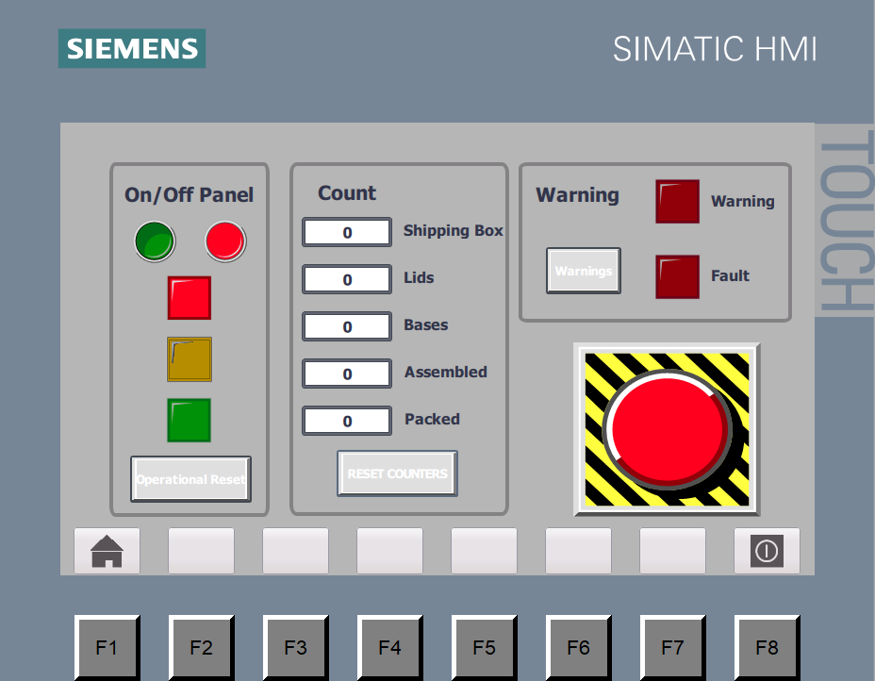
Figure 4: HMI Root Screen

Warning Screen

The Warning Screen is split into panels to help the user clearly identify the error counts, warnings and alarms of each element, Figure 5. The panels are:

- The ‘Error Counts’ panel monitors the production of lids and bases against each other, providing a value in terms of ‘Over-Production’ (OP) should either part be produced in greater number than the other. There is also a count for ‘Not Packed’ error values. This is determined by monitoring the assemblies out of the system against the number of assemblies packed, triggered by activation of the ‘Two Axis Pick & Place (Detected) sensor.

- The ‘Warning’ panel hosts a series of lights to indicate which of the warnings are currently active within the system. Further details on the ‘Warning’ panel methodology are contained in Alarm & Warning Strategy section of this report.

- The ‘Alarm’ panel hosts a series of lights to indicate which of the alarms are currently active within the system. Further details on the ‘Alarm’ panel methodology are contained in Alarm & Warning Strategy section of this report.

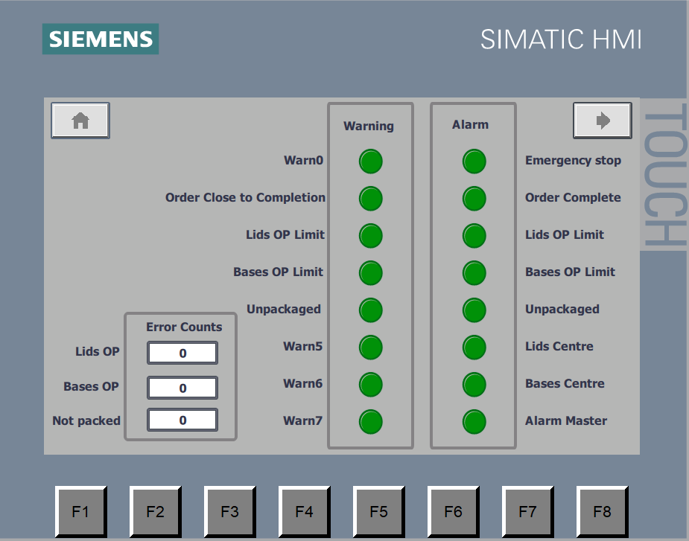
Figure 5: HMI Warning Screen

Engineers Screen

The Engineer’s Screen is split into panels to help the user clearly identify the warning value and alarm value thresholds of each parameter to be controlled, Figure 6. The values are stored in the program to retain the last entered values, provided the program remains connected to Factory IO. The panels are:

- The ‘Order Size’ panel allows the engineer to set the maximum number of completed assemblies the system is required to produce before an automatic shutdown is initiated.

- The ‘Warning Value’ panel allows the engineer to determine the warning threshold of each type of error count being monitored.

- The ‘Alarm Value’ panel allows the engineer to determine the alarm threshold of each type of error count being monitored.

The screen also contains a button to reset all current active warnings and error signals within the system. This enables the system to be restarted once any of the issues creating the alarms have been cleared.

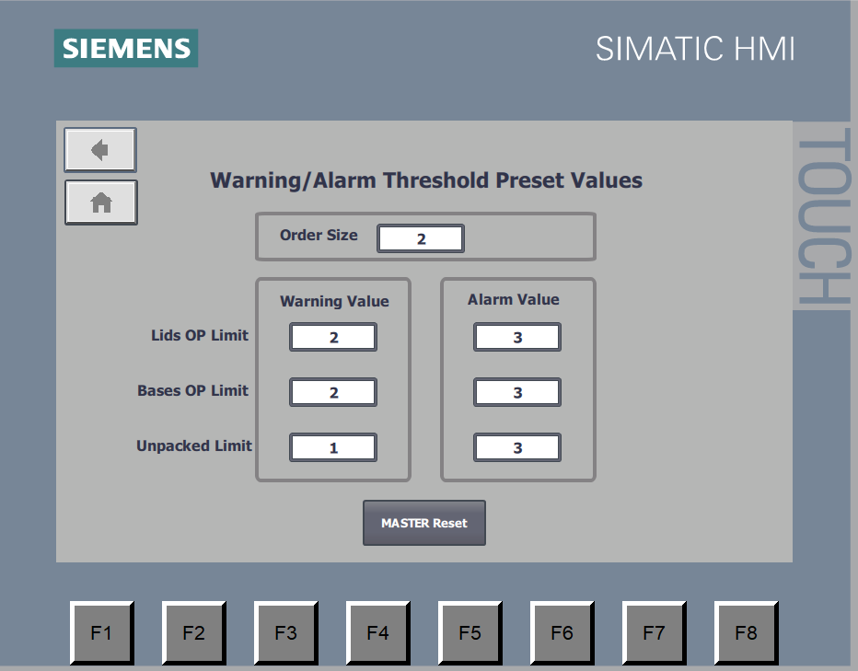
Figure 6: HMI Engineers Screen

Alarm & Warning Strategy

The system has been designed to accommodate two different levels of defect alert scenarios, triggering different responses to each scenario. These are:

- Warnings – defect scenarios that are communicated to the operators, but do not impede the operation of the system.

- Alarms – defect scenarios that are communicated to the operators, but also result in the automatic shutdown of the system.

A full breakdown of the ‘Alarm & Warning Strategy for the factory this report is based on can be found in Table 1.

Where a parameter to be monitored has both a ‘Warning’ and an ‘Alarm’ value attributed to it, the system assess the current state of the parameter against both values in a loop. An example for the ‘Incorrect Assembly’ process flow is shown below, Figure 7.

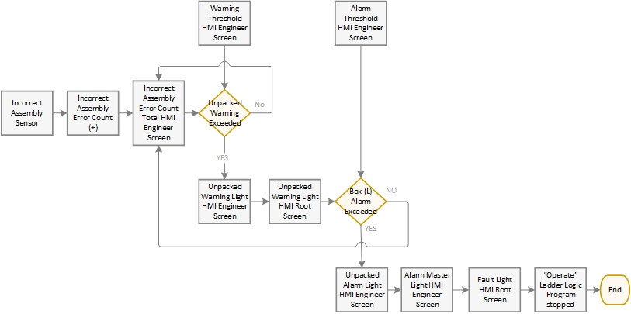
Figure 7: Incorrect Assembly error checking process flow

A ‘Manual Reset’ button has been incorporated into the HMI Engineer Screen, Figure 6, to reset all warning and alarm statuses back to their initial program start default settings.

# | Warning |  | Alarm
# | Name | Parameters | Name | Parameters
0 |  |  | Emergency Stop | Activates once the ‘Emergency Stop button on the HMI ‘Root Screen’ has been engaged and remains until the ‘Emergency Stop’ has been released
1 | Order Close to Completion | Subtracts 1 from the ‘Order Size’ value entered on the ‘Engineer’ screen and provides a warning once the number of ‘Packed’ parts reaches this value | Order Complete | Assesses the ‘Order Size’ value entered on the ‘Engineers Screen’ and provides an alarm once the number of ‘Packed’ parts reaches this value
2 | Lids Over-Production (OP) Limit | Subtracts the number of ‘Bases’ made from the number of ‘Lids’ made to indicate whether more ‘Lids’ have been made than ‘Bases’. Limit value is set by the Engineer using the ‘Warning Value’ ‘Lids OP Limit’ input on the ‘Engineer’ screen. | Lids Over-Production (OP) Limit | Subtracts the number of ‘Bases’ made from the number of ‘Lids’ made to indicate whether more ‘Lids’ have been made than ‘Bases’. Limit value is set by the Engineer using the ‘Alarm Value’ ‘Lids OP Limit’ input on the ‘Engineer’ screen.
3 | Bases Over-Production (OP) Limit | Subtracts the number of ‘Lids’ made from the number of ‘Bases’ made to indicate whether more ‘Bases’ have been made than ‘Lids’. Limit value is set by the Engineer using the ‘Warning Value’ ‘Bases OP Limit’ input on the ‘Engineer’ screen. | Bases Over-Production (OP) Limit | Subtracts the number of ‘Lids’ made from the number of ‘Bases’ made to indicate whether more ‘Bases’ have been made than ‘Lids’. Limit value is set by the Engineer using the ‘Alarm Value’ ‘Bases OP Limit’ input on the ‘Engineer’ screen.
4 | Unpackaged | Calculates the number of unpackaged assemblies caused by incorrect assembly, separating the lid and the base. Each detected incorrect assembly is then ejected from the run and discounted from the ‘Packaged’ total to ensure the system completes the full order number. Limit value is set by the Engineer using the ‘Warning Value’ ‘Unpackaged’ input on the ‘Engineer’ screen. | Unpackaged | Calculates the number of unpackaged assemblies caused by incorrect assembly, separating the lid and the base. Each detected incorrect assembly is then ejected from the run and discounted from the ‘Packaged’ total to ensure the system completes the full order number. Limit value is set by the Engineer using the ‘Alarm Value’ ‘Unpackaged’ input on the ‘Engineer’ screen.
5 |  |  | Lids Centre | Detects if the ‘Machine Centre’ is providing a ‘Has Error’ signal.
6 |  |  | Bases Centre | Detects if the ‘Machine Centre’ is providing a ‘Has Error’ signal.
7 |  |  | Alarm Master | Acts as signal to be activated should any of the other ‘Alarms’ be triggered
Table 1: Full breakdown of the 'Alarm & Warning Strategy' for the factor

