Assessment component: Report

Student Name : Krishna Lakhu Khunti
Student ID : 2515605
Module Name: International Business Concepts
Module Code: LCMB7034
Lecturere’s Name: Jean Wang
Word Count : 5000 words (± 10%)
Term 2

Table of contents
Section 0: Introduction to the report ………………………….………………………...….. 4
Section 1 : International Market Entry …………………………….…...………………..... 5
1 Organisational Classification and Global Strategy of Chipotle Mexican Grill .….…... 5
2 Macro-Environmental and Market Attractiveness of Japan ………….………….….... 8
2.1 Host Country Analysis ……..….……………………………..…………………..... 8
2.2 External Environment Analysis Using PESTLE ……..….…………..…………..... 9
2.3 Market Opportunities and Challenges ………...….……………………………..... 13
2.4 Market Entry Synthesis Using Dunning’s Eclectic Paradigm ………………...…. 14
3 Entry Mode Strategy and Strategic Synthesis …...……………..………..…….….…. 16
3.1 CMG’s Historical Pattern Recognition …...………….……..………..…….….…. 16
3.2 Strategic Fit & Entry Mode Justification ….……….………..………..…….……. 17
3.3 Strategic Recommendations …………………..….……..………..…..…….……. 18
Section 2: Reflection ………………………….…………………………………..……... 20
References …………………………….………………………………………………..… 22

AI Use Acknowledgement
I hereby confirm that this report is my own original work based only on credible academic literature, industry reports, course materials and university instructions. At any stage, no Generative AI tools or automated writing assistants were used to research or develop the academic content. I only relied on grammarly strictly for proofreading and finding grammatical errors to manually correct them by myself.

0.0. Introduction
Chipotle Mexican Grill (CMG) is a leading fast-casual restaurant chain offering Mission-style Mexican cuisine through it’s 4100 locations across USA and Canada. It has pioneered customization, made-to-order Mission burritos, bowls and tacos. CMG has been following centralized global strategy but currently it is pivoting towards a flexible transnational model. The firm has announced its recent joint venture agreements in South Korea, Singapore, and Mexico.
This report critically evaluates market entry of Chipotle Mexican Grill (CMG) into Japan; Where CMG currently has no operational presence. To critically assess the viability of entering Japan, Section One provides an organizational classification of CMG using Bartlett and Ghoshal’s (1989) typology, followed by a targeted macro-environmental appraisal focusing on Japan's specific social, cultural, economic and legal dimensions. These environmental insights are synthesized using John Dunning’s Eclectic Paradigm (OLI Framework) to evaluate localized ownership, location, and internalization advantages. Furthermore, a critical analysis of CMG's historical entry patterns provides an evidence-based justification for a tailored entry mode strategy that balances operational control against host-country risks. Concluding the report, Section Two offers an academic reflection on the research methodologies and challenges encountered during the planning process, structured through an experiential learning cycle to effectively bridge international business theory with corporate practice.

1.0 Organisational Classification and Global Strategy
1.1 Strategic Categorization
As of 2026 report, Chipotle Mexican Grill (CMG) operates more than 4,000 ‘fast casual restaurants’ globally (Chipotle Mexican Grill, 2026).
Bartlett and Ghoshal's (1989) integration-responsiveness framework evaluates multinational strategy based on two axes: pressure for global integration and efficiency, and pressure for local responsiveness. According to Bartlett and Ghoshal’s (1989) typology, Chipotle is a typical example of Global Strategy; which is a model with high pressures for operational efficiency and low pressures for local responsiveness (Bartlett and Ghoshal, 1989). Which is evident in Chipotle's operating model, which is built around a deliberately small, largely unchanging menu consisting of burritos, bowls, tacos and salads built from a limited set of proteins, vegetables and toppings.CMG considers this simple but customizable menu a source of efficiency and consistency rather than a constraint. This menu simplicity is explicitly protected even in the newest international openings. As Chipotle's Puerto Rico operations include standardized recipes, CMG’s predecided strict kitchen protocols and set food-safety, portion-size and pricing standards. Here local managers only have authority over staffing and logistics rather than the product or operating model itself (Wishart Lab, 2026). The "Food with Integrity" sourcing standard and the digital ordering ecosystem (app, loyalty programme, Chipotlane) do not adapt to market either. They are deployed as fixed, globally consistent assets (Umbrex, 2026).
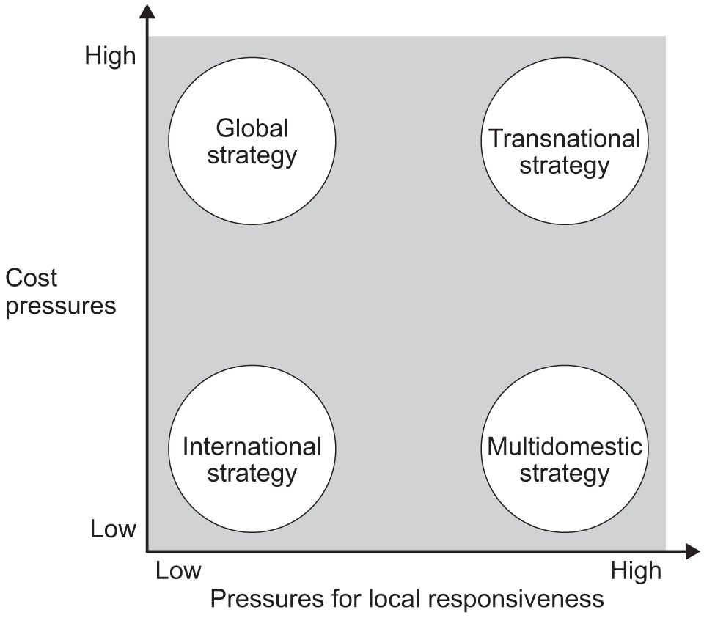
(Source: https://www.aqa.org.uk/resources/business/as-and-a-level/business-7131-7132/teach/teaching-guide-bartlett-and-ghoshals-international-multi-domestic-transnational-and-global-strategies )
Historically, Chipotle absolutely maintained standardization of its "Food with Integrity" menu and operational processes as it faced minimal pressure to adapt its core offerings. Chipotle retained complete ownership of its North American and European operations by following Wholly Owned Subsidiaries (WOS) model (Chipotle Mexican Grill, 2025a). These factors allowed it to enforce unified and stringent food safety protocols globally.
However, further critical analysis reveals that Chipotle has realised the limitations and rigidness of WOS model and recently transitioned towards a Transnational strategy because of it’s diverse operations in distinct markets with diverse cultures. Transnational model tries to balance global efficiencies with localized learning and responsiveness (Hill, 2021). This transition can be recognized when Chipotle partnered with SPC group in 2025 to launch in it’s first Asian subsidiaries in South Korea and Singapore by 2026 (Chipotle Mexican Grill, 2025a). Similar agreements followed with Alshaya group in middle east and Alsea in Mexico (Chipotle Mexican Grill, 2025b).
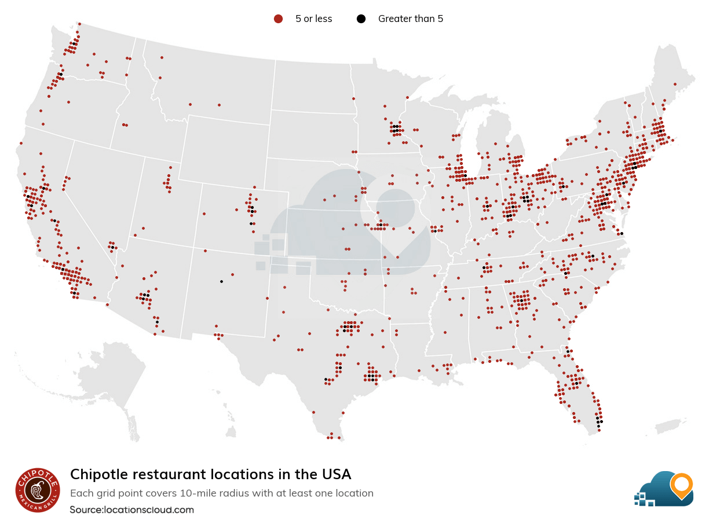
(Source: https://www.locationscloud.com/intelligence-reports/chipotle-usa/ )

Japan is a market characterized by stringent food import regulations and highly distinct dining habits. Hence same transnational strategy will be required for CMG to enter such market. The firm must leverage local market expertise while maintaining the global brand standards that drive its success.
1.2 Global Configuration and Value Creation
Chipotle is primarily concentrated in the United States and Canada but it is rapidly expanding it’s presence in Europe, Middle East and Asia (Chipotle Mexican Grill, 2025a). Chipotle utilized this concentration to achieve economies of scale and highly centralizzed procurement to drive value creation. The firm standardized its supply chain, cerntralized its purchasing power for sustainably raised meats and organic produce; which allowed it to maintain premium pricing while protecting profit margins against inflation. Furthermore, Chipotle heavily digitized and unified it’s infrastructure, which has turned into a competitive advantage. This has allowed allowed high margin sales through it’s digital platform and ‘Chipotlane Drive-Thrus’, which accoutned for a significant portion of it’s growth and new store developments through 2025 (Chipotle Mexican Grill, 2026).
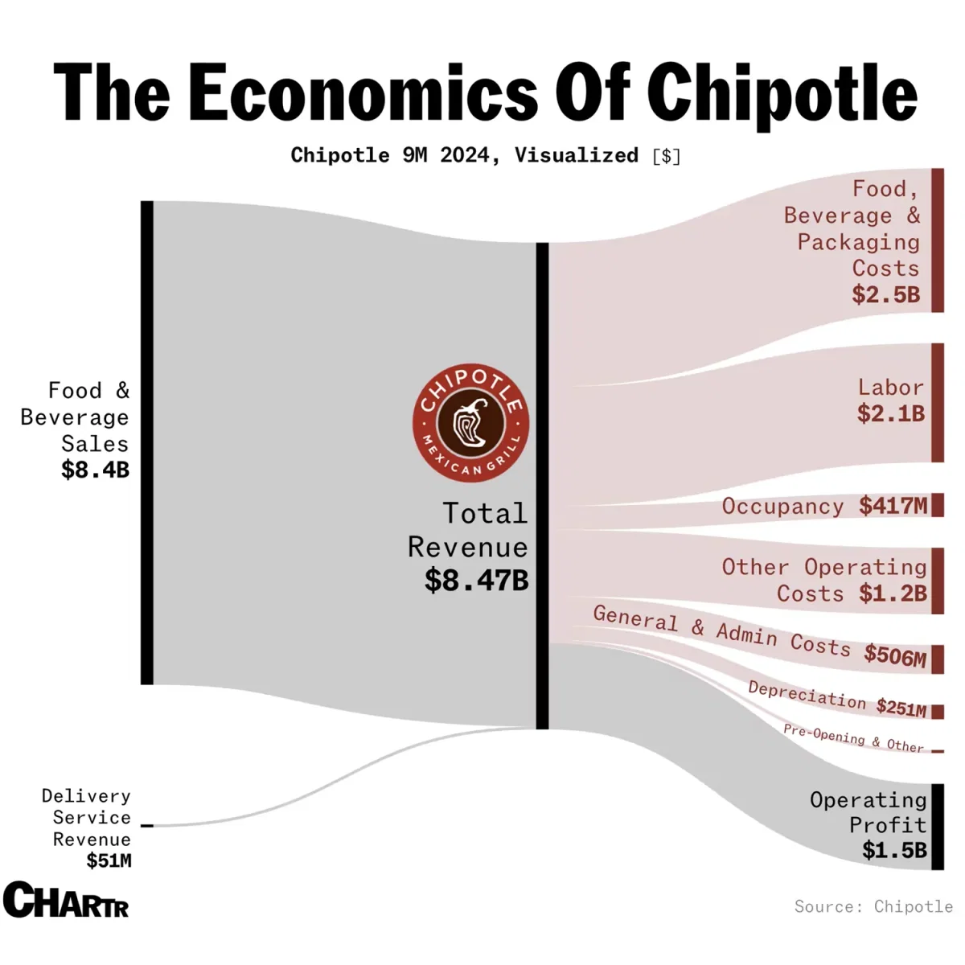
(Source: https://www.voronoiapp.com/business/The-Economics-Of-Chipotle-3303 )
Now this value creation model must adapt structurally as Chipotle expands its geographic footprint into diverse markets like Asia and Middle-east. Exporting its North Americal supplychain to Japand and would incur logistical costs as well as operational risks. The firm is leveraging its regional partners to establish new regional supply networks and localized logistics for its South Korean and Singaporean entries (Chipotle Mexican Grill, 2025a). These regional hubs will allow Chipotle to achieve same economies of scale as America and meet its rigorous standards.
Similarly, an entry into Japan will not only add a new revenue stream but it will structurally enhance Chipotle’s Asian geographic footprint, distribute operational risk and reduce supply chain bottlenecks. All these will increase the overall resilience of Chipotle’s new global network.

2 Macro-Environmental and Market Attractiveness
2.1 Host Country Analysis
Japanese QSR sector was valued at 62.2 US billion dollars in 2025 and it is projected to maintain 8.55% of compound annual growth rate (CAGR) through 2034 (IMARC Group, 2026). Moreover, Chipotle’s digital integration and its core value proposition directly aligns with Japan’s socio-economic trends of health-conscious consumption and automated service (Mordor Intelligence, 2026).
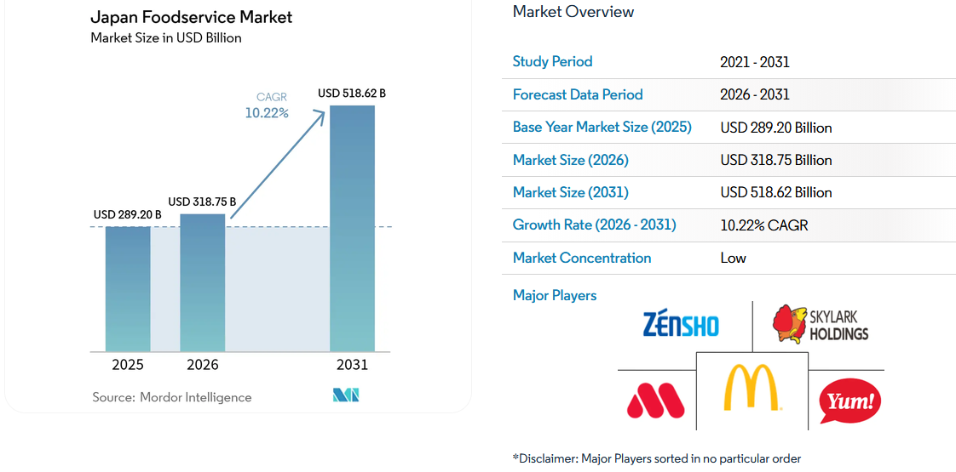
(Source: https://www.mordorintelligence.com/industry-reports/japan-foodservice-market)
However, a generic market analysis of Japan would consider Japan an attractive market as most descriptive indicators (GDP size, political stability, infrastructure quality) are favourable; but largely irrelevant to the specific risks Chipotle would face. Hence, a PESTLE analysis given below is narrowed to the most relevant factors that directly determine the success of mexican fast-casual concept in Japan.

2.2 External Environment Analysis Using PESTLE
Inorder to judge the viablity of market CMG’s market entry, PESTLE provides robust framework to critically analyze each external factor.
Political factors
Japan's political system is stable and low-risk with mature parliamentary democracy, strong rule of law and no meaningful expropriation risk; which is generally considered supportive of inward FDI. More consequential political factor for Chipotle's specific business model is recently tightened labour and immigration policy. As of April 2026, the government suspended new admissions under the Specified Skilled Worker (SSW) visa route for the food-service sector as the admissions cap is full (TreeGlobalPartners, 2026; VisasUpdate, 2026). However, CMG relies on it’s automation and technology to offset labour shortages to run its assembly-line format. A second political factor is trade diplomacy around meat imports with a well documented history of beef-import suspensions largely driven by politics. US meat imports are essential for Chipotle's protein-led menu (USDA FSIS, 2026). This risk is currently mitigated by the US - Japan Trade Agreement, under which tariffs on US beef and pork have been progressively reduced to parity with CPTPP and EU suppliers (USMEF, 2026); however, it is not a permanent reality.
Chipotle has political advantage because Japan eyes 100 trillion yen in Foreign Direct Investment by 2030 and it has built tax incentives, deregulation measures and dedicated "Invest Japan Business Support Centers" within JETRO to provide one-stop administrative support for foreign companies entering the market (JETRO, 2026).
Economic factors
Japan's fast-food market is valued at USD 62.2 billion in 2025 with quick-service formats holding 45% share; it is forecasted to grow at a 5.95% CAGR by 2034, which offers a substencial opportunity with large addressable market (IMARC Group, 2026).Additionally, Japanese currency hit its 40-year lows against the dollar after breaking above ¥163 in July 2026; largely driven by a persistent interest-rate gap between the US Federal Reserve and the Bank of Japan (EBC Financial Group, 2026). While a weak yen fovours the opportunity for market entry, as it lowers the dollar-denominated cost of Japanese real estate, construction and initial investment (Deloitte, 2026); it also inflates the cost of imports such as beef and agriculture products that CMG heavily relies in daily operations. However, Japanese consumers are willingness to pay 8-12% premium for meals with organic and locally sourced ingredients (Mordor Intelligence, 2026).
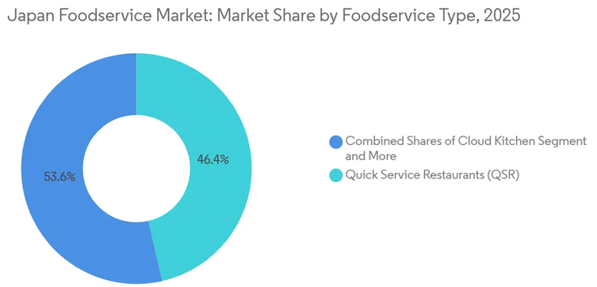
(Source: https://www.mordorintelligence.com/industry-reports/japan-foodservice-market)
Japan’s tourism sector has been driving substantial growth in restaurant spending. Japan welcomed a record 42.68 million visitors in 2025, who spent ¥9.4559 trillion, and the government has set a target of 60 million visitors and visitor spending of ¥15 trillion by 2030 (Travel Market News, 2026). Crucially, Mexico emerged as Japan's highest per-visitor-spending tourist market (Travel and Tour World, 2026); which positively signals that high value Mexican-diaspora travellers are present in japan and could become early customer base alongside Japan's domestic consumers.
Social Factors
Socially and Culturally, Japanese eating habits are evolving, particularly among Gen Z and millennial consumers in urban areas such as Tokyo and Osaka (Mordor Intelligence, 2026). Due social media and tourism, Consumer demand is growing for menus with transparent calorie labeling, organic ingredients and even plant-based alternatives (IMARC Group, 2026). Chipotle's "Food with Integrity" positioning aligns well with Japanese consumers, who value responsibly sourced, minimally processed ingredients of good quality. On the contrary, Taco Bell entered Japan in the 1980s and failed, re-entered in 2015 with substantial interest on opening-day but it is still struggling to convert Japan's growing demand for mexican food into sustainable sales volume. The fact that Japanese consumers readily embrace other foreign cuisines such as Korean and Sichuan food suggests that the barrier lies in format or fit with existing eating occasions (Ashkanemura, 2026). This can be mitigated by Chipotle's highly customizable menu format.
Legal
Japan has strictest regulatory environment in the world for imported food. Hence legal factors are directly consequencial to Chipotle's supply chain. Businesses are required to submit an import notification to Ministry of Health, Labour and Welfare (MHLW) quarantine stations before importing food for commercial sale. Specifically, Beef and meat products require exporting facilities to be individually approved and listed under USDA-administered programmes such as the QSA Program for Japan before any shipment is allowed to enter Japan (USDA FSIS, 2026; GourmetPro, 2026). While this is not a prohibitive environment, as thousands of foreign food brands operate successfully in Japan and MHLW has recently digitized the process of notifications for repeated food imports in late 2025; Replicating Chipotle's US supplychain model would require establishing new and individually certified supplier relationships and increased compliance cost. On labour law, suspension of the SSW food-service visa route (noted above) is not merely political but a legal constraint on Chipotle’s staffing options.

Factors | Critical Analysis | Classification
Political | Political landscape has become favourable for CMG, specifically because of recent US – Japan Trade Agreement.  - Tariffs on beef (fresh, chilled and frozen) reduced from 38.5% to 9% (Office of the United States Trade Representative, 2019). | Favourable :  This reduces the cost of imports and protect CMG's profit margins.
Economic | - Japanese QSR sector is facing severe labor shortages (Mordor Intelligence, 2026).  - However, Japanese consumers are willingn to pay higher prices(8 -12+%) for meals including organic and locally sourced ingredients (Mordor Intelligence, 2026). | Favourable :  While labor shortages are minor threat, other economic factors perfectly support CMG’s “Food with Integrity” pricing model that can pass additional cost of sustainable sourcing on the consumer.
Social | Japanese eating habits are rapidly evolving due to urbanized younger consumers demanding healthier options with transparent calorie labeling and plant-based alternatives, and (IMARC Group, 2026). | Mildly Favourable :  CMG’s highly customizable menu is exact cultural fit for this surge in demand.
Technological | Japanese consumers are well accustomed to advance QSR infrastructure.  - 40% of all QSR transactions in Japan are done on mobile ordering platforms  - Deployment of in-store robotics and automated workflows increased by 67% in 2024 (Mordor Intelligence, 2026). | Highly favourable :  CMG can achieve immediate operational efficiency by deploying it’s industry-leading digital infrastructure and proprietary technology in such highly matured digital market.
Legal | - Regulations are the most significant barrier to entry for CMG as Japan has some of the strictest food safety regulations under the Food Sanitation Law of 1947 (GourmetPro, 2026).  - Rigorous quarantine and inspection processes, testing for pathogens and extensive compliance documentation is required by The Ministry of Health, Labour and Welfare (MHLW) for raw and fresh agricultural imports (GourmetPro, 2026). | Unfvourable :  CMG relies on fresh produce supplychain, failing to comply with legal framework could halt supply chains and entire operations.  Moreover, CMG does not have extensive experience with international supplychains.
Environmental | Growing market expectaitons for sustainable and ethical sourcing of ingredients perfectly aligns with CMG’s core brand values. | Favourable :  CMG can pass higher cost of sourcing on to the consumers

2.3 Market Opportunities and Challenges
Market Opportunities
The clearest opportunities are a large and growing fast-food market, a broadly supportive trade policy, a currency environment that lowers the dollar cost of physical entry, rising appetite for Mexican food, digital ordering adoption rising steadily and consumer values that perfectly align with Chipotle's quality positioning. Crucially, Chipotle now has a proven, replicable template and well demonstrated experience of entering a culturally distant market without diluting brand or sourcing standards.
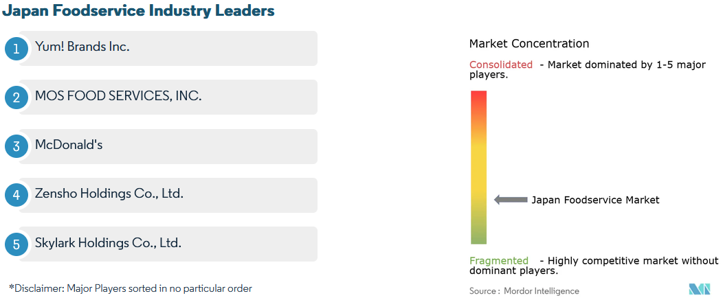
(Source: https://www.mordorintelligence.com/industry-reports/japan-foodservice-market )

Market Challenges
Japan carries a category specific risk that a market size figure alone does not capture. As Taco Bell’s failure suggests that consumer curiosity about mexican food does not reliably translate into sustained demand for fast-casual format. Operationally, clearest challenges are structural rather than cyclical. Labour crisis in the Japanese food sector are genuine. The national minimum wage rose significantly (+6.3%) in the fiscal year 2025 revision and still continues the climb. The labour shortfall projected to reach 6.4 million workers across the economy by 2040 (VisasUpdate, 2026). Moreover, suspension of new specified skilled worker visa admissions for food service worsens the situations for Chipotle, who depends on a large in-store crew. Strict, facility-specific meat-import certification regime that requires new supply-chain investment. Weaker Yen inflates the cost of any imported ingredients Chipotle can not source domestically; such as certain chillies, spices and cheeses that remain difficult to source within Japan.

2.4 Market Entry Synthesis: Dunning’s Eclectic Paradigm (OLI Framework)
To systemetically evaluate CMG’s market entry mode, John Dunning’s Eclectic Paradigm is a robust framework to identify and compare benefits and challenges for market entry inorder to mitigate losses and risks. OLI framework dictates that CMG should invest in Japan when it gains specific benefits from three core pillars: Ownership, Location, and Internalization.
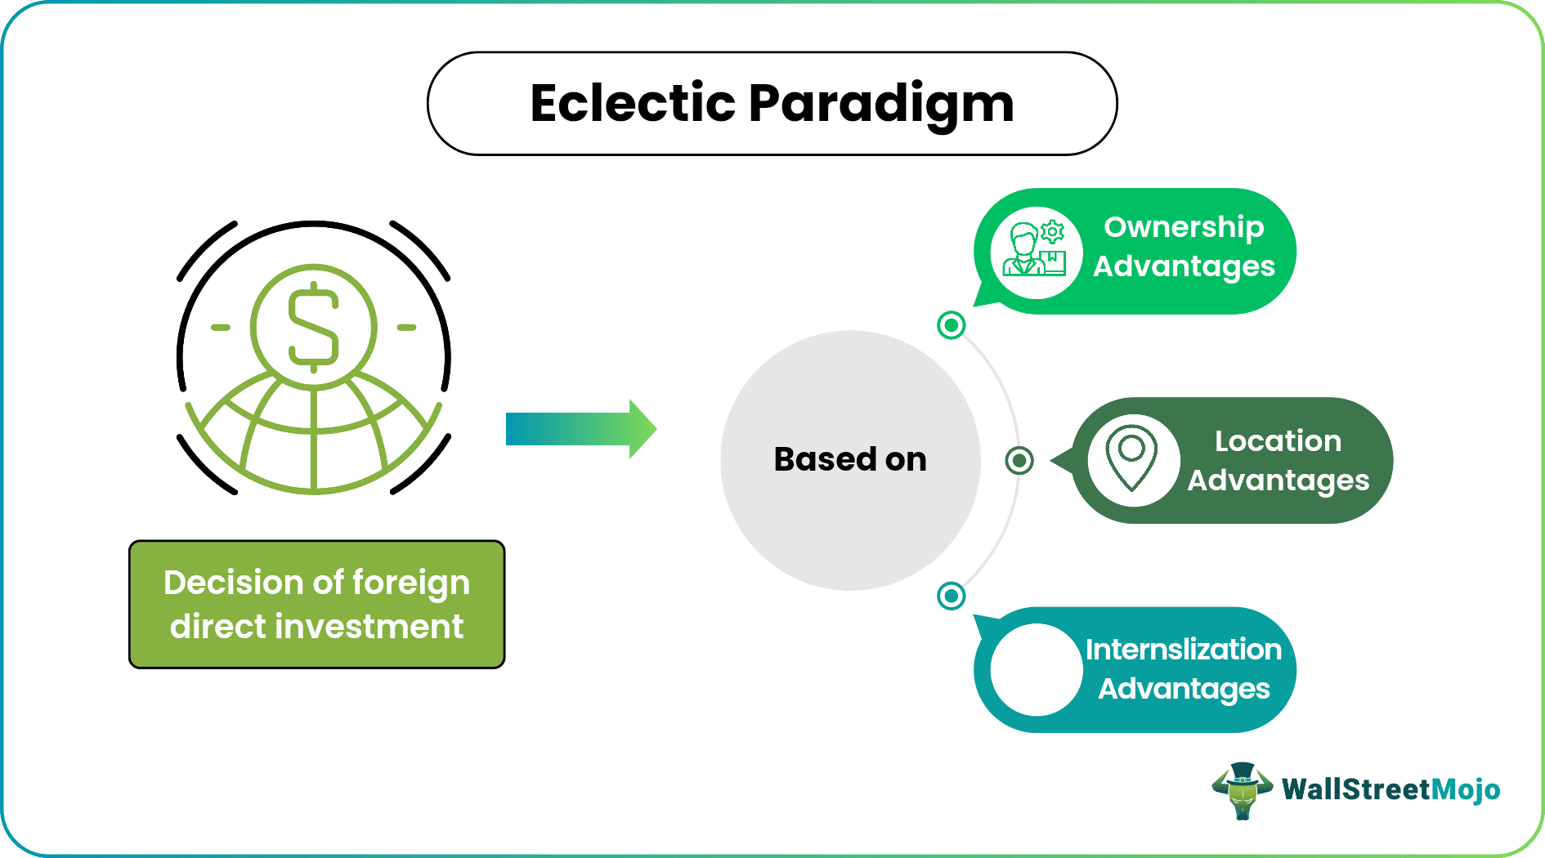
(Source: https://www.wallstreetmojo.com/eclectic-paradigm/)
- Ownership advantages are CMG specific proprietary assets that allow it to compete and operate profitably abroad (Dunning, 1988).
- Location advantages dictate why CMG should directly enter Japan rather than serving the market remotely via exports (Dunning and Lundan, 2008).
Ownership Advantage: Chipotle's O-advantages are substantial but not unconditionally transferable. The firm's "Food with Integrity" sourcing standard is reinforced by supplier partnerships and RFID-based traceability to track every product from farm to restaurant (Supply Chain Digital, 2025). Its digital ecosystem (loyalty programme) has 40+ million members and accounted for 36.7% of CMG’s $11.9 billion total revenue (Chipotle Mexican Grill, 2026b). Chipotlane drive-through format with automation (Autocado and the Hyphen robotic make-line) is present in over 80% of new openings; giving the brand a differentiation and hard-to-replicate quality assets.While these are genuine, firm-specific advantages but the sourcing pillar is location dependent as authentic Mexican ingredients such as certain chillies, spices and cheeses are difficult to source locally in Japan. This is a direct threat to CMG’s "integrity" positioning by forcing it to import at high cost or substitute domestic alternatives (Geinokai BIJ, 2025).
Location-Specific Advantages
Mexican food has been rising in popularity among Gen Z and millennial consumers, primarily living in urban centres like Tokyo and Osaka (Geinokai BIJ, 2025). Japanese market is largely fragmented but intensely competitive with premium urban real estate and high-cost operating environment due to rising labour costs; this raises the fixed-cost base for CMG. Taco Bell (similar format, origin and category) has struggled twice in Japan and currently failing to convert Japan's growing taco enthusiasm into sustained success (SoraNews24, 2026). Moreover, Japan's food distribution networks are notoriously insular and multi-tiered. CMG will require localized partnerships to navigate these domestic supply routes without friction.
Japan offers lucrative market in size with digital infrastructure, tourism-driven exposure to foreign cuisine; but a weak category-specific L-advantages for CMG. Hence, CMG’s customizable menu should adaptat to localized dietary preferences without altering the core supply chain.
Internalization (I) Advantages
CMG’s O-advantages(enforced sourcing protocols, digital platform, brand standards) are strong but its market-specific knowledge is weak and the risk of misjudging local demand is high. The failure mode Taco Bell's more autonomously operated entry illustrates the same. Moreover, the transaction costs of independently building a compliant, greenfield supply chain during severe national labor shortages are now prohibitively high.

Synthesis on Ideal Market Entry
OLI framework suggests that A joint venture or master-franchise agreement with an experienced Japanese F&B operator would let Chipotle internalise its core O-advantages contractually while externalising the location-specific risks of consumer insight, site selection and cost management to a partner who already understands them. A Joint Venture will allow CMG to leverage its proprietary technology and brand while local Japanese partner will absorb the regulatory friction, secure real estate and manage domestic distribution networks.

3 Entry Mode Strategy and Strategic Synthesis
3.1 CMG’s Historical Pattern Recognition
Historically, Chipotle preferred full ownership entry mode. It briefly experimented with franchising during 1990s, but bought back franchised units and currently operating as a 100% company-owned system across the United States since 2006 (Point Franchise, 2022). Same model was extended to Chipotle's expansion into Canada, UK, France and Germany (Restaurant Online, 2024; Gulf News, 2026). Company’s zero-debt balance sheet gives it the ability to self-fund this growth and deliberately choose wholly owned model.
This pattern only broke when CMG singed it’s first franchise development agreement with Kuwait-based Alshaya Group in July 2023, to enter the Middle East (Stratrix, 2026). Since then joint venture led market entry has been the strategic choice to every subsequent market entry: a development agreement with Alsea for Mexico, a joint venture with South Korea's SPC Group covering South Korea and Singapore (Restaurant Dive, 2025; Restaurant Times, 2025).
History suggests a clear bifurcation in Chipotle's revealed entry-mode strategy: Wholly owned FDI in Western European markets, where cultures and institutions are similar. CMG is moving away from WOS and towards Partner-led modes (franchising or joint venture) to accelerate global growth and mitigate the capital intensity of new market entries In geographically, culturally and operatinally distant markets from Chipotle's US home base.
3.2 Strategic Fit & Entry Mode Justification
After evaluating the trade-offs between control, risk, and resource commitment through OLI framework; partner-led pattern is the better fit rather than historical wholly owned mode. Japan is a stable, high-income economy with strong rule of law and low expropriation risk; This lower political and financial risk supports A wholly owned mode with maximum control entry with strong ownership advantages; However, implementing a WOS in Japan carries significant operational and commercial risk. CMG’s knowledge of local consumer behaviour, real estate and competitive dynamics is limited. As established earlier in this report, Taco Bell (Chipotle's closest US Mexican-QSR analogue) has struggled during its two separate entries into Japan despite genuine and growing consumer interest in mexican food. This is a deeper cultural and format mismatch rather than simple unfamiliarity. This is precisely the kind of market uncertainty CMG can avoid by utilizing lower control entry modes.
Hence, partner-based entry is more efficient than direct investment, because a local partner absorbs information-acquisition costs and reduces the firm's exposure to misjudged demand. The Uppsala internationalisation model also reinforces this. CMG should gain experiential knowledge of a market through lower risk entry mode and incrementally increase its resource commitment as psychic distance is overcome through learning, rather than through a large upfront capital commitment.
Chipotle's success with Middle East and Asian agreements show that brand can enforce quality standards within a franchise or joint-venture through strict auditing (Restaurant Times, 2025).
3.3 Strategic Recommendations
CMG should select a Japanese partner with a strong existing real estate portfolio in high-density areas (Tokyo, Osaka) and reliable temperature-controlled domestic logistics network to ensure food safety compliance. CMG should retain absolute control over its proprietary digital ecosystem and loyalty program, but integrate it into the local partner's operations to maximize the throughput.
A phased rollout beginning in Tokyo would allow Chipotle to test format and menu localisation at lower capital exposure before any wider expansion. As Tokyo has stronger receptiveness towards Mexican food because of inbound tourism and Gen Z population. CMG should utilize the partner's regional knowledge to introduce localized, high-margin items in addition to its core menu. If the venture validates demand, brand can increase equity involvement over time.
3.4 Conclusion
Based on the synthesis of Bartlett and Ghoshal’s transnational model, Dunning’s OLI framework and CMG’s own historical pivots; replicating Chipotle's legacy model of WOS is economically and operationally unjustifiable in Japan. A Joint Venture will allow CMG to internalise its core ownership advantages (sourcing standards, digital platform,brand identity) through contractual quality-control provisions while transferring location-specific risks to a partner already operating in the market.

Section 2 : Reflective Account
Reflection helps in transforming academic learning into actionable competence. I have adopted Gibbs’ (1988) Reflective Cycle to critically evaluate my journey of researching, analyzing and synthesizing the international market entry strategy for Chipotle Mexican Grill (CMG) into Japan. This model provides a structured, six-stage framework consisting of Description, Feelings, Evaluation, Analysis, Conclusion, and Action Plan; which allowed me to examine methods and choices of this learning process.
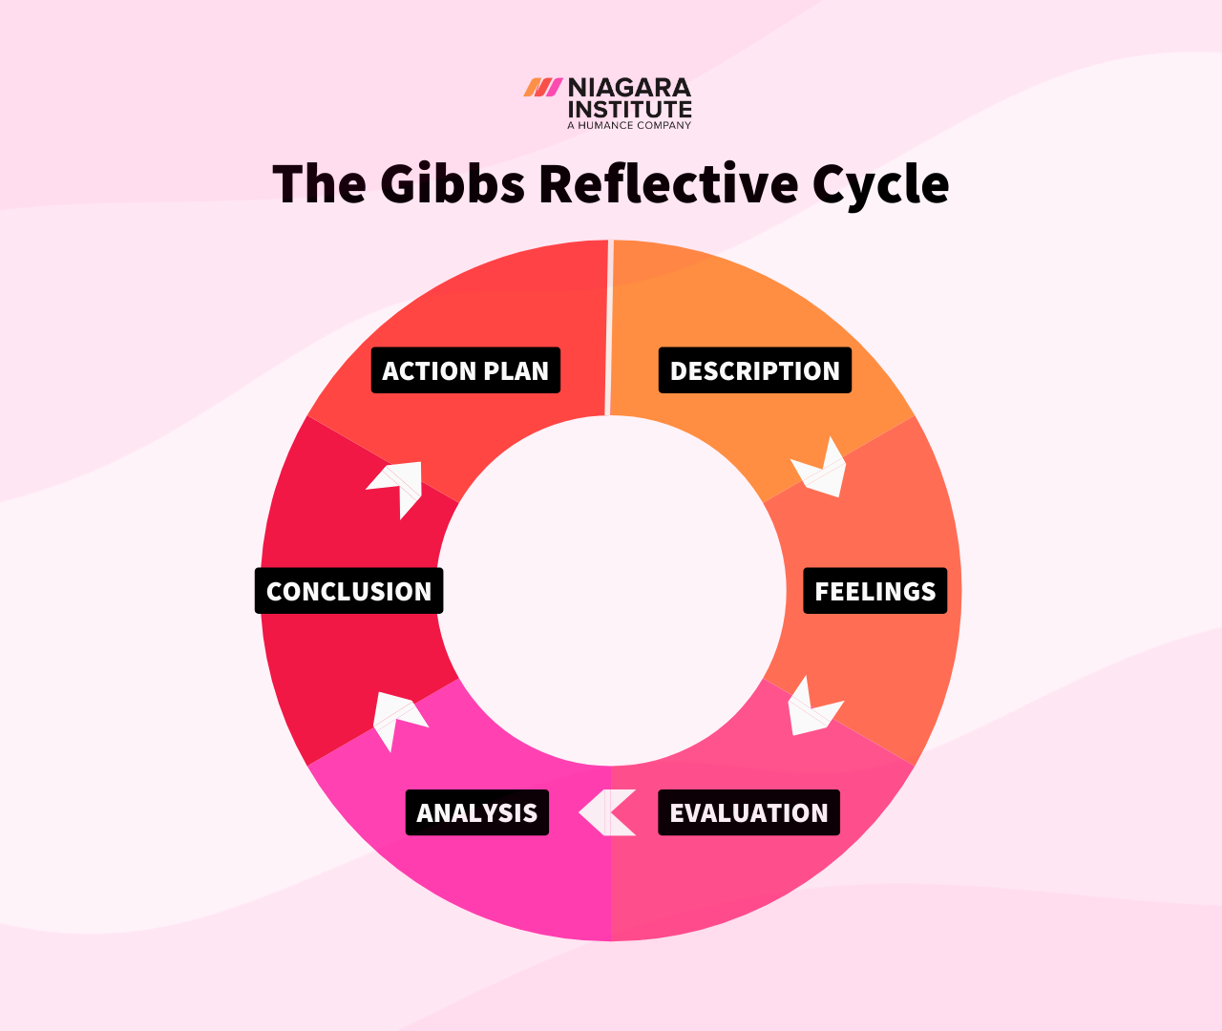
(Source: https://www.niagarainstitute.com/blog/gibbs-reflective-cycle )
1. Description
This assignment required me to select a multinational corporation with no current operational presence in a target country. I chose Chipotle Mexican Grill (CMG) into Japan. I was required to critically evaluate CMG’s international strategy, the host country's macro-environment, and CMG’s entry-mode options using established international business frameworks.
To execute these tasks, I started with secondary research. I gathered CMG’s corporate disclosures, 2025 and 2026 annual reports and SEC filings and finally applied Bartlett and Ghoshal's (1989) typology to classify Chipotle's global strategy and establish historical guideline. Then I conducted a focused PESTEL analysis of Japan to assess macro-environmental appraisal and market attractiveness of Japan, applyied Dunning's (1988) OLI framework to assess market entry, and finally evaluated Chipotle's historical entry modes against Japanese market realities. Across these tasks I continiously moved between company disclosures, annual reports, industry press and academic theory to finally synthesize a strong evidence-based argument for CMG’s market entry in Japan.
2. Feelings
I was already familiar with theoretical frameworks (Bartlett and Ghoshal, Dunning, entry-mode theory) from lectures, which made me feel confident in the beginning. Chipotle has no operations in Japan and Chipotle-specific case studies were scarce. This means I could not analyze or describe any existing market entry; I had to construct a forward-looking, evidence-based argument about a market the company has not yet entered. This was an anxious situation as there was limited literature available to anchor my analysis and applying theoretical frameworks proved difficult on relatively limited data. Further in the research process I found the Taco Bell’s presence in Japan; Which is a US Mexican-QSR brand directly comparable to CMG with a documented, decades-long struggle to establish itself in Japan. This was a turning point in the process which gave my analysis an varifiable anchor and real pattern was visible once I applied the theoretical frameworks.
3. Evaluation
What went well was working through the assignment in sequence : host-country analysis first, then OLI, then entry mode because each section was built upon the last. The frameworks also reinforced one another but only after I gathered enough evidence:During the PESTLE analysis, I came to know about Japan's labour shortage and rising minimum wage along with stricter immigration laws; this analysis fed directly into the location segment of the OLI analysis and ultimately shaped my justification for a joint-venture entry mode over Chipotle's historically preferred wholly-owned model.
The challenging part was time management around source verification as relevant data was fragmented and contradictory. Avoiding pure description in the PESTLE analysis and keeping it focused and relevant to CMG was difficult and i repeatedly went over my word limits because of detailing general Japanese economic statistics. Another hurdle was that i had to repeatedly check the figures and confirm with multiple sources to ensure that I was citing the most current version rather than an outdated one.
4. Analysis
Before completing this assessment, I viewed strategic frameworks like Bartlett and Ghoshal’s (1989) model as static boxes and believed companies permanently belonged to a single category. While working through the PESTLE and OLI sections, I also became more conscious of how easily a large-market-size statistic can create a misleading picture. Finding a connection between theory and Taco Bell case made my argument feel more rigorous rather than merely speculative.
5. Conclusion
Overall, I conclude that the assignment was manageable but should have identified the Taco Bell casestudy earlier in the research process and I could have used it to structure my research phase rather than later. I have also learned that my source mix leaned more towards industry data and government reporting and less on peer-reviewed academic literature, which is partly because report requires recent data and company has recently started expanding.
6. Action Plan
For my future such assignments or projects in my professional career, I intend to begin with a structured, parallel research plan rather than a sequencial one: find core academic literature to support the frameworks I will apply; while simultaneously search for current market-specific evidence to further solidify my arguments. Furthermore, I will dedicate a refinement phase in the research phase to review and critically evaluate my arguments before drafting them.

References
1. Bartlett, C.A. and Ghoshal, S. (1989) Managing Across Borders: The Transnational Solution. Boston: Harvard Business School Press., https://www.hbs.edu/faculty/Pages/item.aspx?num=32 (Accessed on : 2 July, 2026)
2. Chipotle Mexican Grill (2025a) Chipotle to Expand to Asia for the First Time Through a Joint Venture with SPC Group. https://ir.chipotle.com/2025-09-10-CHIPOTLE-TO-EXPAND-TO-ASIA-FOR-THE-FIRST-TIME-THROUGH-A-JOINT-VENTURE-WITH-SPC-GROUP (Accessed: 3 July 2026)
3. Chipotle Mexican Grill (2025b) Chipotle Signs Development Agreement with Alsea to Open Restaurants in Mexico for the First Time. Available at: https://ir.chipotle.com/2025-04-21-CHIPOTLE-SIGNS-DEVELOPMENT-AGREEMENT-WITH-ALSEA-TO-OPEN-RESTAURANTS-IN-MEXICO-FOR-THE-FIRST-TIME (Accessed: 3 July 2026).
4. Chipotle Mexican Grill (2026) Chipotle Announces Fourth Quarter and Full Year 2025 Results. https://ir.chipotle.com/2026-02-03-CHIPOTLE-ANNOUNCES-FOURTH-QUARTER-AND-FULL-YEAR-2025-RESULTS (Accessed: 3 July 2026).
5. Hill, C.W.L. (2021) International Business: Competing in the Global Marketplace. 13th ed. New York: McGraw-Hill Education. https://omeka.urbeuniversity.edu/files/original/be97eab4d313f8d9e200430ff1e67c757e085c8e.pdf (Accessed: 3 July 2026)
6. IMARC Group (2026) Japan Quick Service Restaurants Market Size & Report 2034. Available at: https://www.imarcgroup.com/japan-quick-service-restaurants-market (Accessed: 12 July 2026).
7. Mordor Intelligence (2026) Japan Foodservice Market Size & Share Outlook to 2031. Available at: https://www.mordorintelligence.com/industry-reports/japan-foodservice-market (Accessed: 12 July 2026)
8. Office of the United States Trade Representative (USTR) (2019) FACT SHEET on Provisions of the U.S.-Japan Trade Agreement Beef and Beef Products. Available at: https://ustr.gov/about-us/policy-offices/press-office/fact-sheets/2019/october/provisions-of-the-us-japan-trade-agreement-beef (Accessed: 13 July 2026).
9. GourmetPro (2026) Japan Food Import Regulations: The 2026 Compliance Guide for F&B Exporters. Available at: https://www.gourmetpro.co/blog/what-are-japan-food-import-regulations/ (Accessed: 29 July 2026)
10. Supply Chain Digital (2025) A Better Burrito: Chipotle's Supplier-Driven Integrity. https://supplychaindigital.com/news/a-better-burrito-chipotles-supplier-driven-integrity (Accessed: 29 July 2026)
11. Geinokai BIJ (2025) Tacos in Tokyo: Why Mexican Food in Japan Is Growing in Popularity. https://geinokai.jp/blog/2025/04/19/mexican-food-in-japan-tacos-in-tokyo/ (Accessed: 29 July 2026)
12. SoraNews24 (2026) Why is Taco Bell failing in Japan, even as the country falls in love with tacos? https://soranews24.com/2026/07/25/why-is-taco-bell-failing-in-japan-even-as-the-country-falls-in-love-with-tacos/ (Accessed: 29 July 2026)
13. Dunning, J.H. and Lundan, S.M. (2008) Multinational Enterprises and the Global Economy. 2nd ed. Cheltenham: Edward Elgar Publishing.
14. Dunning, J.H. (2000) 'The eclectic paradigm as an envelope for economic and business theories of MNE activity', International Business Review, 9(1), pp. 163-190.
15. TreeGlobalPartners (2026) SSW Food Service / Restaurant Worker Salary in Japan 2026. https://treeglobalpartners.com/en/articles/ssw-food-service-salary-japan/ (Accessed: 1 Aug 2026)
16. USDA FSIS (2026) Japan — Food Safety and Inspection Service. https://www.fsis.usda.gov/inspection/import-export/import-export-library/japan (Accessed: 1 Aug 2026)
17. USMEF (2026) Free Trade Agreement — Japan. https://usmef.org/export-data/free-trade-agreement (Accessed: 1 Aug 2026)
18. Ashkanemura, S. (2026) The Mystery of Japan's Missing Mexican Cuisine. https://satoshiashkanemura.substack.com/p/the-mystery-of-japans-missing-mexican (Accessed: 1 Aug 2026).
19. VisasUpdate (2026) Japan's Restaurant Crisis 2026: Labor Shortages, Visa Freezes, Soaring Costs, and a Sector on the Brink. https://www.visasupdate.com/post/japan-restaurant-crisis-2026-labor-shortages-visa-freezes (Accessed: 5 August 2026)
20. Gibbs, G. (1988) Learning by doing: a guide to teaching and learning methods. Further Education Unit. Oxford: Oxford Polytechnic.
21. Umbrex (2026) Chipotle Strategy and Business Model. https://umbrex.com/resources/company-profiles/chipotle/ (Accessed: 5 August 2026).
22. Wishart Lab (2026) Chipotle Puerto Rico: A Detailed Look at Operations, Menu, and Local Context. https://ccdb3.wishartlab.com/ccd/chipotle-puerto-rico-a-detailed-look-at-operations-menu-and-local-context (Accessed: 6 August 2026).
23. JETRO (2026) Business-Friendly Government Policies. https://www.jetro.go.jp/en/invest/investment_environment/whyjapan/ch5.html (Accessed: 7 August 2026)
24. Travel and Tour World (2026) Japan Tourism Boom Shifts as Mexico Emerges as Highest-Spending Tourist Market. https://www.travelandtourworld.com/news/article/oxuj6598c4td/ (Accessed: 8 August 2026)
25. Travel Market News (2026) Japan Tourism Record 2026: Arrivals, Weak Yen, New Taxes. https://travelmarketnews.com/japan-inbound-tourism-record-2026 (Accessed: 8 August 2026)

