

LCBB5003 Management economics

Essay

Lecthurer:Vasilios Tavlaridis

Stratsimir Milushev : 2009416

Date: 04.04.2022

Contents

INTRODUCTION…………………………………………

MAIN BODY…………………………………………….

The Covid19 pandemic had an effect to all the economies across the world. Using economic policy analysis outline and evaluate the effects on employment and standard of living in the UK with respect to managerial decision-making in organisations (SMEs or large organisations)

Measures anti-epidemic……………………………………
Statistics on fatalities………………………………………
Vaccine…………………………………………………
Finance…………………………………………………
Standart of living………………………………………….
Employment……………………………………………..

CONCLUSION…………………………………………...

REFERENCE…………………………………………….

Introduction: What is a COVID-19

Coronavirus is a severe infectious disease of the respiratory tract in humans, which can range from mild to very serious and even deadly. This disease has changed the way of life and continues to do so worldwide.

Main body:

In terms of decision-making in response to the Pavid 19 pandemic, life in the UK is drastically different and, in my opinion, significantly more difficult than it was prior to the pandemic. This is likely one of the worst-case scenarios for what should happen against the reality of what is occurring, and what's worse is that this calamity occurs concurrently with Brexit. However, this is another large subject comparable to covid 19. Let us examine or attempt to track the events and policies that the UK government has implemented and enforced on residents, as well as the impact these policies have had on the UK economy and development. (IMF, n.d.)
The UK economy was not just put to the ultimate test by the outbreak of this epidemic. Cohesion and collaboration were critical in dealing with both the people and the state's condition in this situation. The provision of assistance in a variety of forms to individuals, businesses, and organisations in a variety of industries has had a substantial effect on preserving a certain standard and way of life. However, the government is paying a significant price for this, as it assisted in funding and supporting these businesses and individuals. These are substantial sums that have undoubtedly had an influence, yet the overall impact of what occurred remains unfavourable. Numerous businesses have been forced to close, and others have been closed permanently. Others have been placed on indefinite leave. Others were simply given the option of continuing to work but under certain terms and company reorganisation, such as relocating from work to home. Several restaurants have been converted into food take-out establishments. Coronavirus was announced as the first case in December 2019 (Frontiers, n.d.) and a pandemic was declared shortly afterwards. The UK economy suffered a drop following the pandemic's revelation. It results in the establishment of crisis management procedures to ensure the survival of the country's industry and economy. Additionally, the provision of assistance in a variety of forms to ensure the continued existence and maintenance of the work process. These are procedures that exacerbate the already precarious position that has existed since the United Kingdom's exit from the European Union.

-Measures anti-epidemic

-Numerous techniques are employed to contain the outbreak, including "lockdown," which involves preventing or prohibiting individuals from leaving their homes, closing schools, closing restaurants and hotels, and closing retail centres.

-These measures are universally applicable, regardless of These precautions are intended to limit people's freedom of movement and consequently the virus's transmission. Key workers are exempt from this rule.

-These are employees who must work and move about when the lockdown is in effect. Medical personnel, retailers, and factory workers are all examples of critical employees... However, these individuals are subject to various constraints and limitations in order to prevent the virus's spread.

-Quarantine is another method of containing and isolating persons who are already ill or infected with the virus in order to prevent it from spreading.

-These individuals are typically segregated in separate rooms or residences and are not permitted to leave until the threat has gone.

-Additionally, so-called (shielding) measures are used; these are precautions for persons who are more vulnerable and at a high risk of being badly infected, such as those with side effects and disabilities.

-Social distance is a preventative approach that lowers contact and consequently the chance of infection. (Harari, Keep and Brien, 2021)

Statistics on fatalities

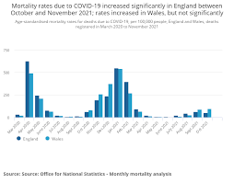

www.ons.gov.uk

From March 2020 to February 2022, this graphic shows the death statistics for England and Wales. It demonstrates how, during the start of the epidemic, and for about a year afterwards, deaths are at an all-time high. These are extremely high rates of illness and mortality not only in England, but throughout the world.

-Vaccine

- To address the condition, intense research is being conducted to develop a vaccine. This requires time and must also be done swiftly and precisely to avoid adverse impacts on people. society for their circumstances, their opportunity, and their decision to receive immunisation in order to help society and the economy overcome this difficult and dangerous time. As a result, the public is informed in a variety of ways and made aware of the dangers of serious sickness. This is a terrible period for the economy and for individuals. In England, 99 percent of the population has a high level of antibodies, which is an excellent result. (www.ons.gov.uk, n.d.) Vaccination is one of the most effective measures for containing a viral pandemic. This has been demonstrated by the ongoing battle against covid19. The government's purpose in enacting the limits is to safeguard the people's lives and livelihoods. The government is determining the steps of adjustment necessary to recover fast from the pandemic. unable to exert control over the situation. Vaccines have steadily abolished previously imposed limits. This is critical for the survival of the free way of life and the economic recovery.
(www.ons.gov.uk, n.d.)

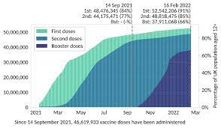

www.ons.gov.uk

This graph depicts the percentage of the English population who have had one, two, or three doses of 12+ vaccination, accordingly. By September 2021, 84% of England's population had received one dose of vaccination, 77% had received a second dose, and the booster programme had not yet commenced. And by February 2022, 85% of the population will have received two doses and 66% will have received a booster. The rapidity with which vaccines were introduced in the United Kingdom is critical and has placed the country in an excellent position. England is the first country to permit the use of vaccines manufactured by Pfizer and Astra Zeneca to combat the virus. (www.ons.gov.uk, n.d.) The government initially decided to immunise at-risk and elderly members of the community. These government actions are critical for reopening the economy and eliminating restrictions. In 2021, the government was able to lift some of the limitations in England due to the introduction of vaccination. The government implemented limits in four stages. England's majority of limitations will be abolished in July 2021, making it one of the countries that will open earlier. Booster vaccinations began simultaneously. In England, one of the earliest measures taken by the government was to restrict travel, which is one approach used to cope with similar circumstances. Due to the appearance of the new Omicron variety, the government was compelled to enact measures aimed at containing its spread. The economic impact of Omicron is currently unknown. In just a few months following the introduction of Omicron, inflation increased by around 5%.
(House of Commons Library, 2019)

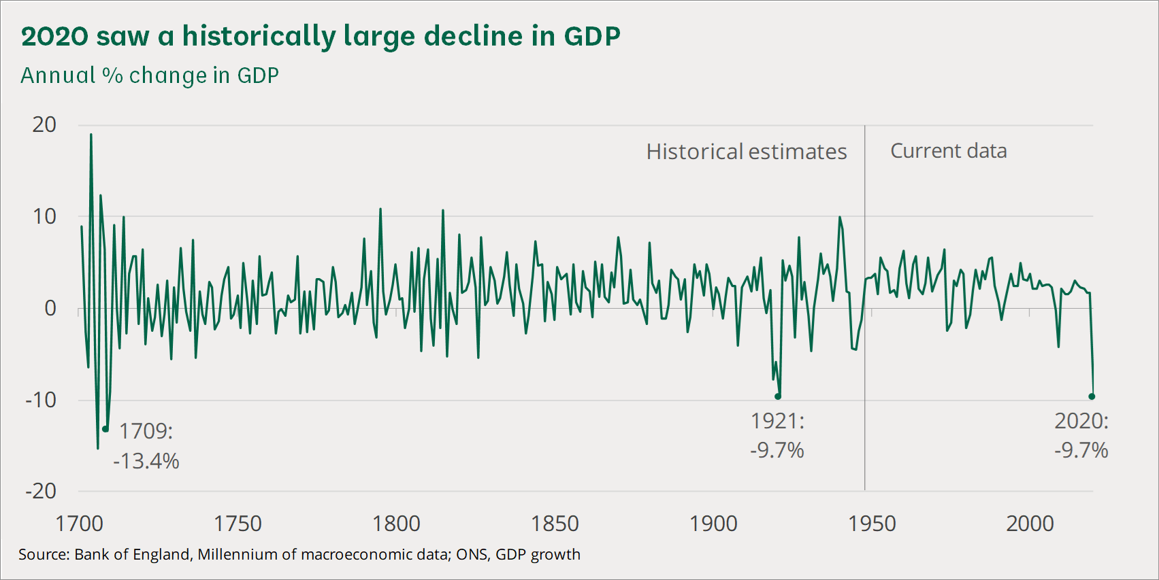

www.commonslibrary.parliament.uk

When we examine the chart, we realise that the recession induced by the pandemic in 2020 is enormous. These are levels that might be described as painful for the economy and have the potential to bring the economy to a halt.

There are several aspects that have failed to work fully in this crisis.
Oftentimes, crisis management is the weak link in the chain. The presence of "technical" crisis units governed by stringent operational and composite processes instantly shown that they were unable to manage such a complex, fast, and interrelated crises affecting all facets of business life. (House of Commons Library, 2019)
Specialized units are frequently found: (a) designed to manage significant crises but with limited duration and impact on processes; (b) who have prioritised external communication with Authorities and Stakeholders over strategic, organisational, managerial, and even psychological aspects of management; and (c) whose roles, responsibilities, and powers have prevented him from confronting the critical junction of the chain of decision-making and command in times of crisis. To be effective, however, the pandemic scenario demands rigorous and quick management based on focused decisive and operational levers, fundamental and timely information flows, and various clear and immediate rules to be followed. (Frontiers, n.d.)
In certain instances, evaluations of the management abilities of crisis management actors have also failed: there are no managers for all "seasons."

In extreme circumstances such as the current one, the distinctive attitude toward reaction, the proclivity to operate under duress with limited accessible knowledge, organisational abilities, and ability to prioritise should be favoured above traditional technical assessments. Global crisis coordination inside multinational corporations demonstrated comparable difficulties to those identified at the government level: delayed and disorganised responses. In many instances, corporate insensitivity to the true nature of the problem throws the weight of decision-making and governance to local government, which is not often prepared or able to deal with such a tsunami.
Each separate entity responds in a unique and uncoordinated manner, resulting in unpredictable and difficult-to-control consequences, particularly for the movement of commodities and people on a local, national, and worldwide scale, as well as for the environment. It has been and continues to be difficult to identify stabilisation efforts in the country because of the legal ambiguity that has evolved, resulting in difficulties, particularly among multinational corporations and organisations. The difficulty in obtaining masks, disposable gloves, and other tools for restricting the transmission of the virus increases the likelihood of work being disrupted, particularly for jobs that cannot be performed at a distance or that do not meet the safety criteria that have been established. Fear, panic, and anxiety are pervasive in the population, resulting in instances of exaggerated response. For example, many workers no longer feel protected at work and demand that non-essential job tasks be ceased. Similarly, everyday living routines are changing, travel is being greatly decreased, and consumption volumes and varieties are shifting (such as fuel consumption, public transport, eating in bars and restaurants, etc. is declining in favour of other types of consumption such as private utilities and home delivery). All of this inevitably has an effect on national gross domestic product and the global economy. Nobody knows for certain how long this scenario will endure, how much money and resources would be required to address the crisis and restore normalcy. This unpredictability exacerbates the difficulty of both identifying crisis management alternatives in advance and evaluating their efficacy and viability. Businesses are made up of people, and individuals need to have a sense of belonging even when they are compelled to return home. Communications are critical during times of crisis - they must show empathy to employees, keep them informed about corporate happenings, be hopeful, and give everyone a sense of what to anticipate. Offering something else to focus on in the face of the virus's relentless negativity may be important during these trying times and can help sustain employee and coworker morale.

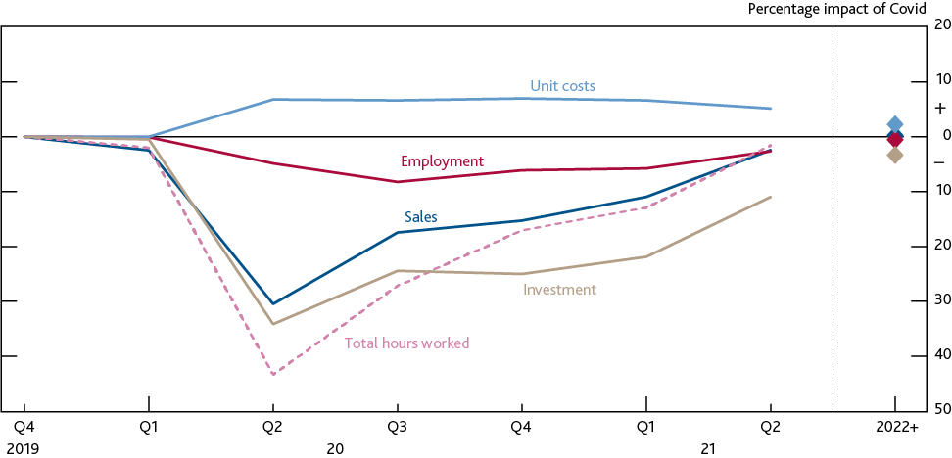

www.bankofengland.co.uk

This chart summarises the anticipated revenue, investment expenses, labour hours, and business costs.

It is obvious that while the COVID-19 situation continues, assessing the long-term success of policy measures would be challenging, not only because we lack information at the moment, but also because governments will have to balance divergent short- and long-term concerns and interests. What is obvious, however, is that the conditions surrounding the COVID-19 crisis are likely to increase the vulnerability of decision-making processes to information processing errors due to the high stakes, time constraints, complexity, and ambiguity. The Covid-19 issue, which is presently affecting the entire world, has created a slew of unexpected obstacles and problems. Politicians make critical judgments on how to react based on constantly changing and inadequate facts, while working under tight deadlines and under great uncertainty and public pressure. Businesses are made up of people, and those individuals must continue to have a sense of belonging to the business, even if they are forced to return home. Communications are critical during times of crisis - they must show empathy to employees, keep them informed about corporate happenings, be hopeful, and provide everyone with a notion of what to anticipate. Offering something fresh to focus on in the face of the virus's relentless negativity may be beneficial in these trying times and can help sustain employee and coworker morale.

-Finance

Tax and expenditure measures to assist households and families during a health emergency include the following: I increased funding for the NHS, public services, and charities (£ 48.5 billion); (ii) business support measures (£ 29 billion), (Harari, Keep and Brien, 2021) including property tax holidays, direct subsidies to small and high-impact businesses, and sickness benefits; and (iii) strengthening the social security network in support of vulnerable people (£ 8 billion) through an increase in payments under the universal basic income. Other measures include a six-month extension of the increase in payments for universal credit claims (£ 2.2 billion), an extension of the full VAT reduction for the hotel sector (£ 5 billion) until the end of September (with a phased return to normal by April next year), a quarterly extension of the current stamp duty reduced rate until the end of June (with a phased return to normal by the end of September), and a freeze on the alcohol and fuel tax (£ 1.1 billion). (International Monetary Fund, 2021)

-Standart of living

The United Kingdom is undergoing a living standards crisis. Too many people lack reliable access to the resources necessary to meet the everyday costs of a livable standard of living. Around 32% of the population in the United Kingdom is believed to live below the socially acceptable standard of living. The pandemic's repercussions are not beneficial; housing costs have increased, redundancies have occurred, and working-age benefits have been reduced. (Arnold, Harper and Stirling, n.d.)
The United Kingdom is a global leader in poverty - the percentage of poorest households falling below the poverty line was the second highest among the Organization for Economic Cooperation and Development's 37 countries (OECD). Over the next two decades, the lowest 10% of families' incomes increased by only 3% after housing costs - six times less than the average. As a result, nearly three out of every ten people now live in homes with MIS-adjusted income. (Arnold, Harper and Stirling, n.d.)
However, with the pandemic's commencement, this decline in living conditions has accelerated considerably and at a breakneck pace. As the numbers show, by 2020, almost 2.8 million persons had asked for state aid, and by the end of 2021, their number had increased dramatically to 5.9 million more than doubling in only one year. (Arnold, Harper and Stirling, n.d.)

-Emloyment

Numerous businesses were unable to operate normally as a result of the Covid stoppage. Numerous staff were unable to report to work, and customers were unable to purchase their products or services.

Some businesses have been able to obtain a loan to cover overhead costs such as rent in order to stay alive. Additionally, people may sell items online. Restaurants, theatres, and construction industries have been particularly hard hit. (Bank of England, 2021)
The government compensates employers for a portion of their payroll while their employees are unable to work (this is referred to as "leave"), which lowers the cost of loans to individuals and businesses and aids in the recovery of the economy.
The economy is showing indications of recovery. By the summer of 2021, job vacancies had restored to their pre-pandemic levels. (Bank of England, 2021)

Conclusion:

The possibility of political prejudice and errors in decision-making has the potential to create significant public harm during the current crisis. We highlighted group thinking, a restricted emphasis on virus containment, and rising involvement as significant hazards to decision-making processes in the COVID-19 crisis response. As the crisis unfolds, it is critical for politicians to take actions to improve the quality of decision-making and to raise the likelihood of favourable outcomes. Implementing a reflective decision-making process can assist politicians in moving forward by reducing information processing error and allowing for the establishment of more holistic methods that balance several problems, such as public (mental) health, the economy, and human rights.
The COVID-19 crisis is developing as the first really worldwide test of the business system's resilience. Triage, the process of identifying hazards, prioritising, and allocating work, will remain an art form for the majority of enterprises. We believe that this trying experience will assist the entire system in strengthening its potential for survival and inventing new business models

References:

- Arnold, S., Harper, A. and Stirling, A. (n.d.). The UK’s living standards crisis. [online] New Economics Foundation. Available at: https://neweconomics.org/2021/06/the-uks-living-standards-crisis.

- www.bankofengland.co.uk. (2021). The UK economy during Covid-19: insights from the Bank of England’s Citizens’ Panels. [online] Available at:

- https://www.bankofengland.co.uk/get-involved/citizens-panels/the-uk-economy-during-covid-19-insights-from-the-bank-of-englands-citizens-panels.

- Brodeur, A., Gray, D.M., Islam, A. and Bhuiyan, S. (2020). A Literature Review of the Economics of Covid-19. SSRN Electronic Journal. [online] Available at: https://docs.iza.org/dp13411.pdf.

- - Frontiers (2014). Frontiers | Peer Reviewed Articles - Open Access Journals. [online] Frontiers. Available at: http://frontiersin.org.

- GOV.UK. (n.d.). COVID-19 Response: Living with COVID-19. [online] Available at: https://www.gov.uk/government/publications/covid-19-response-living-with-covid-19/covid-19-response-living-with-covid-19.

- Harari, D., Keep, M. and Brien, P. (2021). Coronavirus: Effect on the economy and public finances. commonslibrary.parliament.uk. [online] Available at: https://commonslibrary.parliament.uk/research-briefings/cbp-8866/.

- House of Commons Library. (2019). House of Commons Library. [online] Available at: http://commonslibrary.parliament.uk.

- International Monetary Fund (2021). Policy Responses to COVID19. [online] International Monetary Fund. Available at: https://www.imf.org/en/Topics/imf-and-covid19/Policy-Responses-to-COVID-19.

- - International Monetary Fund (2021). Policy Responses to COVID19. [online] International Monetary Fund. Available at: https://www.imf.org/en/Topics/imf-and-covid19/Policy-Responses-to-COVID-19.

- Ons.gov.uk. (2015). Home - Office for National Statistics. [online] Available at: http://ons.gov.uk.

