HTML & CSS Web Development
Author: Steven Moore
(1801309)
Web and Database Concepts
(ACCA4023)
School of Applied Computing Wales Institute of Science and Art Date of submission: 25/04/2021

Table of Contents
Requirements 3
Subject Matter 3
Purpose 3
Target Audience 3
Relevance 3
Implementation 3
Logo 4
Home Page 4
Perseverance (Content Page 1) 5
Curiosity (Content Page 2) 6
Opportunity (Content Page 3) 7
Contact Page 8
Validation 9
HTML Validation 9
CSS Validation 10
Evaluation 11
Website Usability 11
Availability and Accessibility 11
Clarity 12
Learnability 13
Credibility 13
Relevancy 13
Search Engine Optimisation (SEO) 13
Title Tags 14
Meta Tags 14
Mars Rovers Evaluation 15
Usefulness 15
Navigation 15
Features 16
Information 18
Problems and Improvements 19
Problem 1 – Image Card Spacing 19
Problem 2 – Nasa API Uptime 20
SEO Integration 20
Accessibility 21
Perceivable 21
Operable 21
Understandable 21
Robust 21
Contrast Check 22

  - Introduction
This report covers the requirements, implementation and validation referring to a HTML & CSS website the author has designed. The report also includes an evaluation section where the author identifies usefulness, SEO (search engine optimisation) and accessibility of the website.

Requirements
In this section the author discusses the websites target audience, subject matter, purpose, and relevance. The website will include a minimum of 5 responsive pages and will include an appropriate navigation method.

Subject Matter
The website is about the rovers Nasa has sent to Mars. It will cover three of the more famous rovers: Perseverance, Nasa’s most recent rover at the time of writing. Curiosity, and Opportunity. The website will also include a home page with suitable navigation and a contact page.

Purpose
The purpose of the website is to provide information, graphics, and videos to the user regarding Nasa’s Rovers and their mission goals. The secondary purpose of the website is to provide a way for users to interact with the site / previously mentioned rovers.

Target Audience
The main target audience for the website is people of all ages who are interested in Nasa and in particular the rovers they send to mars. The website will not target at any browser however, it will run on desktop and mobile devices.

Relevance
The information on the website needs to be informative, engaging, helpful and entertaining. The information regarding the rovers should be accurate and up to date. Any logo’s, images or videos used should be relevant to the website topic.

Implementation
This section will demonstrate the implementation of the website with screenshots of each page of the finished website. The author has also created a short video demonstrating the website which is available here: https://www.youtube.com/watch?v=YxwvVJjM-mY

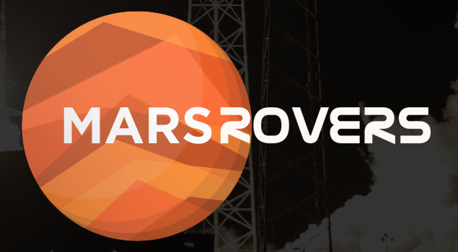
Logo
The logo was created using Photoshop.
It includes a simple illustration of mars and the website title.

Home Page
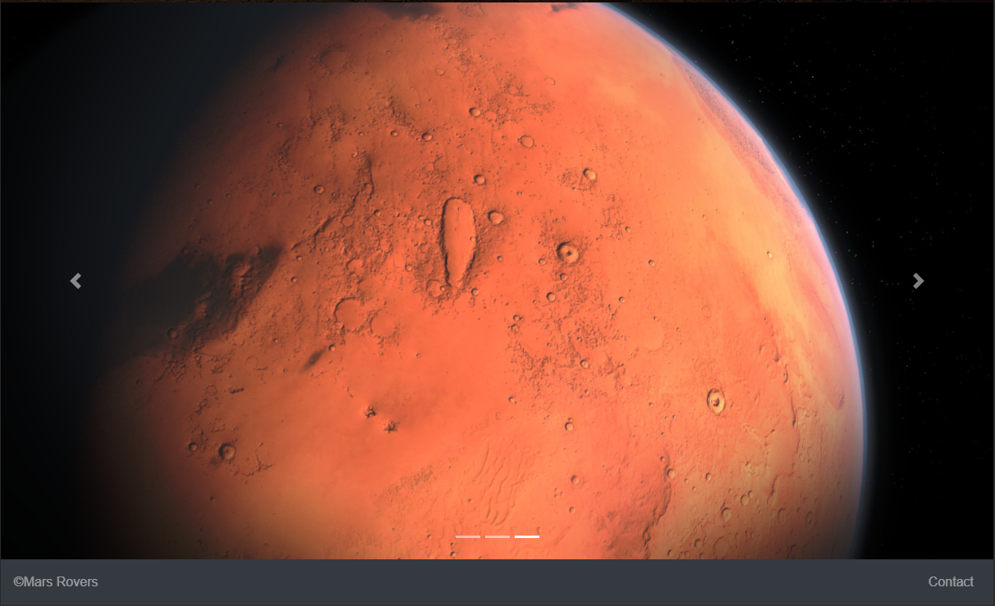
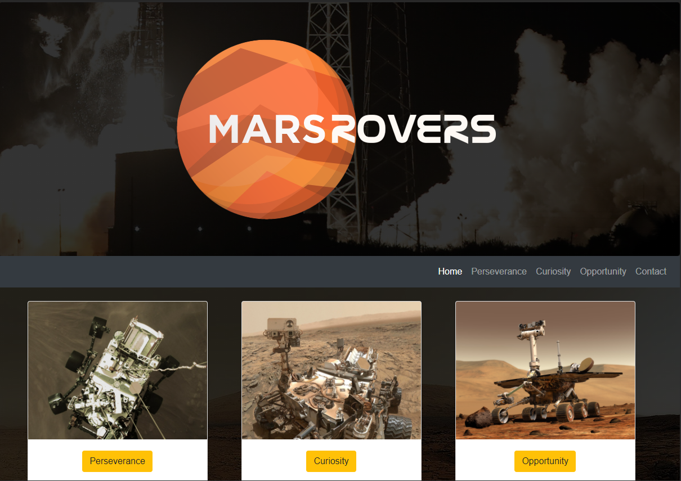

The home page contains the logo, navigation bar, image cards which also act as navigation methods, an image carousel and a footer containing contact button.

Perseverance (Content Page 1)
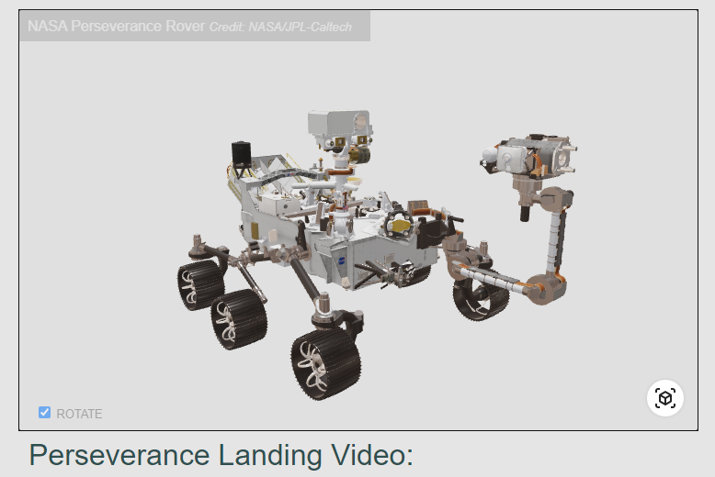
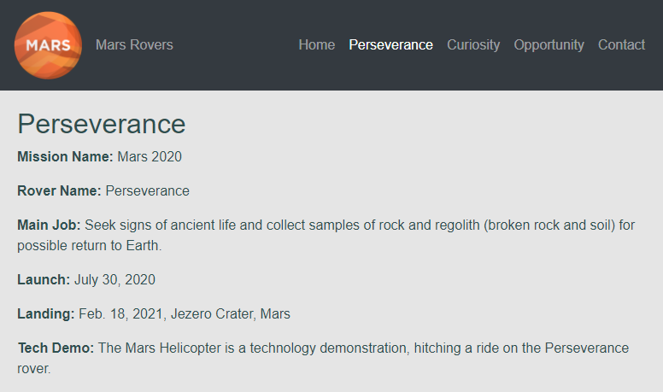

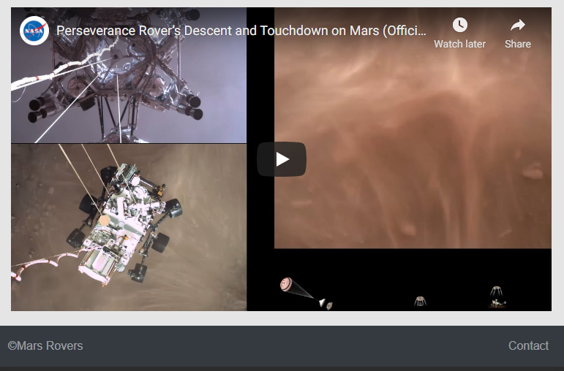

Curiosity (Content Page 2)
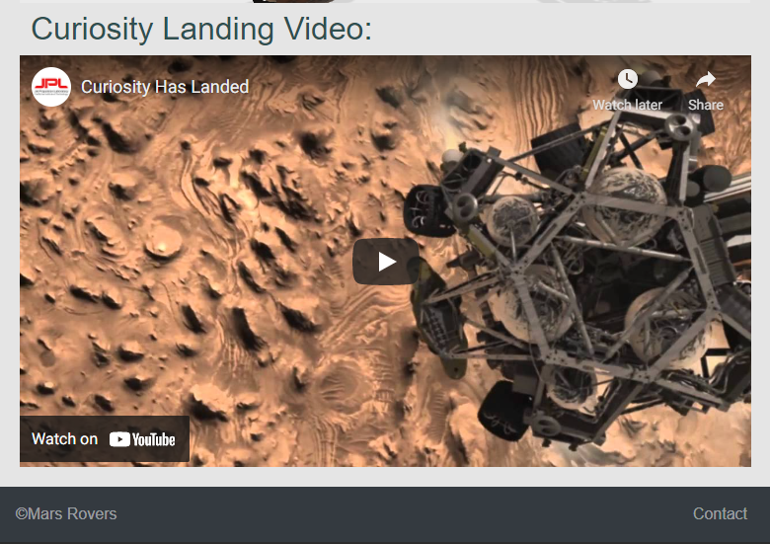
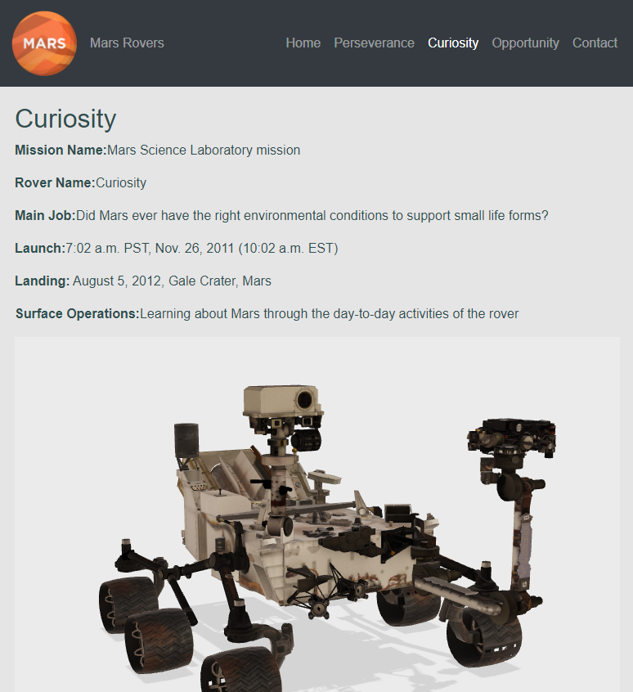

Opportunity (Content Page 3)
(3D model down at time of screenshot)
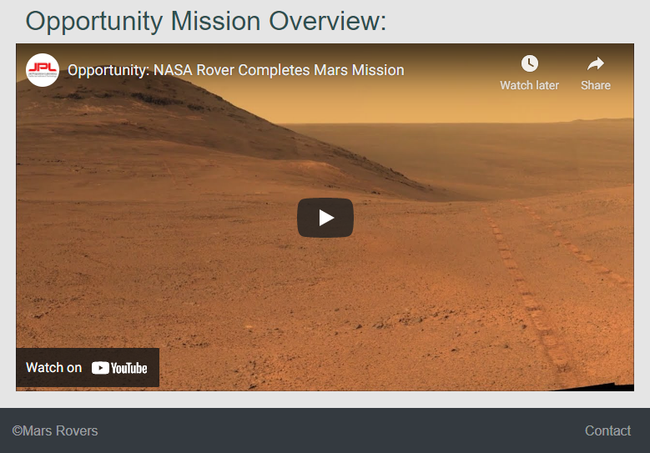
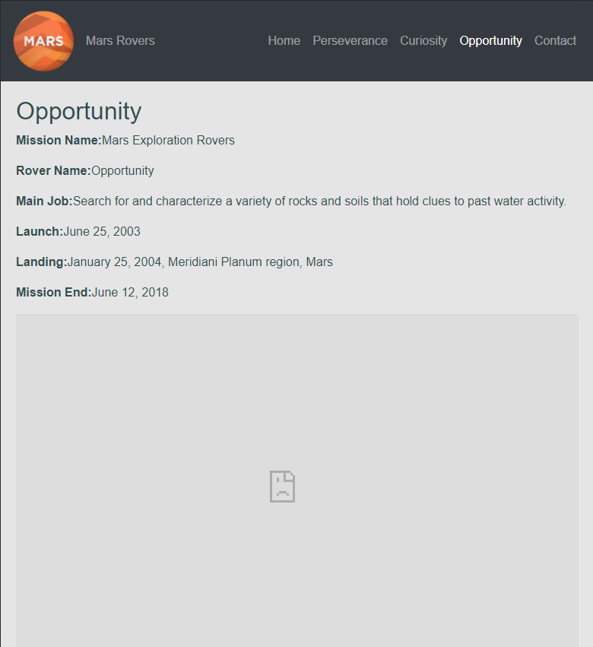

Contact Page
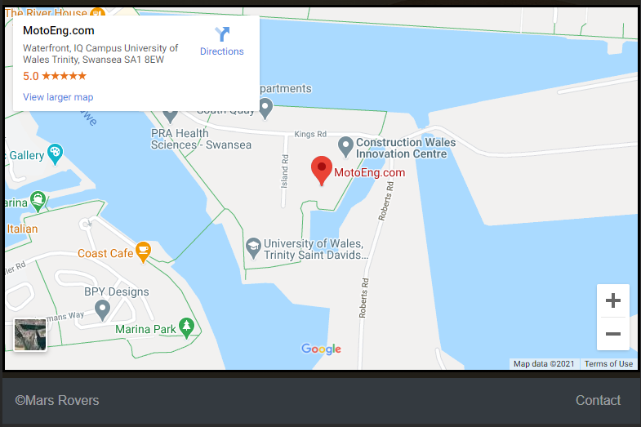
  - 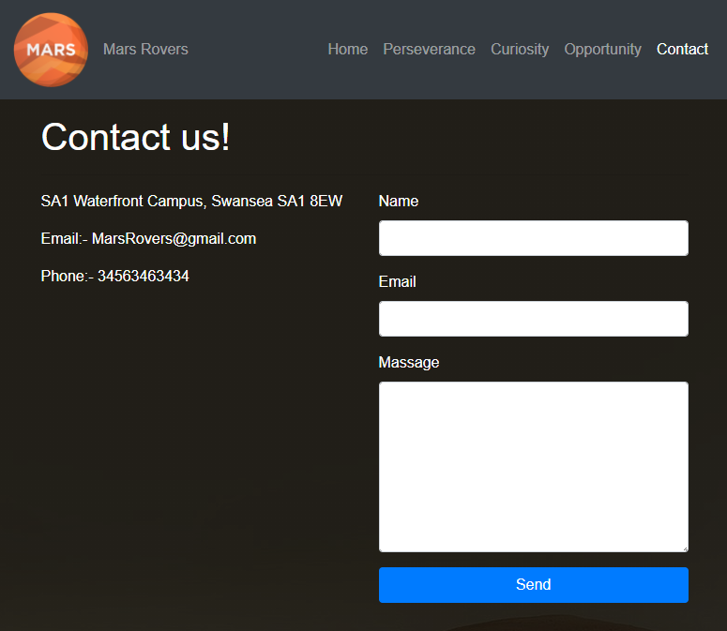

Validation
This section the author will validate the HTML and CSS of the completed website. The purpose of validation is to identify and fix any errors within the HTML or CSS code.

HTML Validation
To test the HTML the auther used an online tool avaliable at: https://validator.w3.org/nu/#file This test flagged 5 errors within the HTML code.
The first error is:
The author believes this error is caused because of the use of Bootstrap code for the “Jumbotron” (Logo section). Because of this the author will not correct this error.
The second, third and fourth errors are:
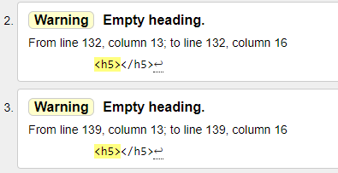
These errors are regarding empty header tags which were accidently left in the code as shown below:
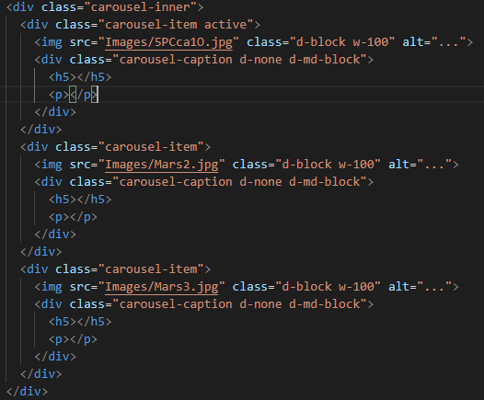
These empty heading tags were deleted without any adverse effects.

The fifth error is:
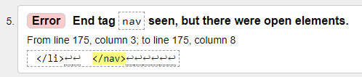
This error is regarding this section of code:
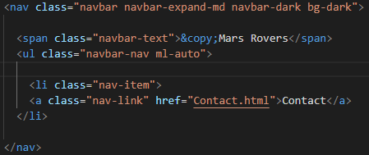
The author has checked through the file and found that no elements are left open. Apart from the “ul class=”navbar” which is a self-closing bootstrap tag. Because of this the author has disregarded the error.

CSS Validation
To test the CSS used for the website the author has used an online tool available at: http://jigsaw.w3.org/css-validator/#validate_by_upload
The CSS validation tool failed to find any errors within the website’s CSS file. The results are shown below:
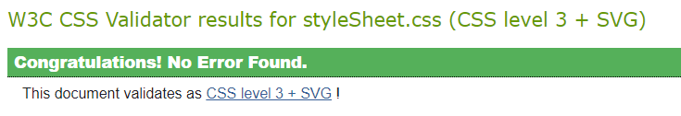

Evaluation
In this section the author will discuss the websites usability, accessibility, SEO. The author will also discuss how these elements have been considered when designing and creating the Mars Rovers website.

Website Usability
Website usability refers websites which are user centred in their design and development. As indicated by Younhhwa Lee and Kennef Kozar [1], there are 5 key constructs to website usability. These include:
- Availability and accessibility
- Clarity
- Learnability
- Credibility
- Relevancy

Availability and Accessibility
According to Michigan Education Association [2], website availability refers to whether the website is accessible and if all its features work as intended.
Accessibility could refer to device availability and support. For example, websites should be built for mobile first, meaning the design and implementation for a website should be centred around mobile devices. However accessibility also relates to availability towards disabled people.
Availability is simply referring to a website’s uptime. Most organisations aim to have 99.999% uptime for their website. This is commonly referred to as the “five-nines of availability” which roughly means around 5 minutes of downtime per year [3].
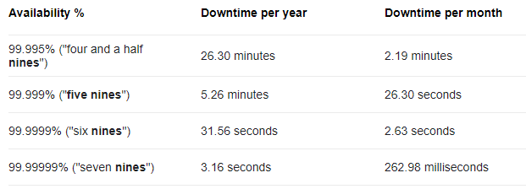
https://en.wikipedia.org/wiki/High_availability

Clarity
Clarity refers to the actual design of the website and focuses on communicating information quickly and clearly.
According to Steven Snell [4], good clarity can be achieved with simplicity, familiarity, and consistency. For example, familiarity could refer to using traditional website layouts such as placing the navigational bar at the top of the website.

Learnability
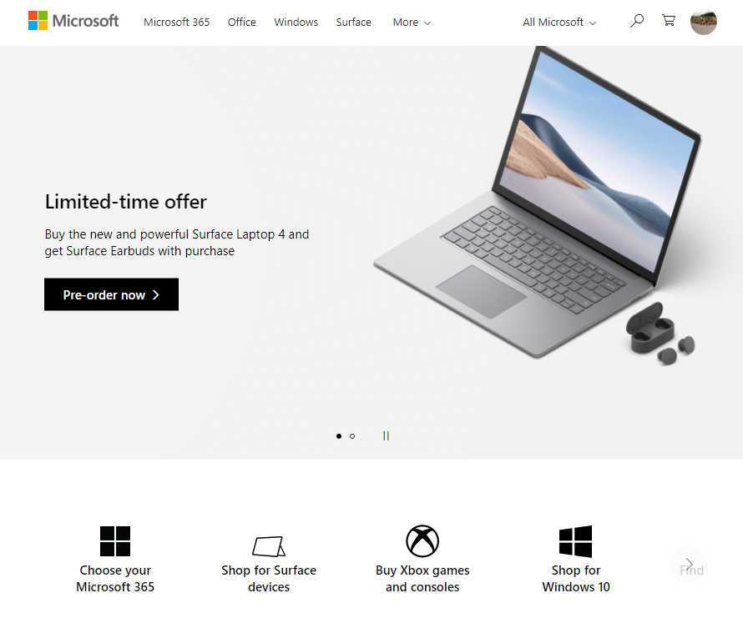
According to StrategiQ [5], learnability refers to the design and implementation of interfaces on the website. For example, navigation and interaction should not require any instruction and should be intuitive. To achieve this one should follow traditional website layouts. A good example of this can be seen in Microsoft’s website:
https://www.microsoft.com/

Credibility
According to userlike.com [6], credibility refers to if a website’s audience trust the information on the website. Information should be reliable and accurate. Mistakes including spelling and grammar can make user’s especially wary when using a website.

Relevancy
Relevancy refers to if the information on the website relates to the purpose of the website. For example, Microsoft’s website will not contain any information that is not related to Microsoft or its products. To achieve this a website must have a clear definition of its own purpose and target audience.

Search Engine Optimisation (SEO)
Search engine optimisation or SEO simply refers to improving a website’s chance of showing up in relevant searches. In terms of actual website development, one of the most important SEO a developer can implement is title tags [7].

Title Tags
A title tag is a small HTML (Hypertext Markup Language) tag which is used to store a title of a webpage. Search engines such as Google use title tags to link user searches to relevant information and websites.

Meta Tags
Meta tags are like title tags however they are typically used to store a small description of a website. Meta tags are usually under 156 characters in length. An example of this can be seen below:
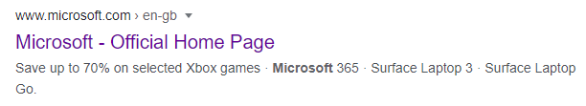
- Title Tag – Microsoft – Official Home Page.
- Meta Tag- Save up to 70% on selected Xbox games etc.

Mars Rovers Evaluation
This section is for the evaluation of the Mars Rovers website previously discussed in this report. The evaluation will include usefulness, search engine optimisation and accessibility.

Usefulness
The Mars Rovers website uses numerous design standards which improve its usability and functionality. For example, it follows traditional navigation methods for desktop and mobile browsers as shown below:

Navigation
Desktop:
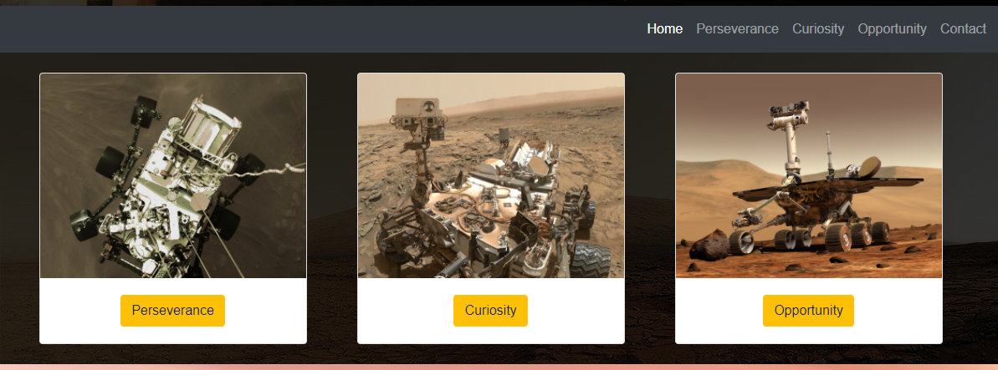
The screenshot above shows the desktop version of the website which includes a traditional navigational bar at the top of the page. The user may also choose to use the pictures or buttons located on the home page to navigate to different pages. The navigation bar also highlights which page the user is currently browsing so that it is easier to navigate the site.
All the navigation methods discussed above also contain rollover effects which allows the user to easily see what they are clicking on improving usability and functionality. For example, the images will zoom in whenever the user hovers their curser over an image.
Mobile:
Closed: Open:
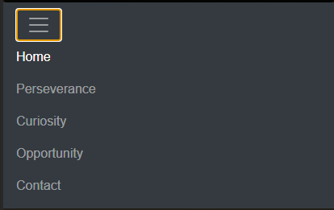
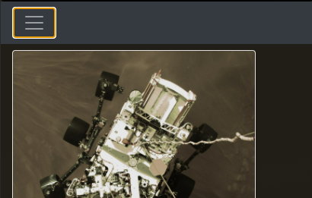
The mobile version of the site contains a hamburger style menu which is demonstrated above: These styles of menus are more compact and considered more mobile friendly.

Features
The Mars Rovers website contains various features which improve its usefulness including 3D models, videos, and map integration. These are all demonstrated below.
3D Models:
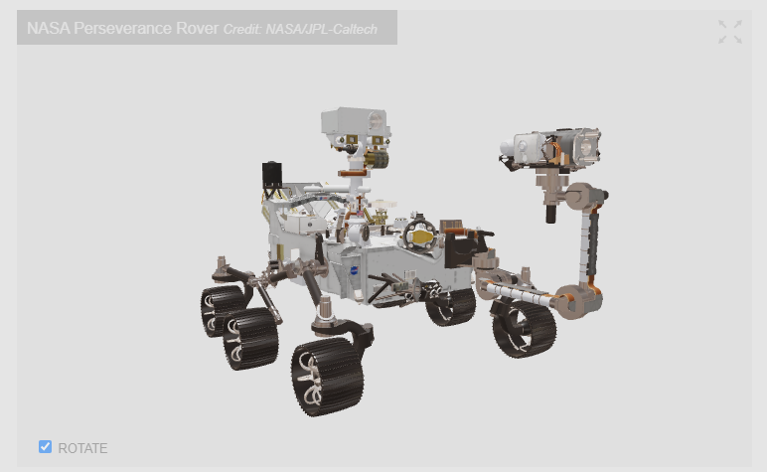
On each page regarding actual rovers, are 3D models of the rover. These allow the user to interact with the site in a more playful way which can be more engaging then just an image or video. These models also work as intended on mobile however, they do take slightly longer to load.
Videos:
Each information page also contains an embedded video which ether show the rover landing on Mars or information regarding its mission. Videos offer the user an alternative to reading to get information about the subject. They also make the website more engaging. 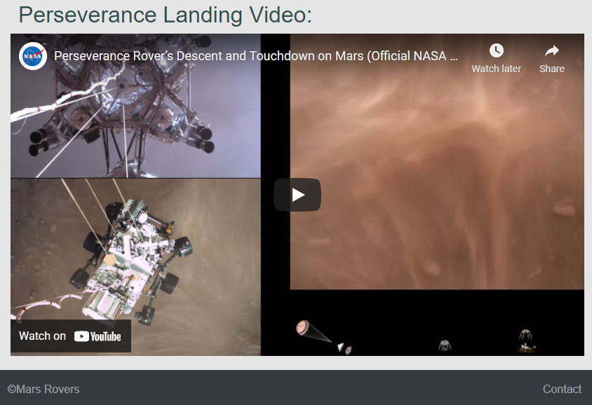

Contact Form and Map:
The contact page contains a contact form which allows the user to send a message to the author. The contact page also contains an embedded map which uses Google’s map API to ping a chosen location.
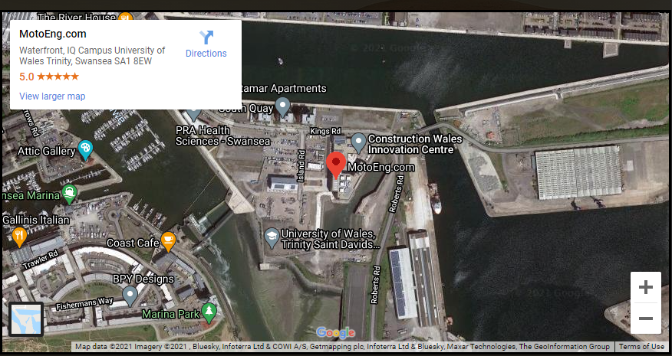
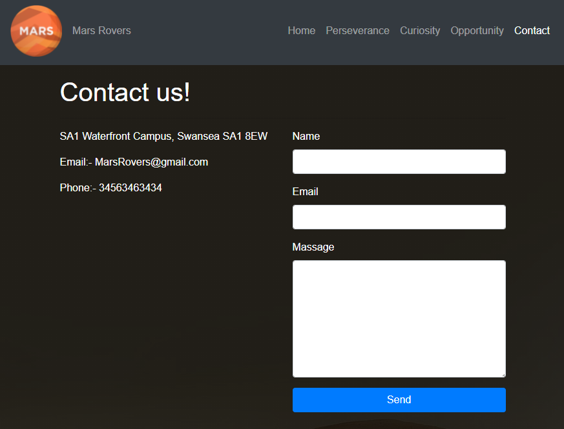

Image Carousel:
The home page also contains an image carousel which will auto scroll through different images relating to the website’s topic. This feature adds life to the otherwise static homepage which should grab the user’s attention. The user can also use the buttons provided to navigate between different images:
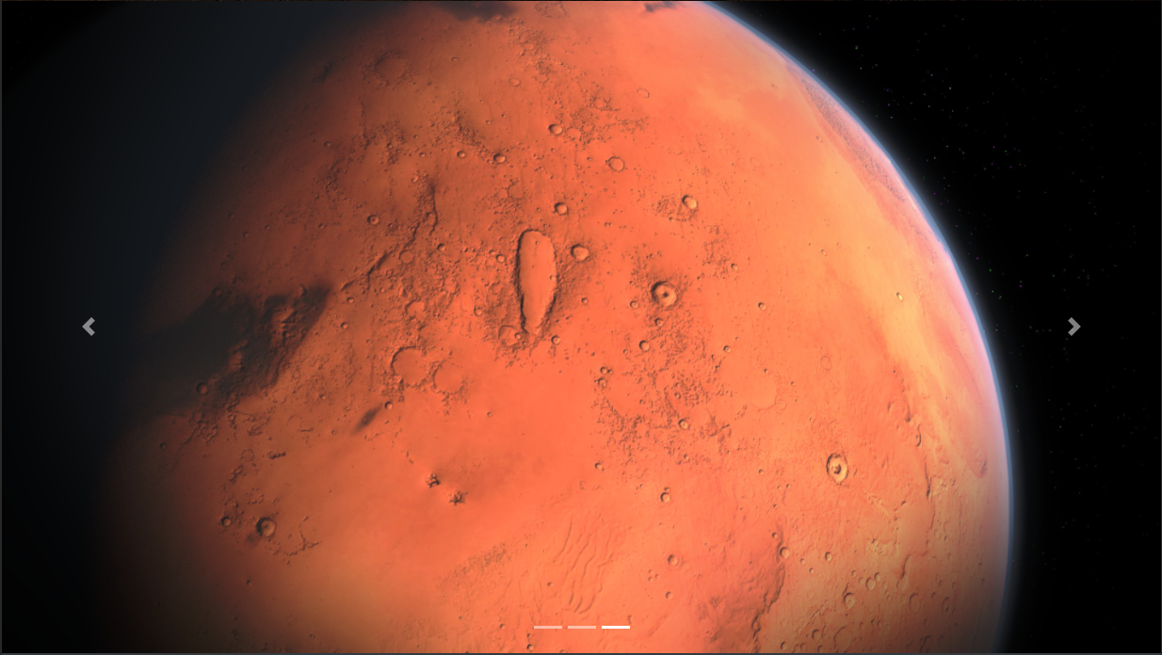

Information
The website contains information regarding the different rovers and their missions on Mars. This information is adapted from Nasa’s own website, so it is accurate and relevant. The information is summarised into categories, so it is easily read and memorable:
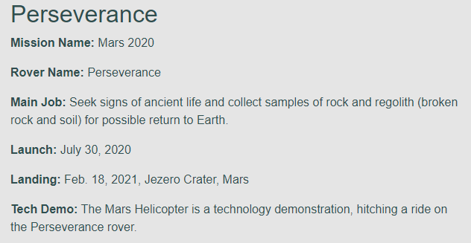

Problems and Improvements
In this section the author will discuss any problems with the Mars Rover website and any improvements that could be made to it.

Problem 1 – Image Card Spacing
This issue is located on the home page and only occurs on mobile. The issue is that the image cards do not maintain proper spacing when the website is in mobile view. This is an issue with the bootstrap code which due to time constraints the author cannot solve. The problem is illustrated below:
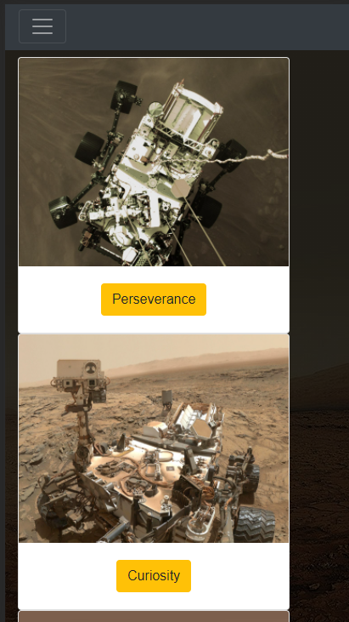
One way of fixing this issue is replacing the bootstrap code used for image cards with a simpler HTML / CSS solution. This way the author could manually set the card spacing depending on the user’s screen size.

Problem 2 – Nasa API Uptime
This issue is relating to the 3D models used within the website. They are embedded from Nasa’s website and are not always available. This is shown below:
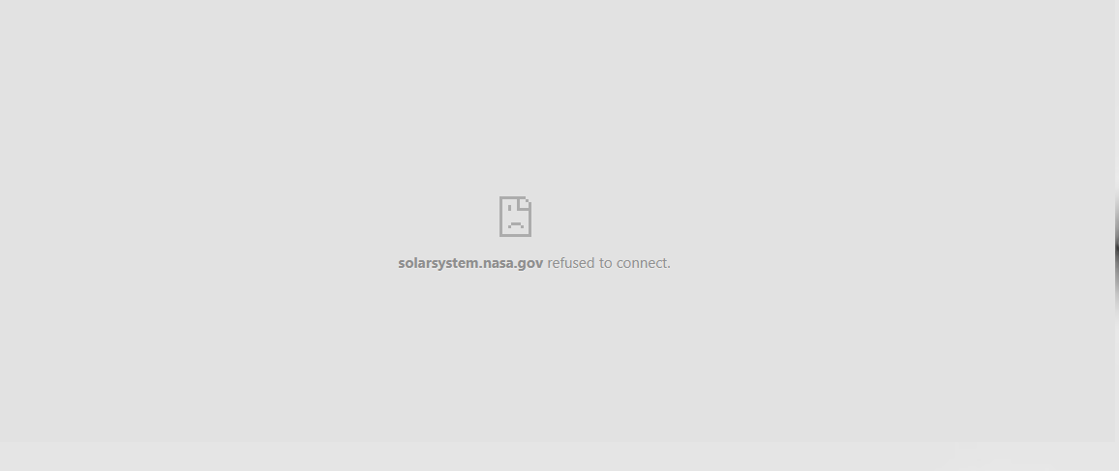
One solution to this issue could be creating videos of the 3D models to replace the 3D model embed on the page. However, this solution loses functionality and the playful interaction with the website which the 3D models provide.

SEO Integration
The website contains simple but effective SEO optimisation using title tags and meta tags. These are shown below:
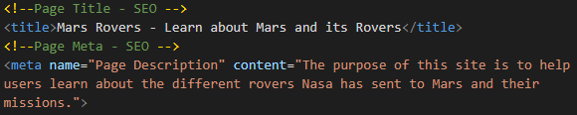
The title tag is also used as a tab title when viewed in a web browser. The author has also implemented a logo into the tab title. These elements are demonstrated below:
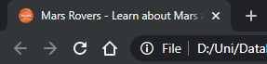

Accessibility
In this section the author will evaluate the Mars Rovers website accessibility about the four principles of accessibility laid out by WCAG (Web Content Accessibility Guidelines) [8].
- Perceivable
- Operable
- Understandable
- Robust

Perceivable
Perceivable refers to if the information on the website and whether it can be interacted with in multiple ways. For example, the Mars Rovers website contains text, images, videos with sound and 3D models which can be interacted with via mouse or touch.

Operable
This mainly refers to the navigational methods and general user interface. The Mars Rovers website contains multiple ways for users to navigate including standard navigational bar and linked pictures and buttons throughout the site.

Understandable
This refers to the information and the operation of the user interface. The Mars Rovers website uses a traditional navigation method so most users will understand how to use it. The information on the website is clearly laid out and contrasts with the background colour as shown below:
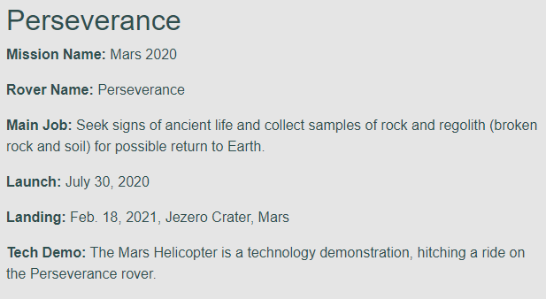

Robust
This refers to whether the website will function on a wide variety of devices and new technologies. The website is fully responsive meaning it will scale to different size screens including desktop and mobile screens.

Contrast Check
This is an online tool which assess and grades a website based on how readable text is. The tool is available at: https://contrastchecker.com/ [9]. The Mars Rovers website score is shown below:
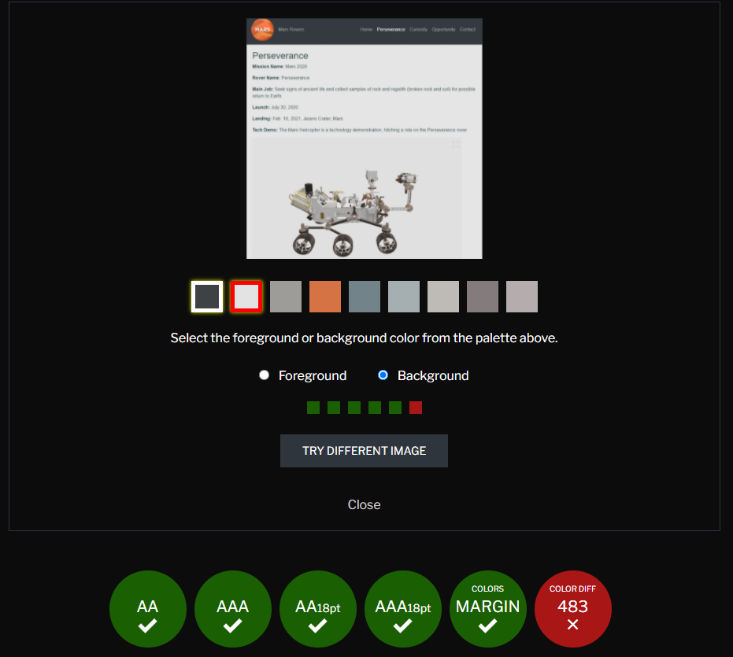
The green ticks represent passes for websites which are in alignment with the WCAG text and background contrast standards. The website did, however, fail the grayscale test meaning people with colour blindness may struggle to read the information.

  - Conclusion
This reports the author has discussed the requirements, implementation and validation referring to a HTML & CSS website the author has designed. The author has also evaluated usefulness, SEO (search engine optimisation) and accessibility of the website.

  - Bibliography
[1]Y. Lee and K. Kozar, "Understanding of website usability: Specifying and measuring constructs and their relationships", Decision Support Systems, vol. 52, no. 2, pp. 450-463, 2012.
[2]"What is website availability?", Mymea.org, 2021. [Online]. Available: https://www.mymea.org/cfdocs/Using_ClusterCATS/overview4.html. [Accessed: 13- Apr- 2021]
[3]"High availability - Wikipedia", En.wikipedia.org, 2021. [Online]. Available: https://en.wikipedia.org/wiki/High_availability. [Accessed: 13- Apr- 2021]
[3]"Clear And Effective Communication In Web Design — Smashing Magazine", Smashing Magazine, 2021. [Online]. Available: https://www.smashingmagazine.com/2009/02/clear-and-effective-communication-in-web-design/. [Accessed: 13- Apr- 2021]
[5]"The Importance of Learnability in Web Design - StrategiQ", StrategiQ, 2021. [Online]. Available: https://strategiq.co/importance-learnability-web-design/. [Accessed: 13- Apr- 2021]
[6]"10 Crucial Elements for Website Credibility", Userlike Live Chat, 2021. [Online]. Available: https://www.userlike.com/en/blog/10-crucial-elements-website-credibility. [Accessed: 13- Apr- 2021]
[7]JavaScript Mastery, SEO for Developers | 2020 SEO Tutorial. 2021 [Online]. Available: https://youtu.be/JSm4aQl4w_U. [Accessed: 13- Apr- 2021]
[8]"10 Crucial Elements for Website Credibility", Userlike Live Chat, 2021. [Online]. Available: https://www.userlike.com/en/blog/10-crucial-elements-website-credibility. [Accessed: 13- Apr- 2021]
[9]"WCAG - Contrast Checker", Contrast Checker, 2021. [Online]. Available: https://contrastchecker.com/. [Accessed: 16- Apr- 2021]

