

BA BUSINESS MANAGEMENT
Assignment 1

Module Name: Community Engagement
Module Code: LCBB4002
Lecture name: Akinseye Aluko
Student Name: Stefan Genchev
Student ID: 2131735

SUBMITTED ON THE 30RD November 2022

Contents
Introduction 3
Running for Everyone Project 4
Relationship between the Stakeholders 5
Engagement through social media platforms 5
Importance of community participation and collaboration 8
Importance of community engagement 8
Community Engagement Approach 8
Conclusion 10
References 11

Introduction
Community engagement is a way for the organizers to work collaboratively with the locals in a group with special social interests, or situations to affect the well-being of general people (Bandy, 2019). It is an effective way to bring behavioral and social changes positively. The main purpose of such engagement is to fulfill the community commitment and create a better bonding between the organizers and the locals. Community engagement encourages one to take a decision considering all the stakeholders of the decision (Samuel, 2022). Community engagement projects are those projects that serve a purpose of the local’s or a group’s well-being. The Commonwealth game is an international multi-sport platform for the members of the Commonwealth of Nations, it is also known as Birmingham 2022 because it took place in Birmingham. There were many significant community engagement projects in that game such as cycling for everyone, getting started in boxing, running club for everyone, etc. In this report, the community engagement project “Running for everyone” will be demonstrated and the relationship between the stakeholders, and how they involve the locals using social platforms will be discussed in-depth.

Running for Everyone Project
The commonwealth game is organized for the commonwealth nations as a multi-sport international event. Every 4 years different nations of the commonwealth organize this game and focusing on this game many other events and projects take place. In 2022, Birmingham was the host nation for the Commonwealth game so it took place in Birmingham at the end of July, it is commonly called Birmingham 2022. There were many games in the Commonwealth 2022, for example, aquatics, athletics, badminton, basketball, beach volleyball, boxing, etc. (Birmingham, 2022). One of these games was the running for everyone which was organized by the City of Birmingham Striders.
This organizer took a special initiative to make it a project considering the well-being of the local group. This is a UKA-affiliated running club that promotes running at all levels, to engage the community with this notion the organizer collected information about the community regarding its lifestyles and demographic behaviors (COBS, 2022). The organizer tried to create a relationship with the local community and formed teams encouraging them with their motives. The organizers tried to plan the whole project ensuring the well-being of the community with their purpose (Zarrela, 2020).
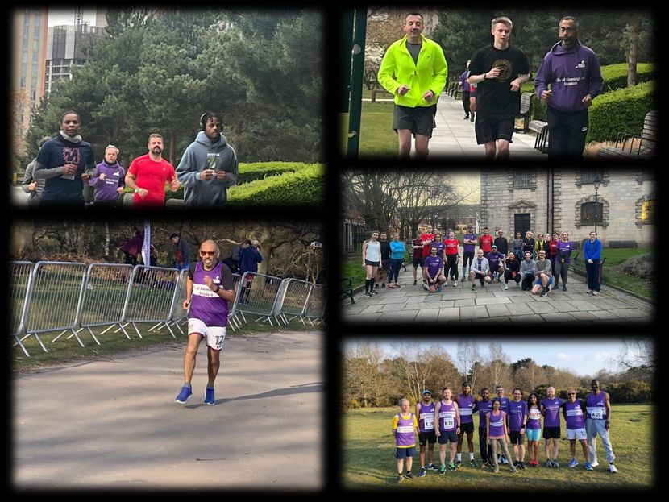
Figure 1: Running club for everyone (Birmingham, 2022)
The running club for everyone project mainly promotes that people can run at all levels or ages. There are a lot of choices for running groups or clubs in Birmingham but there are some issues regarding the age or levels, so people do not feel motivated to continue running and the quitting percentage is more. Here the project aimed to show that running clubs are for everyone, they initiated this to change this perception about running. They planned to promote how running can be a thing for all levels despite who they are or how old they are, and that’s the focus point of this community engagement project. This project wants to include men, women, and all of different ages encouraging them to run at whichever level they are without any judgments or discrimination.

Relationship between the Stakeholders
Stakeholders are very important for any project; they can be either individual parties or a group of people altogether. In the case of community engagement projects, the stakeholders are mainly the local group of people whose well-being is the purpose, here the people of the commonwealth nations are the main stakeholders who would form the participants of the game (Bandy, 2019). Also, the audiences are another vital stakeholder for the project to reform the perception of running, being a community engagement project the vital role here is to serve a well-being purpose to a group or local community for the organizers. For that, social media can be a great way of communicating with stakeholders as nowadays more people are connected through social media, and it is a cheaper, easier, and faster way to communicate and build an influence over the stakeholders. Using social media platforms, the event details and purpose can be easily shared with the stakeholders and common people to create a buzz about the project.

Engagement through social media platforms
Social media is a weapon to use for communication, marketing, more of to outreach mass people. It is the fastest, most sustainable, and easier platform to outreach people in a blink as now most people use social media either for work or professional purposes and spend a good amount of time thereby, so influencing people through social media is now a more realistic way (Samuel, 2022). Also, it can be used to connect with the right audience through observing social media reach and other variables of the platform, so of course, it is the most effective way to engage regarding the project to let people know about the initiative,

Facebook
Facebook is one of the most popular social media platforms around the world, it is widely used by a range of people. Millions of people regularly spend a good amount of time on Facebook now as the platform is upgrading day by day and being more attention-catching for people. People unknowingly scroll Facebook for hours so anything on this platform can reach millions of people in a blink of an eye if communicated and visualized properly (Miller et al., 2019). The organizers of the running for everyone project can use their Facebook page for letting people know about the project using posts, pictures, or hashtags. They can promote their websites and open event pages to specifically promote their campaigns among the people, this will help them with buzz creation.

Figure 2: Cycling Campaign of Running club for everyone (Source: Facebook)
Instagram
Instagram is currently another most used platform, around 1.39 billion active users are using Instagram. It is the 4th most used social media platform worldwide. People post different pictures or video content on Instagram using hashtags, reels, or different features. It is popular among influencers (Surplice, 2021). COBS running club can engage with people with Instagram posts or reels, which would create a good reach for the project as the active users of Instagram is a lot, it can create sponsored advertisements on Instagram to catch more eyes.

Figure 3: United with the Birmingham 2022 ( Source: Instagram).
Twitter
Twitter is another social media platform where people can tweet short reviews or comments. It is a bit précised as the content cannot be lengthy, so a lot of people use this social media platform (Bell, 2018). A lot of widely known people use Twitter regularly to share their opinions. It can be a great platform to promote the project as it would catch the eyes of many people with short tweets, and they will try to know about the project.
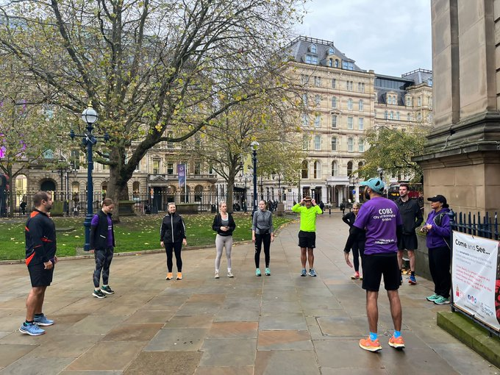
Figure 4: Running for everyone sessions (Source: Twitter)

Importance of community participation and collaboration
Running club for everyone project mainly focuses on creating the perception that anyone can run despite who they are or which level they are. They want to motivate people of all ages to run so that they would not quit running. They want to encourage people to join the project for running despite their age and level. This project will be a great help for the communities to change the perception about running and encourage running for everyone in society. To change the perception and to fulfill the purpose of the project it is important to ensure community participation because only then it will outreach people and bring change (Surplice, 2021). Without community participation, the project cannot reach its motive. And about the collaboration, it would create a place for the project in the local’s minds if the community members choose to collaborate with the organizers. Without that, it would be hard to reach the community with the project’s purpose. Also, collaborating with other individuals, or communities can create a good relationship and influence the project among the audience (Bell, 2018). Both collaboration and participation are important for the project to reach its aim, as the project is a community engagement project so the participation and collaboration of the community can only lead it to success influencing the people to change their perception regarding running and encouraging running at all levels, making it a comfortable sport or practice among the people (Head, 2017).

Importance of community engagement
Community engagement is a must to fulfill its purpose, as the whole thing is for community development and well-being. Hosting an event like the Commonwealth games brings a lot of possibilities and opportunities for the country itself, and other community engagement projects also create a great influence over the society and community (Miller et al., 2019). To make all these possible, the community needs to engage themselves in such events while enjoying it as that would lead to their benefit, in the end, both socially, economically, or resource-wise as a country after the game. And for making a memorable event of such games, it is important for the local community to participate.

Community Engagement Approach
To connect with the community and understand how to reach them it is important to make intentional interactions between communities and the organizers who are responsible for taking decisions for the well-being of the mass. It is important to take a front seat to understand their needs and perceptions before taking a decision. Organizers should go to community meetings for a community engagement approach, as it would be less time-consuming and let the people express their thoughts (Bell, 2018). This way both the community locals and the organizers would be able to interact with each other sharing ideas and more, so this will be a good help for the organizers to understand how they can communicate with the local people in a proper way and how they can be engaged actively. Running club for everyone project’s organizers should schedule multiple community meetings with the locals for better engagement response. Organizers should create sessions for the local people who are interested to participate, it would let them know about the community and how active they are or how effective engagement can be created through them (Bandy, 2019). Intentional interactions or interviews would help the organizers to understand the locals and how they can be encouraged for community engagement. This way organizers would better understand how they can create a relationship with the locals. Also, there should be a good flow of knowledge and information regarding the project and the overall event so that people feel encouraged to participate voluntarily.

Conclusion
A community engagement project is a process to provide a service or purpose for a community or group of people. It plays a vital role in community progress and development. In the case of such events, it plays an important role to engage the community with the events for achieving the aims of such community engagement projects, it ultimately protects the purpose of both parties benefiting them. Community engagement in general shapes the community with different values and changes the perceptions of the community uplifting the lifestyles of the community (Samuel, 2022). Every organizer should especially focus on community engagement as society is one the major stakeholders of every organization, and benefiting them should be a choice of concern for the organizers (Birmingham, 2022). Also, in the case of such engagement projects, the community needs to participate and collaborate actively to make the purpose successful and take it forward positively. To make the running for everyone project a success it would be important for the locals to participate and collaborate in the events actively. COBS wants to promote its cause that running is for everyone and wants to stop the stigma for running, it will encourage people from all stages to join running and reduce the rate of quitting due to demotivation (COBS, 2022). To make the project a success the community engagement and connection need to be sustainable and effective, so a proper approach should be followed to know and understand how to engage with the community, also proper social media coverage would be done to outreach the mass people regarding the community engagement project of running for everyone.

References
(COBS), C.of B.S. (2022) City of birmingham striders (COBS): Home, City of Birmingham Striders (COBS) | Home. Available at: https://cobs.org.uk/ (Accessed: November 22, 2022).
Bandy, J. (2019). What is service learning or community engagement. Center for Teaching, Vanderbilt University. https://cft. vanderbilt. edu/guides-subpages/teaching-through-community-engagement.
Bell, B.A.R.B.A.R.A. (2018). Legacy, Leverage and Community Sport Birmingham 2022–A triumph of hope over evidence?.
Head, B.W. (2017). Community engagement: participation on whose terms?. Australian Journal of Political Science, 42(3), pp.441-454.
Home of the Birmingham (2022) commonwealth games (2022) Commonwealth Games - Birmingham 2022. Available at: https://www.birmingham2022.com/ (Accessed: November 22, 2022).
Miller, D., Sinanan, J., Wang, X., McDonald, T., Haynes, N., Costa, E., Spyer, J., Venkatraman, S. and Nicolescu, R. (2019). How the world changed social media (p. 286). UCL press.
Running Club for everyone (2022) Commonwealth Games - Birmingham 2022. Available at: https://www.birmingham2022.com/united-22/2636828/running-club-for-everyone (Accessed: November 22, 2022).
Samuel, D. (2022) “Celebrating Birmingham 2022 Festival,” The Lancet, 1(2), pp. 69–72. Available at: https://doi.org/10.1016/s0140-6736(01)18856-2.
Surplice, P. (2021). Will the Commonwealth Games enhance Birmingham’s reputation?.
Zarrella, D. (2020). The social media marketing book. " O'Reilly Media, Inc.".

