

To what extent is there comorbidity in children and adolescents with an ASD diagnosis?

Johnathen Wyatt
(P144511)

Acknowledgments

First and foremost, I would like to extend my appreciation and many thanks to the entire health and social care staff; without them it would have not been possible to get through this final year. Secondly, I would also like to thank my supervisor, Dr. Ben Duxbury and Stefan Eckardt as they have been extremely influential and supportive throughout the entire year. Thirdly, many thanks to all my friends at university (Deion, Dion, Pablo, Yousouf, Wes, Toby etc) as they have been extremely supportive and helped me with academic and non-academic problems. Finally, this university journey would have not been possible without all the support from my family, in particular Nan and Grampa Wyatt, and Nana Car.

Contents Table
Acknowledgments 3
ABSTRACT 5
CHAPTER 1: INTRODUCTION AND BACKGROUND 5
Justification 9
Aim and Objectives 9
CHAPTER 2: METHODS AND METHODOLOGY 9
Systematic Reviews and Methodology 10
Search Strategy 11
CHAPTER 3: THEMATIC ANALYSIS OF LITERATURE 16
ADHD 16
Results 19
Anxiety 19
Results 23
Depression 24
Results 26
OCD 26
Results 28
CHAPTER 4: DISCUSSION CONCLUSION AND RECOMMENDATIONS 29
Discussions on findings 29
Strengths and weaknesses 31
Conclusion 33
Recommendations 34
Reference List 36
Appendix 1: Gantt Chart 48
Appendix 2: Thesis Search Sheet 49
Appendix 3: Methodology and Creation of Themes 51

ABSTRACT

While ASD prevalence rates are mirrored at 1% globally, it does not differentiate children from adults who have an ASD diagnosis. It is reported that people with autism spectrum disorder (ASD) are at a higher risk of developing mental health comorbidities, with anxiety, depression, attention deficit hyperactive disorder (ADHD) and obsessive-compulsive disorder (OCD) being the most prominent. Yet, there appears to be a lack of literature reviews that focus on the comorbidity of ASD in children (up to the age of 18). This literature review examined the extent of comorbidity in children by using thematic analysis and a critical appraisal tool (CASP) to identify four main themes; ADHD, OCD, depression and anxiety. In the findings, it is reported that age, gender and IQ were identified as risk factors for children with ASD. Additionally, it is apparent that disorders such as anxiety, depression and OCD have symptoms that overlap with each other. Furthermore, for children with a comorbid diagnosis (ASD + anxiety) increases the risk of experiencing several symptoms from the other disorders. While there have been numerous studies on ASD comorbidity, there is a general consensus that the diagnostic tools readily available are not specific enough, therefore children are being miss diagnosed or not diagnosed appropriately. Lastly, although ASD has been recognised as problematic, in the United Kingdom (UK) there is a number of legislation implemented to support those with ASD; however, each legislation has its own faults, therefore more must be done to improve the standards for further research and for a more inclusive governmental approach in designing legislation that is fit for purpose nationwide.

CHAPTER 1: INTRODUCTION AND BACKGROUND
Comorbidity is defined as the co-occurrence of two or more disorders in the same person (Matson and Nebel-Schwalm, 2007). In order to classify a comorbid condition a second diagnosis is required, which needs to be distinctly different from the original disorder (Wedzicha and Martinez, 2009). According to Matson and Nebel-Schwalm (2007) assessing comorbidity in autism spectrum disorder (ASD) is a topic that has been infrequently addressed. The term 'autism spectrum disorder' is currently an umbrella term used to categories three of the pervasive developmental disorders (PDD) determined by the tenth edition of the World Health Organization's International Classification of Diseases (ICD-10): Asperger’s disorder, autistic disorder and pervasive disorder- not otherwise specified (PDD-NOS) (WHO, 2007; Baird et al., 2001). The life-long developing disorder (ASD) is characterised by three core deficits; impaired reciprocal social interaction, impaired communication and repetitive behaviours (WHO, 1992; Matson and Sturmey, 2011; Haney, 2013). The impairments presented range in severity and often cause limitations with the acquisition of developmental skills and daily living (Verdic and Reeve, 2012). In addition, Ayres et al (2018, p.774) provides a definition of ASD as:
…Autism spectrum disorder (ASD) is a neurodevelopmental disorder with impact throughout the lifespan. Children and adults on the autism spectrum have an increased susceptibility to a range of comorbid psychiatric and neurological disorders such as anxiety disorders, depression and epilepsy.
One of the main difficulties in diagnosing comorbid disorders is the availability of diagnostic tools designed to specifically screen for these disorders in individuals with ASD. The instruments designed for assessing comorbid disorders in individuals with ASD are typically standardised based on a particular population (Matson, 2018). For instance, assessing adults with ASD for comorbid disorders include instruments such as the Psychopathology in Autism Checklist (PAC) (Helverschou, Bakken and Martinsen, 2009) and the Autism Spectrum Disorders-Comorbidity for Adults (ASD-CA) (Matson, Terlonge and González, 2006), whereas the diagnostic instruments used for children range depending on age or stage. For example, the Baby and Infant Screen for Children with Autism Traits (BISCUIT) was devised to screen infants aged 16-37 months for comorbid psychopathology (Matson, Boisjoli and Wilkins, 2007), and the Autism Spectrum Disorders Comorbidity-Child Version (ASD-CC) is a sperate diagnostic instrument used to assess children for comorbid psychopathology up until the age of adolescences (Matson and González, 2007)
Although there are comorbid disorder diagnostic tools available for children, they are considered developmental amongst most clinicians and lack validity (Luiselli, 2014; Ollendick et al., 1994). The ability to assess and diagnose comorbid disorders within children has been reported to be difficult (Matson, 2016; Volkmar et al., 2005; Amaral et al., 2011). While autism is no longer regarded as a single entity it is still difficult to diagnose as many present a range of deficits from sever to non-apparent (Patel and Greydanus, 2012). Matson (2016) articulates that in comparison to adolescents and adults, children with ASD have significant difficulties with social communication which makes traditional methods of assessment difficult or near impossible to carry out.
A common misconception of ASD is that individuals lack the capability to process and display emotions (Paxton and Estay, 2007). O'Neill (1999) emphasises that adults or children with autism will have emotions but have the emotional capacity of a younger person. In addition, Kong (2006, p.57) discusses that people with the disorder can be 'hyper-emotional' resulting in mood swings and anxiety. These correlating disorders are common with ASD as people with the disorder are more vulnerable to ill-mental health (Deudney and Shah, 2004). It could be therefore be argued that other disorders correlate with autism due to its nature. Having already defined ASD, this next section will illustrate the prevalence of ASD.
The Sixty-Seventh World Health Assembly identified and recognized autism as a global problem with its prevalence showing no sign of abating (World Health Organization, 2014). This prevalence estimate represents continuous growth in pervasiveness and increasing awareness of autism spectrum disorder [ASD] (Baron-Cohen et al. 2009). Nevertheless, ASD global prevalence estimations are difficult to ascertain with individuals in developing countries and/or non-Western countries going undetected and undiagnosed (Sauna, 1984; Zhang et al 2006). It is noted that approximately 1 percent of the world population are on the autism spectrum (Malcolm-Smith et al., 2013); with similar rates irrespective of ethnicity, social status or nationality (Delaney and Madigan, 2015). Within Europe it is estimated that 1 percent of the population (approximately 7.5 million people) are on the autism spectrum, mirroring the global prevalence statistic (ESIPP, 2018). Furthermore, it is noted that the prevalence of autism within the U.K shares the same prevalence rate with 1 percent of the population (600,000 people) diagnosed with ASD (Parliamentary Office of Science and Technology, 2008). In 2001, the World Health Organization (WHO) reported that an estimated 25 percent of the global population experience some sort of mental of behavioural disorder during their life. These mental and behavioural health issues according to Hugo et al (2003) it contributes 12 percent of the global burden of disease and is predicted to grow to 15 percent by the year 2020. In addition, WHO reported in 2001 that in many Western-countries, mental disorders are the leading cause of disability with it being responsible for 30-40 percent of chronic sick leave, consequently costing 3 percent of GDP (World Health Organization, 2010).
The correlation and co-occurrence of psychiatric disorders with ASD is a particular area of concern for individuals diagnosed with the disorder (Matson and Minshawi 2007). Correlation is defined as a process of measuring the linear relationship between two quantitative variables (Gravetter and Wallnau, 2008). The measurements enable to establish comparisons between variant models or proposed explanations of behaviour variables (Curwin and Slater, 2004). This calculation according to Curwin and Slater (2004) is commonly known as coefficient correlation. The coefficient correlation refers to Pearson’s product moment correlation which is an index of the severity of linear relationship by measuring two variables on an interval or ratio scale (Schumacker and Lomax, 2016).
The second term, co-occurrence mentioned above replaced the terms dual diagnosis and dual disorder when referring to co-existing psychiatric disorders (Sun, 2009). Fagan and Ax (2011) discusses that the term co-occurring is frequently more used in today’s literature rather than other synonyms as it particularly refers to more than one mental- disorder (e.g. personality disorder, developmental disorder and mental illness) simultaneously occurring in the same individual.

Justification
The prevalence of comorbid mental health conditions in autism is high, for example, previous studies have suggested that the majority of individuals with ASD meet the criteria for at least one concurrent psychiatric disorder (van Steensel et al., 2017; Bitsika and Sharpey, 2016; Reina et al., 2017; Stewart et al., 2016). Moreover, Matsonand Nebel-Schwalm (2007) identified that those with ASD are more exposed to elevated comorbidity psychiatric disorders than those without the disorder. These include mood disorders, anxiety, and depression, attention deficit hyperactivity disorder (ADHD) and obsessive compulsion disorder (OCD). Eaves and Ho (2008) reported that out of their sample 77% of young autistic adults had additional mental health diagnoses, including anxiety, depression, attention deficit hyperactivity disorder (ADHD) and bipolar disorder. Such co-occurrence may potentially impact negatively on individuals’ social performance and general health and well-being (Kat et al., 2013; Bitsika and Sharpey, 2016). Additionally, White et al (2011) articulate that having one disorder increases the risk of developing another. Mash and Barkley (2003) argues that the co-occurrence of two separate disorders is the result of environmental and/or biological factors. In addition, this dissertation will explore shared symptoms between ASD and other psychiatric disorders.

Aim and Objectives
The aim of this dissertation is to explore the comorbidity of ASD to identify the full extent of which a person with ASD can experience. To fully achieve the aim, the research will endeavour to meet the following objectives:

• Conduct a comprehensive literature review examining the comorbidity of ASD.
• Identify and critique relevant research.
• Discuss the implications of findings to provide recommendations to health organisational bodies with the endeavour of improving individuals with ASD.

CHAPTER 2: METHODS AND METHODOLOGY

Systematic Reviews and Methodology
Having already introduced the scope of the dissertation in Chapter One, this present chapter progresses on to a discussion of methodology and methods used. It is perhaps important to begin by providing theoretical perspectives of methodology. In order to answer the research title, it is imperative that the methods and methodology utilised stand up to scrutiny.
According to Daphne and Gioia (2015) the terms methodology and method are not synonyms although they are treated as such. Sprague (2005) explains that the term methodology is considered narrowly technical. However, Bailey (1994) makes an important distinction between ‘methodology’ and ‘method’. Bailey (1994) states that method refers to research technique or instruments used to gather data, whereas methodology refers to the research strategy as a whole. Likewise, Sprague (2005) simply explains that methodology is the process to conduct research systematically. In order to conduct research systematically in this dissertation, the chosen approach was the literature review. Aveyard (2014) explains that conducting a literature review requires having a ‘systematic approach’ and continuously adhering to the process Hunt and Mckibbon (1997) established that a systematic approach is an effective process in assembling evidence as it eliminates bias. Young (2008) describes the importance of critical appraisal as a systematic process that identifies the strengths and weaknesses within the research. The advantages of a literature review done systematically, as pointed out by Malletta et al (2012) are that it creates transparency throughout the research and assists and enables the reader to assess the research credibility and usefulness and whether the findings are trustworthy. While this may be the case, a few issues have been noted with regard to conducting a systematic review. Craig and Smyth (2012) reports that a systematic review is only current up until the date of publication and subsequent published studies will not have been included, these may have impacted the results and conclusion of the systematic review.
In addition, Van Lent et al (2015) discuss that bias, or in particular report bias often occurs as researchers fail to report prespecified outcomes and report statistical secondary results as primary outcomes. It is noted that numerous literature reviews are associated with explicit qualitative and quantitative data and meta-analysis data, all adhere to the same standards for critically appraising and reporting evidence (Houser, 2012). However, Florian (2014) explains that by quantitatively combining the results of several studies, meta-analyses can create more precise, conclusive and convincing conclusions. Koricheva et al (2013) defines meta-analysis as the incorporation of statistical techniques that only concerns with quantitative data. By amalgamating results from numerous studies, the evidence gathered from systematic reviews can be very influential in policy- making, future research and clinical practice (Ajetunmobi, 2002).

Search Strategy
The initial process of this dissertation concentrated on searching for published work within a ten-year spectrum. However, during the initial searches it became apparent that the breadth of published research was extensive, hence earlier work of fundamental and seminal importance were also included. As a reflection of the breadth of work, the incorporation of studies from several westernised countries were included. In addition to the scale of published work, it was identified that within such field a wide variety of terms associated with ASD are used interchangeably, therefore searches of the several databases included a comprehensive use of key words and combinations of key terms, including: Autism Spectrum Disorder (ASD), comorbidity, comorbid disorders, correlating disorders, psychiatric disorders, mood disorders, ASD plus anxiety, ASD plus depression, ASD plus ADHD and ASD plus OCD.
While conducting the literature review several recognised techniques were applied encompassing a systematic approach to locate and identify the most pertinent range of published sources to meet the dissertation’s aim and objectives (Aveyard, 2014). Appropriately, the utilization of electronic databases were made including, Academic Search Premier, ProQuest, Science Direct, MEDLINE, PsychArticle, National Centre for Biotechnology Information (NCBI), Google Scholar, Google Books and Google. Furthermore, manual searches of psychology, counselling and health and social care journals were conducted in the university libraries. In addition to searching electronically and manually, reference lists of relevant materials were inspected and pursued using a ‘snowball technique’ (Bailey, 1994).

Thematic analysis
In the realm of research, thematic analysis has been proposed to be beneficial as it relates to any practice that involves deriving themes from qualitative data (Boyatzis, 1998). According to Boyatzis (1998), this broad definition encapsulates all research methodologies that occur within qualitative research. In addition, Braun and Clarke (2006) note that thematic analysis specifically relates to the process of identifying patterns in set of data which relate to a specific question. While this dissertation utilised a literature review as its methodology, thematic analysis was applied to identify themes associated with the topic. For Instance, recurring words within the main body of materials sourced were highlighted in a colour coded fashion to create four themes relating to the comorbidity of ASD ( see appendix 3 on page 56).

Methods Used (CASP)
Critical appraisal tools are frequently used by consumers of research (educators, clinicians and researchers) to evaluate the quality and usefulness of published research (National Health and Medical Research Council, 2000). Chiappelli (2010) discuses that all study instruments are separated into three sections in relation to the results, the relevance of practice and the internal validity. The advantage of critical appraisal tools is that it provides analytical evaluations of the quality of conducted research, especially the methods used to minimise biases in research (National Health and Medical Research Council, 2000). In addition, Young (2008) describes the importance of critical appraisal as a systematic process that identifies the strengths and weaknesses within the research. While it is noted that these factors potentially impact study results and the interpretation of the findings, consumers should be aware of these issues to assess whether the study is valid and can be implemented into various fields such as further studies, policy, clinical practice and education. Therefore, selecting an appropriate tool is an essential aspect of conducting research.

With that said, the Critical Appraisal Skills Program (CASP) is a design- specific tool consisting of ten questions that addresses methodological concerns, epidemiological principles and assesses the studies validity, relevance and results (Elwood, 1998). In addition, both quantitative and qualitative studies can be critically appraised by using the CASP tool. During the gathering of relevant sources, it was apparent that the main stem of articles consisted of quantitative research, RCTs and control studies, hence CASP was applied as it can appraise both quantitative and qualitative research. In addition, the Critical Appraisal Skills Programme was utilised as a quality control measure (Polit and Beck, 2006). Donyai et al (2017) notes that utilizing CASP provides assistance with the development of critical skills that enables the reader to understand sensitive and scientific research. Furthermore, Baker (1997) explains that CASP is prominently used within the health care sector as it enables professionals within the sector to plan or make an informed clinical decision.
Levine and Parkinson (1994) emphasises the importance of the validities because of their importance which effects the likelihood of reaching a correct conclusion and the generalizability of the research. Therefore, making it suitable for appraising because it critically appraises systematically and assesses the validity, results and relevance (Ellis, 2016; Aveyard, 2014; Aventis Pharma, 2001). Although, CASP provided an opportunity to analyse and go through an inclusion-exclusion process, the time taken to complete CASP meant that it is an ineffective process as it highlighted a number of articles to lack good evidence of interest (NES, 2017).

Ethical Considerations
There is a general consensus that ethics are important within research (Cees and Smit, 2018; Parsons and Dickinson, 2017). For any research involving human subjects a code of ethics must be upheld (Killewo, et al., 2010). Aveyard (2014) explains that ethics within research should always be considered, especially where human participation is concerned. In addition to this, the World Medical Association (WMA) created the Declaration of Helsinki as a statement of ethical principles that covers research that requires human participation which encourages researchers to adopt and abide by the set principles (WMA, 2014). Similarly, the British Psychological Society (2010) emphasise that research with ‘participants’ have the right to remain anonymous and it would unethical to do otherwise. In addition to human participants, Aveyard (2014) explains that to undertake primary research (for instance, collecting data via questionnaires and interview) it is necessary to gain ethical approval to ensure participants safety. However, given that examining and collecting data from published literature relating to the topic, Aveyard (2014) notes that no contact with participants who engaged with the literature examined, therefore no requirement for formal approval from a research ethics committee
Accordingly, the limitations of the evidence discussed in this dissertation indicate a need for more research, in particular systematic reviews and meta-analyses on all four pertaining themes to gain a specific prevalence rate of each disorder amongst the ASD population. The following section therefore sets out a number of recommendations that have resulted from this dissertation.

Limitations
In an attempt to be transparent and comprehensive, the results presented in this literature review must be considered in the context of a number of limitations. Due to the high heterogeneity of selected materials, it is difficult to be exact with the prevalence and comorbidity of ADHD, anxiety, depression and OCD. Although the heterogeneity is high, the results presented from the published literature is a realistic presentation of the comorbidities in ASD to date. Out of the original sixteen studies which were selected due to their appropriateness to this literature review, six were excluded because of their lack of clarity on prevalence and symptoms, although they were included for seminal importance (Leppä, 2003). Moving on from the limitations of published literature, it is also worth noting the limitations of the process on conducting a literature review. Firstly, due to the restrictions set (word count set at 10,000 words, and 4 to 6 themes), examining each theme comprehensively was difficult as exceeding parameters would result in mark deduction. Secondly, due to the inexperience of conducting research, abiding by the set time scale provided challenges as locating and critiquing literature proved to be extensive and time consuming.

CHAPTER 3: THEMATIC ANALYSIS OF LITERATURE

Having described ASD, comorbidity and the prevalence of ASD in Chapter One and the methodology and methods used in this dissertation in Chapter Two, this chapter moves on to a review of the literature of the four themes identified, beginning with Attention Deficit Hyperactive Disorder (ADHD).

ADHD
According to the Diagnostic and Statistical Manual of Mental Disorders, fifth edition (DSM-5) attention deficit–hyperactivity disorder (ADHD) is characterized by numerous symptoms of impulsivity, inattention, and hyperactivity that emerge in childhood (DSM-5, 2012). Originally it was thought that the disorder solely affected children (Wender, 1998). However, Wender (1998) notes that adults can also be diagnosed with ADHD but with the symptoms differing from children with the disorder. Moreover, Joshi et al (2010) articulate that three-fourths of individuals with ASD reach the criteria for co-existing psychiatric disorders. Whereas Jang et al (2013) reported that individuals diagnosed with ASD are calculated to be two to four times likely to develop comorbid mental health disorders, including ADHD that of typical developing peers.
ADHD and ASD frequently co-occur (Rommelse et al., 2010), which warrants reciprocal assessment. It is noted that there is a general consensus that the prevalence of ADHD in individuals with ASD range from 14-78% (Gargaro et al 2011; Factor et al., 2017; Jang et al., 2013), van der Meer Oerlemans, and van Steijn (2012) highlighted that ADHD is present in ASD as frequently as 30 to 80%, whereas the presence of ASD in children with ADHD is estimated to be 20 to 50%.
Van der Meer et al (2012) investigated whether subgroups exist in comorbid symptoms and whether ey overlap. The study consisted of three proposed groups: comorbid ADHD and ASD, predominant ASD and ADHD, and ADHD (participants n=644) (children and adolescents 5 to 17 years of age). The authors provided clinical descriptions via Conner’s Parent Rating Scale (CPRS) and the Social Communication Questionaire (SCQ). In their research, van der Meer et al (2012), provided evidence of symptoms such as poor social skills, oppositional behaviour and emotional dysregulation were found in both ASD and ADHD. In addition, the authors reported the significant lack of facial emotions in ASD and ADHD, and ADHD and ASD groups, in comparison to the ADHD group alone. On the other hand, there were no significant differences reported in cognitive flexibility, visual spatial awareness, working memory and verbal attention.
In a similar vein to Van der Meer et al (2012), Craig et al (2015) conducted a quantitative study investigating emotional and behavioural problems, ASD symptoms, ADHD symptoms, adaptive behaviours and intelligent quotient (IQ) through the following tests: Conners' Rating Scales-Revised, the Social Communication Questionnaire, Child Behaviour Checklist, SNAP-IV Rating Scale, , Vineland Adaptive Behaviour Scales, Wechsler Intelligence Scale for Children and Wechsler Preschool and Primary Scale of Intelligence or Leiter International Performances Scale Revised to determine what symptoms overlap in ASD and ADHD and what symptoms are distinct.
Craig et al (2015) studied a sample of 181 subjects which were enrolled at the Child Neuropsychiatric Unit at the University Hospital of Bari. All participants were clinically diagnosed by clinical experts according to the DSM-IV-TR. Participants were placed into four groups: ASD group (n= 43 children/adolescents (male= 36, female= 7) (age range= 5.6-8.6)), ADHD group (n=51 children/adolescents (male=46, female=5) (age range= 7.2-9.8)), ASD plus ADHD group (n=31 children/adolescents (male=26, female=5) (age range=7.05-9.5) and a control group (n=56 children/adolescents (male=43, female=13) (age range=7.6- 9.5)).
Craig et al (2015) compared the scores from all four focus groups to identify what symptoms overlapped ASD and ADHD. The study found that while autism is distinct from ADHD the ASD and ADHD group showed similarities to the ADHD group with regard to emotional behaviour problems. The ASD+ADHD group reported higher anxiety (70%), depression (48.4%), ADHD (65.5%) and ODD (16.8) in comparison to ASD alone. Furthermore, the study indicates that the disorders are core to ASD and ADHD and showed an overlap and that children with ASD did not differ from those with ADHD with regards to the overall comorbidity rate, although, anxiety disorder was the more prominent disorder. Although studies have been conducted on emotional and behavioural disorders in children with ASD and ADHD, Craig et al (2015) states that ASD plus ADHD still remains poorly investigated.
Lyall et al (2017) investigated the prevalence of ADHD symptoms in children aged 2- 5 years with ASD, typical development (TD), and developmental delay (DD), and the association between ADHD symptoms and cognitive and behavioural functioning in children with ASD. The authors articulate that symptoms of ASD and ADHD suggests that there is a greater social impairment, internalizing and externalizing problems in children with comorbid ASD and ADHD in comparison with ASD alone, from acknowledging work from various commentators (Holtmann et al. 2007; Rao and Landa 2014; Visser et al. 2016).
The study utilized instruments such as Aberrant Behaviour Checklist (ABC), an informant-rated measure designed to specifically assess behavioural problems. The instrument uses a scoring system to determine the severity of each behaviour problem ((0) not at problem to (3) problem in severe degree). In addition, the ABC includes five subscales (Hyperactivity, irritability, stereotype, and inappropriate speech). At the time of the study the participants (n=1151) involved were part of CHARGE (Childhood Autism Risk from Genetics and the Environment), a large, on-going population-based-case-control study which is conducted in California. From the three case groups; ASD (n=584), TD (n=423), and DD (n=180) it was found that the ASD cases showed to have a significant higher sub-scale score; hyperactivity subscale (42%), hyperactivity impulsivity subscale (35%) and inattention subdomain (40)) in comparison to the other group.
Although Lyall et al (2017) reported that ADHD symptoms are apparent in ASD they claim that the stability of the symptoms in their studied population (2-5 years) is relatively unknown, and the process of measuring behaviours at a young age can be challenging as ADHD symptoms show a tendency to change through development (Berger, et al., 2015; Walsh and Hemmens, 2008).

Results
As reported above, seven studies found evidence of ADHD co-occurring in individuals with ASD, with four of the studies identifying the prevalence rate ranging between 14-80% (Gargaro et al, 2011; Factor, et al., 2017; Jang, et al., 2013; van der Meer Oerlemans, and van Steijn, 2012). Of the seven studies, three qualitative studies devised there study sample into different groups evidencing symptom overlap between ASD and ADHD in children and adolescents (Lyall et al., 2017; Craig et al., 2015; Van der Meer et al., 2012), although one study reported that assessing and evidencing symptoms in young children is relatively unknown as ADHD traits/symptoms change during development (Lyall et al., 2017). In addition, one study sample were already a part of an on-going population-based-case-control study. Lastly, in collecting primary data, all three qualitative studies used various recognised instruments. After reviewing the literature of ADHD and ASD it could be argued that children with an ASD diagnosis are likely to experience symptoms of ADHD.

Anxiety
In most descriptions anxiety is defined as apprehension, tension, or uneasiness that stems from the anticipation of negative scenarios, which may be consequently internalized or externalized (Budman and Gurman, 1989; Watson and Gresham, 1998; Crozier, 1997; Bray et al., 2011; Merrell, 2008). However, some definitions highlight the distinction between fear as an emotional reaction and as a reaction to a situation that does not justify such a response (Rosqvist, 2005; Gimpel, et al., 2003). WHO (1993) ICD-10 classify anxiety as a period of a minimum of six months with prominent tension, worry and feelings of apprehension, about every-day events and problems. Although anxiety is a part of life it can be useful in certain aspects. For example, anxiety can make an individual more motivated, alert, careful and vigilant in numerous situations (Csoti, 2003; WHO- ICD-10, 1993).
In terms of the clinical environment, anxiety is considered the most comorbid psychiatric concern for children and adolescents with ASD (Lubetsky, et al., 2011; (van Steensel and Heeman, 2017; Simonoff et al., 2012), with the prevalence rates varying between 11 and 84% (White et al., 2009; Davis et al., 2014). van Steensel and Heeman (2017) conducted a meta-analysis of anxiety in ASD. The authors examined whether anxiety levels in children with ASD are elevated. The meta-analysis consisted of a total of 83 articles from 2010 to 2016 which were selected from a systematic literature search that were included in the meta-analysis. The study conducted two main meta-analysis (1): ASD vs. typically developing children, and (2) ASD vs. clinically referred children. For both meta-analysis moderate analyses were conducted with the inclusion of mean age and mean IQ entered as predicators. In their findings the authors report four major findings which are the following: (1) anxiety levels in youth with ASD are significantly higher than the typically developing children; (2) the anxiety levels of children with ASD appear elevated in comparison to children that were clinically referred in general; (3) as IQ increased, so does the difference in anxiety levels between ASD and typically developing children, and (4) as age increased, so does the difference in anxiety levels between ASD and clinically referred children (van Steensel and Heeman, 2017). However, van Steensel and Heeman (2017) were not surprised by their findings as they considered that children with ASD are more prone in developing anxiety problems.
van Steensel and Heeman (2017) noted a number of limitations and implications within their attempt to conduct the meta-analysis, one of which was the majority of their sample, which used questionnaires that were not specific for ASD. While they were necessary to make a valid comparison to the typically developing children or to the clinically referred it posed a potential risk of measurement bias. Secondly, the moderating influence of age and IQ was consistently found in the meta-analysis, however, most the studies sample used ASD groups with normal cognitive and functioning with the mean age ranging from 8 and 14. In their conclusion they state that that research should, therefore focus on both children (<6) and adolescents (>15 years)with ASD and those with a lower IQ (<70).

As afore mentioned, (see p.26) anxiety is one of the most prevalent comorbid psychiatric problems in children with ASD (van Steensel and Heeman, 2017; Simonoff et al., 2012). In order to prevent the escalation of anxiety, Wijnhoven et al (2018) state that the identification of risk factors that predict the development of anxiety is crucial. Subsequently, prevention and treatment can be specifically tailored those with elevated symptoms in those with ASD (Allen et al., 2010). Due to the inconsistency in studies investigating the prevalence and risk factors of anxiety in children with ASD, Wijnhoven et al (2018) conducted a randomized controlled trial (RCT) examining data to provide an overview of the prevalence of anxiety in children with ASD; and to investigate and assess gender, age, IQ and ASD subtype as potential risk factors on their sample to test the effect of an anxiety intervention for children with ASD. The research was assisted by specialized services that included two mental health institutes and one secondary special education school. Furthermore, ethics were considered during the RCT as the study was carried out with the approval of the medical ethics committee “Commissie Mensgebonden Onderzoek Arnhem-Nijmegen” in the Netherlands and in the accordance with the ethical standards the Declaration of Helsinki (Wijnhoven et al., p.3, 2018). Moreover, active and written informed consent was received.
Wijnhoven et al’s (2018) study consisted of screening questionnaires on anxiety comprising of two models: [Spence Children’s Anxiety Scale for Children (SCAS-C) and Spence Children’s Anxiety Scale for Parents (SCAS-P)]; focus group (n=2), participants ((children n=172, 134 were males (77.9%) and 38 were females (22.1%), aged 8-15) (mean=11.25, SD=2.02). Furthermore, 105 children attended primary school (61.0%). 67 attended secondary school (39.0%). Of those who attended primary school, 39 followed a special education programme (37.1%). In addition, children in secondary school, 38 followed vocational training (43.3%), 2 studied vocational/ high school training (3.0%), 8 followed high school training (11.9%). Lastly, 15 followed pre-university training (22.4%), 6 followed pre-university training (9.0%), and 5 (7.5%) studied other secondary education provision. Following the questionnaires, the data collected from the cohort was utilized to provide a holistic view on ASD prevalence and associated risk factors.

In their findings, Wijnhoven et al (2018) reported that at least 60% of the children with ASD had at least subclinical anxiety symptoms according to children. In contrast, according to parents more than 80% of the children with ASD had subclinical symptoms of anxiety. The second aim of the study was to investigate gender, age, ASD subtype, and IQ as risk factors for anxiety amongst children with ASD. The authors reported that the youngest out of the sample and girls with ASD had more symptoms of anxiety compared to the older children and boys with ASD. They further report that children with a lower IQ (verbal) and higher IQ (non-verbal) were also subject to developing or hav more phobia symptoms. Moreover, these findings indicate that the majority of anxiety disorders decrease with age, because childhood anxiety may progress to other psychiatric disorders in adolescents, for instance, depression (Lebowitz and Omer, 2013). This supports van Steensel and Heeman (2017) study showing that the prevalence of anxiety symptoms are elevated in young children with a high IQ.
Similar findings were made in Factor et al’s (2017) qualitative study of the presence of anxiety and ADHD symptoms in children with ASD. The researchers examined the presence of anxiety and compared impairment scores using the social responsiveness scale,2nd edition; SR-2) in a sample of 57 children ranging from 3-17 years (mean=7.25), were (82.5%) male (n=47), and (87.2%) were white; with children diagnosed with ASD, with or without elevated anxiety and ADHD symptoms. Initially the sample consisted of a sample of 127 participants. However, Factor et al (2017) reported that 52 were excluded from the studying for failing to meet the diagnostic criteria for ASD, and a further 18 were removed for being aged 18 years and older. In an attempt to analyse and compare scores of anxiety symptoms participants were divided into the following groups:
ASD+Anx (i.e. clinical anxiety symptoms) and ASD-Anx (i.e. without clinical anxiety symptoms). Within the two groups participants undertook the Anxiety Problems subscale of the Child Behaviour Checklist (<5 years and >6 years) questionnaire.
Factor et al (2017) noted in their descriptive analysis that there was a significant difference between ASD-diagnosed children with and without clinical anxiety symptoms on the following subscales; Social Cognition, Social Communication, Social Motivation, and Interests and Repetitive Behaviours, with more social difficulties reported in the ASD+Anx group in comparison to the ASD-Anx group. With the overall results differing between the two groups, Factor et al (2017) also reported consensus that anxiety symptoms may worsen or elevate social deficits in children with ASD. Subsequently, adding that whilst the results are distinctive, this could only assist in the development of potential treatments that can have an important impact on children’s social skills. Alongside highlighting the presence of anxiety and the necessity for developing treatments, one of the study’s main messages for clinical professionals, Factor et al (2017, p.1131) stresses that anxiety should be ‘routinely assessed in children with ASD and taken in consideration for treatment planning’.

Results
The studies utilised a range of research methodologies including met-analysis, RCT and a quantitative approach in examining anxiety comorbidity prevalence. Two of the studies included in the review involved participants of both genders and under the age of eighteen (Factor, et al., 2017; Wijnhoven et al., 2018), whereas one study focused on obtaining articles involving children of both genders (van Steensel and Heeman, 2017). Sample sizes ranged from 57 to 172 for the RCT and quantitative study and 83 articles for the meta-analysis. All studies reported rates of elevated symptoms of anxiety amongst children and adolescents with ASD. In particular, one study noted that individuals diagnosed with comorbid anxiety and ASD have more social difficulties than those with ASD and anxiety alone (Factor, et al., 2017). Whilst two studies identified age, IQ and gender being risk factors for those with ASD (Factor et al., 2017; Wijnhoven et al., 2018), one study reported further increased risk as children’s age increased. Furthermore, there is evidence to suggest that rates of anxiety increase regardless of being clinical referred or not compared to typically developing children. Although the studies report a consensus on anxiety prevalence amongst the ASD population, one study reports that there is a lack of diagnostic tools available in assessing anxiety. Lastly there is a consensus that the identification of anxiety within ASD can promote awareness and assist in preventing, assessing and treating anxiety. Moreover, one could argue that anxiety is one of the main issues that children with ASD experience.

Depression
Due to its chronic and contextual nature, the World Health Organization has recognised depression as one of the most severe diseases that impose as the world’s third largest health burden (WHO, 2008). Although depression is considered a mental health problem, it also inflicts damage on an individual’s physical health, which can facilitate the maintenance of depression (Stevens and Rodin, 2011; Scully, 2010; Kamolz et al., 2012). In the latter part of the current decade numerous commentators have agreed that depression is a major concern (Magnuson and Constantin, 2011; Gotham et al., 2014; Gadow et al., 2012; Santomauro et al., 2016). In fact, depression has been described as the most common psychiatric disorder in children and adolescents with ASD (Bitsika and Sharpley, 2016; Matson and Nebel-Schwalm, 2007). The reported prevalence of depression in ASD varies widely, from 2% to 30% (Matson and Nebel-Schwalm, 2007). However, accurately measuring depression/ depressive symptoms in individuals with ASD has been problematic (Matson and Sturmey, 2011; DeFilippis, 2018). DeFilippis (2018) explains that this is due to the lack of appropriate diagnostic scales for this population.

Gotham et al (2014) studied a sample of 50 verbally fluent adolescents and adults with ASD (age: 16-31) examining and measuring depression symptoms using numerous instruments that include: BDI-II ( a-21-item self-report questionnaire designed to measure emotions and depression on a scale 0-3), Self-Report Depression Questionnaire (SRDQ), The Adult Self- Report (ASR), the Children’s Depression Scale (CDRS), CDI- Parent-Rated (CDI-P) and the Adult Behaviour Checklist (ABCL). The authors note that majority of assessment criteria for depression relies on ‘self- report, which relies on communication skills often absent in ASD’ (Gotham et al., 2014. p.491). Moreover, Gotham et al (2014, p.501) highlight that their study lacked a ‘golden standard, standardized measuring instrument (e.g the Structured Clinical Interview for DSM-IV Axis I Disorders).
On measuring depressive symptoms amongst adults and adolescents, Gotham et al (2014) noted that guilty feelings, worthlessness, sadness, self- criticism and suicidal thoughts were re-occurring. To their Gotham et al (2014) report that the cognitive symptoms of depression recorded contradicted the notion of collecting information on emotions from ASD individuals difficult. Additionally, the authors identified that ten individuals met the criteria for clinical mood disorder; 3 out of 5 women had a depressive diagnosis compared to 7 out of 45 men. While cognitive symptoms of depression were more evident, the authors suggest that depression in ASD population warrants a revisit alongside developing instruments to assess mood disorders for those with limited language and instinctual disabilities (Gotham et al., 2014, p. 502).

Similarly, Gadow et al (2012) focused on comparing depression symptoms in boys with ASD. All the participants involved (boys) were clinically referred and evaluated at the same university hospital. Gadlow et al’s (2012) study comprised of four groups: ASD+ADHD (n=74), ASD/-ADHD (n=107), CMTD+ADHD (n=47), and ADHD Only (n=59), clinical evaluations, informal observations and the use of the Child- Symptom Inventory-4 (CSI-4) to record results. Prior to the clinic evaluations the authors provided potential candidates caregivers a package of materials including behaviour rating scales, background questionnaire and a permission form for schools to release additional information.
Gadow et al (2012) reported widespread concerns that depression is a common co-occurring disorder in individuals with ASD. The results illustrate that out of the four groups the two comorbid groups (ASD+ADHD, CMTD+ADHD) presented more severe depression symptoms (e.g depressed, suicidal thoughts, worthlessness, less confidence), according to parents and teachers. However, the ASD only group obtained significantly more depression symptoms than those of the controlled groups, indicating that notion of boys with ASD are more likely to develop depression regardless of having co-occurring disorders. Additionally, IQ or verbal ability and global depression scores showed little relation in children with ASD.

Results
Among the reviewed literature depression is regarded as problematic due to its lack of ‘golden standard’ diagnostic instruments, and that the existing instruments require verbal communication which those with ASD show a lack of or absent (DeFilippis, 2018; Matson and Sturmey, 2011; Gotham et al., 2014; Gadow et al., 2012). Nevertheless, depressive symptoms such as depressed, suicidal thoughts, worthlessness, less confidence were measured and apparent amongst the ASD population (Gotham et al., 2014; Gadow et al., 2012). One study sample evidenced that a fraction of participants met criteria for mood disorders. However, one study sampled only boys and reported those with comorbid ASD+ADHD had higher levels of depression than those with ASD alone (Gadow et al., 2012). Drawing from the findings of the two studies, it appears that individuals with ASD+ADHD and boys with ASD are more likely to develop depressive thoughts and develop further mood disorders. In terms of the evidence base of the correlation between ASD and depression, it would therefore appear that children with ASD are at a higher risk of developing depression as they experience symptoms which correlate with depression

OCD
According to Mind (2013) Obsessive Compulsive disorder (OCD) is an anxiety disorder that consists of two aspects; obsessions and compulsions. Alternatively, OCD is characterized by recurrent intrusive thoughts or images, and repetitive behaviours (American Psychiatric Association, 2000). It is reported that the disorder commonly occurs during childhood and continues through adolescence (Elliott and Smith, 2008; March,1998). In evaluating literature on the comorbidity of ASD, several commentators have reported that alongside depression, anxiety and ADHD, OCD incidence has increased in the ASD population (Kumar et al., 2012; West et al., 2009; Pittenger, 2017; Amaral et al., 2011).
Mack et al (2010) conducted a case-control study investigating the clinical characteristics and symptom severity of OCD in children with Asperger’s syndrome or high functioning autism. The authors explain that whilst there is a vast amount of research highlighting anxiety and ASD, there is a shortage of information about the relationship between OCD and ASD. However, they note that there are existing studies that examine the presence of obsessive-compulsive (OC) symptoms in individuals with ASD. Mack et al (2010) further report that it is currently still unclear whether the severity and pattern of OC symptoms differ in children with ASD and OCD compared to typically developing children. In an attempt to identify the characteristics and severity of OCD symptoms participants were drawn from patients referred to a special OCD service at the Maudsley Hospital in London between 1996 and 2006. Out of the total referred patients (n=418) 318 met the ICD-10 criteria which were examined by psychiatrists and psychologists. In assessing the characteristics and severity of symptoms the authors used three different measures; the Children’s Yale Brown Obsessive-Compulsive Scale (CY-BOCS-SC), the Children’s Obsessive-Compulsive Inventory (ChOCI), and the Strengths and Difficulties Questionnaire (SDQ). The measures utilized identified numerous characteristics of obsession and compulsion; aggressive, sexual, hoarding/saving, contamination, cleaning; checking, repeating and counting. However, the authors identified that the severity of mentioned symptoms showed no significant difference between the groups. With reporting similarities in severity among all groups, Mack et al (2010) state that results indicate that individuals with ASD are overrepresented in OCD, lthough, they found that 3.8 percent of individuals with OCD met the criteria for ASD. While the results of Mack et al’s (2010) study indicated little difference, they acknowledged that their study had several limitations: (1) small sample prevented and underpowered the analysis to detect difference between all groups, (2) limited structured diagnostic interviews, and (3) treatment outcome data was not obtained.
Similarly, Meier, et al (2015) conducted a longitudinal study assessing the patterns of comorbidity and the risks of OCD symptoms in those with ASD. The study followed a large cohort (total= 3,380,170), observing 18,184 diagnosed with ASD and 11,209 diagnosed with OCD from 1994 to 2012. In addition, the participants included in the study were all born in Denmark between 1955 and 2006. Meier, et al (2015) found that incidence rate of ASD consisted of 3.2 per 10,000 and 2.0 for OCD. Unlike Mack et al (2010) findings, Meier et al longitudinal analyses identified that individuals diagnosed with ASD had a higher risk of receiving a later diagnosis of OCD compared to those without ASD. In addition, individuals with Asperger’s syndrome were more likely to develop and receive a diagnosis of OCD. Moreover, individuals firstly diagnosed with OCD showed a higher likelihood of developing ASD compared to individuals without OCD.

Results
Drawing from the reviewed literature, only two articles were identified as a number of commentators (clinicians, health professionals and researchers) have noted that OCD comorbidity in ASD is not well researched in comparison to ASD and anxiety, although OCD prevalence has increased (Kumar et al., 2012; West et al., 2009; Pittenger, 2017; Amaral et al., 2011; Mack et al., 2010). Although the two studies were conducted at different times and at different settings (London and Denmark) both studies reported the same symptoms that kept recurring. However, severity outcome of symptoms varied between the two studies, for instance, Mack et al’s (2010) case-controlled study determined that the severity of symptoms did not differ from those with ASD arguing that that the ASD population is overrepresented. However, Meier et al (2015) longitudinal study results indicate that those with ASD are more likely to receive an OCD diagnosis than those of typical development. In addition, it is further reported that individuals with OCD are likely to receive an ASD diagnosis. In terms of the evidence base of the correlation between ASD and OCD, it would therefore appear that although children with ASD can develop OCD, it could be argued that individuals with ASD can be overrepresented.

CHAPTER 4: DISCUSSION CONCLUSION AND RECOMMENDATIONS

Discussions on findings
The previous chapter reviewed published literature pertaining to four specific themes relating to the comorbidity of children with a diagnosis of autism spectrum disorder. This chapter progresses on to the discussion of the findings of this review, before providing concluding comments and recommendations for the future development of assessing and identifying comorbid conditions in for children and adolescents living with ASD.
During the past decade, researchers have been investigating the comorbidity of ASD, paying particular attention towards children and adolescents with an ASD diagnosis. As reviewed in Chapter Three, this dissertation discovered that the main body of literature identified several comorbidities co-existing in children and adolescents with ASD including ADHD, anxiety, depression and OCD (Meier et al., 2015; Mack et al., 2010; Gadow et al., 2012; Gotham et al., 2014; Factor et al., 2017; Wijnhoven, et al., 2018; van Steensel and Heeman, 2017; Lyall et al., 2017; Craig et al., 2015; Van der Meer et al., 2012; Rommelse et al., 2010; Gargaro et al, 2011; Jang et al., 2013; van der Meer Oerlemans and van Steijn, 2012; Lubetsky, et al., 2011; van Steensel and Heeman, 2017; Simonoff et al., 2012; White et al., 2009; Davis et al., 2014; Bitsika and Sharpley, 2016; Matson and Nebel-Schwalm, 2007).

Although it was not possible to ascertain an exact prevalence rate for each disorder, the review identified a number of significant issues. Firstly, IQ, age and gender appeared to be risk factors for children and adolescents with ASD in developing comorbid disorders such as ADHD, anxiety, depression (Gadow et al., 2012; Factor, et al., 2017; Wijnhoven et al., 2018). Secondly, a number of studies note that having a comorbid diagnosis such ASD+ADHD increase likelihood of experiencing more social difficulties, anxiety, depression and depressive symptoms such as worthlessness, suicidal thoughts and low confidence Gadow et al., 2012; Factor, et al., 2017; Wijnhoven et al., 2018). Thirdly, although OCD is not examined as frequently as anxiety, depression and ADHD, it appears that OCD correlate as those with ASD will gain a diagnosis OCD and visa versus (Meier et al, 2015). While it appears that comorbid disorders correlate in children and young people with ASD, it which supports the notion that children with comorbid disorders needs to be further investigated and addressed (Gillberg and Billstedt, 2000).
Over subsequent years, there has been a drive to implement specific legislation to support individuals with ASD in a number of Western countries such as the United States of America (USA), Canada, Australia, New Zealand and the UK. For example, in the US, they have the Combating Autism Act of 2006, and in Australia they have the Helping Children with Autism Act (HCWA) (Prior and Roberts, 2012). However, in the UK, devolution has made developing an overall strategy increasingly difficult as each country (England, Scotland, Northern Ireland and Wales) has their own view on how ASD should be addressed. For instance, in England and Wales, the Autism Act (2009) was introduced to combat the needs for those with ASD; however, the legislation fails to cover the needs of children with ASD. To combat this, Wales implemented an action plan which extended certain aspects of the Autism Act (2009) to cover the lifespan of both children and adults with ASD, particular focusing on raising awareness and improving services in health and social care, and education (Welsh Assembly Government, 2011). In Scotland, the autism strategy adopted by the government specifically focuses upon improving the diagnosing process with effective transition planning (Scottish Government, 2011). Recently, the Welsh Government drafted a proposed bill (Autism Wales),
with the intention to create a new law for people with ASD. Among other things, the proposed bill intended to seek the following:
• Regular publications that consists of evaluations of the autism the strategy that aim to improve services for autistic people across Wales
• autism diagnosis assessments are carried out in a timely manner
• the right data is collected so autism services can be better planned and improved professionals, such as teachers and GPs, receive appropriate autism training
(National Autistic Society, 2018).

While there was support for the Autism (Wales) Bill from several parties in the Senydd, the Welsh Government and several backbenchers from the Welsh Labour Party voted against the bill, losing out 28 votes to 24, therefore the bill did not pass (National Autistic Society, 2018). One of the arguments made by Assembly Member (AM) Mick Antoniw was that:
“the approach in the Bill does not amount to good legislative practice and would not lead to good law. In addition, the appropriate way to have achieved this would have been to introduce a Bill related to neurodevelopmental disorders generally” (National Assembly for Wales, 2019). As a consequence for not passing the bill, children and adults with ASD in Wales will continue to receive inadequate and inconsistent support and treatment, therefore it could be argued that the Welsh government do not see ASD as problematic, thus devaluing the severity of ASD.

Strengths and weaknesses
The majority of the studies identified in this literature review found evidence of prevalence, risk factors and symptom overlap within children and adolescents with ASD. However, the findings presented should be interpreted with some degree of caution as the majority of studies comprised of various methodologies such as RCT’s, meta-analysis, case controlled, longitudinal and qualitative studies. On the other hand, using various methodologies can be considered advantageous in research. Given that robust research can provide numerous sets of data and provide an overall picture of a topic, it also increases the ability of understanding the literature and of its quality and credibility (Kumar et al., 2017). For instance, meta-analysis allows data to be pooled from several studies and re-analysed to provide an overall result (Mullen, 1989); RCT’s directly compare one group from another to establish superiority (Koshy, 2008) and longitudinal studies are able to repeat the same measurements over again to the same participants in analysing symptoms over a period of time (Hedeker and Gibbons, 2006).
When investigating and identifying symptoms in an individual with ASD, several commentators have reported great difficulty as it presents a number of challenges. Firstly, there is widespread conviction that the diagnostic tools readily available are not sufficient for assessing an individual with ASD available (DeFilippis, 2018; Matson and Sturmey, 2011; Gotham et al., 2014; Gadow et al., 2012). Subsequently, a number of studies used questionnaires that were not specified for ASD. Although the instruments used were relative in terms of making a comparison between, clinically referred, typically developing and those with ASD, it may pose a risk for potential measurement bias (van Steensel and Heeman, 2017). Secondly, as the majority of diagnostic tools require a level of verbal communication, many individuals with ASD lack verbal communication, thus making the assessment process a challenge. Thirdly, one study noted that assessing symptoms in children can be challenging as symptoms have a tendency to change during development (Lyall et al., 2017).

Gaps in literature
From the acquired literature, the evidence identified numerous symptoms that co-occur in children and adolescents with ASD, with symptoms being elevated with individuals with a comorbid diagnosis. While it does suggest that children and adolescents with ASD are highly likely to experience these symptoms, current research seems to lack in several areas. Firstly, in the literature identified, there appeared to be little, if not, no mention of ethnicity being taken in consideration in the majority of the studies sample, even though the ASD prevalence rate is 1 percent globally irrespective of ethnicity (Malcolm-Smith et al., 2013). Secondly, while conducting researching on the comorbidity of ASD, it appeared that the research particularly focused on children and adolescents with only one study incorporating adults with ASD (Gotham et al., 2015). Thirdly, the geography of research sourced mainly comprised of western nations, with no literature focusing outside these parameters. With that said, only one study was found from the United Kingdom (UK), with the majority of studies being based from the United States and Europe. Fourthly, although it has been noted that this subject area has been robustly researched, there was a clear lack of meta-analysis and systematic reviews which examine the prevalence and symptoms of depression, OCD and ADHD.

Conclusion
As explained in Chapter One, ASD is a spectrum of neurodevelopmental, life-long disorders which affect one percent of the global population. With widespread concerns of its comorbidity, individuals living with ASD experience several symptoms outside the spectrum making it a complex disorder to diagnose and treat. The aim of this dissertation was therefore to assess the comorbidity of ASD, identifying the most common reoccurring disorders and symptoms within children and adolescents. In order to achieve this aim, the dissertation set out three objectives:
• Conduct a comprehensive literature review examining the comorbidity of ASD.
• Identify and critique relevant research.
• Discuss the implications of findings to provide recommendations to health organisational bodies with the endeavour of improving individuals with ASD.
In order to assess whether the dissertation aims were met, it is necessary to examine the extent to which each objective of the dissertation was met, in turn. As regards conducting a comprehensive review of the literature, identifying and sourcing relevant researching and conducting a critique of the literature, Chapter Three examined a variety of materials which comprised of empirical research and non-empirical- in a systematic approach that is set out in Chapter Two, in the methodology section- and set out the following four pertaining themes: ADHD, anxiety, depression and OCD.
With regards to discussing the results of the studies and identifying the various methodologies used in the literature, this present chapter has considered and included literature across each of the four themes and presented the results immediately at the end of each theme- and discussed the findings of the studies and evaluated their methodological strengths and weaknesses. In doing so, this dissertation highlighted that ASD comorbidity is contextual and can inflict many challenges and complications for children and adolescents.
Additionally, some of the studies consider that further research is needed to enable clinicians and health care professionals to improve identifying comorbid disorders, therefore, improving treatments for individuals with ASD. At the current time, however, it appears that the existing evidence suggests that there is a widespread consensus amongst clinicians that children and adolescents with ASD are at a higher risk of experience co-occurring disorder. Yet, it is continuously argued that there is still a lack of an exact prevalence rate, given that the heterogeneity between studies vary. Although it is possible for the ASD population to be over represented, anxiety, depression, OCD and ADHD are prominent and common in children and adolescents with a diagnosis of ASD compared to typical developing children. This suggests that the lack of specific diagnostic tools for ASD and for children and adolescents with ASD are hindering these individuals and have an effect on the true representation of ASD comorbidity.

Recommendations
This dissertation investigated ASD with the intention the identify extent of comorbidity. Given that there is clear evidence of several disorders which correlate with ASD, a number of recommendations can be made with regard to policy, research and education. As regards to research, firstly:
- There is a need to give more consideration to the methodologies used in research regarding comorbidity in people ASD as there appears to be a lack of systematic and meta- analysis studies. Furthermore, the use of standardised and/or non- specific ASD diagnostic hinder the heterogeneity of studies, therefore developing more specific diagnostic tools will aide clinicians and all other health professionals in diagnosing and assessing ASD and its comorbidity.

As regards to policy, secondly:
- There is a need to give more consideration to those who live with ASD as the disorder subjects’ individuals to several other disorders, which impacts and hinders their quality of life. Although successive governments across the UK have pledged to improve outcomes for people with ASD, each governmental strategy lacks transparency, therefore there needs to be a clear, overall strategy implemented across the UK to meet the needs for those with ASD.

As regards to recognition, thirdly:
- There is a need for more accurate information available to the general public and professionals alike, as it can assist with planning and identifying relevant services available. In addition, a fully equipped society and health workforce can improve the identification of ASD in children and adults.

As regards to practice, fourthly:
- Consideration should be given to the provision of training for front-line health and social care professionals as training can improve recognition, referral times and strategies used to effectively address the needs of people living with ASD.

Reference List
Allen, P. J., Vessey, J. A., Schapiro, N. (2010). Primary Care of the Child with a Chronic Condition E-Book. 5th ed. St Louis: Elsevier Health Sciences.
American Psychiatric Association. (1994). Diagnostic and Statistical Manual of Mental Disorders. 4th ed. Washington, DC: American Psychiatric Association.
American Psychiatric Association. (2000). Diagnostic and statistical manual of mental disorders. 4th ed. Arlington, VA: Author.
Amaral, D., Dawson, G., Geschwind, D. (2011). Autism Spectrum Disorders. New York: Oxford University Press.
Autism Act (2009), c.15. Available from:
http://www.legislation.gov.uk/ukpga/2009/15/pdfs/ukpga_20090015_en.pdf
AVENTIS Pharma (2001) What is critical appraisal. [Online] Available at: http://citeseerx.ist.psu.edu/viewdoc/download?doi=10.1.1.524.2610&rep=rep1&type=pdf[Accessed 8 November 2018].
Aveyard, H. (2014). Doing a Literature Review in Health and Social Care: A Practical Guide. 3rd ed. Maidenhead: Open University Press.
Ayres, M., Parr, J. R., Rodgers, J., Mason, D. (2018). A systematic review of quality of life. Autism: 774-783.
Bailey, K. D. (1994). Methods of Social Research. New York: The Fresh Press.
Baird, G., Charman, T., Cox, T., Baron-Cohen, S., Swettenham, J., Wheelwright, S., Drew, A. (2001) Screening and surveillance for autism and pervasive developmental disorders. Arch Dis Child, 84:468–475
Baron-Cohen, S., Scott, F., Allison, C., William, J., Bolton, B., Matthews, F. (2009). Prevalence of autism spectrum disorder conditions: U.K. school-based population study. British J G.
Berger, I., Remington, A., Leitner, Y., Levinton, A. (2015). Brain Development and the Attention Spectrum. London: Frontiers Media SA
Bitsika, V., Sharpley, C. F. (2016). The association Between Social Responsivity and Depression in High-Functioning Boys with an Autism Spectrum Disorder. Journal of Developmental Physical Disabilities, (28): 317-331.
Boyatzis, R. E. (1998). Transforming qualitative information: Thematic analysis and code development. London: Sage.
Braun, V., Clarke, V. (2006). Using thematic analysis in psychology. Qualitative Research in Psychology, 3(2). 77-101
Bray, M. A., Kehle, T. J., Nathan, P. (2011). The Oxford Handbook of School Psychology. New York: Oxford University Press.
Budman, S. H., Gurman, A. S. (1989). Theory and Practice of Brief Therapy. New York: A Division of Guilford Publications, Inc.
Caron C, Rutter M. (1991) Comorbidity in child psychopathology: Concepts, issues and research strategies. Journal of Child Psychology and Psychiatry, 32: 1063–1080
Cees, S., Smit, T. (2018). Ensuring Research Integrity and the Ethical Management of Data. Hershey: IGI Global.
Chiappelli, F. (2010). Evidence-Based Practice: Toward Optimizing Clinical Outcomes. London: Springer Science + Business Media.
Craig, F. et al. (2015). Overlap Between Autism Spectrum Disorders and Attention Deficit Hyperactivity Disorder: Searching for Distinctive/Common Clinical Features. Autism Res, 8(3), p. 328–337.
Craig, J. V., Smyth, R. L. (2012). The Evidence-Based Practice Manual for Nurses: with Pageburst online access. London: Elsevier Ltd.
Crozier, R. W. (1997). Individual Learners: Personality Differences in Education. London: Routledge.
Csoti, M. (2003). School Phobia, Panic Attacks and Anxiety in Children. London: Jessica Kingsely Publishers.
Curwin, J., Slater, R. (2004). Quantitative Methods: Short Course. London: Thomson Learning.
Daphne, W., Gioia, D. (2015). Mixed Methods Research. New York: Oxford University Press.
Davis, T. E., White, S. W., Ollendick, T. H. (2014). Handbook of Autism and Anxiety. London: Springer International Publishing.
DeFilippis, M. (2018). Depression in Children and Adolescents with Autism Spectrum Disorder. Children (Basel), 5(9): 112-121.
Deudney, C., Shah, A. (2004). Mental Health in People with Autism and Asperger Syndrome: A guide for health professionals. London: The National Autistic Society.
Donyai, P., Grant, D., Patel, N. (2017). Successful Learning in Pharmacy: Developing Communication and Study Skills. Oxford: Oxford University Press.
American Psychiatric Association. (2012) DSM-5 development. American Psychiatric Association: Arlington.
Eaves, L.C. (2008). Young adult outcome of autism spectrum disorders. Journal of autism and developmental disorders, 38(4): 739-747.
Elliott, C. H., Smith, L. L. (2008). Obsessive-Compulsive Disorder for Dummies. London: John Wiley & Sons, Inc.
Factor, R. S., Ryan, S. M., Farley, J. P., Ollendick, T. H. (2017). Does the Presence of Anxiety and ADHD symptoms Add to Social Impairment in Children with Autism Spectrum Disorder? Journal of Autism Developmental Disorders (47): 1122-1134.
Fagan, T. J., Ax, R. K. (2011). Correctional Mental Health: From Theory to Best Practice. London: SAGE Publications, Ltd.
Francisca J., van Steensel, A., Emma, J., Heeman, J. (2017) Anxiety Levels in Children with Autism Spectrum Disorder: A Meta-Analysis Child Family Study. Journal of Autism Developmental Disorders. (26):1753–1767
Gadow, K. D., Guttmann-Steinmetz, S., Rieffe, C., DeVincent, C. J. (2012). Depression Symptoms in Boys with Autism Spectrum Disorder and Comparison Samples. Journal of Autism Developmental Disorders. (42): 1353-1363.
Gimpel, G. A., Peacock, G. G., Holland, M. L. (2003). Emotional and Behavioural Problems of Young Children: Effective Interventions. New York: The Guilford Press.
Gotham, K., Unrugh, K., Lord, C. (2014). Depression and its measurement in verbal adolescents and adults with autism spectrum disorder. Autism. 19(4): 491-504.
Gravetter, F., Wallnau, L. (2008). Essentials of Statistics for the Behavioural Science. Belmont: Thomson Learning, Inc.
Hedeker, D., Gibbons, R. D. (2006). Longitudinal Data Analysis. Hoboken: John Wiley & Sons, Inc.
Helverschou, S.B., Bakken, T.L., Martinsen, H. (2009). The Psychopathology in Autism
Checklist (PAC): A pilot study. Research in Autism Spectrum Disorders. (3): 179-195
Holtmann, M., Bolte., F Poustka, F. (2007) Attention deficit hyperactivity disorder symptoms in pervasive developmental disorders: association with autistic behaviour domains and coexisting psychopathology. Psychopathology. 40(3):172–177.
Hugo, C. J. et al., (2003). Community attitudes toward and knowledge of mental health illness in South Africa. Social Psychiatry and Pyschiatric Epidemology, 12(38): 715-719.
Jang, J. et al., (2013). Rates of comorbid symptoms in children with ASD, ADHD, and comorbid ASD and ADHD. Research in Developmental Disabilities. (34); 2639-2378.
Joshi, G. et al. (2010). The Heavy Burden of Psychiatric Comorbidity in Youth with Autism Spectrum Disorder: A Large Comparative Study of a Psychiatrically Referred Population. Journal of Autism Developmental Disorders. (43): 1361-1370.
Kat, A.J., Gadow K.D., Lecavalier, L. (2013) Psychiatric symptoms impairment in children with autism spectrum disorders. J Abnorm Child Psychol: 41(6): 959–69
Kamolz , L.P.et al. (2012). Handbook of Burns Volume 2: Reconstruction and Rehabilitation. New York: Springer Wein New York.
Killewo, J., Heggenhougen, K., Quah, S. R. (2010). Epidemiology and Demography in Public Health. London: Elsevier Inc.
Koshy, A. (2008). Portal Hypertension - ECAB. New Delhi: Elsevier, Ltd.
Kumar, B., Prakash, A., Sewal, R. K., Medhi, B., Modi, M. (2012) Drug therapy in autism: a present and future perspective. Pharmacol Rep: (64):1291-1304.
Levine, G., Parkinson, S. (1994). Experimental Methods in Psychology. Hove: Psychology Press
Lubetsky, M. J., Handen, B. L., McGonigle, J. J. (2011). Autism Spectrum Disorder. New York: Oxford University Press, Inc.
Luiselli, J. K. (2014). Children and Youth with Autism Spectrum Disorder (ASD): Recent Advances. New York: Oxford University Press.
Lyall, K. et al. (2017). Inattention and hyperactivity in association with autism spectrum disorders in the CHARGE study. Res Autism Spectr Disord. (35): 1-12.
Mack, H. et al. (2010.) Obsessions and compulsions in children with Asperger's syndrome or high-functioning autism: a case-control study. Australian and New Zealand Journal of Psychiatry. (44):1082-1083
Magnuson, K. M., Constantin, J. N. (2011). Characterization of Depression in Children with Autism Spectrum Disorders. Journal of developmental and behavioural Paediatric. 32(4): 332-340.
Malcolm-Smith, S., Hoogenhout, M., Ing, N., Thomas, K., de Vries, P. (2013). Autism spectrum disorder: Global challenges and local opportunities. Journal of Child and Adolescent Mental Health, 25(1): 1-5.
March, J. S. (1998). OCD in Children and Adolescents: A Cognitive-behavioural Treatment Manual. New York: Guilford Press.
Matson, J. L. (2016). Handbook of Assessment and Diagnosis of Autism Spectrum Disorder. Los Angeles: Springer International Publishing.
Matson, J. L. (2018). Handbook of Childhood Psychopathology and Developmental Disabilities Assessment. Los Angeles: Springer International Publishing.
Matson, J., Nebel-Schwalm, M. (2007). Comorbid psychopathology with autism spectrum disorder in children: an overview. Research in Developmental Disabilities. (28), 341–352.
Matson, J. L., Sturmey, P. (2011). International Handbook of Autism and Pervasive Developmental Disorders. New York: Springer.
Matson, J. L., Minshawi, N. F. (2007). Functional assessment of challenging behaviour: Toward a strategy for applied settings. Research in Developmental Disabilities (28): 353–361.
Matson, J.L., Terlonge, C., González, M.L. (2006). Autism Spectrum Disorders Comorbidity-Adult Version. Baton Rouge, La. Disability Consultants, LLC.
Matson, J.L., Boisjoli, L. (2008). Autism spectrum disorders in adults with intellectual
disability and comorbid psychopathology: Scale development and reliability of the
ASD-CA. Research in Autism Spectrum Disorders. (2): 276-287.
Matson, J.L.,González, M. L. (2007). Autism Spectrum Disorders – Comorbidity – Child
Version. Baton Rouge, La. Disability Consultants, LLC.
Merrell, K. W. (2008). Helping Students Overcome Depression and Anxiety. Second Edition. New York: The Guilford Press.
Mind, 2013. Obsessive-Compulsive Disorder (OCD)
Meier, S. M. et al. (2015). Obsessive-Compulsive Disorder and Autism Spectrum Disorders: Longitudinal and Offspring Risk. PLOS One. 10(11): 1-12.
Mullen, B. (1989). Advanced Basic Meta-analysis: Version 1.10. Hillsdale: Lawrence Erlbaum Associates, Inc.
National Health and Medical Research Council (Australia) (2000). Strategic Research Development Committee: Canberra
Ollendick, T. H., King, N. J., Yule, W. (1994). International Handbook of Phobic and Anxiety Disorders in Children and Adolescents. New York: Springer Science+Business Media.
O'Neill, J. L. (1999). Through the Eyes of Aliens: A Book about Autistic People. London: Jessica Kingsley Publishers Ltd.
Patel, D. R., Greydanus, D. E. (2012). Autism Spectrum Disorders: Practical Overview for Paediatricians. Philadelphia: Elsevier Inc.
Parsons, R. D., Dickinson, K. L. (2017). Ethical Practice in the Human Services: From Knowing to Being. London: SAGE Publications, Ltd.
Paxton, K., Estay, I. (2007). Counselling People on the Autism Spectrum: A Practical Manual. London: Jessica Kingsley Publishers.
Pittenger, C. (2017). Obsessive-compulsive Disorder: Phenomenology, Pathophysiology, and Treatment. New York: Oxford University Press.
Rao, P.A., Landa, R.J. (2014). Association between severity of behavioural phenotype and comorbid attention deficit hyperactivity disorder symptoms in children with autism spectrum disorders. Autism. 18(3):272–280
Reina, S. Factor., Sarah, R., Julie, Thomas, H., Ollendick., Scarpa (2017). Does the Presence of Anxiety and ADHD Symptoms Add to Social Impairment in Children with Autism Spectrum Disorder? Autism Development Disorder. 47:1122–1134
Rommelse, N, et al. (2010). Shared heritability of attention-deficit/hyperactivity disorder and autism spectrum disorder. Eur Child Adolesc Psychiatry. 19(3): 281-295.
Rosqvist, J. (2005). Exposure Treatments for Anxiety Disorders: A Practitioner's Guide. Hove: Routledge.
Santomauro, D., Sheffield, J., Sofronoff, K. (201). Depression 6 in Adolescents with ASD: A Piolt RCT of a Group Intervention. Journal of Autism and Developmental Disorders. (46): 572-558.
Sauna, V.D. (1984). Is infantile autism a universal phenomenon? An open question. International Journal of Social Psychiatry. 30 (3):163–177
Scully, C. (2010). Medical Problems in Dentistry E-Book. 10th ed. London: Elsevier Ltd.
Scottish Government. (2011). The Scottish strategy for autism. [Online] Available from:
http://www.scotland.gov.uk/Publications/2011/11/01120340/0. [Access: 3rd April 2019]
Simonoff, E. et al. (2012). Severe mood problems in adolescents with autism spectrum disorder. Journal of Child Psychology and Psychiatry. 53(11): 1157-116.
Sprague, J. (2005). Feminist Methodologies for Critical Researchers: Bridging Difference. Oxford: AltaMira Press.
Stevens, L., Rodin, I. (2011). Psychiatry E-Book: An Illustrated Colour Text. 2nd ed. London: Elsevier Ltd.
Stewart, E., Cancilliere, M., Freeman, J., Wellen, B., Garcia, A., Sapyta, J., Franklin, M. (2016). Elevated Autism Spectrum Disorder Traits in Young Children with OCD. Child Psychiatry Hum Dev. (47):993–1001
Sun, A. P. (2009). Helping Substance-Abusing Women of Vulnerable Populations. Chichester: Colombia University Press.
Twisk, J. W. R. (2003). Applied Longitudinal Data Analysis for Epidemiology: A Practical Guide. Cambridge: Cambridge University Press.
van der Meer, J. M., Oerlemans A.M., van Steijn, D.J. (2012) Are autism spectrum disorder and attention-deficit/hyperactivity disorder different manifestations of one overarching disorder? Cognitive and symptom evidence from a clinical and population-based sample. J Am Acad Child Adolesc Psychiatry. 51: 1160-1172.
van Lent, M., InHout, J., Out, H. (2015). Difference between information in registries and articles did not influence publication acceptance. J Clin Epidemiology. 68(9): 1059-1067.
van Steensel, F. J. A., Heeman, E. J. (2017). Anxiety Levels in Children with Autism Spectrum Disorder: A Meta-Analysis. J Child Fam Stud. (26): 1753-1767.
Visser, J.C., Rommelse, N. N., Greven, C. U., et al. (2016). Autism spectrum disorder and attention-deficit/hyperactivity disorder in early childhood: A review of unique and shared characteristics and developmental antecedents. Neurosci Biobehav Rev. (65):229–263
Volkmar, F. R., Paul, R., Klin, A., Cohen, D. J. (2005). Handbook of Autism and Pervasive Developmental Disorders, Diagnosis. New Jersey: John Wiley & Sons, Inc.
Watson, S. T., Gresham, F. M. (1998). Handbook of Child Behaviour Therapy. New York: Plenum Press Publishing Corporation.
Walsh, A., Hemmens, C. (2008). Introduction to Criminology. London: SAGE Publications, Inc.
Wedzicha, J. A., Martinez, F. J. (2009). Chronic Obstructive Pulmonary Disease Exacerbations. New York: Informa Healthcare, USA, Inc.
Wender, P. H. (1998) Attention-deficit hyperactivity disorder in adults. Psychiatry Clin North Am. (21):761–74.
Welsh Assembly Government (2011). Autistic Spectrum Disorder (ASD) Strategic Action Plan for Wales. [Online] Available from:
http://wales.gov.uk/strategy/strategies/autism/asdplane.pdf?lang=en. [Access: 3rd April 2019]
West, L., Waldrop, J., Brunssen, S. (2009) Pharmacologic treatment for the core deficits and associated symptoms of autism in children. JPediatr Health Care (23):75-89.
White, S.W., Oswald, D., Ollendick, T., Scahill, L. (2009). Anxiety in children and adolescents with autism spectrum disorders. Clin Psychol Rev. (29) :216–29
Wijnhoven , L. A. M. W., Creemers, D. H. M., Vermulst, A. A., Granic, I. (2018). Prevalence and Risk Factors of Anxiety in a Clinical Dutch Sample of Children with an Autism Spectrum Disorder. Front Psychiatry. (9):1-10.
World Health Organization (1993). The ICD-10 Classification of Mental and Behavioural Disorders: Diagnostic criteria for research. [Online]. URL: www.who.int/classifications/icd/en/bluebook.pdf (accessed December, 2018).
WHO. (2014). World Health Organization, Sixty-Seventh World Health Assembly. WHO: Geneva.
World Health Organization (2007). International Statistical Classification of Diseases and Related Health Problems, 10th Revision. [Online]. Available at: http://www.who.int/classifications/apps/icd/icd10°nline/ [Accessed, January 2019]
World Health Organization. (2010). Mental Health. [Online] Available at: http://www.euro.who.int/en/health-topics/noncommunicable-diseases/mental-health/mental-health [Accessed 29 January 2019].
Young, C. (2010). Help Yourself Towards Mental Health. London: Karnac Book Limited.
Zhang, J., Wheeler, J., Richey, D. (2006). Cultural validity in assessment instruments for children with autism from a Chinese cultural perspective. International Journal of Special Education. 21(1):109–114.

Appendix 1: Gantt Chart

Here is a snapshot of the process and time scale of the dissertation, which was used to conduct the dissertation in a systematic and efficient manner.

Appendix 2: Thesis Search Sheet

My research question / aim / objective : |  | Question: To what extent is there comorbidity in children and adolescents with a ASD diagnosis.  Aim: The aim of this dissertation is to explore the extent to which people with autism spectrum disorders have other concurrent psychiatric disorders to establish the aspects that hinders individuals’ health and development  Objective: Conduct a comprehensive literature review to identify whether ASD symptoms cross over with other psychopathological disorders by gathering current research and evidence which shows these symptoms overlap.
Places to search for information: |  | See Table Bellow
Date | Database Name |  | Search Terms | No of Results | Comments
22/10/18 | ProQuest |  | ASD and Depression | 4638 (total)  3556 (2010-2019)
22/10/18 | PsychArticle |  | ASD and Depression | 12
24/10/18 | PsychArticles |  | ASD and Anxiety | 29
24/10/18 | MEDLINE |  | ASD or Autism Spectrum Disorder | 32, 256
24/10/18 | MEDLINE |  | ASD symptoms | 1495
30/10/18 | Academic Search Premier |  | ASD and Psychiatric Disorders | 378 (2011-2018)
30/10/18 | Academic Search Premier |  | ASD and correlating disorders | 1
30/10/18 | Google Scholar |  | ASD symptoms and Psychiatric disorder symptoms | 17,000  (2014-2018)
26/10/18 | Academic Search Premier |  | ASD and low mood symptoms | 4 (2010-2018)
26/10/18 | ProQuest |  | ASD and ADHD | 6,943 (2010-2018)
24/10/18 | ProQuest |  | ASD prevalence | 11,827 (2010-2018)
22/10/18 | Google |  | Definition of ASD | 28,600,000
22/10/18 | Google |  | ASD prevalence in the UK | 638,000
1/11/18 | Google Books |  | Systematic review | 10,100,000
29/1/19 | Google |  | Links between ASD and depression | 5,330,000
29/1/19 | Academic Search Premier |  | ASD and low mood | 6 (2006-2016)
21/2/19 | Academic Search Premier |  | ASD and ADHD | 901 (2009-2019)
21/2/19 | Psych Artcles |  | ASD comorbidity | 7 (2005-2013)
22/2/19 | Science Direct |  | ASD and AHDH | 3640
22/2/19 | Science Direct |  | ASD comorbidity | 4,881
21/2/19 | Academic Search Premier |  | ASD comorbidity | 134 (2009-2019)

This is an example of the key terms used in order to identify and source relevant materials.

Appendix 3: Methodology and Creation of Themes
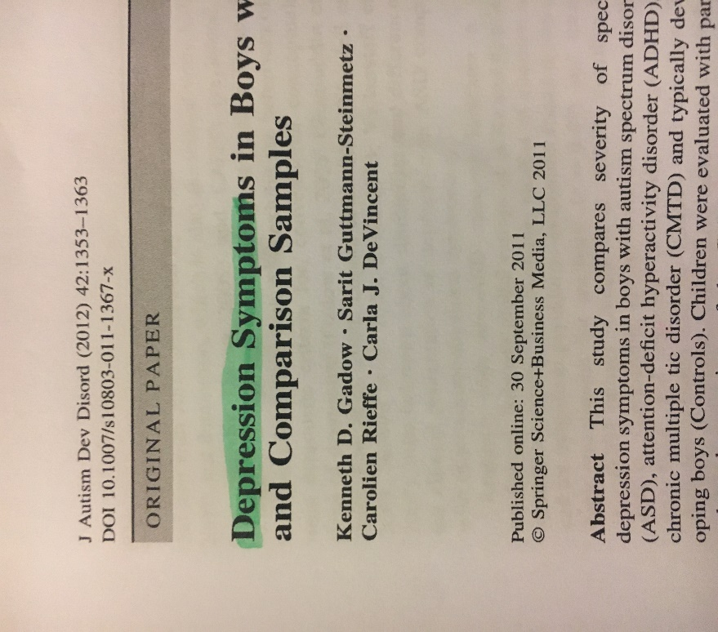
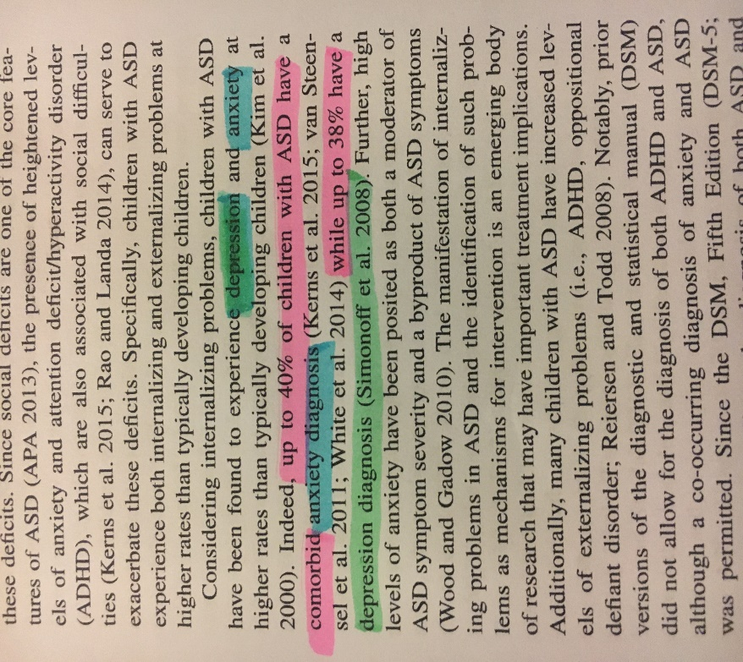

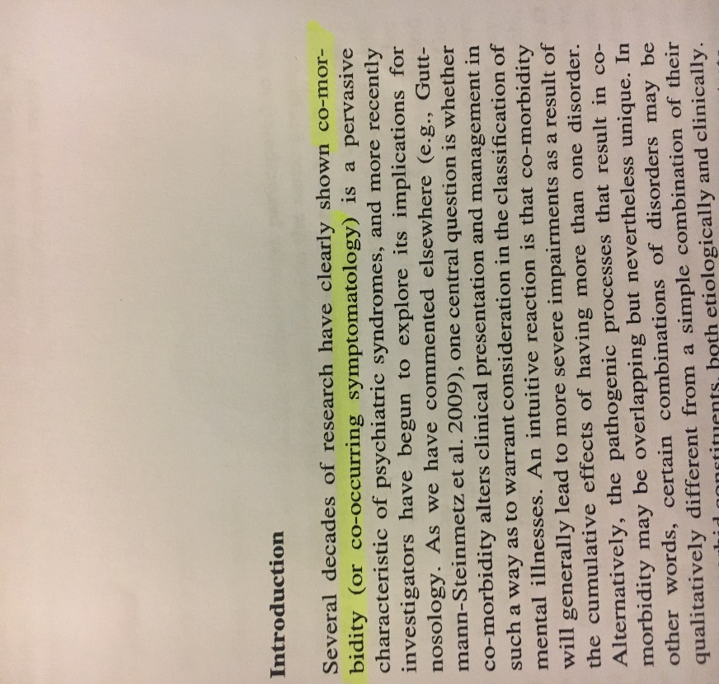

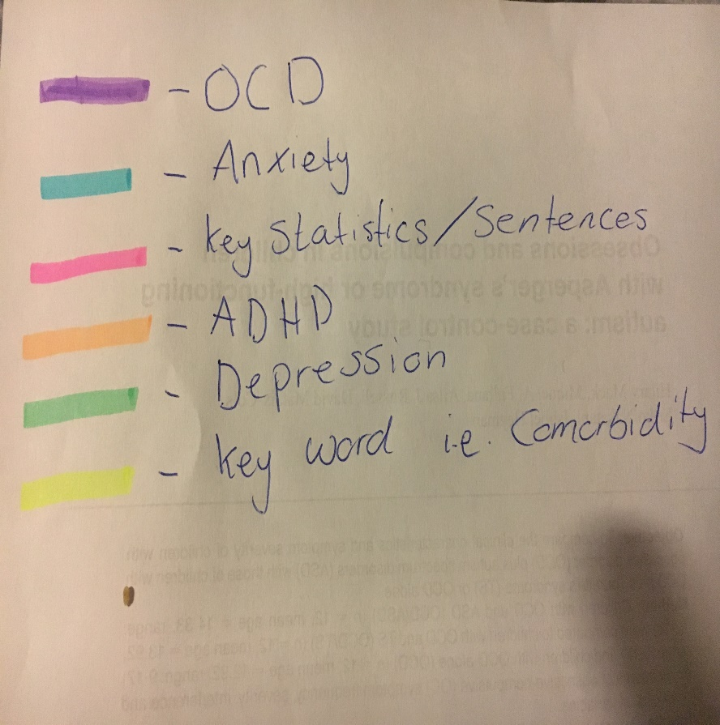
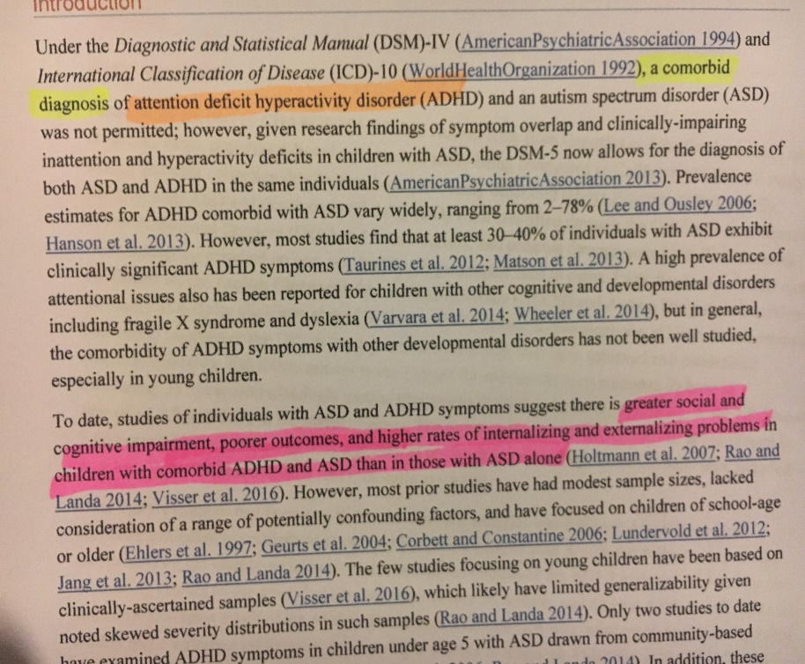
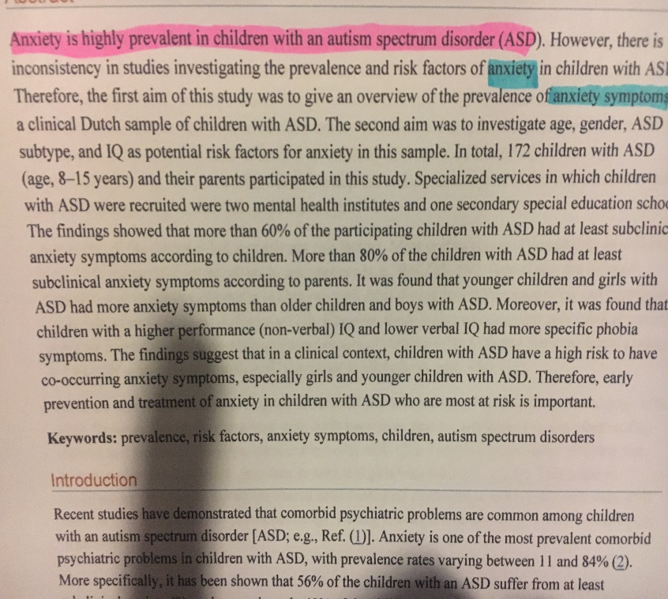
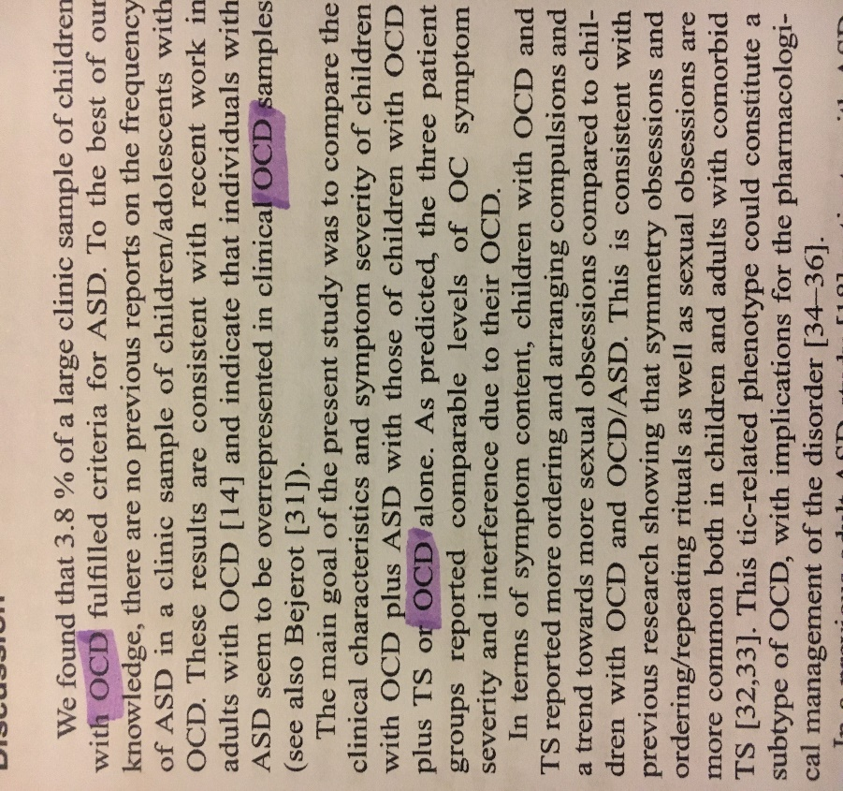
Here is an example of thematic analysis being used (as explained on page 14) to derive four themes relating to the comorbidity of ASD

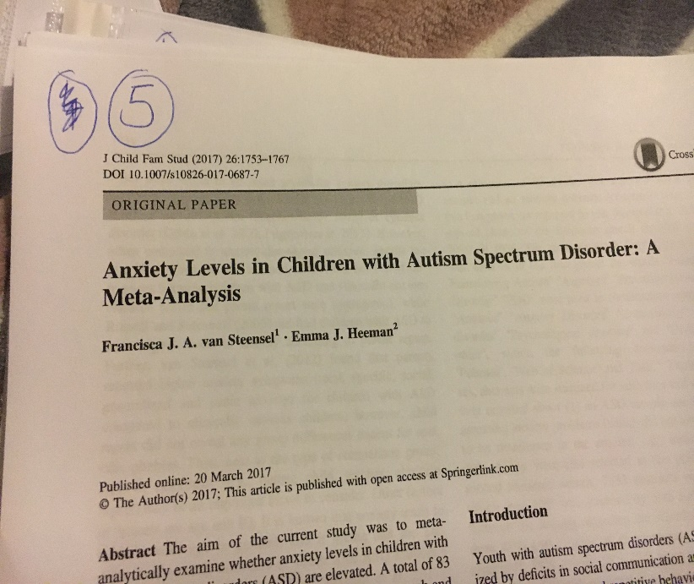
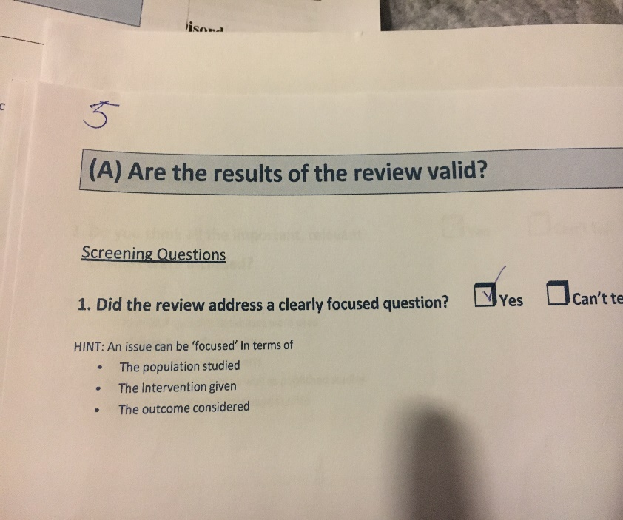
Here is an example of CASP being applied to assess the validity and relatability of studies.

