HOTEL ADMINISTRATION AND FRONT OFFICE -RECEPTION
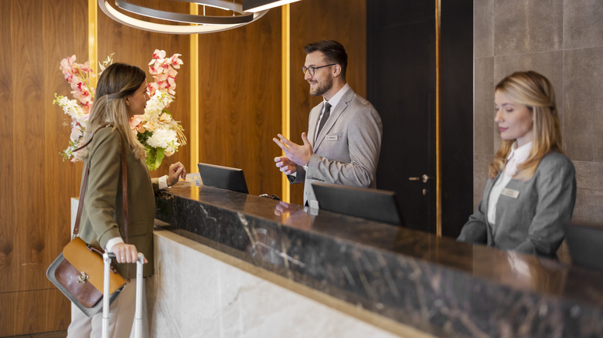

Student: Adriana Ghiocel-Ioaniciu
Student number:2127376
Lecturer: Lisa-Marie Bassler
Module code: BMIH5008
ACKNOWLEDGEMENT: I confirm that I have not used any AI tools in the research and creation of this assignment. I confirm that I have not presented any AI-generated materials as my own work. I confirm I have copies of my drafts, notes, and other resources I used, which I may be asked to provide in evidence.

Contents
Part 1 3
INTRODUCTION 3
1. Description 5
2. Feelings 5
3. Evaluation 5
4. Analysis 6
5. Conclusion 6
6. Action plan 6
Part 2 8
Hotel feedback 8
Part 3 14
Tutor feedback 14
Part 4 18
Reflection on hotel and academic tutuor feedback 18
Introduction 18
1.1 Understanding the feedback 18
1.2 Impact of the feedback 19
1.3 Action steps to grow 19
1.4 Conclusion 20
References 22

Part 1

INTRODUCTION

A hotel front desk is the reception area that is located close to the entrance of the hotel. It is the place where guests can enter and exit the hotel, obtain information, and make requests for a variety of services.It significantly impacts the guest experience by providing excellent customer service, efficiently handling reservations, and ensuring that check-in and check-out processes run smoothly. This assignment examines the primary duties, skills, and learning objectives that should be achieved during a placement at the hotel's front desk.
As a reflection of the establishment's quality and reputation, the reception staff at the Morgan Hotel Swansea maintains high standards of professionalism and hospitality at all times. It is the responsibility of the reception desk, which serves as a primary point of communication, to coordinate with numerous departments, including housekeeping, food and beverage, and maintenance, in order to guarantee that the visitor experience is always smooth.
The Morgan Collection is divided into three buildings: the Morgan Hotel, The Georgian, and Townhouse. There are a total of 54 rooms, which come in different types, including superior, deluxe, classic and suite.
According to Gov. UK the receptionist is the person who visitors come into contact with for the first time.
To be a good receptionist, must have a positive attitude, smile, and assist customers with their needs. The reception department at the Morgan Hotel Swansea provides an excellent opportunity to develop essential hospitality and customer service skills, and this placement could be described as an excellent opportunity. A solid foundation for a successful career in the hospitality industry, whether it be in front office management, guest relations, or hotel administration, will be provided by the practical experience that is gained.I intend to make a good contribution to the hotel's reputation and guarantee that high service standards are maintained by gaining knowledge from seasoned professionals and taking part in direct interactions with visitors.
My confidence in my ability to handle real-life challenges, such as resolving issues with guests or adapting quickly during times of high demand, increased as a result of my participation in this job placement. The importance of maintaining a calm and professional attitude at all times, as well as clear communication and attention to detail, was emphasised here. In addition to preparing me for the responsibilities that come with working in the front office, these experiences have also motivated me to continue my pursuit of personal development within the hospitality industry. When it comes to taking on new responsibilities and working cooperatively as a member of a professional hotel team, I now feel more prepared than I did before.
I got the opportunity to witness and participate in the daily operations of the front desk during the course of the placement, which allowed me to gain significant insights into the interactions that guests have with the hotel as well as the protocols that are followed.In a hospitality context, the experience has helped me to comprehend the significance of teamwork, paying close attention to details, and being able to adapt to changing circumstances. During the placement, ive made the observation that it is of utmost significance to encourage clients to provide feedback, regardless of whether it is positive or negative, in order to determine whether or not changes are required and what changes are required.
The objectives of this reception placement are to develop communication skills and understand the importance of hospitality etiquette, professionalism, and problem-solving in guest interactions.
I will use the Gibbs model to describe my experience working on the reception.
Gibbs' reflective model consists of several steps, and at each one, you must answer numerous questions to delve as deeply as possible into your thoughts. Gibbs suggests these steps: describing, feeling, judging, analysing, concluding, and planning for what to do next.
The goal of this model is to organise thoughts and feelings into separate categories. Most of the time, the different stages help us think more slowly so that we don't make hasty decisions.

Description

During my placement at the reception department of Morgan Hotel, I encountered a challenging situation involving vulnerable men.
That day was a little busy at the reception. Amy and I took care of each customer until it was the lady's turn to check in. However, a man came in front of us and started to become frustrated, saying he'd been waiting for a long time and should have been checked in before the lady. The lady was kind, and she just took a step back to let him make the check-in.
I was a little shocked by his attitude towards a woman, and I didn’t know how to respond. Amy was there to manage the situation; she did the check-in for the men, and after, she apologised to the lady for his attitude and offered her an upgrade to a room.

Feelings

Emotions can play an important role in how you think and behave. The emotions you feel each day can compel you to take action and influence the decisions you make about your life, both large and small. (Cheery,Kendra 2022)
When we finished the check-in, I realised not all people are friendly and show respect for others. I was unable to say anything to the lady at that time, and I began to feel sorry for her and for the embarrassing situation.
I was lucky because my colleague was there, and she knew exactly what to do to make the lady feel special.

Evaluation

Positive aspect :
In this situation, I remain calm and kind.I asked my colleague to help me to fix this problem of guests because I didn’t expect something like that.

Negative aspects :
I was unprepared to deal with guests who had unpleasant attitudes due to my limited experience in hotel service.Because I didn’t know how to manage the situation, this had an impact on the guest's first impression.

Analysis
Problems with guests can occur frequently in hotel service because some people may have a bad day, and others may be irritated by waiting times. Regardless of the reason, I must learn how to handle unhappy guests.My inexperience in dealing with guests with unpleasant attitudes was one of the challenges of this placement in the reception department. It is very important to have a good connection with colleagues, as they can offer help in difficult situations.

Conclusion

From this experience, I learned that not knowing how to manage a situation can have a negative impact on the service. I also realise that it is essential to look for alternative solutions to fix the problem with the guest as soon as possible.

Action plan

According to Hanna,Katie Terrel,2022 the document known as an action plan is a list of the actions that need to be taken in order to accomplish a particular objective. It simplifies the process of achieving the goal by breaking it down into a series of steps that can be easily followed and monitored.
Developing the appropriate skills, maintaining a professional appearance, becoming an effective communicator, being aware of what is going on in the workplace, and maintaining a positive attitude at all times are all necessary components of being a good receptionist. (indeed,2024).
To be able to do this job very well, I did an action plan.
- Improve communication skills: practice during my shift and participate in hospitality communication training.
- Improve my customer service skills: learn how to handle guest complaints, learn from my colleagues, take notes, and ask for feedback from my supervisor.
- Develop multitasking abilities: Learn how to handle multiple tasks (such as answering the phone, checking in guests, and processing payments) without becoming overly stressed.
- Improve language skills : learn from my colleagues the basic greetings and key phrase spoken by guest and practice every day on the language learning app.
- Improve my ability to solve problems: Learn from my colleagues how to think and make decisions quickly so I can handle guest problems well.
- Be professional and have a positive attitude :always wear the uniform ,have a good attitude and be kind with guest .
- Learn about the hotel and local area: memorise all details about the hotel service ,local restaurants ,local attraction .
- Learn how to handle a conflict: When dealing with unhappy guests, learn how to calm down a tough situation professionally by watching managers
If I following this action plan in few months I will be an excellent receptionist .

Part 2

Hotel feedback

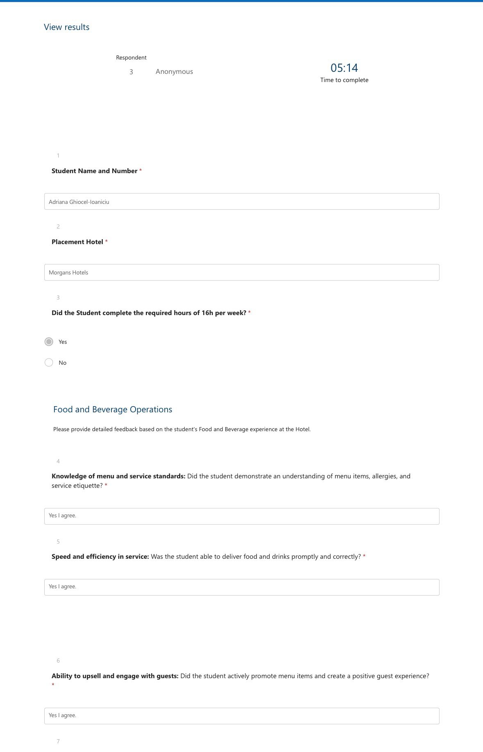
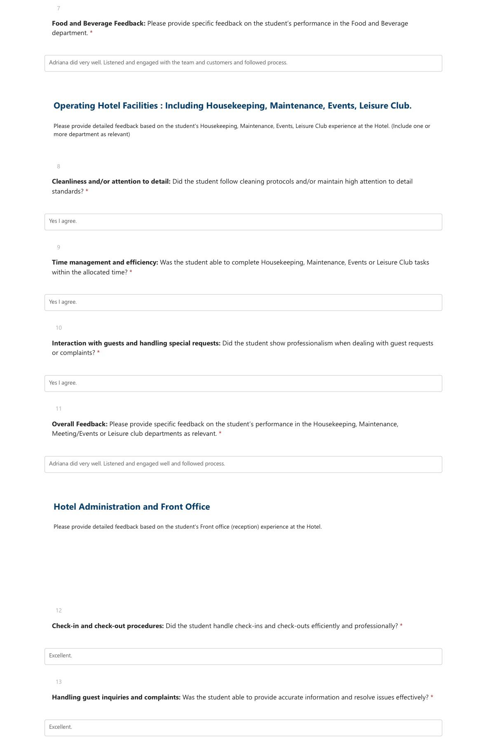
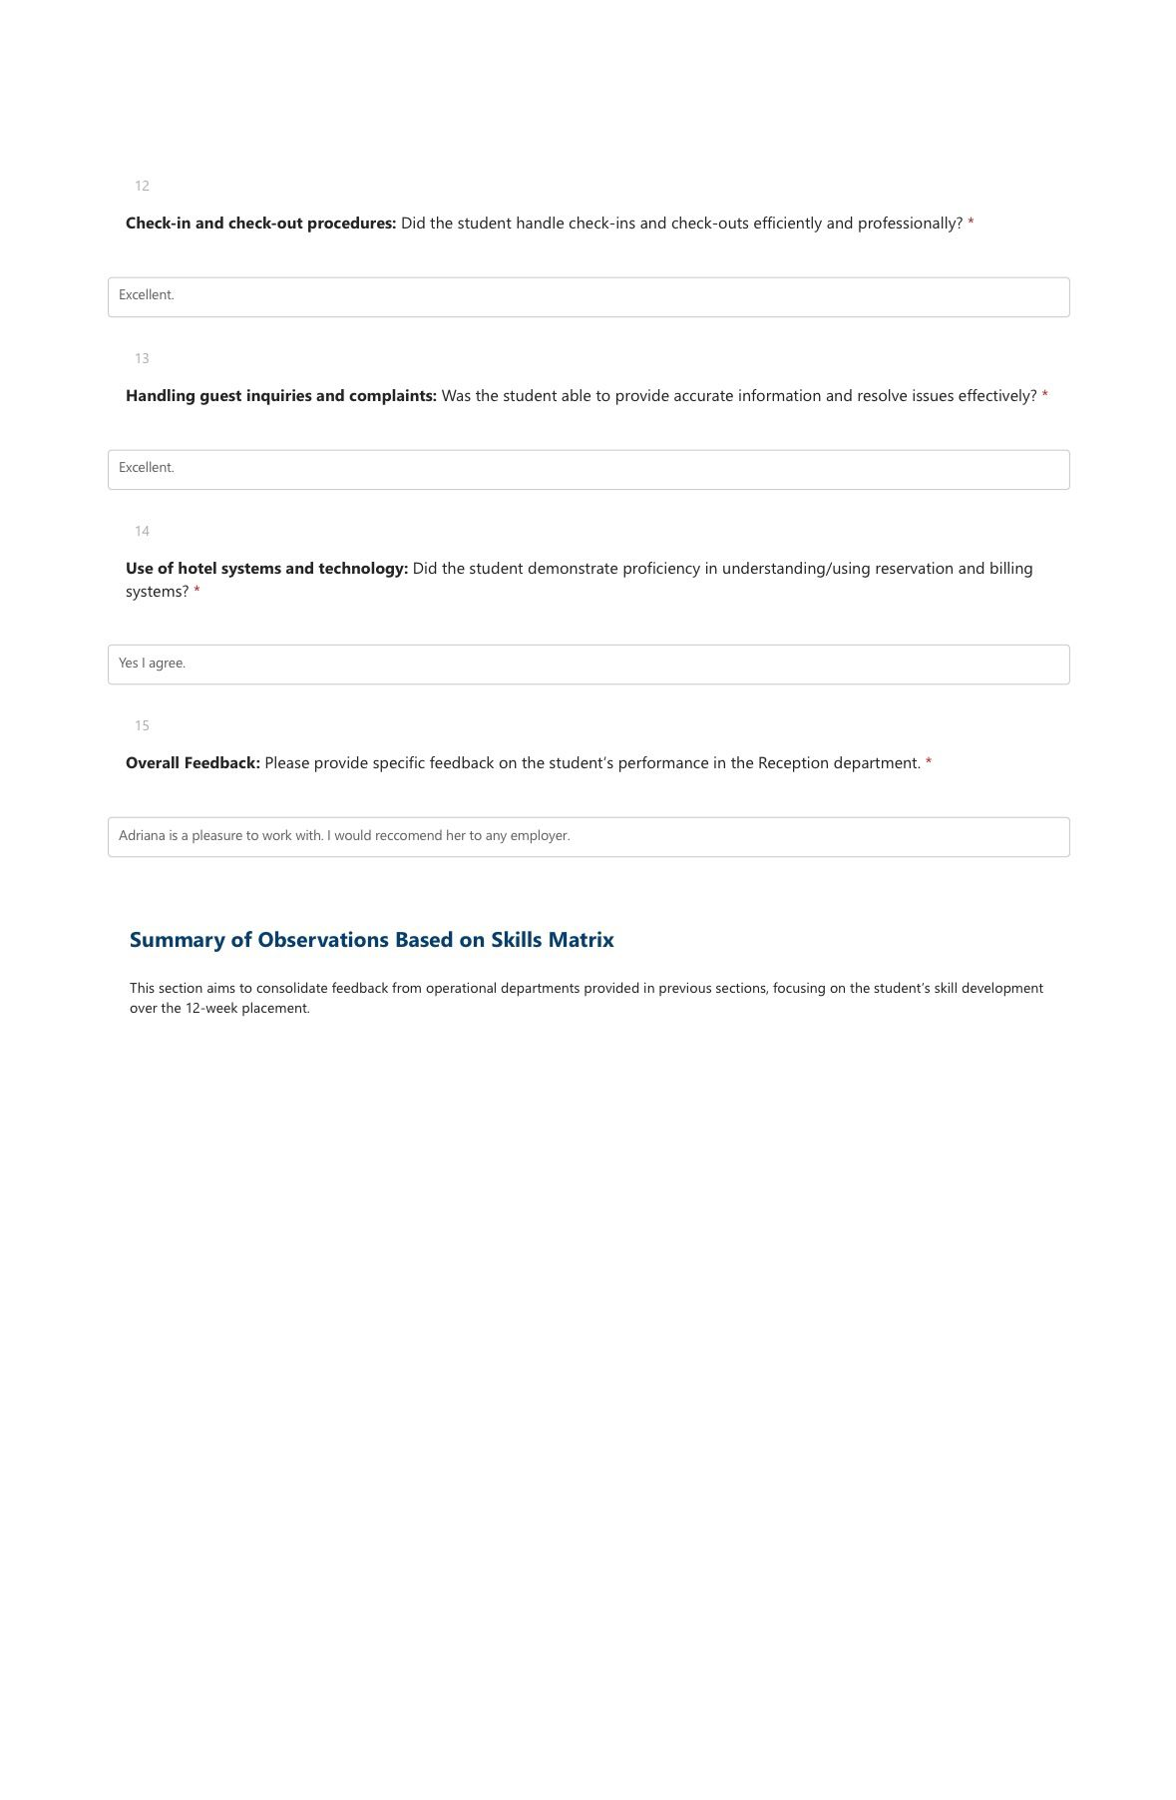
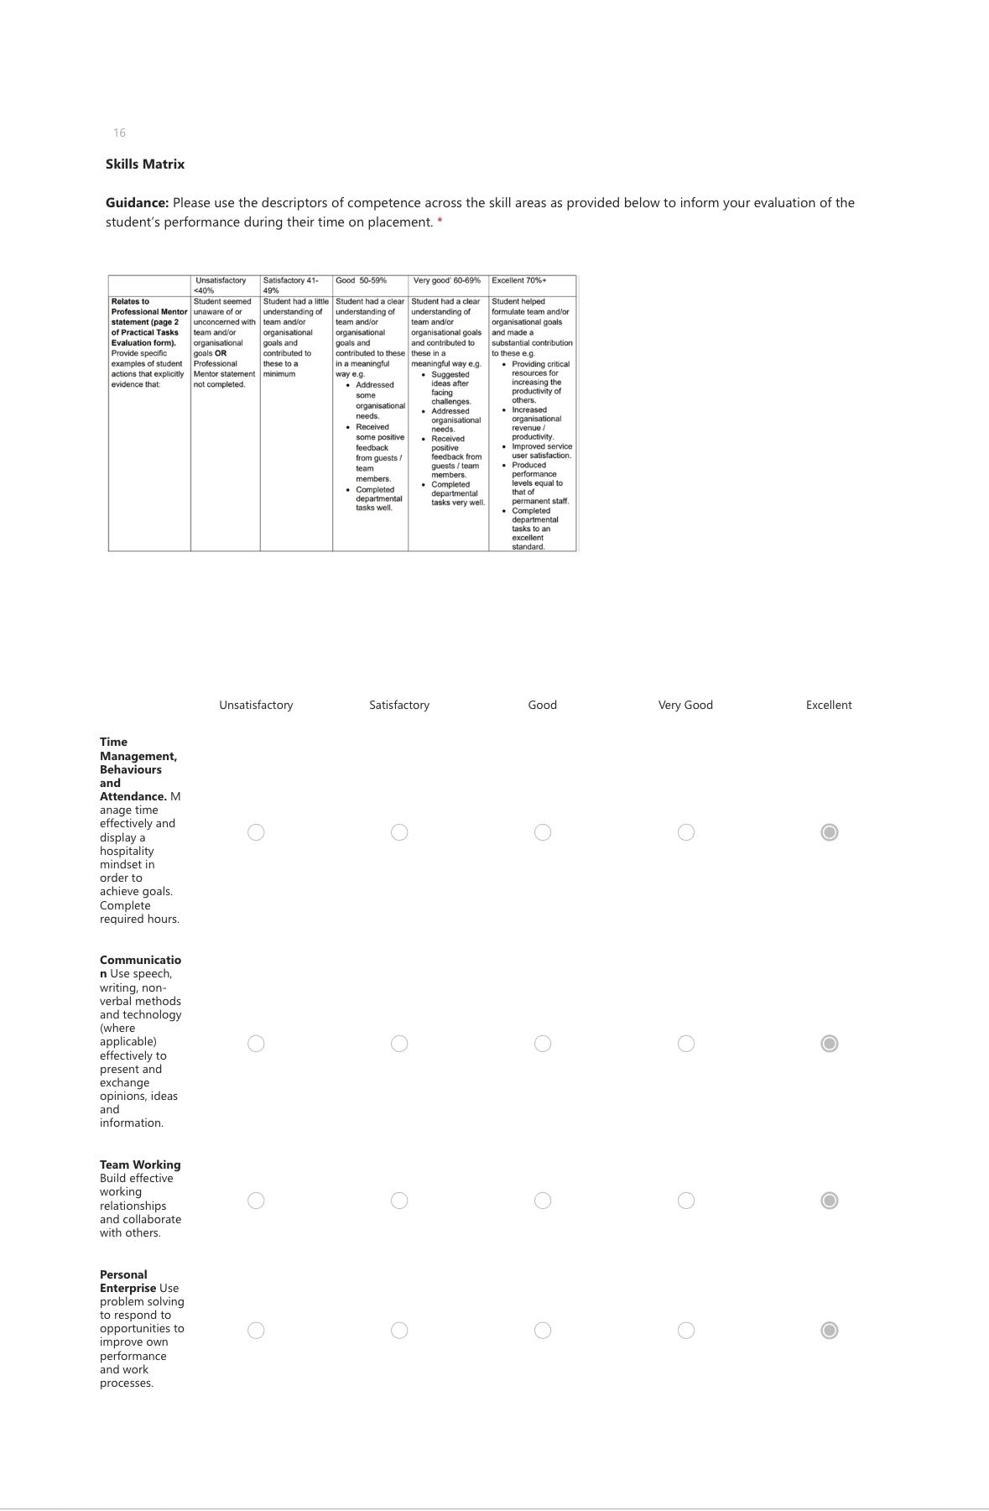
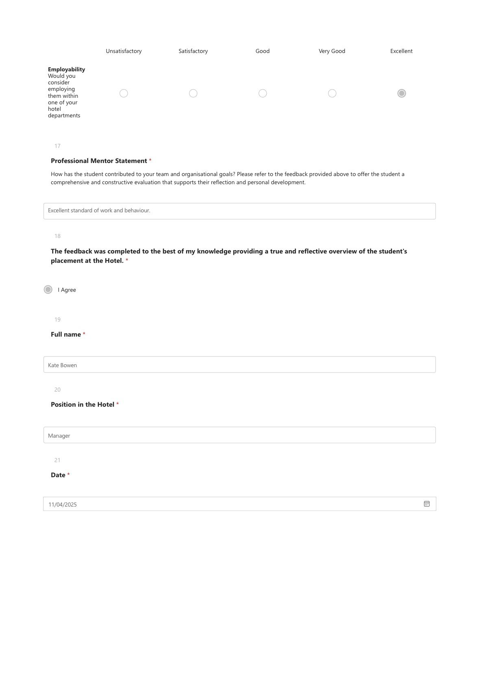

Part 3

Tutor feedback

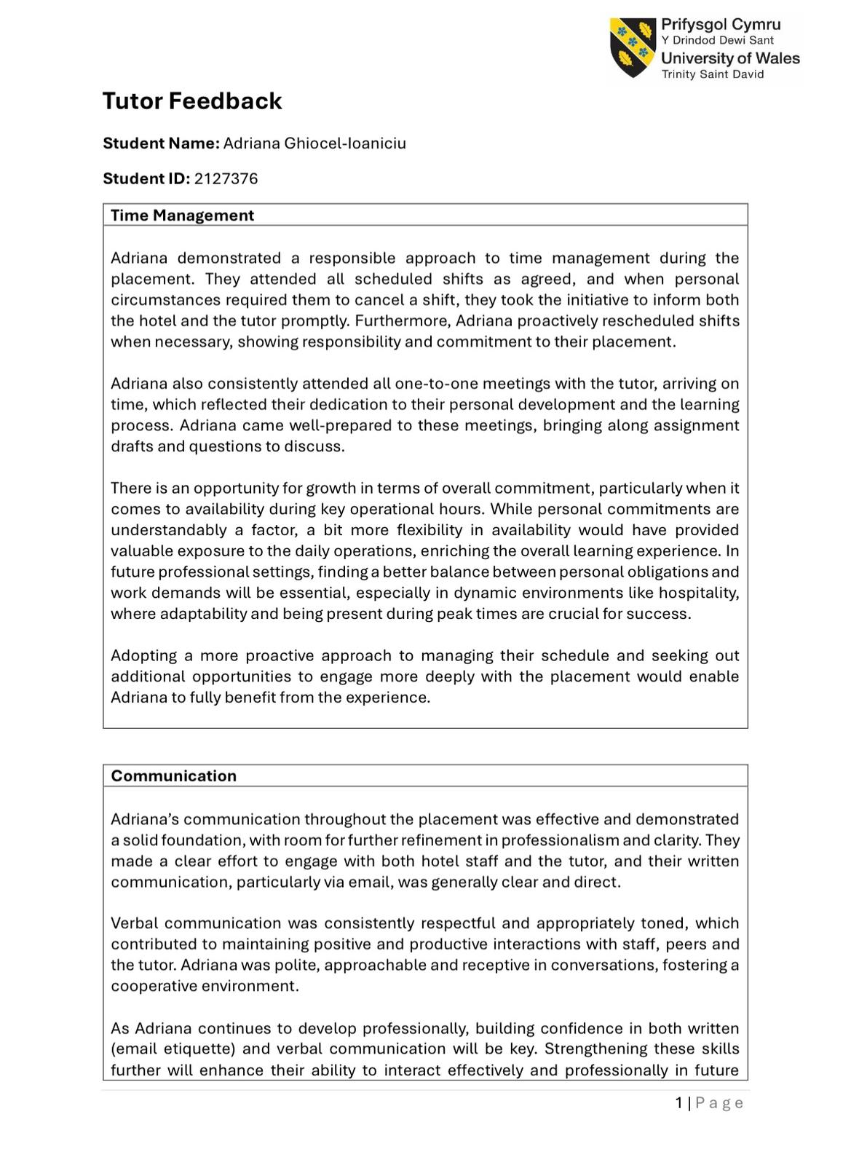

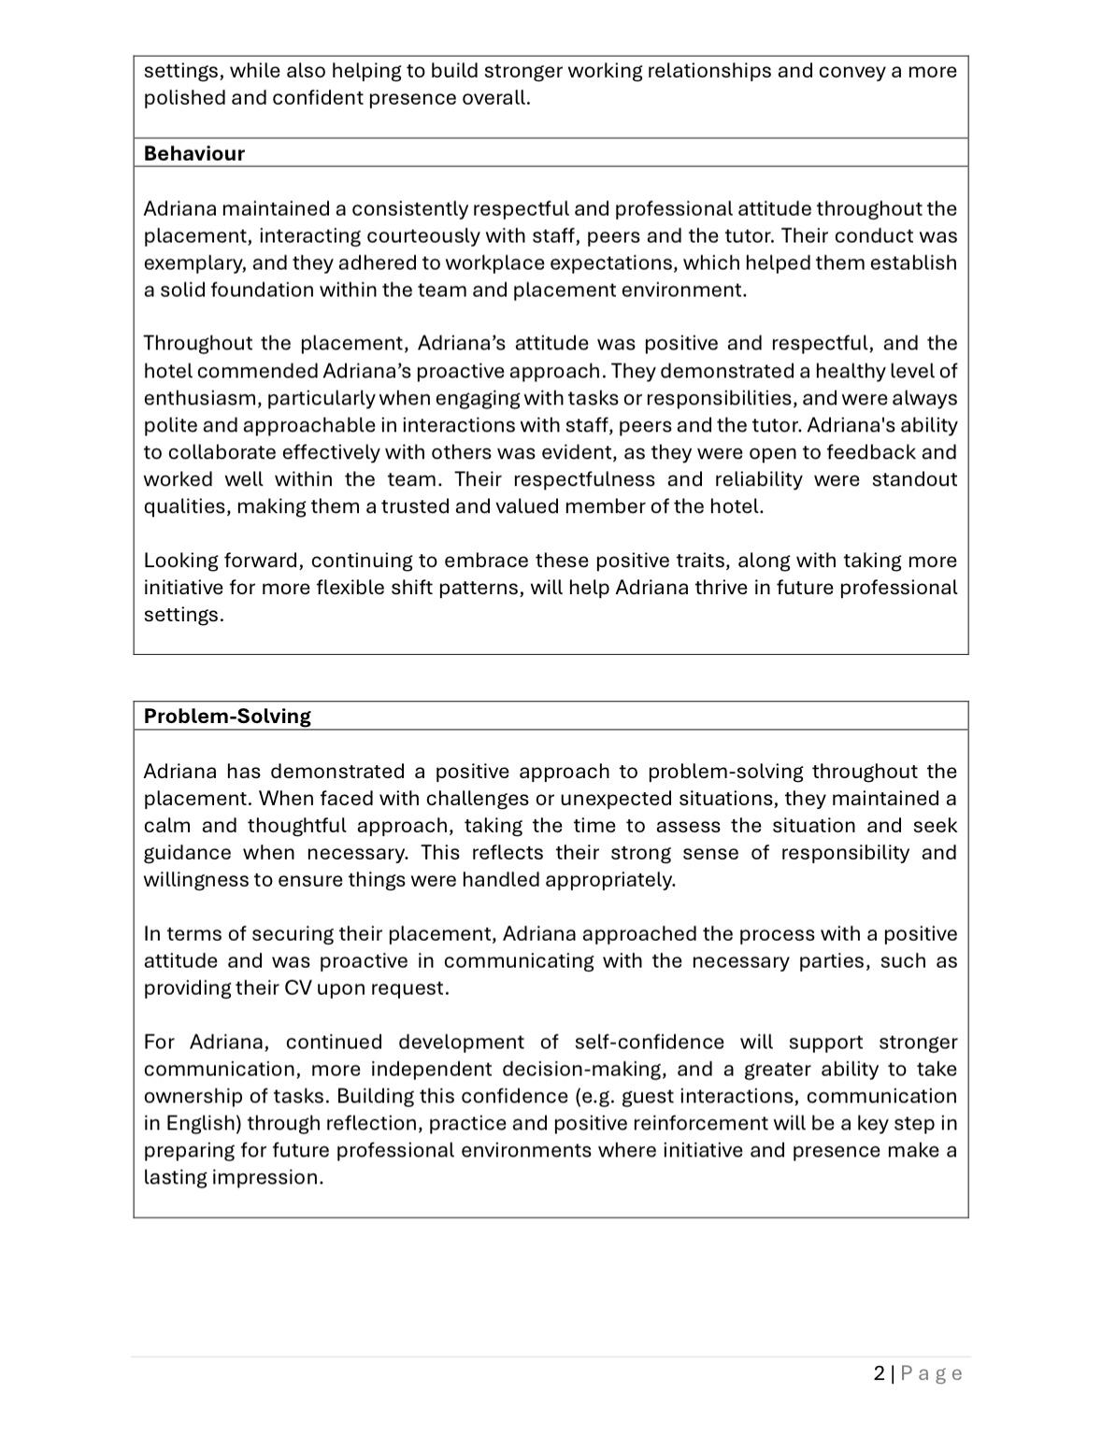


Part 4

Reflection on hotel and academic tutuor feedback

Introduction

In this reflection, I will examine the comments that I received from my academic tutor and my hotel mentor when I was working in the Reception department. My contacts with guests, my communication skills, my ability to work well with others, and my general professionalism were the primary areas of attention for this feedback.Because I'm being honest, polite, and able to work well with others, this reflection will help me understand my skills better. It will also show me what I need to work on, like having more confidence when dealing with tough scenarios and being more proactive when things are busy. Thanks for the feedback It helps me understand how other people see my work and how I can make it better. I can learn from my mistakes and take clear steps to grow as a person and as a worker by thinking about this feedback. I'll feel better about my skills and get ready for future jobs in the hospitality business thanks to this process.

1.1 Understanding the feedback

Both my hotel mentor and my academic tutor gave me feedback on how I was doing during my placement in the reception area. Getting this feedback gave me a balanced picture of my skills and weaknesses in a front-of-house setting.Based on the comments, it was clear that I was friendly, approachable, and professional when talking to guests. I was able to do important tasks at the front desk, like meeting guests, answering questions and helping people check in and out. As expected, I did what I was supposed to do and paid close attention to every detail. People also said nice things about how I looked and how on time I was, which showed how professional and reliable I was.I was praised for being able to communicate clearly and politely with both guests and coworkers, both orally and in writing. I knew how to use the phone properly and was able to transfer calls and take texts correctly. But there was also feedback that made me feel more comfortable taking care of guests' requests on my own, especially when there were problems, or the welcome area was busy. To become more fluent and confident in English, it was suggested that I keep working on my speaking skills, especially when I'm under a lot of stress.It was also said that I worked well with others and was ready to change with the fast-paced front desk environment. I got praise for being helpful and aware of what my coworkers needed. But I now know that being good at greeting also means being able to take the lead, especially when things are busy, and I need to improve in this area to fully help the team.

1.2 Impact of the feedback

The feedback I got has made a big difference in my personal and career growth. It made me feel good about the basic skills I already have, like politeness, clear communication, and paying attention to details. It also pushed me to take the next steps in my growth. Seeing that I'm doing well in customer service jobs makes me feel like I've picked a work path that fits my skills. I like working with others, finding solutions to issues, and making sure guests have a good time. Knowing that my politeness and good mood are appreciated makes me want to keep taking these traits to work.at the same time , the feedback made me more aware of how important it is to take the lead and be sure of myself when things get tough. I know that to be good at reception, I need to be able to anticipate problems, think on my own, and sometimes make choices on the spot. I can follow the rules and help guests with their needs. I still need to work on this. The words about language and self-assurance also made me think about how I talk to people. I now see speaking as more than just a skill; it's a key part of being a leader and being present in hospitality.

1.3 Action steps to grow

Based on the feedback, I will take action to grow and develop my skills.
- Build confidence in guest interaction
I plan to find additional opportunities for real-time practice so that I may become more confident in my ability to handle the demands of guests on my own.

- Improve spoken English fluency
My goal is to improve my communication skills by engaging in daily English practice, with an online course language that is specific to the hotel industry. To improve my fluency, I intend to make use of several methods, including conversation groups, a variety of English language study apps, and movies with hospitality speech. I will be able to become more self-assured and natural in both informal and professional interactions if I consistently engage in conversation with native speakers.

- Learn the front desk system
I would like to become more familiar with the Property Management System as well as the other software tools that are utilised at the reception desk so that I can feel more in charge of my responsibilities. As I get greater familiarity with the system, I will be able to help both the staff and the visitors in a more timely and effective manner.

- Request feedback

To help me track my progress, I will ask my colleagues and manager for feedback after the shift.

1.4 Conclusion

Reflecting on the reception department feedback has helped me identify my strengths and weaknesses. I pride myself on my polite communication, professionalism, and guest satisfaction. I need to improve my language, decision-making, and initiative to be more confident, proactive, and effective in receiving roles. I know I can improve with focused action, practice, and stepping outside my comfort zone. I want to use this reflection to become a more confident and professional.

References

Brown, Nicole. “Reflective Model according to Gibbs.” Dr Nicole Brown, Dr Nicole Brown, 2022, www.nicole-brown.co.uk/reflective-model-according-to-gibbs/. Accessed 1 Apr. 2025.
Cherry, Kendra. “The Purpose of Emotions.” Verywell Mind, Verywellmind, 22 July 2022, www.verywellmind.com/the-purpose-of-emotions-2795181. Accessed 28 Apr. 2025.

“Front Desk.” AltexSoft, www.altexsoft.com/glossary/front-desk/. Accessed 6 May 2025.
GOV.UK. “Receptionist | Explore Careers.” Service.gov.uk, 2019, nationalcareers.service.gov.uk/job-profiles/receptionist. Accessed 6 May 2025.
Hanna, Katie Terrell . “What Is Action Plan? - Definition from WhatIs.com.” WhatIs.com, Dec. 2022, www.techtarget.com/whatis/definition/action-plan. Accessed 25 Apr. 2025.
“How to Be a Good Receptionist (with Definition and Tips).” Indeed Career Guide, 2024, uk.indeed.com/career-advice/starting-new-job/how-to-be-a-good-receptionist. Accessed 6 May 2025.
PixelsEffect. “Hotel Front Desk Stock Photos, Pictures & Royalty-Free Images - IStock.” Istockphoto.com, 2025, www.istockphoto.com/search/2/image-film?phrase=hotel+front+desk. Accessed 6 May 2025.

