E-Portfolio (3 Components)

Jessica Hazelden

Table of Contents
Task One – Article Summary 3
Task Two – Infographic 4
Task Three – Essay Plan 5
Library Search Screenshots 6
Summary of Sources 7
References 8

Task One – Article Summary

How does music make you feel?
This article begins with discussing the link between music and emotions, how certain types of music make you feel certain types of emotions – for instance “major music sounds happy and minor music sounds sad” (Nendick, 2022). The article then goes on to discuss people’s individual differences when it comes to their response to certain music, whether we all have similar responses to the same type of music, and what type of emotion music evokes from someone, while looking at factors such as whether a memory, specific event, time period or a person/place has any impact (Belfi et al., 2016).
The article also talks about how pleasure responses to music can be directly linked to activity in the amygdala, as well as the medial prefrontal cortex and ventral striatum (Blood & Zatorre, 2001). It then moves on to look at other researchers such as Leonard Meyer and Patrick Juslin and the research that they have been conducting with regards to emotional responses to music, and the theoretical framework that they have developed around this subject. It also includes a discussion on how more research is needed due to internal and external factors that may also have an effect on music-induced emotions. The article also then goes on to discuss how emotional responses to music have been used in the field of musical therapy, relieving stress as well as studies of people with Alzheimer’s in which they have seen an improvement in memory recall (Fraile et al., 2019).
To conclude, the article discusses different theories on how music affects a person’s emotions, however it also suggests that although there has been a lot of progress in research in the last few decades around this subject, there is a lot more scope for further research as to how music and emotions are linked, as theoretical frameworks are still at an early stage.

Task Two – Infographic
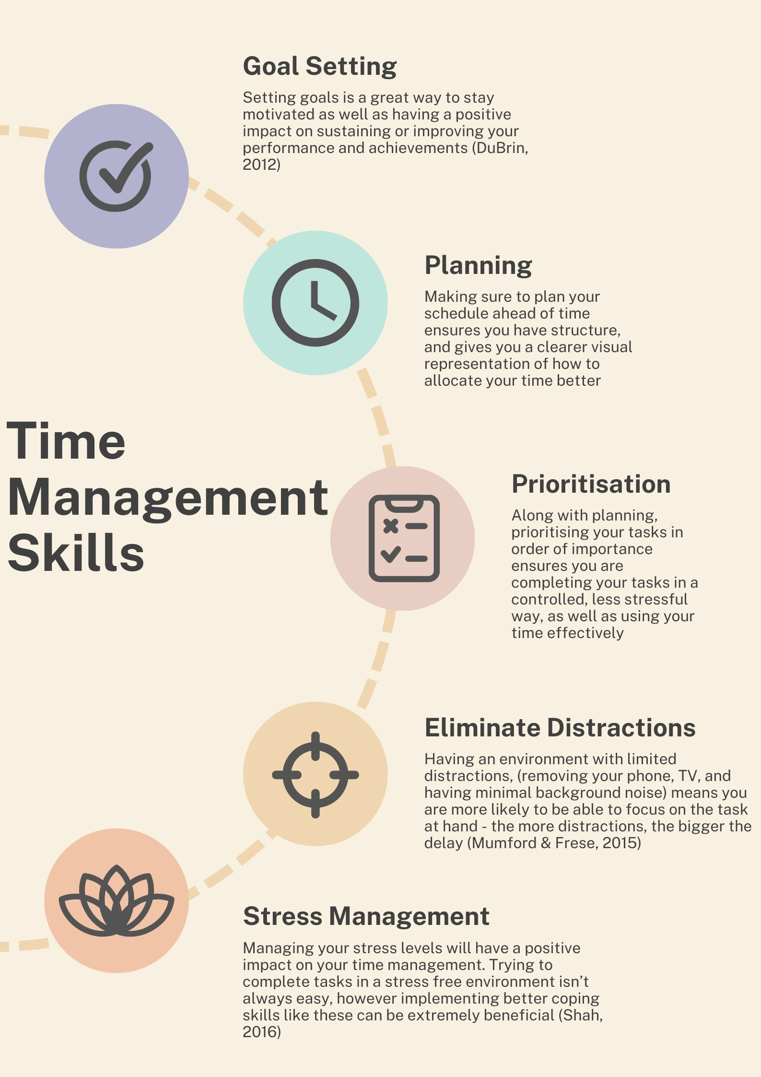

Task Three – Essay Plan

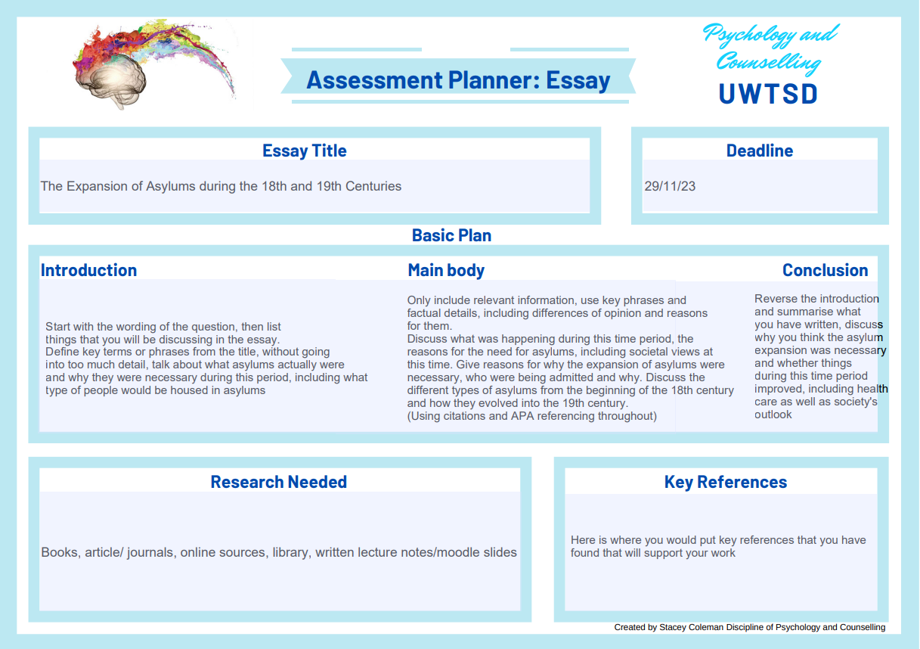

Library Search Screenshots
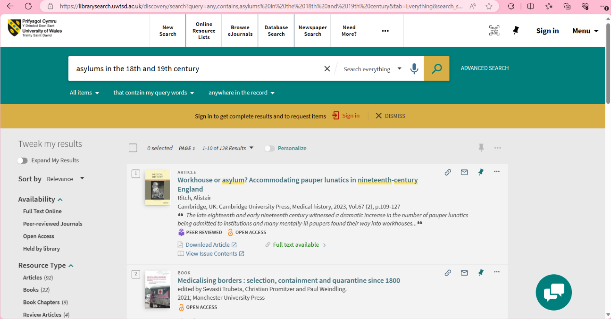
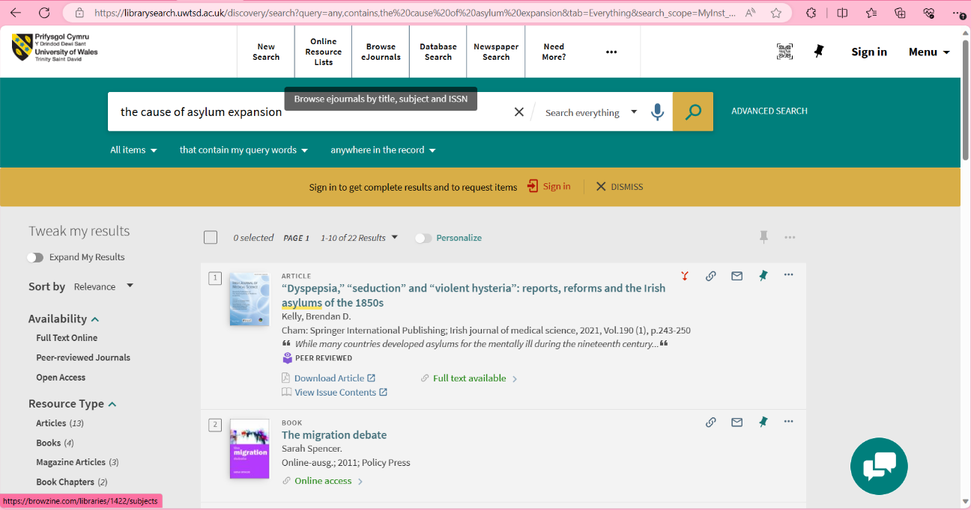
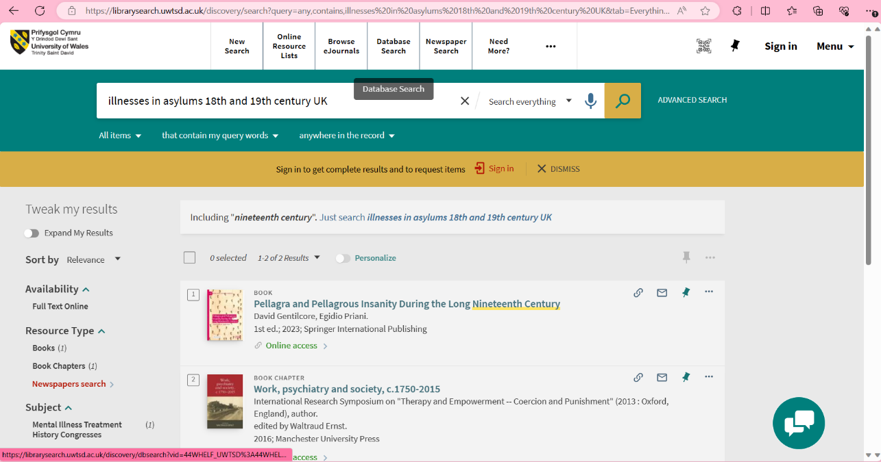

Summary of Sources
To decide which sources I will use, I first make sure that the article/book/journal etc I have found has key words in it from the question – for example I will only be looking at sources from the UK, and that will only talk about the 18th and 19th centuries. I will also look at credible sources, ensuring that they have come from a reliable source, ensuring you do this whilst looking for resources online is incredibly important as there is a lot of information on the internet that can be false or misleading, I make sure it has come from a reliable website, by using Google Scholar and seeing whether the source is peer-reviewed.

References

Belfi, A. M., Karlan, B., & Tranel, D. (2016). Music evokes vivid autobiographical memories. Memory, 24(7), 979-989.
Blood, A. J., & Zatorre, R. J. (2001). Intensely pleasurable responses to music correlate with activity in brain regions implicated in reward and emotion. Proceedings of the national academy of sciences, 98(20), 11818-11823.
Fraile, E., Bernon, D., Rouch, I., Pongan, E., Tillmann, B., & Lévêque, Y. (2019). The effect of learning an individualized song on autobiographical memory recall in individuals with Alzheimer’s disease: A pilot study. Journal of clinical and experimental neuropsychology, 41(7), 760-768.
Nendick, Z. (2022, September 12). How does music make you feel? - The British Psychological Society. Www.bps.org.uk. https://www.bps.org.uk/psychologist/how-does-music-make-you-feel

Infographic
DuBrin, A. J. (2012). Essentials of management. Mason, OH: Cengage South-Western.
Mumford, M. D., & Frese, M. (2015). The Psychology of Planning in Organizations: Research and Applications. In Google Books. Routledge. https://books.google.co.uk/books?hl=en&lr=&id=Fz7eCQAAQBAJ&oi=fnd&pg=PA312&dq=how+eliminating+distractions+helps+time+management&ots=7ce3nip-Yk&sig=9PzyKOx3_TqBZN5ndgQnlLyzK08#v=onepage&q=how%20eliminating%20distractions%20helps%20time%20management&f=false
Shah, N. (2016, February 2). Why is time management key? The Stress Management Society. https://www.stress.org.uk/why-is-time-management-key/

