

TITLE: CHILDREN, YOUNG PEOPLE AND FAMILY
TERM: 2
DEBATE TYPE: VULNERABILITY OF CHILDREN, YOUNG PEOPLE AND FAMILY
TOPIC: CRITICAL EXAMINATION OF A CHOSEN CASE STUDY OF VULNERABILITY (JULIA’S CASE) PARENTAL SUBSTANCE MISUSE
STUDENT’S NAME: SHEDRACK CHIDI ASINOBI
STUDENT’S NUMBER: 2013434
LECTURER’S NAME: BIANCA SANFILIPPO
MOODLE NUMBER: BMHP5004
CATEGORY: LONDON CAMPUS
SCHOOL: UNIVERSITY OF WALES
SUBMISSION DATE:

TABLE OF CONTENTS
INTRODUCTION
IDENTIFICATION OF A CASE STUDY WITH EXAMPLES OF VULNERABILITY
SPECIFIC REASONS WHY THE CHILD, YOUNG PERSON AND FAMILY OR FAMILLY WERE IN POSITION OF VULNERABILTY
FACTORS MEANT THAT THERE WERE SPECIFIC ISSUES IN THIS CASE WHICH MIGHT NOT BE SEEN IN AN AVERAGE FAMILY
CASE STUDY
DEMONSTRATION OF THE KNOWLEDGE OF SPECIFIC ISSUES OF THE CASE
THEORITICAL KNOWLEDGE
POLICY AND PROFESSIONAL PERSPECTIVES
EVIDENCES OF THE RISKS OF THE VULNERABILITY
FACTORS CONTRIBUTING TO THE RISKS
ANALYSIS
EXPLAINATION OF PROCESS OF INTERVENTION BY RELEVANT HEALTH AND SOCIAL CARE AGENCIES/ CURRENT RELEVANT POLICY
THE POINT AT WHICH THE CHILD, YOUNG PERSON OR FAMILY BECAME THE SUBJECT OF ASSESSMENT BY THE HEALTH AND SOCIAL AGENCIES
THE ACTION THE SPECIFIC AGENCY DECIDED TO TAKE
DISCUSSION AND EVALUATION OF CURRENT POLICY AND THE ROLES OF MULTI-DISPLINARY SERVICES WITHIN THE CASE
IMPACT OF THEIR ACTION ON THE CHILD, YOUNG PERSON AND FAMILY
EVALUATION/ CONCLUSION
CRITICAL ANALYSIS OF THE RESPONSE OF THE RELEVANT AGENCIES
CRITICAL ANALYSIS BASED ON OWN PERSPECTIVE OF WHAT COULD HAVE BEEN DONE DIFFERENTLY
RECOMMENDATION
RECOMMENDATIONS FOR IMPROVEMENT APPROPRIATE TO THE NEEDS OF THE CHILDREN/YOUNG PEOPLE AND FAMILY INVOLVED IN THE CASE STUDY
REASONS FOR OWN SUGGESTION WITH LITERATURE REFERENCES
REFERENCES

INTRODUCTION: This support paper to the presentation will be focusing on the case study of a family facing adversity and that will be Julie family in Bradford in United Kingdom it will be covering the factors of vulnerability and their impact on the live of the children in this family. The paper will also discuss the intervention of the social service and evaluate the outcome.
What is vulnerability?
Vulnerability according to oxford language dictionary is ‘the quality or state of being exposed to the possibility of being attacked or harmed, either physically or emotionally’. Oxford dictionary (2022).
Factors of vulnerability include:
Parental involvement with criminal justice system. NSPCC (2018)
Parents involved in domestic abuse. NSPCC (2018)
Parents misuse of drugs/alcohol (substance misuse). NSPCC (2018).
Parents with mental health problems. NSPCC (2018).
Identification of a case study with example of vulnerability
Julie family in Bradford in United Kingdom is a typical example of a vulnerable family. UWTSD module (2022). For the sake of word count the detailed story have been moved to the appendix of this supporting paper.
Specific reasons why this family was in position of vulnerability
This family was in position of vulnerability as a result of the following reasons: Julie being the only parent in the family was periodically away from the family home, she was involved in criminal behaviour and was involved in substance misuse (Heroin addiction). As result of this drug intake the family was poor.
Factors in this case which might not be seen in an average family include:
Parental substance misuse: Parent substance misuse is the long-term misuse of drugs and /or alcohol by a parent or carer. NSPCC learning (2021).
Parent involved in criminal justice system: In this case, it is factor apparently seen in the life history of Julie.
Prostitution involvement: Julie was involved in prostitution to fund her drug consumption
School absenteeism: None of the children were attending school on regular bases and three of the boys were permanently excluded from school.
Antisocial and criminal behaviour: The children were involved in antisocial and criminal behaviours such as criminal damage, shoplifting begging and rowdy behaviours and the neighbours were unhappy with them.
Poverty: The family was poor because Julie was spending on drugs
Case study: see appendix.
Demonstration of the knowledge of the issues of the case
The main issue of the case study is ‘’Parental substance misuse’’
Theoretical knowledge and Professional perspective: According to NSPCC Parental substance misuse is the long-term misuse of drugs and alcohol by a parent or carer. NSPCC Learning (2021).
The impact:
Child neglect: Parents who take drug find it difficult to stay organised as to be able to give the children the support they need NSPCC (2021).
They find it difficult to keep the family tidy as a result of being in the influence of drug NSPCC (2021).
Physical abuse: Parent who take drug may find it difficult to control their emotion and this results in physical abuse of the child. NSPCC (2021).
Emotional abuse: Parent who take drug could act in an unpredictable and irrational manner and this in turn affects the child NSPCC. Aldgate et.al. (2011).
Impact on brain: drug intake by parent can cause impairment in the cognitive development of the child example, control of the impulse. Shonkoff et.al. (2011).
Criminal activity: Parent who take drug may likely involve in crime to fund their dependency this act, in turn affects the children. Brophy (2006). The act also results in children taking to criminality as seen in this case study.
Societal effect: Due to this act by the parent the society their informal relationship with the society became scary as seen by the altitude of the neighbours.
Analysis:
The point at which the child, young person or family became subject of assessment by health and social care agencies
The child, Young Person and the family is subject to assessment at the point where the child is in need. NSPCC (2018). That is exactly the point in Julie’s family where the mother is involved with substance abuse, she is regularly away from home, she is prostituting, the children are involved in anti-social behaviour, the neighbours are not happy with them etc.
According to children’s Act 1989 section 47, the local authority reserves the right to intervene after due enquiries where the child cannot live without the intervention of the social services.
The process of intervention
The process of intervention starts with referral, this is where the case is reported to the relevant social service or authority. The social service then, take the process of assessment based on the framework of the policy of working together to safeguard the children, children act (1989). Julie’s family, was assessed based on the three main points in assessment criteria and these are:
Parental capacity
family and environmental factor
and children developmental need.
Action of the social services: After the referral and the assessment, the social services started working in multi-agencies based on the (children’s act 1989 and 2004) (working together in multi-agencies)
Evaluation of the current policy and the role of the multi- agencies
The act 1989 and 2004 were applied by the multi-agency, the family were kept together children act (2004) despite the level of abuse seen in this family.
RESULT
Potential impact of the actions of the multi-disciplinary services
With the intervention of the multi-disciplinary services, the family got a new home, Julie was rehabilitated, she stopped criminal behaviour, number of unwanted visitors reduced, Children’s school attendance improved to 90%, anti-social behaviour stopped and their tenancy was made permanent.
The intervention of social services in providing the necessary needs to the family was informed based on Maslow’s theory of hierarchy of needs, that states that people are motivated to fulfil basic needs before moving onto other more advanced need. Maslow hierarchy of need (1954).
Evaluation/Recommendations: The social service intervention in this case, brought an incredible improvement to the life of this family however there are other things they would have done differently based on Kolb’s model of experiential learning (1984)
The social service should give considerable number of years to follow-up with this family and monitor their school attendance on regular bases, they should also devout time with the family, register and finance the children in some social activities like children’s club, sports and provide other children welfare facilities, this is in line with Brofenbrenner’s Ecological theory that states the importance of provision of service in a child’s development. Bronfenbrenner (1977). Based on these, the social service, the school and the family should have a cordial relationship aimed at the development of the children.
REFERENCES

NSPCC (2018) ‘Children living in families facing adversity’ NSPCC Learning [online] available at: (Accessed date:03/04/2022).
Oxford dictionary (2022) ‘meaning of vulnerability’ oxford university press [online] Available at: (accessed date: 03/04/2022).
Oxford dictionary (2022) ‘meaning of vulnerability’ oxford university press [online] Available at: (accessed date: 03/04/2022).
ONS (2021) ‘Number of children in need at 31 match 2013 -2021’ Education-statistics. Service.gov.uk [online] Available at: (accessed date: 02/04/2022).
NSPCC (2021) ‘Parent substance misuse’ NSPCC Learning.org.uk [online] Available at: (Accessed date: 03/04/2022).
NSPCC (2019) ‘Children living in families facing adversity’. (online) Available at: learning.nspcc.org. (Date accessed: 21 March 2022)
Maslow, A.H. (1954) ‘Motivation and personality’. New York, NY: Harper & Row Publishers. [online] Available at: (accessed date: 03/03/2022).
United Nations (1989) ‘The United Nations Convention on the Rights of the Child’ [Online]. Available at: Layout 1 (unicef.org.uk) (date accessed: 21 March 2022).
Bronfenbrenner, U. (2005) ‘Making human beings human: Bioecological perspectives on human development’. Thousand Oaks, CA: Sage [online] Available at: (accessed date: 21/03/2022).
Children Act 2004, c. 31. [Online]. Available at: legislation.gov.uk (date accessed: 28 March 2022).
Children Act 1989, [Online]. Available at: Children Act 1989 legislation.gov.uk (accessed date: 28 March 2022).
HM Government (2018) ‘Working Together to Safeguard Children A guide to inter-agency working to safeguard and promote the welfare of children’ [Online]. Availableat:assets.publishing.service.gov.uk/government (accessed date: 21 March 2022).
Troubled family (2021) ‘Communities and local government’ [online] Available at: Communiteis.gov,uk (Accessed date: 03/04/2022).

APPENDIX
Julia family in Bradford (United Kingdom)
Julie family in Bradford is a typical example of a vulnerable family. She is a single mother of six children, four boys and two girls. Julie was constantly away from family home, was a suspected prostitute who engage in substance misuse and had been involved in criminal behaviours. Her children were being taken care of by her sister. The eldest child had a criminal record. There was no regular school attendance among her children, concerns about the neglect of the children were evident and the family was poor. Housing providers could not rehouse them because of their high level of antisocial criminal behaviour.
There was fear of the children being taken to a care home and this was doused by the agreement that the family will engage with a key worker to improve the situation. To this effect, a short-term tenancy was given to this family with the intervention compliance plan integrated. The key worker helped them to get the new home in decent order when they move in. There was a change of life to the new environment as they cooperate with the key worker.
Julie was referred to local drug support project and she also completed an educational course on basic literacy. Julie stopped a criminal behaviour and reduced the number of unwanted visitors at home. The children school attendance improved to 90 per cent and other areas of the family live improved as a result of the intervention which was principled on putting the family together.

PRESENTATION SLIDES FOR DEBATE ON VULNERABLE FAMILY (ASSESSMENT ONE)
SLIDE1
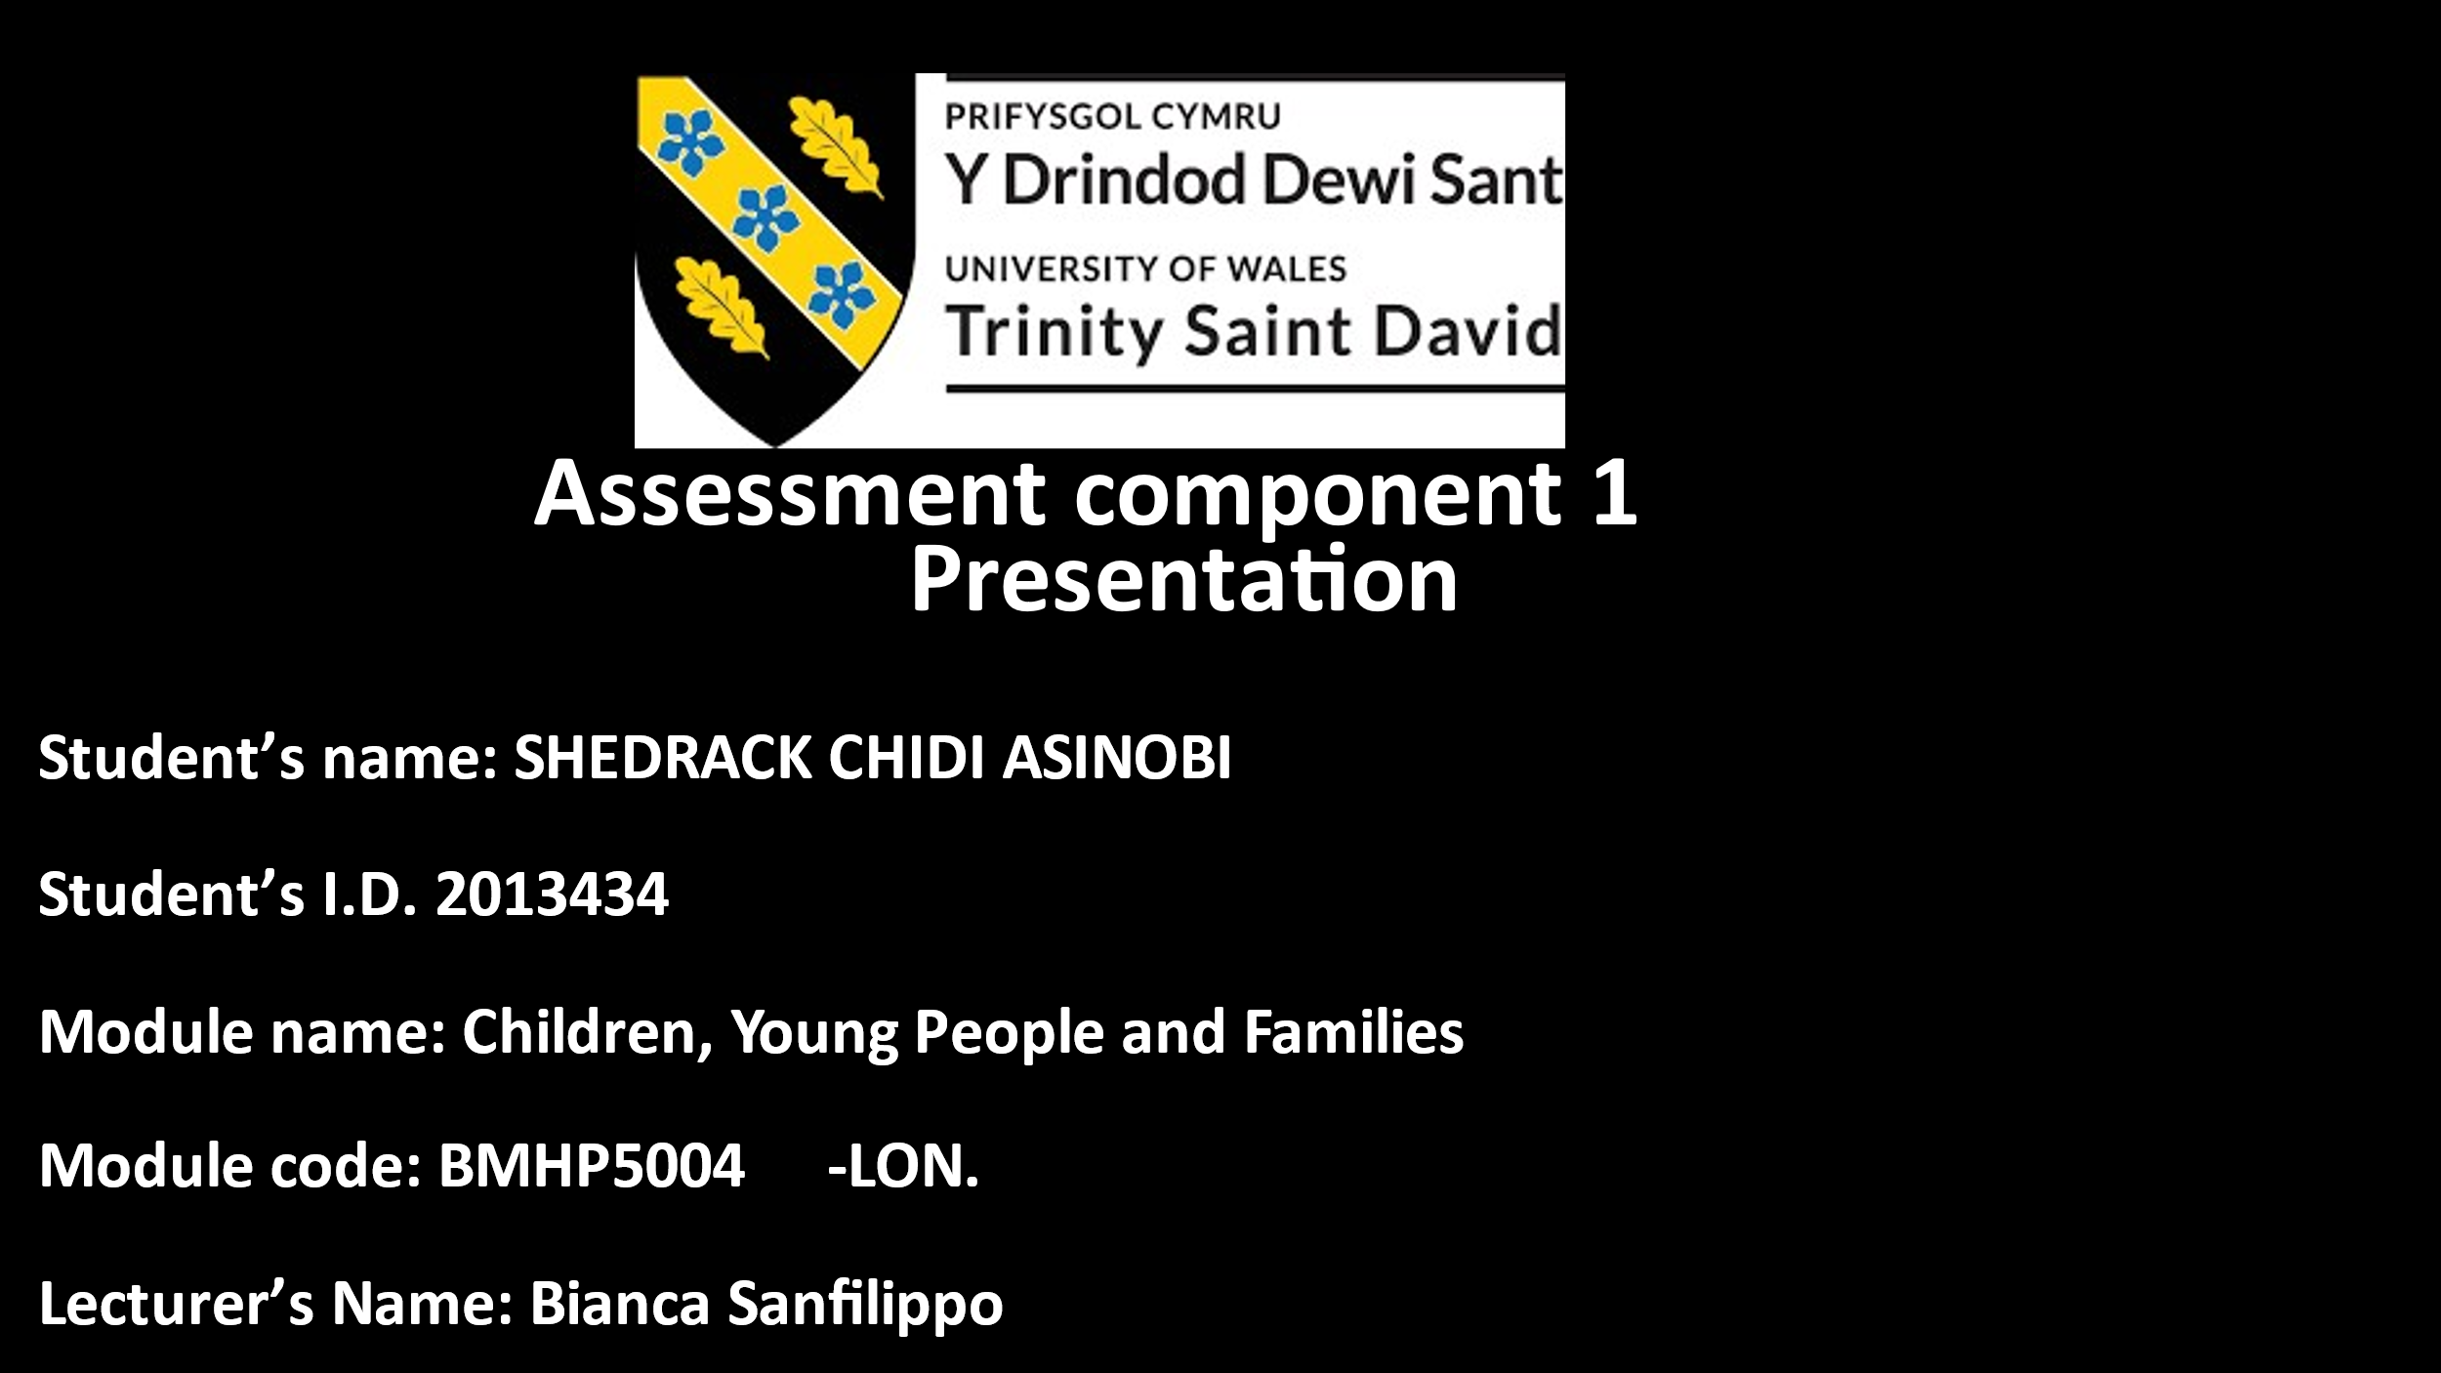

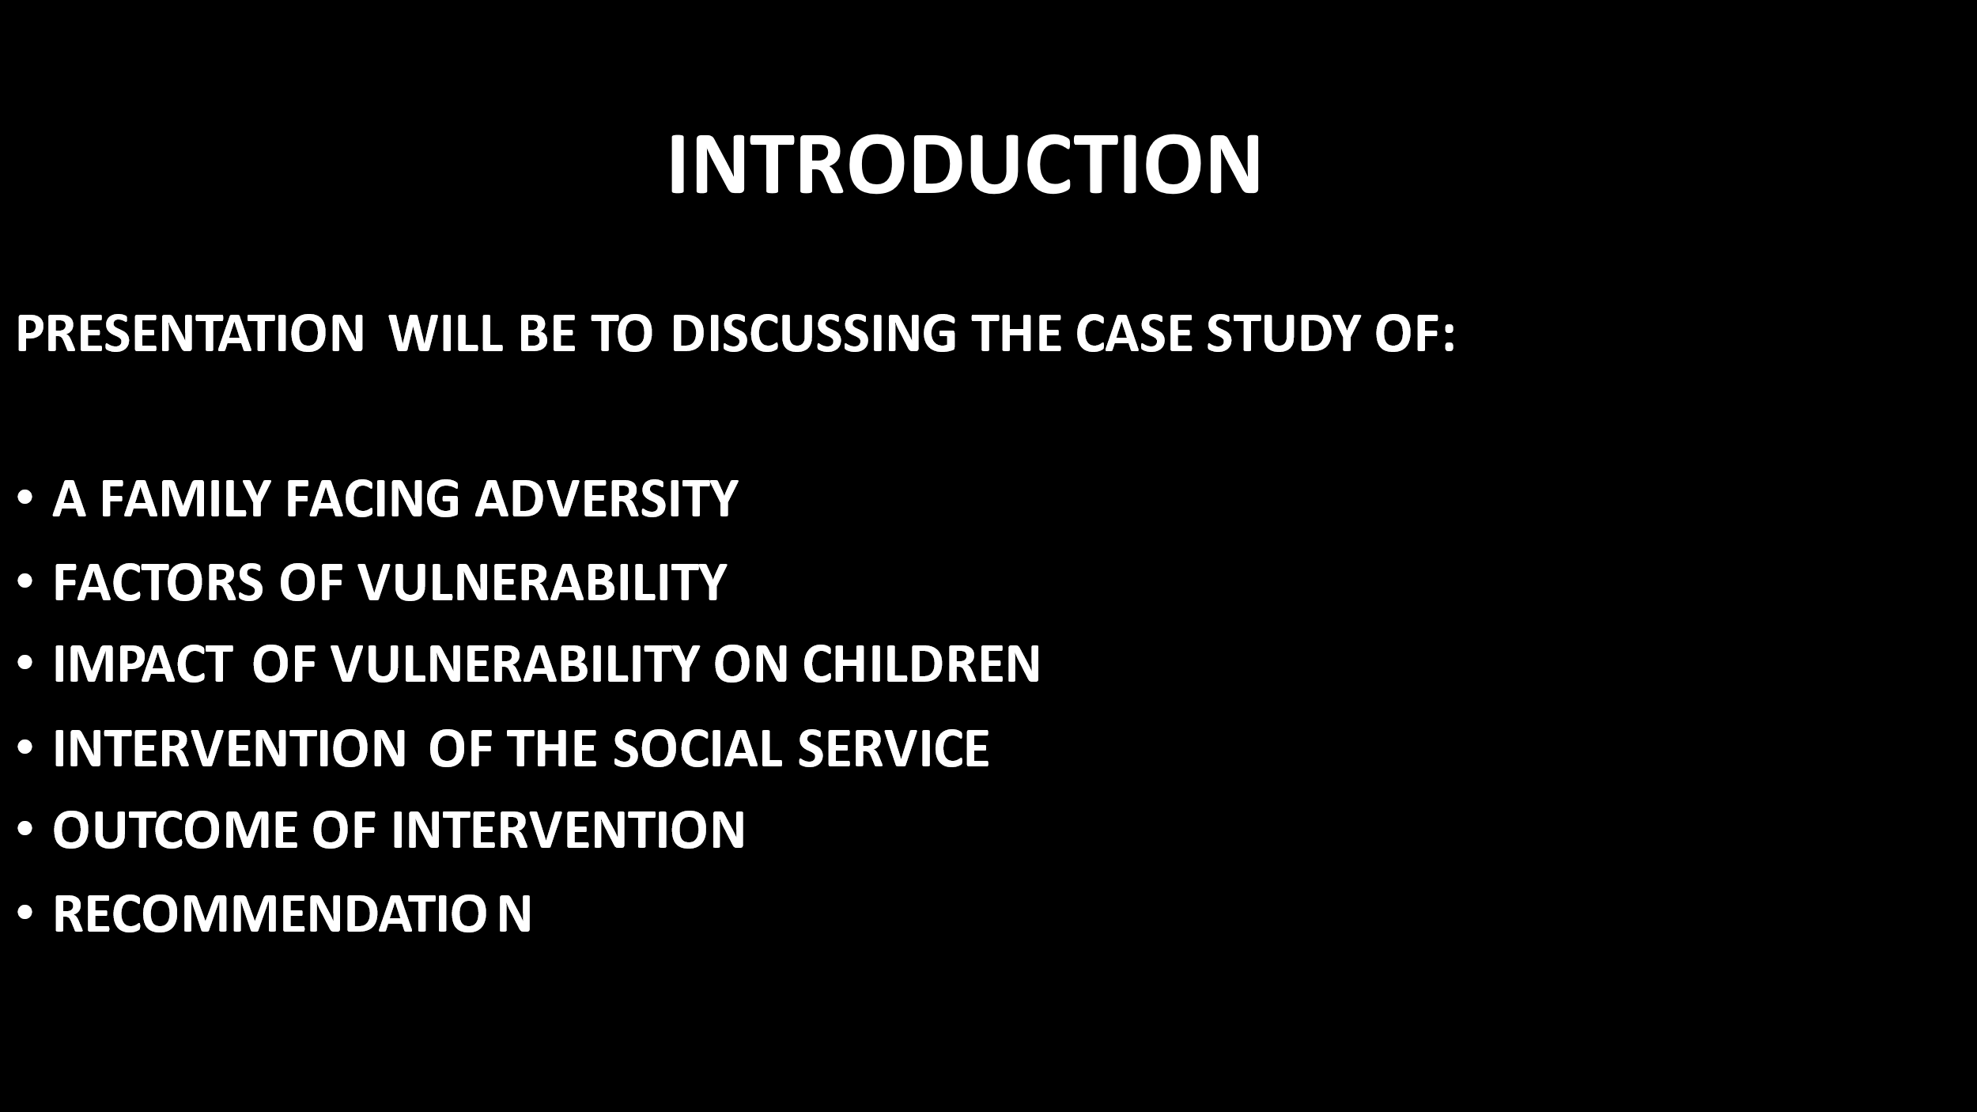
SLIDE 2

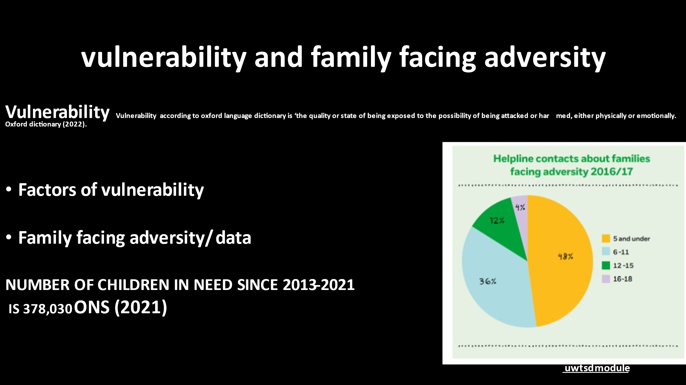
SLIDE3

SLIDE4
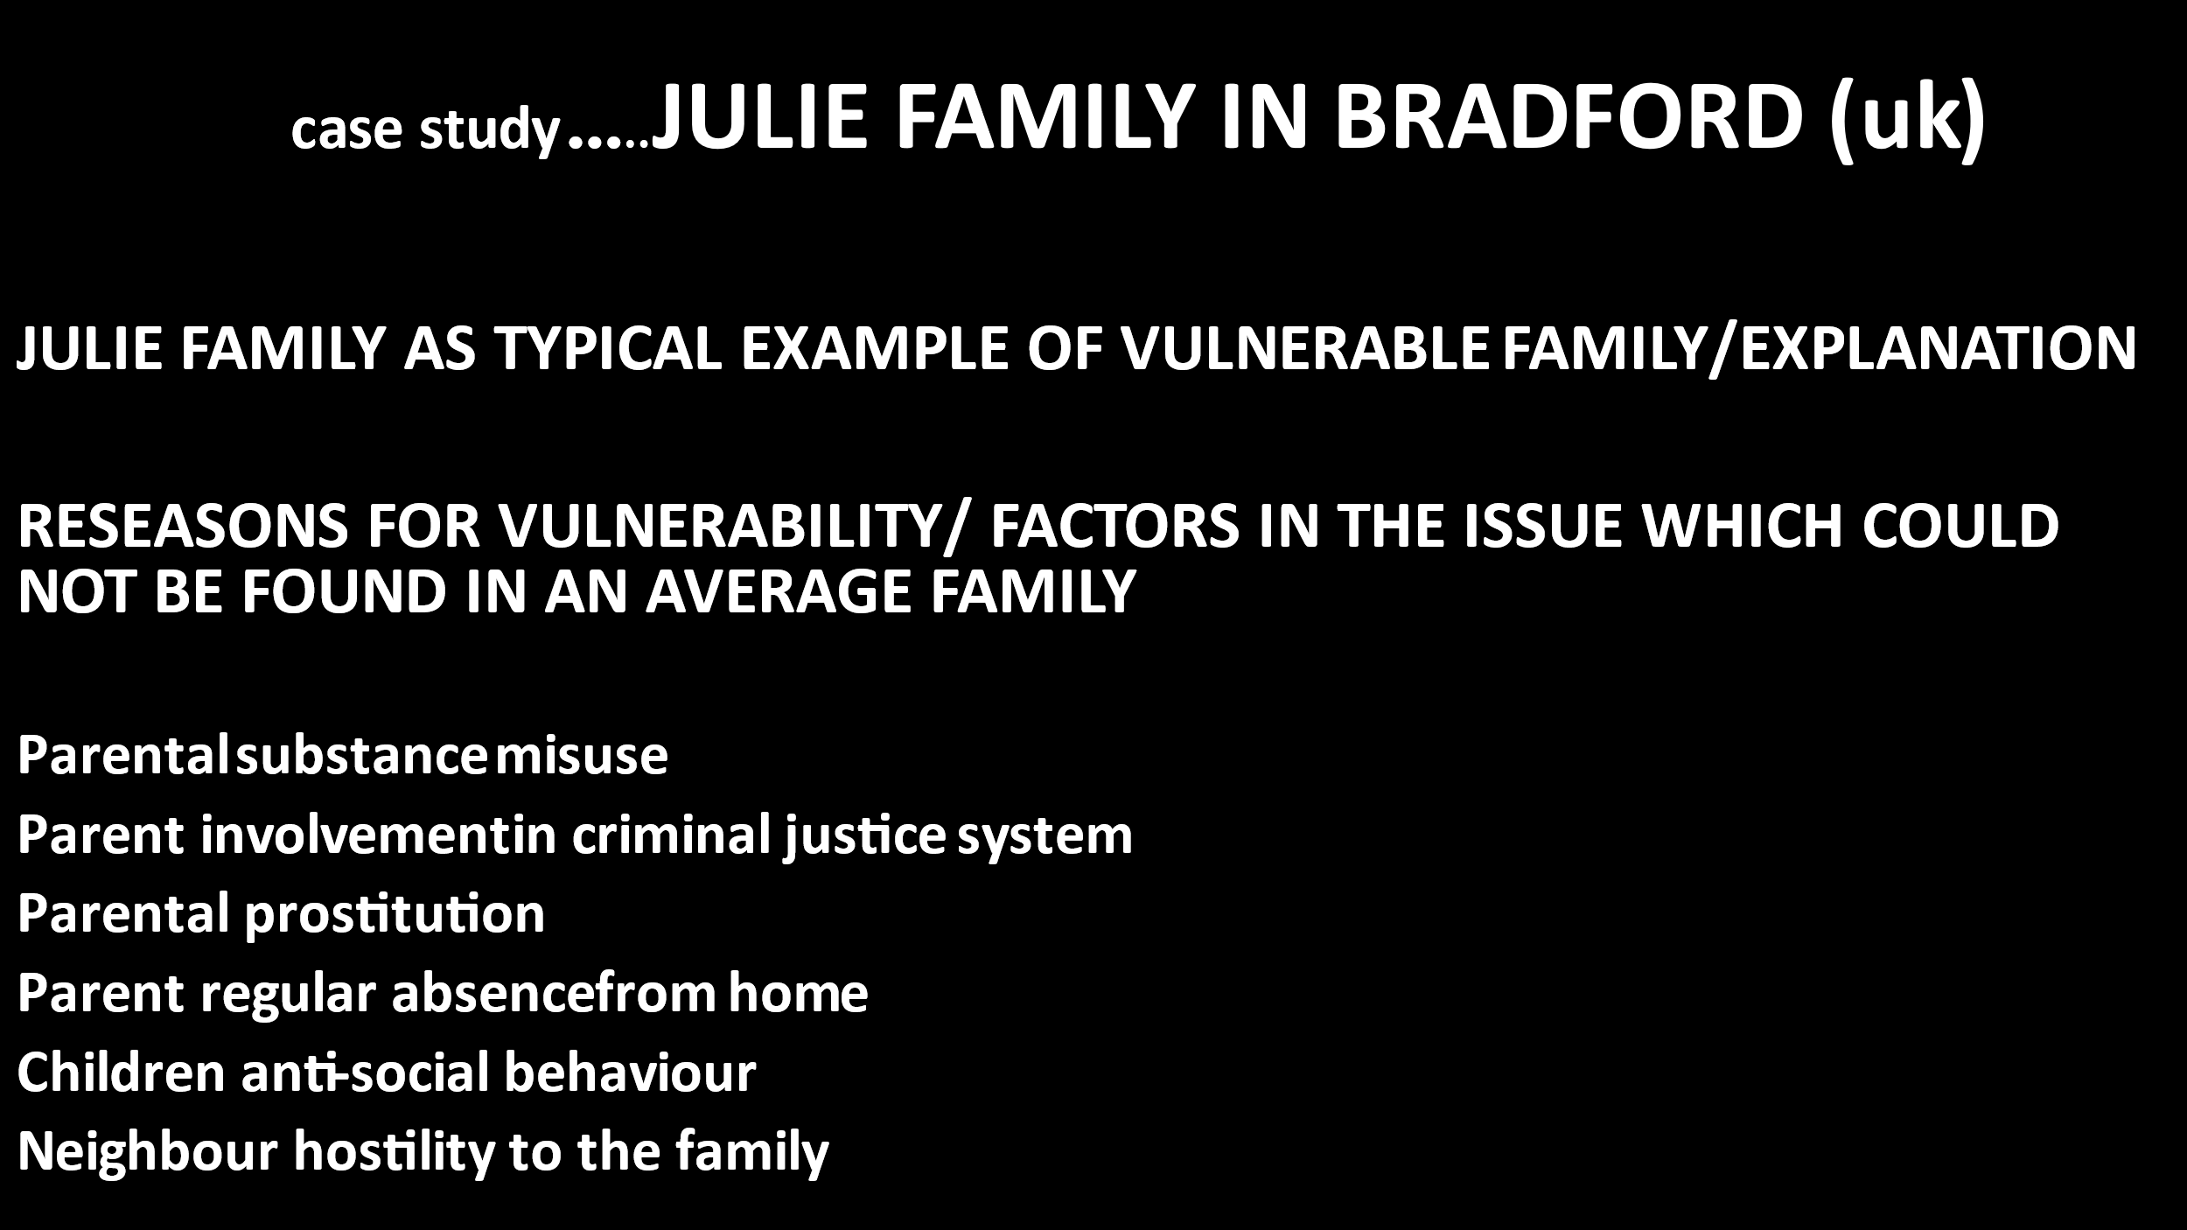

SLIDE5
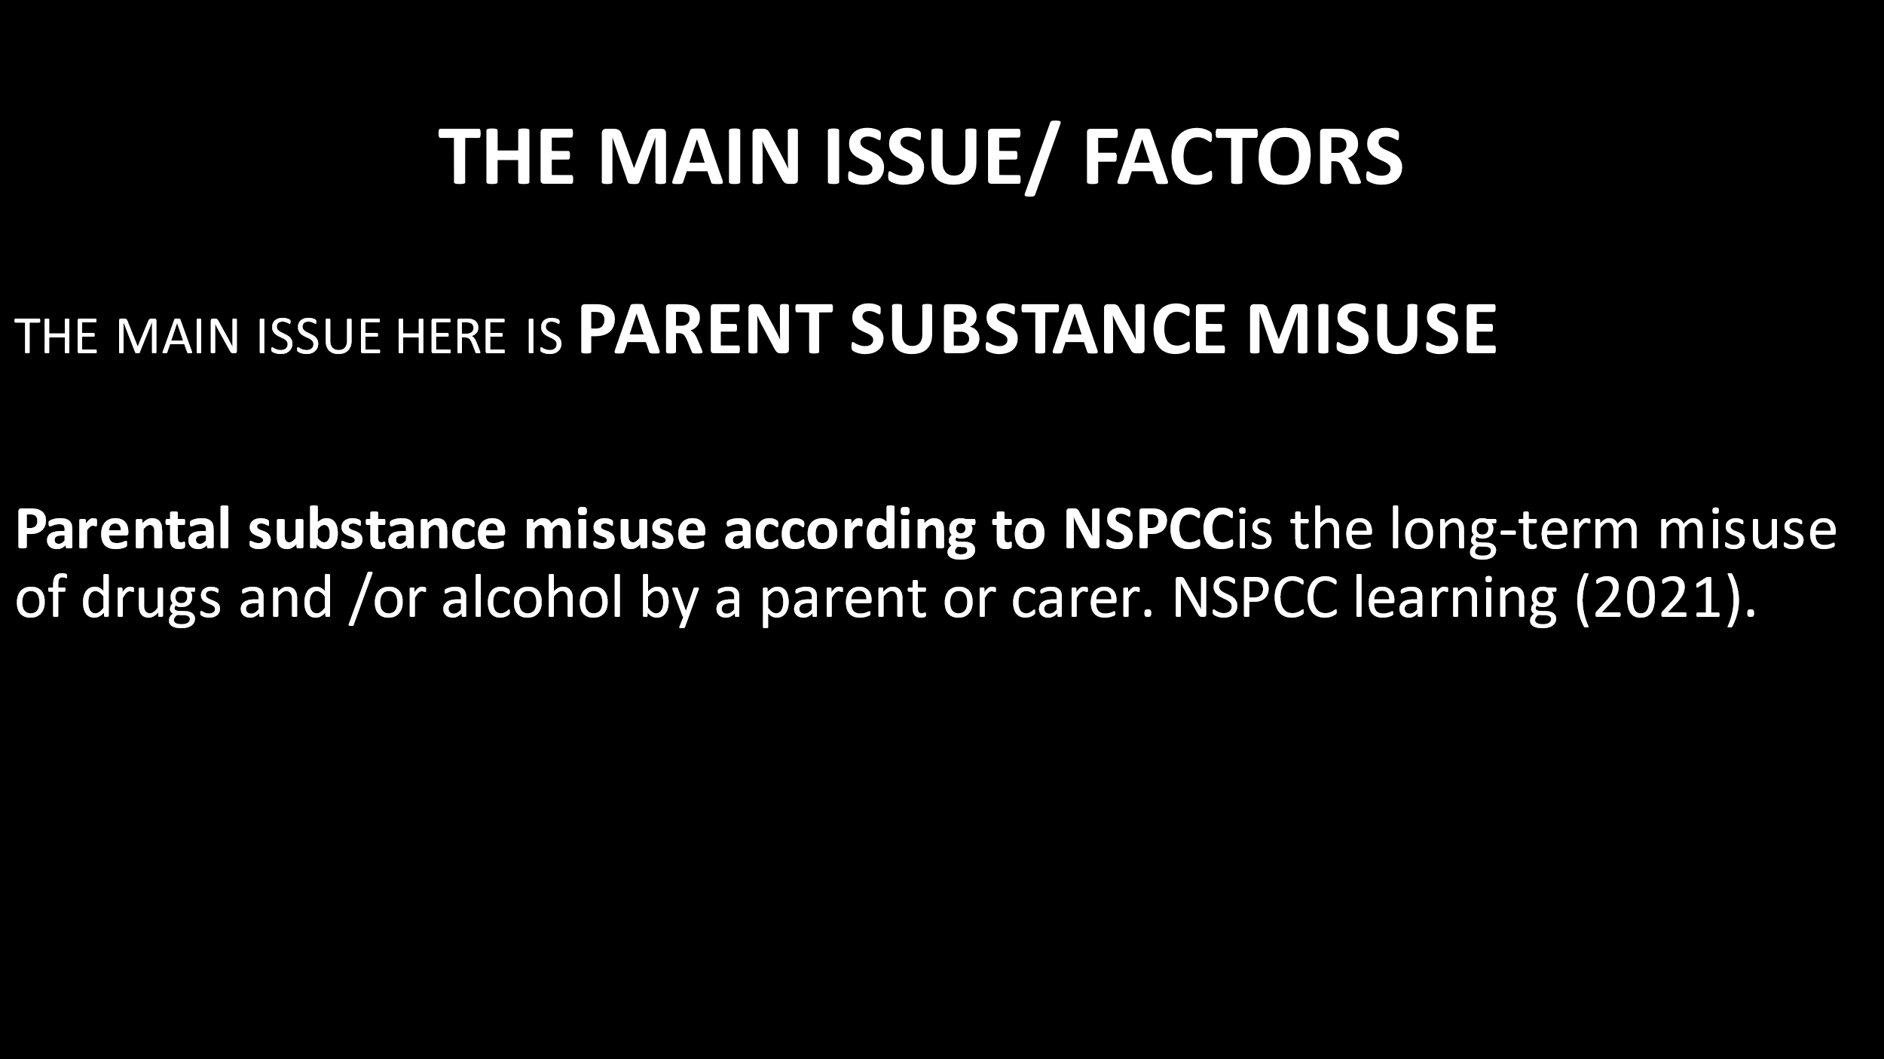

SLIDE 6 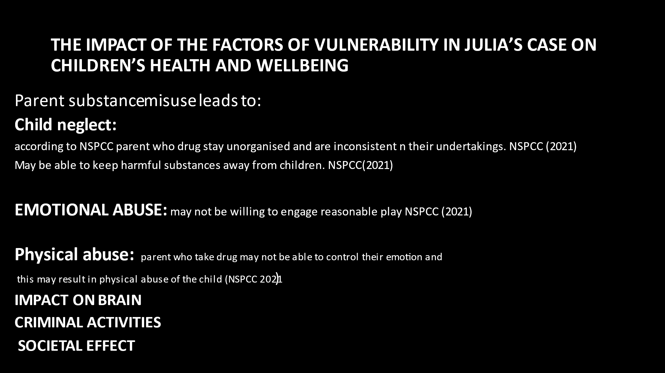

SLIDE7
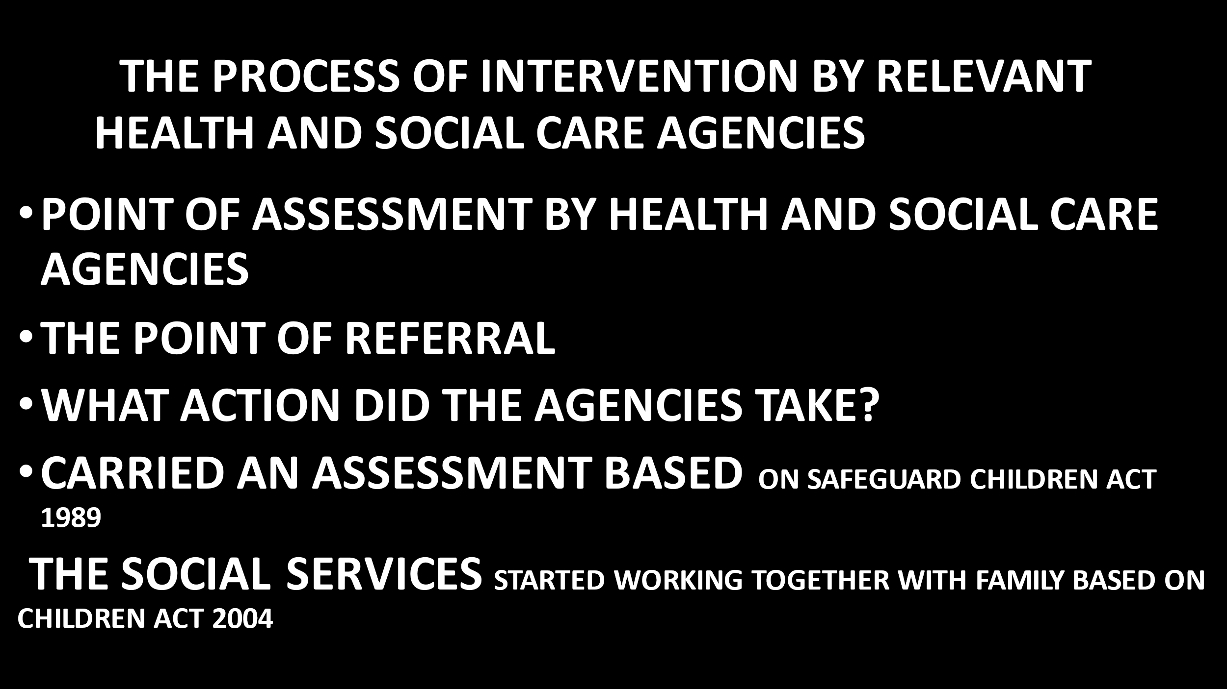

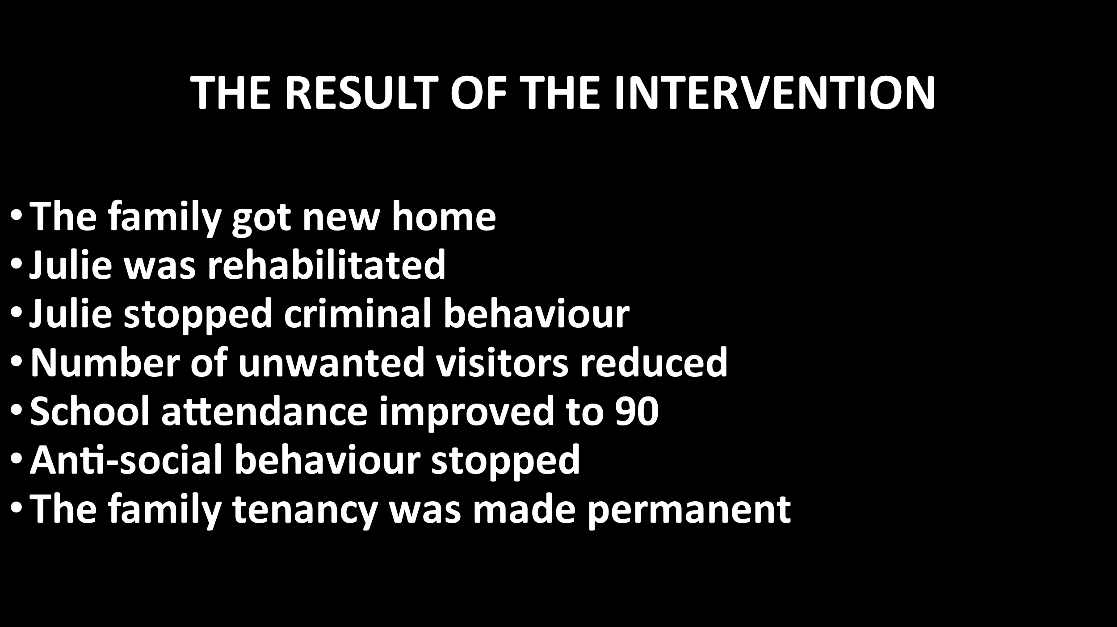
SLIDE 8

SLIDE 9
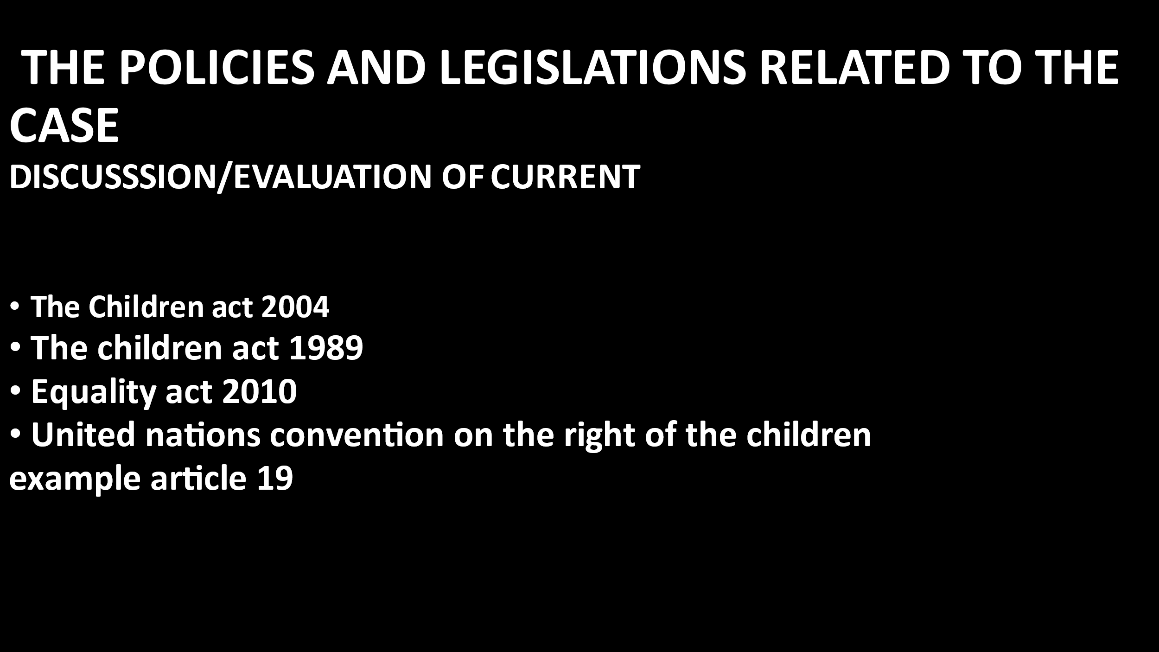

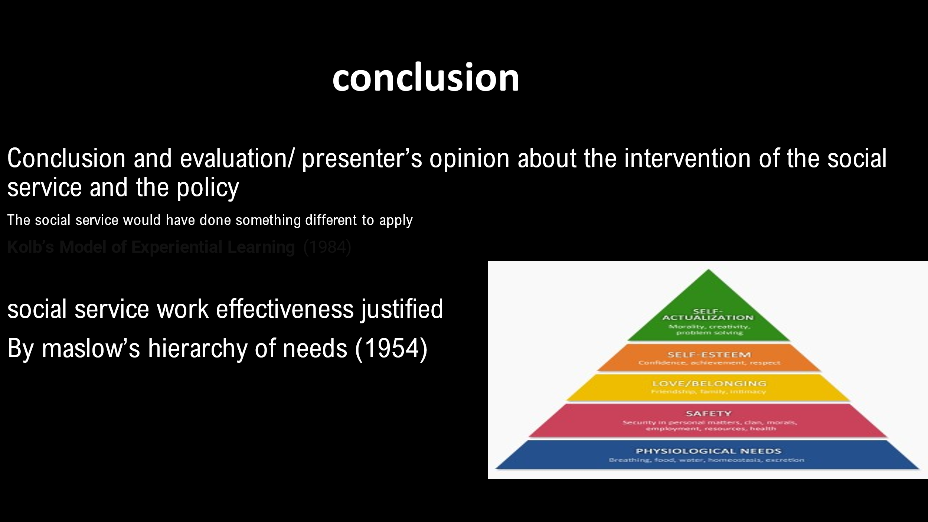
SLIDE 10

SLIDE 11
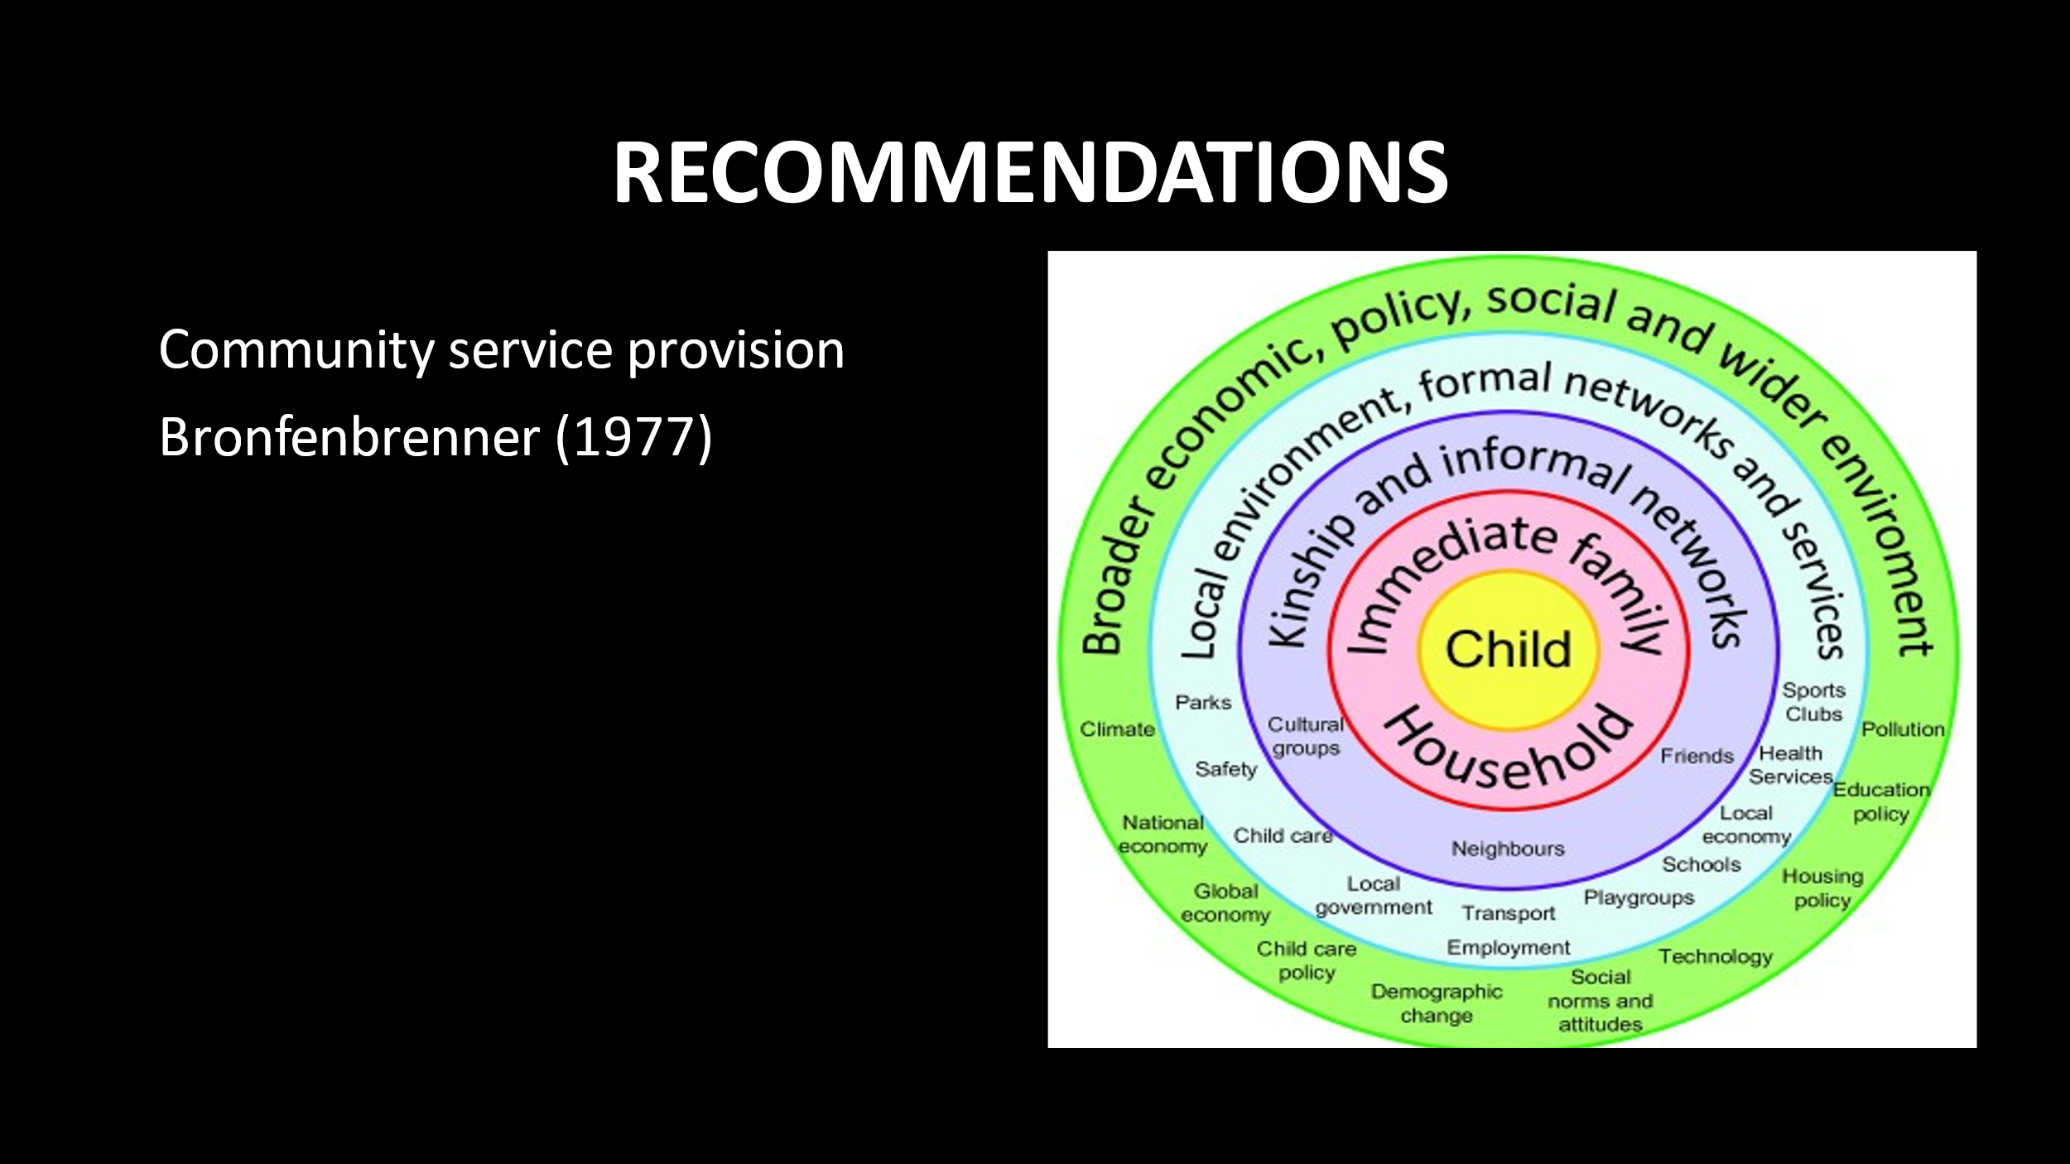

SLIDE 12


