BMSW4001

Assignment Title: Academic and Employability Skills

Component 1 –Task 1 - Academic report - ‘What is the most effectiveway to motivate staff?’

Student name: Hristina Birova-Kokkini

Student ID: 2120089

Contents
Task 1 - Academic report - ‘What is the most effective way to motivate staff?’ 3
Introduction 3
Main body 3
Pay 3
Recognition and awards 4
Additional holiday 4
Good working conditions 4
Motivational strategies 5
HIERARCHY THEORY OF MASLOW 5
Herzberg’s Two-Factor Theory 6
Recommendations 7
Conclusion 9
Referencing list 10

Task 1 - Academic report - ‘What is the most effective way to motivate staff?’

Introduction

Team member motivation is the most important part of the management and the company success. This is the main reason why at each management interview there is few questions linked to how the future manager or supervisor will be able to motivate his team members for maximum company success. Due to the importance of the motivation and the close link to the company profit it is critical for the company to maintain high level of consistent daily motivation across the team members. In the below report will be covered the different factors which influencing the motivation levels. The motivation process is very complex work to be done successful way and this is the reason why there is need of proper detailed analysis and understanding of the motivation factors and details (Al-Tit,2020).

Main body

Pay

Payment is most of the occasions the main motivator for starting work, but also there many occasions where the payment is perfect, but if other factors aren’t good then the payment losing his importance and the employee willing to resign the position and move to other company. The payment is top priority, but there is need of collaboration with other factors for achieving better success and profit as outcome from the motivation. For example one supervisor can work for very good payment, but in case the line manager is rude, there is impossible expectations, the daily stress is consistently high and all this will lead to demotivation despite the good level of payment (Zimmermann,2020).

Recognition and awards

When there is good mix provided to the team members between the pay level and the recognition and awards this significantly increasing the level of the company motivation which then reflecting to the company increasing of the profit and results. Every member as visible from the figure 1 Maslow theory need recognition and awards as part of his needs. The self-actualization is mostly more visible when the employee wants promotion and progress within the company organization and to achieve better position and recognition from the line management or owners.

Additional holiday

Extra paid holiday is other benefit which can significantly improve the motivation levels. Now a days there is poor balance between the work time and family time and there is people who work 12-15 hours per day including the travel time so those people highly evaluate the option of receiving extra holidays to spend with their family and kids. The team members who want promotion work hard and very long shifts in order to prove their capabilities and expertise. For them the additional holiday time is like award and appreciation for their hard work and this will motivate them to work even more dedicated for the company profit and success (Symmons,2020).

Good working conditions

Setting and achieving goals, having realistic expectations, gaining respect and feedback, and supportive management all help to boost workplace motivation. It thrives in a supportive workplace, which explains why so many business executives are interested in discovering fresh approaches to inspire their staff. The physical workplace may also have an impact on elements like employee outcomes, happiness, and efficiency. "If the working environment isn't straightforward to use, if it isn't free of challenges and constraints, then it's going to have a real influence on productivity, which, in turn, will have an impact on motivation," says Chris Moriarty, managing director of workplace efficiencies benchmarking organization Leesman UK and Ireland (Zhiqiang,2020).
By providing a variety of workspaces, employers can help employees find the setting that best suits their needs. This needs to include places that promote teamwork as well as quiet areas for focused individual work. These various surroundings can be customized by an organization to fit the activities and responsibilities that employees carry out. Additionally, social spaces can help to fortify bonds between people, which can promote greater collaboration and information exchange and aid in employee retention by fostering social connections at the office (Cooke,2020).

Motivational strategies

HIERARCHY THEORY OF MASLOW
Maslow, the most well-known motivation theorist, asserts that individuals are motivated by needs, which can be categorized according to importantance. Individuals regularly yearn for good conditions, according to Maslow they yearn for what they do not yet possess. Maslow categorized his needs into five main categories, and the key idea behind this theory is that higher tier needs can only be met after lower level needs have been met. Maslow made an effort to compile a substantial body of work on human motivation. To describe what motivates, guides, and maintains human behavior before Maslow, investigators concentrated individually on such variables as genetics, accomplishment, or strength (Chiamaka,2020).
Figure 1
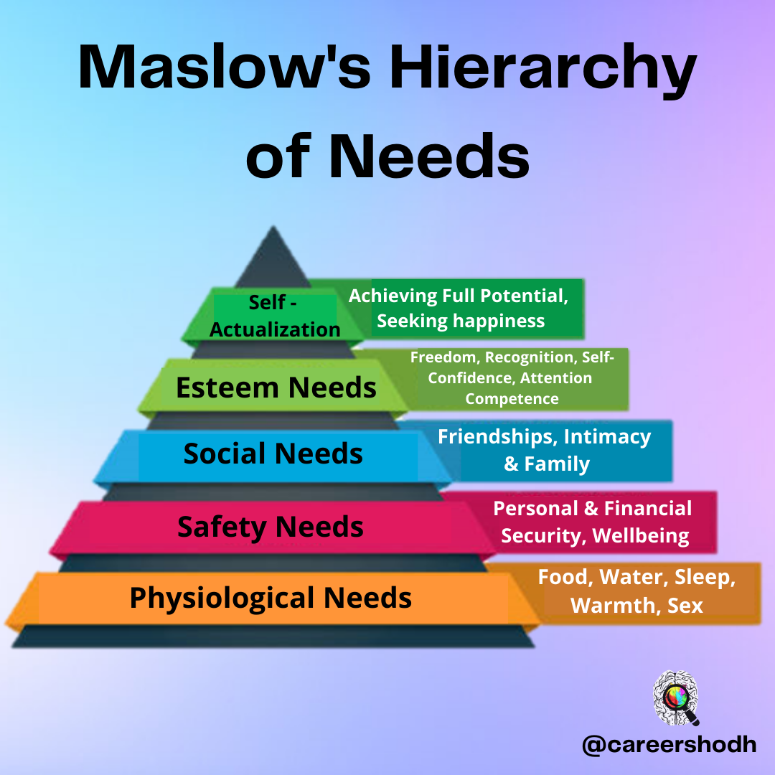

Herzberg’s Two-Factor Theory

Herzberg's Motivator-Hygiene theory, also referred to as the Two-Factor Theory, was developed in response to a study of engineers and accountants to find out what makes people feel positive or negative about their jobs. Herzberg identified five characteristics of work—accomplishment, appreciation, the job itself, personal accountability, and advancement—as "satisfiers" for workers. On the other end of the spectrum, Herzberg identified factors that may demoralize workers, including institutional politicians, the managerial style, supervisory, pay, interactions at work, and working conditions. When an employee has reached a certain point in their professional life, they should be supported, and they should also be recognized for special accomplishments, such as when they achieve amazing results in their content areas (Yilmaz,2020).
Figure 2
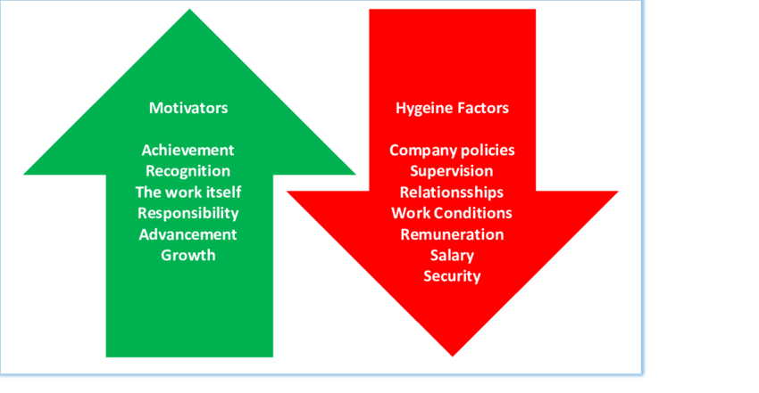

Recommendations

Someone team can only be inspired and motivated if they are aware of the goals they are starting to work forward into. Make absolutely sure your staff is informed of your vision for the company and your ultimate objectives. This motivates everybody to cooperate in order to get better outcomes. Additionally, regularly establish goals that are constituted by this perception and that are both transparent and quantifiable so that you and your team members can track progress and be able to see their achievement up close. Promoting orientation within and between teams fosters improved efficiency and can encourage and value workers (Symmons,2020).
Excellent team communication is crucial for establishing clear objectives. Since since communication is a two-way street, you must make absolutely sure that you and your staff members are in constant contact. By doing this, you can both inform them of what must be accomplished and give them a chance to voice their ideas and viewpoints. This will finally advantage your company because they might attempt to reach problems differently than you do. Keep checking in with your coaching staff and give them a chance to come talk to you. Make absolutely sure you are reachable, and adopt an open and friendly and open demeanor when communicating (Symmons,2020).
Since it enables employees experience less alone and more invested in their work, inspiring and supporting team working increases efficiency. You can achieve this by wanting to hold proper team events and occasions for your teammates to connect and get to know each other though. Take into account how new hires will contribute to the group and the company culture when making hiring decisions. Regardless of whether someone has worked in a particular position, it really doesn't presume that they will automatically get along with the remaining portion of your staff.
Make your workplace a fun environment to work in and a place where your staff members want to spend their spare time. Pay attention to confidentiality, loud sounds, pollution levels, natural sunlight, relaxing areas, and atmosphere. Inspire healthy behaviors by providing wholesome snacks and the opportunity for physical activity, whether it takes the form of a workout or team fitness activities. You can assist your employees in maintaining their energy levels and lowering their stress by encouraging healthy behaviors. These kinds of office benefits will also increase your team's sense of appreciation and motivate them to work their hardest (Zimmermann,2020).
The value of praise and recognition for accomplishment is often undervalued, but it motivates teammates because they can see how they are moving in the direction of the organisational objectives. Always express your gratitude and be precise in your compliments when workers perform well, go above and beyond, or produce success.
Should not just say "good job," for instance, describe the merits of the position and how they benefited the company. This will inspire your worker and assist them to succeed in their future endeavors. It is critical important to do not implement or use only one strategy or element from the explained above they all need to be used in high effective collaboration in order to deliver maximum results and profit for the company. In case is used only one component this will limit the achieved results and there could be increasing of the labor turnover as outcome. The companies need to be very consistent when comes to staff motivation and engagement in order to achieve maximum long term delivering of results and accomplishing the company targets (Al-Tit,2020).

Conclusion

From the provided information we can see how important is the team member motivation and that the company management have the difficult and complicate task to implement daily activities and strategy for delivering maximum profit for the company. From the provided information above is visible that the mix of different tools and strategies can deliver high level of motivation and many benefits for the company success.

Referencing list

Al-Tit, A.A., 2020. The impact of AMO-HR systems on proactive employee behavior: The mediating contribution of leader-member and team-member exchange. International Journal of Engineering Business Management, 12, p.1847979020947236.
Caligiuri, P., De Cieri, H., Minbaeva, D., Verbeke, A. and Zimmermann, A., 2020. International HRM insights for navigating the COVID-19 pandemic: Implications for future research and practice. Journal of international business studies, 51(5), pp.697-713.
Vindrola-Padros, C., Andrews, L., Dowrick, A., Djellouli, N., Fillmore, H., Gonzalez, E.B., Javadi, D., Lewis-Jackson, S., Manby, L., Mitchinson, L. and Symmons, S.M., 2020. Perceptions and experiences of healthcare workers during the COVID-19 pandemic in the UK. BMJ open, 10(11), p.e040503.
Baydas Onlu, O., Abdusselam, M.S. and Yilmaz, R.M., 2020. Interaction between Group Work, Motivation and Instructional Feedback in Project-Based Courses. ie: inquiry in education, 12(1), p.9.
Mulrooney, H.M. and Kelly, A.F., 2020. Covid 19 and the move to online teaching: Impact on perceptions of belonging in staff and students in a UK widening participation university. Journal of Applied Learning and Teaching, 3(2).
Abbas, S.M. and Zhiqiang, L., 2020. COVID19, mental wellbeing and work engagement: The psychological resilience of senescent workforce. International Journal of Research in Business and Social Science (2147-4478), 9(4), pp.356-365.
Kobushko, Y.V., Kobushko, I.M., Starynskyi, M.V. and Zavalna, Z., 2020. Managing team effectiveness based on key performance indicators of its members.
Mahmoud, A.B., Reisel, W.D., Grigoriou, N., Fuxman, L. and Mohr, I., 2020. The reincarnation of work motivation: Millennials vs older generations. International Sociology, 35(4), pp.393-414.
Song, Z., Gu, Q. and Cooke, F.L., 2020. The effects of high‐involvement work systems and shared leadership on team creativity: A multilevel investigation. Human Resource Management, 59(2), pp.201-213.
Collins, I.N., Stephen, E.I. and Chiamaka, O., 2020. Leader-member Exchange and Transformational Leadership Style: A Prediction to Thriving at Work. Asian Journal of Advanced Research and Reports, pp.37-43.

