Date: 15/05/2023
Digital Degree Apprenticeship L4 - Introduction to Web and Database Concepts (ACCA4023)
Website Development
Tyler Williamson (2237644)
Table of Contents
Table of Figures 1
1 Introduction 2
2 Requirements 2
3 Implementation 3
3.1 Generic Website Format 3
3.2 Index Page 3
2.3 Home Page 4
2.4 Latest News Page 5
2.5 UFOs Page 5
2.6 Extra-Terrestrials Page 6
2.7 Merchandise Page 6
2.8 Checkout Page 7
2.9 Contact Us Page 7
3 Validations 8
3.1 HTML 8
4.2 CSS 8
5 Evaluation 9
5.1 Website Usability 9
5.2 Website Search Engine Optimisation 9
5.3 Website Accessibility 10
6 Conclusion 10
7 References 10
8 Appendices 12
8.1 HTML Code: index.html 12
8.2 HTML Code: spacehomepage.html 13
8.3 HTML Code: latestnews.html 15
8.4 HTML Codes: ufos.html 16
8.5 HTML Codes: aliens-ET.html 17
8.6 HTML Code: merch.html 19
8.7 HTML Code: checkoutpage.html 20
8.8 HTML Code: contact.html 25
8.9 CSS Code: tylercss.css 26

Table of Figures

Figure 1 – Index Page 3
Figure 2 – Home Page 4
Figure 3 – Home Page 4
Figure 4 – Latest News 5
Figure 5 – Un-Identified Flying Objects 5
Figure 6 – Un-Identified Flying Objects 6
Figure 7 – Extra-Terrestrials 6
Figure 8 – Extra-Terrestrials 7
Figure 9 – Merchandise 7
Figure 10 – Checkout 8
Figure 11 – Checkout 8
Figure 12 – Contact Us 9
Figure 14 - tylerscss.css validation results 10

Table 1 - Text listing of codes 34

Introduction

The purpose of this website is to give all readers and users information around Un-Identified Flying Objects and Extra-Terrestrials. The fun element has been added to this website for being able to purchase merchandise relating to this theme of space. It’s been designed with a target to readers or users of all ages. HTML is shortened for Hyper Text Markup Language and is not a language used for programming, but it is a markup language used specifically for web pages (documents) [1]. CSS is also a shortened acronym for Cascading Style Sheets. CSS in its simplest explanation is used for how the content should look like, whereas HTML is for what content is used within the website itself. This report in summary is for identifying the requirements on the website and the design of it, how this has been implemented, running validation checks on the website to find any potential errors in the coding, evaluating the website’s useability, accessibility, and search engine optimisation.

Requirements

The design concept and development of this website is coherently based around the theme of Space. In the theme of Space, the topic of conversation for this website is more specifically aimed around Un-Identified Flying Objects and Extra-Terrestrials. In total there are eight webpages with a striking index landing page to access the main part of the website. The overall purpose of this website is to enhance the knowledge and theoretical views or opinions of readers. The aim of this design concept is around keeping the information minimal but informative and readable. The intended target audience for this website is for readers of all ages. The requirement for this target audience aim is to ensure that the website content is kept as reasonably simple as possible and making sure that the usability of the website is accessible for all ages such as young and old. The thesis for this project is around designing a website using wide ranges of techniques to gain an understanding of how a website is developed and the site’s responsiveness to the different platforms, which can be used by the reader to gain access to the website. This study will enhance the knowledge of website designing and development using the elements available within raw coding of Hyper Text Markup Language and Cascading Stylesheets.

Implementation

Generic Website Format

The theme for the whole website and all its pages with regards the navigation bar and the footer all follow the same pattern along with the typical layout. The only page where the content may differ slightly in terms of the layout is the checkout page.

Index Page

The index page to the website is often called the landing page [2]. This design idea is useful to grab the reader’s attention to intrigue the mind of curiosity to continue looking. HTML coding for the hero image and hero text is used to attract the attention to the website [3]. The button is used to gain access into the main home page of the website [4].
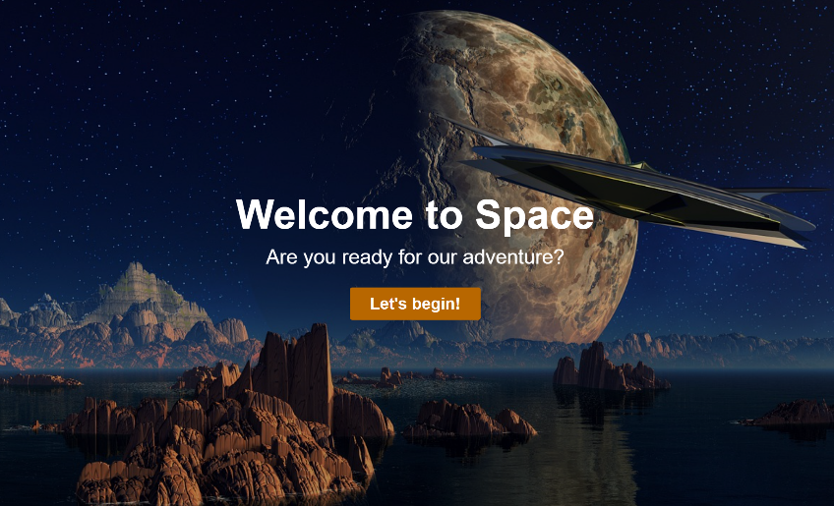

Figure 1 – Index Page

Home Page

In the main body of the home page shown below in Figure 2 – Home Page and Figure 3 – Home Page, the hero image and hero text code has been used to create a colourful and attractive home page [5]. This coding has been pulled from the index page HTML code where I developed the knowledge from the referenced website originally.

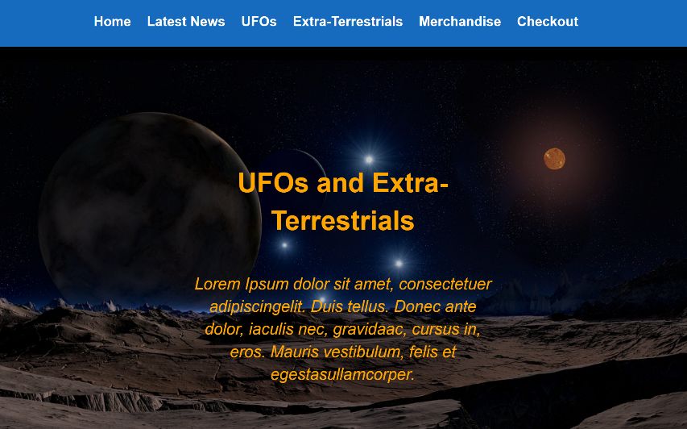

Figure 2 – Home Page
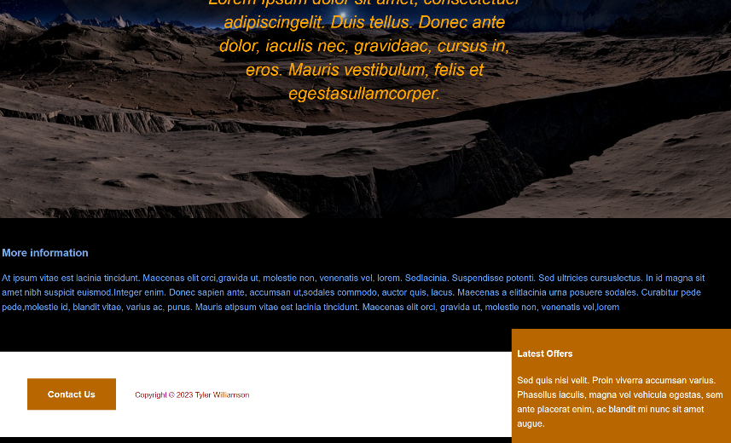

Figure 3 – Home Page

Latest News Page

Use of the original template layout as shown in Figure 4 – Latest News has been implemented with an extra code used to allow for an image to be placed within the contents of the main body [6]. The background within the heading of the body has been used within most of the webpages [7].
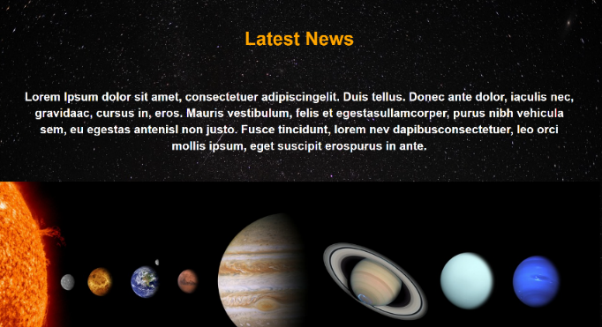

Figure 4 – Latest News

UFOs Page

As demonstrated in Figure 5 – Un-Identified Flying Objects and Figure 6 – Un-Identified Flying Objects, there has been a variation in coding to allow for three images to align next to each other [8] [9] [10] [11]. This page has also implemented an Iframe section for further information [12] [13].
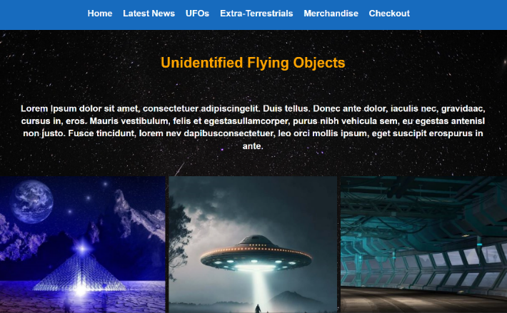

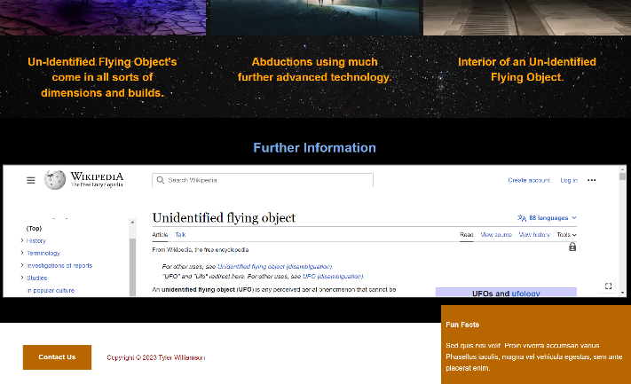
Figure 5 – Un-Identified Flying Objects

Figure 6 – Un-Identified Flying Objects

Extra-Terrestrials Page

In Figure 7 – Extra-Terrestrials and Figure 8 – Extra-Terrestrials as shown below the original template has remained the same using a code to display an image within the main contents of the page [14]. Also demonstrated is the use of the iframe code to create an in-site view of another website containing further information for readers [13] [15].
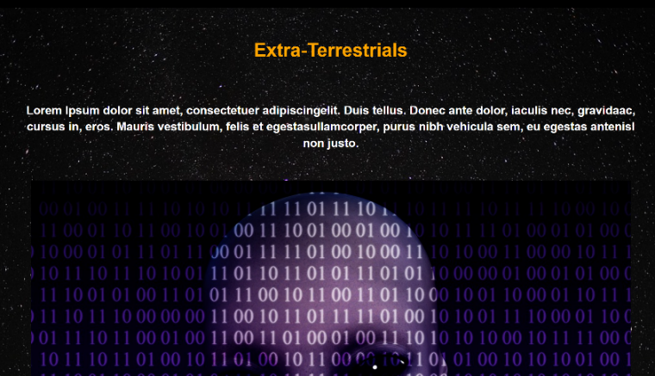

Figure 7 – Extra-Terrestrials
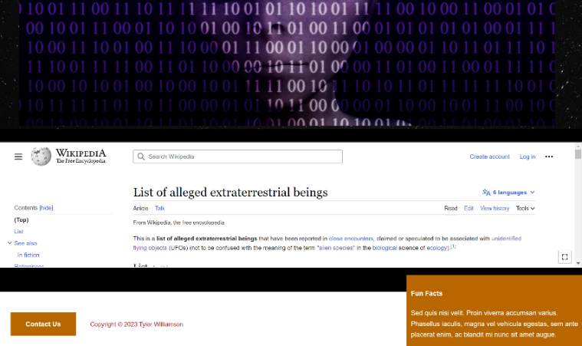

Figure 8 – Extra-Terrestrials

Merchandise Page

The merchandise page is differed slightly from the other “standard” web pages by including product cards [16]. Whilst the original template layout for each page is kept intact. The product cards have images and button functionality to add to a cart [17] [18] [19] [20].
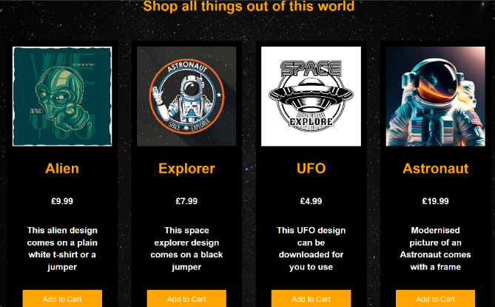

Figure 9 – Merchandise

Checkout Page

Demonstrated within Figure 10 – Checkout and Figure 11 – Checkout is a form attribute, which has been coded to allow readers to purchase products from the merchandise page and make payment [21]. The checkout basket isn’t functioning fully to add things directly; however, this is just a demonstration as to how the form would be illustrated.
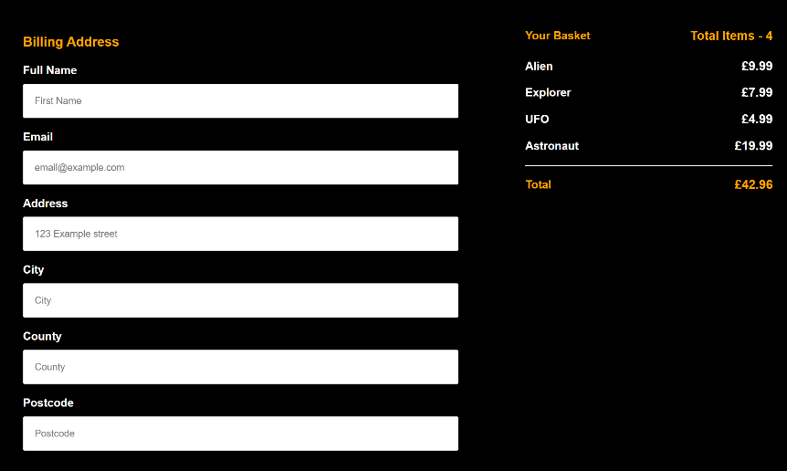

Figure 10 – Checkout
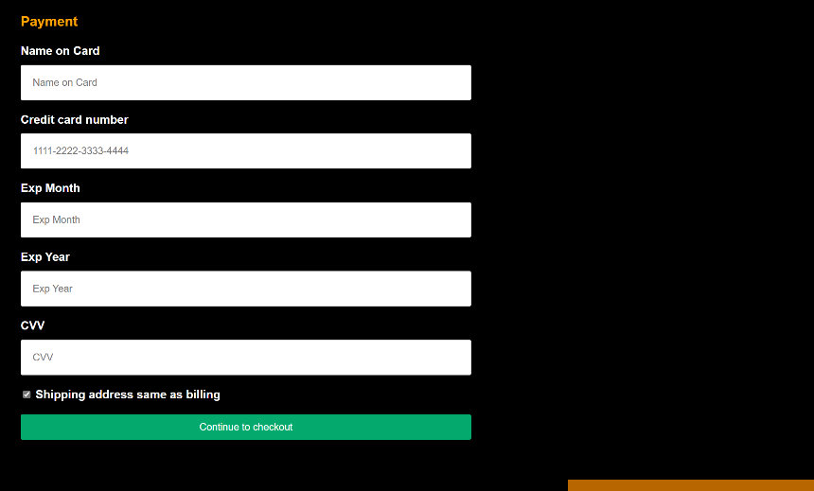

Figure 11 – Checkout

Contact Us Page

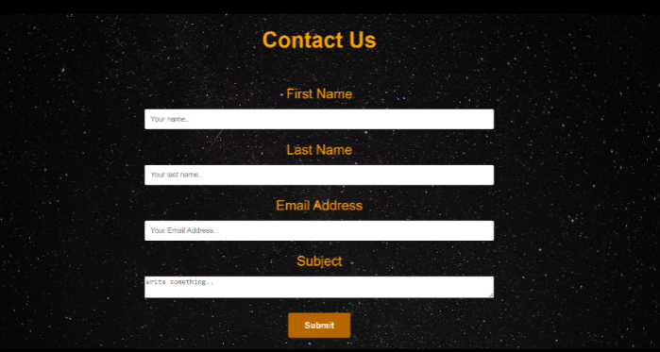
Figure 12 – Contact Us displays a form, which will allow readers to contact the company who are behind the website [22].

Figure 12 – Contact Us

Validations

HTML

Figure 13 - Spacehomepage.html validation results display the errors returned on the HTML code for the home page [23]. These have been corrected within the main code of the webpage by editing the codes, which were typed incorrectly and removing the slash on the void elements. The language attribute for English was added to the code to declare the language of the documents.
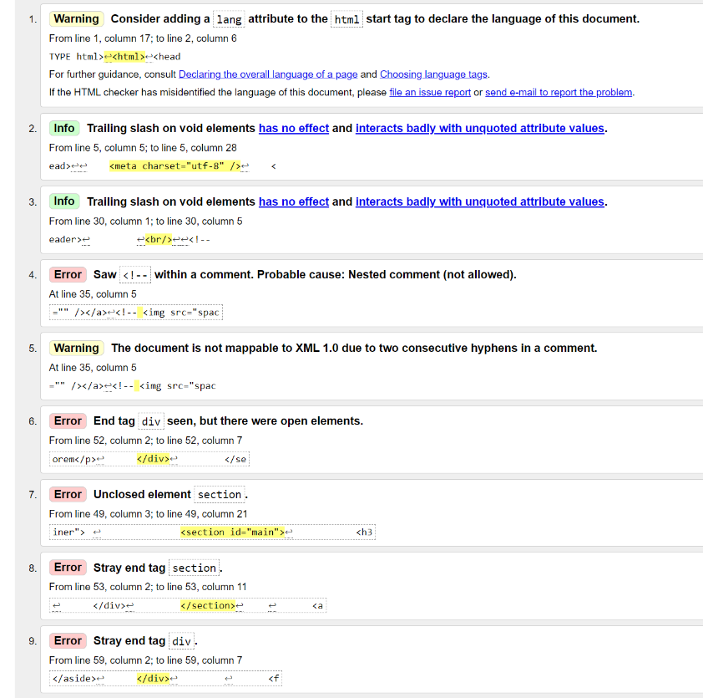

Figure 13 - Spacehomepage.html validation results

CSS

The CSS validation as shown in Figure 14 - tylerscss.css validation results have been resolved by removing all the errors described as these were not necessary within the code [24].
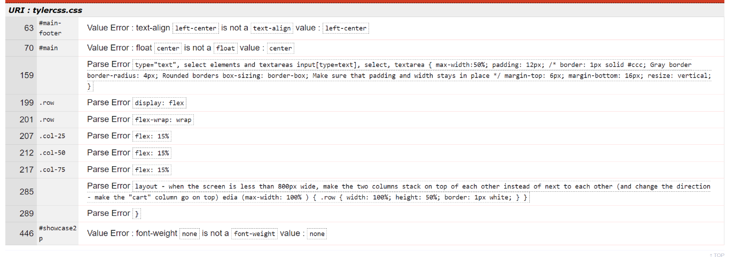
Figure 14 - tylerscss.css validation results

Evaluation

Evaluation of this website design is covered in this section of the report for website usability, website search engine optimisation and website accessibility. This research has been carried out around and explains what the findings are for describing what each of these terms mean and identifying the impacts and direct role they have on the website’s overall functionality.

Website Usability

Website usability is a term which defines the users or readers experience of using the specified website. This terminology refers to how the users experience is affected by the websites overall design and graphics. For example, a disabled user might not be able to use the website as the websites design and content is not able to be used by the user’s computer equipment. Target audiences can have an impact on the definition of the website’s usability criteria. This is because the website should be easily readable and navigable to the reader as well as the colour scheme. The questions raised into whether the usability of the website has been successfully achieved can be found within the journal authored by Kathy Dempsey [25]. The role that the usability of the website plays is to ensure that the website is continuously reaching target audiences and in turn also has an impact on the accessibility to various users.
Upon evaluation of the website the target audience is users of all ages from teenagers to the older generation and this has been achieved by using contrasting colours for readability large and precise displays of functions such as buttons and navigating around the website. With the understanding that the website must have a content within that is of use to the readers this has been enhanced with extra sources of information being included using iframe codes to bring another website into the main body of the web page providing additional information.

To conclude the recommendations to further enhance the usability of this website is to ensure further information is included in the contents of the website, whilst additionally providing more graphics and different types of mental stimulation to grasp the readers interest further.

Website Search Engine Optimisation

Search Engine Optimisation is where either paid “branded” keywords or generic keywords are used to boost the websites visibility within a search engine. The data is collated using these keywords are used to help the website designer optimise the website to generate more traffic to the website. This data is collected using the “branded” or generic keywords and helps the business or website owner to identify which type of these are the most beneficial to them [26]. These keywords have been utilised for the search engine optimisation within the website design concepts and are found within the main page names and titles of these pages also within the headings of each page for the description of the contents.

Website Accessibility

Website accessibility has four main principles the website must follow, these are: perceivable, operable, understandable, and robust. The implemented website and its design concepts meet these criteria because the website has the following: a good use of colour contrasting, text alternatives for images, there is no content that could cause seizures, easy to use navigation around the website and between the pages, content appears in predictable ways and the website has responsiveness to the design meaning its flexible to adapt with different types of access [27].

Conclusion

In conclusion this report aimed to identify the key areas of the website design concepts and implementation and provide a reflection on this by evaluating the website to find what can be improved within the website’s structure and design to elevate the overall site. Key points are that the website has a reasonable design and structure, but this could be improved by utilising and carrying out further research into the different areas that make up the website as an overall. The keywords of the website could be further enhanced along with the accessibility of the website potentially having additional features to enable a wider range of choice to use the site. Following this report and conduction of research the knowledge for the different parts that make up a website has been expanded.

References

[1] | J. N. Robbins, “Learning Web design: A beginners Guide to HTML, CSS, JavaScript and Web Graphics,” in Learning Web design: A beginners Guide to HTML, CSS, JavaScript and Web Graphics, O'REILLY, 2012, p. 12.
[2] | Pixabay, Pixabay, 14 April 2016. [Online]. Available: https://pixabay.com/illustrations/landscape-water-rock-spaceship-1328858/. [Accessed May 2023].
[3] | W. Schools, “How TO - Hero Image,” 2023. [Online]. Available: https://www.w3schools.com/howto/howto_css_hero_image.asp. [Accessed 7 May 2023].
[4] | W. School, “CSS Buttons,” 2023. [Online]. Available: https://www.w3schools.com/css/css3_buttons.asp. [Accessed 7 May 2023].
[5] | Pixabay, 14 January 2017. [Online]. Available: https://pixabay.com/illustrations/lunar-landscape-stars-brown-dwarf-1978303/. [Accessed May 2023].
[6] | Pixabay, 19 August 2022. [Online]. Available: https://pixabay.com/illustrations/planets-solar-system-mercury-earth-7395817/. [Accessed May 2023].
[7] | Pixabay, 1 September 2020. [Online]. Available: https://pixabay.com/photos/meteor-shooting-star-perseid-5515383/. [Accessed May 2023].
[8] | W. Schools, “CSS Layout Float Examples,” 2023. [Online]. Available: https://www.w3schools.com/Css/css_float_examples.asp. [Accessed 7 May 2023].
[9] | Pixabay, 23 April 2018. [Online]. Available: https://pixabay.com/illustrations/spaceship-corridor-3d-sci-fi-3334826/. [Accessed May 2023].
[10] | Pixabay, 3 March 2023. [Online]. Available: https://pixabay.com/illustrations/ai-generated-alien-abduction-ufo-7826408/. [Accessed May 2023].
[11] | Pixabay, 16 March 2017. [Online]. Available: https://pixabay.com/photos/ufo-spaceship-flying-saucer-space-2147931/. [Accessed May 2023].
[12] | Wikipedia Contributors, “Unidentified Flying Objects,” 13 May 2023. [Online]. Available: https://en.wikipedia.org/w/index.php?title=Unidentified_flying_object&oldid=1154516840. [Accessed May 2023].
[13] | W. Schools, “HTML Iframes,” 2023. [Online]. Available: https://www.w3schools.com/html/html_iframe.asp. [Accessed 7 May 2023].
[14] | Pixabay, 21 November 2021. [Online]. Available: https://pixabay.com/illustrations/alien-technology-control-fantasy-6809416/. [Accessed May 2023].
[15] | Wikipedia Contributors, “List of alleged extra-terrestrial beings,” 8 May 2023. [Online]. Available: https://en.wikipedia.org/w/index.php?title=List_of_alleged_extraterrestrial_beings&oldid=1153883909. [Accessed May 2023].
[16] | W. Schools, “How TO - Product Card,” 2023. [Online]. Available: https://www.w3schools.com/howto/howto_css_product_card.asp. [Accessed 7 May 2023].
[17] | Freepik, 2023. [Online]. Available: https://www.freepik.com/free-ai-image/astronaut-with-planet-sunset-background_40431795.htm#page=2&query=astronaut%20on%20moon&position=0&from_view=keyword&track=ais. [Accessed 30 April 2023].
[18] | Freepik, 2023. [Online]. Available: https://www.freepik.com/free-vector/alien-poster_10112333.htm#query=alien%20head&position=27&from_view=keyword&track=ais. [Accessed 30 April 2023].
[19] | Freepik, 2023. [Online]. Available: https://www.freepik.com/free-vector/ufo-vector-illustration-monochrome-extraterrestrial-spaceship-aliens_11235609.htm. [Accessed 30 April 2023].
[20] | Freepik, 2023. [Online]. Available: https://www.freepik.com/free-vector/space-explorer-patch-emblem-design_4827863.htm. [Accessed 30 April 2023].
[21] | W. Schools, “How TO - Checkout Form,” 2023. [Online]. Available: https://www.w3schools.com/howto/howto_css_checkout_form.asp. [Accessed 7 May 2023].
[22] | W. Schools, “How TO - Contact Form,” 2023. [Online]. Available: https://www.w3schools.com/howto/howto_css_contact_form.asp. [Accessed 7 May 2023].
[23] | W. M. Validator, “Markup Validation Service,” [Online]. Available: https://validator.w3.org/. [Accessed 7 May 2023].
[24] | W3C, “CSS Validation Service,” 2009. [Online]. Available: https://jigsaw.w3.org/css-validator/. [Accessed May 2023].
[25] | K. Dempsey, “Could your Website be better?,” Information World Review, 2002. [Online]. Available: https://www.proquest.com/trade-journals/could-your-web-site-be-better/docview/199318631/se-2. [Accessed 8 May 2023].
[26] | R. A. J. M. P. Anett Erdmann, “Search engine optimization: The long-term strategy of keyword choice,” Journal of Business Research, vol. 144, no. 0148-2963, pp. 650-662, 2022.
[27] | W3, “WCAG 2.1 at a Glance,” 5 June 2018. [Online]. Available: https://www.w3.org/WAI/standards-guidelines/wcag/glance/. [Accessed May 2023].

Appendices

HTML Code: index.html

<!DOCTYPE html>
<html lang="en">
<head>
<meta charset="utf-8">
<title>Tyler's Website Assignment on Space</title>
<link rel="stylesheet" type="text/css" href="tylercss.css">
<style>
.button2 {
display: inline-block;
border-radius: 4px;
background-color: #B86700;
border: none;
color: #FFFFFF;
text-align: center;
font-size: 28px;
padding: 15px;
width: 225px;
transition: all 0.5s;
cursor: pointer;
margin: 5px;
}

.button2 span {
cursor: pointer;
display: inline-block;
position: relative;
transition: 0.5s;
}

.button2 span:after {
content: '\00bb';
position: absolute;
opacity: 0;
top: 0;
right: -20px;
transition: 0.5s;
}

.button2:hover span {
padding-right: 30px;
}

.button2:hover span:after {
opacity: 1;
right: 0;
}
</style>
</head>

<body>

<div class="hero-image" alt="Space landscape with spaceship">
<div class="hero-text">
<h1>Welcome to Space</h1>
<p>Are you ready for our adventure?</p>
<a class="button2" href="spacehomepage.html"><span>Let's begin!</span></a>
</div>
</div>

</html>

HTML Code: spacehomepage.html

<!DOCTYPE html>
<html lang="en">
<head>

<meta charset="utf-8">
<title>Tyler's Website Assignment on Space</title>
<link rel="stylesheet" type="text/css" href="tylercss.css">

</head>

<body>
<nav id="navbar">
<div class="container">
<ul>
<li><a href="spacehomepage.html">Home</a></li>
<li><a href="latestnews.html">Latest News</a></li>
<li><a href="ufos.html">UFOs</a></li>
<li><a href="aliens-ET.html">Extra-Terrestrials</a></li>
<li><a href="merch.html">Merchandise</a></li>
<li><a href="checkoutpage.html">Checkout</a></li>
</ul>
</div>
</nav>

<header id="main-header">
<div class="container">
</div>
</header>

<br>

<section id="showcase2">
<div class="hero-image2" alt="Space Lunar Scene">
<div class="hero-text2">
<h1> UFOs and Extra-Terrestrials </h1>
<p> Lorem Ipsum dolor sit amet, consectetuer adipiscingelit. Duis tellus. Donec ante dolor, iaculis nec, gravidaac, cursus in, eros. Mauris vestibulum, felis et egestasullamcorper.</p>
</div>
</div>
</section>

<div class="container">
<section id="main">
<h3> More information </h3>
<p>At ipsum vitae est lacinia tincidunt. Maecenas elit orci,gravida ut, molestie non, venenatis vel, lorem. Sedlacinia. Suspendisse potenti. Sed ultricies cursuslectus. In id magna sit amet nibh suspicit euismod.Integer enim. Donec sapien ante, accumsan ut,sodales commodo, auctor quis, lacus. Maecenas a elitlacinia urna posuere sodales. Curabitur pede pede,molestie id, blandit vitae, varius ac, purus. Mauris atipsum vitae est lacinia tincidunt. Maecenas elit orci, gravida ut, molestie non, venenatis vel,lorem</p>
</div>
</section>

<aside id="sidebar">
<h4> Latest Offers </h4>
<p>Sed quis nisi velit. Proin viverra accumsan varius. Phasellus iaculis, magna vel vehicula egestas, sem ante placerat enim, ac blandit mi nunc sit amet augue.</p>
</aside>

<footer id="main-footer">
<p><a href="contact.html" class="button">Contact Us</a> Copyright &copy; 2023 Tyler Williamson </p>
</footer>

</body>
</html>

HTML Code: latestnews.html

<!DOCTYPE html>
<html lang="en">
<head>

<meta charset="utf-8">
<title>Tyler's Website Assignment on Space</title>
<link rel="stylesheet" type="text/css" href="tylercss.css">

</head>

<body>
<nav id="navbar">
<div class="container">
<ul>
<li><a href="spacehomepage.html">Home</a></li>
<li><a href="latestnews.html">Latest News</a></li>
<li><a href="ufos.html">UFOs</a></li>
<li><a href="aliens-ET.html">Extra-Terrestrials</a></li>
<li><a href="merch.html">Merchandise</a></li>
<li><a href="checkoutpage.html">Checkout</a></li>
</ul>
</div>
</nav>

<header id="main-header">
<div class="container">
</div>
</header>

<section id="showcase">
<div class="container0">
<h1> Latest News </h1>
<p>
Lorem Ipsum dolor sit amet, consectetuer adipiscingelit. Duis tellus. Donec ante dolor, iaculis nec, gravidaac, cursus in, eros. Mauris vestibulum, felis et egestasullamcorper, purus nibh vehicula sem, eu egestas antenisl non justo. Fusce tincidunt, lorem nev dapibusconsectetuer, leo orci mollis ipsum, eget suscipit erospurus in ante.
</p>
<img src="solarsystem.jpg" alt="solar system">
</div>
</section>

<aside id="sidebar">
<h4> Live News </h4>
<p>Sed quis nisi velit. Proin viverra accumsan varius. Phasellus iaculis, magna vel vehicula egestas, sem ante placerat enim, ac blandit mi nunc sit amet augue.</p>
</aside>

<footer id="main-footer">
<p><a href="contact.html" class="button">Contact Us</a>Copyright &copy; 2023 Tyler Williamson</p>
</footer>
</body>
</html>

HTML Codes: ufos.html

<!DOCTYPE html>
<html lang="en">
<head>
<meta charset="utf-8">
<title>Tyler's Website Assignment on Space</title>
<link rel="stylesheet" type="text/css" href="tylercss.css">

</head>

<body>
<nav id="navbar">
<div class="container">
<ul>
<li><a href="spacehomepage.html">Home</a></li>
<li><a href="latestnews.html">Latest News</a></li>
<li><a href="ufos.html">UFOs</a></li>
<li><a href="aliens-ET.html">Extra-Terrestrials</a></li>
<li><a href="merch.html">Merchandise</a></li>
<li><a href="checkoutpage.html">Checkout</a></li>
</ul>
</div>
</nav>

<header id="main-header">
<div class="container">
</div>
</header>

<section id="showcase">
<div class="container">
<h1> Unidentified Flying Objects </h1>
<p>
Lorem Ipsum dolor sit amet, consectetuer adipiscingelit. Duis tellus. Donec ante dolor, iaculis nec, gravidaac, cursus in, eros. Mauris vestibulum, felis et egestasullamcorper, purus nibh vehicula sem, eu egestas antenisl non justo. Fusce tincidunt, lorem nev dapibusconsectetuer, leo orci mollis ipsum, eget suscipit erospurus in ante.
</p>
<div class="row2">
<div class="column2">
<img src="ufo2.jpg" alt="ufo with a purple glow" style="width:100%">
<p style="text-align:center; color:orange; margin-left:30px; margin-right:30px">Un-Identified Flying Object's come in all sorts of dimensions and builds.</p>
</div>
<div class="column2">
<img src="ufoabduction.jpg" alt="abduction" style="width:100%">
<p style="text-align:center; color:orange; margin-left:30px; margin-right:30px">Abductions using much further advanced technology.</p>
</div>
<div class="column2">
<img src="spaceshipcorridor.jpg" alt="spaceship corridor" style="width:100%">
<p style="text-align:center; color:orange; margin-left:30px; margin-right:30px">Interior of an Un-Identified Flying Object.</p>
</div>
</div>
</div>
</section>
<section id="main">
<h2 style="color:#79A9E7; text-align:center; font-size:30px"> Further Information </h2>
<iframe src="https://en.wikipedia.org/wiki/Unidentified_flying_object" title="ufo wiki" height="300px" width="100%"></iframe>
</section>

<aside id="sidebar">
<h4> Fun Facts </h4>
<p>Sed quis nisi velit. Proin viverra accumsan varius. Phasellus iaculis, magna vel vehicula egestas, sem ante placerat enim.</p>
</aside>

<footer id="main-footer">
<p><a href="contact.html" class="button">Contact Us</a> Copyright &copy; 2023 Tyler Williamson </p>
</footer>

</body>
</html>

HTML Codes: aliens-ET.html

<!DOCTYPE html>
<html lang="en">
<head>

<meta charset="utf-8">
<title>Tyler's Website Assignment on Space</title>
<link rel="stylesheet" type="text/css" href="tylercss.css">

</head>

<body>
<nav id="navbar">
<div class="container">
<ul>
<li><a href="spacehomepage.html">Home</a></li>
<li><a href="latestnews.html">Latest News</a></li>
<li><a href="ufos.html">UFOs</a></li>
<li><a href="aliens-ET.html">Extra-Terrestrials</a></li>
<li><a href="merch.html">Merchandise</a></li>
<li><a href="checkoutpage.html">Checkout</a></li>
</ul>
</div>
</nav>

<header id="main-header">
<div class="container">
</div>
</header>

<br>

<section id="showcase">
<div class="container">
<h1> Extra-Terrestrials </h1>
<p>Lorem Ipsum dolor sit amet, consectetuer adipiscingelit. Duis tellus. Donec ante dolor, iaculis nec, gravidaac, cursus in, eros. Mauris vestibulum, felis et egestasullamcorper, purus nibh vehicula sem, eu egestas antenisl non justo.</p>
<img src="et.jpg" alt="E.T">
</div>
</section>

<section id="main">
<div class="container">
<iframe src="https://en.wikipedia.org/wiki/List_of_alleged_extraterrestrial_beings" title="alien species" height="300px" width="100%">
</iframe>
</div>
</section>

<aside id="sidebar">
<h4> Fun Facts </h4>
<p>Sed quis nisi velit. Proin viverra accumsan varius. Phasellus iaculis, magna vel vehicula egestas, sem ante placerat enim, ac blandit mi nunc sit amet augue.</p>
</aside>

<footer id="main-footer">
<p><a href="contact.html" class="button">Contact Us</a> Copyright &copy; 2023 Tyler Williamson </p>
</footer>

</body>
</html>

HTML Code: merch.html

<!DOCTYPE html>
<html lang="en">
<head>

<meta charset="utf-8">
<title>Tyler's Website Assignment on Space</title>
<link rel="stylesheet" type="text/css" href="tylercss.css">

</head>

<body>
<nav id="navbar">
<div class="container">
<ul>
<li><a href="spacehomepage.html">Home</a></li>
<li><a href="latestnews.html">Latest News</a></li>
<li><a href="ufos.html">UFOs</a></li>
<li><a href="aliens-ET.html">Extra-Terrestrials</a></li>
<li><a href="merch.html">Merchandise</a></li>
<li><a href="checkoutpage.html">Checkout</a></li>
</ul>
</div>
</nav>

<header id="main-header">
<div class="container">
</div>
</header>

<section id="showcase">
<div class="container">
<h1> Shop all things out of this world </h1>
<div class="row">
<div class="column">
<div class="card">
<img src="aliendesign.jpg" alt="Alien Design" style="width:100%">
<h1>Alien</h1>
<p class="price">£9.99</p>
<p>This alien design comes on a plain white t-shirt or a jumper</p>
<p><button formaction="checkoutpage.html" class="fa fa-shopping cart">Add to Cart</button></p></div>
</div>
<div class="column">
<div class="card">
<img src="spaceexplorer.jpg" alt="Space explorer Design" style="width:100%">
<h1>Explorer</h1>
<p class="price">£7.99</p>
<p>This space explorer design comes on a black jumper</p>
<p><button formaction="checkoutpage.html" class="fa fa-shopping cart">Add to Cart</button></p></div>
</div>
<div class="column">
<div class="card"><img src="ufodesign.jpg" alt="ufo Design" style="width:100%">
<h1>UFO</h1>
<p class="price">£4.99</p>
<p>This UFO design can be downloaded for you to use</p>
<p><button formaction="checkoutpage.html" class="fa fa-shopping cart">Add to Cart</button></p></div>
</div>
<div class="column">
<div class="card"><img src="astronaut.jpg" alt="astronaut" style="width:100%">
<h1>Astronaut</h1>
<p class="price">£19.99</p>
<p>Modernised picture of an Astronaut comes with a frame</p>
<p><button formaction="checkoutpage.html" class="fa fa-shopping cart">Add to Cart</button></p></div>
</div>
</div>
</div>
</section>

<aside id="sidebar">
<h4> Upcoming Merchandise </h4>
<p>Sed quis nisi velit. Proin viverra accumsan varius. Phasellus iaculis, magna vel vehicula egestas, sem ante placerat enim, ac blandit mi nunc sit amet augue.</p>
</aside>

<footer id="main-footer">
<p><a href="contact.html" class="button">Contact Us</a> Copyright &copy; 2023 Tyler Williamson </p>
</footer>

</body>
</html>

HTML Code: checkoutpage.html

<!DOCTYPE html>
<html lang="en">
<head>
<meta charset="utf-8">
<title>Tyler's Website Assignment on Space</title>
<link rel="stylesheet" type="text/css" href="tylercss.css">
<style>

body {
font-family: Arial;
font-size: 17px;
padding: 8px;
}

* {
box-sizing: border-box;
}

.row {
display: -ms-flexbox; /* IE10 */
display: flex;
-ms-flex-wrap: wrap; /* IE10 */
flex-wrap: wrap;
margin: 0 -16px;
}

.col-25 {
-ms-flex: 25%; /* IE10 */
flex: 25%;
color: orange;
}

.col-50 {
-ms-flex: 50%; /* IE10 */
flex: 50%;
color: orange
}

.col-75 {
-ms-flex: 50%; /* IE10 */
flex: 50%;
}

.col-25,
.col-50,
.col-75 {
padding: 10px 30px;
}

.container3 {
background-color: black;
padding: 15px 20px 15px 20px;
border: 1px;
border-radius: 3px;
font-size: 20px
}

input[type=text] {
width: 100%;
margin-bottom: 20px;
padding: 20px;
border: 1px solid #ccc;
border-radius: 3px;
font-size: 17px
}

label {
margin-bottom: 10px;
display: block;
color: white;
font-size: 20px
}

.icon-container {
margin-bottom: 20px;
padding: 0px 0;
font-size: 20px;
color: white;
}

.btn {
background-color: #04AA6D;
color: white;
padding: 12px;
margin: 10px 0;
border: none;
width: 100%;
border-radius: 3px;
cursor: pointer;
font-size: 17px;
}

.btn:hover {
background-color: #45a049;
}

a {
color: white;
margin: 0px;
padding: 0px;
}

hr {
border: 1px solid white;
}

span.price {
float: right;
color: white;
}

@media (max-width: 800px) {
.row {
flex-direction: column-reverse;
}
.col-25 {
margin-bottom: 20px;
}
}
</style>
</head>

<body>
<nav id="navbar">
<div class="container">
<ul>
<li><a href="spacehomepage.html">Home</a></li>
<li><a href="latestnews.html">Latest News</a></li>
<li><a href="ufos.html">UFOs</a></li>
<li><a href="aliens-ET.html">Extra-Terrestrials</a></li>
<li><a href="merch.html">Merchandise</a></li>
<li><a href="checkoutpage.html">Checkout</a></li>
</ul>
</div>
</nav>

<header id="main-header">
<div class="container">
</div>
</header>

<br>

<br>
<form>
<h4><style color="white">Checkout</style></h4>
<div class="row">
<div class="col-75">
<div class="container3">
<form action="/action_page.php">
<div class="row">
<div class="col-50">
<h3>Billing Address</h3>
<label for="fname"><i class="fa fa-user"></i> Full Name</label>
<input type="text" id="fname" name="firstname" placeholder="First Name">
<label for="email"><i class="fa fa-envelope"></i> Email</label>
<input type="text" id="email" name="email" placeholder="email@example.com">
<label for="adr"><i class="fa fa-address-card-o"></i> Address</label>
<input type="text" id="adr" name="address" placeholder="123 Example street">
<label for="city"><i class="fa fa-institution"></i> City</label>
<input type="text" id="city" name="city" placeholder="City">
<label for="County">County</label>
<input type="text" id="County" name="County" placeholder="County">
<label for="Postcode">Postcode</label>
<input type="text" id="Postcode" name="Postcode" placeholder="Postcode">

<h3>Payment</h3>
<label for="cname">Name on Card</label>
<input type="text" id="cname" name="cardname" placeholder="Name on Card">
<label for="ccnum">Credit card number</label>
<input type="text" id="ccnum" name="cardnumber" placeholder="1111-2222-3333-4444">
<label for="expmonth">Exp Month</label>
<input type="text" id="expmonth" name="expmonth" placeholder="Exp Month">
<label for="expyear">Exp Year</label>
<input type="text" id="expyear" name="expyear" placeholder="Exp Year">
<label for="cvv">CVV</label>
<input type="text" id="cvv" name="cvv" placeholder="CVV">
<label>
<input type="checkbox" checked="checked" name="sameadr"> Shipping address same as billing
</label>
<input type="submit" value="Continue to checkout" class="btn">
</div>
</div>
</div>
</div>
<div class="col-25">
<div class="container3">
<h3> Your Basket </h3>
<h4>
<span class="price" style="color:white">
<i class="fa fa-shopping-cart"></i>
<b style="color:orange">Total Items - 4</b>
</span>
</h4>
<br>
<p><a href="merch.html" style="color:white">Alien</a> <span class="price" style="color:white">£9.99</span></p>
<p><a href="merch.html" style="color:white">Explorer</a> <span class="price" style="color:white">£7.99</span></p>
<p><a href="merch.html" style="color:white">UFO</a> <span class="price" style="color:white">£4.99</span></p>
<p><a href="merch.html" style="color:white">Astronaut</a> <span class="price" style="color:white">£19.99</span></p>
<hr>
<h3>Total <span class="price" style="color:white"><b style="color:orange">£42.96</b></span></h3>
</div>
</div>
</form>
</div>
</form>

<aside id="sidebar">
<h4> Upcoming Merchandise </h4>
<p>Sed quis nisi velit. Proin viverra accumsan varius. Phasellus iaculis, magna vel vehicula egestas, sem ante placerat enim, ac blandit mi nunc sit amet augue.</p>
</aside>
</div>

<footer id="main-footer">
<p><a href="contact.html" class="button">Contact Us</a> Copyright &copy; 2023 Tyler Williamson </p>
</footer>

</body>
</html>

HTML Code: contact.html

<!DOCTYPE html>
<html lang="en">
<head>

<meta charset="utf-8">
<title>Tyler's Website Assignment on Space</title>
<link rel="stylesheet" type="text/css" href="tylercss.css">

</head>

<body>
<nav id="navbar">
<div class="container">
<ul>
<li><a href="spacehomepage.html">Home</a></li>
<li><a href="latestnews.html">Latest News</a></li>
<li><a href="ufos.html">UFOs</a></li>
<li><a href="aliens-ET.html">Extra-Terrestrials</a></li>
<li><a href="merch.html">Merchandise</a></li>
<li><a href="checkoutpage.html">Checkout</a></li>
</ul>
</div>
</nav>

<header id="main-header">
<div class="container">
</div>
</header>

<section id="showcase">
<div class="container2">
<h1> Contact Us </h1>
<form action="action_page.php">

<label for="fname">First Name</label>
<input type="text" id="fname" name="firstname" placeholder="Your name..">

<label for="lname">Last Name</label>
<input type="text" id="lname" name="lastname" placeholder="Your last name..">

<label for="email">Email Address</label>
<input type="text" id="email" name="email" placeholder="Your Email Address..">

<label for="subject">Subject</label>
<textarea id="subject" name="subject" placeholder="Write something.." style="min-height:40px;max-height:200px;min-width:50%;max-width:50%"></textarea>
</br>
<a class="submit">Submit</a>
</br>
</form>
</div>
</div>
</section>

<footer id="main-footer2">
<p>Copyright &copy; 2023 Tyler Williamson</p>
</footer>

</body>
</html>

CSS Code: tylercss.css

body{
background-color:black;
color:#555;
font-family:Arial, Helvetica, san-serif;
font-size:16px;
line-height:1.6em;
margin:0;
}

.container{
width:100%;
margin:auto;
overflow:hidden;
color: orange;
}
.container0{
width:100%;
margin:auto;
overflow:hidden;
color: orange;
}

#main-header{
background-color:white;
color:white;
}

#navbar{
color:white;
background-color: #176BBE;
text-align: center;
}

#navbar ul{
padding:15px;
list-style:none;
}

#navbar li{
display:inline;
}

#navbar a{
font-size:25px;
padding-right:25px;
}

a{
font-weight: bold;
color:white;
text-decoration: none;
}

a:hover{
color:orange;
}

#main-footer {
background:white;
color:#A10606;
text-align:left;
padding:25px;
margin-top:40px;
font-size:1vw;
}

#main{
width:100%;
padding:10px;
box-sizing: border-box;
color:#79A9E7;
}

#sidebar{
float:right;
width:30%;
background:#B86700;
color:white;
padding:10px 10px;
box-sizing: border-box;
margin-left:2%;
}

#showcase{
background-image: url("meteor.jpg");
background-size: cover;
background-repeat: no-repeat;
opacity:1.0;
background-position:Center;
margin-bottom:20px;
text-align:center;
}

#showcase h1{
color:orange;
font-size:40px;
line-height:1.4em;
padding:20px;
margin:3%;
}

#showcase p{
color:white;
font-size:25px;
font-weight:bold;
line-height:1.4em;
padding:20px;
margin:3%;
}

@media(max-width:600px){
#main{
width:100%;
float:none;
}

#sidebar{
width:100%;
float:none;
}

#navbar li{
display:block;
color: white;
}
}

.button {
background-color:#B86700;
border: none;
color: white;
padding: 15px 36px;
text-align: center;
text-decoration: none;
display: inline-block;
font-size: 16px;
margin: 10px 30px;
cursor: pointer;
}

input[type=text], select, textarea {
max-width:75%;
padding: 12px;
margin-top: 6px;
margin-bottom: 16px;
resize: vertical;
}

.submit {
border: none;
color: white;
padding: 10px 30px;
text-align: center;
text-decoration: none;
display: inline-block;
font-size: 16px;
margin: 20px 30px;
background-color:#B86700;
border-radius: 4px;
cursor: pointer;
}

input[type=submit]:hover {
background-color: #B86700;
}

.container2 {
border-radius: 4px;
background-color: #f2f2f2;
padding: 5px;
}

#main-footer2 {
background:white;
color:#A10606;
text-align:center;
padding:5px;
margin-top:5px;
}

.row {
display: -ms-flexbox;
display: flex;
flex-wrap: wrap;
margin: 0% 0%;
}

.col-25 {
flex: 15%;
}

.col-50 {
flex: 15%;
}

.col-75 {
flex: 15%;
}

.col-25,
.col-50,
.col-75 {
padding: 15% 15%;
}

.container3 {
background-color: #f2f2f2;
padding: 4px;
border: 1px solid lightgrey;
border-radius: 4px;
}

input[type=text] {
width: 50%;
margin-bottom: 10px;
padding: 10px;
border: 1px solid #ccc;
border-radius: 3px;
}

label {
margin: 15px;
display: block;
color: orange;
font-size:25px;
}

.icon-container {
margin-bottom: 20px;
padding: 20px 15px;
font-size: 24px;
}

.btn {
background-color: #04AA6D;
color: white;
padding: 12px;
margin: 10px 0px;
border: none;
max-width:75%;
border-radius: 4px;
cursor: pointer;
font-size: 17px;
}

.btn:hover {
background-color: #45a049;
}

span.price {
float: right;
color: grey;
}

media (max-width: 100% ) {
.row {
width: 100%;
height: 50%;
border: 1px white;
}
}

.col-25 {
margin-bottom: 4px;
}

.col-50 {
margin: 4px
}
.col-75 {
margin: 4px
}

body, html {
height: 100%;
}

.hero-image {
background-image: linear-gradient(rgba(0, 0, 0, 0.2), rgba(0, 0, 0, 0.3)), url("hero image.jpg");
height: 100%;
background-position: center;
background-repeat: no-repeat;
background-size: cover;
position: relative;
}

.hero-text {
text-align: center;
position: absolute;
top: 50%;
left: 50%;
transform: translate(-50%, -50%);
color: white;
font-size: 35px
}

* {
box-sizing: border-box;
}

body2 {
font-family: Arial, Helvetica, sans-serif;
}

.column {
float: left;
width: 25%;
padding: 0 10px;
}

.row2 {margin: 0 -5px;}

.row2:after {
content: "";
display: table;
clear: both;
}

.card {
box-shadow: 0 4px 8px 0 rgba(0, 0, 0, 0.2);
padding: 16px;
max-width: 100%;
max-height: 100%;
margin: 10px;
text-align: center;
font-family: Arial;
background-color: black;
color: white;
}

.price {
color: grey;
font-size: 22px;
}

.card button {
border: none;
outline: 0;
padding: 15px;
color: white;
background-color: orange;
text-align: center;
cursor: pointer;
width: 100%;
font-size: 22px;
}

.card button:hover {
opacity: 0.7;
}
@media screen and (max-width: 600px) {
.column {
width: 100%;
display: block;
margin-bottom: 20px;
}
}

.responsive {
width: 100%;
height: auto;
}

#showcase2{
height:100%;
max-width: 100%;
margin-bottom:20px;
text-align:center;
}

#showcase2 h1{
font-weight:bold;
color:orange;
font-size:50px;
line-height:1.4em;
}

#showcase2 p{
color:orange;
font-size:30px;
font-style: italic;
line-height:1.4em;
padding:3%;
margin-left: 3%;
margin-right: 3%;
}

.responsive {
width: 100%;
height: auto;
}

.hero-image2 {
background-image: linear-gradient(rgba(0, 0, 0, 0.2), rgba(0, 0, 0, 0.3)), url("lunarhome.jpg");
height: 100%;
background-position: center;
background-repeat: no-repeat;
background-size: cover;
position: relative;
}

.hero-text2 {
text-align: center;
position: absolute;
top: 50%;
left: 50%;
transform: translate(-50%, -50%);
color: white;
font-size: 50px
}

.column2 {
float: left;
width: 33.33%;
padding: 5px;
}

.row2::after {
content: "";
clear: both;
display: table;
}

Table 1 - Text listing of codes

