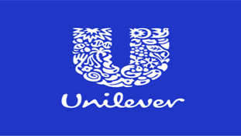
STRATEGIC MANAGEMENT OF UNILEVER

by Manuela Manolova

Course: BA Business management
Professor: Dr Hossein Shokri
University of Wales Trinity Saint David
Date: 24.04.2024

Table of Contents

Introduction 3
Company Description 4
Making Strategic Choice 6
Porter's Generic Strategies 7
Ansoff Matrix Application 9
Resources and Capabilities 11
VRIO Analysis 12
Porter’s Value Chain Analysis 13
Strategy Implementation Success 14
The SAF Framework 14
Assessing Strategies Implementation 15
Competitiveness and Sustainability 15
Future Strategic Direction 16
Conclusion 17
Reference List 18

Introduction
Modern businesses depend on strategic management in adapting to the current dynamic and multifaceted business environment. Specifically, the strategic procedures enable companies to effectively handle constant dynamics in competition pressure, consumer taste, technology, and regulations. Strategic management can be seen as a mix of plans and actions used from the company to achieve its purpose. It implement experimenting, finding market opportunities and creating competitive advantages. It is characterised with emergent initiatives in case of resources utilisation to enhance the company performance and competitiveness in the external environment. (Lynch, 2018). Strategic management process include mission of the firm identifying its high and low quality objectives, conductive an external and internal analysis, make strategic choice and implementation strategy that lead to competitive advantages (Barney and Hesterly, 2019). Major objectives is achieving a specific outcome expressed in statements for example profit statement, level of sales and share valuation (Johnson, 2019). The objective of the report is to provide a strategic review and to identify what is the corporate and business strategy of the British company Unilever. The procedure can allow Unilever to develop an effective resource allocation, change management, and monitoring process for pursuing its long-term goals.

Company Description
Unilever is a British fast-moving consumer goods multinational company that commenced operations in the 1860s. Today, the UK-based company sells refreshments, food, personal care, and home care products to customers located in over 190 nations internationally. Recent statistics indicate that the company reaches approximately 3.4 billion customers daily through its different outlets. The company provides FMCG (fast-moving consumer goods) through its home care, beauty & wellbeing, ice cream, nutrition, and personal care segments. The most popular Unilever brands in the global FMCG industry are Hellmann's, Knorr, Sunsilk, Lipton, Close-Up/ Signal, Ben & Jerry's, Lifebuoy, Rexona, Vaseline, Lynx/Axe, Dove, Sunlight, Lux, Surf/Omo. Markedly, the UK-based company owns 31 brands, employs approximately 128,000 people worldwide, with engagement score of 84% in UniVoice employee survey and generates €59.6 billion turnover in 2023. Working with 57 000 suppliers in 150 countries, in more than 280 factories, Unilever serve around 23 millions orders. The company owns more than 20 000 patents and investing millions on innovation, development and research.. Unilever relies on diversification, supplier collaboration, sustainability, and quality optimisation strategies in optimising its competitiveness in the international FMCG market. However, the company can utilise effective strategic management in enhancing its profitability and competitiveness in the future. (Unilever, 2024)
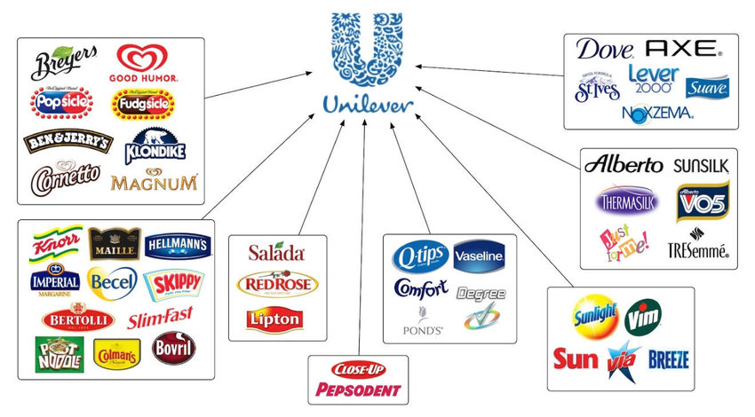
Unilever Brands (Ulaj, 2019)
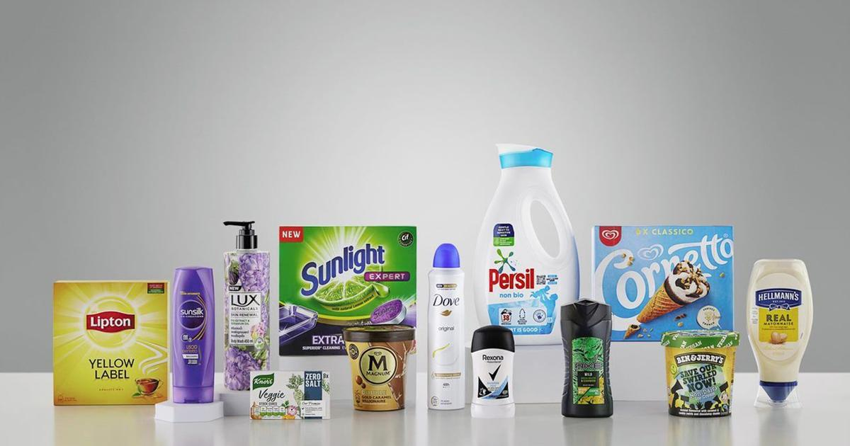
Unilever Products (Unilever, 2024)

Making Strategic Choice
There are three main choices in front of the firm. The first one is about the position of the company around the competitors and on the business market. For example which one would bring better pursue- cost leadership or differentiation. The second choice is for strategic direction- selection of a product, market and industry or more specific should the firm approach new market and new products or stay focused. The third choice is leading to the strategy methods, that can be organic, alliance or acquisition (Barney and Hesterly, 2019). In multinational companies such as Unilever, management teams make strategic choices at business and corporate levels (Harrison & John, 2014). The corporate-level strategy entails making decisions concerning the general organisational scope and direction. The decision-making process at this stage focuses on guiding corporate-level strategies like divestments, acquisitions and mergers, downsizing, and diversification. On the contrary, the business-level strategy involves making decisions that enable a company to accomplish its goals and milestones. The decision-making process at this level aims at guiding strategies such as cost focus, differentiation focus, differentiation leadership, and cost leadership. In this scenario, the Ansoff Matrix and Porter's generic strategies offer comprehensive details regarding Unilever’s strategic choice.

Porter's Generic Strategies
Porter's generic strategies support companies in developing strategies for boosting their competitiveness in their markets. The framework classifies corporate-level strategies that optimise organisational competitiveness in current markets into three major groups, namely focus, cost leadership, and differentiation strategies (Johnson, 2019).
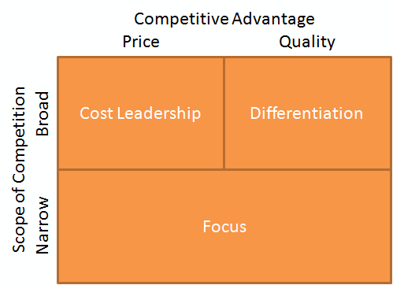
The cost leadership strategy enables Unilever to utilise cost reduction strategies in optimising its competitiveness in the market. In particular, the company focuses on providing the best quality products at lower prices than its competitors in the FMCG industry (Unilever, 2024). Strategies that support Unilever’s cost reduction strategy are optimised supply chain efficiency, operating cost, VCC (value chain configuration), and economies of scale. For instance, a British FMCG company depends on an extensive supply chain network in acquiring quality raw materials at competitive prices. Similarly, the VCC procedure supports the company in reducing production costs through technological development, improved inventory management, and high-performing workforce creation. The UK-based company supports its cost leadership by regulating its overall overhead and production costs.
Unilever relies on the differentiation strategy in developing and sustaining its unique identity in the global FMCG industry. Specifically, the tactic enables the multinational company to differentiate its products from those of its different competitors. Key Unilever’s competitors in the global market are Kraft Heinz, Mars, Nestle, Procter & Gamble, Nestle, Johnson & Johnson, AmorePacific, L’Oréal, and GSK. Successful product differentiation is based on the company’s focus on R&D, innovation, automation, and supplier collaboration. Unilever combines these strategies to create high-quality, unique, and sustainable products that meet customer requirements. For instance, the company allocated around £810.71 million to its R&D program to facilitate the development of new, innovative and unique products. Maintaining unique and quality products allows Unilever to generate high switching costs, which improves its capability to retain loyal customers. Creating unique products further supports the British company in attracting the rising population of environmentally conscious clients in the market.
The company utilises the focus strategy in addressing the specific requirements and needs of its diverse consumer populations. The business-level strategy enables Unilever to tailor its marketing efforts and products to meet the unique preferences and needs of particular market segments. The multinational company relies on the strategy of capitalising on available market niches to optimise its sales volumes and profitability. Unilever achieves this objective by stressing the unique design, size, taste, value, and price of its products based on their capacity to meet specific consumers’ needs. For instance, the cost focus helps the company in retaining price-sensitive clients in different markets internationally. The company’s management understands the role of price reduction and quality enhancement in optimising value for money. Continuous adjustments to product design and packaging materials enable the company to satisfy its target customers’ unique psychological expectations. Essentially, R&D, quality, and innovation are crucial factors reinforcing the focus strategy for this multinational company.

Ansoff Matrix Application
Ansoff product/market matrix generate four directions for companies growth. Usually a company starts in the first zone- Market penetration and it may increase along new products/services or new markets. The process is called diversification. When the new products or services are in relationship to the existing business it is known as related diversification. A firm can choose to move in both directions- new products and new markets, this strategy is conglomerate (unrelated) diversification. In conglomerate diversification the product or market are not in relationship to the existing ones. (Johnson et al., 2017)
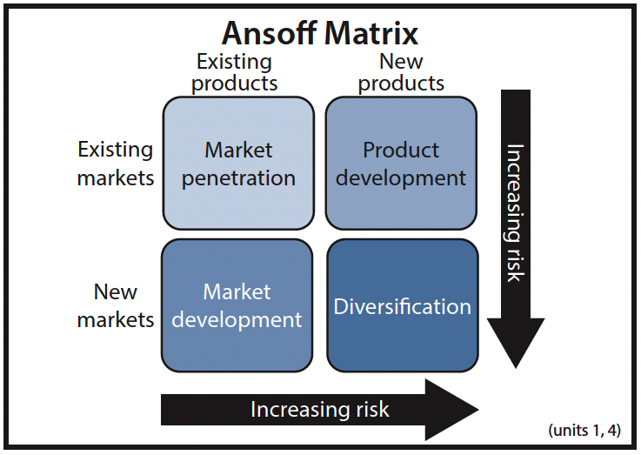
Unilever has capitalised on the tactic of increasing product offerings beyond home care products. Specifically, the British company implements unrelated and related diversification tactics in maintaining competitiveness in different industries. For instance, related diversification has been accomplished by creating strategic alliances with food, refreshment, and dairy. On the contrary, the unrelated diversification has necessitated the acquisition of subsidiaries providing beauty and cosmetics products.
Third, Unilever employs the market penetration strategy in facilitating its growth within existing markets using its existing products. The strategy enables the company to support the growth of its products within markets where it has managed to maintain its brand presence. The market penetration strategy involves operations like strategic partnership formation, effective marketing operation, competitors’ acquisition, and competitive pricing. For instance, Unilever relies on its effective marketing campaigns in popularising its products within its existing markets. Competitive pricing and competitors’ acquisition enable the British company to maintain competitiveness within these markets, which protects its market share and profitability interests. Finally, the market development strategy supports Unilever’s intensive growth agenda through existing products' introduction to new markets. Various strategies utilised by the company’s professional team in driving its market development strategy are marketing, R&D, and regional expansion. The marketing procedure enables the FMCG company to popularise its existing products within new markets, which facilitates its global and regional expansion.

Resources and Capabilities
Resources and capabilities serve as foundational elements for organisational strategies in the current globalised market. Therefore, professional and management teams are expected to capitalise on available resources and capabilities to support their business/corporate strategies. The resource-based theory stresses the need to use limited resources in supporting their different operations (Johnson et al., 2020). Key resources for Unilever are broadly classified as tangible and intangible resources. Various tangible resources for the multinational company include suppliers, infrastructure, plant, equipment and machine, cash, and raw materials. Intangible resources that support the company’s operations include intellectual property, copyrights, a strong distribution network, brand reputation, skilled employees, and online resources. The current Unilever’s success is based on its capacity to leverage its unique capabilities such as customer connectivity, effective collaboration, customer engagement, transformational leadership, innovation, and accountability. The unique resources and capabilities offer the multinational company greater economic performance and sustainable competitive advantage.

VRIO Analysis
The VRIO analysis is an effective method for evaluating resources that provide companies with a competitive advantage in their respective markets. VRIO analysis create four questions about companies resources and capabilities in case of creating competitive advantages: Value, Rarity, Imitability and Organisation. The resources are valued if they bring opportunities for the company, reduce costs, neutralised threads or manage risk effectively. They bring a significant value and gain a competitive advantages. Rarity is considered for resources that are not easy available. In princip they are unique and develop strong brand name.Rarity capabilities can be tangible (licenses and patterns) or intangible( partnership and very skilled employees). Imitability are resources that are hard to be copied. Organisation question is about if a company can efficiently use its resources and capabilities to achieve a competitive advantages. (Barney and Hesterly, 2019)
In this case, the tool suggests that Unilever’s criteria align with valuable, inimitability, rarity, and organisation dimensions. For instance, the company possesses valuable resources that offer it benefits like competitiveness, customer satisfaction, and cost advantage. Valuable resources controlled by the FMCG company include superior brands, highly trained employees, and sufficient monetary assets (Johnson et al., 2020). Adequate financial resources enable the company to invest in emerging opportunities in different industries, which optimises its competitiveness. Unilever controls rare competencies that are unavailable to its different competitors in its existing markets. Rare competencies that make the company highly competitive in its markets include adaptability, problem-solving skills, and a strong R&D program. Unilever’s competitiveness results from its inimitable resources and competencies such as effective marketing communications, strategically located stores, quality product offerings, and competitive pricing. Additionally, the company’s professional team effectively organises distribution networks and available financial resources in a way that offers it a sustainable competitive advantage.

Porter’s Value Chain Analysis
Porter’s Value Chain Analysis framework helps in analysing international organisational activities to generate value for target clients. The assessment tools enable professionals to identify activities that offer organisations a competitive advantage in their markets (Unilever, 2024). Essentially, the framework broadly categorises organisational activities for organisational performance optimisation into primary and secondary/supportive activities. Primary activities that help in enhancing Unilever’s performance include inbound logistics, sales and marketing, operations, outbound logistics, and services. Inbound logistics represents the procedure of acquiring and storing components and raw materials required for production. Acquired raw materials are converted into finished products through operations such as assembly, packaging, machining, and testing. Outbound logistics refers to various activities that facilitate product delivery to clients including warehouse management, packaging, order processing, and shipping products. Various secondary/support activities that support Unilever’s operations include infrastructure, human resource management, procurement, and technological development. The value chain activities help in supporting relevant primary activities for the multinational company.

Strategy Implementation Success

The SAF Framework
The SAF framework utilises three key assessments in informing the decision-making process during the strategy implementation, namely suitability (S), acceptability (A), and feasibility (F). The suitability assessment helps in determining the alignment of specific strategies with long-term organisational goals (Moulton & Sandfort, 2017; Walker et al., 2015). Suitable strategies for pursuing Unilever’s long-term goals are optimised product quality, product diversification, innovative techniques, and sustainable practices. The company relies on these techniques to achieve long-term expansion goals and adapt to the complex market. Product differentiation enables Unilever to meet different customers’ preferences while maintaining profitability. Acceptability assessment focuses on stakeholder returns, risks, and reactions related to the adoption of a particular business strategy (Johnson et al., 2020). For instance, an acquisition strategy offers the company the capabilities and resources it requires to develop quality and affordable products. The feasibility assessment helps in determining the capabilities and resources required in ensuring the effective implementation of a specific corporate/business-level strategy. The assessment proves that the British company requires highly trained workers, adequate financial resources, and a collaborative workforce to implement its different strategies.

Assessing Strategies Implementation
Choosing Success Strategy for Unilever
Strategy | Suitability (S) | Acceptability (A) | Feasibility (F) | Accept/Reject
1. | Lipton tea is a suitable brand for acquisition. The brand acquisition strategy can support Unilever’s expansion, cost curtailment, and product innovation agenda. | The Lipton tea brand acquisition aligns with cost leadership and differentiation strategies for the multinational company. Unilever can utilise the strategy in optimising its profitability and competitiveness. | Lipton company possesses the capabilities and financial resources to reinforce Unilever’s growth agenda. Unilever’s reputation can contribute to the further strengthening of this brand. | Accept
2. | Luxury brand acquisition is an unsuitable growth strategy for Unilever. | Unilever’s stakeholders may reject luxury brands since they like low-cost and high-quality products. | Unilever can incur unnecessary huge costs in its attempt to acquire luxury brands in the FMCG market. | Reject

Competitiveness and Sustainability
Unilever has focused on implementing environmentally sustainable strategies in improving its competitiveness within the international FMCG industry. Key environmental sustainability initiatives for the company include regenerating agriculture, carbon emission reduction, plastic waste reduction, and renewable energy usage. For instance, Unilever aims to reduce its carbon footprint in its production, logistics and distribution, and procurement levels (Lawrence et al., 2018). The management focuses on minimising carbon emissions at its logistics and distribution levels by acquiring electric vehicles. The company intends to decarbonise its warehouses and production facilities through investment in renewable energy. Unilever focuses on investing in innovative product portfolios within its homecare segment to reduce emissions. A collaborative process with suppliers has enabled the company to convert captured carbon into soda ash. Investment in sustainable packaging materials has supported the multinational company in minimising plastic utilisation by approximately 70% (Unilever, 2024). The management has further expressed its commitment towards adopting 100% renewable energy in its warehouses, stores, offices, and manufacturing facilities (Unilever, 2024). Environmental sustainability has supported the company in adhering to ecological policies and attracting eco-conscious customers.

Future Strategic Direction
Strategic choices available for Unilever’s strategic direction in the future include product diversification, supplier collaboration, product differentiation, environmental sustainability initiatives, and competitor acquisition. The differentiation strategy can support Unilever in offering high-quality products at affordable prices to its clients (Unilever, 2024). In this regard, the company will collaborate with different suppliers in ensuring convenience in acquiring quality but low-cost raw materials. Investment in R&D, advanced technology, and a talented workforce will support the company in differentiating its products from its various competitors. Unilever will accomplish further product diversification through the acquisition of different brands from competitors. In some instances, the company will acquire competitors to protect its market share and maintain competitiveness in the global market. Future environmental sustainability programs will enable the company to utilise 100% eco-friendly packaging materials, adopt 100% renewable energy, and attain a net zero emission level.

Conclusion
Modern businesses rely on strategic management in adapting to today’s dynamic and multifaceted business environment. Specifically, Unilever can utilise the strategic management operation in creating effective allocation, change management, and monitoring processes for pursuing its long-term goals. Unilever is a British FMCG that provides products through its home care, beauty & wellbeing, ice cream, nutrition, and personal care segments. Crucial corporate-level strategies for the multinational company are product diversification, divestments, acquisitions and mergers. Important business-level strategies for this company are focus strategy, differentiation, and cost leadership. Unilever relies on its resources and capabilities to overcome pressure from competitors such as Kraft Heinz, Mars, Nestle, Procter & Gamble, Nestle, Johnson & Johnson, AmorePacific, L’Oréal, and GSK. Based on the SAF framework, suitable growth strategies for the multinational company are optimised product quality, product diversification, innovative techniques, and sustainable practices. The company further depends on environmentally sustainable strategies in maintaining competitiveness in the FMCG market.

Reference List
Lynch, R. (2018). Strategic Management. Pearson UK.
Johnson, G. (2019). Exploring Strategy, Text and Cases, 12th Edition. Pearson UK.
Barney, J.B. and Hesterly, W.S. (2019). Strategic Management and Competitive Advantage. Harlow, United Kingdom: Pearson Education, Limited.
Unilever (2024). Our Company. [online] Unilever. Available at:
https://www.unilever.com/our-company/.
Johnson, G., Scholes, K., Angwin, D., Regner, P. and Whittington, R. (2017). Exploring Strategy : Text and Cases. 11th ed. Harlow, England: Pearson.
Harrison, J. S. and John, C. H. S. (2014). Foundations in strategic management. Boston: South-Western Cengage Learning.
Henry, A. (2021). Understanding strategic management. Oxford: Oxford University Press.
Johnson, J., Whittington, R., Regnér, P., Angwin, D., Johnson, G. and Scholes, K. (2020).
Exploring strategy. London: Pearson UK.
Lawrence, J., Rasche, A. and Kenny, K. (2018). Sustainability as opportunity: Unilever’s
sustainable living plan. In Managing Sustainable Business: An Executive Education Case and Textbook (pp. 435-455). Dordrecht: Springer Netherlands.
Moulton, S. and Sandfort, J. R. (2017). The strategic action field framework for policy
implementation research. Policy Studies Journal, 45(1), 144-169.
Nazarova, V. (2015). Corporate diversification effect on firm value (Unilever group case study).
Annals of Economics and Finance, 16(1), 173-198.

Unilever. (2024). Implementing growth action plan at pace Unilever. Unilever. [Online] Available at:
https://www.unilever.com/news/press-and-media/press-releases/2024/implementing-growth-action-plan-at-pace/ [Accessed on: 13 April2024]
Unilever. (2024). Leading and delivering on sustainability through our Compass commitments.
Unilever. [Online] Available at: https://www.unilever.com/news/news-search/2023/leading-and-delivering-on-sustainability-through-our-compass-commitments/ [Accessed on: 13 April2024]
Wadström, P. (2019). Aligning corporate and business strategy: managing the balance. Journal
of Business Strategy, 40(4), 44-52.
Walker, S., McAuslane, N., Liberti, L., Leong, J., & Salek, S. (2015). A universal framework for
the benefit-risk assessment of medicines: is this the way forward?. Therapeutic Innovation & Regulatory Science, 49(1), 17-25.

