Digital Skills and Research Methods
Executive Summary
VLE learning process is trending in present times. The students, as well as the universities, along with schools, are used to use the VLE to keep maintaining the study environment in this pandemic situation. This research study has focused on making the primary and secondary data analysis to understand the impact of the VLE process among the students of the University of Wales Trinity Saint David London Campus.

Table of Contents
Introduction 4
Research Methodology 6
Primary Data Analysis 7
Secondary Data Analysis 12
Reflection 15
Conclusion 17
References 18

Introduction
The research report is conducted to understand the impact of Virtual Learning Environment (VLE) – Moodle and the learning experience the students have gained studying in the University of Wales Trinity Saint David London Campus. Furthermore, aim and objective will be derived based on which primary and secondary analysis will be conducted.
Aim: To understand the impact of the virtual learning environment – Moodle on the learning capability of the students at the University of Wales Trinity Saint David London Campus.
Objectives
1. To identify the significance of VLE among the students of the University of Wales Trinity Saint David London Campus.
2. To analyse the challenges faced by the students while incorporating VLE-Moodle regarding learning experience in the University.
3. To find out the ways to mitigate the challenges for the students who are incorporating VLE as their learning tool.
Research Question
1. What is the significance of VLE among the students who adapted the program at the University of Wales Trinity Saint David London Campus?
2. What are the challenges faced by the students while incorporating VLE-Moodle regarding learning experience in the University?
3. What are the ways to mitigate the challenges for the students who are incorporating VLE as their learning tool?
Rationale
Moodle is an acronym for multiple object-oriented dynamic learning environments. Furthermore, moodle denotes multiple things from the course and learning management system, which is conducted through Virtual Learning Environment (VLE). The students of the University of Wales Trinity Saint David London Campus are adapting to the learning experience, and the issues they are facing will be discussed in the report. Furthermore, the strategies to mitigate the issue will also be evaluated (Stiles, 2018).

Research Methodology
Data Analysis
In this particular report, both qualitative and quantitative methods have been followed (Allen, 2017). This will support the researcher to derive accurate and effective outcome for the research (Byrd, 2020).
Data collection tool & techniques
In the primary analysis, a survey tool will be used where a questionnaire will be formed and distributed among the students online (Queirós, Faria and Almeida, 2017). Furthermore, in order to conduct the secondary analysis, reviews of the student will be gathered aligned with the objectives of the research, and themes will be developed (Hennink, Hutter and Bailey, 2020)
Sample Size
The random approach will be applied, using ten students as an example, and questionnaires will be supplied for each. and then they will conduct an expansion of the sample to further find out the size of this additional population (Solymosi and Bowers, 2018)
Ethical considerations
The report has been conducted after following all the ethical rules and regulation of the data protection act. Furthermore, consent from the University authority has been taken for conducting the survey. Moreover, all the confidential data are kept securely, and privacy has been maintained.

Primary Data Analysis
1. Do you use VLE for learning purpose?
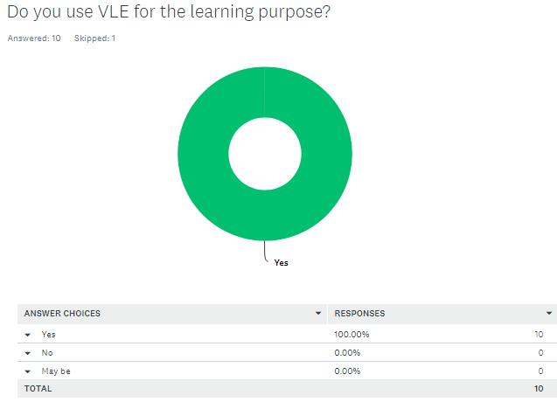
(surveymonkey, 2021)
The survey has been conduct to know the impact of the VLE learning process among the students of Wales Trinity Saint David London Campus University. This question has focused about the popularity of VLE process among the students by getting 100 percent responses regarding using the VLE for the learning purpose within the University of Wales Trinity Saint David London Campus.
2. What is the major reason for using the VLE?
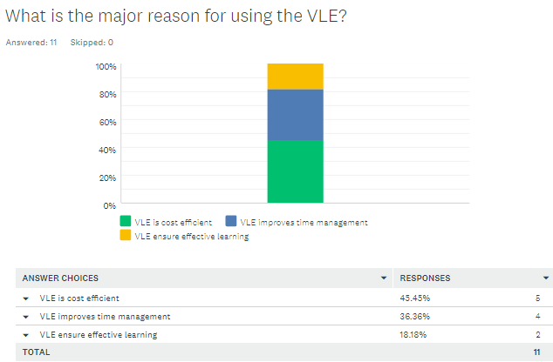
(surveymonkey, 2021)
There are several reasons for using VLE for studies. According to the survey, it is clear that, the major reason for the students to use the VLE is that, it is cost effective. The students are used to conduct study in the cost effective ways, hence they choose the technology based learning process. There are about 45% responses regarding the cost effectiveness of VLE processes. Along with that, 36% variables have stated that the major reason to use the VLE is that, it helps them to effectively manage the time of studies. Moreover, about 18% variables stated that, they use VLE as it is a effective earning process.
3. Do you enjoy studying using the VLE?
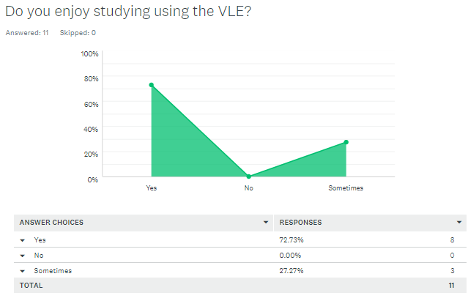
(surveymonkey, 2021)
It is important for the students to enjoy the learning process. In this case, it can motivate the students to focus on learning wide range of topics while conducting the learning process in an interesting way. This question has focused on analysing the interesting aspects of the VLE. As per the survey, it is clear, that, about 72% variables have stated that the process of learning by using VLE is interesting. There is about 20% response which has stated that the learning process using VLE is sometimes interesting. On the other hand there is no one, who has stated that the VLE process is not interesting.
4. What are issues you face in the study process of VLE?
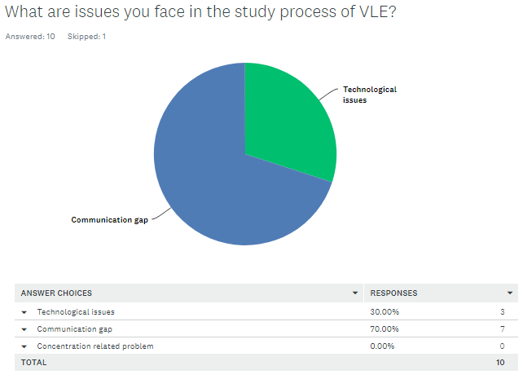
(surveymonkey, 2021)
Every learning process may have some interesting aspects as well as some issues. It is important for the students to understand the issues of the learning processes to mitigate them properly for the development of their study skills. This question has focused on analysing the issues of the VLE process. As per the survey among the students of the University of Wales Trinity Saint David London Campus it can be said, that the students mostly face the issue of communication gap during the VLE. There are about 70% responses on the communication gap option. There are about 30% variables that face issues regarding technological aspect while using VLE
5. What is the major step to reduce the most disturbing issue of VLE?
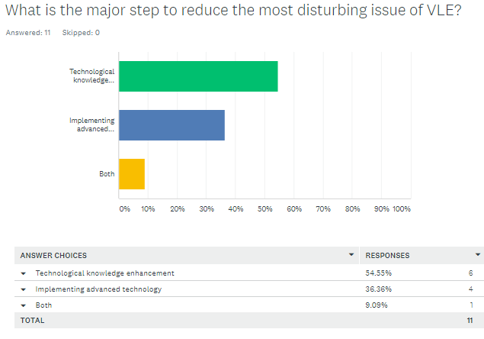
(surveymonkey, 2021)
According to 54% students, technological knowledge needs to be enhances among the students for reducing the issues related with the VLE process. On the other hand, as per 36% variables, the university must focus on implementing advanced technology for reducing the challenges of using VLE process.
6. Do you think reducing the challenges of VLE would be effective for the long run?
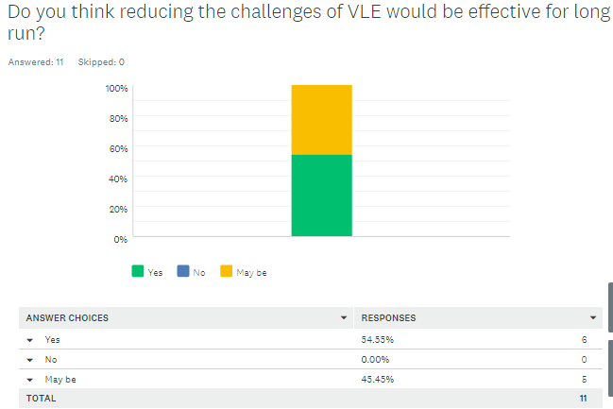
(surveymonkey, 2021)
The above-mentioned question was asked to the students for collecting their responses to find out whether reducing challenges regarding VLC could be effective or not. 54% of the research participants agreed with the question as they believed mitigating challenges could provide better outcomes to the students. On the other hand, 45% of the participants did not sure about their answer as they were confused.

Secondary Data Analysis
The feedback of the students of the University of Wales Trinity Saint David London Campus has been observed. It has helped to understand how education through VLE has benefited and negatively affected the students.

Source: (whatuni, 2021)
Benefits of VLE as per students’ feedback-
The above-mentioned feedback is some of the feedbacks which are available on the company’s website. Responses like these have clarified that the virtual learning methods have helped students to complete their studies. They have been able to complete their syllabus in the pandemic time when they were advised not to go out of their accommodations (Kerimbayev, 2016). The students were able to interact with their tutors reading their subjects, and take their help. The students have said that the tutors have been interactive and have made well-structured plans to deliver lectures. The lectures have been organised daily, which helped the students have social interaction without disobeying the rule of social distancing. The University professors have shared the lecture notes with the students, which made it easier for them to understand the lessons (whatuni, 2021).
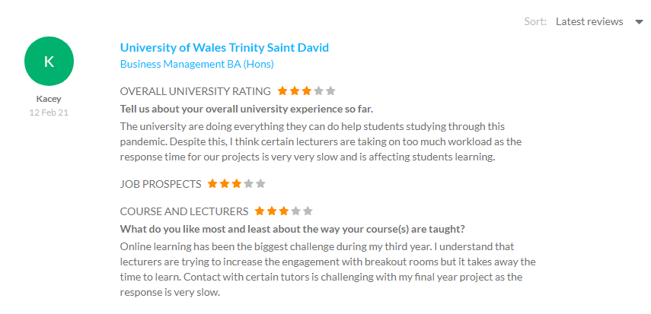
Source: (whatuni, 2021)
Challenges of VLE as per students’ feedback-
Many negative feedbacks have also been received from the students. The students have faced several issues, like the professor’s inability to connect with them faster. They have been unable to provide quick responses to the assignments of the students due to work pressure. It made the students unable to understand their mistakes and rectify them on time. Many other students have claimed that virtual classes sometimes get disrupted due to network congestion. The students have to exit the platform and again enter, which causes disturbances during the classes (Dillenbourg and Synteta, 2019). The students even complaint about the breakout rooms which their lecturers introduce. However, they feel that the involvement of breakout rooms has consumed huge time. They are unable to invest their time in their studies.
Methods to mitigate the challenges of VLE that students face-
The network issues which the students are facing can be mitigated if they opt for a strong WiFi connection. Apart from that, the university professors can record the whole lecture and share it with the students at the need of the class. It will help the students update the information they have not been able to gather due to their network issues. The professors need to be active while providing feedback to the students regarding their projects. This will keep the students engaged and interested in the students. The professors need to conduct query-solving classes to help the students more (Wegener and Leimeister, 2018). It will help the students to get more opportunities to discuss their doubts regarding the lessons. The time for the breakout rooms needs to be minimised. It will help students to have time to learn the lessons that they have studied. They can even be able to practice the knowledge that they have gathered in the classes. The professors need to make the students engaged in their studies by providing them more assignments (Stiles, 2018).

Reflection
Gibbs’ reflective cycle can be described in order to focus on the experience that I have gained while attending Virtual Learning Environment moodle. The use of this specific model is effective to learn from previous experience (Rumson, 2018). The following step of Gibbs’ reflective model will demonstrate my experience of learning virtually.
Topic: The impact of VLE on the students of the University of Wales Trinity Saint David London Campus
Para 1-
Description: I attended the VLE classes to learn about the specific module, and the overall experience was quite pleasant for me. The tutors were helpful, and they tried to make comfortable the students while teaching them virtually. They have developed regular classes on the VLE to make the students more engaged in their study.
Feelings: I was excited and nervous at the same time as I knew that my experience would be different from the regular experience that I gained from attending classes at my University. Moreover, I felt encouraged to improve my technical skills while learning virtually.
Para 2-
Evaluation: My overall experience was quite good as I got the opportunity to gain new knowledge while learning from VLE. I was pleased to improve my technical and digital skills while attending the class. However, due to some technical issues, I faced some difficulties.
Analysis: I got the opportunity to learn about self-paced learning, and I was able to improve my presentation skills from VLE. Moreover, my knowledge about technology was increased, and I was able to enhance my research skills while learning virtually.
Para 3-
Conclusion: Virtual Learning Environment has a positive impact on my learning experience as I got the chances to develop several new skills and knowledge. However, I need to focus on some of the aspects in future to get the best outcomes.
Action plan: I should focus on developing my interaction with the teachers while attending VLE classes so that I can develop a clear understanding of study topics. Moreover, I should always maintain self-discipline while participating in VLE classes so that I can improve my engagement towards my study.

Conclusion
The research report has focused on the significance of the Virtual Learning Environment and its impact on the students. VLE is a web-based technology that, in recent times, the educational sectors uses to increase inclusivity. The report has also focused on the challenges that the students often face while incorporating VLE classes. The ways to mitigate the challenges have provided to help the students for getting a better experience for virtual learning. Both the primary and secondary research methods have utilised in order to get suitable data and information regarding the research topic. Furthermore, a self-reflection has provided by evaluating Gibbs’ Reflective Cycle.

References
Books and journals
Allen, M. ed., 2017. The SAGE encyclopedia of communication research methods. Sage Publications.
Byrd, R., 2020. Qualitative research methods.
Dillenbourg, P. and Synteta, P., 2019, September. Virtual learning environments. In Proceedings of the 3rd Hellenic conference information & communication technologies in education (pp. 3-18).
Hennink, M., Hutter, I. and Bailey, A., 2020. Qualitative research methods. Sage.
Kerimbayev, N., 2016. Virtual learning: Possibilities and realization. Education and Information Technologies, 21(6), pp.1521-1533.
Queirós, A., Faria, D. and Almeida, F., 2017. Strengths and limitations of qualitative and quantitative research methods. European Journal of Education Studies.
Solymosi, R. and Bowers, K., 2018. The role of innovative data collection methods in advancing criminological understanding. The Oxford handbook of environmental criminology, pp.210-237.
Stiles, M.J., 2018. Effective learning and the virtual learning environment. In Proceedings: EUNIS 2000–Towards Virtual Universities, Instytut Informatyki Politechniki Poznanskiej.
Wegener, R. and Leimeister, J.M., 2018. Virtual learning communities: success factors and challenges. International Journal of Technology Enhanced Learning, 4(5-6), pp.383-397.
Website References-
Rumson, R., 2018. GIBBS – REFLECTIVE CYCLE MODEL (1988). [Online] Available at: https://www.eln.io/blog/gibbs-reflective-cycle-model-1988 [Accessed 2 April 2021].
Surveymonkey, 2021. analyze. [Online] Available at: https://www.surveymonkey.com/analyze/dXj9W5co6S2mAES5CxIsOm2QvNcvxNcWHPGs9N1KLxs_3D?tab_clicked=1 [Accessed 02 April 2021].
Whatuni, 2021. 1,681 University of Wales Trinity Saint David reviews. [Online] Available at: https://www.whatuni.com/university-course-reviews/university-of-wales-trinity-saint-david/5225/ [Accessed 02 April 2021].

