Qualification: CIPD Diploma in Applied Human Resources

Module Name: Contributing to the Improvement of Individual and Organisational Performance

Assessment 5AIOP - I1A10003

Word Count:
LO 1: 934
LO 2: 828
LO 3: 1,049
Total: 2,811

Student Name: Sharon Richards
Student Number: 2014447
CIPD Membership Number: 57493181

By signing below, I confirm that the work/evidence presented is my own, unaided work. I understand the regulations pertaining to candidate malpractice and the action that may be taken as a result.

Signed: S Richards
Date: 17th September 2021
Contents Page

Evidence Matrix 3
Personal Statement for Learning Objective 1 6
Reference List for Learning Objective 1 9
Evidence for Learning Objective 1 10
Personal Statement for Learning Objective 2 17
Reference List for Learning Objective 2 19
Evidence for Learning Objective 2 20
Personal Statement for Learning Objective 3 35
Reference List for Learning Objective 3 38
Evidence for Learning Objective 3 40

Candidate name: Sharon Richards |  |  |  |  | CIPD Membership/registration No.:  57493181
Qualification title: CIPD Level 5 Diploma in Applied Human Resources |  |  |  |  | Unique Learner No. (ULN): 2014447
Unit code | Unit title |  | Assessment criteria no. | Evidence description | Evidence reference number |  | Assessor  initials | I/V initials if sampled
5AIOP | Contributing to the Improvement of Individual and Organisational Performance |  | 1.1 | PADR Forms and Supporting Information | 1.1
5AIOP | Contributing to the Improvement of Individual and Organisational Performance |  | 1.1 | PADR Guidance for Appraisers | 1.2
5AIOP | Contributing to the Improvement of Individual and Organisational Performance |  | 1.1 | Checklist for Appraisers | 1.3
5AIOP | Contributing to the Improvement of Individual and Organisational Performance |  | 1.1 | Guidance for Appraisees | 1.4
5AIOP | Contributing to the Improvement of Individual and Organisational Performance |  | 1.1 | Checklist for Appraisees | 1.5
5AIOP | Contributing to the Improvement of Individual and Organisational Performance |  | 1.1 | Personal Development Plan template | 1.6
5AIOP | Contributing to the Improvement of Individual and Organisational Performance |  | 2.1 | Email offering Performance Management / PADR training for managers | 2.1
5AIOP | Contributing to the Improvement of Individual and Organisational Performance |  | 2.1 | Email confirmation that the PADR policy is under review | 2.2
5AIOP | Contributing to the Improvement of Individual and Organisational Performance |  | 2.2 / 2.3 | Email confirmation of attendance at Managers Passport course at which PADR / Performance training was delivered | 2.3
5AIOP | Contributing to the Improvement of Individual and Organisational Performance |  | 2.2 | Email to team members signposting to PADR supporting documents prior to PADR | 2.4
5AIOP | Contributing to the Improvement of Individual and Organisational Performance |  | 2.2 | Extracts of completed PADR | 2.5
5AIOP | Contributing to the Improvement of Individual and Organisational Performance |  | 2.2 | Review of objectives during pandemic | 2.6
5AIOP | Contributing to the Improvement of Individual and Organisational Performance |  | 2.2 | Current team PADR and training compliance | 2.7
5AIOP | Contributing to the Improvement of Individual and Organisational Performance |  | 1.3 / 2.2 | Email from a line manager seeking advice on PADR process | 2.8
5AIOP | Contributing to the Improvement of Individual and Organisational Performance |  | 2.1 / 2.2 | Evidence of preparation of documents for the ‘Improving Together’ programme | 2.9
5AIOP | Contributing to the Improvement of Individual and Organisational Performance |  | 2.1 / 2.2 | Email and presentation slide on baseline assessment of current position | 2.10
5AIOP | Contributing to the Improvement of Individual and Organisational Performance |  | 3.2 | Learning and Development Plan on a Page | 3.1
5AIOP | Contributing to the Improvement of Individual and Organisational Performance |  | 3.3 | Notes of meeting with Line Manager | 3.2
5AIOP | Contributing to the Improvement of Individual and Organisational Performance |  | 3.3 | Email to Culture and Workforce Experience Manager with recommendations and response | 3.3
Candidate declaration:
- I confirm that the work/evidence presented for assessment is my own unaided work.
- I have read the assessment regulations and understand that if I am found to have ‘copied’ from published work without acknowledgement, or from other candidate’s work, this may be regarded as plagiarism which is an offence against the assessment regulations and leads to failure in the relevant unit and formal disciplinary action.
- I agree to this work being subjected to scrutiny by textual analysis software if required.
- I understand that my work may be used for future academic/quality assurance purposes in accordance with the provisions of the Data Protection Act 1998.
- I understand that the work/evidence submitted for assessment may not be returned to me and that I have retained a copy for my records.
- I understand that until such time as the assessment grade has been ratified through internal and external quality assurance processes it is not final.
Signature: |  | S Richards |  |  |  | Date: | 17/09/21

Personal Statement 1
Contributing to the delivery of performance management activities within the organisation.

1.1 Performance Management Policy
The Performance Appraisal and Personal Development Plan (PADR) Policy (Hywel Dda, 2021a) outlines the process for ensuring that staff have clear performance objectives with agreed development plans.

The PADR policy covers the process, documentation and meeting requirements ‘to ensure a competent workforce who are developed and supported to realise their full potential.’

Underpinning the policy are five principles:
- A commitment to lifelong learning through, continuous personal and professional development;
- Learning, training and development is responsive to organisational need;
- Development needs are identified and agreed in partnership between the member of staff and their manager;
- Equal opportunity and access to learning and development opportunities, and;
- A consistent and fair approach to funding learning and development.

The policy is explicit in defining the role and responsibilities of each party involved in the process, from the management of the policy, ensuring deployment across Directorates, dissemination to managers, delivery and participation.

1.2 Links to other information sources and legislation
Alongside the PADR Policy, there are several other additional policies that need to be considered as part of the performance management process including:
- Equality and Diversity
- All Wales Capability
- All Wales Grievance
- Learning and Development
- All Wales Pay Progression
- Data Protection Act

In developing the Policy, the Health Board conducted an Equality Impact Assessment (Hywel Dda, 2019) to assure itself that the policy would have no adverse impact on any groups or individuals with protected characteristics (Equality Act 2010, c4).

The policy also references the Health Board’s responsibilities in terms of the Data Protection Act 2018 and ensuring that all documents relating to identifiable individuals are treated as confidential.

1.3 Performance Management activities
The PADR Policy sets out the activities that are required to be undertaken as part of the performance process. Managers are supported to deliver these activities via a suite of guidance documents and forms (Evidence 1.1)

The performance management process is based on an ongoing cycle of learning (Armstrong, 2006):
- Reviewing how individuals are performing against the requirements of their role and identifying any development needs;
- Agreeing a Personal Development Plan, detailing the learning and development to take place within an agreed timeframe, and the date of the next review;
- Undertaking the learning and development identified, and;
- Evaluating the learning and development and reflecting on how it has been applied to work.

The policy sets out the requirement for staff to have at least one annual performance appraisal development review.

1.4 Documentation
There are two separate PADR forms in use within the Health Board; one for those with no staff management responsibilities (‘Core’ PADR form) and one for those in a staff management role (‘Leadership and Management’ PADR form). Both forms can be found in the PADR Policy.

The ‘PADR Appraiser Guidance’ (Evidence 1.2) sets out the additional evidence required for those in a staff management role. These focus on staff management objectives such as regular team 1:1s and the active promotion of health and well-being amongst staff.

The Health Board has provided guidance and checklist for both appraisees and appraisers aimed to support them through the process by providing guidance on how to complete the documentation as well as how to prepare and what to expect from the conversation (Evidence 1.2, 1.3, 1.4 and 1.5)

Guidance is also available to staff to help them prepare for their appraisal with their manager.

1.5 Objective setting
Stage one of the PADR process involves the setting of objectives at three levels:
- Service – how the staff member will contribute to the organisation’s objectives;
- Team – how the staff member will contribute to team objectives, and;
- Personal – what the staff member is expected to do in the next year.

Every member of staff has 2 core objectives. These are to:
- Complete all mandatory training, and;
- Engage with and complete an annual PADR.

Staff are encouraged to set no more than eight SMART objectives (Mindtools, 2021) that also align to the organisational values (Evidence 1.2). In line with one of the five principles outlined above, objectives should be agreed in partnership between the staff member and their line manager.

1.6 Personal Development Plan
Stage two of the PADR process involves the agreement of a Personal Development Plan with the staff member which details the learning and development requirements and an agreed timeframe in which to complete these.

Managers have access to a Personal Development Plan template to complete with the member of staff to capture the value of any learning and development undertaken in terms of expected impact on effective delivery the role and the expected outcome (Evidence 1.6).

The Health Board requires all staff to complete Mandatory Training before they can undertake any further training or development opportunities.

1.7 Dealing with under-performance
The policy sets out the responsibilities of managers to ensure that the Health Board process is followed when dealing with performance issues; this process is set out in the Health Board’s Capability Policy and Procedure (Hywel Dda, 2021b, pp8-10).

This procedure provides guidance to managers on the approach to dealing with capability issues:
- Informal stage - discussion to take place between the employee and line manager as part of day-to-day management to help to clarify the expected performance standards, identify any areas of concern, establish the causes of poor performance, identify any training needs and set targets and timescales for improvement. This approach aligns with ACAS guidance (n.d.) to investigate the reasons for under-performance before deciding on the next step to take.
- Formal stage - if the informal discussion does not result in a satisfactory improvement an assessment will be undertaken to decide if there are grounds for taking action through a formal capability hearing.

Reference List

ACAS (n.d.) Capability Procedures. Available at Capability procedures - Acas. (Accessed: 9th September 2021)

Armstrong, M (2006) Performance Management: Key Strategies and Practical Guidelines. 3rd edn. London: Kogan Page.

Data Protection Act 2018. Available at Data Protection Act 2018 (legislation.gov.uk). (Accessed: 9th September 2021).

Equality Act 2010. Available at https://www.legislation.gov.uk/ukpga/2010/15/contents. (Accessed: 9th September 2021)

Hywel Dda University Health Board (2021a) The Performance Appraisal and Personal Development Plan Policy. Available at https://hduhb.nhs.wales/about-us/governance-arrangements/policies-and-written-control-documents/policies/performance-appraisal-and-personal-development-plan-padr-policy/. (Accessed: 9th September 2021)

Hywel Dda University Health Board (2021b) Capability Policy and Procedure. Available at https://hduhb.nhs.wales/about-us/governance-arrangements/policies-and-written-control-documents/policies/all-wales-capability-policy/. (Accessed: 9th September 2021)

Hywel Dda University Health Board (2019) Equality Impact Assessment. Available at A toolkit for carrying out (nhs.wales). (Accessed: 9th September 2021)

Mindtools (2021) ‘SMART goals’ Available at SMART Goals - Time Management Training From MindTools.com. (Accessed: 9th September 2021)

Evidence for Personal Statement 1

Evidence 1.1 PADR Forms and Supporting Information

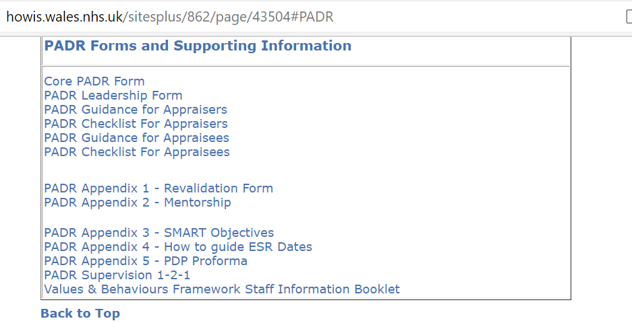

Evidence 1.2 PADR Guidance for Appraisers

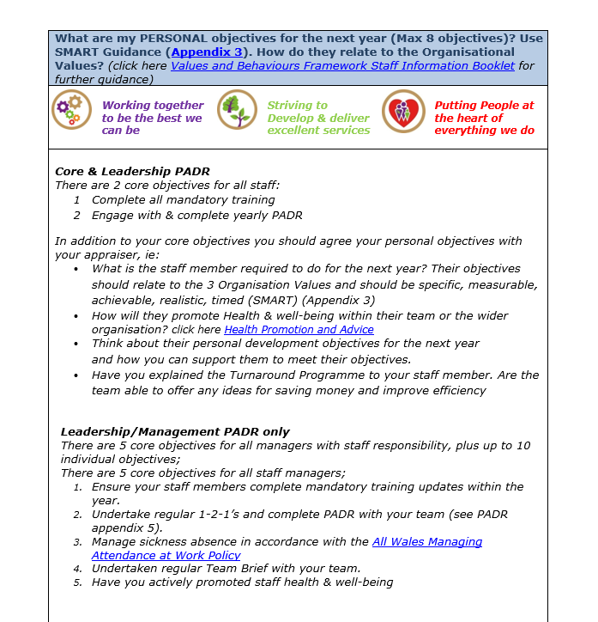

Evidence 1.3 Checklist for Appraisers

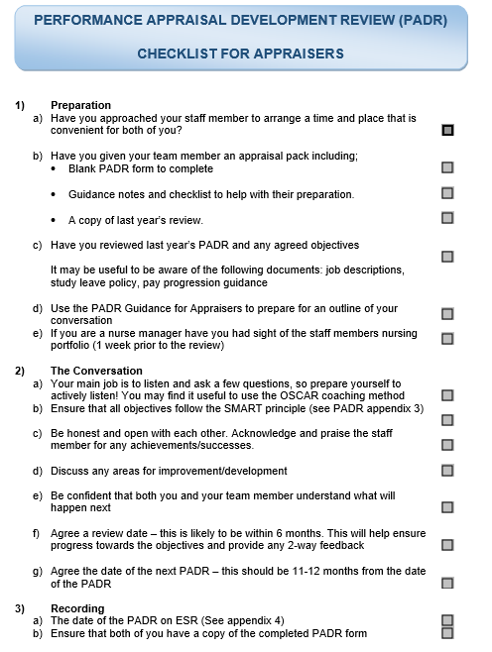

Evidence 1.4 Guidance for Appraisees

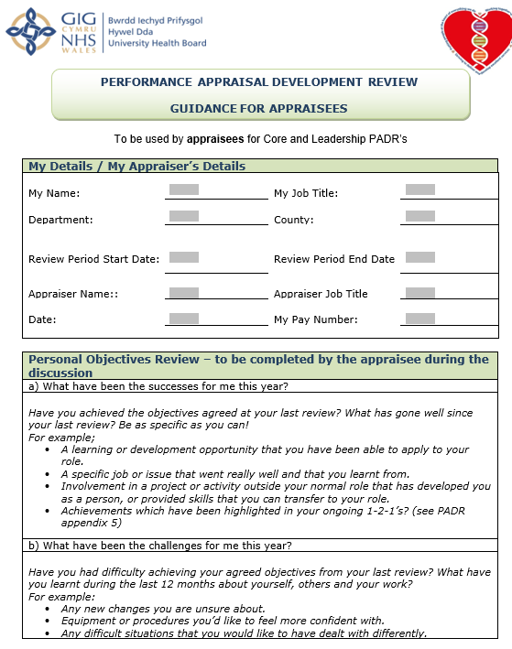
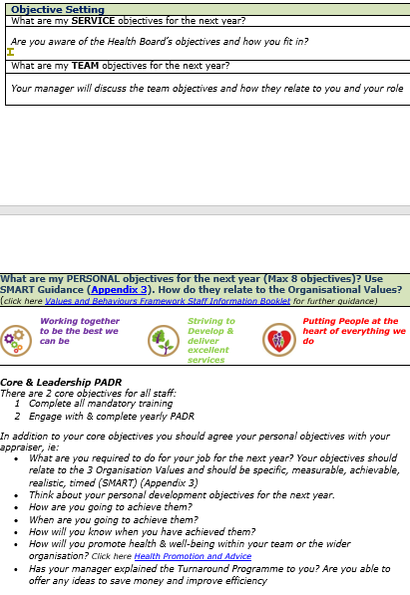
Evidence 1.5 Checklist for Appraisees
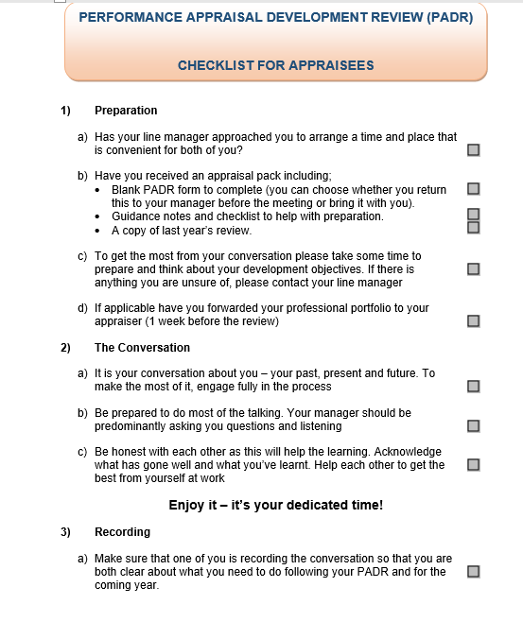

Evidence 1.6 Personal Development Plan template
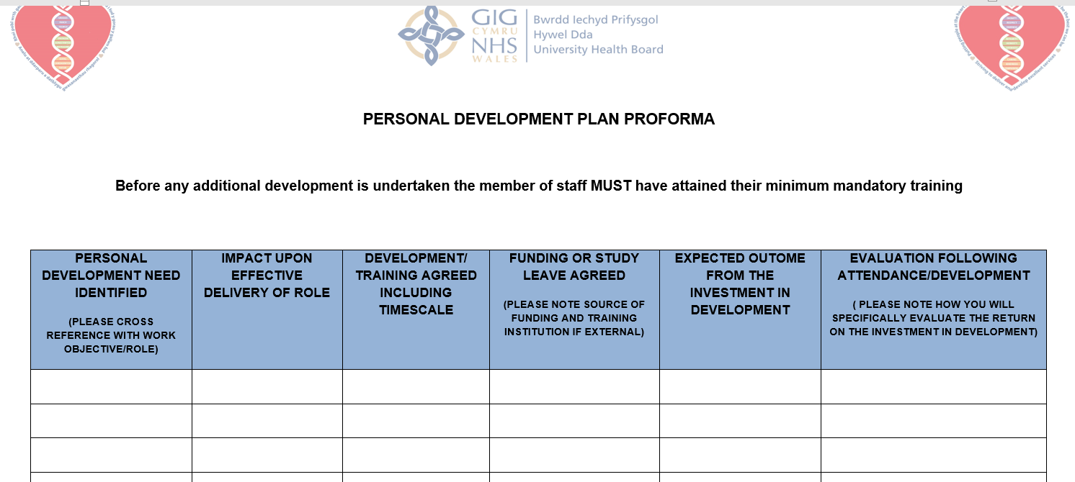

Personal Statement 2
Supporting line managers to deliver performance management activities within the organisation

2.1 Analysis of support required for managers in my organisation
Within the organisation, performance management sits within the Organisational Development pillar and is managed by a ‘Culture and Workforce Experience’ team, with leads at strategic, management and operational levels. It is this team that managers are signposted to for advice and support on performance management activities.

Line managers have responsibility for the day to day performance management of their team (Taylor, 2016, p211) including;
- setting individual and team objectives;
- measuring performance;
- providing feedback;
- recognising and acting on training and development needs, and;
- managing under-performance.
Hutchinson (2013, p123)

To support managers with the process, the organisation offers PADR training to managers (Evidence 2.1). Due to COVID restrictions training is currently being delivered virtually. As well as being available as stand-alone sessions, PADR training is offered as part of a range of other internal management courses. PADR training includes
- Definition of performance management and it’s benefits
- When the PADR should take place
- The managers role in performance management.
- Setting SMART (CIPD, 2020) objectives
- Personal Development Plan

Whilst the Health Board policy, guidance documents and training go a long way to support to line managers with performance management activities, managers would benefit from further guidance on some aspects contained in the policy.

- The PADR Policy (Hywel Dda, 2021, p6) sets out the requirement for managers to collate Personal Development Plans into a departmental training plan and to submit to the Learning and Development Department via the Training Needs Analysis process. This will ensure that the Learning and Development Department can develop an Organisational Training Plan to support a fair and robust response to training requests. However, there is no link to this process in the policy, and despite searching the intranet, I have been unable to find any evidence of the Training Needs Analysis process.
- The policy (p6) also refers to the availability of a guidance booklet for managers and staff explaining the process and providing a clear explanation of the process and associated documentation. Again, I have been unable to find any evidence of the guidance document on the intranet. On enquiry, I understand that the policy is currently under review, pending approval (Evidence 2.2).

2.2 Experience of performance management activities as a line manager
I was fortunate to undertake PADR training face to face as part of the Manager’s Passport course attended during the period December 2019 to February 2020 (Evidence 2.3). This training enabled me to effectively undertake PADRs with members of my own team (Evidence 2.4 / 2.5). Evidence 2.5 demonstrates the application of learning as a result of the PADR training undertaken - objectives are Specific, Measurable, Achievable, Relevant, and Time-bound – or ‘SMART’ (CIPD, 2020).

Armstrong (2006, p17) describes performance management as a process of ‘plan, act, monitor and review’. IAs a result of the pandemic, the team were informally deployed to support Workforce in the mass recruitment of staff. As a result, objectives quickly became outdated. I felt that it was important to update objectives to reflect progress to date and to include the additional tasks that the team had achieved and therefore undertook a review of objectives with each individual in May 2020 (Evidence 2.6).

I have achieved 100% compliance with the PADR process and mandatory training within my team. (Evidence 2.7)

2.3 Providing advice to other line managers
Whilst not directly responsible for Performance Management advice to managers, I am often approached for various advice on HR matters from former colleagues outside of the Directorate. For example, an ex-colleague who has recently moved to a new job with line management responsibilities sought my advice on the PADR process. I was able to provide relevant advice which led him to set up PADRs with the new team. (Evidence 2.8)

2.4 Supporting a new approach to performance management in the organisation
During the period September 2020 to June 2021, I project managed the development of a new strategic approach to performance management across the organisation, known as ‘Improving Together’. (Evidence 2.9) The aim of Improving Together was to implement a wide-ranging strategic improvement approach, including quality and performance, which is clear on expectations and accountability arrangements from Board level to all teams.

Improving Together is based on Kaizen principles (Kaizen Institute, n.d.) of continuous improvement involving everyone in the organisation. The first step of Improving Together is to set the vision and measures for success at a strategic level. Team and individual objectives are then aligned to the strategic goal creating a ‘golden thread’ (BusinessBalls, 2020) through the organisation.

To understand managers thoughts and feelings about the current performance management system, I considered the most recent staff survey results and presented these to the Steering Group as part of a desktop baseline assessment (Evidence 2.10). This informed the development of the Improving Together framework. Whilst I am not longer involved in this project due to a change in role, progress has continued and ‘Improving Together’ will be formally launched later in the Autumn.

References
BusinessBalls (2020). The Golden Thread. Available at The Golden Thread (businessballs.com). (Accessed: 11th September 202)

CIPD (2020) Performance Management: an introduction. Available at Performance Management | Factsheets | CIPD. (Accessed: 11th September 2021)

Hutchinson, S (2013) Performance Management: theory and practice. London: CIPD

Hywel Dda University Health Board (2021) The Performance Appraisal and Personal Development Plan Policy. Available at https://hduhb.nhs.wales/about-us/governance-arrangements/policies-and-written-control-documents/policies/performance-appraisal-and-personal-development-plan-padr-policy/. (Accessed: 11th September 2021)

Kaizen Institute (n.d.) What is Kaizen? Available at What is KAIZEN™. (Accessed: 11th September 2021)

Taylor, S (2016) ‘Improving Organisational Performance’ in Taylor, S. and Woodhams, C. (ed) Human Resource Management: People and Organisations. 2nd edn. London: CIPD

Evidence for Personal Statement 2

Evidence 2.1 - Email offering Performance Management / PADR training for managers
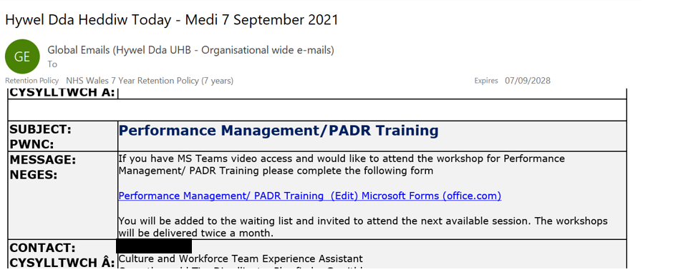

Evidence 2.2 – Email confirmation that the PADR policy is under review

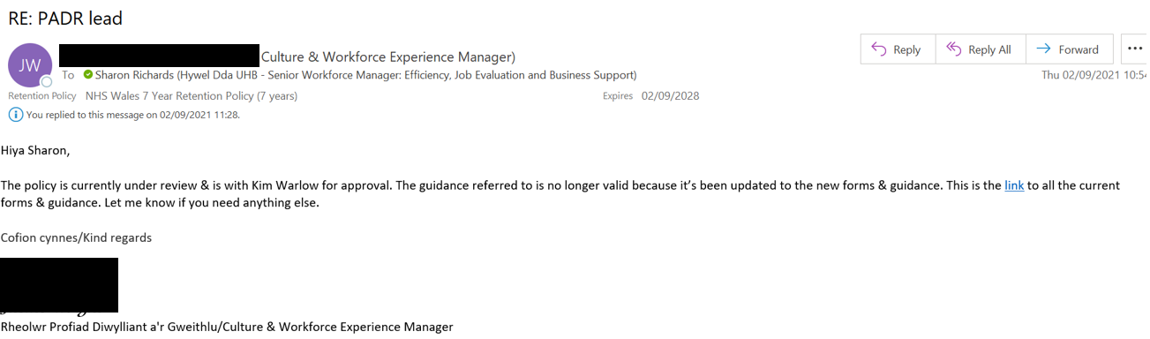

Evidence 2.3 – Email confirmation of attendance at Managers Passport course at which PADR / Performance training was delivered
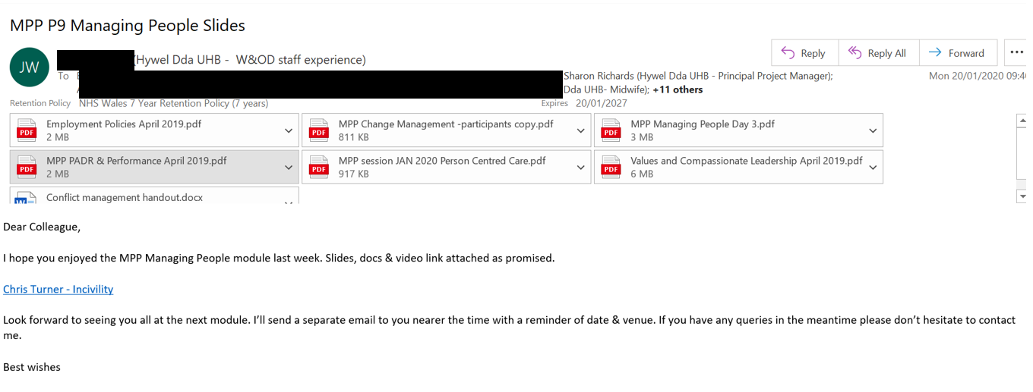

Evidence 2.4 – Email to team members signposting to PADR supporting documents prior to PADR

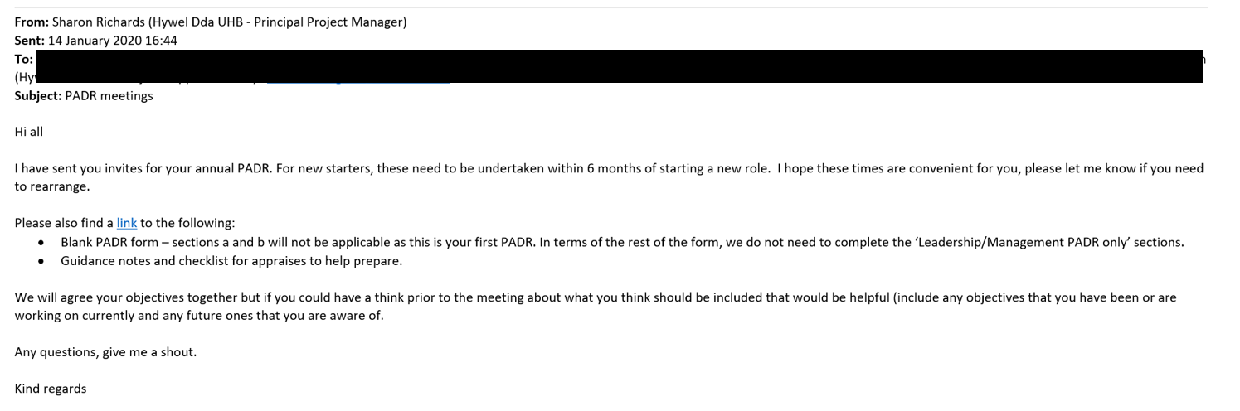

Evidence 2.5 – extracts of completed PADR

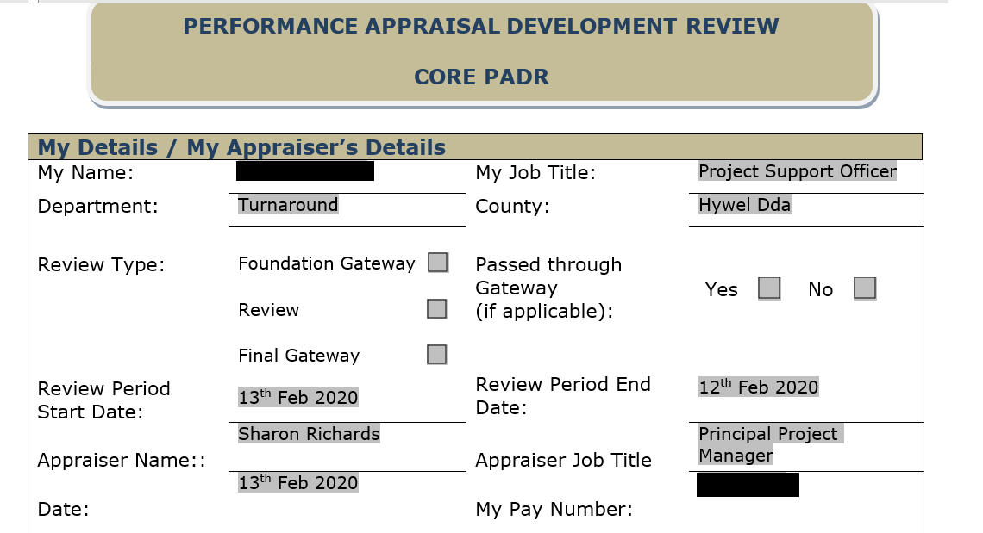

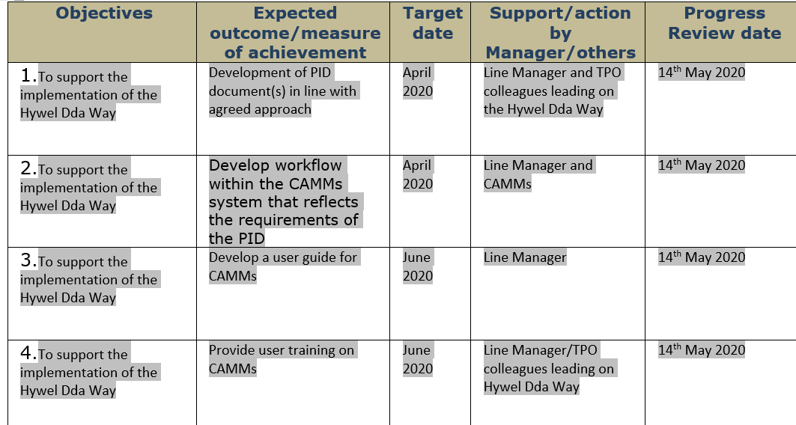

Evidence 2.6 – Review of objectives during pandemic

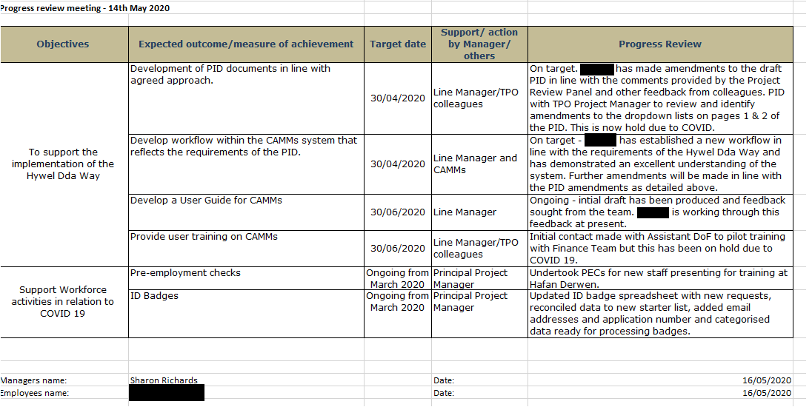
Evidence 2.7 – current team PADR and training compliance

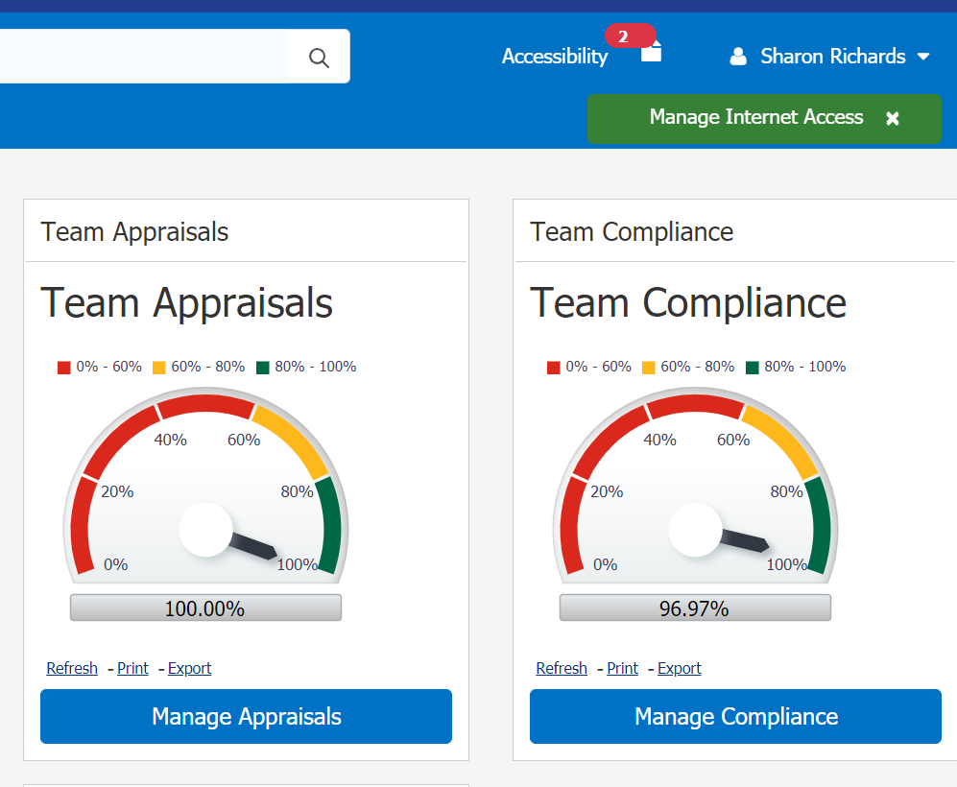

Evidence 2.8 – Email from a line manager seeking advice on PADR process

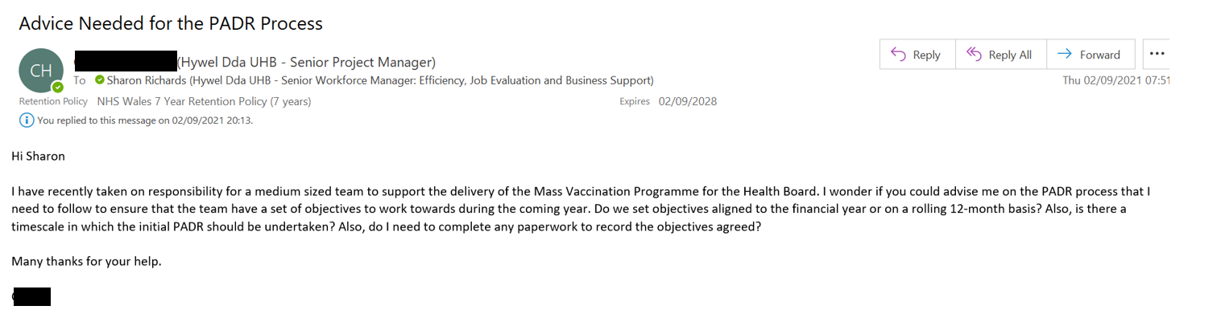

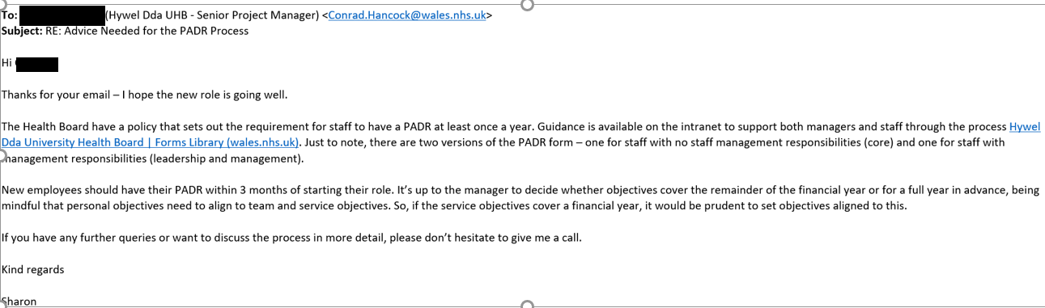
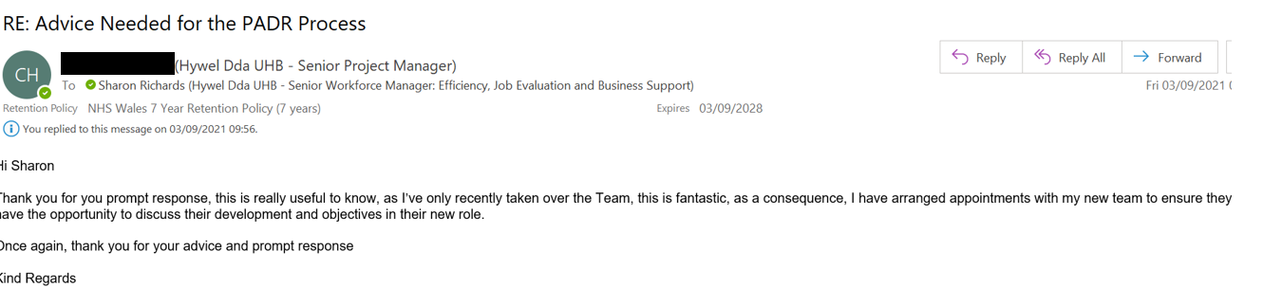

Evidence 2.9 – Evidence of preparation of documents for the ‘Improving Together’ programme

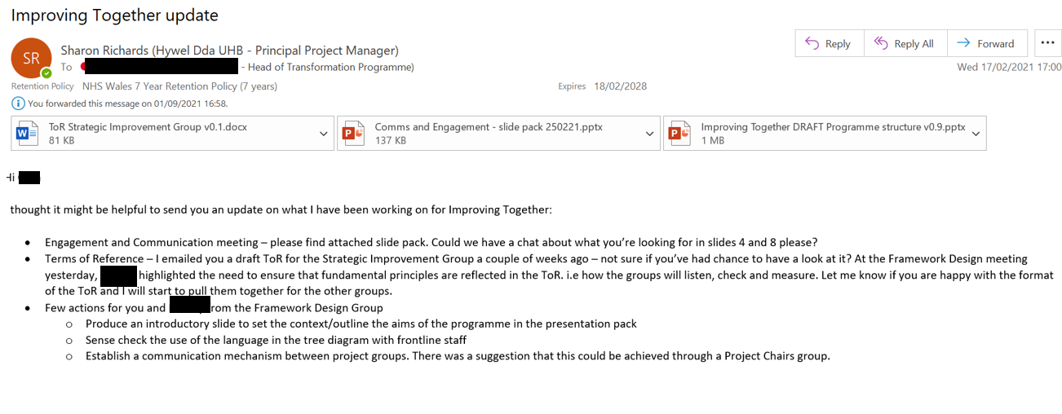
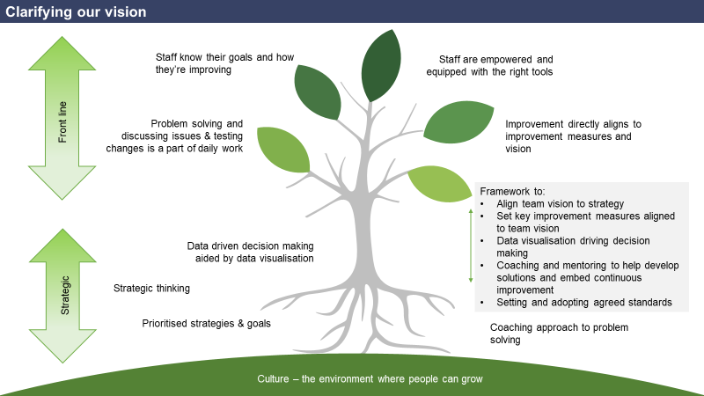
Evidence 2.10 – email and presentation slide on baseline assessment of current position

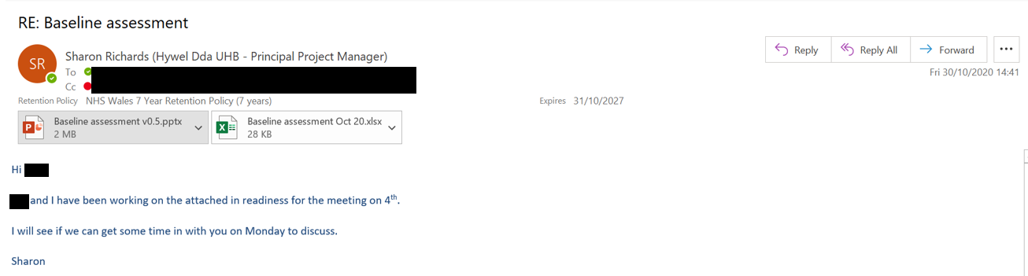
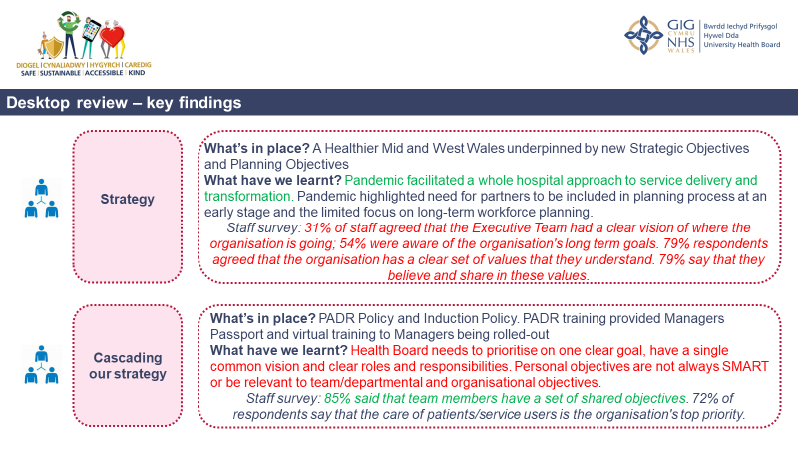
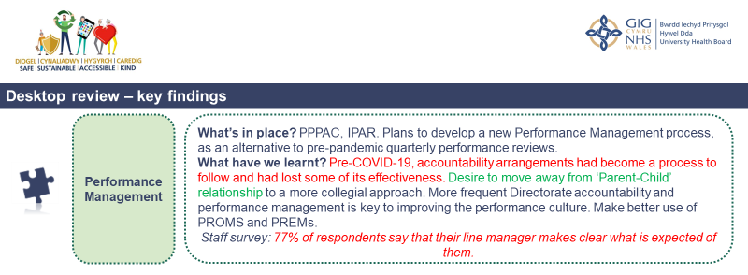

1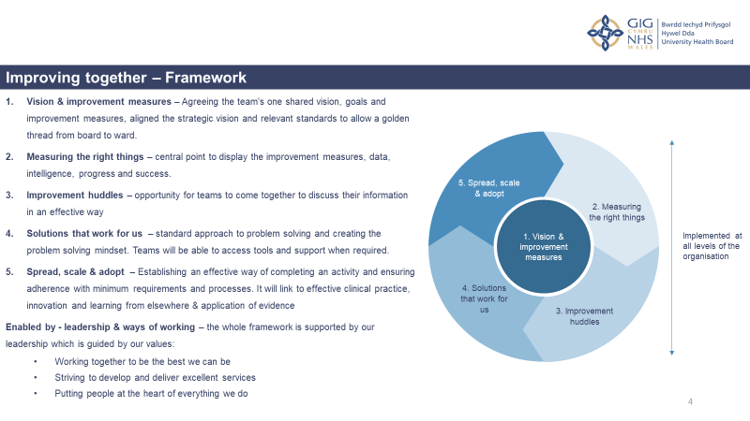

Personal Statement 3
Assessing the impact of performance management activities on organisational performance and recommendations for enhancement.

3.1 An assessment of the organisation’s approach to High Performance Working
High Performance Working (HPW) is a collection of human resource policies and practices that, when complementary, support an organisation to achieve improved performance, often referred to as a ‘bundle’ (Taylor, 2016, p199). Marchington et al (2016, pp56 - 70) summarise the key elements of the bundle as:

- Job security and development opportunities;
- Robust recruitment and selection processes;
- Investment in professional and personal training and development activities;
- Effective communication and employee engagement;
- Teamworking;
- A fair and equal pay system that rewards performance;
- A performance management system that aligns individual performance to organisational performance;
- Standardised terms and conditions, and;
- A better work-life balance for all employees.

Other factors suggested by Taylor (2016, p199) include internal promotion, a just grievance process without fear of reprisal and flexible working opportunities.

Hywel Dda University Health Board support HPW through a suite of employee policies and written control documents; some are local to the Health Board, others are All Wales policies (Hywel Dda, 2021a). Some examples of the policies in effect that support HPW include:

- Performance Appraisal and Personal Development Policy – supports staff to develop through the setting of clear performance objectives and an agreed development plan.
- The PADR process aligns closely with the All Wales Pay Progression Policy that aims to provide a framework for linking pay progression with performance rather than time served in a role. The NHS Terms and Conditions Handbook (NHS Employers, 2021) sets out that ‘pay progression is conditional upon individuals demonstrating that they have the requisite knowledge and skills/competencies for their role and that they have demonstrated the required level of performance and delivery during the review period’.
- Learning and Development Policy – aims to ensure an equitable and fair system to support access to personal and professional development to all staff to allow them to reach their full potential within their role. The Health Board have agreed a planning objective to support the delivery of equitable access to training (Evidence 3.1)
- Secondment Policy – offers opportunities for staff to develop and progression whilst helping the organisation to address a short-term need to cover a post. It also facilitates the transfer of learning from one department or organisation to another and is considered valuable for both employee and the organisation (CIPD, 2021a).
- Respect and Resolution Policy – aims to resolve employee requests fairly, constructively and without unreasonable delay. This policy recognises the importance of a positive working environment and the impact on performance and productivity (CIPD, 2020)
- Work/Life balance flexible working policy – the policy describes three types of flexible working: number of hours worked; times in which the work is undertaken and place of work. Flexible working has advantages for both employer (increased productivity, retention and recruitment) and for employee (well-being, financial savings and job satisfaction) (Croner, 2019)

3.2 Impact of HPW on performance in Hywel Dda University Health Board
My assessment of Hywel Dda’s performance management activities and complementary policies and approaches that span all aspects of employee management lead me to conclude that the organisation shows a commitment to High Performance Working. In terms of the impact on performance, COVID 19 has significantly impacted on the organisation’s ability to meet the Welsh Government’s performance targets (NHS Wales, 2020-21) for essential services (Hywel Dda, 2021b). However, during 2020/21, the Welsh Government reduced the Health Board’s escalated performance monitoring status from ‘targeted intervention’ to ‘enhanced monitoring’, in recognition of continued improved performance (Hywel Dda, 2021b, p89).

As discussed in section 2.4, the organisation has committed to a new approach to performance management to deliver two Strategic Objectives – ‘Working together to be the best we can be’ and ‘Striving to deliver and develop excellent services’. This new framework will align each member of staff towards a long-term vision; having a shared vision is one of the key principles of a high-preforming team (Alimo-Metcalfe and Alban-Metcalfe, 2018).

3.3 Impact of the pandemic on performance activities
The current PADR policy does not reflect the impact of the pandemic and, following discussion with my line manager (Evidence 3.2), I have identified several key areas that the Health Board will need to consider as changes to working practices become more embedded into our working lives. These may include:
- Pre-pandemic, staff were used to working in traditional ways i.e. co-located in the workplace, working in well-established organisation systems and cultures. With the likely continuation of home working, McKendrick (2020) refers to research that suggests that ‘the process of innovation needs rethinking’.
- The impact on working from home on productivity and efficiency. Can working from home put individuals more risk of making mistakes due to a loss of concentration as a result of exposure to more non work-related interruptions at home e.g. caring responsibilities, deliveries? Or, does working from home increase productivity as staff are experiencing less interruption than they might in the office (NI Business Info, n.d.).
- Whether working from home provides less opportunity for staff to have direct access to line managers, putting more junior staff at risk of making isolated decisions due to their reluctance in disturbing their line manager to seek advice.
- With more flexible working, should consideration be given to what we are measuring progress against –i.e. a move away from measuring inputs and more a focus on outputs (Powell, 2021).
- How overall well-being impacts performance when people are not always on site. Health and well-being are critical to engagement and performance and help to ‘prevent stress and create positive working environments where individuals and organisations can thrive’ (CIPD, 2021b).

3.4 Recommendations
Based on my assessment of performance activities in Hywel Dda Health Board, my recommendations for further development are:
- Reflecting on 2.1 above, and given the recent restructuring of the Directorate, issue a communication to staff that inform them of the current review of the PADR Policy and a provide a contact for any queries.
- With the move to more home working, consider how objectives can reflect performance in terms of innovation to ensure the same standard of drive and innovation is maintained as that in pre-pandemic days.
- Consider how objectives can reflect performance in terms of how teams are kept motivated, engaged and managed remotely.

3.5 Conclusion
I have shared my observations with the Health Board operational lead for Performance Management and have received a comprehensive response to these (Evidence 3.3).

References
Alimo-Metcalfe, B and Alban-Metcalfe, K (2018) ‘Five principles of high-performing teams’ in Personnel Today. Available at Five principles of high-performing teams - Personnel Today. (Accessed: 13th September 2021)

CIPD (2020) Managing Conflict in the Modern Workplace. Available at managing-conflict-in-the-workplace-1_tcm18-70655.pdf (cipd.co.uk). (Accessed: 13th September 2021)

CIPD (2021a) Learning Methods. Available at Learning Methods | Factsheets | CIPD. (Accessed: 13th September 2021)

CIPD (2021b) Well-being at Work. Available at Wellbeing at Work | Factsheets | CIPD. (Accessed: 25th August 2021)

Croner (2019) Benefits of Flexible Working for Employers. Available at Benefits of Flexible Working for Employers | Croner. (Accessed: 13th September 2021)

Hywel Dda (2021a). Policies and written control documents. Available at Policies and written control documents - Hywel Dda University Health Board (nhs.wales). Accessed: 13th September 2021

Hywel Dda (2021b) Annual Report and Accounts 202-2021. Available at https://hduhb.nhs.wales/about-us/your-health-board/board-meetings-2021/annual-general-meeting-agenda-and-papers-29-july-2021/agm-papers-29-july-2021/item-4-hdduhb-annual-report-and-accounts-2021-21-bilingual/. (Accessed: 13th September 2021)

Marchington, M, Wilkinson A, Donnelly R and Kynighou, A (2016) Human resource management at work. London: CIPD

McKendrick, J (2020) Work from home fallout: productivity up, innovation down. Available at Work From Home Fallout: Productivity Up, Innovation Down (forbes.com). (Accessed: 13th September 2021)

NHS Employers (2021) NHS Terms and Conditions of Service Handbook. Available at NHS Terms and Conditions of Service Handbook | NHS Employers. (Accessed: 13th September 2021)

NHS Wales (2020-21) NHS Delivery Framework 2020 – 21. Available at 2020-21 Delivery Framework.pdf (wales.nhs.uk). (Accessed: 13th September 2021)

Powell, C (2021) ‘Line Managers focusing on output over hours since COVID’ in People Management. Available at Line managers focusing on output over hours since Covid, research finds (peoplemanagement.co.uk). (Accessed: 13th September 2021)

Taylor, S (2016) ‘Improving Organisational Performance’ in Taylor, S. and Woodhams, C. (ed) Human Resource Management: People and Organisations. 2nd edn. London: CIPD

Evidence 3.1 – Learning and Development Plan on a Page

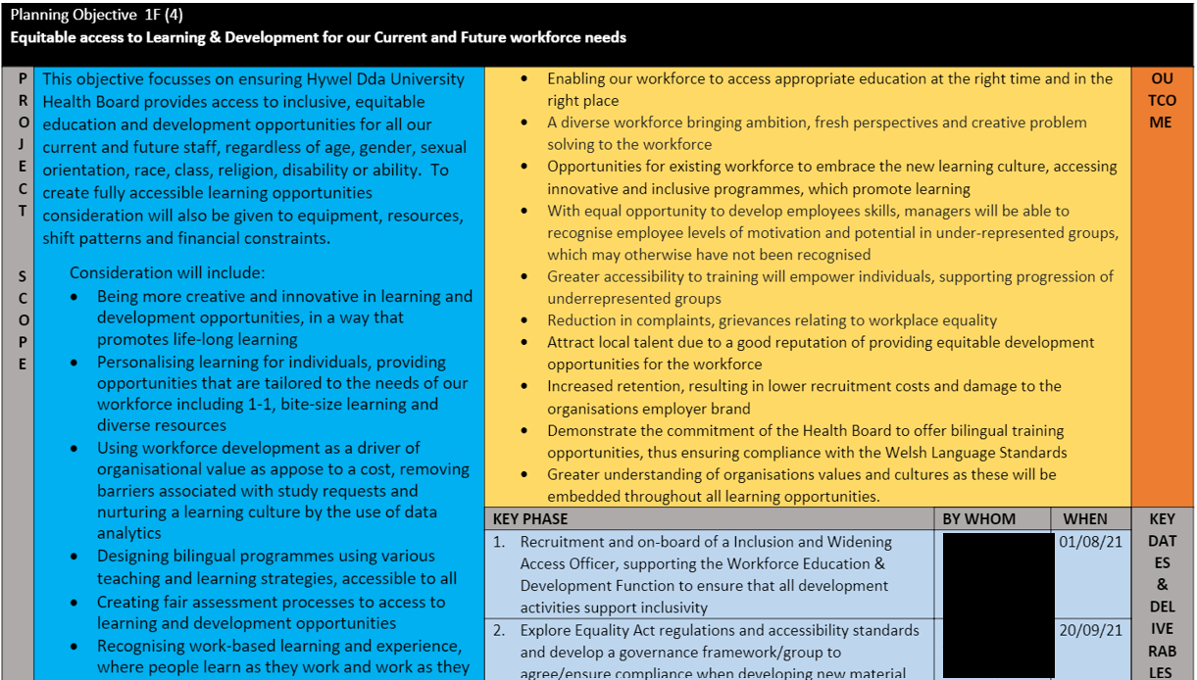

Evidence 3.2 – Notes of discussion with line manager

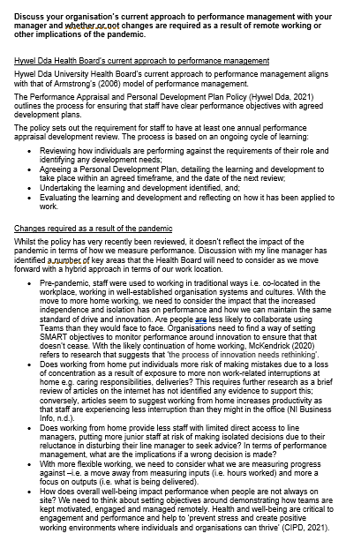

Evidence 3.3 – Email to Culture and Workforce Experience Manager with recommendations and response



