
Module name: Changemakers: Building your personal brand for sustainable employment.
Module code: BMHP5015
Student name: Daberechi Onyinye Eze
Lecturer name: Caroline Salami
Student ID:2232114
Date of submission:5thDecember 2025
Assignment Title: Part 1: Online portfolio

Table of content
Introduction…………………………………………………………………………….3
Reflection on unit: Ambition, Goal Setting, and Motivation…………………………3
Screenshot of set a career goals, self-determination…………………………………3.
Reflection on unit 2……………………………………………………………………….4
Screenshot of forum post on Networking Definition……………………………………4
Reflection on unit 3…………………………………………………………………………7
Reflection on unit 4………………………………………………………………………….8
Conclusion…………………………………………………………………………………….9
Reference………………………………………………………………………………………10

Introduction
Reflecting on my journey, I have come to realize that improving health and social care goes beyond individual effort—it relies heavily on collaboration and building meaningful connections. By expanding my network, I have gained access to current ideas, shared experiences, and valuable opportunities for growth. This module in mindset has encouraged me to see networking, brand , it’s a small world, opportunity knocks, and pursuit of happiness not as a task, but as a powerful tool for my learning and creating positive change within the sector (Downham et al., 2024).
Perspectives in health and social care involves critical examination of evolving health care models. Example current ideas, integrated care, technology driven enabled services, and their implications for professional practices, especially networking.
This process is important for adaption to a new dynamic environment and capitalising on new opportunities for improved patient outcomes and professional growth. My personal reflection on changing perspectives on healthcare:
- Enhancing self-awareness and adaptability.
- Fostering life – long learning and innovation.
- Improving collaborative practice.
what is ambition?
According to Maddau, 2016, ambition is a desire to achieve success in life. It is a desire like any other type of desire. A desire to achieve a personal or professional advancement. Ambition is to achieve fame, power, money, or position. It is important as it can strengthen my beliefs and give me the energy to navigate through obstacles. When a man is ambitious, it gives the person more courage to take calculated risk in pursuit of goals. That kind of silence and determination can be extremely critical for success in life (Maddux, 2016).
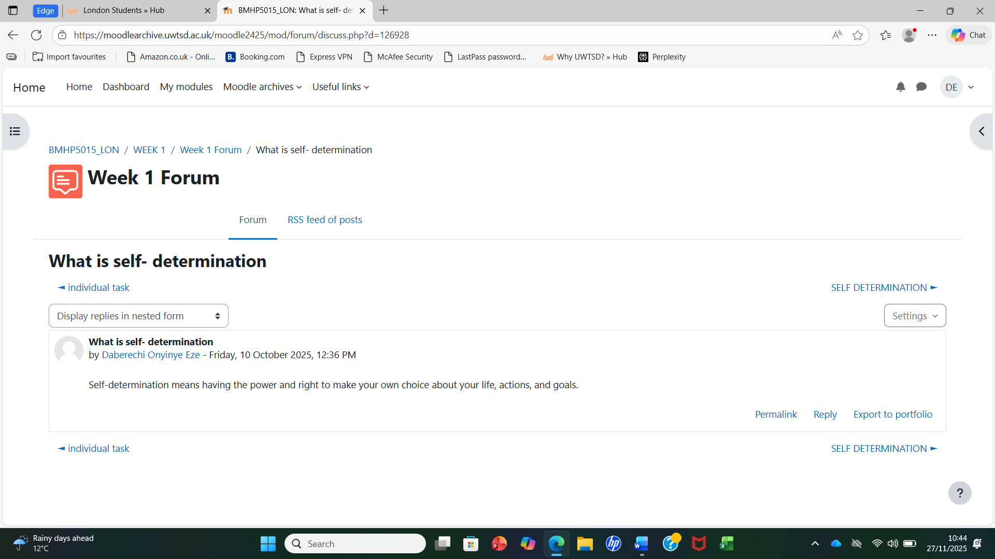
Ambition means having a powerful desire to achieve something meaningful or to improve oneself, often driving continuous effort and growth. It reflects a purposeful motivation to reach goals and to progress despite challenges. Having ambition encourages me to keep learning new skills and strive for excellence in the care I provide.
What is goal setting in health and social care

Goal setting is the process of defining desired outcomes and creating an action plan to achieve your goals or dreams (Bird et al.,2024). Defining goal setting involves finding specific aims, breaking them down into smaller, manageable steps, tracking my progression to stay motivated and focused. (Ogbeiwi, 2021). Example from health and social care (Care Assistant), visualising being a supervisor and later the manager someday. This activity helped me realise that I am motivated when I set clear goals for myself. This activity made me understand how driven I become when I have a goal to work toward. Setting goals ensures I stay organised, meet deadlines, and deliver consistent, high-quality care.
- Key components of goal setting
- Defining aims, by showing what I want to achieve.
- Creating an action plan which involves breaking down larger task or goals into smaller and achievable task.
- Establish a timeline to achieve my set out goals (Houston, 2019).
- Monitoring my progression which helps me stay motivated.
- Monitoring and focus help set my priorities, gives me a clear sense of purpose and direction.
Brief definition of motivation
Motivation is the psychological force that drive your ambition. It is the reason for acting or behaving in a particular way, and it is fuelled by one’s desires, needs, and goals. It plays a significant role in setting and achieving goals. It is a driving force that initiates, guides and keep goals-oriented behaviours (Peck, 2006). I want to work on setting realistic milestones to reach my long-term career goals. This task made me reflect on how planning my goals gives me direction and focus.
Define Networking
Networking is defined as a goal directed behaviour which occurs both inside and outside of an organisation and focusses on the creation, cultivating and using interpersonal relationships. Networking is influenced by different individuals, job, and organisational level factors and lead to increased visibility and power job performance. Organisational level factors can lead to access to strategic information and career success. Access to information and social capital are proposed as mechanism that helps the efforts of networking outcome (Gibson et al., 2014).

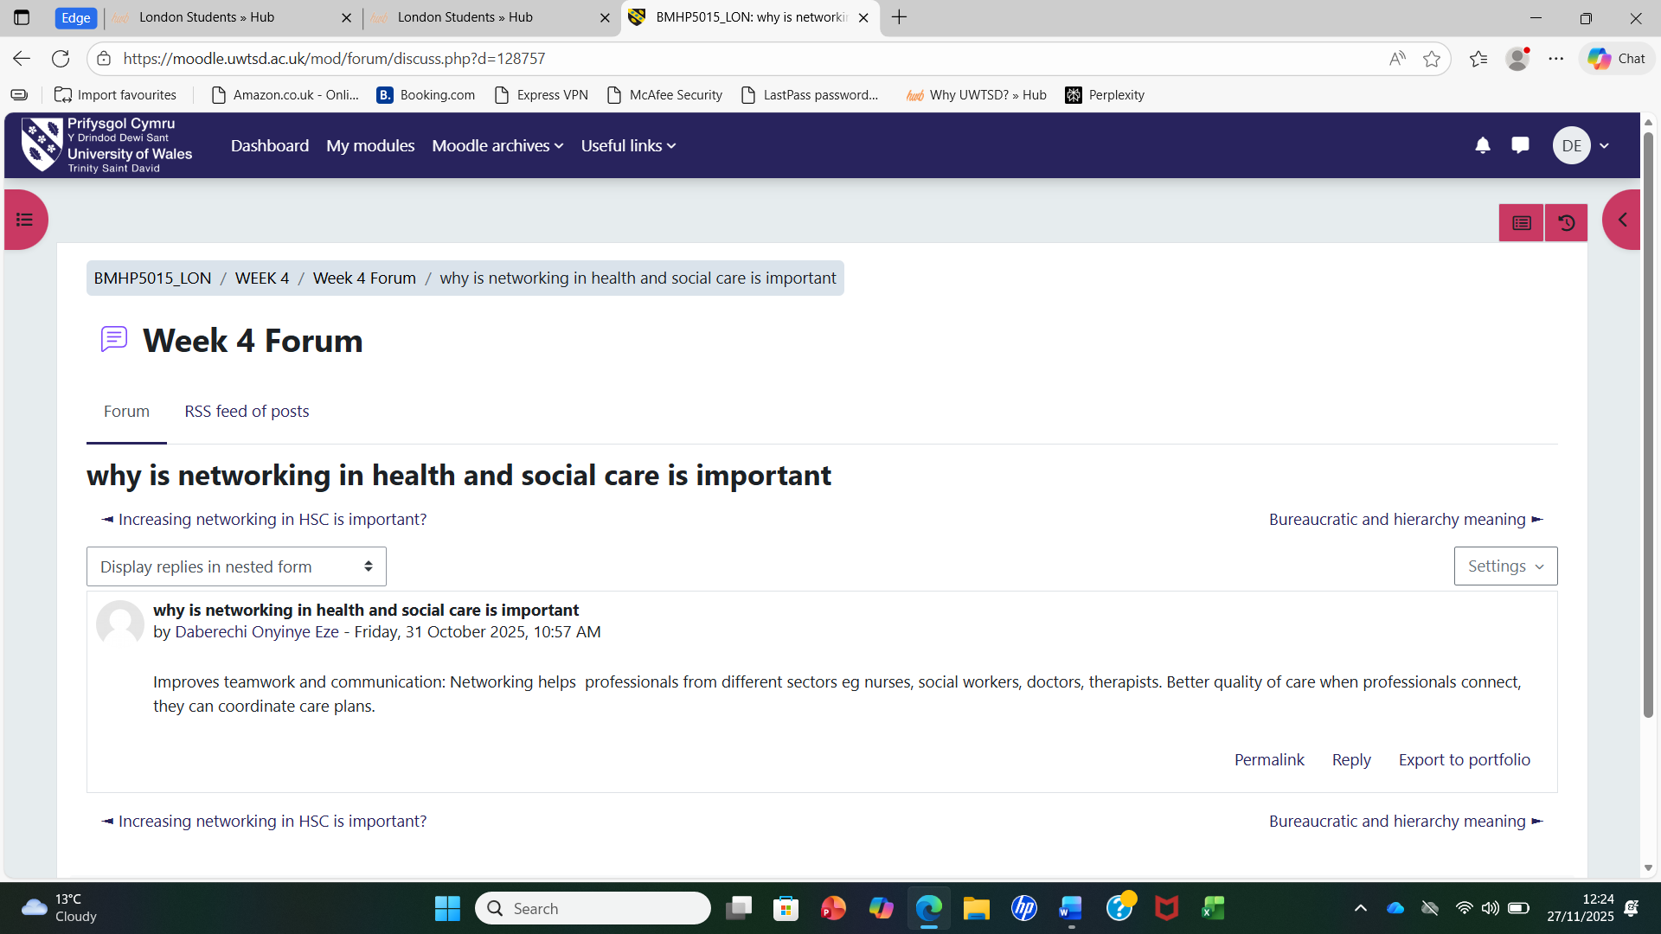
Networking Opportunities
Networking and collaborations in organisations and educational institutions are increasingly becoming popular (Peters,2010). Networking means building relationships with other professional colleagues, sharing information with people that are in the same profession or interest group. Networking among professional groups take different forms. One is talking to people at conferences, being active on LinkedIn, exchanging journals and engaging in conversations about your subjects on twitter. Networking is everywhere but it depends on one’s understanding of how they work and how to use them. In today’s interconnected world, everything is connected to everything else. Network and interconnectivity are everywhere like the social network for big cooperation and transport system (Marques et al., 2020). This activity made me understand how driven I become when I have a goal to work toward.
What is evaluation?
Evaluation is a method of appraising the quality and suitability of a resource and how it is especially useful to apply to its network. Evaluation can help one to develop awareness of value judgements for personal and professional development. These strategies can open opportunities for you and give you the connection to work with continuous from the small world of improvement. Evaluating personal and professional networks, allows you to review your activities, intentions and connections in goal-based evaluations, process-based evaluations, and outcome-based evaluations (Dickinson et al.,2016).
Importance of changing perspective in health and social care
According to Jason (2023) in his studies “Springers Nature” health and social care are at a cross road with implications on how service users’ needs are been met and how assessment encroaches on power and surveillance and the extent to which service users “voice” is been translated into the health and social care policy and practices that help them facilitate their independent and quality of life (Muhammad et al., 2023).
This study is one of the best to develop new perspectives from Foucault in the application of health and social care policy, theory, and practice. The book draws insight from gerontology as it relates to older people (Axel et al., 2025). Values and promotes better health for all. This broader outlook leads to compassionate.

What does stretch goal mean?
Stretch goals are those aims that prompts a company to achieve greater results beyond its expectations. Companies and organisations can make stretch goals to fulfil their mission, improve their performance, and increase their profits. In companies, team leaders decide if stretch goals are right for their projects as it can help in increasing their profits (Miller, 2025). One important example of stretch goals is the advantage of working on random projects to leading a project by the end of the year. Learning new financial platform by the end of the quarter or designing new advert materials than any other organisation (Indeed, 2025)

How website help in health and social care
Websites help the health and social care sector by providing the patients with information and tools to manage their health. They also offer access to guidance, resources, and efficient way to manage their task efficiently. Websites fasten or help communication through online appointments with hospital and self-referrals. Websites help the health and social care sector through professional development with access to research and best professional practice (Reeves et al., 2017). Websites provide health information e.g. NHA website, Service Access, patient stories and support for specific conditions.
What is grit?
According to Bashant (2014) in his journal for leadership and instruction. Grit is the quality that enables individuals to work hard. Grit is the combination of passion and perseverance for long term goals, standing for a determined and resilient approach to achieving success. It involves one consistently working hard and staying dedicated to the pursuit of happiness or result despite setbacks in the outcome. Key aspects of grit are passion and perseverance which is not a sprint but a marathon. It involves the maintenance of a consistent effort; grit involves a long-term goal which help to achieve a distant and challenging goal. Another key factor is resilience which enables individuals to overcome failures of life without giving up their commitments. Studies have found that grit is a predicator of various challenges of life such as performing well in your academic grades and graduating from high school (Burrell,2024).
How to improve on grit
Improvement on grit can come from two approaches which focuses on individual skills development and the creation of a supportive organisation. Professionals can get personal grit and resilience through mindfulness and self-care which involves physical activity, ensures adequate sleep, healthy eating and the practice of relaxation techniques. Grit allows and cultivates a growth mind on health and social care professionals whose views set back policy and see failures as temporary learning opportunities (DePierro et al.,2024). The improvement of grit helps health care professionals in the use of self – reflection practice which uses tools like reflective diaries to understand personal emotions, show stressors and evaluate progress towards goals. Improving grit on health and social care professionals can set out achievable goals, break the goals down in small barriers and into smaller manageable tasks.
While improving grit, health and social care professionals can seek support from colleagues, friends and families. Connecting with others helps put challenges into perspective and provide a crucial support system (DePierro et al.,2024).

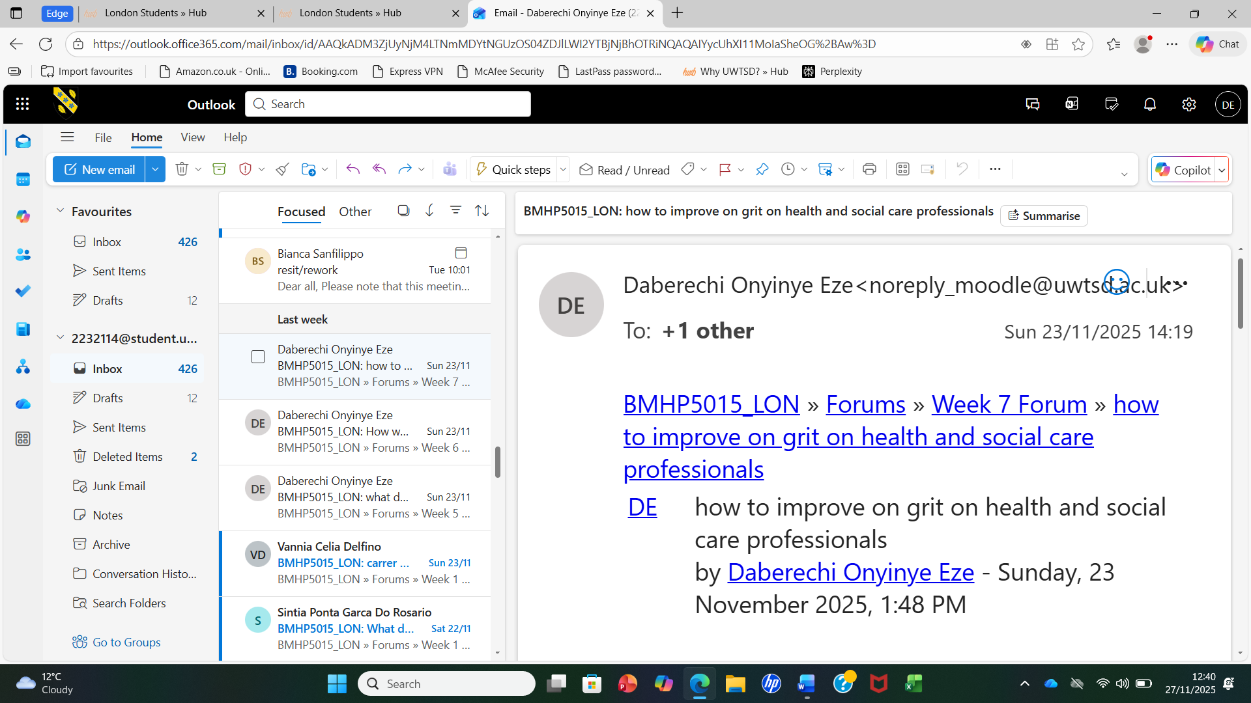

What is failure?
Failure is a social concept of not meeting a desirable or intended aim. Failure is opposite of success. The English Dictionary describes failure as when something is not working as it is supposed to work (Rundell, 2002). Collins English dictionary defined failure as the act or an instance of failing. A person or thing that is unsuccessful or disappointing (Szczepaniak, 2006).

Conclusion
This module has demonstrated that developing a personal brand involves ongoing reflection, skill refinement, and alignment between personal values and professional ambition. The experience has strengthened both confidence and clarity in professional identity, equipping me with the tools to enhance employability and contribute effectively to the evolving demands of health and social care settings.

Reference
Axel Kaehne and Feather, J. (2025). Handbook of Health Services Evaluation. Springer Nature. Dickinson, H. and O'Flynn, J., (2016). Evaluating outcomes in health and social care. Policy Press.
Bird, M.D., Swann, C. and Jackman, P.C. (2024) ‘The what, why, and how of goal setting: A review of the goal-setting process in applied sport psychology practice’, Journal of Applied Sport Psychology, 36(1), pp. 75–97.
Burrell, D.N. (2024). Leadership Action and Intervention in Health, Business, Education, and Technology. IGI Global.
Duckworth, A. (2016). Grit: The power of passion and perseverance. New York; London; Toronto; Sydney; New Delhi: Scribner.
Downham, L. and Cushion, C., (2024). Reflection and reflective practice in high-performance sport coaching: A heuristic device. Physical Education and Sport Pedagogy, 29(6), pp.601-620.
Gibson, C., H. Hardy III, J. and Ronald Buckley, M., (2014). Understanding the role of networking in organizations. Career Development International, 19(2), pp.146-161.
Ho, S.S., Sosina, W., DePierro, J.M., Perez, S., Khan, A., Starkweather, S., Marin, D.B., Sharma, V., Ripp, J.A., Peccoralo, L.A. and Charney, D.S., (2024). Promoting resilience in healthcare workers: A preventative mental health education program. International Journal of Environmental Research and Public Health, 21(10), p.1365.
Indeed (2025). Indeed. [online] Indeed.com. Available at: https://www.indeed.com.Assessed on 23rd of Nov 2025.
Maddux, J.E. (2016). Self-efficacy. In Interpersonal and Intrapersonal Expectancies (pp. 41–46). Routledge.
Marques, L., Martins, M. and Araújo, C., (2020). The healthcare supply network: current state of the literature and research opportunities. Production planning & control, 31(7), pp.590-609.
Miller, K. (2025). MORE Is Better. CRC Press.
Muhammad Waheed Akhtar, Poulova, P., Akbar, A., Huo, C. and Naz, S. (2023). The psychological outcomes for leadership and employees in the education sector. Frontiers Media SA.
Ogbeiwi, O., (2021). General concepts of goals and goal setting in healthcare: A narrative review. Journal of Management & Organization, 27(2), pp.324-341.
Peck, E., (2006). Leadership and its development in healthcare. Healthcare Management, p.323.
Peters, L.D., Johnston, W.J., Pressey, A.D. and Kendrick, T., (2010). Collaboration and collective learning: networks as learning organisations. Journal of Business & Industrial Marketing, 25(6), pp.478-484.
Reeves, S., Lewin, S., Espin, S. and Zwarenstein, M. (2017). Interprofessional teamwork for health and social care. New York, NY: John Wiley & Sons.
Rundell, M., 2002. Macmillan English Dictionary: The End of.
Szczepaniak, R. (2006). The Role of Dictionary Use in the Comprehension of Idiom Variants. de Gruyter.

