APPENDIX GA36a

LEVEL 4 ASSESSMENT SPECIFICATION

Student name: | Kewin Baranowski | Student ID number: | 1810551/1
Programme: | BSc (Hons) Computing Portfolio
Module: | Internet Technology and Security
Module code: | ACCA4018 | Contribution to Overall Module Assessment (%): | 50%
Lecturer: | Dr Carlene Campbell | Internal Verifier: | Dr Kemi Ademoye
Assignment Title: | Synthesize a solution to a potential real life scenario | Word count (or equivalent): | 2500
Submission deadline: | 10th January 2019 | Return date of provisional marks & written feedback:
Submission method: | All written assessments, where practical and possible, must be submitted via Turnitin unless otherwise instructed by the Lecturer. (Please DO NOT put this assessment specification into Turnitin or it will match many similarities with other students’ submissions.)  Alternative submission method (if applicable):  Late submission of the assessment will result in a late penalty mark. Penalties for late submission: Up to one week late, maximum mark of 40%. Over one week late, 0%. Only the Extenuating Circumstances Panel may approve a change to submission dates.
Academic honesty / referencing: | Academic honesty is required. In the main body of your submission you must give credit to authors on whose research and ideas your work is based. Append to your submission a reference list that indicates the books, articles, etc. that you have used, cited or quoted in order to complete this assessment.

Module Learning Outcomes
(from module syllabus)
- Demonstrate systematic understanding of security policies and measures to mitigate internal and external attacks and threats in a network.

TASK DESCRIPTION

Synthesize a solution to a potential real life scenario

Background:
The proliferation of mobile Internet devices such as laptops, tablets, smartphones, mobile phones, PDAs and even Satnavs is called IT consumerism. Because people use these mobile devices to connect to the Internet to make payments for services, email, blogging, social interaction, shopping, entertainment, research etc, there is immense pressure on IT managers and IT policy makers in corporate environments to allow employees, senior staff, and even clients of the companies to access their corporate networks using their personal mobile devices. The use of these personal Internet mobile devices to access corporate networks is called Bring your Own Device (BYOD) also referred to as Bring Your Own Technology (BYOT).

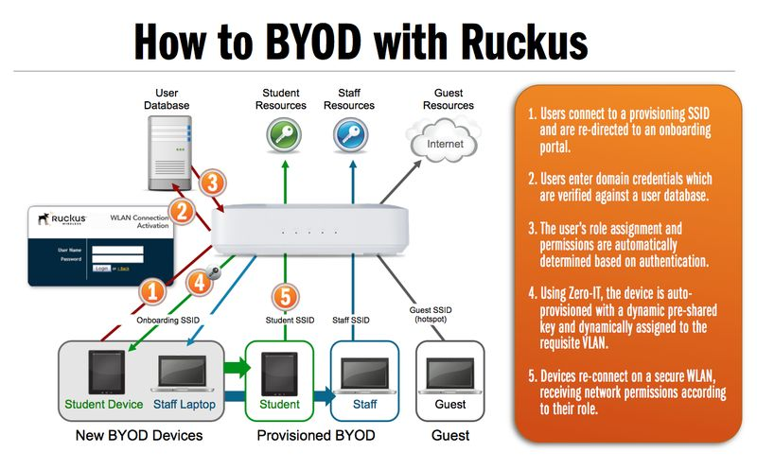
Figure 1: BYOD deployment at a corporate LAN.

Scenario:
Hyper-fort is a consultancy company specializing in the energy sector. Hyper-fort has extensive presence around the globe. The company uses cloud services to deliver IT services to its staff and clients. It is estimated that almost 95% of the company's network is wireless based. The company also has a massive online presence and social media presence to promote its activities.

Because of its large staff and customer base, the company has recently come under immense pressure to allow both its staff and customers to use their personal devices to access the company's network/resources. Security of personal staff's data and client's data is the company's major concern. The company is also concerned about protecting its intellectual properties, which is worth billions.

You are an IT Security Consultant hired by Hyper-fort to recommend guidelines on a comprehensive security policy that covers all aspects of its enterprise network, including online and offline resources.

You are asked to state all assumptions made in your report.

Task:
The principal feature of BYOT, which makes it attractive to users is that the user owns, maintains and supports their device. This poses so many security challenges to the data controllers at the enterprise network. The security of customer data, employee data, and intellectual properties is the main concern.

From the scenario given above, develop a comprehensive BYOT framework that covers all aspects of the company's enterprise network. This implementation must be submitted on Moodle.
- The framework should reflect your study stream this could include but not limited user policy, device management policy, security policy etc.
- A data flow diagram showing the implementation of your BYOT management architecture is required.
- Use appropriate software such as Cisco Packet Tracer or any other suitable tools to demonstrate the configuration of the Hyper-fort Ltd enterprise network.
  - The countermeasures employed for the implementation should demonstrate secured and restricted access to the company such as their services, email, blogging, social interaction, etc.
- Select a Mobile Device Management Software for your BYOT and explain the rationale for your choice.
- Write the advantages and disadvantages of BYOT (Think of increase in productivity as opposed to risks).

Your design should also assess the following issues and mitigate threats emanating from them when used in the proposed BYOT to be deployed at Hyper-fort.

- What type of data is retained by the mobile devices connecting to Hyper-fort network?
- What is the potential for data leakage when the participating devices leaves the office environment?
- How to address the blending of personal and business usage when devices are in office.
- What strategy to deploy to deal with different brands of devices.
- What strategy to deploy to deal with different Operating System platforms.
- What strategy to deploy to deal with different application on user devices.
- What mitigating strategy will be deployed when the owner of a participating device leaves their employment or the device is lost, stolen, or fails.

GUIDANCE FOR Students IN THE COMPLETION OF TASKS

Report Requirements:
- The report should be 2500-3000 words.
- The report should be typed and font size should be 12 Times New Roman.
- The lines or the bars in the same figures should use different line styles if they are not in colour.
- The figures should be clear enough so that all the captions will be clearly readable.
- You are required to produce a full progress and configuration of your network.

Report format:
- Abstract
- Introduction
- Related work (Research aspect/literature review focus)
- Problem formulation, if necessary (this will outline the problem that you will investigate and implement)
- Implementation (Discuss of the implementation through medium/method use e.g. simulation or practical experiment)
- Results/Findings & discussions
- Conclusion, recommendation and future work (From your findings what do you recommend, discuss or state these. What can be done in the future to improve on your findings will be the future work).

NOTE: The guidance offered below is linked to the five generic assessment criteria overleaf.

- Engagement with Literature Skills (15%)
Your work must be informed and supported by scholarly material that is relevant to and focused on the task(s) set. You should provide evidence that you have accessed an appropriate range of sources, which may be academic, governmental and industrial; these sources may include academic journal articles, textbooks, current news articles, organisational documents, and websites. You should consider the credibility of your sources; academic journals are normally highly credible sources while websites require careful consideration/selection and should be used sparingly. Any sources you use should be current and up-to-date, mostly published within the last five years or so, though seminal/important works in the field may be older. You must provide evidence of your research/own reading throughout your work, using a suitable referencing system, including in-text citations in the main body of your work and a reference list at the end of your work.

Guidance specific to this assessment: Your work must include articles published by peer reviewed journals, conference proceedings, books, and related website (e.g. IEEE, ACM, Science direct). Information from website such as how, wiki, forums, etc. will not be accepted.

Marks will be awarded for:
- Diversity of sources and materials used
- Key concepts discussed
- Appropriate summaries of articles and level of critical appraisal of literature
- Application of appropriate referencing conventions (9 marks allocated for proper and appropriate referencing)

- Knowledge and Understanding Skills (15%)
At level 4, you should be able to demonstrate knowledge of the underlying concepts and principles associated with your area(s) of study. Knowledge relates to the facts, information and skills you have acquired through your learning. You demonstrate your understanding by interpreting the meaning of the facts and information (knowledge). This means that you need to select and include in your work the concepts, techniques, models, theories, etc. appropriate to the task(s) set. You should be able to explain the theories, concepts, etc. to show your understanding. Your mark/grade will also depend upon the extent to which you demonstrate your knowledge and understanding.

Guidance specific to this assessment: On chosen topic, your work must demonstrate understanding of concepts and underlying principles. You should explain and analyse the scenarios you have derived for the company from your chosen topic in a meaningful way. The security policy you create will be the blueprint that dictates your scenarios for the campus.

This will be assessed by
- Depth of the research
- Strength of the statements
- Structure of the paper
- Quality of the report
- Following IEEE format

- Cognitive and Intellectual Skills (40%)
You should be able to present, evaluate and interpret qualitative and quantitative data, in order to develop lines of argument and make sound judgements in accordance with basic theories and concepts of your subject(s) of study. You should be able to evaluate the appropriateness of different approaches to solving problems related to your area(s) of study and/or work. Your work must contain evidence of logical, analytical thinking. For example, to examine and break information down into parts, make inferences, compile, compare and contrast information. This means not just describing what! But also justifying: Why? How? When? Who? Where? At what cost? You should provide justification for your arguments and judgements using evidence that you have reflected upon the ideas of others within the subject area and that you are able to make sound judgements and arguments using data and concepts. Where relevant, alternative solutions and recommendations may be proposed.

Guidance specific to this assessment: Your work must demonstrate critical analysis and evaluation of chosen technologies. Your work must also justify your choice and provide evidence that your choice is better than other methods.

This will be assessed by the quality of your comments and conclusions, throughout the report:
- Innovative approach used in designing a complete countermeasure solution for the campus.
- Key observations and impact identified to support security measures for future growth.
- Observations are well thought through and discussed
- Organisation of ideas and evidence
- Analysis of the findings

- Practical Skills (20%)
At level 4, you should be able to apply the basic underlying concepts and principles to evaluate and interpret these within the context of your area of study. You should be able to demonstrate how the subject-related concepts and ideas relate to real world situations and/or a particular context. How do they work in practice? You will deploy models, methods, techniques, and/or theories, in that context, to assess current situations, perhaps to formulate plans or solutions to solve problems, or to create artefacts. This is likely to involve, for instance, the use of real world artefacts, examples and cases, the application of a model within an organisation and/or benchmarking one theory or organisation against others based on stated criteria.

Guidance specific to this assessment: You must use software such as Packet Tracer, or any other suitable networking tools to demonstrate the network design you have adopted.

This will be assessed by the network or web/database model construction based on:
- The configuration of the infrastructure (LAN/WAN, WEB/DATABASE, etc. technology use)
- The countermeasures employed for the implementation
- Implementation of secured access and restricted access to the necessary site(s)
- Application used
- Protocol involved

- Transferable Skills for Life and Professional Practice (10%)
Your work must provide evidence of the qualities and transferable skills necessary for employment requiring the exercise of some personal responsibility. This includes demonstrating: that you can communicate the results of your study/work accurately and reliably, and with structured and coherent arguments; that you can initiate and complete tasks and procedures, whether individually and/or collaboratively; fluency of expression; clarity and effectiveness in presentation and organisation. Work should be coherent and well-structured in presentation and organisation.

Guidance specific to this assessment: You must submit a report which should be approximately 2,500 – 3,000 words in length. The report should be presented in an academic way (IEEE/ACM format) and therefore must include an abstract, an introduction, a conclusion and a list of references. The report must be submitted via Turnitin as well.

This will be assessed based on the written and presentational quality of your report:
- Flow
- Professionalism
- Comprehension (grammar and spelling)
- Completeness and presentation of report

Student FEEDBACK FORM

This section details the extent to which the assessment criteria are demonstrated by you, which in turn determines your mark. The marks available for each category of skill are shown. Lecturers will use the space provided to comment on the achievement of the task(s), including those areas in which you have performed well and areas that would benefit from development/improvement.

Generic Assessment Criteria | Marks available | Marks  awarded
1. Engagement with Literature Skills
.
There was engagement with an appropriate range of literature, including sources retrieved independently. Some over-reliance on texts rather than other sources. Referencing may show minor inaccuracies or inconsistencies. |  | 6
 | 15 | 6
2. Knowledge and Understanding Skills

Some knowledge of the basic underlying concepts and principles is accurate with a good understanding of the field of study but lacks depth and/or breadth. |  | 7
 | 15 | 7
3. Cognitive and Intellectual Skills

Limited attempt at evaluation of the underlying concepts and principles, tending towards description.  Can interpret qualitative and quantitative data but with some errors. Some evidence to support emerging arguments and judgements but these may be underdeveloped or with a little inconsistency / mis-interpretation. |  | 19.6
 | 40 | 19.6
4. Practical Application Skills

An adequate overview of the company’s network infrastructure designed using Packet Tracer given, with a detailed flow diagram showing the implementation of the proposed solution.  A good and appropriate application of basic methods, materials, tools and/or techniques. |  | 13
 | 20 | 13
5. Transferable Skills for Life and Professional Practice

Mostly coherent, organised and accurate work, in a suitable structure and is for the most part clearly expressed. Demonstrates the skills for employment requiring the exercise of some personal responsibility, with some areas of strength and some of minor weakness. |  | 5.5
 | 10 | 5.5

Assessment Mark (Assessment marks are subject to ratification at the Exam Board. These comments and marks are to give feedback on module work and are for guidance only until they are confirmed. ) | Late Submission Penalties (tick if appropriate) |  | 51.1%
 | Up to 1 week late (40% Max) |  | 51.1%
 | Over 1 week late (0%) |  | 51.1%

GENERIC ASSESSMENT CRITERIA

Level 4
In accordance with the Framework for Higher Education Qualifications, at the end of Level 4 students will be expected to have demonstrated knowledge of the basic underlying concepts and principles of a subject, and an ability to evaluate and interpret these within the context of that area of study. They should be able to present, evaluate and interpret qualitative and quantitative data in order to develop lines of argument and make sound judgements in accordance with basic theories and concepts of their subject(s) of study. They will have learned how to evaluate different approaches to solving problems, and will be able to communicate the results of their study/work accurately and reliably, and with structured and coherent arguments. They will be able to undertake further training and develop new skills within a structured and managed environment and will have the qualities and transferable skills necessary for employment requiring the exercise of some personal responsibility.

Level 4 | FAIL | MARGINAL FAIL | SATISFACTORY  (3rd / Pass) | GOOD  (2.2 / Pass) | VERY GOOD  (2.1 / Merit) | EXCELLENT  (1st / Distinction) | EXCEPTIONAL  (1st / Distinction)
Category | 0-29% | 30-39% | 40-49% | 50-59% | 60-69% | 70-84% | 85-100%
Engagement with literature (including reading, referencing,  academic conventions and  academic honesty) | Little or no evidence of reading and/or reliance on inappropriate sources.  Views and findings mostly unsupported and non-authoritative.  Referencing conventions used incoherently or largely absent. | Poor engagement with essential reading. No evidence of wider reading. Reliance on inappropriate sources, and/or indiscriminate use of sources. Heavily reliant on information gained through class contact. Inconsistent and weak use of referencing. | Engagement with a limited range of mostly relevant and credible sources but with some reliance on information gained through class contact. Some omissions and minor errors.  Referencing conventions evident though not always applied accurately or consistently. | Engagement with an appropriate range of literature, including sources retrieved independently. Some over-reliance on texts rather than other sources. Referencing may show minor inaccuracies or inconsistencies. | Engagement with a wide range of literature, including sources retrieved independently.  Selection of relevant and credible sources. Generally sound referencing, with no/very few inaccuracies or inconsistencies. | Engagement with an extensive range of relevant and credible literature. Consistently accurate application of referencing. | Exceptional engagement with an extensive range of relevant and credible literature. High-level referencing skills consistently applied.
Knowledge and understanding (Knowledge of the basic underlying concepts and principles of a subject.) | Major gaps in knowledge and understanding of the basic underlying concepts and principles of the subject matter. Inclusion of irrelevant material. Substantial inaccuracies. | Gaps in knowledge of the basic underlying concepts and principles, with flawed or superficial understanding. Some significant inaccuracies and/or irrelevant material. | Limited knowledge and understanding of the basic underlying concepts and principles within the subject area. Some elements may be missing. | Knowledge of the basic underlying concepts and principles is accurate with a good understanding of the field of study but lacks depth and/or breadth. | Competent knowledge of the basic underlying concepts and principles. Exhibits very good understanding. | Excellent knowledge and understanding of the basic underlying concepts and principles of the subject. | Exceptional, detailed knowledge and understanding of the basic underlying concepts and principles
Cognitive and intellectual skills  (Evaluate underlying concepts and principles of a subject and interpret qualitative and quantitative data in order to develop lines of argument and make sound judgements.) | Wholly or almost wholly descriptive work. Little or no evaluation of the underlying concepts and principles.  Failure to develop arguments, leading to illogical or invalid judgements. Minimal or no use of  evidence to back up views. | Largely descriptive work, with superficial evaluation of the underlying concepts and principles. Weak interpretation of data, flawed development of arguments and judgements. Information accepted uncritically, uses generalised statements made with scant evidence and unsubstantiated opinions. Ideas sometimes illogical and contradictory. | Limited attempt at evaluation of the underlying concepts and principles, tending towards description.  Can interpret qualitative and quantitative data but with some errors. Some evidence to support emerging arguments and judgements but these may be underdeveloped or with a little inconsistency / mis-interpretation. | Good evaluation of the underlying concepts and principles. Can interpret qualitative and quantitative data, with minor errors.  An emerging ability to use evidence to support the argument.  Mostly valid arguments and logical judgements. | Sound evaluation of the underlying concepts and principles. Can interpret qualitative and quantitative data accurately. Ability to devise arguments using evidence to make mostly appropriate and valid judgements. | Excellent evaluation of the underlying concepts and principles. Can interpret qualitative and quantitative data accurately and with some insight. Excellent ability to devise arguments using evidence and make appropriate and valid judgements. | Exceptional evaluation of the underlying concepts and principles based evidence. Outstanding interpretation of qualitative and quantitative data.  Exceptional ability to devise arguments using evidence and make wholly appropriate and valid judgements.
Practical skills  (Different approaches to solving problems in particular contexts.) | Limited or no use of taught, basic methods, materials, tools and/or techniques.  Little or no appreciation of the context of the application.  Very weak evidence of different approaches to problem-solving in particular contexts. | Rudimentary application of taught, basic methods, materials, tools and/or techniques but without consideration and competence. Flawed appreciation of the context of the application.  Weak evidence of different approaches to problem-solving in particular contexts. | An adequate awareness and mostly appropriate application of basic methods, materials, tools and/or techniques.  Basic appreciation of the context of the application.  Can identify problems in particular contexts and propose basic alternative approaches or solutions though there may be errors. | A good and appropriate application of basic methods, materials, tools and/or techniques.  Clear appreciation of the context of the application.  Good evidence of different approaches to problem-solving in particular contexts and proposes mostly appropriate solutions. | A very good application of a range of basic methods, materials, tools and/or techniques.  Very good consideration of the context of the application. Very good evidence of different approaches to problem-solving in particular contexts and proposes appropriate solutions. | An advanced application of a range of taught, basic methods, materials, tools and/or techniques.  The context of the application is well considered, and insightful.  Excellent evidence of different approaches to problem-solving in particular contexts and proposes appropriate solutions. | Exceptional levels of application and deployment skills in particular practical contexts. Outstanding identification of problems in particular contexts and formulation of wholly appropriate, thoughtful solutions / different approaches.
Transferable skills for life and professional practice  (Communicate the results of their study/work accurately and reliably, and with structured and coherent arguments; the qualities needed for employment requiring the exercise of some personal responsibility within a structured and managed environment.) | Work is poorly structured, disorganised, inaccurate and/or confusingly expressed. Very weak use of language and/or very inappropriate style. Failure to work effectively individual or as part of a group. Little or no evidence of the skills for employment requiring the exercise of some personal responsibility. | Work is poorly presented in a disjointed manner. It is loosely, and at times incoherently, structured, with information and ideas often poorly expressed. Weak use of language and/or inappropriate style. Flawed approach to individual or group work, meeting only partial obligations to others. Limited evidence of the skills for employment requiring the exercise of some personal responsibility. | Mostly ordered presentation and structure in which relevant ideas / concepts are reasonably expressed. Work may lack coherence and/or accuracy in places. Can work as part of a group, meeting most obligations to others but perhaps with limited involvement in group activities.  Demonstrates the basic skills for employment requiring the exercise of some personal responsibility, with some areas of minor weakness. | Mostly coherent, organised and accurate work, in a suitable structure and is for the most part clearly expressed. Can work effectively independently and/or as part of a team, with clear contribution to group activities.  Demonstrates the skills for employment requiring the exercise of some personal responsibility, with some areas of strength and some of minor weakness. | Work is accurate, coherent, fluent, well-structured and organised.  Can work effectively independently and/or as part of a team, with very good contribution to group activities. Demonstrates very good skills for employment requiring the exercise of some personal responsibility, with just occasional minor weakness. | Work is coherent, very fluent and is presented professionally. Can work effectively independently and/or as part of a team, with an excellent contribution to group activities. Demonstrates excellent skills for employment requiring the exercise of some personal responsibility with an appetite for further development. | Work is accurate, exceptionally coherent, very fluent and presented well. Can work effectively independently and/or as part of a team, with an exceptional contribution to group activities. Demonstrates exceptional skills for employment requiring the exercise of some personal responsibility with an appetite for further development.

Kewin Baranowski 1810551
HND IT: Information Technology and Security - Synthesize a solution to a potential real-life scenario
23/04/2019

Contents
Abstract 1
Introduction 1
Policies 1
User Policy 1
Internet and E-Mail 1
Downloads 1
Privacy 1
Accounts and Passwords 2
Copyright 2
Viruses 2
Copyright and License Agreements 2
Home and Mobile Use 2
Device Management Policy 2
Security Policy 2
Implementation 3
Flowchart 3
Mobile Device Management Software 3
Network Demonstration 3
Conclusion 4
References 4

Abstract
Hyper-fort Ltd requires a BYOT system in order to allow users to safely connect to their network, employees and customers will be using their devices to access the company’s network and or resources. They require a user policy, a device management policy, as well as a security policy so that the system can work efficiently and safely. A flowchart of the BYOT system can be found which goes over all the processes which will take place. The mobile device management software that will be used will be Cisco Meraki, as it is a secure software which can work with a wide variety of devices and operating systems.
Good

Introduction
Hyper-fort Ltd is expanding, its large staff and customer base has put the company under a lot of pressure and they require a Bring Your Own Technology (BYOT) system which will allow both their customers and employees to access the company’s network. They are looking policy guidelines which will help them create an efficient system while all of the customer data, employee data, and intellectual properties are kept safe. They will require a trustworthy Mobile Device Management Software to help them achieve this, all of this will be explained using a diagram created in Cisco Packet Tracer and a flowchart explaining the processes of the system.
Good

Policies

User Policy
A user policy is a policy which requires all users and representatives of a company to responsibly use IT equipment and data while protecting it and keeping it safe, though the rules and responsibilities included in this policy may vary widely for different companies. Some companies may include rules about the internet and e-mail usage, downloads, privacy, accounts and passwords, copyright, viruses, software copyright, license agreements, home and mobile use.
Good

Internet and E-Mail
In terms of internet and e-mail usage some companies may limit their users to only use these things to forward the company, so employees will only be allowed to use the internet in a respectful and appropriate manner. This could mean that for example, the employees are only allowed to send email and research things related to their work, and they may not be allowed to access online games or video sites or send inappropriate/personal emails. This would also mean they are not allowed to use the internet for any sort harmful or illegal reasons as this could really hurt the company.
Good

Downloads
Employees shouldn’t be allowed to change any crucial data the company holds whenever they feel like it, therefore rules are in place to make sure people aren’t wrongfully downloading and changing data. Employees may not be allowed to download, modify, delete or add any data or applications in either a harmful or illegal manner as this could damage the company or mess with its data.
Good

Privacy
Any information sent out or received over the network and e-mail are counted as property of the business, the business can then have the right to read, inspect and intercept the data if they believe that it is justified that the data included could be harmful. They could even add a rule which makes it so that any form of communication (text, video, audio, images etc.) can be disclosed to the police without the need of consent from the recipient or the sender.
Good

Accounts and Passwords
Companies only want authorised employees to have access to confidential data on the system, therefore these company computer systems have to by protected by access controls. So only certain employees will be able to access certain parts of the systems data, meaning people with important roles such as admins will be able to view, control and modify more data than standard office employees.
Good

Copyright
When sending over any works which belongs to other individuals or business’ the sender must make sure they include the original author’s name and give them full credit for the work. Otherwise if employees accidentally or intentionally use other people’s work without acknowledging and stating that its not theirs, they could get into legal trouble for attempting to steal their work.
Good

Viruses
Companies could also introduce some rules in terms of how to handle or prevent computer viruses, this could be by doing things such as not allowing employees to plug any sort of USB devices into the company machines, intentionally downloading/spreading viruses onto company systems. They could also set some precautions such as having employees tell them if they are suspicious of having a virus on any of the workstations and must power off the device as soon as they find out, this is done so that the issue can be resolved with as fast and as easily as possible.
Good

Copyright and License Agreements
Within the company when working with paid software and applications employees must make sure that all software on the company’s machines must have the appropriate licenses. If any software does not have its required license to prove it was purchased and downloaded illegally, then the company could be exposed to civil and or criminal liability.
Good

Home and Mobile Use
When employees are able to take company systems home (such as laptops or tablets) then there must be some rules about how they take care of these machines and the data stored on them. When employees are out in public they must be careful with others seeing their screen as they could accidentally show some information off to people which could damage the company or give them access into the system if they were to show something off such as a username and password. So, the employees should have to report immediately if they know any information was exposed to someone, or if they lost a company device or if it was stolen.
Good

Device Management Policy
A device management policy could set standards and rules and even restrictions for end users using devices on a company’s network. This can apply to a wide variety of devices including smartphones, tablets, laptops, e-readers and more. That companies can do is tell their employees the best way to keep their devices safe and secure, the best way employees can look after important personal or company data would be by; keeping the software up to date, report loss or theft of device as soon as possible, use a secure PIN, try not to connect to any public networks, backup your device, and encrypt your device.
Good

Security Policy
A security policy must be in place especially for an IT-based company as they really need to secure their data and make sure it is kept as safe as possible by all employees. Usually the main goals within an IT security policy are known the CIA, this stands for Confidentiality, Integrity, and Availability as this is what the policy tries to preserve. This means that confidentiality is about protecting data from any unauthorised entities trying to access it, integrity is about making sure that modifying any data is done is a correct and authorised way, and lastly availability is about users being able to access important data at any given time.
Good
There is a real lack of referencing.

Implementation

Flowchart
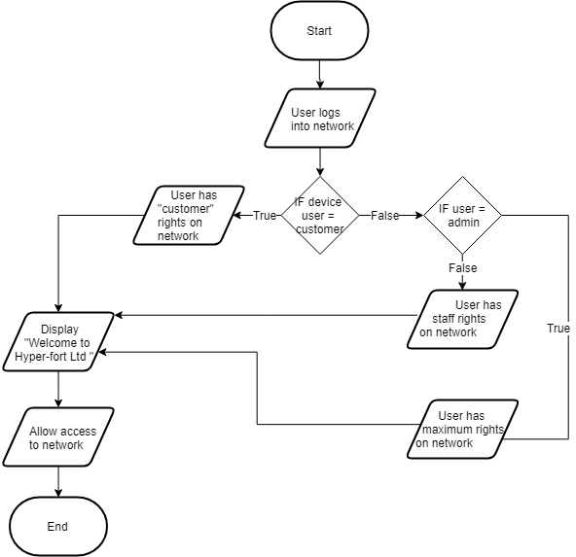
Good

Mobile Device Management Software
The Mobile Device Management Software that will be used for this BYOT system will be “Cisco Meraki”, it is a software which allows all users to stay safe while being able to use a wide variety of devices and operating systems such as iPads, Androids, Macs, and PCs. It is a software which includes a secure support for BYOD and allows you to quickly analyse network activity with automatic reporting which will be very useful for admins. You can view an entire network from a user-friendly central dashboard, and even gives you features such as enforcing devices security policies, deploying software and apps, diagnostics and more.
Good

Network Demonstration
The system will look like the diagram below, there will be the main company server which will be connected to a router and switch which will have all the devices the employees are using such as phone, printer, and personal computers which can be used for company database or website. This switch will also be connected to a wireless router which will customers and employees will be able to connect to, all users will be able to connect their mobile devices to this router such as laptops, tablets, smartphones, and more.
Good
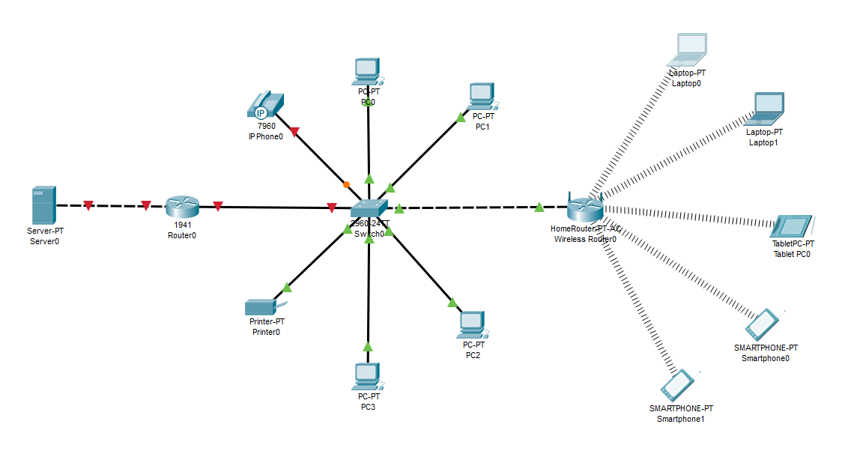
Good

Conclusion
In conclusion Hyper-fort Ltd needs to get a BYOT system as their customer base and number of employees are constantly on the rise and more accessibility is needed within the network. Doing so will allow staff members to be more efficient at work and will give them many new features, and customers will be happy as they will be able to use their devices within the facility easily and securely. The policies included in this report will allow the company to maintain the best possible BYOT system as they cover everything ranging from user policies to security.
Good
Unfortunately, Kevin you have not included a definition / advantages and disadvantages of the BYOD process which was required and there was a lack of referencing, or at least numbering the references displayed at the bottom of the report.
No real strategies or future growth were analysed and overall it lacked any real details or links to case studies etc.

References
[1] IT End User Policy [Online Source] [https://www.axiomatic.co.za/wp-content/uploads/2016/08/Information-Technology-IT-End-User-Policy.pdf]
[2] Mobile Device Management Policies [Online Source] [https://drivestrike.com/mobile-device-management-policy-examples/]
[3] Device Management Policy [Online Source] [https://inside.trinity.edu/information-technology-services/it-policies/device-management-policy]
[4] a [Online Source] [Created: 3 April 2018] [Author: Teena Maddox] [https://www.zdnet.com/article/how-to-write-a-good-security-policy-for-byod-or-company-owned-mobile-devices/]
[5] What is an IT Security Policy [Online Source] [https://www.paloaltonetworks.com/cyberpedia/what-is-an-it-security-policy]
[6] 20 Best Mobile Device Management Software in 2019 [Online Source] [Last Edited: 29 April 2019] [https://financesonline.com/mobile-device-management/]

