University of Wales Trinity Saint David

Wales Institute of Science and Art


Project Planning

Engineering Management (ACHA5012)

Chloe Rees
2218480
October 2024
Table of Contents
Introduction 3
Roles and Responsibilities 4
Project Manager: Myself (2218480) 4
Aerodynamics: Ryan Boardman (2203353) & Catriona Burn (2203239) 4
Mechatronics and Control systems: Charlie Jones (2103718) & Connor Casey (2103540) 4
Vehicle Simulation: Munty Rahman (2112510) 5
Mechanical and Structural design: Joe Howard (2100922) & Tomos Cole (2205508) 5
Personality Traits 5
Belbin’s Model 6
Action Oriented Roles: 6
People Oriented Roles 6
Problem Solving Roles 7
My Scores: 7
Overall Group Tasks and Timings 8
My Tasks and Timings 9
Preliminary Bill of Materials 11
Specialised Equipment 11
Project Milestones 12
My Milestones and Gateway Objective 14
Two Areas of Concern with My Section 14
Gantt Charts 15
Project Gantt Chart 15
Personal Gantt Chart 15
References 16
List of Tables 16
Table of Figures 16

Introduction
For our group project we must design, test and create a small model of an active rear wing for the Morgan in the university workshop. As a team consisting of 8 members, we all have our own responsibilities to create an effective active rear wing design. We each have our own roles to look at that include a Project Manager, Aerodynamics, Mechatronics and Control systems, Vehicle Simulation and Mechanical and structural design. We are doing this in hopes to improve the performance of the Morgan and build a full-scale wing to put on the Morgan. The projects’ objective includes producing an effective aerodynamic active rear wing. We will be measuring success by ensuring that we stick to the regulations, making sure that we meet deadlines, and the budget is not exceeded.

Roles and Responsibilities
There are 5 roles that include:

Project Manager: Myself (2218480)
- Ensure the team is working efficiently.
- Group Organisation.
- Meetings and Documentation.
- Time and Resource Management.
- Budget and Cost Responsibilities.
- Progress Monitoring and Intervention.
- Working with Team Sub-groups.

Aerodynamics: Ryan Boardman (2203353) & Catriona Burn (2203239)
- Create an effective and aerodynamic active rear wing.
- Look at aerodynamic simulation of the wing on the Morgan.
- Complete a CFD analysis using ANSYS.
- Test the scale model in the wind tunnel.

Mechatronics and Control systems: Charlie Jones (2103718) & Connor Casey (2103540)
- Component Selection for Full Scale and Prototype Designs.
- Generation of Control Algorithms to control wing movement.
- Design of Systems to meet control test requirements and wing angle set by Simulation and Aerodynamics Group.
- Using Various Data Handling and Programming Options.

Vehicle Simulation: Munty Rahman (2112510)
- Test how effective the rear wing is by conducting a simulation of the Morgan on track.
- Using OptimumLap, VIGrade and BPS softwares.
- Look at overall lap times and performance improvements.

Mechanical and Structural design: Joe Howard (2100922) & Tomos Cole (2205508)
- Mechanical Design Considerations.
- Designing the Components to match requirements of other areas.
- Testing FEA using SolidWorks or ANSYS.
- Manufacturing Considerations
- Material Selection
- Scale Prototype

Personality Traits
As stated as above my responsibilities for being project manager include organising team meetings to make sure that the team is in communication together weekly, time keeping ensuring that tasks are being completed, looking after the team by maintaining clear communication, identify any potential project risks that might occur and monitor that the budget isn’t being exceeded.
The skills needed to be a project manager include leadership as it is important to motive the team, organisation skills to ensure the team is on track with their tasks and able to multitask. Communication within the team is extremely important as everyone needs to know what is happening with different tasks. Time and risk management skills is also needed as the manager will need to know when to prioritise certain tasks and being able to see any potential risks that might occur and how to mitigate the risk. The ability to plan is also important as meetings need to be planned and when to start tasks (Gurnov, 2024).
Motivation and enthusiasm are a great personality trait needed to be a project manager as most times team member can become unmotivated quickly with the task they are doing and need a positive attitude to get back on track. Also, resilience as a project manager can have a challenging time and it’s important to remain focused.

Belbin’s Model
By doing the Belbin’s Model Test, it’s a great way to see your team management skills and also an effective way to assess the relative strengths and weaknesses of a team (Cambridge, 2016). Established in 1981 by Meredith Belbin, the Belbin Model Test is widely used to support team development. There are 9 team roles personalities (Belbin, no date):

Action Oriented Roles:
Implementer
Strengths- Well organised and predictable and can take basic ideas and makes them work in practice.
Weaknesses- Can be slow and inflexible.

Shaper
Strengths- Have lots of energy and challenging others to move forward.
Weaknesses- Prone to provocation and can offend others.

Complete Finisher
Strengths- Sees the task through to the end and perfects the work.
Weaknesses- Can worry too much and not trust others.

People Oriented Roles
Coordinator
Strengths- A respected leader who helps everyone in the team.
Weaknesses- Can be controlling.

Team Worker
Strengths- Good listener and cares for the individuals in the team.
Weaknesses- Avoids confrontation and indecisive.

Resource Investigator
Strengths- Explores opportunities and outgoing.
Weaknesses- Over-optimistic and lose interest quickly.

Problem Solving Roles
Plant
Strengths- Solves difficult problems, creative and imaginative.
Weaknesses- Have poor communication skills and may ignore details.

Monitor Evaluator
Strengths- Sees all options and thinks carefully.
Weaknesses- Lacks the ability to inspire others.

Specialist
Strengths- Provide specialist knowledge and skills.
Weaknesses- Tends to be disinterested in all other areas.

My Scores:
In order to find your team management skills, you have 7 sections and, in each section, there are 8 statements. You are allocated 10 points that you must distribute through the 8 statements in each section to which statement best suits you.

Implementer- 11 (Average)
Shaper- 7 (Low)
Complete Finisher- 8 (High)
Coordinator- 9 (Average)
Team Worker- 12 (Average)
Resource Investigator- 9 (Average)
Plant- 8 (Average)
Monitor Evaluator- 6 (Average)
Specialist- 8 (Average)

By looking at my scores we can see that I have an average score throughout the whole test, apart from complete finisher where I am above average and shaper where I am below the average score. Throughout the project I must try on improving my shaper trait and look at also improving most of my traits to above average.

Overall Group Tasks and Timings
Task | Start Date | Duration | Finish Date | Hours
Group Allocation | 7/10/24 | 3 Days | 9/10/24 | 6
Team Meetings | 7/10/24 | 72 Days | 17/3/25 | 2 hours each meeting
Risk Analysis | 7/10/24 | 8 Days | 15/10/24 | 16
Initial Sketches | 14/10/24 | 28 Days | 11/11/24 | 56
Study of Regulations | 7/10/24 | 7 Days | 14/10/24 | 14
Aerodynamic Research | 14/10/24 | 42 Days | 25/11/24 | 84
Materials Research | 24/10/24 | 1 Day | 25/10/24 | 2
CAD Design | 11/11/24 | 21 Days | 2/12/24 | 42
Interim VIVA Presentation Preparation | 30/11/24 | 7 Days | 7/12/24 | 12
Interim VIVA | 10/12/24 | 1 Day | 10/12/24
Stress Analysis | 3/12/25 | 38 Days | 10/2/25 | 76
CFD and Aerodynamic Tests | 10/2/25 | 14 Days | 24/2/25 | 28
Prototype Production | 25/2/25 | 6 Days | 3/3/25 | 12
Prototype Assembly | 25/2/25 | 6 Days | 3/3/25 | 12
Wind Tunnel Testing | 3/3/25 | 7 Days | 10/3/25 | 14
Component Selection | 21/3/25 | 41 Days | 1/12/24 | 82
Control Systems Design | 2/12/24 | 42 Days | 13/1/25 | 84
Produce Software and Control Systems | 24/2/25 | 17 Days | 10/3/25 | 34
Test Code and Control Systems | 10/3/25 | 4 Days | 14/3/25 | 8
Tuning of System | 14/3/25 | 3 Days | 17/3/25 | 6
Vehicle Simulation Tests | 3/12/24 | 111 Days | 24/3/25 | 222
Project Evaluation | 18/3/25 | 10 Days | 28/3/25 | 20
Final VIVA Presentation Preparation | 21/3/25 | 7 Days | 28/3/25
Final VIVA | 1/4/25 | 1 Day | 1/4/25 | 1
Total | 7/10/24 | 172 Days | 28/3/25 | 818
Table 1- Overall Project Tasks
Table 1 is the group’s overall timings for all the task we need to do throughout the project. We started on the 7th of October 2024 and plan on finishing on the 1st of April 2025. It is expected that we will eventually hit a wall with a task, and it will take more time than estimated to complete, however we may also complete a task before the estimated deadline.

My Tasks and Timings
Being the project manager, my roles are very different compared to the other roles in the team.
Tasks | Start Date | Duration | Finish Date | Hours
Group Allocation | 7/10/24 | 3 Days | 9/10/24 | 6
Project Meetings and Documentation | 7/10/24 | 72 Days | 17/3/25 | 144 (2 Hours Each Meeting & 1 Hour Write-up)
Risk Analysis | 7/10/24 | 8 Days | 15/10/24 | 16
Tasks and Scheduling | 10/10/24 | 6 Days | 16/10/24 | 12
Interim VIVA Presentation Preparation | 30/11/24 | 7 Days | 7/12/14 | 14
Interim VIVA | 10/12/24 | 1 Day | 10/12/24 | 1
Cost and Budgeting | 20/1/25 | 76 Days | 28/3/25 | 20
Final VIVA Presentation Preparation | 21/3/25 | 7 Days | 28/3/25 | 14
Final VIVA | 1/4/25 | 1 Day | 1/4/25 | 1
Table 2- My Overall Tasks
My responsibilities as project manager are to ensure that the project tasks are running smoothly and ensuring that everyone is working as a team. I will document every meeting that occurs, so we can look back at what has been said during the meetings.
I will have to organise the scheduling of tasks within the different subgroups to make sure that task deadlines are being met and they start the task with enough time to complete it. Group meetings are organised every week to monitor what progress team members have made within the week and what tasks can now be started. A group Gantt chart has been created so that the group is able to view it and look at when tasks should be finalised by. Taking to each member of the group and coming up with rough starting and finishing dates for each task did take 6 days, as dates needed to be changed so it could match with other tasks and had to make sure that overlapping tasks were achievable.
A risk analysis will also be looked at and developed as with every project there are risks that can occur. It is important to identify any potential risks early on in the project, as mitigation strategies can then be developed before the tasks has started, some potential risks that can occur is going over budget, making an ineffective active rear wing or not finishing a task on time. it is then essential to look at ways the risk can be mitigated and plan ways to manage and avoid these risks effectively. This should all take me and the group 8 days to think of realistic risks that can occur in every section of the project.
Creating the project presentation will take 7 days as concise important information about each section but also designing the template for the presentation as it needed to be formal

Preliminary Bill of Materials
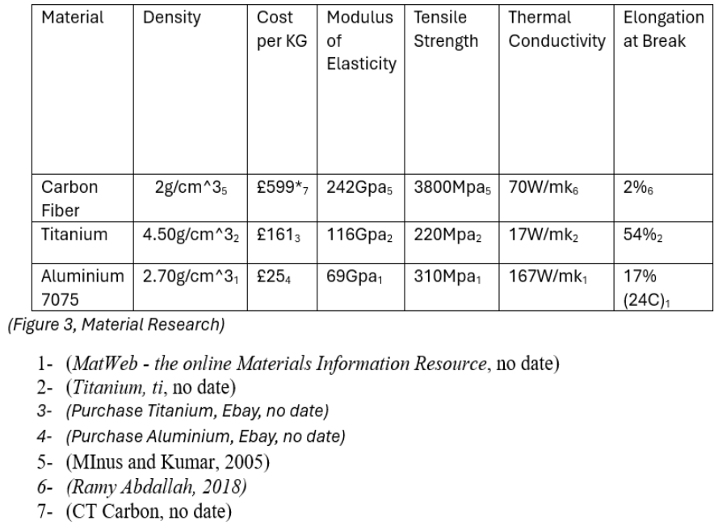
The figure below is the materials research that was done by the mechanics and structure team.
Figure 1- Group Materials Research.

Specialised Equipment
This is the specialised equipment needed for the project.
Equipment | Reason
Computer | Allow me to document meeting and task progress.
Excel | To create the Gantt Chart for the project.
Excel | Managing the budget and spendings.
Solidworks | In Order to design the rear wing.
ANSYS | Using to look at the structure and materials analysis of the wing.
Matlab | To do the code software for the wing activation.
OptimumLap | Look at the vehicle simulation.

Project Milestones
Throughout the project we have identified 10 milestones and 7 of those we consider to be major achievements, as those are the tasks that will take the longest and take the most amount of effort to complete.
At the start of the project, we began with agreeing on an active rear wing design idea. This was completed on the 11th of November; by doing this it will give us enough time to change the design if anything goes wrong.
Aerodynamic research will start on the 14th of October and should roughly take 42 days if everything runs smoothly. The Materials research was quickly completed on the 24th of October only taking one day.
The first major group milestone would be to create a CAD design of the wing using SolidWorks, this is essential as it will allow the aerodynamic and simulation group to carry out analysis of the aerodynamic profile of the wing and a performance simulation of the wing on the Morgan.
Creating a presentation to look at our recent progress and any challenges that has occurred and presenting it for the interim VIVA is our next milestone. The completion of the presentation will start on the 30 of November and should definitely be finished by the 7 of December, this will allow 7 days for everyone to add their research to the slides and then it will be presented in the following week.
After the interim VIVA we will start a stress analysis on the wing, this will show us any weak point and how much load can be put on the wing under pressure. We have allowed ourselves 38 days to do this, as this is a task that we might see problems which means that the mechanical and aerodynamics team would have to redesign and do another stress analysis on the wing. This is something that will get repeated as it’s important to have a strong product.
The CFD and aerodynamic testing will hopefully start on the 10/2/25 on the same day the stress analysis has finished. This should hopefully take the aerodynamic group two weeks to complete, we decided to add a few extra days to this task in order to give them enough time to change anything that is needed, this will take the project up to the 24th of February.
Starting the prototype production and assembly will be a big achievement for the whole team as that is when we will see our product for the first time. The start of the production will begin on the 25 of February and the end of the assembly will be on the 3rd of March, giving us 12 days to complete the whole prototype. When the time comes this may be a bit too ambitious as it might take longer, or we might be able to finish it sooner than expected.
The wind tunnel testing will ideally start either on the same day as the assembly has finished or on the following day. This will mean that the aerodynamic bulk of the project will consistently start and finish on a new task. The aerodynamic team has given themselves a week to conduct the testing and analysis, this section should be then completed on the 10th of February.
The milestones for the mechatronics team will be to produce the software and control systems and then test the code and the control systems. The first production of the system will start on the 24th of February and end on the 10th of March, this will give the team 17 days to get started. The testing of the code and control system will start straight after they have finished producing on the 10th of March and we expect this to take roughly 4-5 days to be finalised. With all going well we hope that they can start earlier than expected as this will give them even more time to complete the task.
On the 3rd of December the vehicle simulation test will begin, this will also be a big milestone for the team as we can see how good our design wing is on the Morgan around a track. Right now, as a team we have it aimed to take 111 days and therefore ending on the 24th of March. However, we feel like this can be completed in a shorted amount of time.
Our final milestone is the final VIVA, this will be end of our project, hopefully by then we would have completed everything, and this is where we will show all our progress that we have done.

My Milestones and Gateway Objective
One personal milestone of my role in the group project would be to complete the project time charts, as this is a task that may take a while as it can be difficult to set start dates and when it needs to be finished by. I hope to do this without many issues or setbacks. I will aim to get this completed 75% done before any major tasks needs starting, as the later tasks will only be able to start when others are finished. The other 25% will get started on before the second bulk of tasks start so they will have guidance of dates.
A gateway objective is used as a step forward in project to lead onto a new task, without the gateway objective being completed the project cannot move forwards. It is important that I make sure the project planning is completed as this can be considered a gateway objective. I will need to look at the start and end dates of tasks, the budget and resources. Without this being done the team cannot move forward as they would not know when to start.

Two Areas of Concern with My Section
As project manager there are many situations that could go wrong when conducting a project. one area of concern in my section would be budgeting. It is very easy to run away with many ideas and solutions that will then increase the spending. This could also in turn lead to delays and resource strain on the certain section. This may prevent another task from being completed to its full potential as money would have been spent somewhere else. To mitigate this from happening each section should have a certain amount of money to spend.
My second area of concern is team communication and coordination. It is important to have a team that we have clear communication, and that team is working together effectively. Miscommunication can lead to errors in the team, members confused with what needs to be done and inefficiencies. To avoid this, it is important that I document what has happened in meetings and what has been said about tasks, as this can avoid duplicated work. Clear communication within the team is essential and that we have one main way to communicate with everyone.

Gantt Charts

Project Gantt Chart
This is the project Gantt Chart showing dates from when we started on the 7th of October to 1st of December:
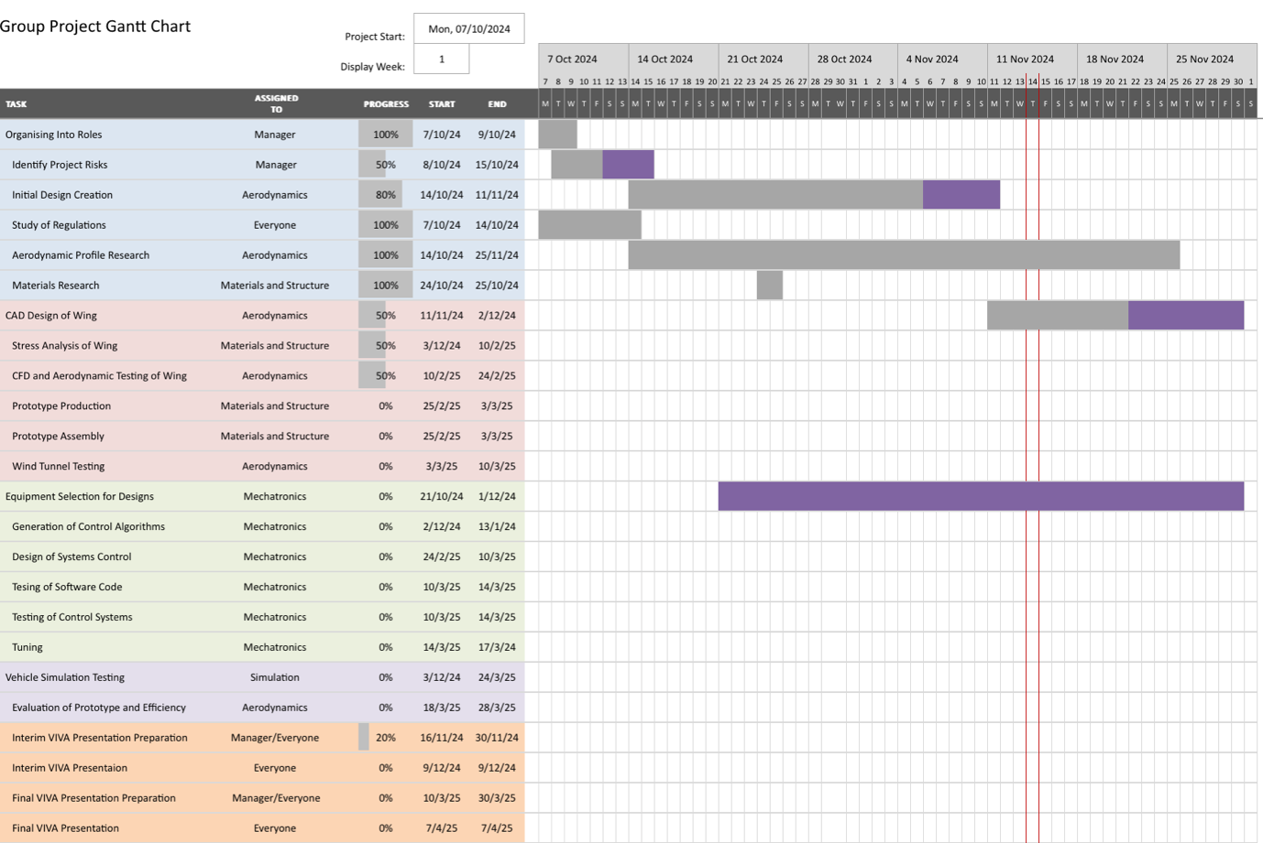
Figure 2- Group Gantt Chart.

Personal Gantt Chart
This is my personal Gantt Chart:
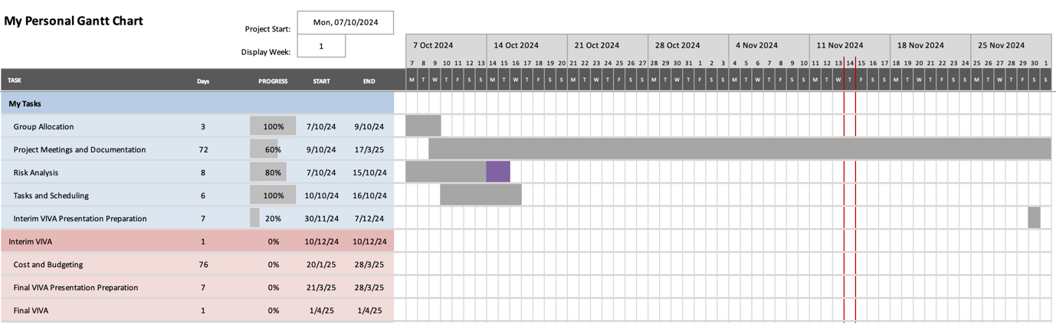
Figure 3- My Gantt Chart.

References
Belbin, no date. belbin. [Online]
Available at: https://www.belbin.com/about/belbin-team-roles
Cambridge, U. O., 2016. IFM. [Online]
Available at: https://www.ifm.eng.cam.ac.uk/research/dmg/tools-and-techniques/belbins-team-roles/#:~:text=An%20effective%20way%20to%20assess,tools%20to%20support%20team%20building.
Gurnov, A., 2024. What Are Project Management Skills?. [Online]
Available at: https://www.wrike.com/project-management-guide/faq/what-are-project-management-skills/

List of Tables
Table 1- Overall Project Tasks 8
Table 2- My Overall Tasks 9

Table of Figures
Figure 1- Group Gantt Chart. 13
Figure 2- My Gantt Chart. 13

Word Count:2922

