Assignment 1

Kalan Hughes
1902299

Higher National Diploma: Computing (Web Development)
OOP and Advanced Software Development (Algorithms)
3 May 2021

Table of Contents
Introduction 2
Part A 3
1: 3
2: 4
3: 6
Part B 7
1: 7
2: 8
Part C 9
Conclusion 9
Appendix 10
Connect 4 Code Listing: 10
References 14

Introduction
This document will contain information regarding a variety of different things. First, in Part A, the document will talk about the benefits and drawbacks of both arrays and linked lists. The document will then talk about whether arrays or linked lists should be used for a certain scenario. The document will also contain a binary tree for a bunch of different values. In Part B, a graph will be created using Djkstra’s algorithm. There will also be a section which evaluates the performance of O(EV²) and O(E log V). In Part C, the Minimax algorithm will be talked about. A game of Connect 4 will also be created.

Part A

1:
This section is going to talk about the benefits and drawbacks of arrays and linked lists. The first one that will be talked about is arrays. There are many benefits and drawbacks of using arrays. One benefit of arrays is the search time [1]. Arrays have a constant search time. Any element in an array can be found as long as you know the index of the element by adding an offset to the address of the first element. This is one benefit of using arrays. Another benefit of arrays is that it helps to save memory [2]. This is because you are able to allocate memory dynamically. This means that you can always make sure that your array is using the sufficient amount of memory needed to run the array. The third benefit of arrays is that it allows you to reuse code [2]. This is because arrays can be reused multiple times after being declared once. It uses a single variable to represent multiple values. This is the third benefit of using arrays. The fourth benefit of using arrays is multi-dimensional arrays [2]. This is a benefit because you can easily calculate the total number of elements in a multi-dimensional array by multiplying the size of all of the dimensions. The final benefit of arrays is zero-length arrays [2]. This is a benefit because when they are used, the allocated structures do not use any memory. These are some of the benefits of using arrays.
There are also some drawbacks of using arrays. The first drawback of using arrays is that they have a fixed size [3]. This means that if you want to add more elements to the array, you would be unable to as you cannot increase the size of the array once it has been created. Another drawback of arrays is storing objects [4]. This is a drawback as you are unable to store different types of objects in an array. They have to be the same type of objects. The third drawback of using arrays is modifying elements [4]. This is because if you want to change an element, you have to go all the way through the array which can take a lot of time. The fourth drawback of using arrays is that memory can be wasted [1]. This is because if you allocate a certain amount of memory to the array but you do not use all of the memory, the remaining memory will be wasted. The final drawback of using arrays is that an element cannot be inserted into the middle of an array [5]. You are also not able to delete any elements that are in the middle of the array. These are some of the drawbacks of using arrays.
The next thing that will be talked about is linked lists. There are many benefits and drawbacks of using linked lists. One benefit of linked lists is that it is a dynamic data structure [6]. This means that you do not have to specify the size of the linked list unlike an array. Another benefit of linked lists is that no memory is wasted [6]. This is because the size of the linked list can increase and decrease during the run time. This means that no memory is wasted unlike arrays. The third benefit of linked lists is that inserting and deleting elements is easy [6]. This is because you can just update the address that is present in the next pointer of a node. This makes it easy to insert and delete elements unlike arrays. The fourth benefit of linked lists is implementation [6]. This is because it is easy to implement data structures like queues and stacks. The final benefit of linked lists is access time [7]. This is a benefit because the linked list can be accessed quickly without any memory overhead. These are just some of the benefits of linked lists.
There are also some drawbacks of linked lists. One drawback of linked lists is that it requires more memory than arrays [7]. This is because each node that is in the linked list contains a pointer which means that it requires more memory. Another drawback of linked lists is traversal [6]. This is because if you want to access a node that is in the middle of the list, you have to go through all of the nodes that come before it. This can take a lot of time. The third drawback of linked lists is reverse traversal [6]. This is because more memory is required for the pointer [7]. The fourth drawback of linked lists is random access [8]. This is because the linked list uses dynamic memory allocation which means that random access is not possible. The final drawback of linked lists is cache locality [9]. Linked lists have no cache locality which means that the run time of the linked list is increased. These are some of the drawbacks of using linked lists.
In conclusion, there are many benefits and drawbacks of using arrays and linked lists. Depending on the situation, it may be better to use one instead of the other.

2:
This section is going to talk about whether an array or a linked list should be used if you wish to record thousands of new names which are being inserted every day.
If you want to record thousands of new names which are being inserted every day, you should use a linked list. There are a few reasons why a linked list should be used instead of an array. One reason why a linked list should be used is because it has a dynamic data structure. This means that you will not have to worry about setting the size of the linked list as you will be able to enter thousands of names every day without having to worry about filling the linked list. If you used an array, you would have to set the size of the array when creating it. This would be a problem because if the array is not big enough, you would be unable to increase the size of the array which means that you would not be able to record any more names. Another reason why a linked list should be used is because no memory is wasted. This is because the size of the linked list can increase and decrease during the run time. This means that no memory is wasted. However, if you had an array which had a certain amount of memory allocated to it but you did not use all of the memory, the remaining memory would be wasted. The final reason why a linked list should be used instead of an array is because it is easy to implement and delete elements. This is useful because it allows you to easily implement thousands of new names every day. It also allows you to easily delete names if you need to. These are just some of the reasons why a linked list should be used instead of an array.
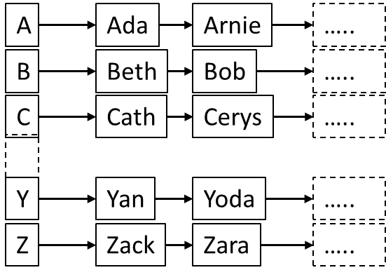

Above is an example of a hybrid approach. This is an array which contains linked lists. This data structure would provide a good performance. This is because you are getting the benefits of using an array and linked lists. Using an array of linked lists allows you to organise all of the names in alphabetical order. For example, this means that all of the names which start with K, would go into the linked list full of names which starts with K. This can help to make the process of recording thousands of names more organised and it would be easier for the user. However, one problem that comes with using this hybrid approach is that one linked list could be significantly bigger than the others. For example, the linked list that contains all of the names that start with H may be a lot bigger than the rest. This means that if you wanted to look at the names beginning with I, you would have to go through all of the names that begin with H. This would take a lot of time. Linked lists also use a lot of memory. This means that there would be a lot of memory which is being used because you would have multiple linked list for each letter of the alphabet. This could be an issue as you may run out of memory.

3:
This section is going to demonstrate how a binary tree is constructed for the values 34, 6, 7, 18, 45, 12, 3, 26. There will also be a section that talks about why it is important to maintain a balanced binary tree.

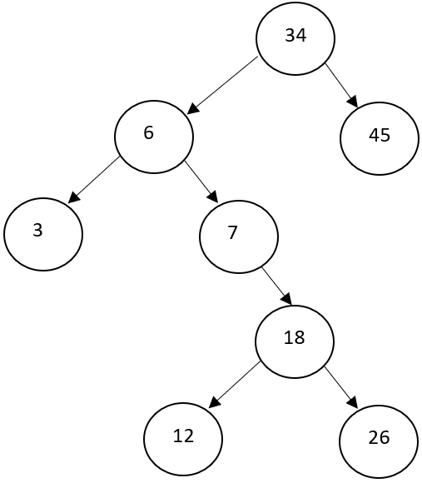

Above is the binary tree that was created for the values 34, 6, 7, 18, 45, 12, 3, 26. The first number was 34 which makes it the root node which is why it is at the top. The second number was 6. 6 is smaller than 34, so it went to the left of it. The third number was 7 which is bigger than 6, so it went to the right of it. The fourth number was 18 which was bigger than 7, so it went to the right of it. The fifth number was 45. This was bigger than 34 so it went to the right of it which made it a leaf. The sixth number was 12 which was smaller than 18, so it went to the left of it. The seventh number was 3 which was smaller than 6, so it went to the left of it. The final number was 26 which was bigger than 18, so it went to the right of it. This is how the binary tree was constructed for the values.
It is important that you maintain a balanced binary tree. This is because it allows you to ignore irrelevant values [10]. This can help to make it easier and faster to find a specific value as you can ignore all of the values that are either smaller or bigger than the value you are looking for. For example, if you are looking for the value 24 and you have a root node which has a value of 15, you would know to look at all of the values to the right of the root node because the branch to the right of the root node will contain all of the values which are bigger than 15 which would include the value 24. This would mean that you would not have to waste your time looking in the branch to the left of the root node as you know that all of values in the left branch will contain values smaller than 15 which would all be irrelevant to the value that you are looking for. This is why it is important to maintain a balanced binary tree.

Part B

1:
This section is going to contain information about Djkstra’s algorithm. It will contain a directed graph that demonstrates how the lowest cost can be calculated. A table will be provided to show how each step was produced.
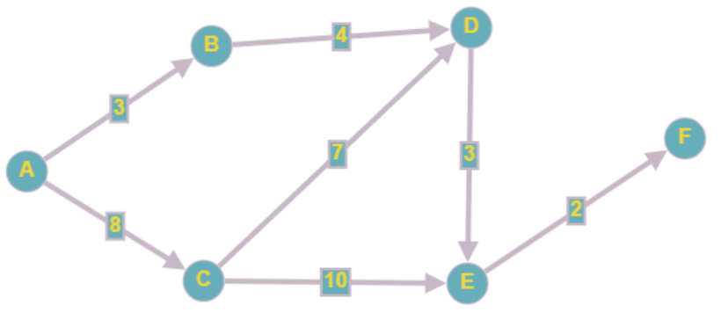
Above is the directed graph that was created to demonstrate how the lowest cost can be calculated. There are three ways that you can get from A to F which is the start and the end of the graph.
The first way is A-B-D-E-F. This means that you will be making four trades which would come to a total cost of 12.
The second way is A-C-D-E-F. This means that you will be making four trades which would come to a total cost of 20.
The final way is A-C-E-F. This way results in the least number of trades with only three trades. However, it has a total cost of 20.
This means that the path with the lowest cost is A-B-D-E-F as it has a cost of 12 while the other two paths have a cost of 20. Below is the table that was created to illustrate each step of the graph. There are 6 steps because there are 6 items. These items are labelled from A to F.
 | Vertex | A | B | C | D | E | F
Start | Parent | null | null | null | null | null | null
 | Cost | 0 | ∞ | ∞ | ∞ | ∞ | ∞
1 | Parent | null | A | A | null | null | null
 | Cost | 0 | 3 | 8 | ∞ | ∞ | ∞
2 | Parent | null | A | A | B | null | null
 | Cost | 0 | 3 | 8 | 7 | ∞ | ∞
3 | Parent | null | A | A | C | C | null
 | Cost | 0 | 3 | 8 | 15 | 18 | ∞
4 | Parent | null | A | A | B | D | null
 | Cost | 0 | 3 | 8 | 7 | 10 | ∞
5 | Parent | null | A | A | B | D | E
 | Cost | 0 | 3 | 8 | 7 | 10 | 12
6 | Parent | null | A | A | B | D | E
 | Cost | 0 | 3 | 8 | 7 | 10 | 12

2:
This section is going to contain information regarding the performance of O(EV²) and O(E log V). The performance of both approaches will be evaluated by creating and plotting two graphs. The number of vertices will increase from 1 to 12.
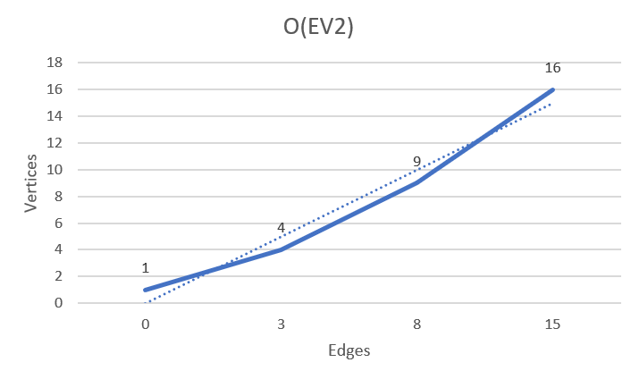

Above is the graph that was created for O(EV²). There was a total of 16 vertices and 15 edges. There is a steady increase as the vertices and edges go up. This shows that the performance for O(EV²) is a steady incline.

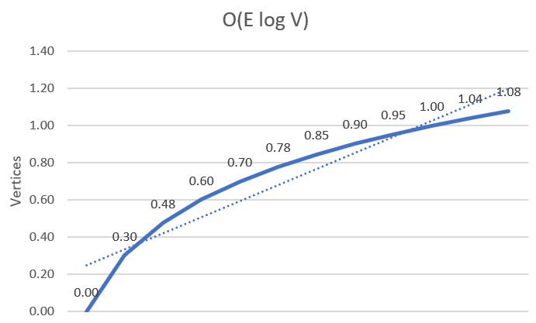

Above is the graph that was created for O(E log V). There was a total of 12 vertices and 11 edges. There is a faster increase as the vertices and edges go up. This shows that the performance for O(E log V) has a faster performance than O(EV²).

Part C

This section is going to contain a brief description of what the Minimax algorithm is and how it works. This section will also contain code in the appendix that demonstrates how the Minimax algorithm can be used to play the game Connect 4.
The Minimax algorithm is an algorithm that tries to find the best possible move in a game [11]. This algorithm is typically used in two player games like tic-tac-toe and connect 4. The Minimax algorithm uses a backtracking approach to decide on the best possible move. The algorithm then takes two players. The first player is the min, and the second player is the max. The algorithm uses the first player to pick the minimum value. The algorithm uses the second player to pick the maximum value. This is what the Minimax algorithm is and how it works.
In the appendix, you can find the code that was created to demonstrate how the Minimax algorithm can be used to play the game Connect 4.

Conclusion
In conclusion, this document has discussed a variety of different things. It has talked about the benefits and drawbacks of both arrays and linked lists. It has also talked about if an array or linked list should be used for a specific scenario. A binary tree was also created for a set of values.
Djkstra’s algorithm was also used to create a directed graph to demonstrate how the lowest cost path could be calculated. A table was also created to show these steps. There were two graphs which were created to evaluate the performance of O(EV²) and O(E log V).
Finally, the Minimax algorithm was talked about and code was created to demonstrate how the Minimax algorithm can be used to play a game of Connect 4.

Appendix

Connect 4 Code Listing:
using System;
using System.Collections.Generic;

class GFG
{
class Move
{
public int row, col;
};

static char player = 'x', opponent = 'o';

// If there are moves remaining on the board
// the function returns true. If there are no moves left to play
// it returns false.
static Boolean isMovesLeft(char[,] board)
{
for (int i = 0; i < 6; i++)
for (int j = 0; j < 6; j++)
if (board[i, j] == '_')
return true;
return false;
}

static int evaluate(char[,] b)
{
// This checks the rows for X or O to see if there is a winner.
for (int row = 0; row < 6; row++)
{
if (b[row, 0] == b[row, 1] &&
b[row, 1] == b[row, 2] &&
b[row, 2] == b[row, 3] &&
b[row, 3] == b[row, 4] &&
b[row, 4] == b[row, 5] &&
b[row, 5] == b[row, 6])
{
if (b[row, 0] == player)
return +10;
else if (b[row, 0] == opponent)
return -10;
}
}

// This checks the columns for X or O to see if there is a winner.
for (int col = 0; col < 6; col++)
{
if (b[0, col] == b[1, col] &&
b[1, col] == b[2, col] &&
b[2, col] == b[3, col] &&
b[3, col] == b[4, col] &&
b[4, col] == b[5, col] &&
b[5, col] == b[6, col])
{
if (b[0, col] == player)
return +10;

else if (b[0, col] == opponent)
return -10;
}
}

// This checks the diagonals for X or O to see if there is a winner.
if (b[0, 0] == b[1, 1] && b[1, 1] == b[2, 2] && b[2, 2] == b[3, 3] && b[3, 3] == b[4, 4] && b[4, 4] == b[5, 5])
{
if (b[0, 0] == player)
return +10;
else if (b[0, 0] == opponent)
return -10;
}

if (b[0, 6] == b[5, 1] && b[5, 1] == b[4, 2] && b[4, 2] == b[3, 3] && b[3, 3] == b[2, 4] && b[2, 4] == b[1, 5])
{
if (b[0, 6] == player)
return +10;
else if (b[0, 6] == opponent)
return -10;
}

// Else if there is no winner, return 0.
return 0;
}

// This is the minimax function. It considers all
// the possible ways the game can go and returns
// the value of the board
static int minimax(char[,] board,
int depth, Boolean isMax)
{
int score = evaluate(board);

// If Maximizer has won the game
// return his/her evaluated score
if (score == 10)
return score;

// If Minimizer has won the game
// return his/her evaluated score
if (score == -10)
return score;

// If there are no more moves and
// no winner then it is a tie
if (isMovesLeft(board) == false)
return 0;

// If this maximizer's move
if (isMax)
{
int best = -1000;

// Traverse all cells
for (int i = 0; i < 6; i++)
{
for (int j = 0; j < 6; j++)
{
// Check if cell is empty
if (board[i, j] == '_')
{
// Make the move
board[i, j] = player;

// Call minimax recursively and choose
// the maximum value
best = Math.Max(best, minimax(board,
depth + 1, !isMax));

// Undo the move
board[i, j] = '_';
}
}
}
return best;
}

// If this minimizer's move
else
{
int best = 1000;

// Traverse all cells
for (int i = 0; i < 6; i++)
{
for (int j = 0; j < 6; j++)
{
// Check if cell is empty
if (board[i, j] == '_')
{
// Make the move
board[i, j] = opponent;

// Call minimax recursively and choose
// the minimum value
best = Math.Min(best, minimax(board,
depth + 1, !isMax));

// Undo the move
board[i, j] = '_';
}
}
}
return best;
}
}

// This will return the best possible
// move for the player
static Move findBestMove(char[,] board)
{
int bestVal = -1000;
Move bestMove = new Move();
bestMove.row = -1;
bestMove.col = -1;

// Traverse all cells, evaluate minimax function
// for all empty cells. And return the cell
// with optimal value.
for (int i = 0; i < 6; i++)
{
for (int j = 0; j < 6; j++)
{
// Check if cell is empty
if (board[i, j] == '_')
{
// Make the move
board[i, j] = player;

// compute evaluation function for this
// move.
int moveVal = minimax(board, 0, false);

// Undo the move
board[i, j] = '_';

// If the value of the current move is
// more than the best value, then update
// best/
if (moveVal > bestVal)
{
bestMove.row = i;
bestMove.col = j;
bestVal = moveVal;
}
}
}
}

Console.Write("The value of the best Move " +
"is : {0}\n\n", bestVal);

return bestMove;
}

// Driver code
public static void Main(String[] args)
{
char[,] board = {{ 'x', 'o', 'x' },
{ 'o', 'o', 'x' },
{ '_', '_', '_' }};
Move bestMove = findBestMove(board);
Console.Write("The Optimal Move is :\n");
Console.Write("ROW: {0} COL: {1}\n\n",
bestMove.row, bestMove.col);
}
}

References

[1] | H. Krohn, “Linked Lists vs. Arrays,” 2 July 2019. [Online]. Available: https://towardsdatascience.com/linked-lists-vs-arrays-78746f983267. [Accessed 29 April 2021].
[2] | A. Singh, “Advantages Of Array,” [Online]. Available: https://www.educba.com/advantages-of-array/. [Accessed 29 April 2021].
[3] | Prabhas, “Advantages and disadvantages of arrays in Java,” 7 February 2018. [Online]. Available: https://www.tutorialspoint.com/Advantages-and-disadvantages-of-arrays-in-Java. [Accessed 29 April 2021].
[4] | K. Kasyap, “What are the drawbacks of the arrays in Java?,” 2 August 2019. [Online]. Available: https://www.tutorialspoint.com/what-are-the-drawbacks-of-the-arrays-in-java. [Accessed 29 April 2021].
[5] | “Advantages and Disadvantages of Arrays in C#,” [Online]. Available: https://dotnettutorials.net/lesson/advantages-and-disadvantages-of-arrays-csharp/. [Accessed 29 April 2021].
[6] | N. Mishra, “Advantages and Disadvantages of Linked List,” [Online]. Available: https://www.thecrazyprogrammer.com/2016/11/advantages-disadvantages-linked-list.html. [Accessed 29 April 2021].
[7] | admin, “Advantages and Disadvantages of Linked List,” 5 October 2020. [Online]. Available: https://www.tutorialandexample.com/advantage-disadvantage-linked-list/#:~:text=%20Advantages%20of%20Linked%20List%20%201%20The,a%20certain%20time%20without%20memory%20overhead.%20More%20. [Accessed 29 April 2021].
[8] | “Advantages and Disadvantages of Linked List,” 28 December 2020. [Online]. Available: https://www.geeksforgeeks.org/advantages-and-disadvantages-of-linked-list/#:~:text=%20Disadvantages%20Of%20Linked%20List%3A%20%201%20Memory,due%20to%20its%20dynamic%20memory%20allocation.%20More%20. [Accessed 29 April 2021].
[9] | S. Agwor, “What are the disadvantages of linked lists?,” [Online]. Available: https://www.quora.com/What-are-the-disadvantages-of-linked-lists. [Accessed 29 April 2021].
[10] | J. Hudgens, “Why do Binary Search Trees Have to be Balanced?,” 16 August 2016. [Online]. Available: https://www.crondose.com/2016/08/binary-search-trees-balanced/. [Accessed 30 April 2021].
[11] | P. Pedamkar, “Minimax Algorithm,” [Online]. Available: https://www.educba.com/minimax-algorithm/. [Accessed 30 April 2021].

