
APPENDIX GA36d
LEVEL 7ASSESSMENT SPECIFICATION

Student name: | Simranjeet Kaur | Student ID number: | 2106253
Programme: | MSc Programme
Module: | Postgraduate Research Method
Module code: | ACFA7004 | Contribution to Overall Module Assessment (%): | 100%
Lecturer: | Chris House | Internal Verifier:
Assignment Title: | Research Proposal | Word count (or equivalent): | 6,000 word(including ethic form)
Submission deadline: | Tuesday 29th March 2022 (Research Proposal Report and Ethics form) | Return date of provisional marks & written feedback: | 20/04/22
Submission method: | All written assessments, where practical and possible, must be submitted via Turnitin unless otherwise instructed by the Lecturer. (Please DO NOT put this assessment specification into Turnitin or it will match many similarities with other students’ submissions.)  Alternative submission method (if applicable):  Late submission of the assessment will result in a late penalty mark. Penalties for late submission: Up to one week late, maximum mark of 50%. Over one week late, 0%. Only the Extenuating Circumstances Panel may approve a change to submission dates.
Academic honesty / referencing: | Academic honesty is required. In the main body of your submission you must give credit to authors on whose research and ideas your work is based. Append to your submission a reference list that indicates the books, articles, etc. that you have used, cited or quoted in order to complete this assessment.
Abstract
The given research paper is based on the development of an analysis on the impact and effectiveness of Wireless sensor networks being applied in the business operations. The research paper followed both qualitative and quantitative research strategies involving a survey on 40 managers working in different business industry sectors. The sensory data obtained from multiple theoretical resources present in the form of articles and journals.

Declaration
I hereby declare that all the information that I have provided in the given research paper is true and to the best of my knowledge. I further declare that the information not copied directly from other’s interest and referenced properly for efficient representation of individual copyrights.

Acknowledgement
I am grateful for those who have helped me in completing this research paper including my mentor and classmates. I have received personal and professional support as well as guidance from my tutor as well as my parents to accomplish the research on time.

TABLE OF CONTENTS
Chapter 1: Introduction 6
1.1. Introduction 6
1.2. Rationale for the research 6
1.3. Aim and objectives of research 6
1.4. Contribution of the research 7
1.5. Structure of dissertation 7
1.6. Conclusion 8
Chapter 2: Literature Review 8
2.1. Introduction 8
2.1.1. Objectives and focus of research 8
2.1.2. How the literature review was conducted 8
2.1.3. Structure of literature review 8
2.2. Review of literature under subheadings 9
2.3. Conclusion 12
Chapter 3: Methodological review 13
3.1. Introduction 13
3.1.1. Link method to aim and objectives of research. 13
3.1.2. Ontology and epistemology 13
3.2. Research method 13
3.2.1. Data collection methods and their suitability 14
3.2.2. Sampling 14
3.2.3. Access and consent 14
3.3. Ethical considerations 14
3.4. Pilot study 15
3.5. Research method limitations 15
3.6. Analysis of data 15
3.7. Conclusion 15
Chapter 4: Results 16
4.1. Introduction 16
4.2. Inferential statistics – Quantitative results 16
4.3. Qualitative results 23
4.4. Conclusion 24
Chapter 5: Discussion 24
5.1. Introduction 24
5.2. Themes 24
5.3. Conclusion 26
Chapter 6 26
6.2. Main conclusions that have drawn from the research 27
6.3. What are findings of the research and add to the corpus of data already and determine links to the chapter 1 27
6.4. Recommendations 27
6.4.1. Industrial/practice developments 27
6.4.2. Future directions of research 28
6.5. Often structured around objectives 28
6.6. Conclusion 28
Reference list 29
Appendix 31

Chapter 1: Introduction

1.1. Introduction
The Wireless Sensor networks (WSN) are defined as the infrastructure-less wireless and self-configured networks that are effective in monitoring the physical as well as environmental conditions that involve sounds, vibration, pressure, temperature, motion, pollutants, and pass data. RFID are such WSN, which are applied in business operations focusing towards productivity increment, and reducing supply related expenses.

1.2. Rationale for the research
The research is significant as wireless networks are critical in the computer networking process. They are effective in developing help towards the development of networks with seamless management of the network build up. Most of the businesses are adopting technological intervention associating with wireless sensors like RFID tags, or any other WSN systems. The research will establish justification on the importance of WSN in monitoring, and tracking along with industrial control management activities (Chenget al. 2018). The scalability of WSN will be represented through the research connecting towards the significant nature of the associated monitoring system.

1.3. Aim and objectives of research
Aim
The aim of the current research paper is to develop critical understanding on the wireless sensor network application in the business. This research will further investigate the wireless network presence in the business setting, drawing identification of the different types of networks that are widely applied.
Objectives
- To identify and discuss the types of wireless sensor networking system
- To identify and discuss the application of wireless network system in the business operations
- To discuss the benefits and the risks present in application of wireless networks in business

1.4. Contribution of the research
The research contributes towards the researchers and businesses gaining critical identification of the possible risks that are to be faced by the business operations while adopting the wireless sensor networks. It will be corresponding towards the critical management of the different instances of management and development leading to a critical identification of the nature of wireless sensor networks that will be holding accountability on bringing business scalability and operational profoundness. It will significantly develop a stronger distribution on the knowledge that corresponds towards the necessity of using WSN systems while focusing on the consequences of maintaining wireless networks in multiple facts of the business operations.

1.5. Structure of dissertation
The dissertation is structured under six chapters. Each chapter holds the significance of presenting a systematic flow of information as depicted below.
Chapter 1 - Introduction: It is aimed at presenting an introduction to the research and primary need for developing the research.
Chapter 2 - Literature review: The second chapter identifies and discusses the different pieces of existing literature on wireless sensor networks and their application in the business.
Chapter 3 - Methodological review: Third chapter of the research is focused on identifying the research strategy that is to be followed to gather the data for the research and accomplish the aims identified.
Chapter 4 - Results: Presents the data that has been gathered
Chapter 5 - Discussion: Analyses and discusses the data obtained in the research paper.
Chapter 6 - Conclusion and Recommendation: Draws the conclusion of the research by presenting strategies that can be adapted for future development of the study.

1.6. Conclusion
The chapter critically identified the core rationale to the research. It has successfully represented a clear identification on the aims, objectives, and the structure of the dissertation that is followed to complete the research.

Chapter 2: Literature Review

2.1. Introduction
The second chapter to the research paper developed a clear discussion on the literatures that are already existing and developed by other researchers or theorists. It provides a review on the concepts of computer networking referring to the wireless sensors that are already existing for business operations.

2.1.1. Objectives and focus of research
The focus of the research literature is to draw significant knowledge on the concepts presented on computer networking structure that is being applied in the business areas. With effective definition of the literature structure, the chapter significantly focuses on strategies used towards the overall literature conducted.

2.1.2. How the literature review was conducted
The literature review has been conducted by conducting a literature search, which will involve the identification of the scope of the view using a database called the Google database, which will be effective in easing out the research process. There will be use of Google Scholar as the only database to gain the literature papers.

2.1.3. Structure of literature review
The literature review structure will be based on the given conceptual framework. The conceptual framework is efficient in identifying the key variables defining the overall relationship between the concepts to be presented in the literature structure.
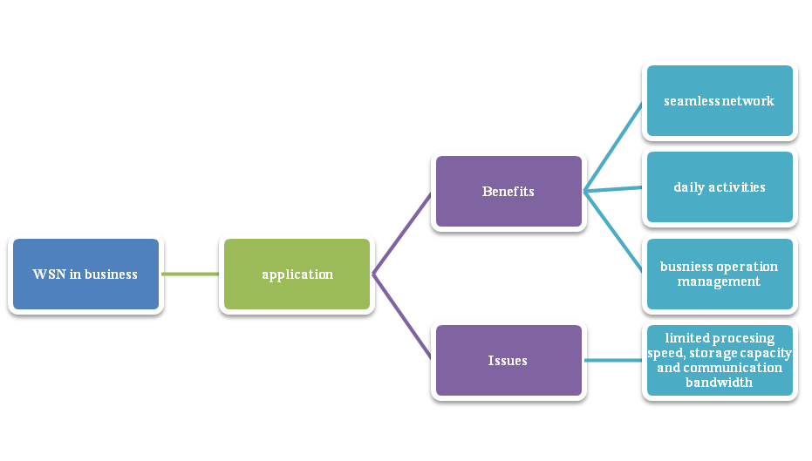
Figure 2.1 Conceptual framework of the literature review
(Source: Self-created)

2.2. Review of literature under subheadings
Wireless sensor network in business
The WSN in business refers to the application subject in developing innovation in the business activities while maintaining and involving non-conventional models that would be designing the processes of the business. It is important to note that the stimulation is further focused on the application systems that are being used in the businesses relating towards the management and monitoring environment in which the sensors of the WSN are present. Thus, accounting towards the application to be situations processes, analysis, mining of data, and storage structure that are related to Internet of Things, Surveillance and Monitoring for security, threat detection process, Noise Level of surrounding, agriculture, landslide detection process, medical application process in the form of patient monitoring. On an average, the WSN consists of the components that involve sensors. Radio nodes, WLAN access points, and evaluation software (Luet al. 2021). These components are essential as they help in bringing critical accountability towards the structuring of innovative design of devices that are effective in maintaining optimized operations in the business operations. The component presents as efficient in determining the key accountability towards the commercial off-the-shelf PDAs, which are being used for the development of the palm or pocket PC operating systems that efficiently manage the development of small package systems.
It is further important to note that the application of the components in the process will be efficient in managing effective communication of the information through the wireless links present in the devices. In the industrial environment, the application of WSN is subject to the monitoring of the operations of the equipment, environment condition, and asset system that will be further corresponding into the management of locations, which are critically inaccessible (Yuldashevet al. 2018). The applications of sensors in businesses are widely based on the locations, which are hazardous or inaccessible due to distance or travelling. The data obtained from the wireless senators are shared to obtain detailed information on the product that is being put under monitoring or the process being followed. The promising nature of the wireless network helps in depicting a clear understanding on the sensor networks that will be seen in the form of a bridge to draw the physical and virtual worlds initiating a clear interaction amongst the both. It is important to note further that the research software development is widely based on the service-oriented architecture, the integration of the enterprise software systems along with the benefits that will be focusing on the business activities in focus (Wardhana, 2020). The applications are further baked on the small and inexpensive sensors that are focused on the usage of micro-electro mechanical systems (MEMS) technology, inexpensive low power processor, and wireless networks allowing in easier deployment of wireless ad-hoc networks that are subjected to the various applications.
Impacts and consequences of wireless sensor networks
The major benefits that are present in the application of the wireless sensor networks are critically based on the existence of the end sensor nodes, base station, routing nodes, and the data collector's sink node. It is going to be effective in bringing the scope of a scalable and secure delivery of efficient as well as reliable network. This accounts towards the understanding that the application of WSN holds multiple benefits based on the types of nodal application being taken into account. The application of WSN is scalable which will allow it to be able to accommodate the newer nodes or the devices at any given time. It is often noted that the wireless sensor networks are highly flexible, increasing their scope of being presented into the physical partitions with affectivity and efficiency. It is further important to note that the concepts of the WSN nodes could be further assessed through the possible centralization of the entire monitoring system being applied (Kumar and Ilango, 2018). Being wireless in nature, the application of WSN does not require the presence of physical amenities in the form of cables, wires, or any other physical infrastructure that will be carrying out the information through the systems. This allows the system to be applied in large-scale applications leading to significant management of the different domains present in the forms of mines, healthcare, surveillance agriculture and many others. It is further important to note that the prospects of managing the WSN and its application will be used for the different types of security purposes holding multiple algorithms. These are underlying as per the wireless technologies and ensure the provision of the reliable network system for the consumers along with the businesses who are the supposed clients to the system.
Apart from the benefits that are drawn from the prospects of managing the key business activities and the advantages present over the same, there is a possibility of increasing the scope of efficiency through improved data communication standards
(Chenget al. 2018). It is important to note that the prospect of increased communication presence would lead to faster transfer of information within the business systems and further between the partners as well as the customers present. It is important to note that the wireless technology of the networking systems helps in ensuring the communication process to be more accurate holding accountability efficiency data transfer systems. There is a significant management of accuracy rate to be addressed in the prospect of managing the status tracking and further leading to the presence of real-time data statistics that will significantly hold accountability towards the management process. The management process is restricted towards the activities of production sites that are present under the rational decisions, which will further hold accountability towards the discovery of abnormalities with active management being constructed within the network technologies present (Bulashenkoet al. 2020). It will further correspond towards the physical manufacturing resources being combined with the integration of the different information sources along with the presence of complex information processing technology system.
The issues in the application of wireless sensor networks are wildly focused on the real-time challenges along with power management, which corresponds, to the overall difficulty in maintaining the scope of developing the system application successfully. It is often noted the corresponding management of the wireless sensor networks are furthermore impacted through the limited results obtained from the WSN systems, which regards the management of the real-time issues in the routing process. The application of the functions are further based on the different times of real-time constraints which are inclusive of the data fusion, data transmission, target and event detection, query processing, and security standards that must be kept accountable for. It is further important to note that the dealing with the real-time data and network application usually focuses on the necessity in identifying the overall requirements of maintaining differentiated services (Farmanet al. 2018). These services are also maintained through the effective routing solutions, which will be corresponding towards the support to be represented among the classes of traffic present. The challenges further moves to the power management process where the low-cost deployment is much more acclaimed and holds the presence of advantages that will be focused on the sensor networks. This will be further disappearing with the overall prospect of managing the development of the fabrication techniques. This further looks out for the energy constraint process that needs to be solved with the presence of slow progress that is further developing the battery capacity. It is important to note that the intended nature of the sensor nodes and the overall sensing enrolment further related to the recalculated management of the feasible solutions. This is often subjected to the natural challenges towards the management of energy efficiency in utilizing the system of development with the prospect of maintaining a partial sensing cleavage process (Hieuet al. 2018). In occasions where the deployment is present for the distance tracking process, the managers or the operators in hand are subjected towards the management of the network directly. This leads to the presence of an indirect remote control of the entire system of management.

2.3. Conclusion
Thus, the chapter critically identifies the different literatures, which are present, and efficiently defines the overall nature of wireless sensor networks and their application impact in business. There has been corresponding identification of the conceptual framework defining the overall literature structure present. The literature was efficient in identifying the application standards of the WSN in business along with the possible downfall that businesses face through its presence.

Chapter 3: Methodological review

3.1. Introduction
The chapter will be discussing about the research strategies applied in the given paper to collect thedesired data aiming to meet the research objectives successfully. It will be defining the data collection tools being utilized in accordance to the research methods followed in completing the research process successfully.

3.1.1. Link method to aim and objectives of research.
The research paper would be following the application of both quantitative as well as qualitative research strategy. The application of the qualitative and the quantitative research strategy would be efficient in presenting secondary as well as primary data collection methods and efficient in meeting the research objectives. The application of both quantitative and qualitative research allowed in meeting the research objectives through numerical as well as theoretical concepts dropping the scope towards generating issues of content bias throughout the data to be gathered.

3.1.2. Ontology and epistemology
To meet the standard application of the qualitative and qualitative research strategies in the given research, there has been the selection of epistemology research philosophy. The selection of the research philosophy has been effective in presenting the experiences of positivism research philosophy. It helped in developing knowledge based on the valid sources with the presence of a wider range of basic as well as important concepts focusing on the cause, space and time of the experience present. The data interpretation has been widely influenced by the type of data that has been gathered leading to successful presentation of the epistemology research process (Goldmanet al. 2018).

3.2. Research method
The research paper followed the application of both quantitative as well as qualitative research approaches in order to gather data that are numerical as well as theoretical drawing necessity strategies to remove the barrier from the research structure.

3.2.1. Data collection methods and their suitability
The data collection method followed in the given research paper is based on the prospect of gathering primary as well as secondary data. The primary data is collected by using a quantitative data collection method referring to the survey process. The application of survey questionnaires holding the multiple close-ended questions has been followed to gather primary data in the research paper. Each question contained a likert scale that has been presented to present the answers to the questions. On the other hand, the secondary data has been gathered by using a qualitative research process, which involves the usage of different types of existing theoretical papers and documents on the application of WSN in the business sectors (Chenet al. 2020). The secondary data collection process did not involve any specific method relating to the standards of management that has been constructed throughout the data collection process.

3.2.2. Sampling
The sampling process that has been followed in the given research paper is based on the application of the primary data collection method of survey. It related to the application of purposive sampling technique that selected 40 managers out of 100 managers who were being approached and are working in different businesses.

3.2.3. Access and consent
The participants have been provided with content form instability through email in order to gain their consent towards voluntary participation in the survey. The consent form presented a clear indication of the research aim and the importance of the survey to the research. The volunteered participants were further provided with the survey link to respond to the survey.

3.3. Ethical considerations
Confidentiality of the participants has been minimized by keeping their data as anonymous without even gaining any information on the gender of the managers being selected as the participants in the survey (Broeschet al. 2020).

3.4. Pilot study
The pilot study has been constructed in the classroom, among ten students in order to gain identification on the possible errors or flaws that might arrive during the actual implementation of the survey.

3.5. Research method limitations
The major limitation to the research method holding the survey method is the presentation of numerical, which would be biased. The application of secondary data collection can be effective in presenting information from the existing theories and researchers from whom the data are to be gathered.

3.6. Analysis of data
The data is to be represented in a descriptive format leading to the presentation and the application of thematic analysis structure (Braun and Clarke, 2019). The results obtained in the form of numerical from the questionnaire and the articles, journals as well as other documents have been confined to a few themes that reflected the meeting of the research objectives and aim thoroughly.

3.7. Conclusion
Thus, it can be concluded that the research chapter has been effective in presenting a clear identification on the different types of research strategy followed marking towards the application of both qualitative and quantitative research process. It created a focus on the research structure that reflected on the questionnaire holding likert scale as the answers to the questions being asked.

Chapter 4: Results

4.1. Introduction
The current chapter presented the results that have been obtained from the survey application on the 40 managers gaining primary data for the research. The chapter also presents the qualitative secondary data obtained by stating them different types of collective themes obtained.

4.2. Inferential statistics – Quantitative results

Q1. How far do you agree wireless networks are efficient in addressing time optimization for day activities in business?

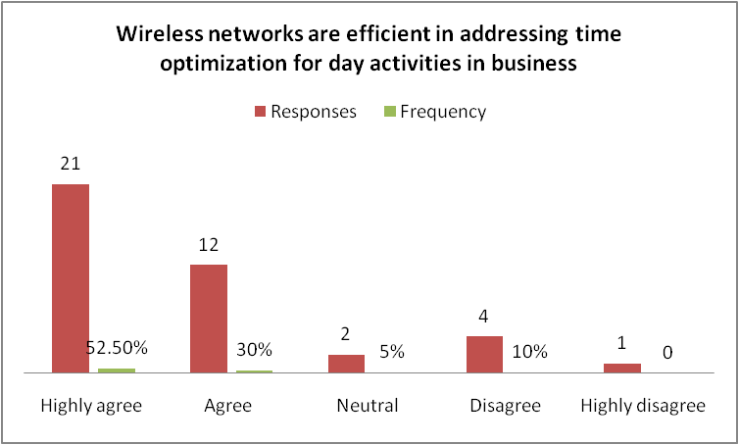

Chart 1: Wireless networks are efficient in addressing time optimization for day activities in business
(Source: self-created)
Interpretation: Nearly 82% of the responses have been highly positive indicating that wireless sensor networks are effective in optimizing daily activities conducted in the businesses. It further helped the managers in managing time and increasing the speed of activities eventually as only 10% of the participants did not agree on the same.
Q2. Do you agree that Businesses applying wireless sensor networks are being cost effective?

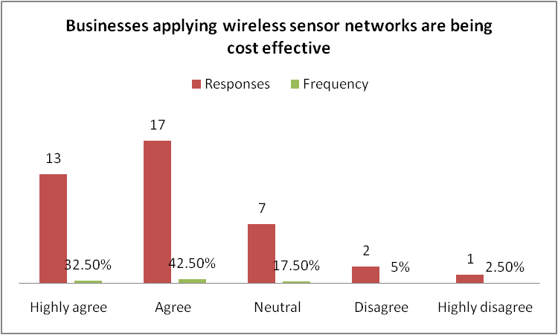

Chart 2: Businesses applying wireless sensor networks are being cost effective
(Source: self-created)
Interpretation: 75% of the respondents agreed that businesses that are applying for wireless sensor networks are able to manage their expenditures effectively leading to reduction in the overall investment being made in the production process.
Q3. How far do you agree that applying wireless sensor networks in business helps in managing supply chain operations?

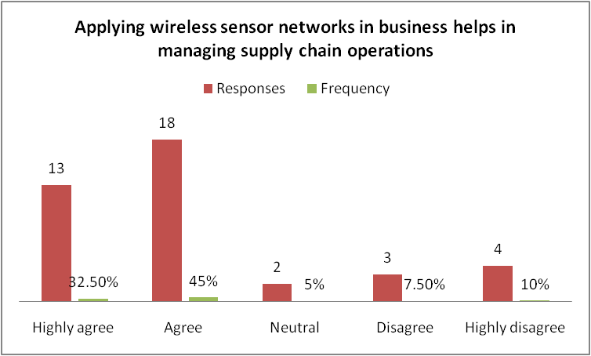

Chart 3: Applying wireless sensor networks in business helps in managing supply chain operations
(Source: self-created)
Interpretation: Nearly 77.5% of the respondents agreed that wireless sensor networks are effective in allowing businesses to be able to manage supply operations effectively. The managers correspond towards a negative response as well but the majority of them reflected similar knowledge identification as well.
Q4. Do you agree product tracking is more efficient with WSN devices like RFID in businesses?

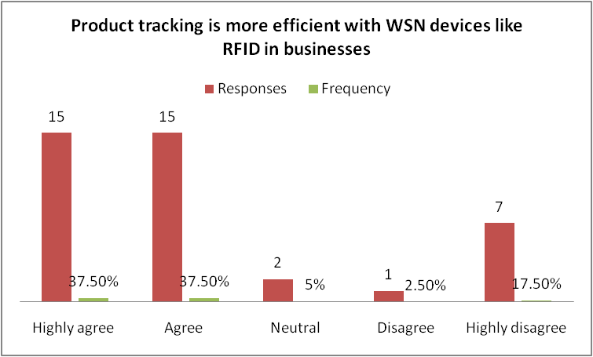

Chart 4: Product tracking is more efficient with WSN devices like RFID in businesses
(Source: self-created)
Interpretation: 75% of the respondents clearly stated that Product tracking becomes more effective with the presence of WSN devices such as RFID in the business activities. However nearly 19% of the respondents did not agree with questions, regardless of the negative response, it could be demonstrated that WSN devices like RFID are efficient in bringing business development with more efficiency.
Q5. How far do you agree that environmental monitoring to check business activity impact is also conducted by WSN systems?

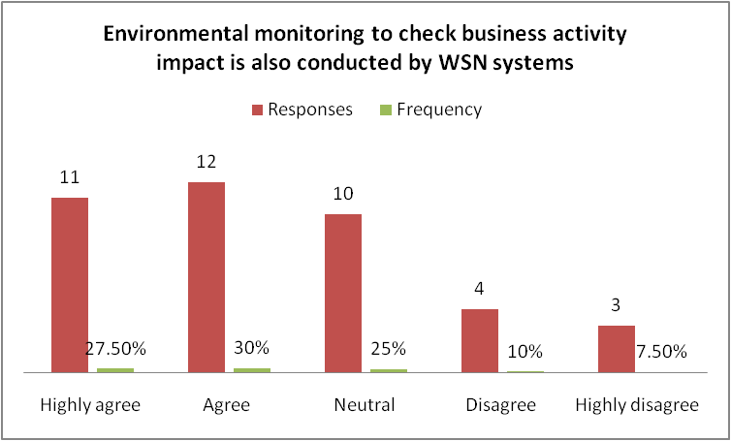

Chart 5:Environmental monitoring to check business activity impact is also conducted by WSN systems
(Source: Self-created)
Interpretation: When asked by the managers their views on the usage of WSN to improve business activities and bring efficient environmental monitoring systems into the business activities, nearly 57% of the managers agreed with the question. However, 25% of the managers were unsure of it, indicating that the possibility of bringing environmental waste production and other safety precaution monitoring activities can be conducted through the application of WSN system in the business activities.
Q6. Do you agree business communication is improved through the application of WSN system devices?

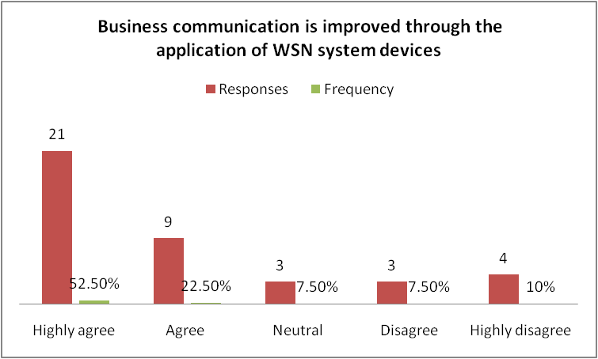

Chart 6: Business communication is improved through the application of WSN system devices
(Source: self-created)
Interpretation: 74% of the managers agreed that the Business communication process is effectively improved through application of WSN system devices in the business operational activities.
Q7. How far do you agree wireless technologies have been effective in improving the rate of efficiency in terms of managing customer satisfaction?

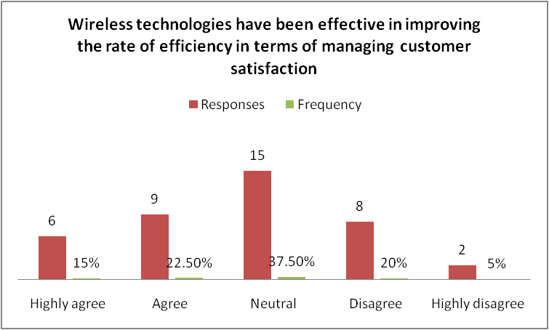

Chart 7: Wireless technologies have been effective in improving the rate of efficiency in terms of managing customer satisfaction
(Source: self-created)
Interpretation: 37% of the managers agreed that wireless technologies have been improving the customer satisfaction management activities in businesses. There has been efficient management of the customer interaction process and information sharing communication standards leading to successful management of the WSN system application in the business operations.
Q8. How far do you agree that WSN applications in business can lead to hacking and lack of speed communication?

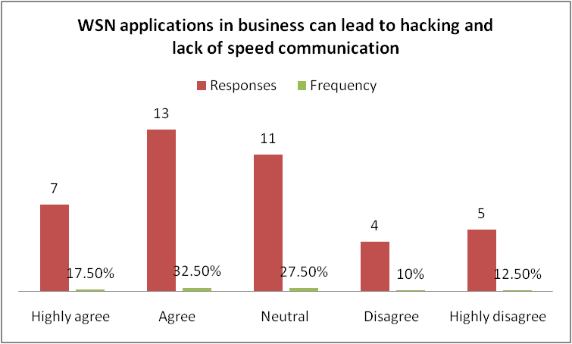

Chart 8: WSN applications in business can lead to hacking and lack of speed communication
(Source: self-created)
Interpretation: The given chart implies that average managers around 50% agreed that lack of speedy communication is an issue towards the application of WSN along with the scope of hacking attacks. However, nearly 27% of the participants were not sure about the issues represented.

4.3. Qualitative results
The qualitative results that have been obtained from the different articles critically identified multiple information on the application of WSN in businesses. The major focus has been established on the importance and the necessity of implementing wireless networks in the business structure and operations. The following instances of information have been obtained from the conduction of the qualitative research process.
- Application of WSN has been coercive in bringing efficient managing in the process of business development by introducing method of energy efficiency along with cost saving process
- Major application of WSN has been RFID technology along manufacturing and supply chain operations in the business operations
- There has been efficient management of environmental applications through optimized energy usage throughout the system application
- Monitoring of products has been widely impacted by the application of WSN system in the industrial application process
- Application of WSN has been often determined to be successful in initiating stronger customer satisfaction levels through faster and efficiency communication along with information sharing with businesses
- However, application of WSN leads to issues of hacking due to presence of low security standards in the system being used
- Possibility of discontinued services as the speed communication process is limited using the WSN system

4.4. Conclusion
The chapter identified results of quantitative statistics obtained in the form of charts and further presented a inferential presentation of the same. The qualitative data has been presented as well in the chapter.

Chapter 5: Discussion

5.1. Introduction
This chapter is efficient in bringing an analysis of the entire results that has been obtained and discussing the same by depicting themes, which reflect and relate to the objectives of the research paper.

5.2. Themes
Types of wireless sensor networks to use
The wireless sensor networks that are to be used in the business operations are based on the different industries where the applications are to be taken into account. This accounts towards five forms of wireless networks, which are Global area network, wide area network, metropolitan area network, local area network, and personal area network. The personal area network is effective in presenting a low-powered, short-distance, wireless network technology that is present in the form of Bluetooth network, wireless USD and ZigBee. The LAN of local area network is focused on the application of wireless network systems in locations that are restricted within a certain area providing the opportunity to instil a connection to the WN. It is further important to note that the metropolitan area network interconnects and further communicates with the various computer resources leading to significant management of the geographic locations holding the size of the urban area system. The WAN is further associated with the modification system in the technology that will be based on the diverse dimensions that delivers data from the web pages as needed using mobile telecommunication cellular network systems.
Applications in business
These accounts for military application, application in the area monitoring system, transportation application process, health application, environmental application, and structural application. The application of the WSN is effective in bringing the fragments of the military intelligence, facility control, communism, investigation, and targeting systems. The use of WSN has been identified to be present in the health application system that corresponds towards the diagnostic, investigative and drug administration process, which further supports the interface for the incapacitated. The application of WSN has been further associated with the structural applications that corresponded towards monitoring the movement of the different projects which are focused on developing structures in the form of buildings or other infrastructural projects. Another application of the WSN would be focused on industrial application that related to the advancement in the technological condition-based maintenance (TCMB), holding accountability towards offering momentous cost reduction or investment processes. It further helped in bringing innovation functionalities as well to the businesses leading to installation of adequate sensors by the overall wiring involved.
Impact on the business activities
It is important to note that the overall results obtained critically identifies that the application of the WSN helps businesses in attaining effective management of the scalability of the businesses. It is efficient in bringing the application of the different types of routing systems ensuring an easier and smooth communication process integrated throughout the operations. It is effective in bringing efficient management of the flexibility in the workplace by bringing scope for innovation throughout business activities that are conducted on a regular basis. It is further important to note that the WSN is significant in bringing the management of the nodes, which can be further assessed, through the prospects of managing a centralized monitoring system. It will be collectively important in bringing significant management towards the overall aspects of the centralized monitoring process to be followed leading to the fewer requirements of using wires or cables that eventually helps in cutting down cost for the company.
Challenges in their application in business activities
The results obtained further demonstrated that the application of WSN in the business activities can lead to certain challenges that are widely prone to security issues further corresponding toward the issue of hacking as well. It cannot be applied to situations that will be requiring a high-speed communication process leading to the necessity of maintaining its application in the low speed applications only.

5.3. Conclusion
Thus, the chapter successfully concluded the overall data and results obtained by using the thematic analysis process.

Chapter 6
6. Conclusion and recommendations
6.1. Introduction
The conclusion and recommendation of this research paper draws an overall summary of the various information and findings regarding the topic of the research work. The conclusion helps in restating the main arguments of the discussion which has been discussed in the research paper. The recommendation of the research paper analyzes the various issues and problems regarding the topic given and identifies ways and processes in order to mitigate the resources or to suggest steps which can help in getting effective results from the various problems and issues which have been mentioned in the research paper.

6.2. Main conclusions that have drawn from the research
The research paper has discussed and investigated wireless network availability for the purpose of performing various business activities, and helps in drawing identification of the different types of networks that are widely applied. The researcher of the research work has used the quantitative survey for the primary data collection and thematic analysis has been done for the secondary data collection method. The researchers have used various information and data in order to conduct this research and study effectively and to find appropriate findings regarding the importance and usefulness of the wireless networks in the business operation as well as in business activities. The research paper also included the research methodology in order to conduct data collection methods for the purpose of gathering relevant information regarding wireless networks (Zala and Vyas, 2020).

6.3. What are findings of the research and add to the corpus of data already and determine linksto the chapter 1
The findings of the research data and information helps in generating a clear idea regarding the understanding of the wireless sensor network application in the business. The research paper has also identified the various benefits and risks which are associated with the application of Along with the disadvantages the wireless network can be beneficial for the business as well as this helps in flexible access of networks and leads to improved efficiency of the business. These findings of the research paper help in linking with the chapter 1 of the research paper as the chapter 1 discusses the various impacts and effects of wireless sensor network application in the business. The findings of the research paper helps in knowing about the implications of the wireless networks while using it for the purpose of business activities (Ouyang et al.,2019)

6.4. Recommendations

6.4.1. Industrial/practice developments
The research paper has identified the various benefits and risks which are associated with the application of wireless networks in business. Wireless networks in business which draws an understanding of the application of the wireless network in the business activities and operation can be harmful as the wireless network can create the problem of limited range of signals which can create hurdles in commencing the business. The wireless network can create more jamming in the networks, which also creates a chance of hurdles and problems in the business activities. The business should focus on proper jamming for conducting effective business operation.

6.4.2. Future directions of research
The research paper helps in understanding about the various wireless networks and also about the use of these networks in various kinds of business activities. The research paper has discussed the importance of wireless networks in the business. The research paper discusses the literature review with various logical structures in order to investigate the wireless network.

6.5. Often structured around objectives
The researcher of the research work has used the quantitative survey for the primary data collection and thematic analysis has been done for the secondary data collection method. The researchers have used various information and data in order to conduct this research and study effectively and to find appropriate findings regarding the importance and usefulness of the wireless networks in the business operation as well as in business activities.

6.6. Conclusion
The research paper has identified the various benefits and risks which are associated with the application. Along with the disadvantages the wireless network can be beneficial for the business as well as this helps in flexible access of networks and leads to improved efficiency of the business.

Reference list
Braun, V. and Clarke, V., 2019. Reflecting on reflexive thematic analysis. Qualitative research in sport, exercise and health, 11(4), pp.589-597.
Broesch, T., Crittenden, A.N., Beheim, B.A., Blackwell, A.D., Bunce, J.A., Colleran, H., Hagel, K., Kline, M., McElreath, R., Nelson, R.G. and Pisor, A.C., 2020. Navigating cross-cultural research: methodological and ethical considerations. Proceedings of the Royal Society B, 287(1935), p.20201245.
Bulashenko, A., Piltyay, S., Polishchuk, A. and Bulashenko, O., 2020, November. New traffic model of M2M Technology in 5G wireless sensor networks. In 2020 IEEE 2nd International Conference on Advanced Trends in Information Theory (ATIT) (pp. 125-131). IEEE.
Chen, A.H., Bakar, N.F.A. and Lam, C.S.Y., 2020. Comparison of open-ended and close-ended questions to determine signs and symptoms of eye problems among children. Journal of optometry, 13(2), pp.81-87.
Cheng, H., Feng, D., Shi, X. and Chen, C., 2018. Data quality analysis and cleaning strategy for wireless sensor networks. EURASIP Journal on Wireless Communications and Networking, 2018(1), pp.1-11.
Cheng, Y., Zhao, S., Cheng, B., Chen, X. and Chen, J., 2018. Modeling and deploying IoT-aware business process applications in sensor networks. Sensors, 19(1), p.111.
Farman, H., Jan, B., Javed, H., Ahmad, N., Iqbal, J., Arshad, M. and Ali, S., 2018. Multi-criteria based zone head selection in Internet of Things based wireless sensor networks. Future Generation Computer Systems, 87, pp.364-371.
Goldman, M.J., Turner, M.D. and Daly, M., 2018. A critical political ecology of human dimensions of climate change: Epistemology, ontology, and ethics. Wiley Interdisciplinary Reviews: Climate Change, 9(4), p.e526.
Hieu, T.D., Duy, T.T., Dung, L.T. and Choi, S.G., 2018. Performance evaluation of relay selection schemes in beacon-assisted dual-hop cognitive radio wireless sensor networks under impact of hardware noises. Sensors, 18(6), p.1843.
Kumar, S.A. and Ilango, P., 2018. The impact of wireless sensor network in the field of precision agriculture: A review. Wireless Personal Communications, 98(1), pp.685-698.
Lu, Y., Huang, Q., Hu, C., Wang, Z., Liu, Z., Qin, J. and Zhu, X., 2021, October. Design of Wireless Sensor Network Architecture for Power Transmission and Transformation Business. In 2021 International Conference on Advanced Electrical Equipment and Reliable Operation (AEERO) (pp. 1-6). IEEE.
Ouyang, Q., Zheng, J. and Wang, S., 2019. Investigation of the construction of intelligent logistics system from traditional logistics model based on wireless network technology. EURASIP Journal on Wireless Communications and Networking, 2019(1), pp.1-7.
Wardhana, D.K., 2020. Internet of Things with Wireless Sensor Network Potential Business Possibility. InComTech: Jurnal Telekomunikasi danKomputer, 10(1), pp.37-48.
Yuldashev, M.N., Vlasov, A.I. and Novikov, A.N., 2018, May. Energy-efficient algorithm for classification of states of wireless sensor network using machine learning methods. In Journal of Physics: Conference Series (Vol. 1015, No. 3, p. 032153). IOP Publishing.
Zala, D.D. and Vyas, A.K., 2020. Comparative analysis of RED queue variants for data traffic reduction over wireless network. In Recent Advances in Communication Infrastructure (pp. 31-39). Springer, Singapore.

Appendix
Questionnaire tabular results
Q1.

Table 1: Wireless networks are efficient in addressing time optimization for day activities in business
(Source: self-created)
Options | Total respondents | Responses | Frequency
Highly agree | 40 | 21 | 52.5%
Agree | 40 | 12 | 30%
Neutral | 40 | 2 | 5%
Disagree | 40 | 4 | 10%
Highly disagree | 40 | 1 | 2.5%

Q2.

Table 2: Businesses applying wireless sensor networks are being cost effective
(Source: self-created)

Options | Total respondents | Responses | Frequency
Highly agree | 40 | 13 | 32.5%
Agree | 40 | 17 | 42.5%
Neutral | 40 | 7 | 17.5%
Disagree | 40 | 2 | 5%
Highly disagree | 40 | 1 | 2.5%

Q3.
Table 3: Applying wireless sensor networks in business helps in managing supply chain operations
(Source: self-created)

Options | Total respondents | Responses | Frequency
Highly agree | 40 | 13 | 32.5%
Agree | 40 | 18 | 45%
Neutral | 40 | 2 | 5%
Disagree | 40 | 3 | 7.5%
Highly disagree | 40 | 4 | 10%

Q4.

Table 4: Product tracking is more efficient with WSN devices like RFID in businesses
(Source: self-created)

Options | Total respondents | Responses | Frequency
Highly agree | 40 | 15 | 37.5%
Agree | 40 | 15 | 37.5%
Neutral | 40 | 2 | 5%
Disagree | 40 | 1 | 2.5%
Highly disagree | 40 | 7 | 17.5%

Q5.

Table 5: environmental monitoring to check business activity impact is also conducted by WSN systems
(Source: Self-created)
Options | Total respondents | Responses | Frequency
Highly agree | 40 | 11 | 27.5%
Agree | 40 | 12 | 30%
Neutral | 40 | 10 | 25%
Disagree | 40 | 4 | 10%
Highly disagree | 40 | 3 | 7.5%

Q6.

Table 6: Business communication is improved through the application of WSN system devices
(Source: self-created)
Options | Total respondents | Responses | Frequency
Highly agree | 40 | 21 | 52.5%
Agree | 40 | 9 | 22.5%
Neutral | 40 | 3 | 7.5%
Disagree | 40 | 3 | 7.5%
Highly disagree | 40 | 4 | 10%

Q7.
Table 7: Wireless technologies have been effective in improving the rate of efficiency in terms of managing customer satisfaction
(Source: self-created)

Options | Total respondents | Responses | Frequency
Highly agree | 40 | 6 | 15%
Agree | 40 | 9 | 22.5%
Neutral | 40 | 15 | 37.5%
Disagree | 40 | 8 | 20%
Highly disagree | 40 | 2 | 5%

Q8.
Table 8: WSN applications in business can lead to hacking and lack of speed communication
(Source: self-created)

Options | Total respondents | Responses | Frequency
Highly agree | 40 | 7 | 17.5%
Agree | 40 | 13 | 32.5%
Neutral | 40 | 11 | 27.5%
Disagree | 40 | 4 | 10%
Highly disagree | 40 | 5 | 12.5%

