14/08/2026
UNIVERSITY OF WALES TRINITY SAINT DAVID
LONDON CAMPUS
Assignment 2
Professional Development Plan (PDP)

Video Link: Begum Eldek- A presentation on Self Evaluation.mp4

Please be sure to give unrestricted access to your video presentation so that your work can be marked by the examiner.
Module Name: Learning in the Digital Era
Module Code: ACCA 4025

Student Name: Begum Eldek
Student ID: 2542321
Group: 1

Lecturer’s Name: Koushik Modak

Table of Contents
Introduction 2
Main Body 2
Video Link: 2
Conclusion 11
References 11

Introduction
This report is about my self-evaluation, professional development and future learning goals. It will include my strengths and weaknesses, my Professional Development Plan with SMART goals, my progress towards one goal, and short summary of lifelong learning and reflection.

Main Body
This assignment will help me understand my strengths and weaknesses and identify the skills I need to improve. It will also help me create a clear development plan for my studies and future career.

Video Link: Begum Eldek- A presentation on Self Evaluation.mp4

Slide 1

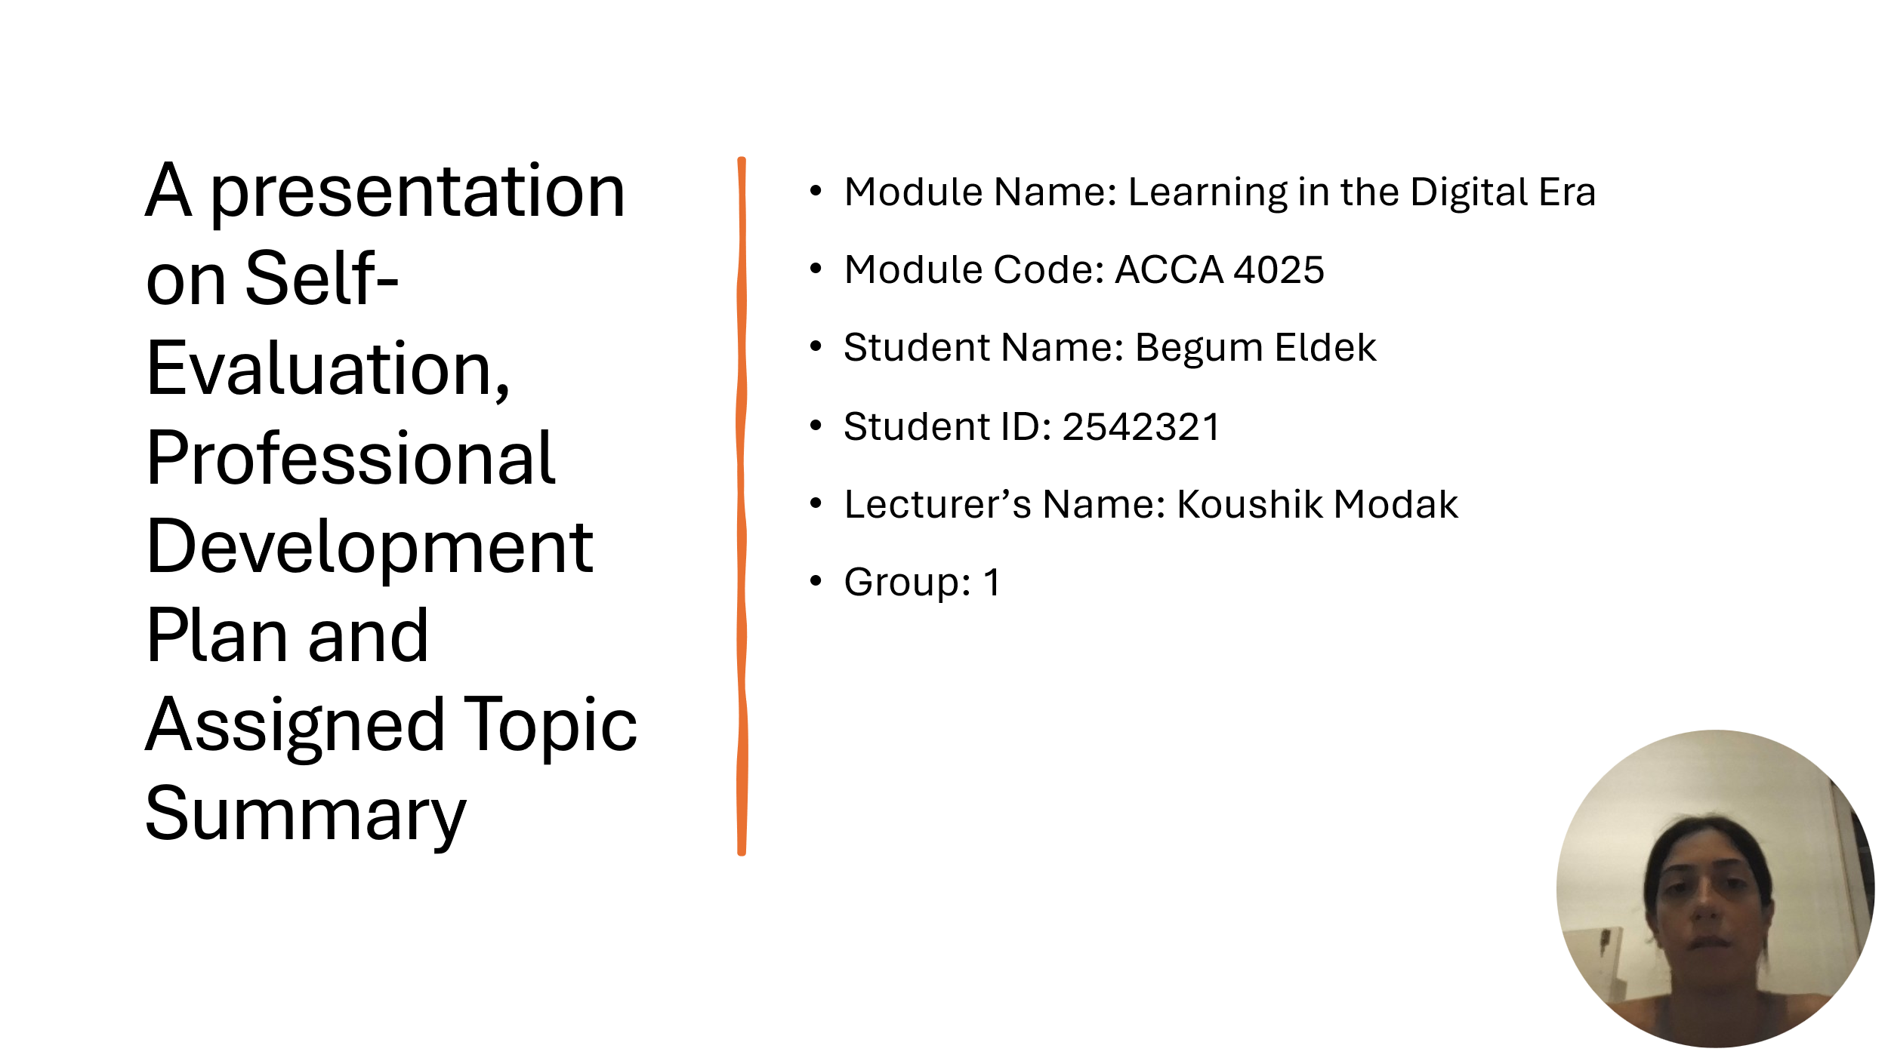

Slide 2
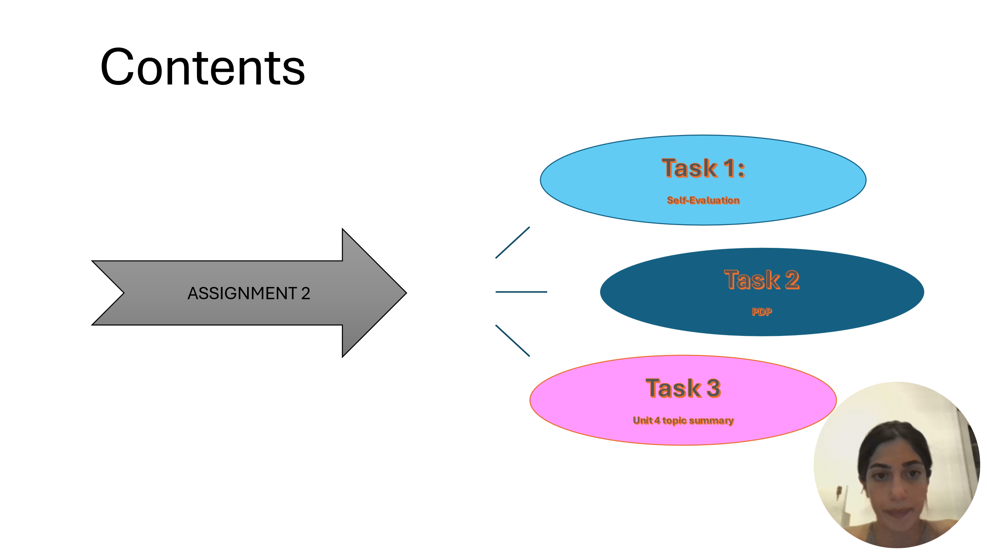

Slide 3

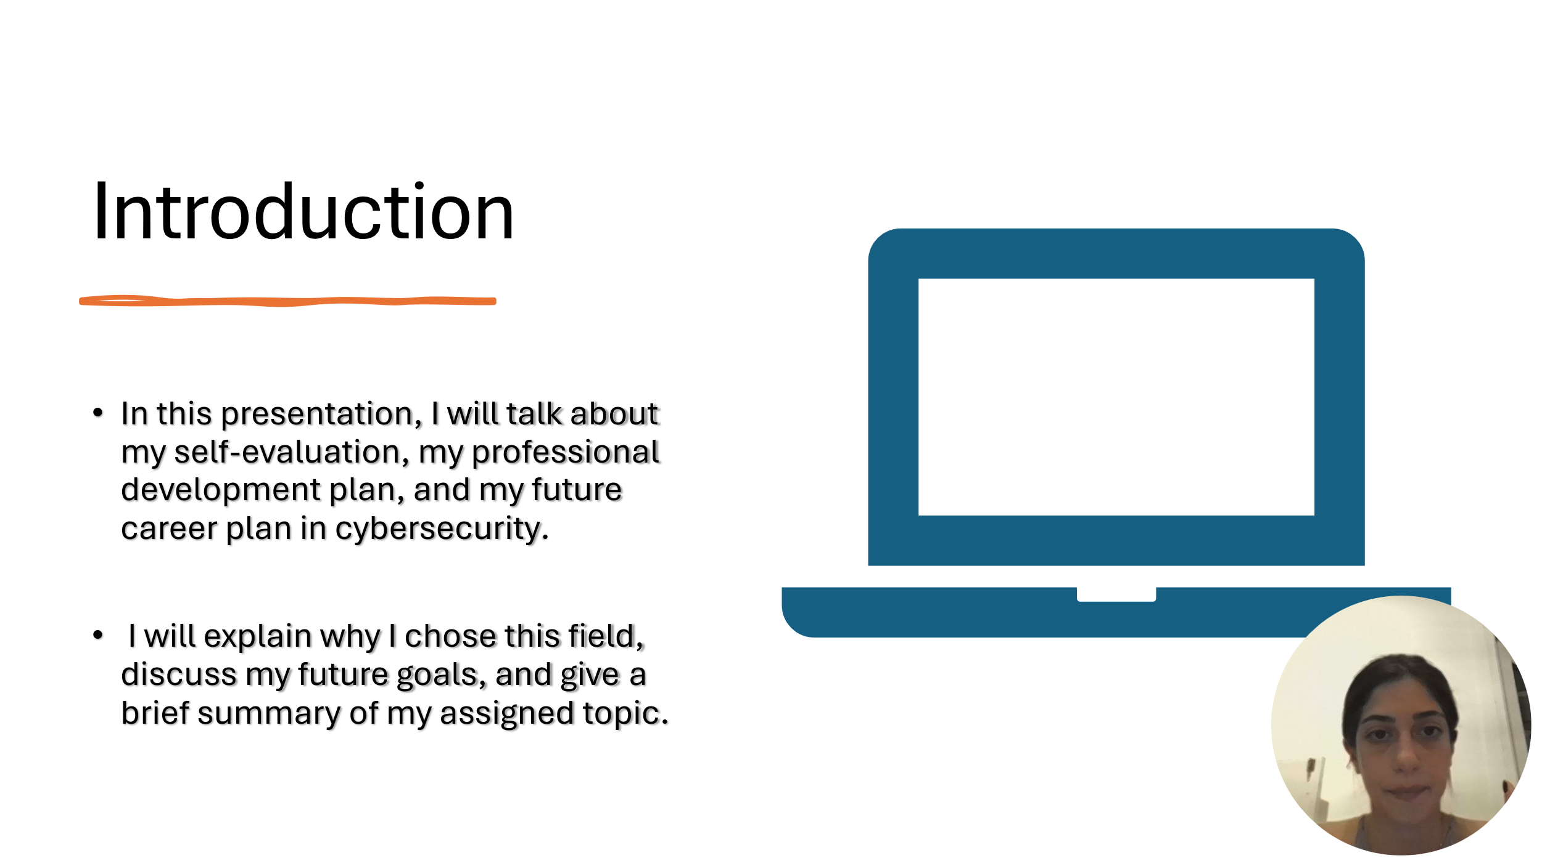

Slide 4
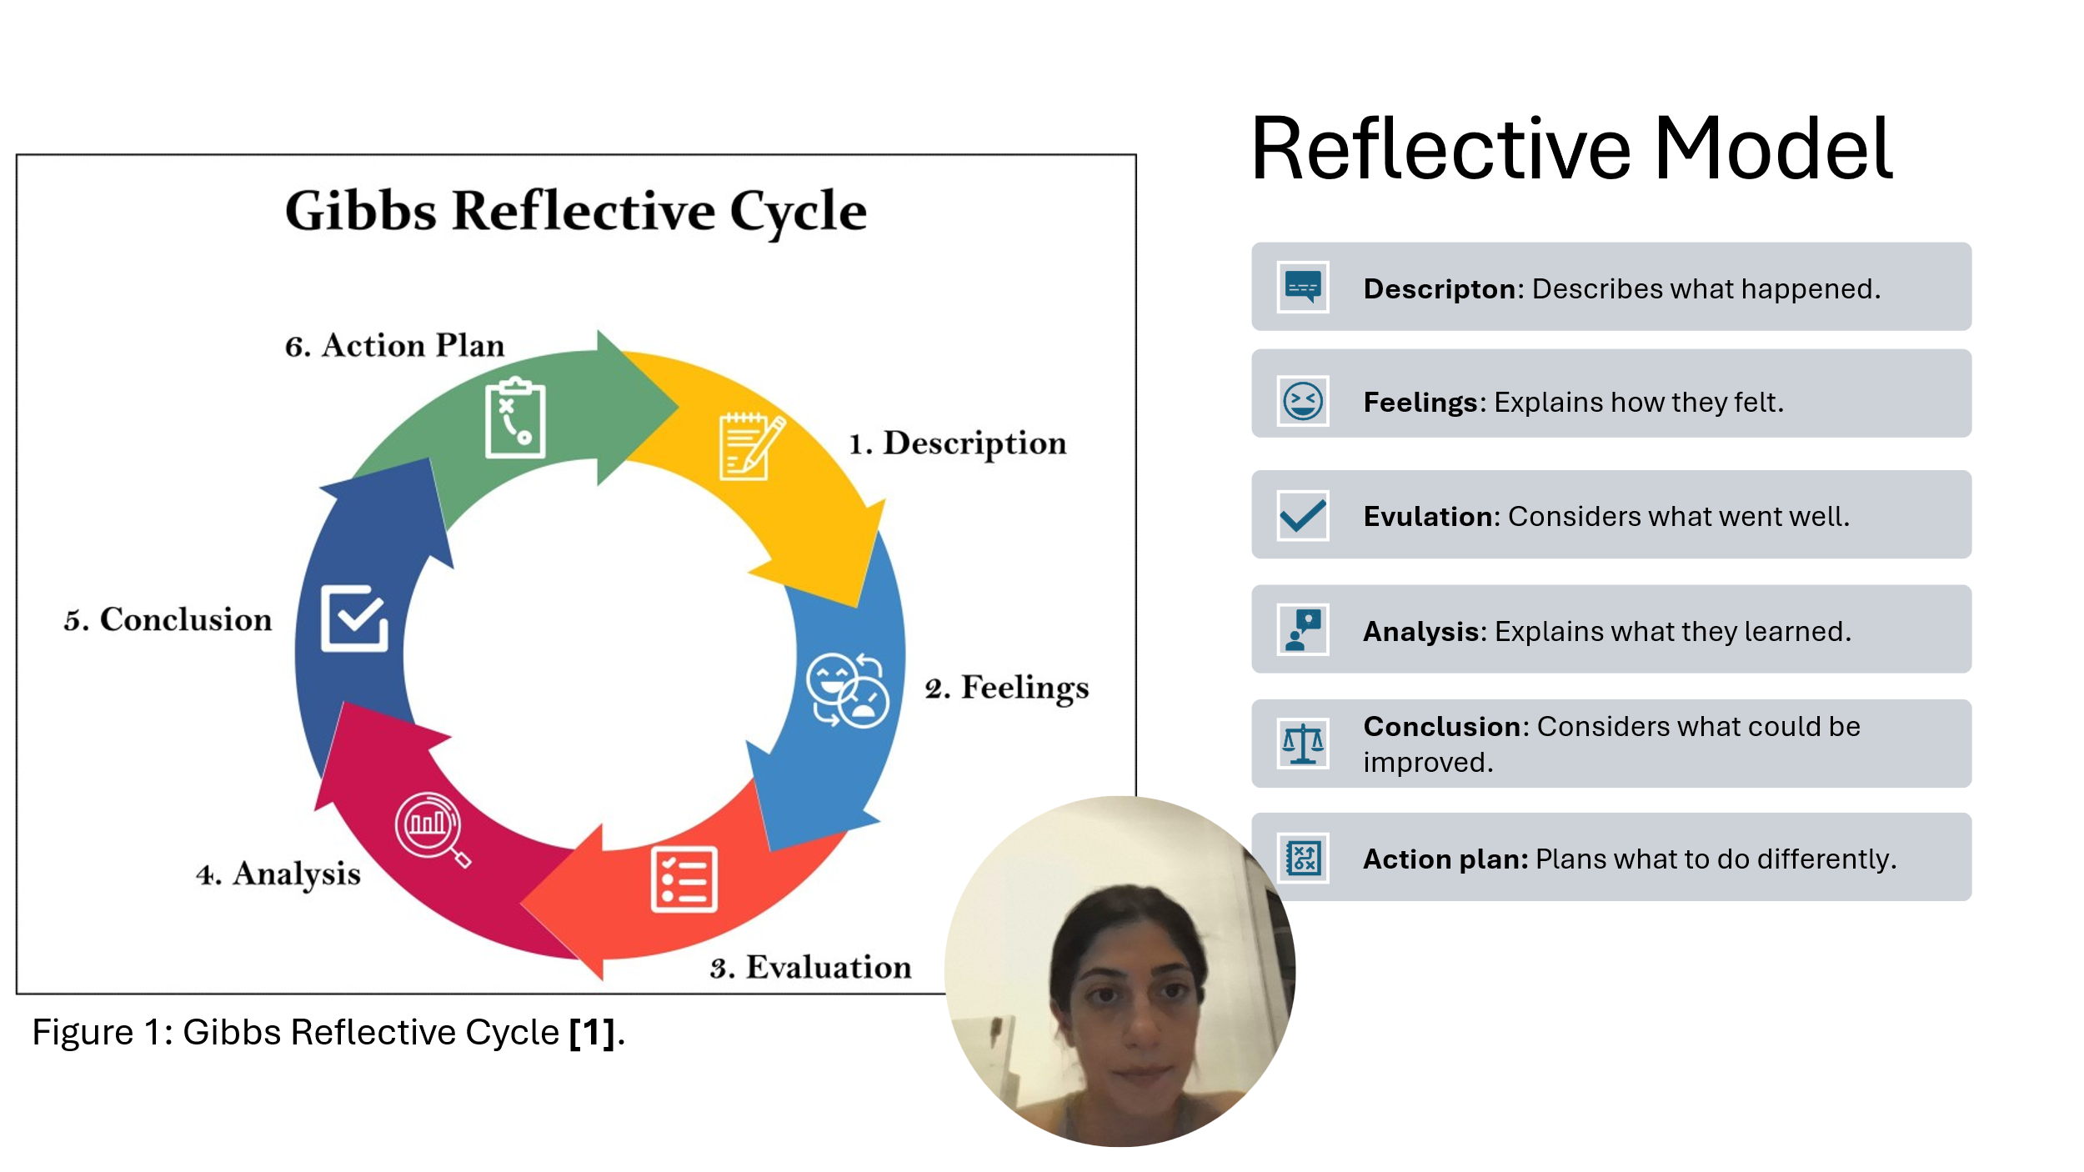

Brief explanation: Gibbs Reflective Cycle is a simple model that helps people learn from their experiences. It has six stages: description, feelings, evaluation, analysis, conclusion and action plan. The model helps people think about what happened, what they learned and what they can do better next time [1] [2].
Description: This stage explains what happened. It focuses on the main facts of the experience.
Feelings: This stage looks at how the person felt before, during and after the experience.
Evaluation: This stage looks at what went well and what did not go well.
Analysis: This stage helps the person understand why things happened an what they learned from the experience.
Conclusion: This stage looks at what could have been done differently and what can be improved.
Action Plan: This stage explains what the person will do next time and how they can improve in the future.
In this assignment, I will use Gibbs model to think about my strengths and weaknesses. It will help me understand which skills I need to improve. I will use this reflection to create my Professional Development Plan (PDP) and set goals for my English, time management and cybersecurity knowledge.

Slide 5
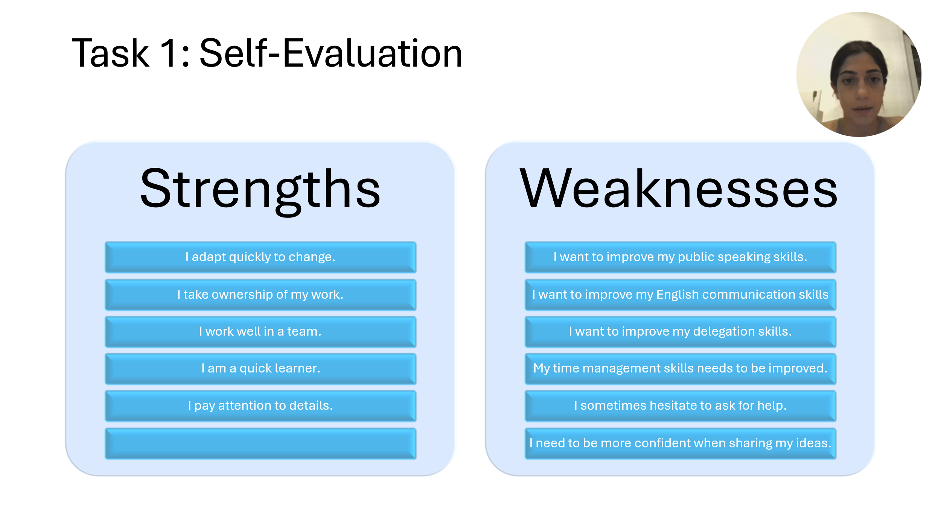
Brief explanation: I used a SWOT analysis to understand my strengths and weaknesses [3].
Strengths
One of my gain strengths is that I can adapt quickly to change. I am also a quick learner, and I take responsibility for my work. I work well with other people, and I enjoy being part of team. Another strength is that I pay attention to details, which helps me complete my work carefully.

Weaknesses
One of my weaknesses is public speaking. I sometimes feel nervous when I speak in front of a group. I also need to improve my time management and delegation skills. Sometimes I hesitate to ask for help, and I am not always confident when I share my ideas. I want to improve these areas because they are important for my studies and my future career.

Slide 6
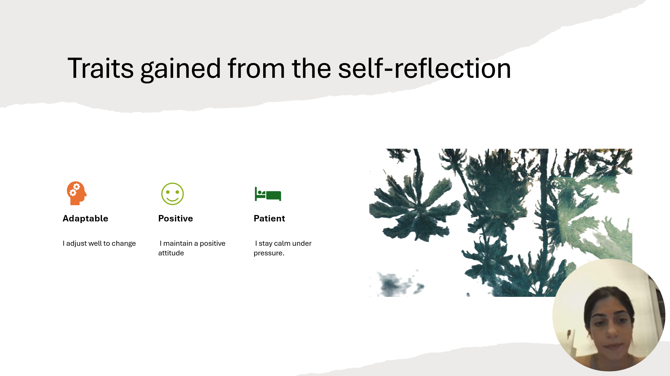

Brief explanation: From my self-evaluation, I identified three main personal traits: adaptability, positivity and patience. I am adaptable because I can adjust to changes and new situations without too much difficulty. I also try to stay motivated and focused. Another important trait is patience. I usually stay calm under pressure and try to think carefully before making a decision.
These traits are useful for both my studies and my future career. Being adaptable can help me deal with new tasks and technologies, while a positive attitude and patience can help me work well with other people and manage difficult situations.

Slide 7
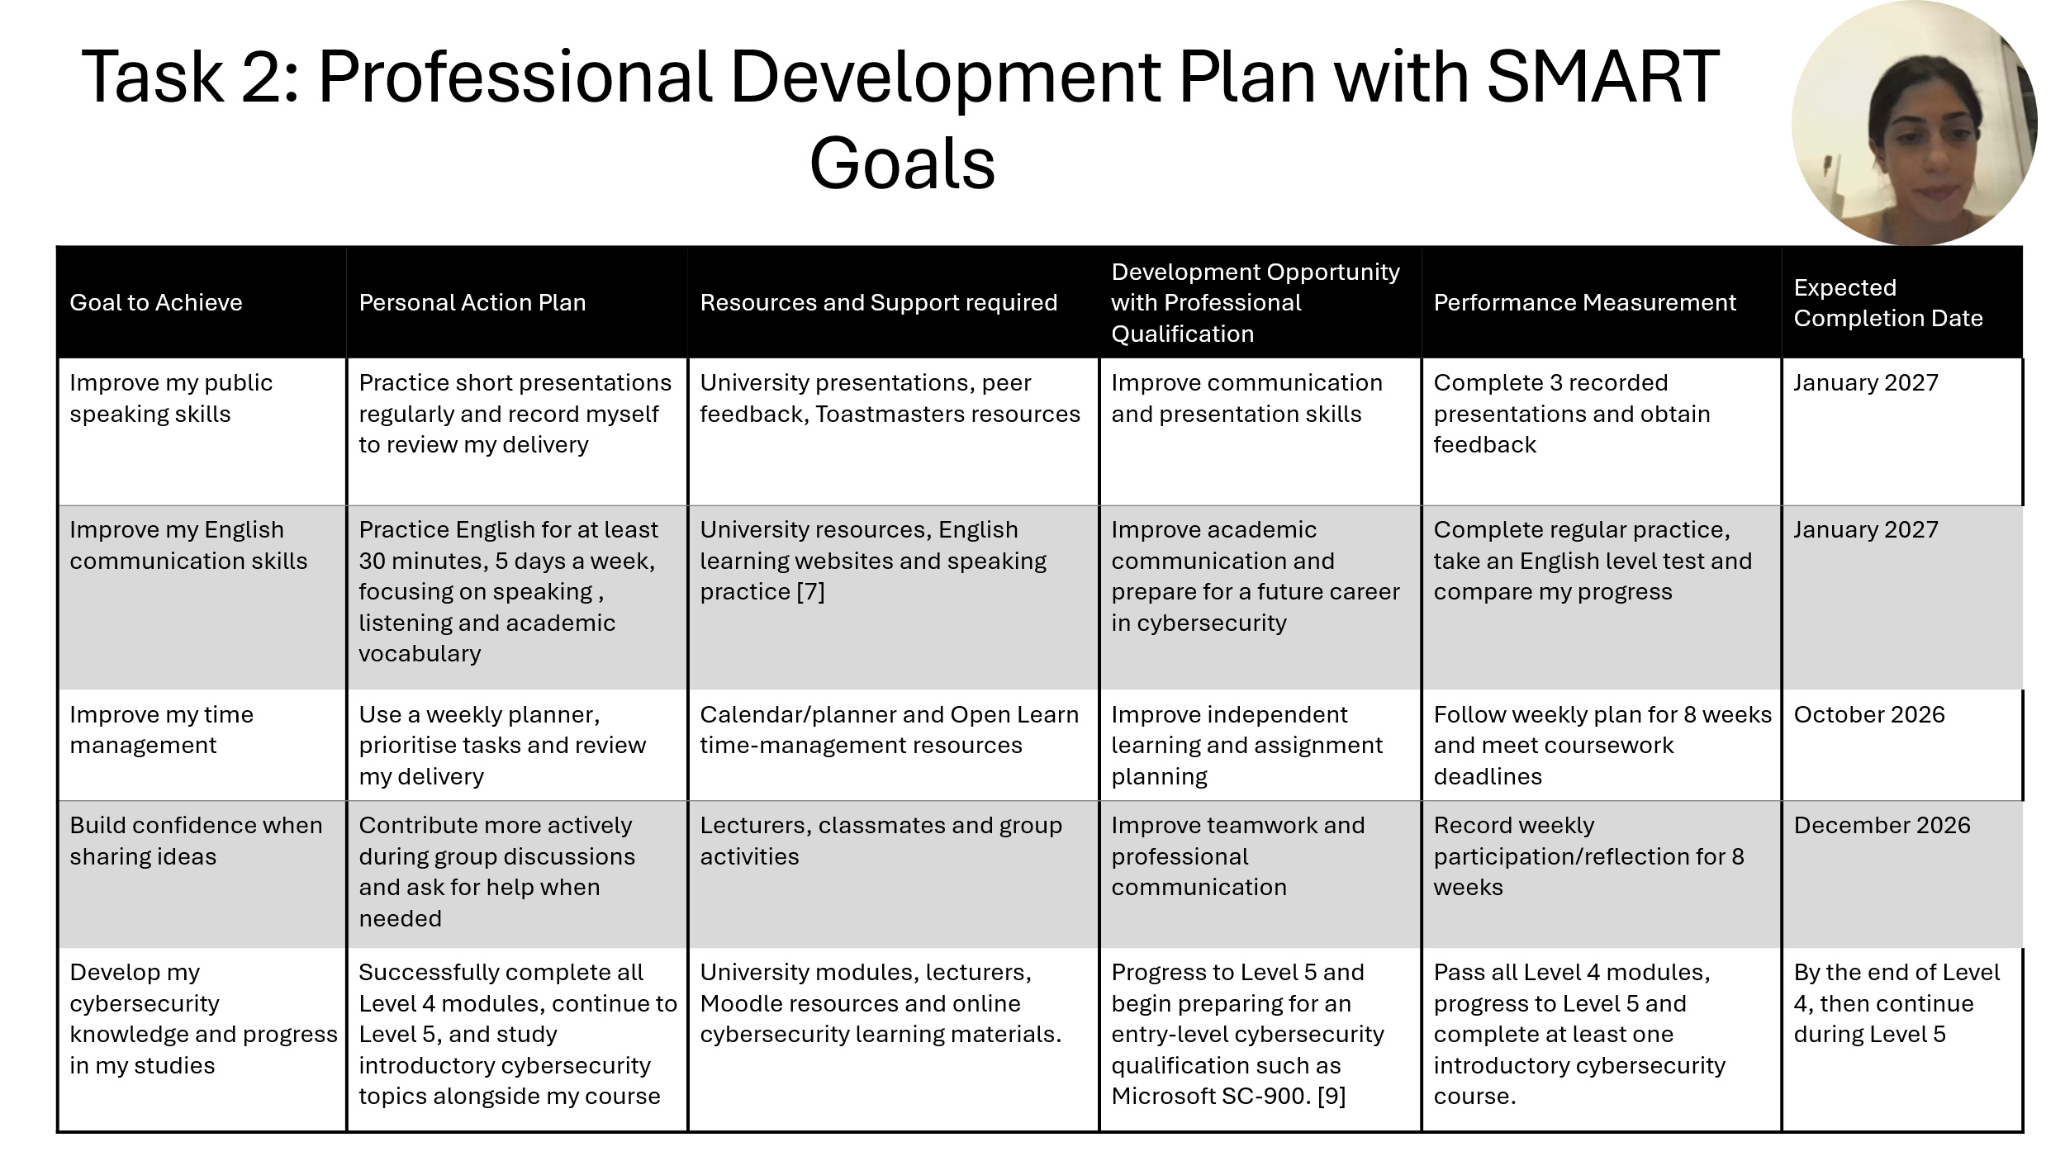

Brief explanation: In this section, I will explain my Professional Development Plan and the skills I want to improve. I will use SMART goals to make sure my goals are specific, measurable, achievable, relevant and time bound [4].

Slide 8
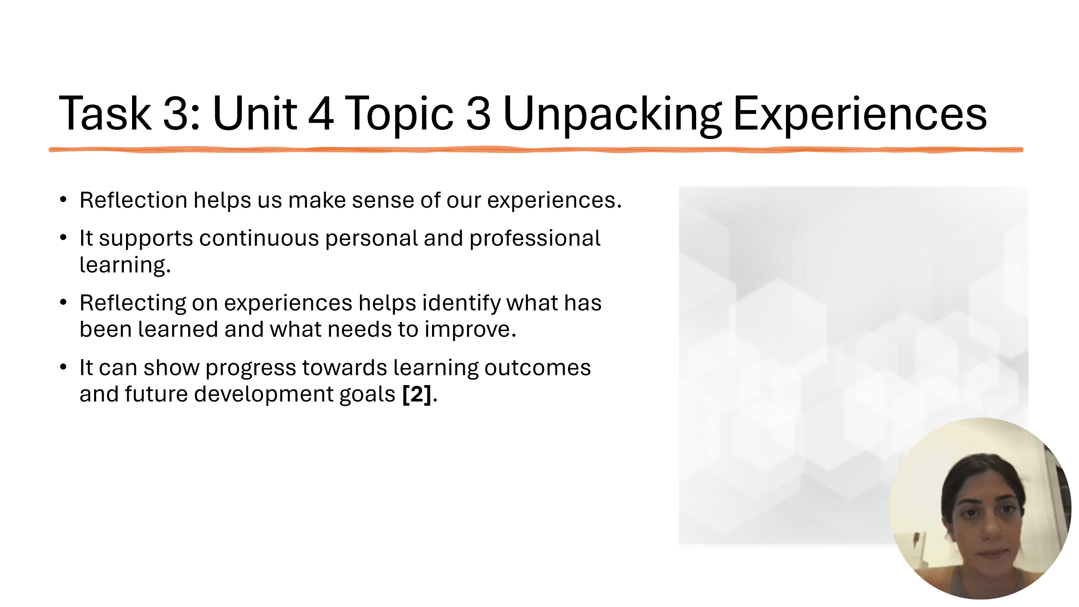

Brief explanation: I chose Topic 3: Unpacking Experiences from Unit 4. This topic explains how reflection can help people understand their experiences and learn from them. Reflection gives us a chance to think about what happened, what we learned and what we could improve in the future [5] [6].
Reflection is important for both personal and professional development because it supports continuous learning. It can help learners recognise their progress, understand their strengths and weaknesses, and identify areas that need more development [7].
By reflecting on my own experiences, I can understand my learning better and make better decisions about my future development goals.

Slide 9
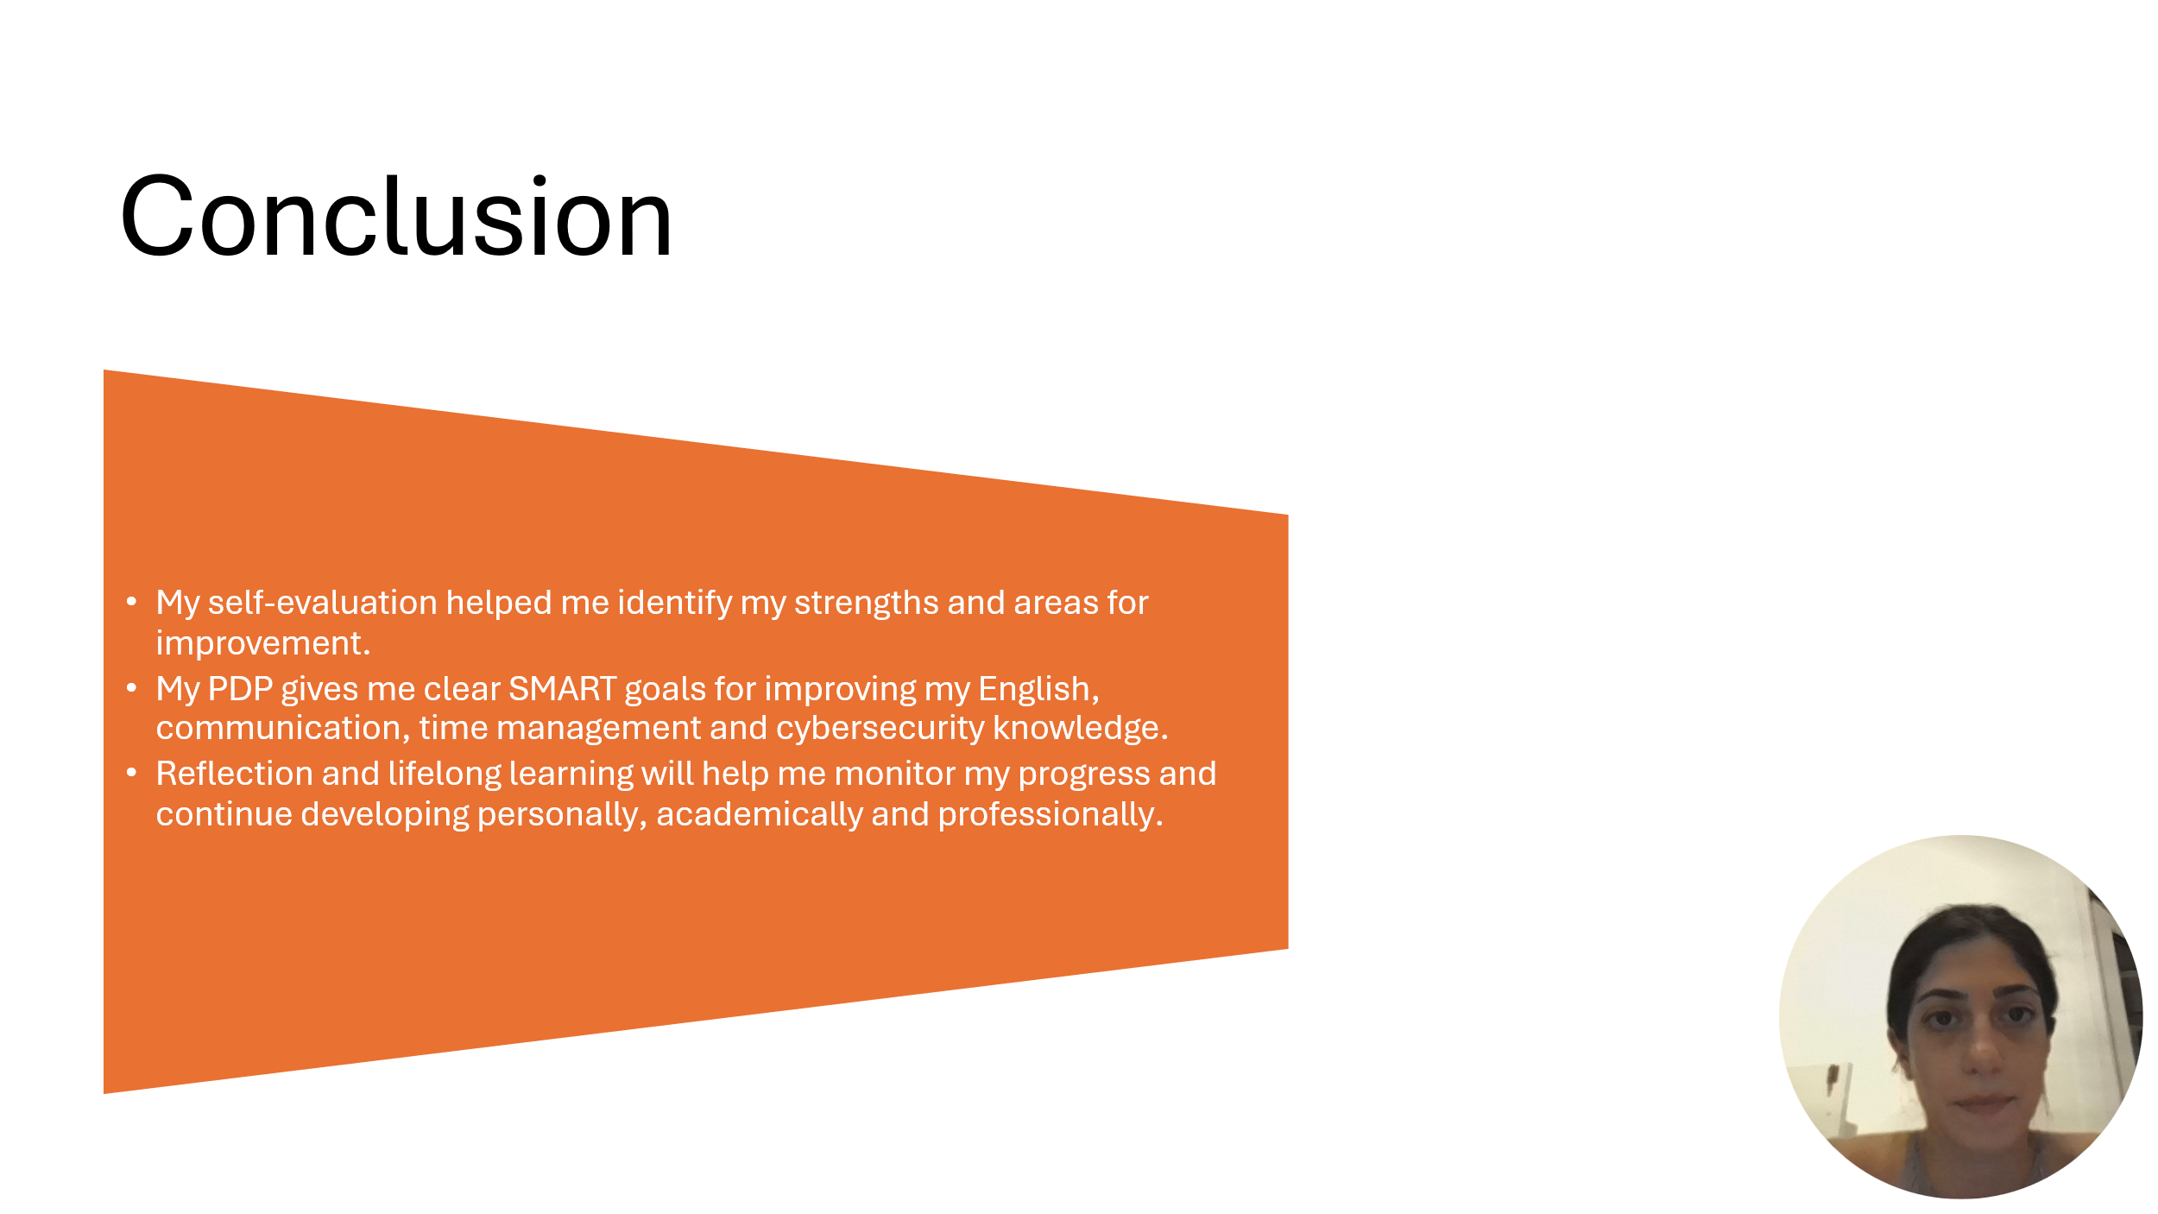

Brief explanation: In conclusion, this assignment helped me understand myself better by identifying my strengths, weaknesses and personal traits. The self-evaluation and SWOT analysis showed me which skills I already have and which areas I need to improve [3].
Using Gibbs’ Reflective Cycle helped me think about my experiences in a more organised way. It also helped me understand what I have learned from different situations and what I can do better in the future. Also be useful for teamwork because it helps team members reflect on their experience, identify problems and improve how they work together in the future.
My Professional Development Plan gave me clear SMART goals for improving my English communication, time management, confidence and cybersecurity knowledge. These goals will help me monitor my progress and stay focused on my studies and future career.
The Unit 4 topic also showed me that reflection and lifelong learning are important for personal and professional development. Overall, this assignment has helped me create a clearer plan for my future and understand the steps I need to take to continue improving.

Conclusion
In general conclusion, this assignment helped me understand the importance of reflection and planning for personal and professional development. It also helped me identify the skills I need to improve and the steps I can take towards my future goals.

References
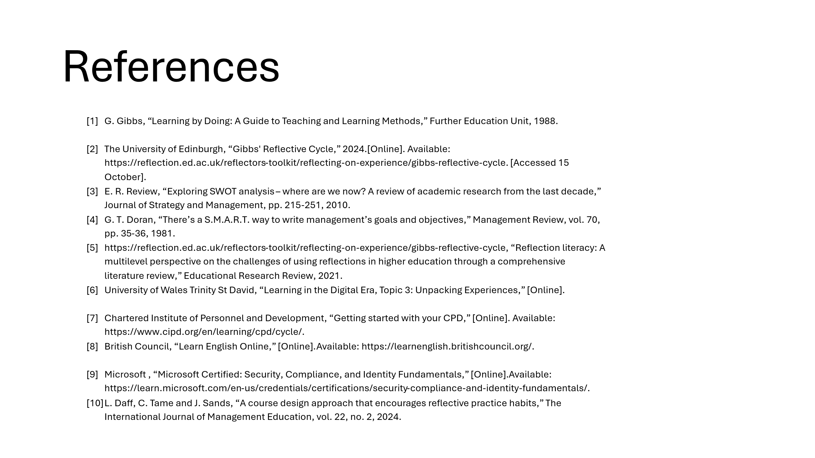

[1] | G. Gibbs, “Leraning by Doing: A Guide to Teaching and Learning Methods,” Further Education Unit, 1988.
[2] | The University of Edinburgh, “Gibbs' Reflective Cycle,” 2024. [Online]. Available: https://reflection.ed.ac.uk/reflectors-toolkit/reflecting-on-experience/gibbs-reflective-cycle. [Accessed 15 October].
[3] | E. R. Review, “Exploring SWOT analysis – where are we now? A review of academic research from the last decade,” Journal of Strategy and Management, pp. 215-251, 2010.
[4] | G. T. Doran, “There’s a S.M.A.R.T. way to write management’s goals and objectives,” Management Review, vol. 70, pp. 35-36, 1981.
[5] | https://reflection.ed.ac.uk/reflectors-toolkit/reflecting-on-experience/gibbs-reflective-cycle, “Reflection literacy: A multilevel perspective on the challenges of using reflections in higher education through a comprehensive literature review,” Educational Research Review, 2021.
[6] | University of Wales Trinity St David, “Learning in the Digital Era, Topic 3: Unpacking Experiences,” [Online].
[7] | Chartered Institute of Personnel and Development, “Getting started with your CPD,” [Online]. Available: https://www.cipd.org/en/learning/cpd/cycle/.
[8] | British Council, “Learn English Online,” [Online]. Available: https://learnenglish.britishcouncil.org/.
[9] | Microsoft , “Microsoft Certified: Security, Compliance, and Identity Fundamentals,” [Online]. Available: https://learn.microsoft.com/en-us/credentials/certifications/security-compliance-and-identity-fundamentals/.
[10] | L. Daff, C. Tame and J. Sands, “A course design approach that encourages reflective practice habits,” The International Journal of Management Education, vol. 22, no. 2, 2024.

