

Module: Human Resource Management

Module Code: LCMB7000

Assignment Title: Assessment 2 (Human Resource Management)

Student Name: Taruna Sewani

Student ID: 2124613
Contents
Introduction 3
Profile of the organisation 4
Change management 5
Kotter’s Eight steps to change 5
Relevance and application to Zara 6
Staffing: Retention 7
Maslow’s hierarchy of needs theory 8
Relevance and application to Zara 9
Leadership development 10
Transactional leadership 10
Lean leadership 11
Relevance and application to Zara 11
Conclusions 12
Recommendations 12
References 13

Introduction
Outlining detained and appropriate human resource strategies denotes to practice the effective strategies that can capture the most possible extent of output from the employees of the organisation. The management of human resource is the responsibility of the HR managers within the organisation to add the superior values from market. The value addition from skilled human resource is highly required at the recent age as the range of competition has been increased to the business sector. The aim of this report is to prepare the human resource strategies for

Profile of the organisation
Zara is a UK fashion retail company that deals with various fashion products including shoes, accessories, cloths, perfumes, beauty products and so one. About 20 types of cloths are mainly sold by Zara to the international retail market. The company was established in 1975 and its mission is to give the customers what they want faster than anyone else to the market. On the hand, the vision of Zara is to become the market leader in the international fashion retail industry. The John Lewis, Walmart, Morrissons, are the direct customers of Zara to the international market. The workplace of Zara is diversified by the participation of 75000 employees who are engaged to 2270 retail outlets of the company. As the company is competing with different market leaders, the adoption of HR strategies is required to the company.

Change management
Though Zara is performing effectively to the retail fashion sector, the due changes are needed for the organisation to adapt new strategies and the importance to board the competitive edge has been increased in the modern age. Change management is the transformation and transition of the policies, mission, process, goals and technologies of the organisation. The motto of change management is to effect the change, control change and associate the employees of the organisation to adapt the changes made by HR managers (Biasca, 2010). As per playing the role of HR director of Zara, the importance and relevance of change management for the context of the company has been focused in this report. The adaption of change has been identified as major issue for the change management procedure and the effectiveness of the change management depends on the proper adaption with changes by the employees.
Change management is associated with leaving the old policies and undertaking the new polices as per the organisational scope to generate the better performance to the organisation. As a HR manager in Zara, I would like the analyse internal and external factors of Zara to manage the change in the management. For instance, the strength and weakness of Zara need to conducted so that the formulated change management criteria can consolidate the strengths of the company (Rasche and Rehder, 2018). I need to search the scope of Zara for change the management structure at first and the possible change management policies can be compared with the existing policies.

Kotter’s Eight steps to change
John Kotter prescribed about eight kinds of to transform the organisation in 1996 as per the research on about 100 different organisations. The momentum of change can be maintained be effective by following this type of change management model to the organisation. The analysis of different steps is analysed below:
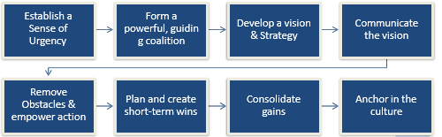
At first the sense of urgency need to be established to the organisation so that the demand of change in the workplace can be analysed in proper manner. After that the powerful guideline coalition can be set to be prancing in changing the organisational structure. The vision and strategies of the company is also required to the set in managing the changes (Biasca, 2010). On the basis of organisational vision and strategies, the change management activities can be implemented. Then, the vision of the company need to be communicated by the HR managers so that the changes can fulfil the organisational vision in effective ways.
According to Reiss (2012) the change management procedure can be faced various obstacles and discrimination. During change the organisational policies, the discrimination and obstacles should be overcome by the managers to ensure the value added change in the management. Whole implementing changes, the short term and long term goals should be set by the managers to capture benefits through change management. Hence, the plan of short term wins can be formulated within the organisation and consulate gains can be analysed to assess the benefits from the change (Lussier & Hendon, 2019). Finally, the HR managers need to anchor the culture of changes to practice the new policies and goals to the organisation.

Relevance and application to Zara
The practices of different kinds of changes are required in the context of Zara as the level of competition and demands of value addition has been increased for the company. For this reason, the implementation of change management model is required to ensure the successful changes of the policies and goals of the company (Reiss, 2012). For implementing the changes of goals and management structure, the human resource management can provide short term and long term orientation of the stuffs so that they can be adapted with the changes in management. Workplace culture of Zara should be changed along with the change management structure to make sure the value added changes within Zara. As a HR director of Zara, I can analyse the macro and micro environmental factors to evaluate the needs of ultimate changes in the organisation. By this way, the relevant change management practices can be fulfilled to the workplace of Zara.

Staffing: Retention
Zara tends to fulfil the demand of the employees towards organisation so that the employee motivation can be managed from the top management of the organisation. Having playing the role of HR director of Zara, I would like to analyse various types of stuff retention strategies so that the employee motivation can be managed by the company and the skilled employees can be retained to the workplace (Fargus, 2010). Zara offers the employees dynamic workplace and the employees of the company are captured from different countries. The cultural background of the stuffs of Zara are also different in this case that creates the challenge on the stuff retention procedure of the company.
Hereby, it can focus on the needs of the employees and the financial and nonfinancial support can be given to the stuffs of Zara. During pandemic, some employees are working remotely and the motivation to the employees is needed to keep their performance high in the workplace. I can also give the flexible work environment, allowing decision making to employees, bonus, flexible work environment, and different types of supportive actions can be implemented towards employees (Waldo Emerson, 2017). Different level of needs of the stuffs is a key issue in the context of employee retention as the HR managers have to fulfil the needs of individual to the workplace to keep their high performance working to the organisation.

Maslow’s hierarchy of needs theory
According to John Abraham Maslow, the needs of the individuals can be divided into three categories and it can be subdivided into five categories. They are basic needs, psychological needs and self-fulfilment needs. This theoretical framework is applicable to the employee retention of the organisation and the satisfaction of the stuffs of the companies can be managed by the proper compliance of this theory. The analysis of hierarchy of needs are explained below:
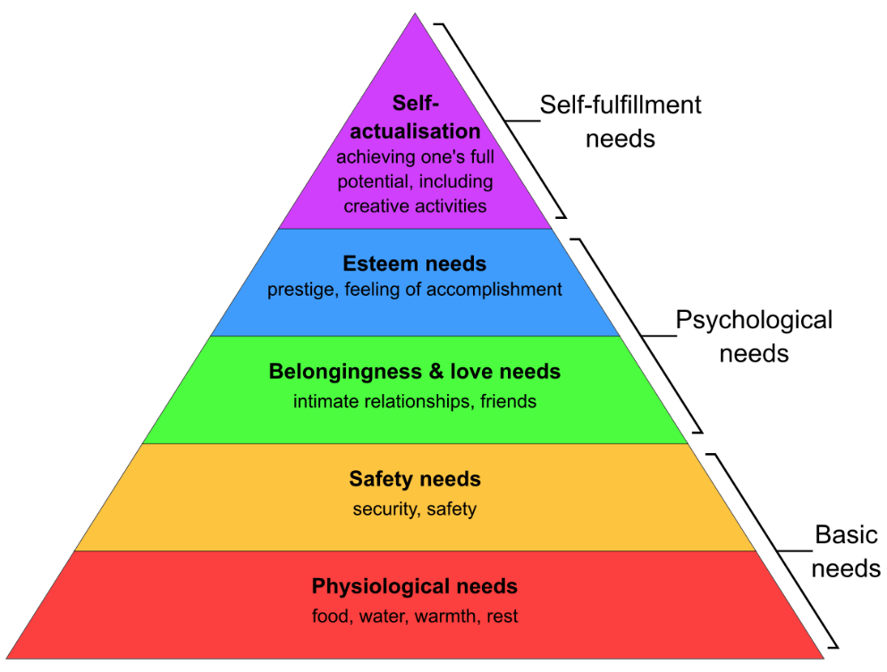
Figure: Maslow’s hierarchy of needs theory
Source: (Fargus, 2010)
Physiological needs: The physiological needs of the employees are defined as the basic need as the needs for foods, water, rest and so on are fulfilled through effective manner. To motivate the stuffs, the management of the organisation must fulfil these needs (NOE, 2022). Without fulfilling these types of needs, the employees can’t live properly and their growth can be hampered in high extent.
Safety needs: The safety and security needs of the stuffs are also needed and it has been desired also as the basic needs. After fulfilling the needs for foods, the individual demands for safety needs (Ivancevich and Konopaske, 2013). These basic needs can enable the organisations to get connected with employees as the regular performance of the stuffs can be maintained by fulfilling their basic needs.
Love and belonging: The psychological growth of the individual can be ensured by love and belongingness from others. If they get belonging from others, their psychological aspects can be ignited (NOE, 2022). The top management of the organisations can provide love and belonging to the stuffs to increase the engagement with them and desired output can be captured from them.
Esteem needs: The esteem needs are defined as the needs for prestige and feeling. At a specific level, the employees demand the prestige from the management. Hence, the recognition and respect needs to be given them so that their level of satisfaction can be increased in the high extent (Ivancevich and Konopaske, 2013). The esteem needs are another kind of psychological need that ensure the top level satisfaction.
Self-actualisation: The peak stage of employee need if self-actualisation. In this stage, the employees need achievement from their creative activities. The acknowledgement of the creative work of the individual can fulfil their self-actualisation needs (Fargus, 2010). The employees having high rank to the organisation can demand this kind of needs. The top level demands of stuffs can be fulfilled in the proper manager as per recognition from the management.

Relevance and application to Zara
Maslow’s hierarchy of needs theory has relevance to be applied in the workplace of Zara as about 73000 employees are working to the organisation and they have different kinds of needs. As Zara maintains the bulky workforce, the segmentation of employee needs through this motivational theory can be applied in desired manner. To apply this employee retention theory, Zara has to divide the employees with different level (Lussier & Hendon, 2019). As the demands of the stuffs are different types, the management should consider the employees with various levels as per their rank in workplace or their set of skills.
Dividing the employees into different segment, the analysis on their physiological, psychological and self-fulfilment needs can be conducted. At this point, Zara can allow the insurance scheme and different safety scheme towards employees who have the safety needs to the organisation (NOE, 2022). To fulfil the psychological needs of the stuffs, the HR managers of Zara can maintain the friendly relationship with the stuffs. Finally, the recognition to the employees can be implemented by Zara to meet the self-fulfilment needs. The organisation can design the strategies separately to fulfil the employee needs in different segments.

Leadership development
Leadership is about to influence the performance of others within the organisation to attain the business objectives. The leaders are people within the organisation who motivate others, take risk and direct the employees to increase the organisational values (BARRACLOUGH, 2016). The leaderships development within Zara has been undertaken so that organisation can apply the desired leadership style to ensure employee participation and managing the best output from the company.
I would like to analyse various leadership styles and their impact to the organisation along with the employees. After analysing various styles of leadership, I will recommend the best leadership style for Zara that can be practiced. Hence, the pros and cons of various leaderships styles are discussed with their impact on the organisational performance on Zara.

Transactional leadership
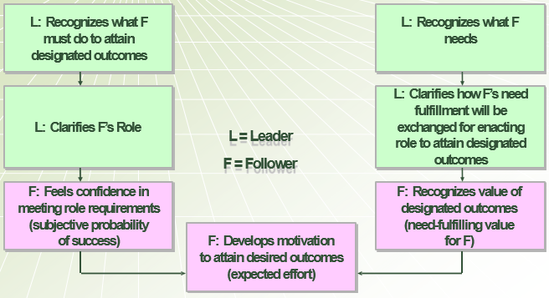
In this kind of leaderships style, the leaders support to the employees about doing the performance to capture the desired goals of the organisation. Hence, the leaders may fulfil the esteem needs of the individuals to capture the best output from them. Sometimes, the leaders depend on the reward and management by exception method to lead the employees can capture from them the most possible extent of output. After designing the employees what must do to get the result the leaders clarity the role of the employees (Van et al., 2010) Moreover, the leaders recognise to the employees about their needs and clarify how to fulfil the result as per playing different kinds of roles to the organisation. Above all, the subordinates can gather knowledge about the experience of the leaders and their performance level can be upgraded in the high extent.

Lean leadership
The team members within Zara can be associated with lean leaderships to get the high performance from the organisation. It is regarded as effective form of leaderships that associate all level of employees of the organisations to fulfil the organisational goals and objectives.
The leaders of Zara must define the organisational vison towards the stuffs to create values within the group. Hence, the lean leaders have to support the employees to capture the shared vision as per providing feedback and consultancy (Vicere, 2018). For example, the coaling, teaching, providing examples, being knowledgeable and varoous techniques can be applied by lean leaders to create values among team members. By this way, the organisational vision can be shared with the subordinates by the leaders and the employees can put their best offer to fulfil the desired results.

Relevance and application to Zara
To develop the leadership within the organisation, the distribution of power is considered as effective factor in the context of Zara. To practice the effective style of leadership is effectively needed to the workplace of Zara as the values of leaderships style determines the organisational performance. By comparing different types of leadership styles such as Lean leadership and transactional leadership, it can be concluded that the transactional leadership can be relevant for Zara. The designed outcomes are discussed with the subordinates and leaders show the ways by himself to the subordinates as per transactional leaderships style and it can be applicable to Zara (Kets et al., 2011). Practicing transaction leadership within Zara can also associates the stuffs with the predetermined goals of the company and business objectives of the company can be meet in effective ways.

Conclusions
It can be concluded that the HR strategies discussed within the report are effective to enhance the performance level within Zara. For instance, the change management, employee retention and leadership development are discussed for the context of Zara to determine the values of these types of HR strategies. The proper description of the strategies and their application to the organisational context of Zara are analysed to apply them to the organisation in significant manner. Particularly, the Maslow’s hierarchy of needs theory can be applied by Zara for employee retention and transactional leadership can be implemented to arise the organisational performance.

Recommendations
- Zara should conduct the internal and external analysis to formulate the HR strategies within the workplace.
- The vision and mission of each kind of HR practices should be discussed with the stuffs to connect them with the organisational plan and procedure.
- The HR management of Zara should allow flexibility to the stuffs to ensure their spontaneous participation in the organisational performance.
- Zara should fulfil the financial and non-financial demand of the stuffs to capture best output from them.

References
BARRACLOUGH, S., 2016. LEADERSHIP. [Place of publication not identified]: HEINEMANN FIRST LIBRARY.
Biasca, R., 2010. Change Management. Ediciones Macchi.
Fargus, P., 2010. Measuring and improving employee motivation. London: Financial Times Prentice Hall.
Ivancevich, J. and Konopaske, R., 2013. Human resource management. New York, NY: McGraw-Hill Irwin.
Kets de Vries, M. and Korotov, K., 2011. Leadership development. Cheltenham, UK: Edward Elgar.
Lussier, R. N. & Hendon, J. R., 2019. Fundamentals of Human Resource Management: Functions, Applications, and Skill Development. 2 ed. London: SAGE Publications, Inc
NOE, R., 2022. Human Resource Management. Columbus: McGraw-Hill US Higher Ed USE.
Rasche, C. and Rehder, S., 2018. Change management. Stuttgart: Kohlhammer Verlag.
Reiss, M., 2012. Change management. [Place of publication not identified]: Books On Demand Gmbh.
Van Velsor, E., McCauley, C. and Ruderman, M., 2010. The Center for Creative Leadership handbook of leadership development. San Francisco: Jossey-Bass.
Vicere, A., 2018. Leadership development. New York, NY: Human Resource Planning Society.
Waldo Emerson, R., 2017. Compensation. La Vergne: Dreamscape Media.

