Marketing Fundamentals

Assignment 2

Name: Paul-Silvian Vornicescu
Student ID: 2246785
Module code: LCBB4004
Module name: Marketing Fundamentals
Lecturer: Tushara Balendran

TABLE OF CONTENT

1. | Introduction | 3
2. | Marketing and Marketing Process | 3
3. | Pestle analysis | 6
4. | Porter's Five Forces Analysis | 9
5. | Advantages and Disadvantages of PESTLE and Porter’s Five Forces Analysis for Porsche | 12
6. | Recommendations for Porsche Using the Ansoff Matrix | 14
7. | Conclusion | 16
8. | References | 18

Introduction
The automobile industry stands at a crucial crossroad, challenged by shifting consumer preferences, the arrival of digital technology, and increasing environmental concerns. Within this context, Porsche AG, a renowned German automaker, has created a niche for itself as a purveyor of luxury, performance, and heritage. Founded in 1931, Porsche has not only survived, but thrived, consistently innovating while staying true to its brand identity (Landenberger, 2023). However, as with all industry giants, Porsche must adapt to remain competitive amidst an evolving macro-environment. This paper aims to elucidate an external analysis of Porsche, examining the opportunities and threats that lie ahead in the broader market. Subsequently, based on these findings, the report will explore future strategic recommendations to ensure the brand's sustained growth and continued relevance.

Marketing and the Marketing Process

According to The Chartered Institute of Marketing (2023) marketing is the management process responsible for identifying, anticipating and satisfying customer requirements profitably.
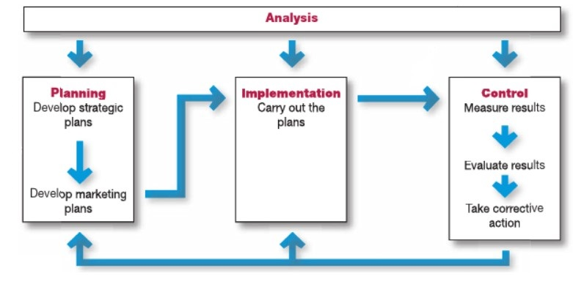
While expertise in marketing is imperative for effective marketing management, emphasis must also be placed on proficient management of the marketing process. This involves a sequence of five pivotal marketing management functions: analysis, planning, implementation, organisation and control. Initially, an organization formulates broad strategic agendas and subsequently refines these into detailed marketing blueprints for every division, product line, and brand identity. The implementation and organisation phases is where these strategies are operationalized. The control function involves assessing the outcomes of marketing endeavours, gauging their success, and instituting necessary adjustments. Integral to this sequence is the analysis, evaluating essential insights and assessments that inform all subsequent marketing operations (Kotler, 2020).
Diagram source: Kotler, P. et al. (2020) Marketing Process Diagram. Harlow, England: Pearson.

1. Situational Analysis:
This preliminary stage focuses on assessing Porsche's current standing within the automotive sector and understanding the myriad factors that could influence its future trajectory. Utilizing tools like the SWOT (Strengths, Weaknesses, Opportunities, and Threats) and PESTEL (Political, Economic, Social, Technological, Environmental, and Legal) analyses, a comprehensive picture is formed. For Porsche, this could mean evaluating their position within the luxury car market, recognizing emerging trends like electric vehicles, and understanding global economic forces that might affect luxury car sales.
2. Objectives:
Upon obtaining a clear understanding of the situational context, the next step is to crystallize specific marketing objectives. For Porsche, these objectives could range from increasing market share in emerging markets, establishing leadership in electric vehicle technology, to enhancing brand loyalty among existing customers. These objectives should be SMART – Specific, Measurable, Achievable, Relevant, and Time-bound.
3. Strategy:
With clear objectives in place, the strategy phase involves delineating the path to achieve those objectives. For Porsche, this could involve decisions related to product development, pricing, distribution channels, and promotional activities. For instance, if one of the objectives is to capture a larger share of the electric vehicle market, the strategy might encompass developing new EV models, forming partnerships for sustainable battery technology, or emphasizing green manufacturing processes in their branding narrative.
4. Implementation:
The translation of strategies into tangible actions is encapsulated in this phase. For Porsche, this could mean the actual production of a new vehicle model, the launch of a global advertising campaign, or the initiation of a partnership with a tech firm for advanced in-car systems. It's vital at this stage to ensure that all departments within Porsche, from design and manufacturing to sales and customer service, are aligned with the overarching marketing strategy.
5. Control:
A continuous assessment mechanism, this phase ensures that the marketing initiatives are on track to meet the set objectives. Using a combination of performance metrics, feedback loops, and periodic reviews, Porsche can determine if their strategies are effective or if mid-course corrections are required. For instance, if sales figures in a particular region do not align with projections, a deep dive into the data might reveal issues with distribution or cultural mismatches in advertising.
In summary, the marketing process is a systematic approach that allows companies like Porsche to navigate the dynamic business environment. From understanding their current position and setting goals to strategizing and ensuring consistent results, each phase is pivotal in ensuring that Porsche remains a dominant force in the luxury automotive sector.

Pestle analysis
PESTEL analysis, an acronym for Political, Economic, Social, Technological, Environmental, and Legal, is a strategic tool used in management and business studies to evaluate and monitor the macro-environmental factors that may impact an organization (CIPD, 2023). By identifying and understanding these external factors, businesses can craft strategies that capitalize on opportunities and mitigate risks in their external environment.
1. Political:
Porsche operates globally and is, therefore, influenced by political climates in various regions. Regulations concerning emissions and the promotion of electric vehicles (EVs) are gaining traction, particularly in Europe and China. While such regulations can challenge traditional combustion-engine manufacturers, Porsche has responded with its EV, Taycan.
Evaluation: Favourable. Porsche's foray into the electric vehicle market with the Taycan demonstrates adaptability and future readiness in the face of political pressures (Canal Vieira, 2022).

2. Economic:
Luxury brands like Porsche are sensitive to global economic shifts. The rise of affluent middle classes in emerging markets like China, India, and Brazil present lucrative opportunities (Singh, 2021). However, economic downturns, as seen in the 2008 financial crisis, can stifle luxury car sales.
Evaluation: Mixed. While emerging markets present growth opportunities, Porsche must remain vigilant to global economic fluctuations that can impact luxury purchases.

3. Social:
There's an increasing societal shift towards sustainability. Consumers, even in the luxury segment, are becoming conscious of environmental impacts. Additionally, Porsche's brand appeal to younger audiences, given the rise of tech giants and changing perceptions of luxury, is another social dynamic (Georgieva, 2022).
Evaluation: Favourable. Porsche's commitment to sustainability, evident in their electric and hybrid models, aligns with societal values. Moreover, collaborations like that with Apple for infotainment systems resonate with younger demographics.

4. Technological:
The automotive industry is on the cusp of revolutionary changes. Autonomous driving, AI integration, and advanced driver-assistance systems (ADAS) are shaping the future. Porsche, being a luxury brand, is expected to be at the forefront of these innovations.
Evaluation: Favourable. Porsche's consistent investment in R&D and partnerships with tech firms position it well to harness technological advancements, offering state-of-the-art features to its clientele (Szumska and Jurecki, 2023).

5. Environmental:
The automotive industry is under scrutiny for environmental reasons. Emission standards are becoming stringent, and there's a push towards eco-friendly vehicles. Porsche's traditional models, with combustion engines, are at odds with this shift.
Evaluation: Mixed. While Porsche's legacy models face challenges in this domain, their vigorous push into electric and hybrid territories, with models like Taycan and Panamera E-Hybrid, showcases adaptability. Yet, the full transition is a complex journey (Bitsche, 2023).

6. Legal:
Regulations concerning safety standards, emissions, and now data security (with the rise of connected cars) impact Porsche (Martins, 2019). Non-compliance can lead to hefty penalties and brand reputation damage.
Evaluation: Mixed. While Porsche is known for its rigorous adherence to safety and quality, the ever-evolving legal landscape, especially around data security in connected vehicles, presents challenges. The brand needs proactive legal strategies to navigate this terrain.

Porsche's journey through the PESTLE landscape is characterized by agility and resilience. While certain factors, particularly legal and environmental, pose challenges, the brand's proactive approach, backed by consistent innovation, aligns it favourably with most macro-environmental dynamics. It's imperative, however, for Porsche to continually evaluate and adapt to ensure its iconic status remains untarnished in an evolving global context.

Porter's Five Forces Analysis
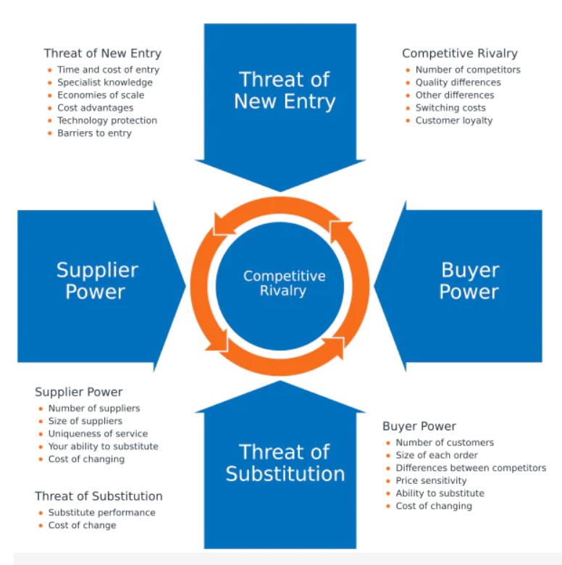
Originally proposed by Michael E. Porter in his seminar 1979 work, this model delineates five fundamental forces that shape the competitive intensity and attractiveness of an industry: the threat of new entrants, the bargaining power of suppliers, the bargaining power of buyers, the threat of substitute products or services, and the rivalry among existing competitors (Porter, 1979). By evaluating these forces, organizations can identify strategic opportunities, anticipate challenges, and make informed decisions that leverage their strengths in the market.

Source: Harvard Business School Publishing Corporation, 1979
1. Threat of New Entrants (Medium):
The luxury automotive industry is marked by high entry barriers, including capital-intensive operations, regulatory challenges, and the need for brand recognition. While established companies might possess the resources to enter the luxury segment, startups face significant hurdles.
However, the rise of electric vehicles has seen new players like Tesla challenging the status quo. Moreover, technology companies like Apple and Google harbour automotive aspirations (Bloomberg, 2021).
Evaluation: Medium. Although traditional barriers keep the threat moderate, evolving technological paradigms and ambitions of tech giants introduce potential disruptors.

2. Bargaining Power of Suppliers (Medium):
Porsche, like other luxury automakers, relies on high-quality parts. This necessitates partnerships with a limited set of suppliers capable of meeting their stringent standards, elevating these suppliers' bargaining power. However, Porsche's strong brand and high order volume make it a valued customer, providing some leverage over suppliers.
Evaluation: Medium. The dual dynamics of dependency on specialized suppliers and Porsche's substantial order volumes balance out supplier power.

3. Bargaining Power of Buyers (Low):
Porsche caters to a niche audience seeking luxury, performance, and brand legacy. The exclusivity associated with Porsche reduces the direct price sensitivity of its clientele. Moreover, the total cost of ownership, encompassing superior after-sales service and brand prestige, further diminishes buyer bargaining power.
Evaluation: Low. Porsche's unique value proposition, brand heritage, and superior service parameters diminish direct buyer leverage.

4. Threat of Substitute Products (High):
The broader automotive industry is abundant with alternatives, from public transport to car-sharing platforms. But for Porsche, the threat comes from within the luxury segment. Competitors like Ferrari, Lamborghini, or more accessible luxury brands like BMW's M series or Mercedes' AMG line, present potent alternatives. Furthermore, the electrification trend has augmented this threat, with brands like Tesla providing both luxury and environmental consciousness (Maamoun, 2021).
Evaluation: High. Given the internal competition and shifting perceptions of luxury in the age of electrification, Porsche faces significant substitution threats.

5. Competitive Rivalry within the Industry (High):
The luxury automotive landscape is fiercely competitive. Brands not only vie for market share but also for brand supremacy, technological leadership, and design innovations. Companies like Ferrari, Aston Martin, and Bentley, among others, continually innovate, making the industry dynamic and rivalry intense.
Evaluation: High. With numerous brands pushing the envelope in design, technology, and brand experiences, Porsche operates in a highly competitive environment.

Navigating the competitive landscape encapsulated by Porter's Five Forces, Porsche finds itself in a complex, ever-evolving environment. While the brand's heritage and value proposition offer buffers against certain forces, the shifting sands of technology, perceptions of luxury, and intra-segment competition necessitate continual evolution and innovation. As the automotive landscape undergoes transformative shifts, Porsche's strategic agility will determine its continued success.

Advantages and Disadvantages of PESTLE and Porter’s Five Forces Analysis for Porsche

In the evolving landscape of the automotive industry, understanding the myriad of external forces at play is indispensable. Two frameworks that are frequently employed for this purpose are the PESTLE and Porter’s Five Forces analyses. When used to evaluate Porsche’s position in the market, both models provide insightful revelations but also come with their limitations.
Advantages:
Comprehensiveness and Foresight (PESTLE): PESTLE’s comprehensive nature is its primary strength. By assessing Political, Economic, Social, Technological, Environmental, and Legal factors, organizations like Porsche gain a panoramic view of the broader environmental factors affecting their operations. Such analysis can guide them in preemptively addressing challenges. For instance, understanding the global push towards environmental sustainability helps Porsche make strategic moves, like the development of the Taycan, their electric vehicle (EV).
Competitive Insight (Porter’s Five Forces): The automotive industry is renowned for its fierce competition, and Porter’s Five Forces provides a detailed breakdown of this competitive landscape. By studying elements such as the threat of new entrants or the power of buyers, Porsche can fine-tune its strategies. Recognizing the intense rivalry in the luxury car segment, for example, can guide Porsche in focusing on unique value propositions or exploring niche markets.
Strategic Roadmap: Together, PESTLE and Porter’s analyses serve as strategic roadmaps. They not only reveal the current landscape but also hint at future trends. This foresight can be crucial for long-term planning and can help Porsche align its R&D, marketing, and operations with anticipated changes.
Disadvantages:
Rapid Evolution: One of the most significant limitations of both PESTLE and Porter’s Five Forces is their inherently static nature. In industries like automotive, where technological and regulatory changes can be rapid, these analyses can quickly become outdated. While the PESTLE might have highlighted the rise of EVs, the speed at which hydrogen fuel cell technology or fully autonomous vehicles become mainstream might render parts of the analysis obsolete.
Potential Overlap (PESTLE): While PESTLE is comprehensive, it also leaves room for potential overlap and ambiguity. Technological advancements related to environmentally friendly propulsion could fall under both Technological and Environmental categories. Such ambiguities might lead to confusion or misallocation of resources.
Overemphasis on External Elements: While understanding external forces is crucial, an over-reliance on PESTLE and Porter’s analyses could lead Porsche to overlook internal competencies, capabilities, and organizational culture. It's imperative to understand that while these models provide invaluable external insights, sustainable competitive advantage often arises from a synergy of external alignment and internal strengths.
Implications for Porsche:
Given the current trajectory of the automotive industry, it’s clear that Porsche's future success lies in its ability to nimbly navigate both macro-environmental and industry-specific challenges. By continuously updating their PESTLE and Porter's Five Forces analyses, Porsche can stay ahead of potential pitfalls while exploiting emerging opportunities. Moreover, a periodic re-evaluation ensures that the analyses remain relevant in an industry characterized by relentless innovation and shifting consumer preferences.
Furthermore, while the benefits of these models are manifold, Porsche must ensure they remain one of many tools in their strategic arsenal. They need to be juxtaposed against other analytical frameworks and internal assessments to provide a holistic strategic direction.
The automotive industry, characterized by its dynamism, presents both opportunities and threats to luxury brands like Porsche. While tools like PESTLE and Porter’s Five Forces offer invaluable insights, they are not without limitations. By recognizing and addressing these limitations, while also leveraging the insights they provide, Porsche can carve a strategic path that ensures continued growth and industry leadership in the coming years.

Recommendations for Porsche Using the Ansoff Matrix

1. Product Development:
Analysis:
The pace of technological evolution in the automotive industry has been unprecedented in recent years. From the PESTLE analysis, it was evident that technology, particularly in the realm of electric vehicles (EVs) and autonomous driving, has become a central pivot. Moreover, the Porter’s Five Forces analysis accentuated the criticality of differentiation in mitigating threats of substitution and competitive rivalry in the luxury automobile sector.
Recommendation:
Porsche must invest more robustly in product innovation. The brand has made significant strides with the Taycan's introduction, but further differentiation is vital. This can include the development of vehicles that integrate AI-powered functionalities, enhanced autonomous driving capabilities, and bespoke infotainment systems that would redefine the luxury driving experience. Furthermore, there’s potential for Porsche to develop hybrid sports cars or SUVs that could combine the brand's legacy of performance with the latest EV technology. Doing so would not just consolidate Porsche's positioning but also lure a younger, tech-oriented demographic who are environmentally conscious yet desire performance.
Considering the brand's racing pedigree, there is also an opportunity for Porsche to venture into the high-performance EV racing segment. Motorsports can act as a testing ground for innovative technologies, which can then be cascaded to consumer vehicles. Racing success in the EV segment can further solidify Porsche’s image as a forward-thinking yet performance-oriented brand.

2. Market Development:
Analysis:
Emerging markets have showcased a tremendous economic upturn, leading to an expanding affluent middle class, as highlighted in the PESTLE assessment. Countries like China, India, and Brazil have become pivotal for luxury brands. While Porsche has made inroads, the depth of market penetration leaves room for expansion.
Recommendation:
Strategizing for deeper market penetration in these economies is paramount (Ansoff, 1957). Porsche should consider introducing tailored models that cater to specific local preferences. Given the traffic conditions and urban topography of many cities in emerging markets, there's potential for compact luxury SUVs or sedans, which blend Porsche's performance with urban practicality.
Additionally, marketing campaigns should be localized. Collaborations with regional celebrities or influencers can be instrumental in enhancing brand visibility and affinity. After-sales service is another area where Porsche can distinguish itself. By establishing state-of-the-art service centres and perhaps even driving schools in these countries, Porsche can offer an unrivalled brand experience, further solidifying customer loyalty.
Furthermore, exploring strategic partnerships with local firms or even considering assembly or manufacturing units in these regions might not only offer cost advantages but also position Porsche as a committed player in these markets.

Incorporating the Product and Market Development strategies from the Ansoff Matrix, Porsche can harness the momentum of technological innovation while capitalizing on the burgeoning demand in emerging markets. However, successful implementation requires keen sensitivity to market nuances, agility in innovation, and a harmonious blend of the brand's illustrious past with a visionary future. By bridging its storied legacy with strategic foresight, Porsche can ensure not only sustained market leadership but also a legacy that continually evolves with the times.

Conclusion
The automobile industry is abundant with both opportunities and formidable challenges, making strategic navigation paramount for luxury brands like Porsche. Through the meticulous exploration of Porsche's external environment, it becomes evident that its continued success is contingent upon a profound understanding of the myriad factors at play and the careful execution of forward-looking strategies.
PESTLE analysis offered an enlightening overview of macro-environmental factors. The emergent shift towards sustainable energy, especially in the automotive domain, is more than a mere trend—it's a paradigm shift. Porsche's endeavours, such as the introduction of the Taycan, resonate with the industry's environmental undertones and the rising consumer demand for electric vehicles. Rapid technological advancements, coupled with evolving regulatory landscapes, necessitate that Porsche remains sharp, applying its strategies to deal with external realities while ensuring alignment with its core brand values.
Moreover, Porter's Five Forces analysis elucidated the competitive pressures and market dynamics inherent to the luxury car sector. Threats from potential entrants, evolving buyer preferences, and the imminent spectre of substitutes are only some of the aspects that Porsche must deftly navigate. Their continued differentiation, steeped in a rich heritage of performance and luxury, will be instrumental in fending off rivals and maintaining a loyal clientele. Yet, even in this domain, complacency could be detrimental. The growing competitiveness necessitates not just differentiation, but innovation—a relentless pursuit of excellence that caters to the modern consumer's desires while echoing the brand's illustrious legacy.
From the Ansoff Matrix, the strategies of Product Development and Market Development emerge as potent avenues. Porsche's foray into innovative automotive solutions and deeper penetration into emerging markets could pave the way for sustained growth. Still, the implementation of these strategies demands a delicate balance, ensuring that brand dilution is avoided and the core essence of "Porsche" remains intact.
While external analyses and strategic frameworks are invaluable, they must not overshadow the brand's inherent strengths. Porsche's legacy, built upon decades of engineering prowess and a commitment to automotive excellence, is its most significant asset. The challenges of the future, while daunting, also present a canvas upon which Porsche can paint its next chapter—a synthesis of heritage, innovation, and foresight.
In conclusion, as Porsche stands at the crossroads of tradition and transformation, its strategic compass must be guided by both external insights and internal convictions. Merging its storied past with a visionary future, Porsche can ensure not just market leadership but a legacy that continually evolves, enchanting car enthusiasts for generations to come.

References
Ansoff, H. (1957) "Strategies for diversification", Harvard Business Review, Sept-Oct, 113-124.
Bloomberg (2021). Apple Accelerates Work on Car Project, Aiming for Fully Autonomous Vehicle. Available at: https://www.bloomberg.com/news/articles/2021-11-18/apple-accelerates-work-on-car-aims-for-fully-autonomous-vehicle?leadSource=uverify%20wall (Accessed August 2023).
Canal Vieira, L., Longo, M. and Mura, M. (2022) Will the regime ever break? Assessing socio-political and economic pressures to climate action and European oil majors’ response (2005-2019). Climate Policy, 22(4), pp.488–501.
CIPD (2023) PESTLE analysis factsheet. CIPD. Available at: https://www.cipd.org/en/knowledge/factsheets/pestle-analysis-factsheet/ (Accessed August 2023).
Georgieva, K. (2022). In what ways does AI support the integration of ESG projects in leading companies within the automotive industry like Tesla, Ford, Audi, BMW, Porsche, and Mercedes? Available at: http://essay.utwente.nl/91321/ (Accessed August 2023).
Kotler, P. et al. (2020) Principles of marketing. Eighth European edition. Harlow, England: Pearson.
Landenberger, D. (2023) Porsche History - Porsche AG. Available at: https://www.porsche.com/international/aboutporsche/christophorusmagazine/archive/379/articleoverview/article14/ (Accessed August 2023).
Maamoun, A. (2021) REVENGE OF THE ELECTRIC CAR IN THE 2020S: A CASE STUDY. Global Journal of Entrepreneurship, 5(1), p.2021. Available at: https://www.igbr.org/wp-content/uploads/articles/GJE_Vol_5_No_1_2021%20pp%2019-30.pdf (Accessed August 2023).

Martins, P. (2019) ‘Data Security in Modern Cars’, Carla Cordeiro and Hugo Barbosa. Proceedings of the Digital Privacy and Security Conference 2019, Porto, Portugal, 16 January 2019.
Otmar Bitsche and Passenberg, B. (2023). CO2- Life Cycle Assessment for the Porsche Taycan. Proceedings, pp.12–20.
Porter, M. E. (1979). How Competitive Forces Shape Strategy. Harvard Business Review, 57(2), pp.137-145.
Singh, J., Shukla, P. and Schlegelmilch, B.B. (2021). Desire, need, and obligation: Examining commitment to luxury brands in emerging markets. International Business Review, p.101947.
Szumska, E. and Jurecki, R. (2023). Technological developments in vehicles with electric drive. Combustion Engines.
The Chartered Institute of Marketing (2023) What is Marketing? | CIM Content hub. Available at: https://www.cim.co.uk/content-hub/quick-read/what-is-marketing/. (Accessed August 2023).

