(LCMB7013)
Managing Performance

Continuous
Performance Management

Student: Juthsna Begum (1907009)
Lecturer: Prof D G Pepple
Due date: 21/07/2023

Contents

Introduction

- Continues Performance Management

MACRO Environment:
Economic Environment
Technological Environment
Demographic Environment
Social and Cultural Environment

- Organization Climate

MESO Environment:

Organisational Culture
Leadership style:
- Authoritarian leaders
- Transformational leadership
- Supportive leaders
Employee Involvement
Efficient Correspondence (Communication)
Distributed Organisational
The competitive landscape and the presence of competitors

- Expectancy Theory - Resource-Based Theory

Expectancy Theory
Resource-Based Theory

- Reflective Report – Gibbs’ model of reflection

Conclusion

Reference

Appendix 1- Case Study: Western County (WC) Fire Brigade

Introduction

Performance management is a critical HR process, ensuring employee performance is aligned with organisational goals and objectives (Pagdonsolan et al., 2019). Additionally, Performance management is a method that helps to manage teams and individuals to maximise organisational performance effectively. As a result, it creates a shared understanding of what needs to be accomplished and a strategy for motivating, leading, and advancing personnel to achieve it (Armstrong & Baron,2004).

In this report, I will explore the concept of continuous performance management and its importance in promoting organisational success using the Western Fire Brigade case study (Appendix 1). Additionally, I will delve into the impact of organisational climate on continuous performance management, drawing insights from the Expectancy Theory and the Resource-Based Theory. Finally, I will share my learnings and insights from studying continuous performance management and its relationship with organisational climate, drawing from relevant research and examples. Additionally, I will provide my thoughts on the topic, reflecting on its significance in today's dynamic work environments and its potential implications for organisational success.

A modern method of performance management called continuous performance management emphasises continuing coaching, development, and feedback. Ongoing performance management encourages frequent, in-the-moment dialogues between managers and employees, unlike traditional performance management, which frequently depends on annual or periodic reviews. This method acknowledges that performance is an ongoing process that needs frequent attention and adjustment rather than a one-time occurrence.

Organisational climate plays a critical role in shaping the effectiveness of continuous performance management. A positive and supportive environment, characterised by open communication, trust, and collaboration, encourages employees to actively participate in the performance management process. On the other hand, a hostile or punitive climate can create barriers to honest feedback and hinder learning and improvement.

Drawing from the Expectancy Theory, which suggests that individuals are motivated by their belief in the link between effort, performance, and outcomes, and the Resource-Based Theory, which highlights the importance of leveraging organisational resources, I will examine how these theories intersect with continuous performance management. Managers can design and implement effective performance management strategies by understanding employees' expectations regarding performance feedback and the resources available within the organisation to support their development.

By delving into the concept of continuous performance management, exploring the impact of organisational climate, and considering theoretical perspectives, this report aims to provide a comprehensive understanding of its practical implications.

- Continuous Performance Management

In human resource (HR) management, continuous performance management is described as ongoing performance management processes that occur all year round.
Continuous performance management is a modern approach to employee performance that emphasises ongoing feedback, regular check-ins, and goal setting. It replaces the traditional annual performance appraisal system with a more dynamic and proactive process. Continuous performance management is crucial for multiple reasons.

Firstly, it enables real-time feedback and enhancement. Rather than awaiting a yearly performance assessment, staff members receive consistent feedback concerning their performance, allowing them to tackle any concerns or implement necessary modifications promptly. This proactive approach helps prevent minor issues from escalating into more extensive problems and promotes continuous growth and development.

Secondly, continuous performance management increases engagement and motivation. Regular check-ins and ongoing feedback contribute to higher employee engagement levels. Employees feel valued when their managers take an active interest in their performance and development. The continuous feedback loop provides opportunities for recognition, reinforcement of positive behaviours, and course correction if needed. Thirdly, continuous performance management allows for agile goal setting and alignment. Traditional annual goals may become outdated or irrelevant as business priorities and strategies evolve yearly. This flexibility helps organisations stay nimble in a rapidly changing environment and ensures that employees' efforts are aligned with organisational priorities.

Furthermore, continuous performance management promotes a development-focused culture. By providing ongoing feedback, regular check-ins, and growth opportunities, continuous performance management encourages employees to take ownership of their development. Workers are authorised to pursue feedback, establish objectives, and actively search for chances to enhance their abilities and competencies. This atmosphere of ongoing education nurtures staff development, amplifies job contentment, and adds to the general accomplishment of the enterprise.
The below diagram shows Continuous Performance Management Cycle; the processes included near-term objectives and goal setting, regular one-to-ones (or “check-ins”) and real-time feedback.

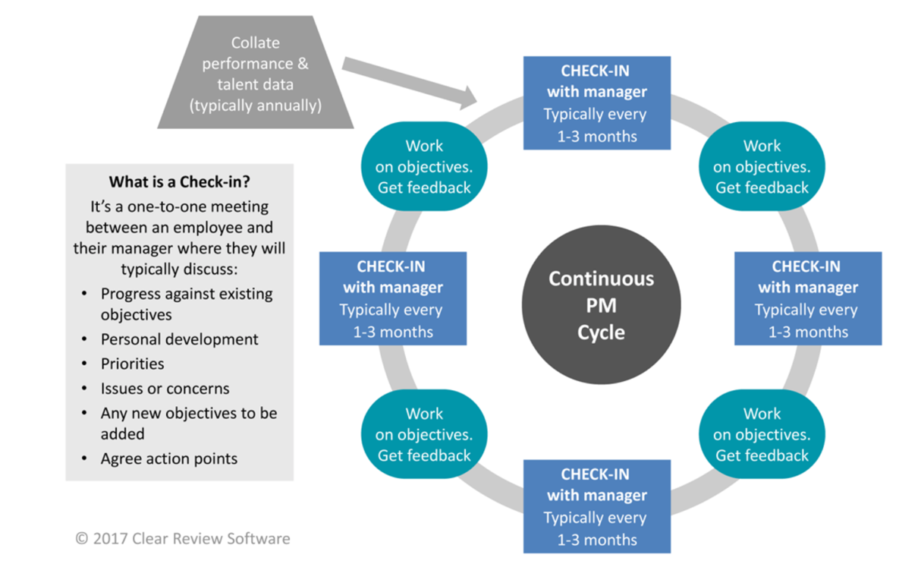
(Clearview,2023)

Most organisations have embraced the concept of continuous performance management, which ultimately supports employees to perform to their highest potential.

Adobe Inc was the first organisation to adopt continuous performance management; they abandoned their annual appraisal process back in 2012 in favour of​“check-ins” and frequent feedback. Since then, Adobe's voluntary turnover has decreased by 30% (Clearview,2023)
compared with ‘Western County Fire Bridge’, which embraced continuous performance management, abandoning annual performance appraisals in 2012 had improved; they had replaced them with regular one-on-one meetings, supported by stable feedback-both positive and constructive since the results have been a marked increase in employee engagement reducing voluntary turnover by 30%. This shows that businesses have come to recognise that traditional annual appraisal has flaws, no longer viable in the modern world; they are turning instead to continuous performance management, adding decreased voluntary turnover by 30%, making a growing trend in human capital management.
Moreover, in 2021, Cargill Inc, a US food producer and distributor, changed its outdated performance management process and introduced “everyday performance management’ (Clearview,2023). They trained their managers to have regular, on-the-job conversations and give frequent, constructive fed back; the results have been remarkable as they saw an increase of 70% of their employees now indicating they feel valued due to their ongoing performance discussions with their manager. This has proven that continuous performance management engages employees to improve and develop themselves; organisations can sustain employees in the long run.

Furthermore, since the COVID-19 pandemic, continuous performance management has experienced a new revolution. Companies are now re-evaluating more than ever before on how they conduct performance discussions, their attitude toward Objectives and Key Results (OKRs) and how the annual appraisal process has impacted employee engagement and company culture (clear review,2023). With the COVID-19 pandemic coming into the mix, businesses must be agile to thrive and compete by implementing a performance management system that accommodates this reality. Overall continuous performance management allows employee autonomy and independence.

Macro Environment
In the context of ongoing HR performance, macro factors refer to broader external influences that can influence an organisation's performance management practices and processes. Considering these macro factors helps HR professionals adapt their continuous performance management practices to align with the external environment, industry trends, and the changing needs and expectations of the workforce.
Macro factors, such as financial variables, population dynamics, technological aspects, natural and environmental influences, political and lawful influences, and societal and traditional impacts, all contribute to the importance of consistent performance administration, as discussed below.

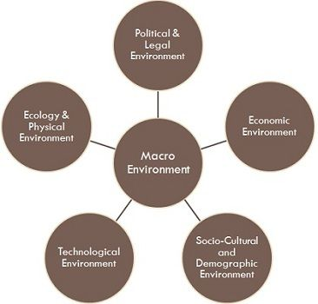(Toppr, 2023)

Economic Environment
The state of the economy, such as economic growth, recession, or inflation, can affect an organisation's financial resources and ability to invest in performance management initiatives.
The study of Appia et al. (2021) argued that the macro environment significantly impacts investment decisions and is an essential factor in the survival of companies.
In today's dynamic and competitive business environment, organisations must be agile and responsive to grow. Continuous performance management enables organisations to adapt and adjust their workforce to changing economic conditions. Businesses can optimise productivity and achieve desired results by enabling constant feedback and adjustments to employee performance. Continuous performance management ensures that employees are aligned with company goals, resulting in improved performance and overall company success (Appiah et al., 2021). In the case of the Western Country Fire Brigade, annual performance appraisals often require significant administrative time and effort from managers. The Western County Fire Brigade saved 40,000 management hours annually by eliminating this process. This translates into cost savings since those hours can be redirected to more productive tasks, allowing the organisation to allocate resources more efficiently.
Also, organisations must be agile and adaptable in a fast-paced and dynamic economic environment. ‘Fire Brigade’, eliminating annual performance appraisals, the fire brigade demonstrated a willingness to embrace change and adapt to evolving business needs. This flexibility can help the organisation respond effectively to economic fluctuations and market uncertainties. Overall, the Fire Brigade by abandoning annual performance appraisals and saving management hours, the fire brigade was able to optimise resources, improve efficiency, enhance employee engagement, and demonstrate adaptability to economic factors. These factors contributed to cost savings and better capital utilisation, benefiting the organisation's financial health and performance.

Technological Environment
Technology advances have profoundly changed how work gets done and how employees collaborate. 24/7 performance monitoring leverages technology for immediate feedback, remote calls, and data-driven performance evaluation. The study by Appia et al. (2021) argues that by integrating technology into performance management processes, organisations can streamline communications, improve transparency, and support timely decision-making. Technology-enabled continuous performance management empowers employees to receive timely feedback, stay connected, and access performance-related information to help them grow and develop. Technological factors in the private sector for Tesco, who introduced online shopping that can be delivered to the home and self-checkout, has provided convenience and ease to customers, resulting in reduced labour cost (Tesco,2023). Tesco related explicitly to continuous performance management can include:

Performance Analytics and Reporting: Tesco can leverage technology to generate performance analytics and reports, providing insights into individual and team performance trends, strengths, and areas for development. These analytics help make data-driven decisions, identify training needs, and align performance with organisational goals.
Real-time Feedback and Coaching Tools: With technology, Tesco can facilitate real-time feedback and coaching interactions between managers and employees. This can include digital communication channels, instant messaging platforms, and virtual meeting tools that enable timely discussions, feedback exchanges, and coaching sessions.

Demographic Environment
Fundamental industry demographic dynamics include population growth, age and family structure change, and geographic shifts (Zacher et al., 2018). A study by Appiah et al. (2021) note that the modern workforce is diverse and consists of multiple generations, each with different expectations and preferences for feedback and development.
Younger employees, such as millennials and Generation Z, often prefer more frequent and informal feedback, including digital communication channels like instant messaging or collaborative platforms. Older employees may choose face-to-face or scheduled meetings for feedback discussions (Zacher et al., 2018).
Younger generations often prioritise career advancement and opportunities for learning and development. They may be more motivated by frequent performance discussions and goal setting. Older employees may have different career goals, such as stability or work-life balance, and may value other aspects of performance management, such as recognition for their experience and expertise (Zacher et al., 2018). Younger generations may be more comfortable with technology, making adapting to digital performance management tools and platforms more accessible. Older employees may require additional training or support to effectively utilise these tools (Zacher et al., 2018).

Workers' physical and cognitive abilities, personality traits, beliefs and goals change with age, which can affect their motivation and performance at work (Zacher et al., 2018). On average, physical fitness, cognitive speed, reasoning ability, and memory decline with age, an age-related loss (Zacher et al., 2018). However, knowledge gained through work and life experience, and the ability to control emotions tend to improve with age; older workers focus on positive emotions and events and report higher levels of job satisfaction, interpersonal trust, loyalty and emotional engagement than younger workers; these traits, therefore, represent an age-related increase (Zacher et al., 2018).

As people age, they emphasise conservation goals, loss prevention, and emotional significance more than growth and development plans. This suggests that job characteristics' perceived importance and preferences, and outcomes also change with age (Zacher et al., 2018). Motivation shifts to a focus on autonomy and flexibility in getting work done using employment stability. Therefore, the basis for work generally stays the same with age, but its content and direction change (Zacher et al., 2018).
Continuous performance management counteracts these demographic effects through constant feedback, coaching, and development discussions. Continuous performance monitoring addresses these trends and improves employee engagement, retention, and productivity. This promotes a positive work environment where employees feel valued, supported, and motivated to perform at their best. At the Western Fire Brigade, employees get regular one-to-one meetings, supported by positive and constructive feedback allowing employees to develop themselves with positive feedback.
Overall, team members of all ages can benefit when leaders structure tasks according to individual age-related skills and motivations to help teams focus on higher-level goals rather than demographic differences (Zacher et al., 2018).

Social and Cultural Environment
Social and cultural dynamics have evolved to emphasise collaboration, transparency, and employee well-being. Continuous performance management aligns with these values ​​by encouraging open communication, fostering a culture of feedback, and supporting employee development. According to the study of Appiah et al. (2021), it creates a positive work atmosphere in which employees experience empowerment, are motivated to take responsibility for their performance and receive support for their progress and advancement. Western County Fire Brigade incorporating these social and cultural influences into a performance monitoring approach can help organisations foster a climate of continuous improvement and novelty. Another organisation example, Tesco, ensures that its performance management practices are fair, unbiased, and inclusive, considering its employees' diverse backgrounds, perspectives, and experiences in a social and cultural environment (Tesco,2023).
Continuous performance management in a developing context for social and cultural environments involves several key considerations. Establishing clear performance expectations that align with the organisation's values and respecting the local social and cultural norms is essential. This ensures that employees understand what is expected of them and can perform culturally sensitively.
In a developing context, CPM should consider the unique challenges and opportunities the social and cultural environment presents. This may involve adapting leadership development, assessment criteria and performance management systems to account for cultural nuances and local contexts, emphasising the creation of social capital.

The focus of CPM in developing contexts emphasises leadership development on building and using interpersonal skills. Gardner (1993) defines interpersonal intelligence as the ability to understand people, a fundamental concern in building trust, respect, and commitment. Critical components of interpersonal competence include social awareness, empathy, service orientation and nurturing others. And Social skills such as cooperation and conflict management (Goleman,1995). Emphasis is placed on the social nature. This ability and the idea that effective development is best done in an interpersonal (i.e., social) context.
The leadership development concept focuses on the interaction of individuals with their social and organisational environmeorganisational1996). This is, therefore, a more complex endeavour than simply developing individual leaders. Although there is still a need to create a solid foundation of intrapersonal and interpersonal skills, the most significant advantage lies in transforming what has traditionally been seen as an individualistic approach to leadership development into a more collaborative and relational approach. It is suggested that it lies in combining with the process.
Interpret leadership development is a form of individual differentiation; this helps individuals strengthen their self-concept and build an independent identity (Hall & Seibert, 1992). Additionally, Leadership development applies self-awareness to social and organisational needs to understand how to relate to others, coordinate efforts, build commitment, and build extended social networks. It can be viewed as a consolidation strategy.
Overall, a holistic approach to leadership development as a form of organisational development strategy requires a targeted transformation towards the integration and differentiation of higher levels of leadership. This is an example of development into 'organised complexity' (Gharajedaghi, 1999, pp. 92–93).

- Organization Climate

Organisational climate refers to the long-term perception of the working environment and culture of the company in which an employee works. You can imagine an environment like the character. Every person has a personality, and every organisation has its own culture (AIHR,2023). Additionally, the organisational climate is shaped by its members' collective perceptions and experiences. When aligned with continuous performance management, organisation climate can significantly impact the effectiveness and success of performance management practices.

Type of organisational climate
People Oriented Climate | An organizational culture with core values ​​focused primarily on valuing people and their achievements.
Rule-oriented climate | An organizational culture that prescribes a set of rules and structures and emphasizes everyone's adherence to those rules and attention to detail.
Innovation oriented Climate | An organizational culture that consistently develops and adopts (and encourages employees to do the same) new ways of working and processes to achieve innovative results.
Goal-oriented climate | An organizational culture that prioritizes values ​​and coordinates process details to achieve desired results.

(AIHR,2023)

The impacts of organisational climate are that it can operate as a constraint system, help employees form a perception of the organisation, influence employee happiness and productivity, and allow the business to achieve its long-term goals (AIHR,2023).

The organisational climate plays a critical role in shaping the implementation and effectiveness of continuous performance management. It encompasses various MESO factors such as corporate culture, leadership style, employee involvement, communication, distribution, competition, competitors, and general industrial factors.

The organisational culture sets the tone for continuous performance management practices. In the case of the Western County Fire Brigade, their decision to replace annual appraisals with regular check-ins and ongoing feedback reflects an organisational culture that values continuous improvement and employee development. This culture creates an environment where employees feel supported and empowered to enhance their performance continuously. A positive and supportive organisational culture encourages open communication, trust, and collaboration. This fosters a common understanding of performance expectations, facilitates the ongoing exchange of feedback, and promotes a growth mindset (Osborne & Hammoud, 2017, p. 54). When employees recognise that their organisation values ​​and prioritises continuous performance improvement, they are more likely to be actively involved in the process and take advantage of opportunities for growth and development.

Leadership style is crucial in influencing the adoption and effectiveness of continuous performance management in a workplace (IVTO, 2018). There are many leadership styles; I will discuss further authoritarian leadership (autocratic), Transformational leadership (visionary) and Supportive Leadership styles concerning CPM:

Authoritarian leaders make decisions quickly and confidently, which makes them great people in a crisis. Authoritarian leaders focus on finding a balance between making leadership decisions and trusting their team to provide insight and feedback (Hogarty,2021).
The are many advantages of an authoritarian leader style in CPM; firstly, these leaders often provide clear direction and instructions, which can help employees understand their roles and tasks within the performance management process; therefore, they can get on with their work. Secondly, autocratic leaders can make quick decisions, expediting and keeping the performance management process on track; therefore, every employee works as a team. Thirdly, authoritarian leaders tend to enforce consistency in performance standards and expectations, ensuring a uniform approach to organisational performance management. However, there are disadvantages to an Authoritarian leadership style; firstly, autocratic leaders may limit employee involvement and decision-making autonomy, inhibiting employee engagement and motivation. Secondly, autocratic leaders may stifle creativity and innovation by imposing rigid structures and processes, potentially hindering the exploration of new ideas or approaches to performance management. Thirdly, authoritarian leaders may limit communication channels, reducing feedback and open dialogue. This can impede the flow of information and hinder employee development and growth.
Chiang et al. (2020) showed that the work climate worsens if authoritarian leaders operate by suppressing subordinates’ emotions. Therefore, WC Fire Brigade, which wants a workforce that gives regular one-on-one meetings with this leadership style, will de-motivate employees and result in a high employee turnover.

Transformational leadership (visionary) is leaders who motivate their teams and sell the company's vision. Combining empathy, enthusiasm, and admiration encourages individual employees to reach their goals, explore new ideas and improve their performance. Under a transformative leader, employees feel empowered and loyal (Hogarty,2021).
Transformational leadership is shown to be effective in both Western and non-Western
societies (Bass, 1997), and correlates with individual and team-level positive job outcomes
(Judge and Piccolo, 2004)
Transformational leadership has been successful in Western and non-Western cultures and is associated with favourable job results at individual and team levels (Khattak et al., 2020). Transformational leadership has many advantages in CPM; firstly, transformational leaders can inspire and motivate employees to reach their full potential. They create a vision and foster a sense of purpose, encouraging employees to go above and beyond, enabling the WC Fire Brigade CPM strategy (Hogarty,2021). Secondly, transformational leaders encourage innovation, creativity, and continuous learning. They provide support and resources for employees to develop new skills and explore new ideas, which can lead to improved performance and growth (Khattak et al., 2020); for example, at the WC Fire Brigade part of CPM, they conduct regular feedback, both positive and constructive. Thirdly, transformational leaders prioritise building solid relationships with their team members. They actively listen, provide support, and offer guidance, creating a positive and supportive work environment that enhances performance and engagement (Khattak et al., 2020). However, there are disadvantages to this type of leadership style; firstly, transformational leadership requires significant time and energy investment from leaders. Inspiring, motivating, and developing employees can be resource-intensive, potentially impacting other managerial responsibilities. Secondly, Suppose the transformational leader leaves the organisation or transitions to a different role. In that case, there is a risk of a decline in performance and engagement among employees who are highly dependent on their leadership style (Hogarty,2021). Thirdly, transformational leaders may have high expectations and push employees to improve continuously, leading to increased stress and potential burnout if they need to be appropriately managed (Khattak et al., 2020).
Research suggests that the mechanism by which transformational leaders influence their employees to accomplish goals has yet to be studied systematically; several other scholars have suggested that attention should be paid to understanding the processes which operate in transformational leadership (Khattak et al., 2020).
Overall, transformational leadership can be highly effective in driving continuous performance in the workplace. Still, it requires careful attention to balance the need for inspiration and motivation with clear structures and processes.

Supportive leaders focus on identifying what changes and support are required to ensure the well-being of their team and, in turn, deliver a high-performance standard by alleviating any unnecessary obstacles (Think Forward,2021).

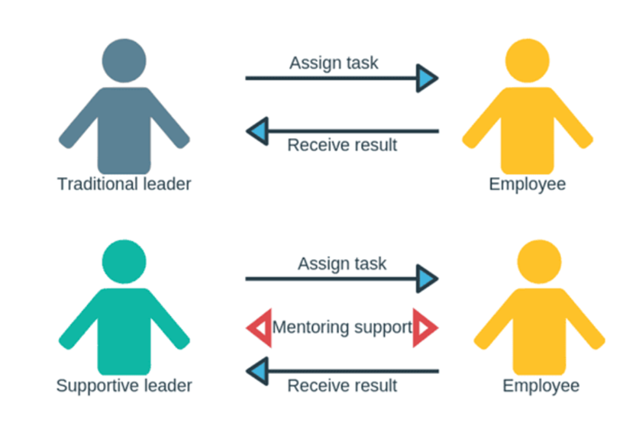(Think Forward, 2021)

Supportive Leadership is critical in shaping the organisation's climate aligned with continuous performance management. Supportive leaders provide guidance, resources, and constructive feedback to employees. They actively participate in the performance management process, set clear expectations, and create an environment that fosters employee growth and development. In the case study, the WC Fire Brigade trained managers on giving and receiving feedback, focusing on developing leadership skills that support continuous performance management practices. Leaders who embrace a coaching and supportive leadership style provide guidance, support, and regular feedback to employees, fostering a culture of constant learning and improvement. Leaders promote employee engagement and motivation by setting clear expectations, establishing meaningful goals, and regularly engaging in performance discussions (Akparep et al., 2019, p. 3).

Employee involvement and participation are vital for the success of continuous performance management. The Western County Fire Brigade allowed different parts of the organisation to determine the frequency of check-in conversations based on their work cycles. Osborne and Hammoud (2017, p53) emphasise that this strategy highlights the importance of involving employees in decision-making and tailoring performance improvement actions to employee needs and circumstances. When employees actively participate in setting goals, monitoring progress, and evaluating performance, they create a sense of ownership and accountability. Their active involvement boosts employee engagement, dedication, and drive. Moreover, engaging employees in the performance enhancement procedure cultivates a collaborative and trust-oriented bond between supervisors and staff, facilitating transparent and candid communication.

Efficient correspondence (communication) is pivotal in triumphant unbroken execution administration. The Western County Fire Brigade replaced annual appraisals with regular one-on-one meetings and ongoing feedback in the case study. This shift highlights the importance of improving communication channels and ensuring that feedback is provided promptly and constructively.
Jankelová and Joniaková (2021) found that clear and transparent communication promotes understanding of performance expectations, fosters a culture of open dialogue, and enables timely exchange of feedback.
Effective communication also reduces the chance of misunderstandings, increases trust, and strengthens the overall performance management process. Additionally, distributional factors such as the geographic distribution of an organisation and the distribution of teams can affect the implementation of continuous performance management.

Distributed organisations with employees in different locations or working remotely may need to leverage technology and virtual communication tools to enable continuous feedback and check-ins (Larson et al., 2020). Aligning performance management practices with sales challenges ensures that all employees receive regular feedback and development opportunities.

The competitive landscape and the presence of competitors can influence the organisation’s approach to continuous performance management. IVTO (2018) states that a robust performance management system is essential as organisations strive to attract and retain top talent in a competitive marketplace. Continuous performance management demonstrates a commitment to employee development that helps an organisation differentiate itself from its competitors. We also ensure our employees have the expertise and competence to remain competitive. Broad industrial aspects, like market shifts, sector regulations, and economic circumstances, may impact the execution and efficacy of ongoing performance supervision.

Organisations must align their performance management practices with industry best practices, comply with regulations, and respond to economic changes. In addition, economic conditions can affect the availability of resources required for training and development efforts, which can affect an organisation’s investment in ongoing performance management practices (IVTO, 2018).

In general, the organisation climate, encompassing factors such as organisational culture, leadership style, employee involvement, communication, distribution, competition, competitors, and general industrial factors, significantly impacts the implementation and effectiveness of continuous performance management. The Western County Fire Brigade case study demonstrates how a positive organisational climate characterised by a supportive culture, effective leadership, employee involvement, and clear communication can increase employee engagement and improve performance outcomes.

Considering these MESO factors ensures that continuous performance management practices are tailored to the organisation's unique context and fosters a culture of constant improvement and development.

- Expectancy Theory - Resource-Based Theory

The Western County Fire Brigade case study exemplifies the importance of continuous performance management in driving employee engagement and organisational success. By integrating the Expectancy Theory and the Resource-Based Theory, we can gain insights into the factors contributing to its significance within this context.

The Expectation Theory developed by Victor Vroom suggests that people are motivated to exert themselves when they believe their efforts will lead to desired performance outcomes (World of Work Project, n.d.). Maslow and Herzberg look at the relationship between internal needs and the resulting effort expended to fulfil them; Vroom’s expectancy theory separates effort (which arises from motivation), performance, and outcomes. Vroom realised that an employee’s performance is based on individual factors such as personality, skills, knowledge, experience, and abilities. He uses the variables Expectancy, Instrumentality and Valence to account for this (your coach, 2022).

Expectancy- the belief that increased effort will improve performance; for the right resources to be available, the right skills to do the job and the support to get the job done (your coach, 2022).

Instrumentality- is the belief that good performance yields valuable results. The degree to which a first-level result leads to a second-level result. For this, there needs to be a clear understanding of the relationship between performance and outcome, fair transparency of the process and trust in the people who will decide (your coach, 2022).

Valence- to be positive, the person must prefer achieving the result to not achieving it. For example, if a person's primary concern is money, that person may not welcome an offer to provide extra free time. Here values are the importance that an individual attaches to an expected outcome (your coach, 2022).

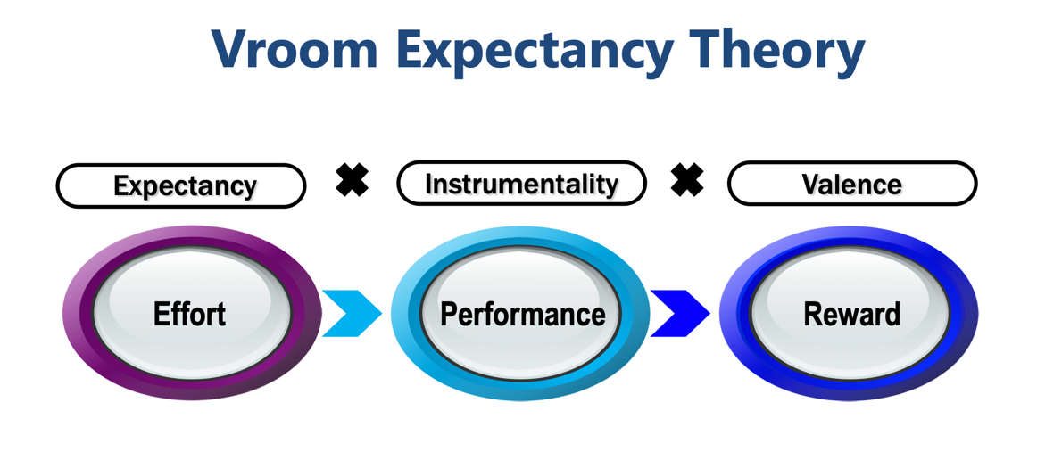
(your coach, 2022)

The Western County Fire Brigade recognised that their traditional performance appraisal system needed to be revised and more effective, leading to disengagement and wasted time. They strategically replaced annual appraisals with regular one-on-one meetings and feedback sessions. A study by Chopra (2019) found that employees are more likely to be motivated and engaged when they believe continuous effort, feedback, and development will improve their performance outcomes (p 338). The Fire Brigade's implementation of continuous performance management provides firefighters with the belief that their ongoing efforts, feedback, and development will lead to improved performance outcomes. By engaging in regular check-in conversations and receiving constructive feedback, firefighters can identify areas for improvement and adjust their performance accordingly.

Instrumentality refers to an individual's belief that successful performance will lead to desirable rewards or outcomes. Continuous performance management in the Western County Fire Brigade ensures a clear link between performance and rewards or recognition. Rather than relying on performance ratings or rankings, employees are assessed based on how well they meet their goals. This reinforces the belief that efforts put into continuous improvement will be recognised and rewarded and motivates firefighters to become actively involved in the process (World of Work Project, n.d).

Valence ​​refers to people's value or desirability for rewards and outcomes. Continuous performance management offers firefighters a valuable product, including opportunities for growth, skill development, and reduced turnover (Communications, 2022).
WC Fire Brigade's emphasis on ongoing feedback and coaching gives firefighters the perception that these outcomes are valuable. This increases their motivation to continuously improve and contribute to the organisation's success. It implemented continuous performance management with the motivational factors identified in the Expectancy Theory. It fosters a belief in the connection between effort and performance outcomes, establishes a clear link between performance and rewards, and provides valuable products that motivate firefighters to participate actively.

Resource-Based Theory
Resource-Based Theory (RBT) was first proposed by Penrose (2009), who proposed a model for the effective management of firm resources, diversification strategies and production opportunities (Barney,1991). Then, in the 1990s, Jay Varney's work contributed to the emergence of RBT, which had become a significant paradigm in strategic management and planning (Barney,1991). RBT provides a framework for highlighting and forecasting performance and competitive advantage foundations. RBT's intermediate focus on corporate performance responded to management's longstanding interest in industry structure, a more macroeconomic perspective. (Barney,1991) RBT addresses an internally driven approach by focusing on internal organisational resources rather than externally driven approaches to understanding the success or failure of leveraging corporate activities (Kozlenkova et al., 2014).

Kennedy et al. (2020) study shows that the Resource-Based Theory focuses on strategically allocating and utilising organisational resources to achieve sustainable competitive advantage. In continuous performance management, resources such as talent, skills, knowledge, and feedback play a crucial role. Ongoing performance management enables organisations to identify and develop talent within the workforce. By providing regular feedback, coaching, and learning opportunities, the brigade can enhance the skills and capabilities of firefighters. This development contributes to developing a highly skilled workforce, enabling the battalion to respond to emergencies and effectively accomplish its mission (Kennedy et al., 2020). Continuous performance management emphasises learning and knowledge sharing. Regular feedback and performance reviews facilitate sharing of information, best practices and lessons learned among firefighters. Knowledge-sharing enhances individual and organisational learning, leading to continuous improvement and innovation in firefighting strategies and tactics. Continuous performance management ensures that timely and accurate performance data is available.
According to Kennedy et al. (2020). This data can identify strengths, areas for improvement, and development needs at both individual and organisational levels. By leveraging this feedback and performance data, the WC Fire brigade can make informed decisions about talent development, resource allocation, and goal alignment, optimising operations and performance. Continuous performance management aligns with the principles of the Resource-Based Theory by optimising and leveraging organisational resources, as discussed by (Kennedy et al., 2020). It facilitates talent development, promotes knowledge sharing and learning, and provides valuable feedback and performance data for informed decision-making. Organisations can maximise their competitive advantage and drive sustainable growth by strategically allocating resources based on performance insights.

In conclusion, integrating the Expectancy Theory and the Resource-Based Theory highlights the importance of continuous performance management in the Western County Fire Brigade. The brigade's implementation of regular feedback, coaching, and development opportunities motivates firefighters by establishing a clear link between effort and performance outcomes. It also optimises organisational resources by developing talent, fostering knowledge sharing, and utilising performance data for decision-making. By continuously improving individual and collective performance, the WC Fire Brigade ensures its readiness and ability to fulfil its critical mission.

- Reflective Report

In this reflective report, I will utilise the Gibbs cycle to reflect on my learning about continuous performance management in my human resource class. I will explore how this knowledge can be applied to my role as a supervisor in a hotel, specifically in managing receptionists and housekeepers. This reflection aims to identify the key takeaways from the course and highlight strategies for implementing effective performance management techniques in my job.

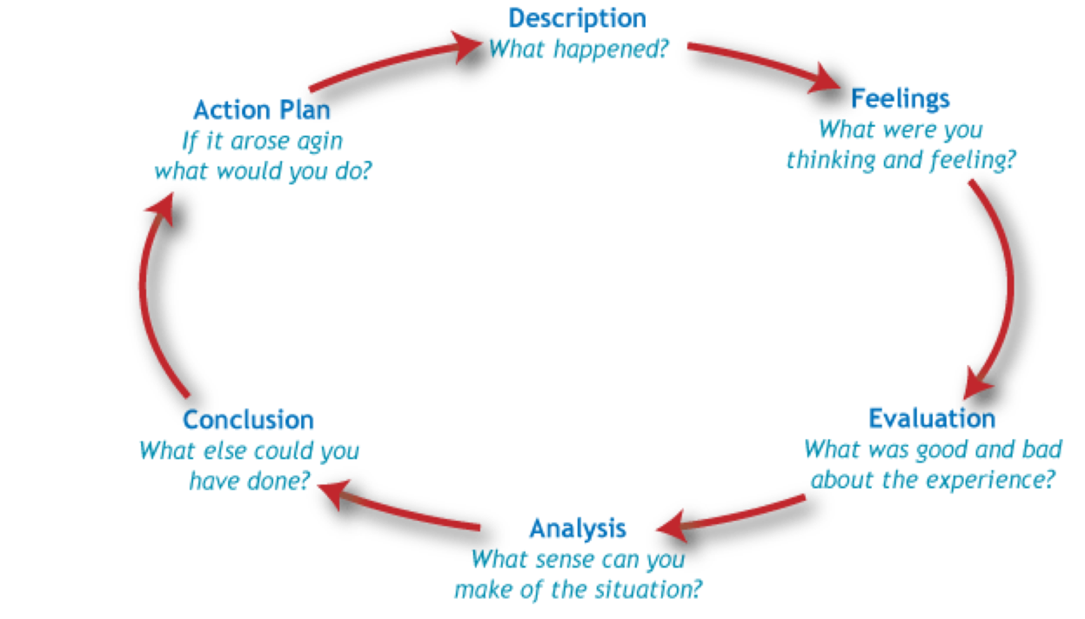

Gibbs’ model of reflection (Gibbs,1988)

Description:
During this module, I comprehensively understood continuous performance management and its significance in fostering employee growth and sustaining organisational success. I learned the importance of a performance management system in an organisation to make an overall outcome on employee performance. I have learned that many organisations are scrapping the annual performance appraisals, which are less effective and replacing this with regular feedback and ongoing communication for a supportive working environment. These concepts resonated with me as I realised their potential to enhance my team's performance at the hotel.

Feelings:
I initially felt excited about incorporating continuous performance management practices into my role. Implementing these techniques could create a more engaged and motivated workforce. However, I also felt a sense of responsibility to ensure that the receptionists and housekeepers would embrace these changes positively.

Evaluation:
Upon evaluating the benefits of continuous performance management, I realised that it aligns perfectly with the nature of our hotel operations. The frequent interactions with guests and the need for high-quality service make it imperative to provide ongoing feedback and support to our employees. The one-on-one meetings, performance check-ins, and coaching sessions emphasised in the course can significantly improve my team members' performance and job satisfaction.

Analysis:
To successfully implement continuous performance management as a supervisor, I must establish a culture of open communication and trust. Regular one-on-one meetings with receptionists and housekeepers will allow me to understand their strengths, weaknesses, and career aspirations. By setting clear performance expectations, providing constructive feedback, and offering development opportunities, I can help them excel in their roles.

Conclusion:
This module on ‘continuous performance management’ has provided me with valuable insights and strategies to enhance my role as a supervisor in managing receptionists and housekeepers at the hotel. Through regular feedback, ongoing communication, and a supportive work environment, I can foster a culture of continuous improvement and empower my team members to deliver exceptional service to our guests.

Action Plan:
To implement continuous performance management effectively, I will:
1. Schedule regular one-on-one meetings with my team members to discuss their goals, progress, and challenges.
2. Provide constructive feedback and recognition to motivate and develop their skills.
3. Offer training and development opportunities to enhance their knowledge and performance.
4. Create a supportive work environment that encourages open communication and collaboration.

I can contribute to my team's and hotel's growth and success by implementing these actions, improving employee engagement, customer satisfaction, and overall performance.

Conclusion

Continuous performance management offers several benefits for millennials, Generation Z, and older employees. It provides regular feedback and coaching, promotes ongoing development, and creates a culture of open communication.
For millennials and Generation Z, who thrive on feedback and personal growth, continuous performance management aligns well with their desire for constant learning and development. It allows for frequent check-ins and updates, enabling them to track their progress and make necessary adjustments.
For older employees, continuous performance management offers a chance to adapt to changing workplace dynamics and technologies. It provides opportunities for upskilling and reskilling, ensuring they remain competitive and valuable.

WC Fire Brigade's workplace has adopted a people-oriented climate by having regular one-on-one meetings, which fosters strong relationships and support within the workplace. These meetings allow leaders to address individual needs and concerns, build trust, and provide guidance. This approach creates a supportive environment that boosts employee morale and engagement.

Supportive leadership is crucial for driving effective results in today's organisation for five generations to working side by side. Leaders who embrace technology and leverage it for better performance management can streamline processes, improve efficiency, and enhance overall productivity. For the Millennial and Gen 2020 generation, there will be an increased emphasis on developing leadership skills specific to technological advancements, such as artificial intelligence, automation, and data analytics. Leaders must understand these technologies and their implications to guide their teams and organisations; nevertheless, the leadership style is effectively adapted to the organisation's objectives and targets.

Applying the Vroom Expectancy Theory within a people-oriented climate aligns with the continuous performance management approach. This theory suggests that employees are motivated to perform better when they perceive a positive relationship between effort, performance, and rewards. By creating a supportive environment and aligning expectations with rewards, organisations can inspire employees to excel.

Overall, continuous performance management, coupled with a people-oriented climate and supportive leadership, can yield the best results for millennials, Generation Z, and older employees while incorporating the principles of the Vroom Expectancy Theory.

Reference

Appendix 1



