Ryan Williams Student Number 1708310
Assignment - Module Application Development
ACCA5012 Dr Kemi Ademoye – 2000/2500 words
Original deadline 9/12/2019
Differentiated Deadline 16/12/2019

Contents
Introduction 3
TASK 1 – APPLICATION DEVELOPMENT CONCEPTS 3
1.1 – Web application trends 3
1.2 Relevant Research Study 3
TASK 2 – IMPLEMENTATION 4
2.1 Software requirements specification 4
2.1 Software Design 4
TASK 3 – REPORT 4
1. Abstract 4
2. Application Development Concepts – Accelerated Mobile Pages 4
3. Requirements 5
5.1 Preconditions or prerequisites 9
5.2 Test steps 9
5.3 Expected result 9
7. References 11

Figures
Figure 1- Smart Brain website homepage 7
Figure 2- About US 7
Figure 3 Smart Brain App description page 7
Figure 4 Buy section 8
Figure 5 frequently asked questions 8
Figure 6 contact us 8

Introduction
The report outlines the current trends in application development. A specific area will be researched and implemented that displays this technology and what it can add to an application or a user experience. The array of different applications that are both available and being developed requires a diverse set of skills in order to develop across many disciplines.

TASK 1 – APPLICATION DEVELOPMENT CONCEPTS

1.1 – Web application trends
The below web application trends have been identified as being important considerations for applications development in 2019 [1], [3]:
- Progressive Web Apps [1]
- Accelerated Mobile Pages
- Responsive websites
- Voice search optimization- [3]
- API-first development-
- Push notifications.
- AI-powered chatbots.
- Motion UI.

1.2 Relevant Research Study

Accelerated Mobile Pages. - [2]- There is a growing need to provide faster and more stable connections to web sites. Page loading due to the increase demand of mobile usage and technology has become vital to businesses. This is vital to ensure productivity remains efficient. (Please see task 3 for a detailed discussion on this research)

TASK 2 – IMPLEMENTATION

2.1 Software requirements specification
The requirements to build the web application are as follows:
- Javascript Interactive design elements such as the api.
- Bootstrap framework
- Html and CSS features

2.1 Software Design

- The web application will be built using the Javascript and html, CSS web languages as mentioned above.
- Functions were created to request and store the data.
- The site has been designed to fetch data from another website.
- A for loop will be used to get and post new stories for the viewer.
- The data gets fetched when a button is clicked on the homepage of the app.
- The data then gets assigned to a variable which is then displayed to the user

TASK 3 – REPORT

Abstract
The report has been created to provide information for the Smart Brain website. Research has been carried out on the latest trends in web application development with a focus on the area of accelerated mobile pages.
The website has been designed to be easy to use to aid Dementia sufferers and provide information pages on how to buy the main mobile application. For this to be successful the website would need to be easy to use with clear instructions for both the users and carers.
To test the website required validation and verification checks being carried out using W3 school’s validation testing tools.

Application Development Concepts – Accelerated Mobile Pages

Failure to load pages fast enough, not only harms productivity but, also stops companies from appearing in search engine results. When combining server side rendered web pages with client-side page loading, users with slow internet connections can have a poor or limited experience.
Search engine optimisation plays a significant role in businesses ability to stay competitive. Search engine tools are becoming available to assist companies in these optimisations.
An example of this is the Google Amp open source project [4]. Google amp is designed to accelerate web page loading on both desktop and mainly mobile devices.

Requirements

    - Introduction:
A web-based application has been created using Html, CSS and Javascript programming languages. A bootstrap framework has been used that was suitable for the product idea.
    - Purpose:
The Smart Brain website has been designed to provide information for the smart Brain app with instructions on how to download the application. Work on all web browsers.
    - Subject Matter:
The application is designed to provide support for dementia sufferers and users with mild cognitive impairments.
    - Target Audience:
The application is intended to help both, dementia sufferers and users with mild cognitive impairments. The target audience include both the sufferers and their families. Carers will be able to use the application to assist the users further.
    - Relevance:
The application has been designed to work on all major browsers. The website is responsive and flexible depending on the device being used. The design principles were intended to provide the same user experience across all devices.

2.1.1 List of the main functional requirements and/or features of the application:
- Provide Information
- Be accessible
- Compatible with all browsers
- Responsive
- Secure
- Fast
- Reliable
- Accuracy
- Api - to provide further information and stories to the users from an external source.
- Efficient

2.1.2 The mobile-first strategy:
With the increasing growth of mobile computing, there is a demand to develop applications that can be used on mobile and desktop devices. The idea behind mobile first is to design for smaller screens and scale up for bigger screens and devices. [5]

    - Media queries used and why (how did you arrive at the breakpoints):

Media queries were built into the bootstrap framework. The queries were used to add and shape parts of the website design. Queries were added for the built-in graphical elements for the bootstrap theme. This was to ensure that the look and feel of the website would stay as intended.
The queries allowed control over the widths, heights and fonts and resolutions of the elements selected. The breakpoints were designed using the screen orientation and would adapt depending on whether the device was in portrait or landscape mode.

    - Content display strategy for the different viewports, i.e. for the display of text, images and/or other media content.

The content display strategy was designed so that elements on the screen would not overlap if the screen resolution changed. This was to provide consistency and to limit errors with different resolutions.

In portrait mode the text and elements would line up vertically to the grid. While in landscape mode the elements were designed so that the image would be on one side of the screen while the text would be on the other

    - Interactive functionality implemented, and details of the web API used.

Design and Implementation- (unable to complete)

main design features and the main scripts, methods, or classes implemented to provide the core functionality for your application:

4. Screen shots of all of the pages/screens of the completed application software (not code).
The screenshots below display the completed web site pages:
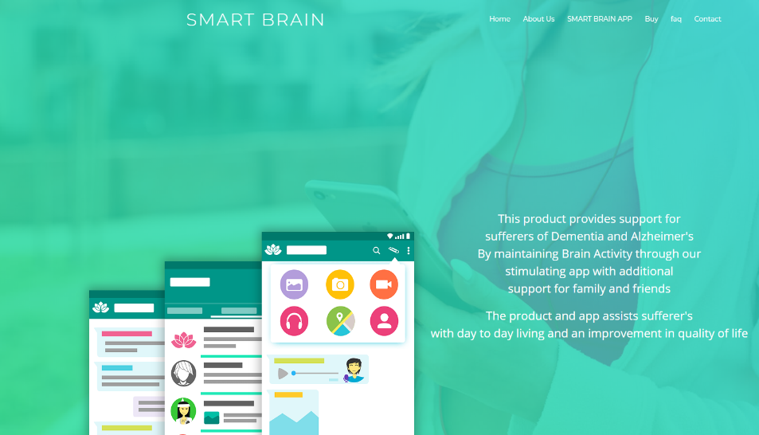
Figure 1- Smart Brain website homepage

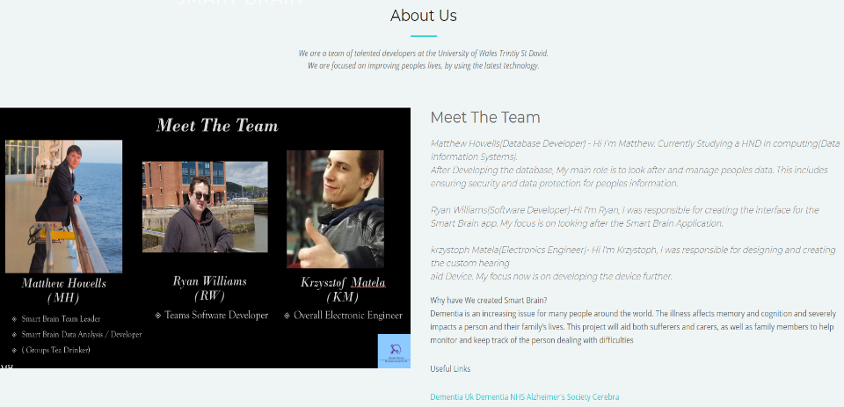
Figure 2- About US

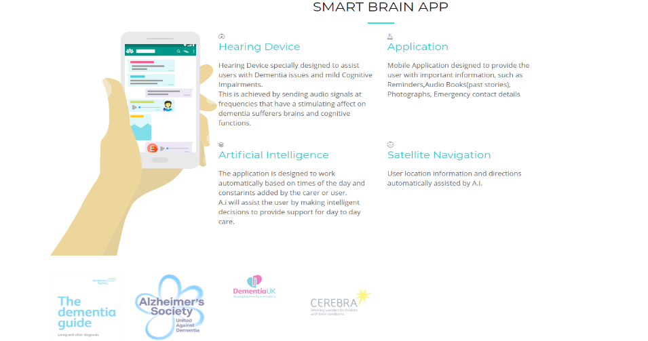
Figure 3 Smart Brain App description page
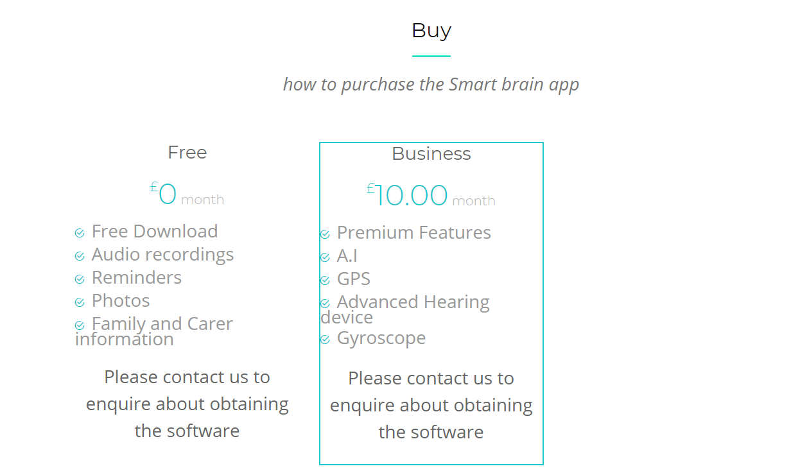
Figure 4 Buy section

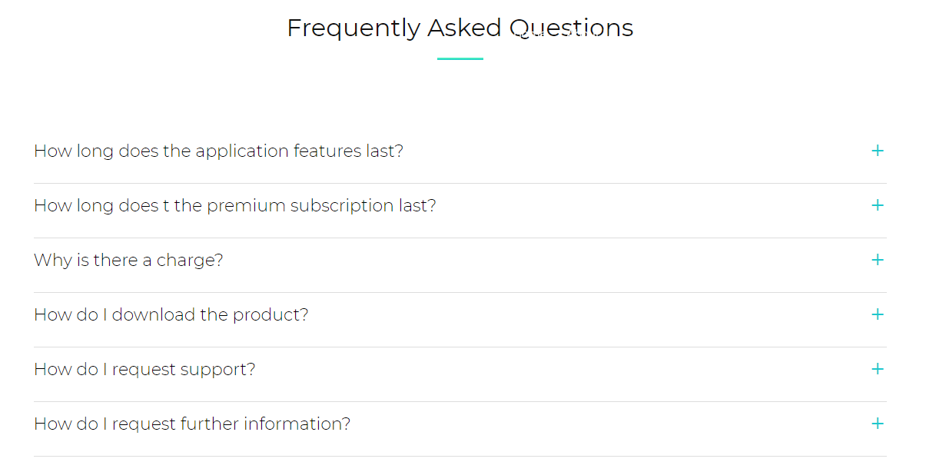
Figure 5 frequently asked questions

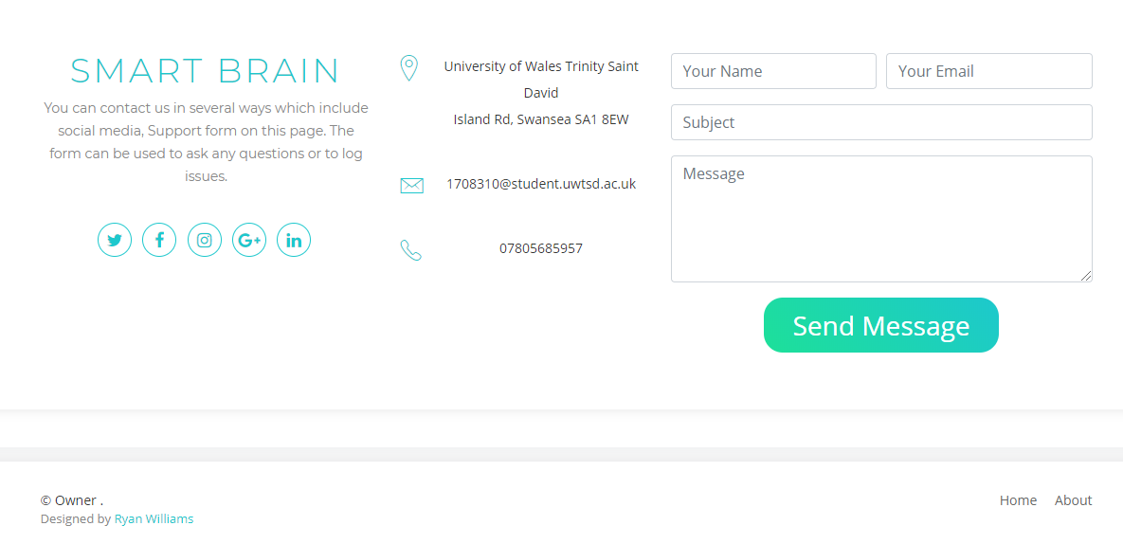
Figure 6 contact us

4.2 List the main JavaScript functions that have implemented:

The Javascript functions used for this project were:
- .scroll(); //Header fixed and back to the top button
- .click(); // To go back to the top of the page

4.3 The Javascript API chosen has the 4 following functions
- getData(); //has been used to request data from a mental health blog
- storeData(); // has been used to store the api data acquired

5. Evaluation

5.1 Preconditions or prerequisites
Testing is required to ensure the web application is fully functional, user friendly, compatible and secure. Test cases were created to check the Smart Brain Web Application for any issues with broken links or incorrect information. [6]
-

5.2 Test steps
Functionality testing- Used to test if the site is functional and operational. That the links were working correctly and that no pages or information was being skipped.

Usability testing- To ensure that the site is easy to use for the audience intended. Navigation is clear and easy to use. The appearance needs to be accessible for different user’s needs.
Compatibility- The technology used needs to be compatible with different browsers and tested to work with Internet explorer and google Chrome.
Security- Testing was carried out to protect user’s data and to ensure the site was safe against malware.

5.3 Expected result
Functionality Testing- The website was expected to pass each stage of the functionality testing
Usability testing- The website was expected to pass each stage of the usability testing
Compatibility- The website was expected to pass each stage of the compatibility testing
Security- The website was expected to pass each stage of the security testing.

5.4 Actual result testing
The below table displays the results for the testing that was carried out. As can be seen the results were as expected, apart from the Html Validation testing. Several errors were flagged up in the html code.

5.5 Testing Table
 | Web Links? | Forms | Responsiveness? | Browsers, chrome or IE?
Functionality | Pass | Pass | Pass | Pass
Usability | Pass | Pass | Pass | Pass
Compatibility | Pass | Pass | Pass | Pass
Security | Fail | Pass | Pass
HTML and CSS Validation | Fail | Pass |  | N/A

- Conclusion
Due to personal health issues it was not possible to implement the Javascript api in time for this submission. I will continue to research and apply the api to the website as was intended
The implementation of the website brought several challenges that needed to be solved. These challenges included questions such as What functions would we need? How we were going to incorporate the API chosen. How would we ensure reliability and compatibility, ease of use and clear instructions to the user?
Future improvements to the site will require connecting to a mobile application and a database to add further functionality. Increasing usage of Javascript will allow for more custom software to be created that may not require bootstrap or other web frameworks.

References

[1] | “8 Web Development trends every CTO Should Be Ready For,” Cleveroad, friday february 2019. [Online]. Available: https://www.cleveroad.com/blog/web-development-trends. [Accessed Monday November 2019].
[2] | S. J. A. Tandel, “international journal of Innovative research in Science, engineering and Technology,” Impact of Progressive Web Apps on Web App Development, vol. 7, no. 9, 2018.
[3] | R. Linnett, “Assitive Toolbar,” Recite me, [Online]. Available: https://reciteme.com/product/assistive-toolbar. [Accessed saturday November 2019].
[4] | N. B. O. Andersson, Google AMP And What it Can Do for Mobile Application In Terms of Rendering Speed, Karlskrona, 2019.
[5] | A. C. P. h. I. Miklosik, “Marketing identiity,” Impact of accelerated mobile pages format on corporate web sites, pp. 204-2014, 2017.

marking criteria and Student FEEDBACK

This section details the extent to which the assessment criteria are demonstrated by you, which in turn determines your mark. The marks available for each category of skill are shown. Lecturers will use the space provided to comment on the achievement of the task(s), including those areas in which you have performed well and areas that would benefit from development/improvement.

Common Assessment Criteria Applied (Assignment 1) | Marks available | Marks  awarded
1. Engagement with Literature Skills

A very basic summary of the chosen application trend. Expand the scope of references to further improve your research work. (Grade mark: 32.00%) | 25 | 8
2. Knowledge and Understanding Skills

3. Cognitive and Intellectual Skills

A basic evaluation of the website has been provided. Please note that you were required to develop test cases for the JavaScript functionality of the website, but the limited JavaScript functionality of the website means there is little to test. (Grade mark: 30.00%) | 20 | 6
4. Practical Application Skills

A very basic attempt. The submitted work unfortunately does not really demonstrate satisfactory knowledge of the concepts as you have used a ready-made Bootstrap content template, https://bootstrapmade.com/demo/Avilon/, which was also not referenced and this does not demonstrate your skills or understanding of the concepts. The submitted website contained a lot of unnecessary files with some of the files duplicated. Please ensure that you only submit necessary files in future. (Grade mark: 32.00%) | 50 | 16
5. Transferable Skills for Life and Professional Practice

The report is of a good standard. See your report for some suggested improvements. (Grade mark: 60.00%) | 5 | 3

Assignment Mark (Assessment marks are subject to ratification at the Exam Board. These comments and marks are to give feedback on module work and are for guidance only until they are confirmed. ) | Late Submission Penalties (tick if appropriate) |  | 33%
 | Up to 1 week late (40% Max) |  | 33%
 | Over 1 week late (0%) |  | 33%

