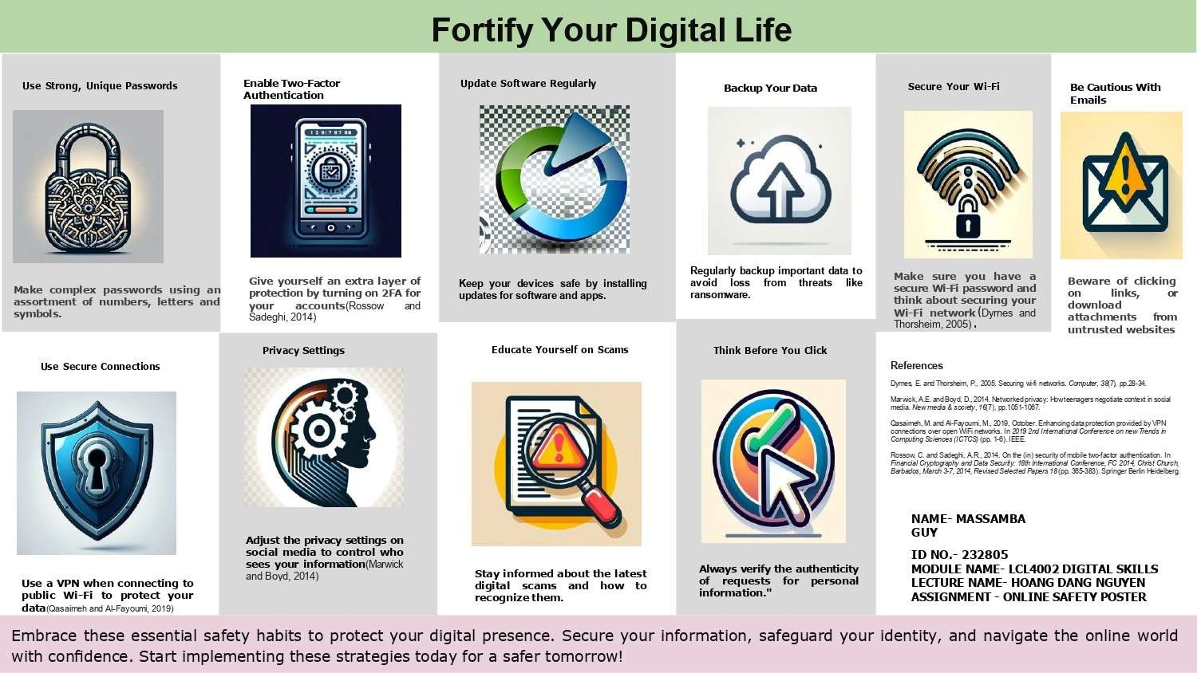
Dear Hoang, I truly appreciate you and your time you spend helping me in many occasions. Thank you very much for the course. I enjoyed every minute of your lecture. as well as your marvelous sense of humor.
Kind Regards Guy Massamba

