

The Physical Demands of CrossFit in Relation to Current ACSM Fitness Guidelines

Module: SHSS6070

Independent Study - Dissertation

Word Count: 9539

School of Sport, Health & Outdoor Education

Assessment Feedback Sheet - Dissertation

Student No./Name: 1701251 Robert Shaw
Module: Independent Study (Dissertation)
Module Code: SHSS 6070

Personal Evaluation – to support your academic progress please complete the section below BEFORE submitting your work.
What do you consider to be the best aspects of this work? |  |  | The concept of the design of the study, compare ACSM guidelines to a popular training method as well as looking into the aspect of a sport specific fitness test base of a Vo2 test.
Which aspects do you consider could have been improved in this piece of work? |  |  | Equipment used could have been improved allowing custom HR zones to be used via polar Pro. If possible, the completing of the incremental fitness test to compare to the Vo2.
What have you found most satisfying whilst undertaking this submission? |  |  | Taking on a study this big on your own, allowing your own design and aspect. Even if the results didn’t show what was initially thought the experience of undertaking the study was satisfying.
ASSESSMENT CRITERIA | Learning  Outcomes |  | GRADE
ASSESSMENT CRITERIA |  |  | Poor  < 20% | Weak  20-29% | Unsatisfactory  30-39% |  | Satisfactory  40 – 49% | Good  50 – 59% | Very Good  60 – 69% | Excellent  70 – 84% |  | Exceptional  85– 100% | %
Abstract | 2 |  |  |  |  |  |  |  |  |  |  |  | 5%
Introduction (including research question and / or hypotheses) | 1 |  |  |  |  |  |  |  |  |  |  |  | 10%
Literature review | 1 |  |  |  |  |  |  |  |  |  |  |  | 20%
Method & research design | 2,3 |  |  |  |  |  |  |  |  |  |  |  | 15%
Results obtained & analysis of results using an appropriate method | 4 |  |  |  |  |  |  |  |  |  |  |  | 20%
Discussion | 4,5 |  |  |  |  |  |  |  |  |  |  |  | 25%
Conclusion | 4 |  |  |  |  |  |  |  |  |  |  |  | 5%
It is expected that students will present work that is proof read, correctly referenced and adheres to the Assessment Checklist. Therefore a range of 0 – 10 marks will be deducted for non-completion of any of the points on the checklist below.
TUTOR COMMENTS:

Submission date: 24/4/20 |  | Return date:  (at least within 4 weeks) |  |  |  | Tutor: |  |  |  |  | Mark:
Undergraduate Dissertation Certificate



Name of the Programme of Study: BSC Sports and Exercise Science

Name of Student (Capital Letters): ROBERT SHAW

DECLARATION

I certify that the whole of this work is the result of my individual effort, and that all sources have been acknowledged.

Signed: R Shaw

Date: 07-05-2020

DECLARATION

I am satisfied that this work is the result of the Student’s effort.

Signed: (Lecturer)

Date:

Acknowledgement

I would like to express my gratitude to my supervisor who helped me through the entire process and for the extra help he put in during the unexpected closure of facilities during testing. As well as the laboratory technician for been available and helping during the pilot study testing and ensuring the equipment was clean, free to use and if needed calibrated.

I acknowledge the contribution of CrossFit Carmarthen co-owners and staff for allowing me to use their facilities and equipment during the testing period of the study. As well as the members of CrossFit Carmarthen for allowing testing to be carried out on them.

Content Page

Abstract, page 6.

Introduction, page 7.

Literature review, page 10.

Methodology, page 18.

Results, page 26.

Discussion, page 34.

Conclusion, page 37.

Reference list, page 40.

Appendices, page 48.

Abstract

Introduction: ACSM guidelines (ACSM, 2020), state that individuals per week should accumulate 150 minutes of moderate aerobic exercise, 75 minute of vigorous exercise or a mixture of the two, as well as at least two weight baring exercises. The aim of this study is to compare CrossFit to ACSM guidelines, as well as to compare a CrossFit base incremental fitness test to a Vo2 max test for more specific heart rate training zones relative to CrossFit.
Methods: N=23 participants took part in the study, all participants wore Polar heart rate monitors for 2x 1-hour CrossFit training classes. N=1 participant completed a Vo2 max test and an incremental fitness test to be used as the pilot study for CrossFit specific training zones.
Results: from the results gathered N=23 showed, each participants heart rated varied on their past and current fitness levels. However, as a class time spent in the zones required to reach guidelines where %. 16 minutes 30 seconds in 77% > and 28 minutes 30 seconds in 64-76% > in session 1 and 19 minutes 50 seconds in 77% > and 19 minutes in 64-76% > in session 2.
Discussion: CrossFit training sessions do relate to meeting the current UK government fitness guidelines (Gov.uk. 2019) and ACSM guidelines (ACSM, 2020). Incremental fitness tests do have a role in sport specific testing however validity and reliability needs improving, or the tests need to be set without any altering or results will vary on specific of the sports and movements.
Conclusion: to conclude you can meet ACSM guidelines via CrossFit as a training method, the amount for 1-hour training session per week to meet the required guidelines is specific per individual. However, from class results, 3-4 sessions per week is the required amount.

Introduction

Health and fitness have always played a key role in humans’ survival in life. From early years of cavemen hunting giant beasts to strength and power on the battlefield, to displays of individual strength as the World's Strongest Man. This leads to Greece who were the first nation recorded to use sports and fitness as a competition, which is still used in today’s society, (Kokkinos and Myers, 2019). Fitness has subsequently developed into a lifestyle choice in modern day society with many employers expecting physical ability to be included in the selection process e.g. police, military services and fire fighter. Fire fighters showing better than average results across multiple fitness tests, (Michaelides et al, 2011).

Benefits of improved physical health are not limited to job preference. There is a plethora of evidence supporting the impact of physical activity on health and the subsequent increase in activity and correlation to increase in chronic health conditions, (see Appendix 12). If a 10% extra became physically active it would save up to – 1.3 million lives per year (WHO, 2020), (Gov.uk, 2019), (PHE, 2020) (Hallal and Ramirez, 2015). The current levels of physical activity across UK range from 29% to 64% (see Appendix 13).

Overweight and obesity are a major issue worldwide with stats in 2005 showing 1.6 billion adults being overweight (BMI > 25kg/m²) and 400 million been classified as obese (BMI > 30kg/m²) via body mass index chart (see Appendix 17). These numbers where expected to raise to 2.3 billion adults overweight and 700 million adults classed as obese by 2015, (Malik et al, 2010). Risk of been inactive aside from fatality are numerous, from coronary heart disease, type 2 diabetes and some forms of cancer (breast and colon), (Lee et al, 2012). With inactivity levels been so significant worldwide, increased activity levels will reduce the risk of fatality and risk of multiple diseases, (Lee et al, 2012), (Hallal et al 2012). Exercise is one of two factors that highlight contribute towards reduction in fatality and chronic diseases, nutritional intake, (Enkhmaa et al, 2018).

Individuals who lead a more sedentary lifestyle and job are seen to be a higher risk of cardiovascular disease (CVD) such as obesity and diabetes, (Enkhmaa et al, 2018). More research found that those individuals with a lower energy expenditure had a 60% > of increased risk of CVD, (Paffenbarger et al, 1978). Type 2 diabetes’s and obesity can be reduced by physical activity has been proved to improve blood glucose control and even delay type 2 diabetes, physical activity and weight loss has been shown to decrease the risk of type 2 diabetes by up to %8% in high risk population, (Colberg et al, 2010).

Physiological benefits of aerobic and anaerobic training are intake and use of oxygen delivered to muscles during aerobic exercise and the adaptions to the neuromuscular system from anaerobic training, (Haff and Triplett, 2016). Wider benefits of physical activity are seen in health gains including physical, mental and emotional well-being, (Gov.uk, 2019), (McKinney et al, 2016). Along with benefits, such as social interaction and community cohesion, (Glassman, 2004). There is greater adherence to exercise programmes where there is a social aspect and interaction, (Nielsen et al, 2014), (Morton et al, 2019).

Current International and UK fitness guidelines for adults (aged 19-64 years old) propose adults partake in aerobics, cardiovascular exercise and anaerobic weight baring exercises for periods of times, (WHO, 2020), (Gov.UK, 2019), 150 min of moderate intensity aerobic exercise, 75 minutes of vigorous intensity aerobic exercise or a mixture of the two intensities in a week. Adults should also take part in two weight classes per week such as going to the gym, yoga, carrying shopping bags back from the shop to build strength and reduce atrophy and muscle loss due to age. The overall goal is to reduce time spent inactive, (Gov.UK, 2019), (ACSM, 2020), (WHO, 2020).

The American College of Sports Medicine (ACSM) guidelines is broken down into intensity levels, sedentary, light, moderate, vigorous and very vigorous. (See Appendix 1) These activities are general for those with a low level of knowledge in physical activity, (Gov.UK, 2019). ACSM (2020) work intensity levels are based off an individual’s heart rate. (see Appendix 1). This method of tracking heart rate with a heart rate monitor and intensity levels of aerobic exercise allows individuals to track time spend in each zone and accumulate the 150 /75 minutes of set intensity levels set by ACSM (2020) guidelines. ACSM and the UK government do not specify what forms of functional weight training and aerobic exercise you have to do, instead the only recommend and give advice to those who lack knowledge in this subject, (Gov.UK, 2019), (ACSM, 2020).

CrossFit is referred to as one of the fastest growing sports in America, (Partridge et al, 2014). CrossFit is a sport/ training programme that attempts to cover 10 fitness domains through its unique training programming. The 10 fitness domains are cardiovascular/respiratory endurance, stamina, strength, flexibility, power, speed, coordination, agility, balance, and accuracy, (Claudino et al 2018). CrossFit’s unique training programme attempt to follow a basis of, ‘constantly varied, high intensity, functional movements’, as its basis of training, prepared for anything with no specific goal in mind, (Glassman, 2004). With typical CrossFit training classes only lasting 1 hour, they are short and time effective, (Crockett et al, 2018), using multiple styles of training in each training session, (Feito et al, 2018).

Research on sporting activities and fitness trends are needed to be compared to the current UK government guidelines on physical activity as recommendations are so vague and loose that one individual moderate run maybe another’s vigorous. The guidelines need to have specific intensity levels that the general public look at and compare their fitness session to or have a set list of activity sessions they can choose from to participate in.

This is important to manage maintain and train individuals with a more direct and stable approach oppose to leaving it to their own knowledge. Current research shows that those individuals who are overweight and lack knowledge have low rates of adherence to exercise and in turn will not meet current UK government fitness recommendations.

Those with knowledge of the benefits of exercise where more likely to adhere and those at risk and have been informed of risk if they do not seek action were also reported to have a high adherence to exercise with supervision, (Barbour and Miller, 2008).

Strategies such as social support for individuals and reinforcement have been shown to be factors that lead to adherence in physical activity, (Picorelli et al, 2014). Although adherence studies on older population where done on home vs group-based exercise classes, results showed 70% rate to class sessions with percentages increasing as mean age decreased throughout studies, (Farrance et al, 2016). Adherence to exercise is seen to be greater in those exercises that are supervised with a coach or trainer present during sessions. (Picorelli et al, 2014).

CrossFit is a new training trend with CrossFit gyms located in 142 countries worldwide, (Claudio et al, 2018). CrossFit will normally involve a WoD (workout of the day) in which the session involves functional movements performed at high intensity, (Glassman, 2007). CrossFit training uses movements from weightlifting, gymnastics and cardiovascular endurance activities such as rowing, running and cycling, (Fisker et al, 2017).

To that extent the aims and objectives of this paper are to compare CrossFit’s unique and functional training programming to the current UK governments guidelines on physical activity. How many CrossFit sessions would an individual need to attend/participate in per week to meet the current UK governments guidelines and what time in each zone does an individual spend time in during a CrossFit training session.

To reach these aims, participants will be recruited from the local CrossFit Gym, the participants must have been training for at least 3 months at the CrossFit gym to be familiar with training routine and mechanic of the movements.

Literature Review

CrossFit is a relatively new sports discipline with over 12,500 affiliates’ around the world (CrossFit Inc, 2017) and an increasingly popular form of training and competition. CrossFit incorporates high intensity, constantly varied, functional movements into training and sport, (Butcher et al, 2015). CrossFit includes aspect of functional training with multiple elements of other training methods such as High intensity interval training (HIIT) and High intensity functional training (HIFT) and incorporates it into their own form of training, (Posnakidis et al, 2020). In 2019 the ACSM worldwide survey of fitness trends results highlighted in 2nd place was group training. 3rd place HIIT. 5th was Bodyweight training and 9th came functional fitness training. In the top 10 alone 4 of the trends are all aspects that are incorporated into CrossFit training programmes (Thompson, 2018). HIIT is a time effective method of training with demonstrable adaptations neurologically in athletic performance proving its effectiveness as a training method, HIIT training is done with aerobic training methods and equipment such as running, rowing and cycling, (Gibala et al, 2012). Improvements via HIIT have been claimed in literature with only 6 total sessions completed from the study, (Driller et al, 2009). HIFT takes what is viewed as the best aspects of HIIT and utilizes its effects with functional training, (Feito et al, 2018). HIFT takes multi joint movements from aerobic and strength exercises into a single training session, the benefit of this is argued that it can be tailored for all fitness and skill levels. HIFT involves greater muscle recruitment due to a wider range of movements increase aerobic performance, strength and flexibility, (Feito et al, 2018). HIFT improvements in aerobic and functional movements, body weight exercise (push ups, air squats, sit ups), when comparted to normal forms of circuit training, (Heinrich et al, 2012).

HIFT & HIIT

All aspects of HIIT and HIFT are used in CrossFit training programmes, (Glassman, 2007). While incorporating different levels of intensity and duration with multiple aspects of training from mono-structural (running, rowing, swimming) gymnastic movements (push ups, pull ups, muscle ups) and weightlifting movements (snatch, clean and jerk, deadlift), (Glassman, 2007), (Feito et al, 2018).

ACSM guidelines (ACSM, 2019) currently state that a healthy adult should partake in 150 minutes of moderate aerobic exercise, 75 minutes of vigorous aerobic exercise or a mixture of the both and to partake in at least 2 weight bearing exercises (yoga or the gym) per week. A study of N= 2002 showed that 68.1% did not reach the current ACSM guidelines for physical health and activity. Even though during the survey over 50% of participants stated they were aware of the health benefits that comes with been physically active, (Martin et al, 2000). This is supported by further studies reporting less than 21% of the United States adults reach aerobic and muscle strengthening guidelines set by the ACSM, (Heinrich et al, 2017). The findings above state that individuals know and are aware of health benefits from regular exercise and are aware of the current guidelines but are not willing to participate. Government’s need options to encourage people to participate and to meet the guidelines, strategies need to be in place and a better guidance than posters to encourage the public. One of the issues found when reviewing the government recommendations was lack of full publicity and clear definitions for the public to both understand and follow.

HIIT over a 6-week period in 39 older males, classed as sedentary (62.7 ± 5.2 yrs) and master athletes (61.1 ± 5.4 yrs). Results identified in both inactive males and master athlete males’ improvements in systolic blood pressure, maximal metabolic capacity and maximal heart rate reserve, showing HIIT as a safe and effective training method in both sedentary and active participants, (Grace et al, 2018). This study shows that high intensity interval training on mature adults had significant health benefits and improvements over a 6-week period, regardless of current training status. Age may have a significant factor on results, the study should be replicated on various age groups to see if a similarity in results are achieved with younger sedentary adults and athletes, demonstrating HIIT is an appropriate training method for all age groups.

N = 14 (participants) completed 3 RX (able to complete all movements to the prescribed standard, NOT scaled and prescribed weight) CrossFit benchmark workout of the day WoD’s, (Workout of the day). Age (years), 32.7 ± 5.7. Height (cm), 174.2 ± 9.0. Weight (kg), 81.5 ± 10.9. BMI (kg/m²), 26.8 ± 1.8. CrossFit Experience (months), 46.3 ± 24.2. All participants took part in all 3 training sessions with 48 hours recovery in-betweens. Participants also took part in Vo2 max testing. Results showed CrossFit benchmark WoD’s cannot be predicted from an individual’s Vo2 max, Wingate or other respiratory testing, only whole-body strength can partially predict some benchmark workouts. CrossFit total was the only test that showed a relative relation to predict other CrossFit benchmark workouts, (Butcher et al, 2015). This study shows that Vo2 cannot be a prediction to CrossFit named workouts. Other than those that are specific to generic training such as the CrossFit total, (sum total weight of lifted from, deadlift, back squat and strict shoulder press). Testing available can give a general idea of an individual’s fitness level, however due to CrossFit’s unique training, a more specific CrossFit test would be needed to be conducted to accrue score or results, this would be an area for future research.

N = 13 (participants) (age 28.4 ± 3.8) (BMI 23-27 kg.m-²) whom had trained for more than 6 months training 3-4 per week, took part in 8-week training block in which they completed 3 HIFT sessions per week. Each session participants completed 4 round of 30 seconds workout, 15 seconds rest for 9 separate exercises. Pre and post testing, anthropometric assessments (body mass, body fat, muscle mass). Cardiorespiratory assessment (Vo2 max, max HR). Isokinetic strength (knee flection and extension). Max vertical jump. Upper body strength (1rm bench press). Muscle endurance (max bench press 65% of 1rm and 1 minute max sit ups). Results showed that in aspects of all fitness assessments there where improvements seen overall. Cardiorespiratory fitness increased in Vo2 by 1.9% ± 2.2 ml.kg-¹ min-¹, a significant improvement over 8 weeks of nonspecific training. Body fat decreased by 0.64 ± 1.01kg, however no changes where seen in muscle mass or fat free mass. Other improvements were seen in muscle strength, endurance and power, no significant changes where noted in isokinetic strength assessment. To conclude over an 8-week period with no other changes to participants lifestyle HIFT has significant improvements to multiple aspects of individuals fitness, (Posnakidis et al, 2020).

Adherence & CrossFit

Adherence to exercise in groups and in CrossFit, with CrossFit becoming a popular training method why do people keep coming back? Unlike other forms of training literature shows that participants from a CrossFit gym are intrinsically motivated, (Ryan and Feito, 2017), (Bycura et al, 2017), (Heinrich et al, 2017), (Bailey et al, 2019). CrossFit’s training programme is built with the community of the gym in mind, building a network of people that will participant in a daily workout together, regardless of age, gender or other factors everyone will be able to complete it together, (Glassman, 2004). With members of CrossFit gyms reported significant levels of bonding and community belongingness compared to traditional gym members, (Whiteman-Sandland et al, 2018).

Approximate 50% of individuals who start a training programme will quit within the first 6 months, during group physical activity an adherence rate of over 95% was seen in university staff over a 6-month period, (Spink et al, 1992).

In elderly adults factors to effect adherence to physical exercise where proportion of participants taking part/attending a training session, proportions of available classes and training sessions available to attend and average home training sessions per week, however adherence was higher in supervised training programmes, (Picorelli et al, 2014).

Factors that influence adherence to CrossFit training are community building and reduce intimidation to new members making it a friendly place for individuals to come together to train. To facilitate realistic goals for all members of a CrossFit gym and to ensure social support for all members, (Heinrich et al, 2017).

Members of current CrossFit gym’s interviews results lead to a prominent theme in results gathered. Results showed a positive relationship with, Accepting and overcoming challenges, commitment, connections and community, empowerment and transformation, (Ryann et al, 2017). Each section was broken down into sub areas more specific within the questionnaire. Social connection and community are a theme throughout all adherence literature based on CrossFit and is one of the values based on, (Glassman, 2004). All participants from the study identifies a strong bond to their ‘CrossFit family’ and friends, that they would often attend the same training session as friends and ‘looked forward to the time with their CrossFit Family’. This community feeling evidently leads to a higher adherence rate within the community and support system.

Surveys where used during all studies to determine why individuals continue to train with CrossFit. Motivation to exercise questionnaire found that, intrinsic factors were reported from one study (N=737) showing that those who partake in CrossFit are more focused on the health benefits and personal reasons, this leads to a higher adherence rate to physical activity as reported, (Bycura et al, 2017). Duration and intensity were also noted to be positive factors that influence adherence to CrossFit, (Bycura et al, 2017). The population of this study was adults (over 18 years at least) who took part in CrossFit training, age range varied and had no specific population in mind. The intervention of the study was participants completed a questionnaire on exercise motivation and why they take part in CrossFit training. The comparison of the study was comparing the data collected with a Pearson correlation. The outcome of the study showed a significant correlation between intensity and frequency and the equipment used. Conclusion was that participants of the study where intrinsically motivated.

Polar

Polar Team and Heart rate monitor T31, (Polar Ltd, 2019). Is a Bluetooth heart rate monitor that sends real time feed to a tablet device with polar team app on, this allows individuals to monitor and record heart rate through physical activity and maintain training zone targets, (Polar Ltd, 2019).

Most literature on the T31 Polar heart rate monitor utilizes the device for exercise evaluation purposes, medical research and validating alternate heart rate monitors (Grace et al, 2018), (Montes and Navalta, 2019). The T31 has been used in studies to compare validity and reliability of multiple styles of heart rate devices such as phone (apple) heart rate system to Hexo skin wearable technology shirts, (Bouts et al, 2018), (Johnstone et al, 2012a), (Johnstone et al, 2012b), (Montes et al, 2015).

When comparing T31 Polar to apples heart rate app and ECG heart rate device a significant correlation between heart rate throughout all stages of exercise was seen between Polar and ECG , however Apples heart rate app showed inconsistent correlations between T31 and only at certain intensity levels was a significant correlation seen, (Bouts et al, 2018).

Although not directly used to compare heart rate of other devices the T31 polar heart rate device was used in three studies as the standard apparatus to use for monitoring participants heart rate through the duration of the testing phases and periods. Leading to its popularity and reliability from other studies, (Johnstone et al, 2012a), (Johnstone et al, 2012b), (Montes et al, 2015).

Polar heart rate monitor is accepted as a precise measurement device however minimal data and literature on reliability exists, (Montes et al, 2019). N=40 took part in a 3-day testing period to test reliability and validity. Results for free roaming and treadmill showed similar results in participants HR, results showing that Polar heart rate device was both reliable and valid in results seen, (Montes et al, 2019). T-31 heart rate monitor through 4 testing stages of aerobic exercise with different watt output showed no difference in results gathered between genders during testing, (Dieli-Conwright et al, 2009), (Montes and Navalta, 2019). The population of the study was young females (n=20) and males (n=20) who had been identified as low risk to health screening questionnaires. The intervention of the study was all participants completed 4 different tests 2 on a track and 2 on a treadmill, heart rate was monitored throughout, testing was completed over a 3-day period. The heart rate was compared between track and treadmill to see if the Polar HR monitor would show a difference. The results showed reliable measures in all 4 tests for walking and jogging in free movement and equipment based physical exercise.

Polar products are at the front of testing when monitoring participants heart rate. With products coming out to replace outdated one’s literature will constantly change on preference of model however the technology is the same and validity and reliability should stay the same as well. The T31 through current literature is used as a gold standard to test other newer products or methods against showing its reliability and validity to be used for sports testing. This is despite there being little literature supporting these claims. Further research to justify this is an area for future research.

Vo2 Test

Vo2 Max test (maximal oxygen consumption), is defined as the consumption and transportation of oxygen during fatigue and exhaustion physical activity and is related to cardiorespiratory fitness, (Koutlianos et al, 2013). A larger score on a Vo2 max test identifies a better aerobic capacity and lactate threshold, as well as reduced risk on cardiorespiratory disease and mortality, (Scribbans et al, 2016), (Bacon et al, 2013). The American College of Sports Medicine (ACSM, 2019), have published many equations to estimate Vo2 Max without the need of the maximal physical exertion, such as walking, stepping and running, (Glass et al, 2007). Other regression models have been tested to estimate an individual’s Vo2 without completing any physical activity, (Bradshaw et al, 2005).

Vo2 is often used a percentage rate for aerobic training, many studies use a set percentage over a numerous period of week, all aspects of HIIT and continuous training have positive aspects on Vo2 max, (lewis et al, 1983), (Scribbans et al, 2016), (Bacon et al, 2013). Vo2 is also used as a measure of exercise performance in testing, a marker for population-based fitness from a percentage and cardiovascular disease, (Levine, 2008).

The most standardized and most common method used during Vo2 testing are the Douglas air bags and Tissot gasometers, to analysis the air samples from Vo2 over newer methods. However new methods are used, using a closed-loop, self-paced testing model, (Beltz et al, 2016).

However, Vo2 testing is not cost or time effective, equipment lab and staff trained are required, each participant requires a working window of 5-26 minutes, this time does not include warm up and cool down, (Koutlianos et al, 2013). Much of the Vo2 max testing is completed using mono exercises which are more common to testing in a laboratory environment. Newer methods of Vo2 max testing need to be investigated in the CrossFit environment. Male athletes (n=55) (age 28.3 ± 5.6) who competed at national and international level (training experience 15 years ± 10.2 years) at sports took part in the study. Vo2 test was completed by all participants and data collected was used for a regression and to compare ACSM prediction of Vo2. Conclusion was that ACSM equation was not accurate at predicting Vo2 for athletes of the age range tested. Only a regression model was moderately accurate.

Incremental Test

Incremental functional fitness tests or multistage fitness test (MFT), functional fitness is the ability to perform everyday movements such as walking home from the shops carrying items to standing up out of a chair without any undue fatigue or physical exertion, (Jones and Rikli, 2002). Incremental functional fitness tests are used to prescribe workload, intensity and percentage of training and adaptation to training. However, stages of incremental training can change results due to intensity or duration of stages which may affect validly of results, (Bentley et al, 2007).

Multistage fitness tests can be designed to suit the needs of specific sports in order to indicate if the athlete has the cardiorespiratory capability to cope with the demands of the sport. Specific multistage dance test was designed to see if dancer’s (N=56), aerobic capacity could cope with the demands this principle cane be placed into multiple contexts using specific movements used in their sport. Results of the study showed all participants oxygen requirement and heart rate through 4 stages of the test where different between stages, (Wyon et al, 2003).

Multistage testing and incremental testing are used through testing for maximal and submaximal efforts. Effective for setting a prescribed intensity or weight for training methods due to a percentage of the final effort makes it an effective and uses tool for coaches and trainers. However, validity of the test will vary due to the type of exercise and intensity chosen. MFT can be deigned to more specific sports, stages can gradually get harder to mark an increment in stages and intensity level. This can be tailored to meet specific needs however reliability and validly will vary. This is an area for future research to look into, a set intensity and escalation of stages that can be used as a MFT with participants only picking specific training or movements in them. Taking forward the suggestions for future research will also bring the available literature up to date.

Overall, the literature was difficult to find specifically related to CrossFit though this may be expected due to the relative newness of this form of sports development. The research initially found to inform this research dissertation were old and focussed more on mono styles of sports. The availability of peer reviewed research was limited and this need for more robust and published research was identified during the literature searches. It is hoped that the research from this study will start to inform the evidence base and future research studies.

Methodology

Participants
Upon ethical approval, (see appendix 18) the independent study could be started, the participant volunteer will be recruited into the pilot study for Aerobic VO₂ max testing and incremental functional fitness testing. The pilot study will consist of two, one hour period when a participant will attend testing at the University of Wales Trinity Saint David, Carmarthen Campus, Sports Laboratory were the Investigator of the study and Laboratory Technician will be present. During the two, one hour period VO₂ max testing and an incremental functional fitness test will be undertaken on separate days. The Servomex gas analyser requires calibration to ensure correct readings. The machine was calibrated prior to testing by the Laboratory Technician.

Prior to testing commencing the subject completed a familiarisation trial of equipment including explanation of Douglas bag equipment. The participants adjusted the bike accordingly to allow for a near locked out leg on full extension of the pedal.

The participants’ will have completed a basic health questionnaire PAR-Q (Physical Activity Readiness Questionnaire) and a consent form to ensure there was no underlying health conditions which would prevent participation in the pilot study and to ensure they were comfortable with the procedure, (see Appendix 14), (see Appendix 15).

All volunteer participants for the two CrossFit training sessions will be recruited from CrossFit Carmarthen Gym. They will be able to volunteer to take part in the study if they met the following criteria, training at the CrossFit gym for a period of 3months or above or at another gym that uses the same training method, be aged 18 years or older, completed and read a PAR-Q (see Appendix 14), Consent form (see Appendix 15) and read and accepted the Participant information form (see Appendix 16), results of the PAR-Q show no issues to stop them participating in the study.

VO₂ max test

VO₂ is the maximal uptake of oxygen and is recognised as one of the fundamental tests for exercise physiology. VO₂ Max testing measures aerobic capacity and cardiac performance and is a recognised valid tool in sports sciences and developing athletic performance. (Hill et al,1923) developed the concept of VO₂ max testing in sports when measuring gaseous exchange in runners.

Equipment used for the Aerobic VO₂ max testing:
- Heart rate monitor, to monitor subjects heart rate throughout testing, (Polar Ltd, 2019)
- Douglas air bag, to collect expired air samples from the participants, (Harvard Apparatus, 2019)
- Stopwatch, to monitor time due to watt bike been used for repeated intervals.
- Mouthpiece & valve, nose-clip, to allow expired air samples to be collected and to stop the participant breathing through their nose, (Harvard Apparatus, 2019)
- Breathing tube, links the mouthpiece and valve to the Douglas air bag, (Harvard Apparatus, 2019)
- Watt Bike, to conduct the fittest test on, (Wattbike Ltd, 2016).
- Servomex gas analyser, to analysis the air sample for O2 and Co2%, (Servomex Ltd, 2019)
- Dry gas meter and vacuum, to analysis expired air, (Harvard Apparatus, 2019)
- Borg (Rate of Perceived Exertion) RPE scale, to monitor participants perceived extortion.

Cycling Protocol

At all times the subject will be monitored by the investigator or Laboratory technician and the testing will be stopped should any ill effects be seen or displayed.

The participant will start with a minimum of a 4-minute period of low intensity cycling on watt bike pro, (Nottingham, UK). The intensity will be lower than that of the starting intensity for the VO₂ max test, generally no gradient level and low cadence level. This warm-up will also allow for the participant to make adjustments to the watt bike such as handlebar height and seat height and to become familiar with the equipment being used during the testing period.

The VO₂ max test will begin with a low intensity power output, resistance level one, with the participant cycling at a reps per minute speed, pre-determined depending RPM (Revolutions Per Minute) on age, gender, cardio endurance and current and previous training status. The participant may wish to start on a RPM level that they see their fitness level at, the Laboratory technician and investigator may advise a level appropriate to the fitness level of the subject if they feel it maybe too easy or hard for the participants.

Intensity of the VO₂ max test will be achieved via power output on the watt bike pro via increments of 1 on the power/resistance level located on the left-hand side of the watt bike.
The increments of the testing will increase by 1 resistance level every minute, upon reaching 10, the subject will increase reps per minute (RPM) by 5 (example, 75rpm > 80rpm) and the resistance level will drop to 8, this will continue to increase until the participant cannot maintain the RPM or they give up via RPE, (Rate of Perceived Exertion), scheme at which point they will give an indication they have 1 minute left of maximal effort left. During that final minute the subject will do a final maximal effort sprint while breathing into a Douglas airbag for a final air sample.

A sample of at least 30 second period, of expired air is required during the final workload of the participant, this is why the participant must signal when they feel they have 1 minute of work effort left before failure or fatigue otherwise a true Vo2 Max result may not be obtained from the results gathered.

Upon completion of the final work effort, (participant completion of VO2 max). The mouthpiece and nose clip are removed. The resistance level on the Watt bike is reduced to 1 and the participant is required to continue to cycle at a much lower RPM level. The subject will be required to continue cycling for a 5-minute period to complete a cooldown reducing heart rate and rate of respiration. After the 5-minute period the participants may get off the Watt bike pro whenever they have recovered.

The equipment used is placed to one side ready to be sanitised and cleaned, the participant once recovered under the supervision of the investigator and/or laboratory technician are able to go and the testing for the day is completed.

Functional fitness maximal effort testing

Equipment used for the Functional fitness maximal effort testing:
- Heart rate monitor, to monitor participants heart rate throughout testing, (Polar Ltd, 2019)
- Douglas air bag, to collect expired air samples from the participants, (Harvard Apparatus, 2019)
- Stopwatch, to monitor time due to watt bike been used for repeated intervals.
- Mouthpiece & valve, nose-clip, to allow expired air samples to be collected and to stop the participant breathing through their nose, (Harvard Apparatus, 2019)
- Breathing tube, links the mouthpiece and valve to the Douglas air bag, (Harvard Apparatus, 2019)
- Watt Bike, to conduct the fittest test on, (Watt bike Ltd, 2016).
- Servomex gas analyser, to analysis the air sample for o2 and Co2%, (Servomex Ltd, 2019)
- Dry gas meter and vacuum, to analysis expired air, (Harvard Apparatus, 2019)
- Borg RPE (Rate of Perceived Exertion) scale, to monitor participants perceived extortion.
- 2x light (12.5kg), medium (17.5kg), heavy (22.5kg) dumbbells, to conduct the fittest test on, (Mirafit, 2020).
- 1x resistance band (black), to conduct the fittest test on.
- 1x dip belt and 12kg kettlebell, to conduct the fittest test on, (Mirafit, 2020).
- Pull up bar, to conduct the fittest test on.

Functional Fitness Protocol

At all times the participant will be monitored by the investigator or Laboratory technician.

The participant will start with a minimum of a 4-minute period of low intensity mobilisation and warm up with specific actions and movements similar to those that will be used during testing. The intensity of the familiarisation of the movements will be lower than that of the starting pace of the anaerobic VO₂ max test. The warmup will also allow for the athlete to adjust grip preference on the pull up bar and adjust dumbbell position during thrusters on their shoulders with a mouthpiece and nose clip in.

The anaerobic VO₂ max test will begin with the participant using two, 12.5kg dumbbells to complete 3 minutes of thrusters. 2 minutes 30 to 3 minutes a 30 second air sample will be collected via Douglas air bag, heart rate and RPE scale will also be recorded at 3 minutes. The participant will then complete 3 minutes of band assisted pull ups. 2 minutes 30 to 3 minutes a 30 second air sample will be collected via Douglas air bag, heart rate and RPE scale will also be recorded at 3 minutes. This will happen for a medium, 17.5kg and heavy 22.5kg weight for both thrusters and body weight and 12kg weighted pull ups.

The increments of testing will increase every 6 minutes and exercise will change every 3 minutes. The participant will conduct 3 minutes of thrusters with 12.5kg weighted dumbbells on each arm. The participant will then conduct 3 minutes of band assisted pull ups. The participant will conduct 3 minutes of thrusters with 17.5kg weighted dumbbells on each arm. The participant will then conduct 3 minutes of body weight pull ups. The participant will conduct 3 minutes of thrusters with 22.5kg weighted dumbbells on each arm. The participant will then conduct 3 minutes of band 12kg weighted pull ups. The participant will have to choose an intensity and pace and maintain it throughout the duration of testing, this will represent RPM on a Watt bike.

The participant may wish to start on an intensity and pace that they see their fitness level at, the Laboratory technician and investigator may advice an intensity and pace they feel suits the participant best if required from the warmup.

The weight of dumbbells and pull ups are chosen to replicate the heaviest RX (the athlete performs all modalities using the prescribed weight and reps), competitive standard weight for single arm dumbbell thrusters and the weighted pull ups represent a weighted vest during workout of the day where a vest is required (7kg female, 10kg male).

Upon completion of the final work effort, (participant completion of VO2 max). The mouthpiece and nose clip are removed. The participant can stop conducting the movement and remove the weight and dip bell from around their hip. The participant will be required to complete a 5-minute cooldown period to lower heart rate reduce breathing to a steady state and stretch of any areas that maybe tight. After the 5-minute period the participant may leave the supervision of the Laboratory technician or investigator whenever they have recovered.

The equipment used is placed to one side ready to be sanitised and cleaned, the subject once recovered under the supervision of the investigator and/or laboratory technician are able to go and the testing for the day is completed.

CrossFit Training sessions Protocol

CrossFit one-hour functional fitness class. All participants will need to sign/ complete an informed consent from (see Appendix 15), physical activity readiness questionnaire (see Appendix 14) and complete and sign the conditions of the participant information sheet (see Appendix 16) which identifies the sessions aim and objectives that they will be participating in.

All participants will be requires to have age taken, height taken on SECA 213 stadiometer, (Birmingham, UK) and weight taken on the SECA 875 scales, (Birmingham, UK), privately so only the investigator, participant can see the results, a third party member (CrossFit Coach) present in the room during any time that the investigator is alone with a participant during testing.

All participants data will be inserted into an iPad tablet (UWTSD, UK). This will allow each participant to have a personalized profile linked to a heart rate monitor, a Polar team pro, (Kempele, Finland), that they will be wearing via heart rate strap across the sternum. The heart rate strap can be adjusted to allow the participants to move freely without any form of restriction and loose enough to not effect heavy breathing from physical excursion from physical activity. The heart rate monitor itself will be attached to the heart rate strap via two push in clips, participants are able to equipment it themselves or if they require assistant can request a coach or same sex member of the CrossFit gym to assist them in adjusting the strap and placing the heart rate monitor on the strap. Maximal HR was determined from the formula, 220 – participants age, (Butcher et al, 2015).

Once all participants have a profile and heart rate monitors linked up, the CrossFit functional training session will be delivered by the CrossFit level 1 certificated coach’s over a one-hour period. The training session will conduct of a warmup, skill or strength element, conditioning period and cool down as programmed by the CrossFit Carmarthen coach.

Post training and only once the CrossFit coach has given the end of the training session brief may the participants remove their heart rate monitors and heart rate straps. No data will be shared with the participants unless requested and after post submission. All participants are required to complete a 48 to 72-hours rest period prior to participation in the second functional fitness training session, as per protocol.

Functional fitness training session 1.

Period | Time | Activity
Warm up | 00:00 - 10:00 | Snatch and clean circle game as a pulse raiser  3 rounds  10 rep’s I’s  10 rep’s Y’s  10 rep’s T’s
Skill/Strength | 10:00 - 30:00 | 4 rounds  10 single arms bent over kettlebell rows  10 dumbbell lateral raises  90 seconds rest between rounds
Conditioning | 30:00 - 50:00 | For Time  (as fast as possible)  60 calories on a Concept 2 Rower  50 kettlebell swings (Russian) 32kg males/24kg females  40 thrusters 50% of body weight  30 burpees over the barbell
Cool down | 50:00 - 60:00 | Stretch off

Functional fitness training session 2.

Period | Time | Activity
Warm up | 00:00 - 10:00 | 200m run  3 Inch worms  3 Spiderman T rotations  Barbell warm up  10 RDL  10 Deadlifts  10 Back squats  10 Strict press  10 Front squats  10 Push press
Skill/Strength | 10:00 - 30:00 | Every 90 seconds for 6 rounds complete clean complex  1 Squat clean  1 Front squat  1 Hang squat clean  “unbroken” don’t put barbell down between reps
Conditioning | 30:00 - 50:00 | 10 rounds for time  10-minute time cap  10 Front squats at 50% of 1rm Front squat  12 Ab mat sit ups
Cool down | 50:00 - 60:00 | Stretch off

Upon completion of the CrossFit training sessions, any used and borrowed equipment such as heart rate monitors and heart rate straps are to be returned to the Investigator and stored in the correct and appropriate cases. Heart rate straps that have been used are to be placed into the correct storage bag as to not mix used and none used equipment for the second training group.

Results

A total of 23 participants (N=23) were recruited into the study. All subjects completed a health questionnaire and there was nothing of significance that would affect participation or the results. Not all participants could attend both CrossFit training sessions.

The results collected were only partially completed. Two CrossFit Training sessions with participants wearing Polar Team (Polar Ltd, 2019), heart rate monitors over a 60-minute period where completed. The pilot study participant completed the VO₂ max test. However, due to the current situation of a pandemic related to a viral infection and immediate closure of the Sports Laboratory at University Wales Trinity Saint David’s, Carmarthen Campus and government guidance of self isolation the pilot study participant was unable to complete an incremental functional fitness based test to simulate work load and effort of a CrossFit session while monitoring heart rate (Polar Ltd, 2019), respiratory throughout (Harvard Apparatus, 2019) and rate of perceived exertion (RPE Borg scale), therefore no data was gathered for this part of the study.

CrossFit Classes 1 & 2

Table 1. CrossFit classes (All), Participants (N), Average HR (%), Maximum HR (%), Calories burnt (Kcal), Time per zone (%).
 | Participants  (N) | Average HR  (%) | Maximum HR  (%) | Calories burnt  (Kcal) | Time per zone  (%)
Session 1  Class 1 | 9 | 69 | 95 | 528 | Zone 1 – 20%  Zone 2 – 24%  Zone 3 – 14%  Zone 4 – 17%  Zone 5 – 13%
Session 1 class 2 | 7 | 68 | 96 | 441 | Zone 1 – 24%  Zone 2 – 20%  Zone 3 – 12%  Zone 4 – 12%  Zone 5 – 16%
Session 2  class 1 | 6 | 66 | 93 | 405 | Zone 1 – 20%  Zone 2 – 24%  Zone 3 – 23%  Zone 4 – 16%  Zone 5 – 3%
Session 2 class 2 | 5 | 68 | 96 | 346 | Zone 1 – 15%  Zone 2 – 23%  Zone 3 – 16%  Zone 4 – 16%  Zone 5 – 13%

Table 2. CrossFit Session 1 class 1, 5pm – 6pm.
Highest average HR% | Highest maximal HR% | Highest time in HR 77%> | Lowest time in HR 77%> | Highest time in HR 64-76% | Lowest time in HR 64-76%
82 | 104 | 31m 09 sec | 9 m 35 sec | 27 m 01 sec | 9m 37 sec

Table 3. CrossFit Session 1 class 2, 6pm – 7pm.
Highest average HR% | Highest maximal HR% | Highest time in HR 77%> | Lowest time in HR 77%> | Highest time in HR 64-76% | Lowest time in HR 64-76%
80 | 119 | 26m 59 sec | 11 m 52 sec | 33m 35 sec | 6 m 04 sec

Table 4. CrossFit Session 2 class 1, 5pm – 6pm.
Highest average HR% | Highest maximal HR% | Highest time in HR 77%> | Lowest time in HR 77%> | Highest time in HR 64-76% | Lowest time in HR 64-76%
72 | 104 | 13m 41 sec | 6 m 19 sec | 36 m 29 sec | 10 m 28 sec

Table 5. CrossFit Session 2 class 2, 6pm – 7pm.
Highest average HR% | Highest maximal HR% | Highest time in HR 77%> | Lowest time in HR 77%> | Highest time in HR 64-76% | Lowest time in HR 64-76%
80 | 100 | 22m 24 sec | 9 m 11 sec | 19 m 59 sec | 10 m 25 sec

The results from each individual CrossFit class (as seen above) was broken down into average and maximal results from the class. The heart rate recording is presented in percentage and time in minutes and seconds. ACSM guidelines on heart rate percentage (HR%) (Appendix 1) state which percentage is the equivalent to appropriate zone. Current UK Government guidelines use these zones for moderate and vigorous intensity levels for aerobic exercise.

Table 6. Paired Samples Statistics.
CrossFit Training session 1 and 2, Average heart rate, Maximal heart rate, Mean, Standard Deviation and Standard error mean.
 |  | Mean | Std. Deviation | Std. Error Mean
Pair 1 | AHR1 | 67.00 | 6.36 | 2.25
 | AHR2 | 69.00 | 6.07 | 2.14
Pair 2 | MHR1 | 97.12 | 9.29 | 3.28
 | MHR2 | 95.37 | 5.37 | 1.89

Table 7. Paired Samples Test.
CrossFit Training session 1 and 2, Average heart rate, Maximal heart rate, Mean, Standard Deviation and Standard error mean.
 |  | Mean | Std. Deviation | Std. Error Mean | Sig (2-tailed)
Pair 1 | AHR1-AHR2 | -2.00 | 6.14 | 2.17 | .388
Pair 2 | MHR1-MHR2 | 1.75 | 8.87 | 3.19 | .594

A paired samples T-test was conducted with all average and maximal heart rate date collected from participants from both CrossFit training sessions. Table 6 shows, the paired sample statics shows the mean, standard deviation and standard mean error from both classes of the two CrossFit training sessions.

The paired samples t-test shows (table 7) average (AHR) and maximal heart rate (MHR), mean, standard deviation and error. AHR, (M -2.00, Std 6.14 ± 2.17) MHR, (M 1.75, Std 8.87 ± 3.19). Showing that there is no significant difference in participants heart rates between the 2 CrossFit training sessions. Session 1, Sig 0.388 and session 2, Sig 0.594.

ACSM HR% zones Moderate 64-76% of maximal heart rate and Vigorous 77-95% of maximal heart rate when compared to 2 CrossFit training sessions.

ACSM guideline maximal heart rate percentage differs to polar team app with zone and intensity level percentage having a significant difference. Due to polar team not allowing custom heart rate zones ACSM moderate (as seen in the table below) was most represented by Polar training zone 2 and 3, ACSM vigorous + was most represented by training zones 4 and 5.

ACSM – guidelines on activity level % | Polar team app
% HR Max | % HR Max
Very light - <37 | Zone 1 – 50-60%
Light 36-45 | Zone 2 60-70%
Moderate 64-76 | Zone 3 70-80%
Vigorous 77-95 | Zone 4 80-90%
Maximal 96> | Zone 5 90-100%

Session 1, average heart rate percent 81% and maximal heart rate percent 112%. The training session demonstrated recorded average heart rate throughout was classed as vigorous and maximal heartrate over 100% of age predicted heart rate, (See appendix 3, 4 & 5).

Session 2, average heart rate percent 76% and maximal heart rate percent 102%. The training session demonstrated average heart rate recorded throughout was classed as moderate and maximal heart rate over 100% of age predicted heart rate, with some time of the class been spent in vigorous intensity zone, (See appendix 6 & 7).

Not only did Class 1 and 2 display significant differences in average and maximal heart rate, time in zone varied significantly for a 60-minute period. Each individual athlete heart zone varied on age predicted heart rate. Results show as a class it will relate to government guidelines as a group with low inaccurate results, individual results show more accurately time spent in each zone.

Individual results from CrossFit Session 1, N = 16 and CrossFit Session 2, N = 11. Showed individual participants heart rates varied widely while conducting the same CrossFit training session.

Significant differences were noticed in strength and skill work to conditioning. CrossFit Session 1 compared 2 participants (see appendix 8 & 9) over 60 minute period. Participant A heart rate only raised to 88% with an average of 59%, 08:40 minutes in zone 4 and 5, vigorous ACSM and only 13:04 minutes in moderate. Whereas Participant B results showed maximal heart rate of 104% with an average of 82%, 31:09 minutes in zone 4 and 5, vigorous ACSM and 21:07 minutes in moderate.

Participant A, Heart rate graph.
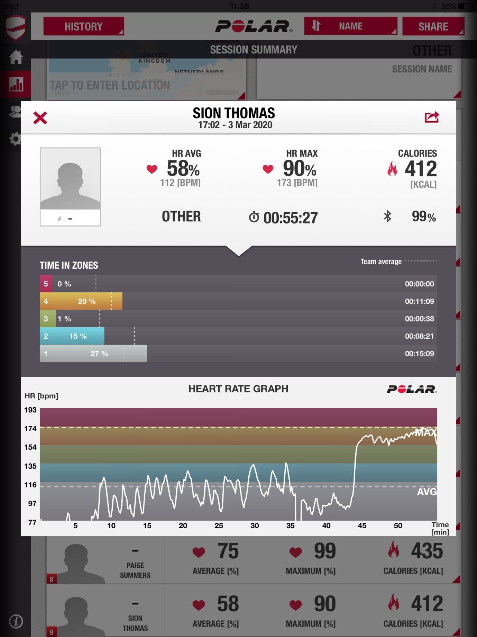

Participant B, Heart rate graph.
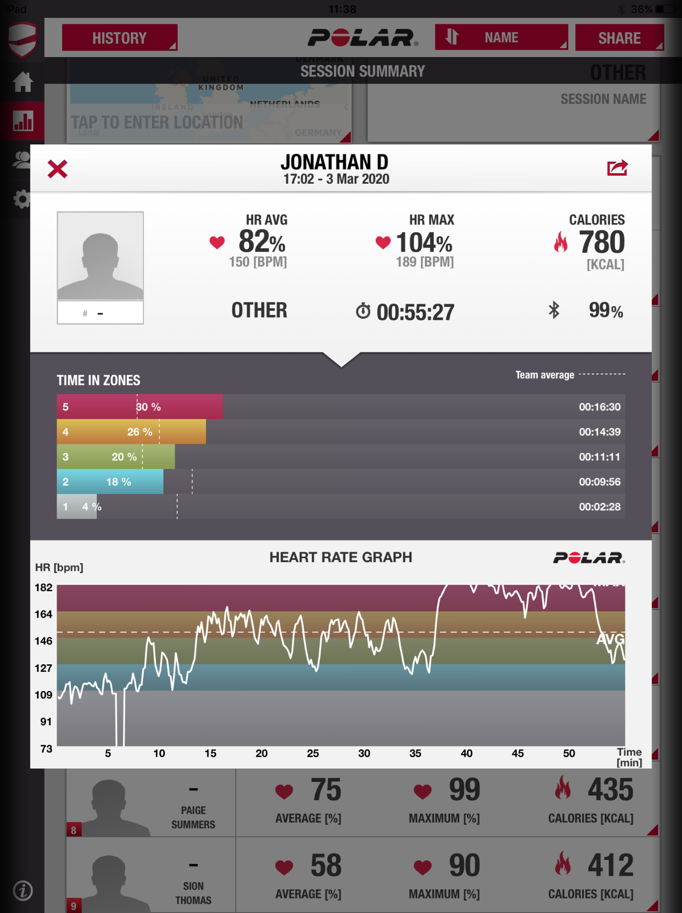

CrossFit Session 2 showed similar results when comparing 2 Participants (see appendix 10 & 11) over 60 minutes Participant C heart rate only raised to 90% with an average of 58%, 11:09 minutes in zone 4 and 5, vigorous ACSM and only 08:59 minutes in moderate. Whereas Participant D results showed maximal heart rate of 97% with an average of 70%, 11:14 minutes in zone 4 and 5, vigorous ACSM and 22:40 minutes in moderate.

Participant C, Heart rate graph.
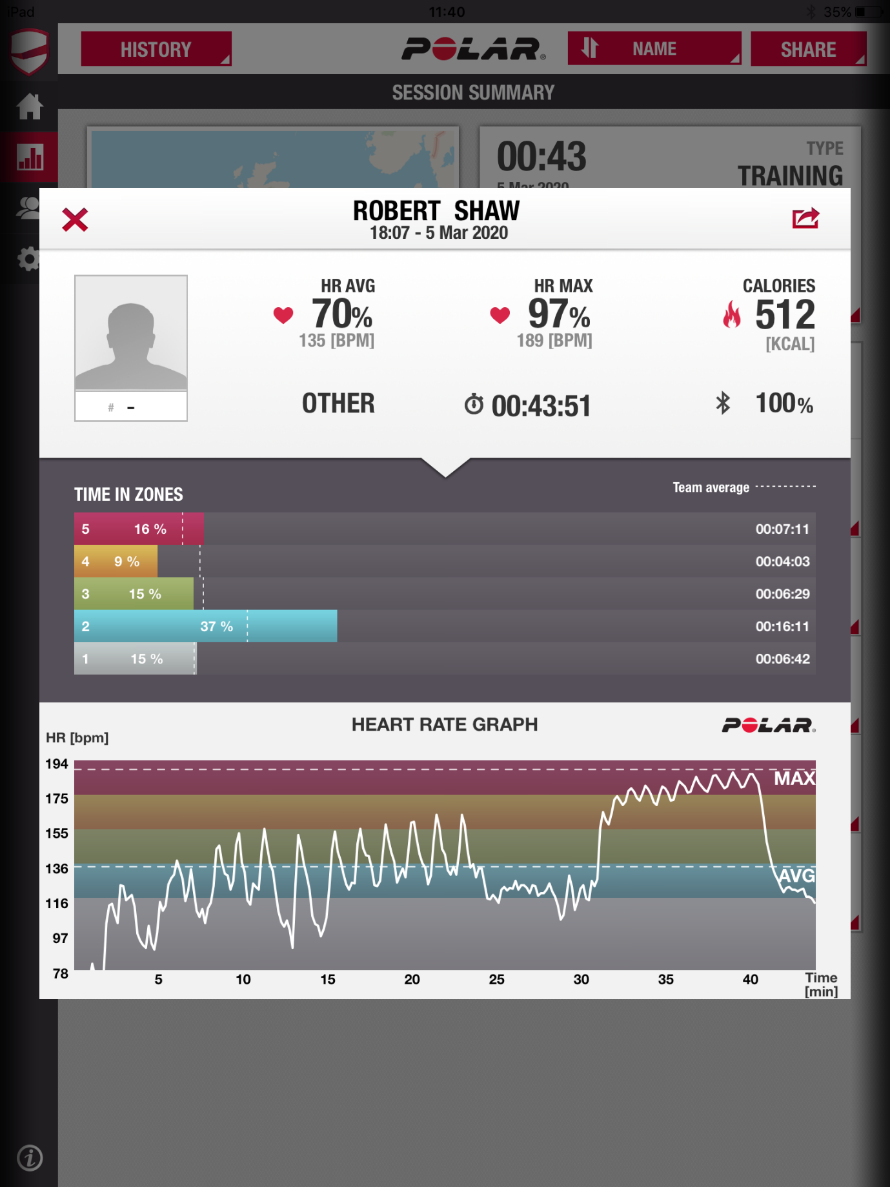

Participant D, Heart rate graph.
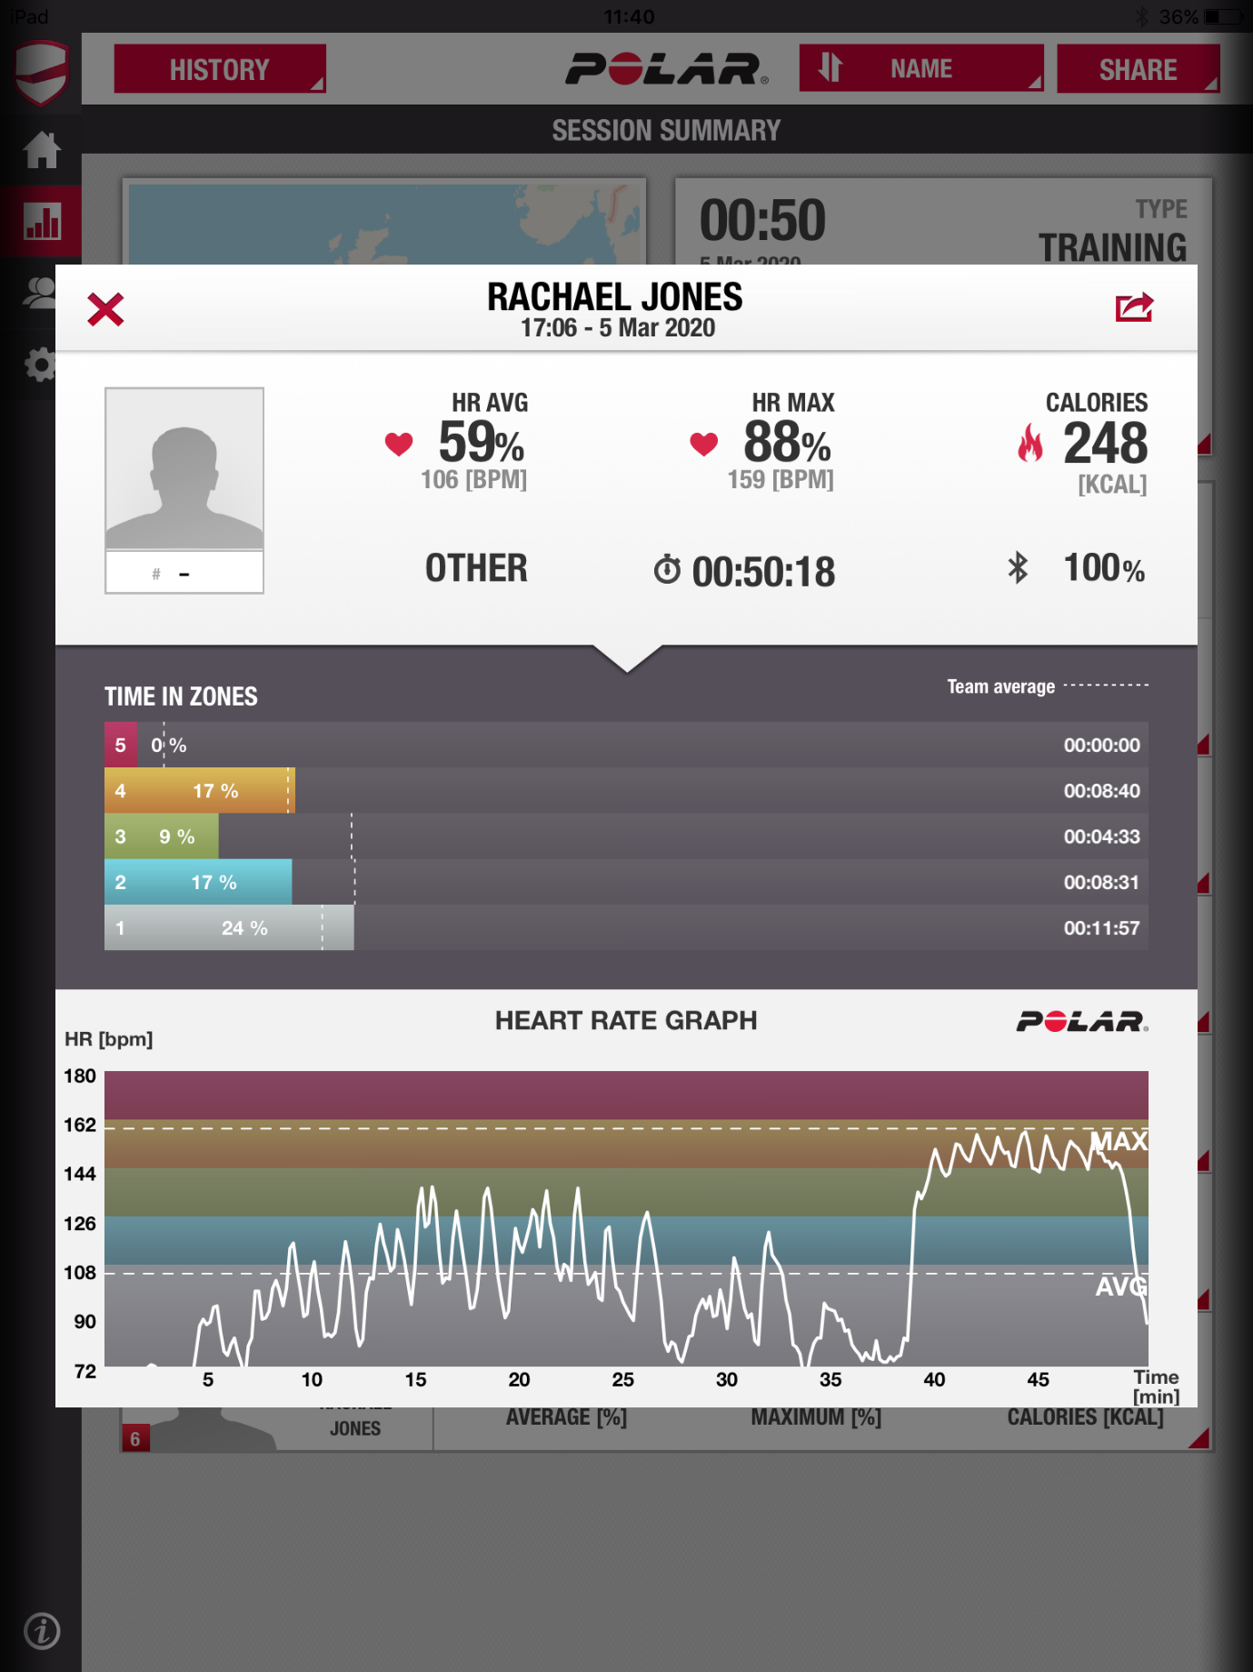

The results demonstrate that the heart rate during functional fitness class regardless of load and intensity varies for individual based on physicals characteristics and pre/current established conditioning. CrossFit sessions can relate to current government physical activity guidelines and ACSM intensity levels this will vary from individual to individual.

VO₂ Max & Incremental Functional Fitness-Based Test

A participant completed a VO₂ Max test as a pilot study, results gathered from this identified the Participants VO₂ max to be 49.0 ml/kg/m, maximum heart rate 175 beats per minute (BPM), 100% of the athletes’ heart rate. Average heart rate 138 bpm, 79% of their max heart rate. When compared to The Physical Fitness Specialist Certification Manual (1997) VO₂ Max norm table, (see appendix 2) the participant results showed excellent when compared to normative data.

Due to the pandemic and restrictive isolation guidelines causing the closure of UWTSD laboratory/testing facilities the 2nd incremental functional fitness test was unable to be completed.

As no results were able to be collected for the incremental functional fitness-based test, the data and results gathered from the pilot studies Vo2 max test no comparison was able to be made to the incremental functional fitness-based test.

Data analysis using statistical software (SPSS) was to be undertaking. The data was to be analysed using a Paired sample T- test to establish if Vo2 max and an incremental functional fitness test had any correlation in Vo2 and heart rate. This would have established:
1. any correlation of change from one exercise to the other; does heart rate stay reliable and steadily increase as a Vo2 or does it vary as intensity stops and starts. 2. The reliability of incremental functional fitness test is when compared to the Vo2 max test.

Discussion

The outline of this study was to compare CrossFit training sessions to current ACSM guidelines by comparing heart rates of participants of CrossFit classes to the heart rates zones of ACSM. The findings will be compared to current recommendations to assess CrossFit’s relationship to the guidelines and if so how many training session a week are required to reach current ACSM fitness guidelines.
The main findings of this study were to compare a Vo2 max test to an incremental functional fitness test based on CrossFit movements which will outline specific heart rate zones from a comparison between the two. The results from the incremental fitness will allow specific heart rate zones during the CrossFit training classes to monitor heart rate.
Although there are current ACSM guidelines (ACSM, 2019) and government recommendation on physical fitness activity levels (Gov.uk, 2019), the population find training methods more suited to them and not what is recommedned (Gov.uk, 2019). The results from this study demonstrated that heart rate varies massively between individual during the CrossFit training class. Each participants heart rate was unique and while some participants hit over a 100% of their predicted Vo2 others only reached 90%, (see appendix 8 ,9, 10 and 11). The heart rate during exercise is an important factor to consider when trying to reach exercise guidelines, intensity and type, which all play a vital health impact on the population reaching these.
The study design was to complete a pilot study then progress to a detailed study with 24 participants toal, this would be achieved by repeating two sets of data gathering of 12 participants in each group. This would equate to 48 sessions of monitoring being completed.

Vo2 and Incremental Fitness Test
A pilot study, with a volunteer participant from Carmarthen CrossFit gym, was initially completed due to restrictions of participants and Laboratory time and availability of equipment. The pilot study allowed for one participant to attend the Labarotary at Trinity St Davids Campus and complete 2 fitness tests, over a 48 hour period, their results were the baseline for all participants to be compared to.
The data gathered was to be compared using SPSS, paired samples t-test, (statistical analysis software). The t-test would compare the pilot studies results from maximal and average heart rate during all 3 stages of the incremental fitness test and the most relevant stage of the Vo2 max. Dry bag meter volume (+1.8L) between the incremental fitness test and the Vo2 max will also be compared in a t-test, the test will show if there is a significant correlation in results, if so then the incremental fitness test will have a positive outcome showing a sport specific test that can show athletes heart rate and Vo2 for CrossFit.
The T-test was to compare the pilot studies average and maximal heart rate and expired air throughout different stages of the Vo2 max test and incremental functional fitness test, to establish any correlation between the two tests and the appropriates stages of guidelines. This would relate current Vo2 max data, (Beltz et al, 2016), and relationship with a functional test (Wyon et al, 2003). Incremental multistage fitness tests (MFT) have been used to create training tests more specific to sports and events to simulate movements and allow for a system to test athletes. The MFT was designed to test participants Vo2 and compare to a specific MFT based on the physical demands of CrossFit and monitor HR.
The participants Vo2 results show their results from the initial test to be 49.0, compared to the normative data table (see appendix 2), this identifies the participant as excellent when compared to the general population.
This data would be used in similar methods to that of Wyon et al (2003), their results showing heart rate response to increasingly harder dance routine and specific techniques and movments, similar to an increase in weight during CrossFit specific movements.

CrossFit and ACSM Guidelines
The findings from the data analysis will be used to compare all participants from the two CrossFit training sessions to the participant from the pilot studies results. This method is not as accurate as testing each individual participant however it is time effect and allows a more accurate range of heart rate training zones specific to CrossFit training instead of Aerobic exercise. With a larger time frame and more availability of equipment, a deeper research could be conducted for a more accurate relationship between CrossFit and government guidelines, (WHO, 2020), (Gov.UK, 2019).
The results show that on a class basis depending on the structure of the training programme in 2 CrossFit training sessions an individual can complete 2 weight baring / training sessions per week and throughout the class with an elevated heart rate they can accumulate time towards 75 minutes vigorous aerobic exercise, 150 minutes moderate aerobic exercise or a mixture of the two, (WHO, 2020), (Gov.UK, 2019).
The paired sample t- test showed no significant difference between all participants heart rates between the first CrossFit training session and the second CrossFit training session. As a class (table 4 and 5), the average heart rate was 81% and 76% of age predicted heart rate of the polar team app. When compared to ACSM guidelines % of activity level this equates to Moderate 64-76% to Vigorous 77-95%. During CrossFit training session 1 participants spent an average of 16 minutes 30 seconds in 77% > and 28 minutes 30 seconds in 64-76% >. CrossFit training session 2 participants spent an average of 19 minutes 50 seconds in 77% > and 19 minutes in 64-76% >. This related to current ACSM guidelines showing that CrossFit as a class will relate to the weekly recommended physical activity recommendations. With 3-4 CrossFit training sessions been enough to rachieve national recommendations.

Limitations
Should be noted that due to the viral infection, Covid - 19, University of Wales Trinity Saint David’s shut down all facilities with immediate effect from Sunday 15th March till further notice on advice from the UK government. Facilities would not re-open until further notice. Due to this worldwide pandemic, not all data was able to be collected resulting in limited results. As only part of the testing was completed it should be advised that more evidence is needed, completion of the initial fitness tests completed for the pilot study to compare a Vo2 max test and an incremental functional fitness test.
Limitations of the study varied on different aspects of testing. More participant to collect heart rate data, allowing for a larger variety of information would get a more accurate result. This could be done by allowing for a longer duration of testing or by approaching other local CrossFit affiliates. However, due to many CrossFit affiliates following their own training programme this may affect the results depending on their own personal goals and aims from their current block of training.
Time frame to test all participants in a Vo2 max test and an incremental functional fitness test would allow for all participants to have their own heart rate zones specific to CrossFit’s training style of HIFT. However, this method would be time consuming and would not be cost effect. It would need an extensive testing time frame depending on the size of the study been carried out.
A lack of literature and studies on ACSM guidelines and CrossFit is available currently. This is a area that requires further research and investigating to be done to relate the training style to recommendations for the general public on training. As well as no access to meaningful data from similar research methods which could have been analysed due to limits on newer field of CrossFit.
There was a limited option to change the methodology of research due to use of heart rate monitor and need for Vo2 max testing. Consideration to vary research through questionnaires was not appropriate as enough data would not be gathered in the time frame remaining.
Conclusion

CrossFit is a popular growing training trend that takes aspects of multiple training styles with many been regular training methods in a worldwide survey on training popularity. The current literature available on CrossFit shows that is a popular training method and a growing sport with more and amore CrossFit affiliates opening worldwide. With its unique training method and aspects of already popular methods such as HIIT and HIFT CrossFit is a suitable and safe method for people to use to reach the current UK government guidelines on fitness.

However the literature on CrossFit relating to current ACSM guidelines and CrossFit training session been monitored for heart rate results are limited the results gathered form the study show that CrossFit is relatable to guidelines with one session adding to the recommended aerobic weekly timeframe and classing as a weight baring session. Each CrossFit class is unique with heart rate varying on the planning however each participant during the study showed time in each zone. With 3-4 1-hour session needed per week to meet guidelines it is a viable choice of exercise.

Not only does CrossFit relate to ACSM guidelines the literature available shows that’s adherence to CrossFit is high with a community support group from their priers to support them while training. It has shown to be a unique and effective training method for all populations with the principle and core of training being good movement pattern.

Word Count: 9539

Conflict of Interest

No conflict of interest was declared.

Reference list

ACSM. (2019). Available at: http://forms.acsm.org/16tpc/PDFs/34%20Moriarity.pdf (accessed on: 25th February 2020)

Astorino, T.A., Rietschel, J.C., Tam, P.A., Taylor, K., Johnson, S.M., Freedman, T.P. and Sakarya, C.E. (2004). REINVESTIGATION OF OPTIMAL DURATION OF VO 2 MAX TESTING. Journal of Exercise Physiology Online, 7(6).

Bacon, A.P., Carter, R.E., Ogle, E.A. and Joyner, M.J. (2013). VO2max Trainability and High Intensity Interval Training in Humans: a Meta-analysis. PloS one, 8(9).

Bailey, B., Benson, A.J. and Bruner, M.W. (2019). Investigating the Organisational Culture of CrossFit. International Journal of Sport and Exercise Psychology, 17(3), pp.197-211.

Barbour, K.A. and Miller, N.H. (2008). Adherence to Exercise Training in Heart Failure: a Review. Heart failure reviews, 13(1), pp.81-89.

Bentley, D.J., Newell, J. and Bishop, D. (2007). Incremental Exercise Test Design and Analysis. Sports medicine, 37(7), pp.575-586.

Beltz, N.M., Gibson, A.L., Janot, J.M., Kravitz, L., Mermier, C.M. and Dalleck, L.C. (2016). Graded Exercise Testing Protocols for the Determination of VO2max: Historical Perspectives, Progress, and Future Considerations. Journal of sports medicine, 2016.

Bouts, A.M., Brackman, L., Martin, E., Subasic, A.M. and POTKANOWICZ, E.S. (2018). The Accuracy and Validity of iOS-based Heart Rate Apps During Moderate to High Intensity Exercise. International journal of exercise science, 11(7), p.533.

Bradshaw, D.I., George, J.D., Hyde, A., LaMonte, M.J., Vehrs, P.R., Hager, R.L. and Yanowitz, F.G. (2005). An accurate VO2max Nonexercise Regression Model for 18–65-Year-old Adults. Research quarterly for exercise and sport, 76(4), pp.426-432.

Butcher, S.J., Neyedly, T.J., Horvey, K.J. and Benko, C.R. (2015). Do Physiological Measures Predict Selected CrossFit® Benchmark Performance?. Open access journal of sports medicine, 6, p.241.

Bycura, D., Feito, Y. and Prather, C. (2017). Motivational Factors in CrossFit® Training Participation. Health Behavior and Policy Review, 4(6), pp.539-550.

Claudino, J.G., Gabbett, T.J., Bourgeois, F., de Sá Souza, H., Miranda, R.C., Mezêncio, B., Soncin, R., Cardoso Filho, C.A., Bottaro, M., Hernandez, A.J. and Amadio, A.C. (2018). CrossFit Overview: Systematic Review and Meta-Analysis. Sports medicine-open, 4(1), p.11.

Crockett, M.C. and Butryn, T. (2018). Chasing Rx: A Spatial Ethnography of the CrossFit Gym. Sociology of Sport Journal, 35(2), pp.98-107.

CrossFit Inc. (2017). Crossfit affiliate map. Retrieved March 2, 2017, 2017, Retrieved from http://map.crossfit.com/

Driller, M.W., Fell, J.W., Gregory, J.R., Shing, C.M. and Williams, A.D. (2009). The Effects of High-intensity Interval Training in Well-trained Rowers. International journal of sports physiology and performance, 4(1), pp.110-121.

Enkhmaa, B., Surampudi, P., Anuurad, E. and Berglund, L. (2018). Lifestyle Changes: Effect of Diet, Exercise, Functional Food, and Obesity Treatment on Lipids and Lipoproteins. In Endotext [Internet]. MDText. com, Inc.

Farrance, C., Tsofliou, F. and Clark, C. (2016). Adherence to Community Based Group Exercise Interventions for Older People: A Mixed-Methods Systematic Review. Preventive Medicine, 87, pp.155-166.

Feito, Y., Heinrich, K.M., Butcher, S.J. and Poston, W.S.C. (2018). High-intensity Functional Training (HIFT): Definition and Research Implications for Improved Fitness. Sports, 6(3), p.76.

Fisker, F.Y., Kildegaard, S., Thygesen, M., Grosen, K. and Pfeiffer‐Jensen, M. (2017). Acute Tendon Changes in Intense CrossFit Workout: an Observational Cohort Study. Scandinavian journal of medicine & science in sports, 27(11), pp.1258-1262.

GOPA. (2020). Available at: http://www.globalphysicalactivityobservatory.com/ (Accessed: 31st March 2020)

GOPA. (2020). Available at: https://onedrive.live.com/?authkey=%21ANGq%2DoF4xXV5vTo&cid=EFBE41ED597E732A&id=EFBE41ED597E732A%215316&parId=EFBE41ED597E732A%213396&o=OneUp (Accessed: 31st March 2020)

GOPA. (2020). Available at: https://onedrive.live.com/?authkey=%21APijXVXB7PzCrS8&cid=EFBE41ED597E732A&id=EFBE41ED597E732A%215321&parId=EFBE41ED597E732A%213396&o=OneUp (Accessed: 31st March 2020)

GOPA. (2020). Available at: https://onedrive.live.com/?authkey=%21AJHG0n%5FQaw9EABI&cid=EFBE41ED597E732A&id=EFBE41ED597E732A%215322&parId=EFBE41ED597E732A%213396&o=OneUp (Accessed: 31st March 2020)

GOPA. (2020). Available at: https://onedrive.live.com/?authkey=%21AOqa3Zt6L0EdXRw&cid=EFBE41ED597E732A&id=EFBE41ED597E732A%215323&parId=EFBE41ED597E732A%213396&o=OneUp (Accessed: 31st March 2020)

Gov.uk. (2019). https://assets.publishing.service.gov.uk/government/uploads/system/uploads/ attachment_data/file/832868/uk-chief-medical-officers-physical-activity-guidelines.pdf (accessed on: 27th January 2020)

Glass, S., Dwyer, G.B. and American College of Sports Medicine eds. (2007). ACSM'S metabolic calculations handbook. Lippincott Williams & Wilkins.

Glassman, G. (2004). What is CrossFit. The CrossFit Journal, 19, pp.1-7.

Glassman, G. (2007). Understanding CrossFit. CrossFit J. 2007;56:1–2.

Grace, F., Herbert, P., Elliott, A.D., Richards, J., Beaumont, A. and Sculthorpe, N.F. (2018). High Intensity Interval Training (HIIT) Improves Resting Blood Pressure, Metabolic (MET) Capacity and Heart Rate Reserve Without Compromising Cardiac Function in Sedentary Aging Men. Experimental Gerontology, 109, pp.75-81.

Haff. G and Triplett, T. (2016). Essentials of Strength Training and Conditioning. 4th edn. National Strenght and Conditioning Association: Unites States of America.

Hallal, P.C., Andersen, L.B., Bull, F.C., Guthold, R., Haskell, W., Ekelund, U. and Lancet Physical Activity Series Working Group, (2012). Global Physical Activity Levels: Surveillance Progress, Pitfalls, and Prospects. The lancet, 380(9838), pp.247-257.

Hallal, P. and Ramirez, A. (2015). The Lancet Physical Activity Observatory: Monitoring a 21st Century Pandemic. Res Exerc Epidemiol, 17(1), pp.1-5.

Harvard Apparatus. (2019). Available at: https://www.harvardapparatus.com/contact-us/ (Accessed: 20th^{rd} March 2020)

Heinrich, K.M., Carlisle, T., Kehler, A. and Cosgrove, S.J. (2017). Mapping Coaches’ Views of Participation in CrossFit to the Integrated Theory of Health Behavior Change and Sense of Community. Family & community health, 40(1), p.24.

Heinrich, K.M., Spencer, V., Fehl, N. and Carlos Poston, W.S. (2012). Mission Essential Fitness: Comparison of Functional Circuit Training to Traditional Army Physical Training for Active Duty Military. Military medicine, 177(10), pp.1125-1130.

Hill, A.V. and Lupton, H. (1923). Muscular Exercise, Lactic Acid, and the Supply and Utilization of Oxygen. QJM: An International Journal of Medicine, (62), pp.135-171.

Johnstone, J.A., Ford, P.A., Hughes, G., Watson, T. and Garrett, A.T. (2012a). BioHarness™ multivariable monitoring device: part. I: validity. Journal of sports science & medicine, 11(3), p.400.

Johnstone, J.A., Ford, P.A., Hughes, G., Watson, T., Mitchell, A.C. and Garrett, A.T. (2012b). Field Based Reliability and Validity of the Bioharness™ Multivariable Monitoring Device. Journal of sports science & medicine, 11(4), p.643.

Jones, C.J. and Rikli, R.E. (2002). Measuring Functional. The Journal on active aging, 1, pp.24-30.

Kokkinos, P. and Myers, J. (2019). Physical Activity, Cardiorespiratory Fitness, and Health: A Historical Perspective. In Cardiorespiratory Fitness in Cardiometabolic Diseases (pp. 1-9). Springer, Cham.

Koutlianos, N., Dimitros, E., Metaxas, T., Cansiz, M., Deligiannis, A.S. and Kouidi, E. (2013). Indirect Estimation of VO2max in Athletes by ACSM’s Equation: Valid or Not?. Hippokratia, 17(2), p.136.

Lee, I.M., Shiroma, E.J., Lobelo, F., Puska, P., Blair, S.N., Katzmarzyk, P.T. and Lancet Physical Activity Series Working Group, (2012). Effect of Physical Inactivity on Major Non-Communicable Diseases Worldwide: an Analysis of Burden of Disease and Life Expectancy. The lancet, 380(9838), pp.219-229.

Levine, B.D. (2008). V02 MaX: What do we Know, and What do we Still Need to Know?. The Journal of physiology, 586(1), pp.25-34.

Lewis, S.F., Taylor, W.F., Graham, R.M., Pettinger, W.A., Schutte, J.E. and Blomqvist, C.G. (1983). Cardiovascular Responses to Exercise as Functions of Absolute and Relative Work Load. Journal of Applied Physiology, 54(5), pp.1314-1323.

Malik, V.S., Popkin, B.M., Bray, G.A., Després, J.P. and Hu, F.B. (2010). Sugar-Sweetened Beverages, Obesity, Type 2 Diabetes Mellitus, and Cardiovascular Disease Risk. Circulation, 121(11), pp.1356-1364.

Martin, S.B., Morrow Jr, J.R., Jackson, A.W. and Dunn, A.L. (2000). Variables Related to Meeting the CDC/ACSM Physical Activity Guidelines. Medicine & Science in Sports & Exercise, 32(12), pp.2087-2092.

McKinney, J., Lithwick, D.J., Morrison, B.N., Nazzari, H., Isserow, S.H., Heilbron, B. and Krahn, A.D. (2016). The Health Benefits of Physical Activity and Cardiorespiratory Fitness. British Columbia Medical Journal, 58(3), pp.131-137.

Michaelides, M.A., Parpa, K.M., Henry, L.J., Thompson, G.B. and Brown, B.S. (2011). Assessment of Physical Fitness Aspects and their Relationship to Firefighters' job Abilities. The Journal of Strength & Conditioning Research, 25(4), pp.956-965.

Mirafit. (2020). Available at: https://www.mirafit.co.uk/ (Accessed: 20th^{rd} March 2020)

Montes, J. and Navalta, J.W. (2019). Reliability of the Polar T31 Uncoded Heart Rate Monitor in Free Motion and Treadmill Activities. International journal of exercise science, 12(4), p.69.

Montes, J., Stone, T.M., Manning, J.W., McCune, D., Tacad, D.K., Young, J.C., DeBeliso, M. and Navalta, J.W. (2015). Using Hexoskin Wearable Technology to Obtain Body Metrics During Trail Hiking. International journal of exercise science, 8(4), p.425.

Morton, L.C., Layton, R.L. and Muraven, M. (2019). Social Modeling of Exercise Inventory: A Measure of Exercise‐specific Social Influence. Journal of Applied Social Psychology, 49(3), pp.178-191.

NHS. (2020). Available at: https://www.nhs.uk/live-well/healthy-weight/height-weight-chart/ (Accessed: 17th April 2020)

Nielsen, G., Wikman, J.M., Jensen, C.J., Schmidt, J.F., Gliemann, L. and Andersen, T.R. (2014). Health Promotion: The Impact of Beliefs of Health Benefits, Social Relations and Enjoyment on Exercise Continuation. Scandinavian journal of medicine & science in sports, 24, pp.66-75.

Paffenbarger JR, R.S., Wing, A.L. and Hyde, R.T. (1978). Physical Activity as an Index of Heart Attack Risk in College Alumni. American Journal of epidemiology, 108(3), pp.161-175.

Partridge, J.A., Knapp, B.A. and Massengale, B.D. (2014). An Investigation of Motivational Variables in CrossFit Facilities. The Journal of Strength & Conditioning Research, 28(6), pp.1714-1721.

PHE. (2020). Available at: https://www.gov.uk/government/organisations/public-health-england (Accessed: 31st March 2020)

PHE. (2020). Available at: https://onedrive.live.com/?authkey=%21APYE%2DLl%5Fo7C2Ctk&cid=EFBE41ED597E732A&id=EFBE41ED597E732A%215318&parId=EFBE41ED597E732A%213396&o=OneUp (Accessed: 31st March 2020)

PHE. (2020). Available at: https://onedrive.live.com/?authkey=%21AOPqU6dr9fMbeV4&cid=EFBE41ED597E732A&id=EFBE41ED597E732A%215319&parId=EFBE41ED597E732A%213396&o=OneUp (Accessed: 31st March 2020)

Picorelli, A.M.A., Pereira, L.S.M., Pereira, D.S., Felício, D. and Sherrington, C. (2014). Adherence to Exercise Programs for Older People is Influenced by Program Characteristics and Personal Factors: a Systematic Review. Journal of physiotherapy, 60(3), pp.151-156.
Polar Ltd. (2019). Available at: https://www.polar.com/uk-en (Accessed: 20th^{rd} March 2020)

Ryan Shuda, M. and Feito, Y. (2017). Challenge, Commitment, Community, and Empowerment: Factors that Promote the Adoption of CrossFit as a Training Program. Transformation, 1, pp.1-14.

Spink, K.S. and Carron, A.V. (1992). Group Cohesion and Adherence in Exercise Classes. Journal of Sport & Exercise Psychology, 14(1).

Scribbans, T.D., Vecsey, S., HANKINSON, P.B., FOSTER, W.S. and GURD, B.J. (2016). The Effect of Training Intensity on VO2max in Young Healthy Adults: a Meta-regression and Meta-analysis. International journal of exercise science, 9(2), p.230.

SECA Ltd. (2019). Available at: https://www.seca.com/en_gb/contact.html (Accessed: 20th^{rd} March 2020)

Servomex Ltd. (2019). Available at: https://www.servomex.com/locations/ (Accessed: 20th^{rd} March 2020)

The Physical Fitness Specialist Certification Manual, The Cooper Institute for Aerobics Research, Dallas TX, revised (1997) printed in Advance Fitness Assessment & Exercise Prescription, 3rd Edition, Vivian H. Heyward, 1998.p48

Wattbike Ltd. (2016). Available at: https://wattbike.com/gb/contact (Accessed: 20th March 2020)

Whiteman-Sandland, J., Hawkins, J. and Clayton, D. (2018). The Role of Social Capital and Community Belongingness for Exercise Adherence: An Exploratory Study of the CrossFit Gym Model. Journal of health psychology, 23(12), pp.1545-1556.

WHO. (2020). Available at: https://www.who.int/ (Accessed: 31st March 2020)

WHO. (2020). Available at: https://onedrive.live.com/?authkey=%21AET3QoYJMNkbEGM&cid=EFBE41ED597E732A&id=EFBE41ED597E732A%215324&parId=EFBE41ED597E732A%213396&o=OneUp (Accessed: 31st March 2020)

Wyon, M., Redding, E., Abt, G., Head, A. and Sharp, N.C.C. (2003). Development, Reliability, and Validity of a Multistage Dance Specific Aerobic Fitness Test (DAFT). Journal of dance medicine & science, 7(3), pp.80-84.
Appendices

Appendix 1.
ACSM guidelines, what the Maximal heart rate percentage is for intensity levels as sated by ACSM on their website.
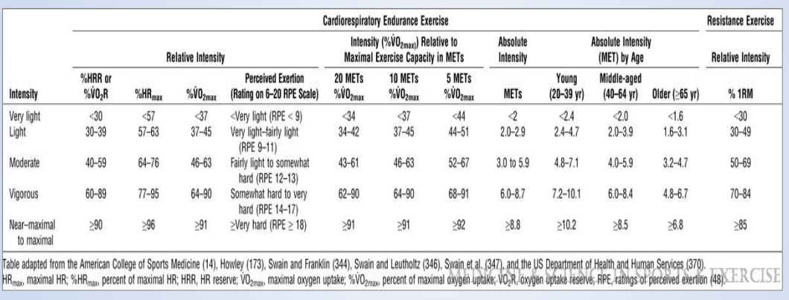

Appendix 2.
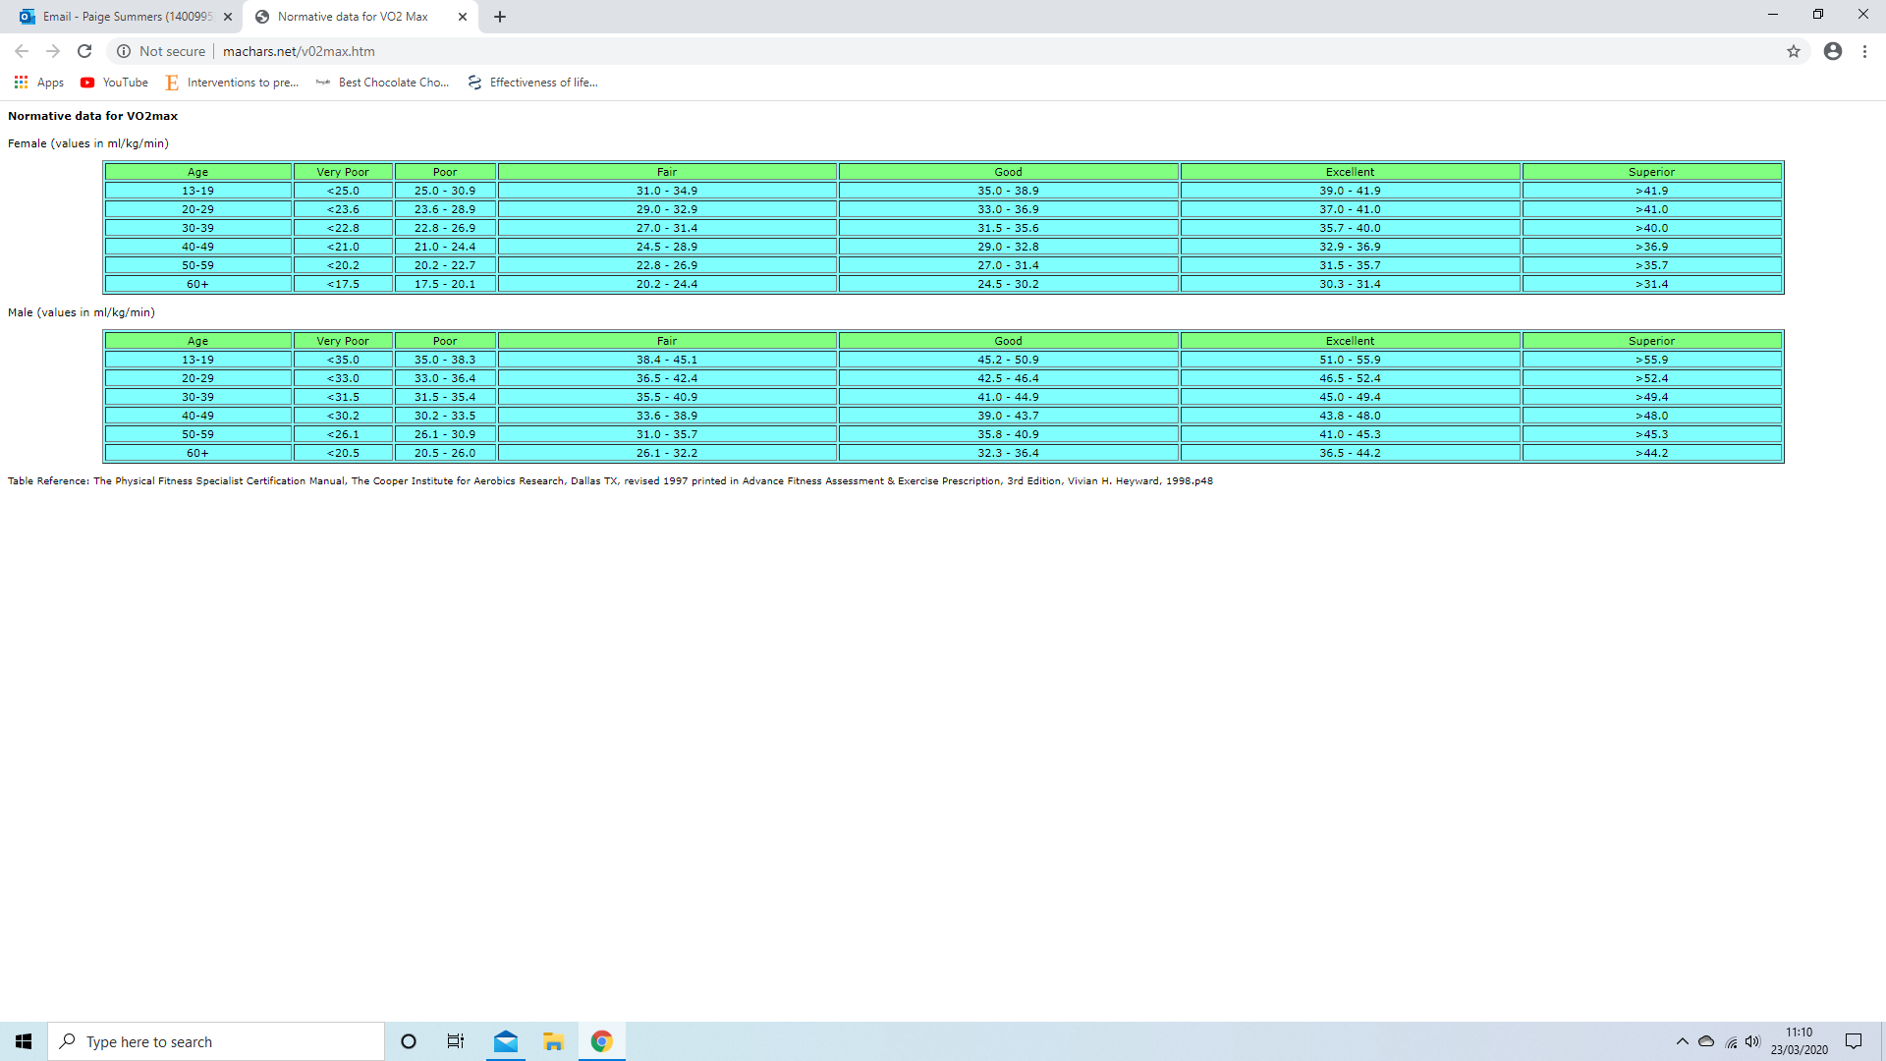
The Physical Fitness Specialist Certification Manual, Male Vo2 Max Norm Table.

Appendix 3.
CrossFit Session 1 class 1, 5pm – 6pm. Class HR data & Zone percentage. N1-6.
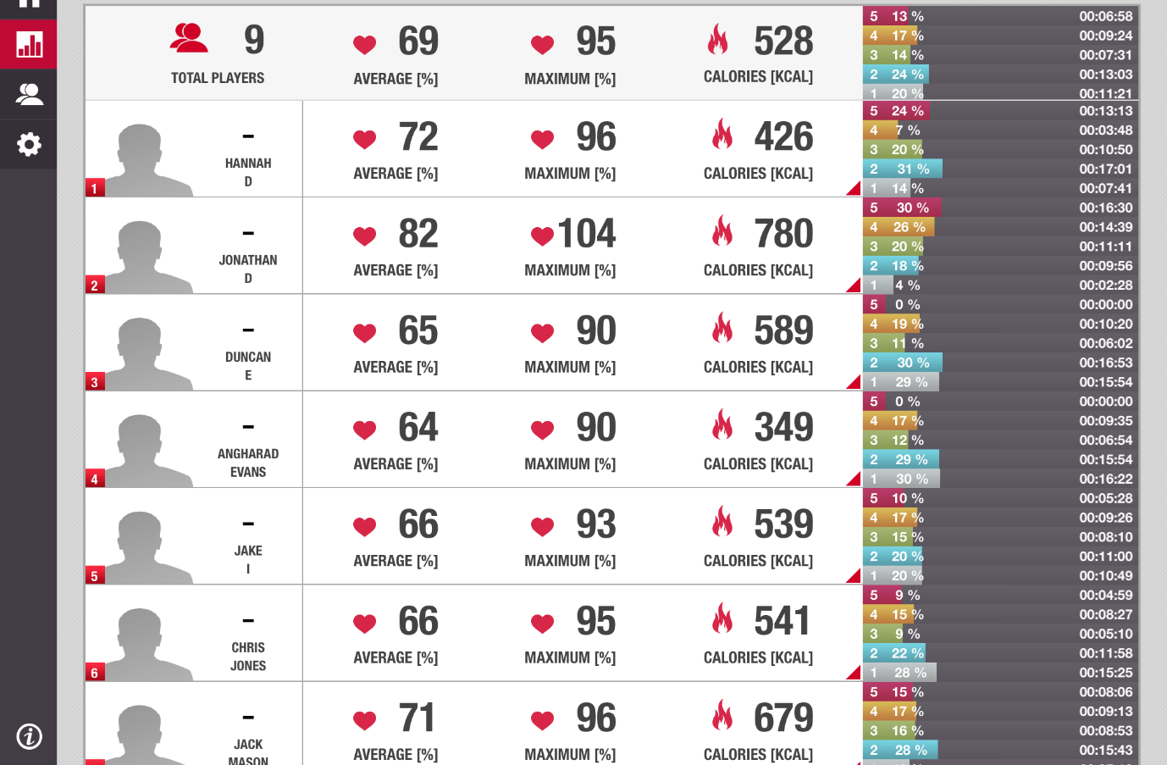

Appendix 4.
CrossFit Session 1 class 1, 5pm – 6pm. Class HR data & Zone percentage. N7-9.
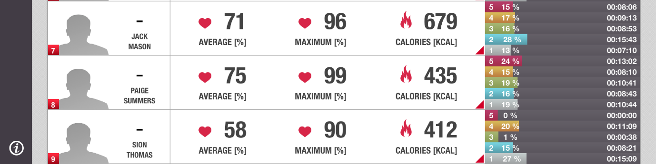

Appendix 5.
CrossFit Session 1 class 2, 6pm – 7pm. Class HR data & Zone percentage.
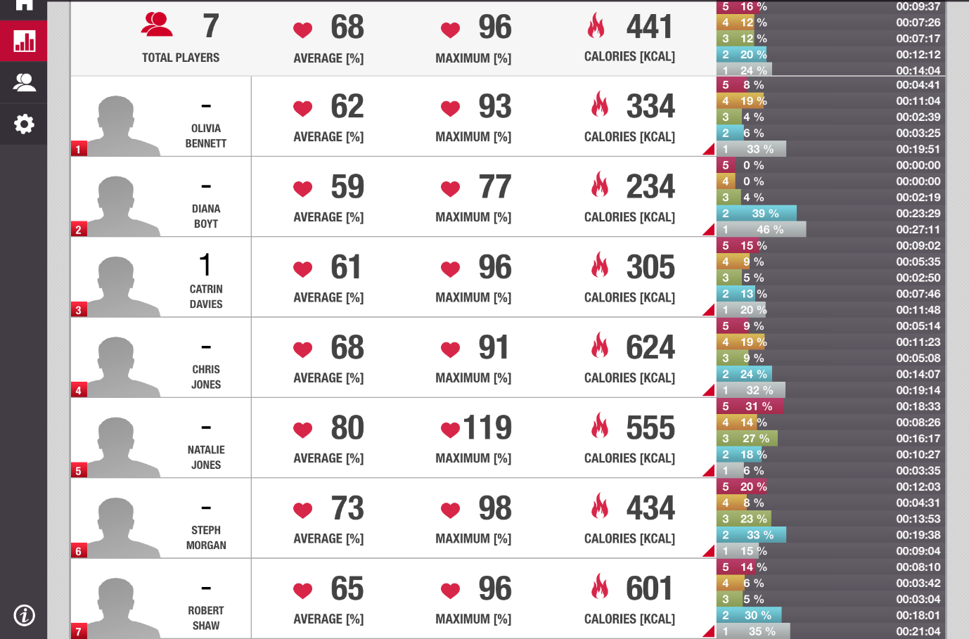

Appendix 6.
CrossFit Session 2 class 1, 5pm – 6pm. Class HR data & Zone percentage.
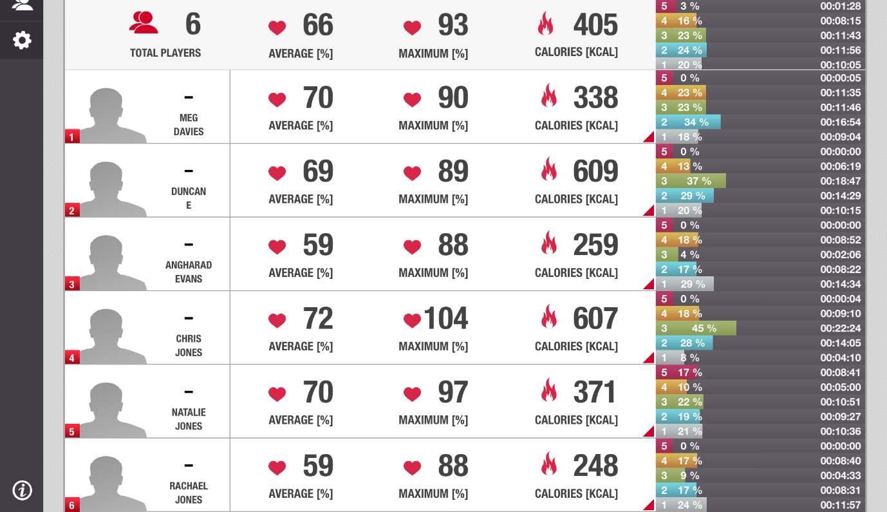

Appendix 7.
CrossFit Session 2 class 2, 6pm – 7pm. Class HR data & Zone percentage.
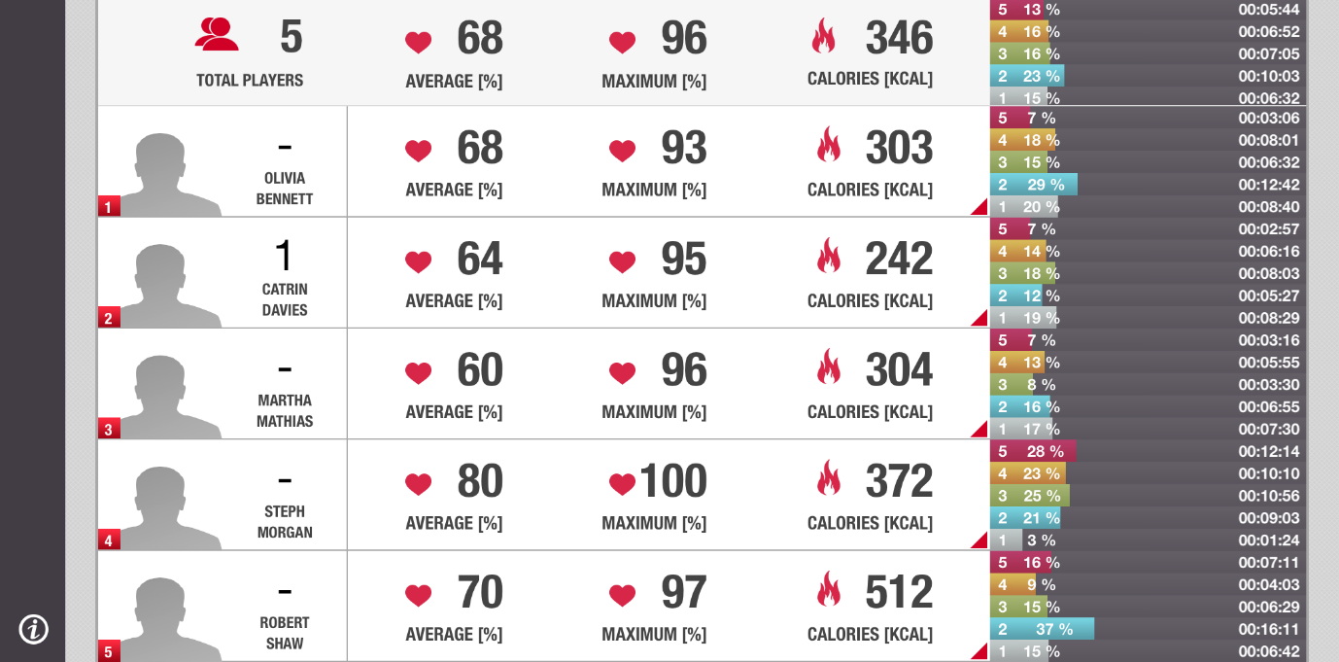

Appendix 8.
Participant CrossFit session 1. Avg HR %, Max HR %, Calories, Time in zones (time & percentage) and heart rate graph.

Appendix 9.
Participant CrossFit session 1. Avg HR %, Max HR %, Calories, Time in zones (time & percentage) and heart rate graph.

Appendix 10.
Participant CrossFit session 2. Avg HR %, Max HR %, Calories, Time in zones (time & percentage) and heart rate graph.

Appendix 11.
Participant CrossFit session 2. Avg HR %, Max HR %, Calories, Time in zones (time & percentage) and heart rate graph.

Appendix 12.
Reduction in Chronic conditions expected with increase in physical activity.

Condition | %
Type 2 diabetes | 40
Coronary heart disease | 35
Depression | 30
Breast and Colon cancer | 20
Joint and Back Pain | 25
Falls, fractures and head injuries | 30
Premature mortality - Worldwide | 9%
Premature mortality - UK | 16.9%
PHE (Brisk walking ref, NIMBS ref)

Impact of inactivity on chronic conditions

Condition | %
Type 2 diabetes | 7
Coronary heart disease | 6
Depression
Breast and Colon cancer | 10
Falls, fractures and head injuries | Unknown
Premature mortality - Worldwide | 9%
Premature mortality - UK | 16.9%
NIMBS ref

Appendix 13.
Physical Active adults across UK.

 | Male % | Female % | Combined %
England | 67 | 55 | 59
Northern Ireland | 60 | 47 | 53
Scotland | 71 | 58 | 64
Wales | 37 | 23 | 29
GoPA Cards ref

Appendix 14.
PAR-Q Form.

PAR-Q Questionnaire Form
Personal Details
First Name:
Last Name:
Student Number:
Course:
Gender:

Please answer the following questions fully and truthfully as it may affect our safety whilst exercising.
- Has a doctor told you that you have a heart condition AND must seek medical advice before participating in regular exercise? YES/NO
- Do you feel pain in your chest when you perform physical activity? YES/NO
- Have you ever had a chest pain when you perform physical activity? YES/NO
- Do you lose your balance due to dizziness or do you ever lose consciousness? YES/NO
- Do you have a bone or joint condition that could be made worse through physical activity? YES/NO
- Are you currently taking any medication for high blood pressure? YES/NO
- Are you currently taking any medication for a heart problem? YES/NO
- Do you take any other medications on a regular basis? YES/NO
- Have you had any recent surgery? YES/NO
- Do you have any chronic health conditions such as asthma, diabetes? YES/NO
- Women only: Are you pregnant or have you given birth in the last 6 months? YES/NO
- Are you currently suffering from any lower limb injury? YES/NO
- Are you currently recovering/rehabilitating from any current/past injury? YES/NO

NOTE: Blood pressure will be taken before testing to see if you will be allowed to continue with the session.

If you have answered YES to any of these then please give details below.
______________________________________________________________________________________________________________________________________________________________________________________________________________________________________________________
If you have answered YES to one or more of these questions, then it would be advisable to talk to your doctor before starting exercise.

Please comment below if you have any further information regarding your health, physical or otherwise, that has not been covered by the above questions (i.e. past or present injuries):
______________________________________________________________________________________________________________________________________________________________________________________________________________________________________________________

Signature:Date:

Appendix 15.
Consent Form.

Consent Form
Please tick the appropriate boxes | YES | NO
I have read and understood the participant information sheet provided to me by the researcher
I have been given the opportunity to ask any questions I have about the testing to be conducted.
I agree to take part in the study explained in the participant information sheet.
I understand that the study will include:
- Collection of sensitive information
- Use of heart rate monitors while conducting physical activity
- Monitoring of myself during physical activity
- Risk of Dom’s and/or injury during physical activity
- Potential of 1RM during physical activity
I understand that my personal data and results will not be revealed to anyone other than the investigator.
I understand that taking part is voluntary and that I can withdraw at any time without giving reasons to why.

Name of Participant Signature Date

Name of Researcher Signature Date

For any further information, please contact:
Robert Shaw
07479868998
1701251@student.uwtsd.ac.uk

Using the scaled and stadiometer at the gym, please use and record height and weight.

D/O/B | Height | Weight

Appendix 16.
Participant Information Sheet.

Participant Information Sheet

You have been invited to take part in a dissertation study. Before you decide if you wish to do so, it is necessary that you understand what is required and why the study is being carried out. It is essential that you take your time to read the information provided and ask any questions if there is something which has not been made clear.

This study aims to investigate the correlation between a 1-hour CrossFit training session and current UK government guidelines for physical activity. Current UK government guiltiness require all adults ages 18-65 to complete 150 minutes of moderate intensity aerobic exercise a week, 75 minutes of vigorous intensity or a mixture of the both. They also require that a minimum of at least 2 weight bearing exercises are completed a week, such as the gym, carrying heavy shopping bags. We hope to monitor physical activity levels during CrossFit in order to see how it would relate to those guidelines.

As a member of CrossFit Carmarthen and have currently been training for at least 3 months, you have been asked to participate in this study. The decision to take part in the study is entirely up to you. If you wish to take part you will keep a copy of this form to refer to in the future, you will also be given a consent form to sign to say you wish to partake in testing. If you agree to take part, then decide later you do not wish to anymore, you are able to withdraw from the study at any time without judgement or effecting the study.

If you wish to take part, you will be given a consent form and PAR-Q to fill in. Once completed you will be asked to attend two session. The first and second session, you will be given time to complete basic information to which the investigator will create a profile to which a heart rate polar team pro will be linked up to. You will be required to wear the heart rate for the full 60-minute duration of the CrossFit session. During some movements may be required to change your position to reduce risk of injury while wearing the heart rate monitor.

Participating in this study should not cause any serious harm. The risks associated with wearing a heart rate monitor and lifting heavy weights, conducting gymnastic movements will be nothing to which could not happen regardless. The CrossFit training session will be conducted by Coach’s and the 60-minute training session will be a programmed WoD, clear instructions and demonstrations will be provided to ensure you become familiar with this.

All data collected in this study will be kept confidential and safe using the Data Protection Act. Your results will be unidentifiable to other people, using number IDs instead of your name. You will not know what number ID you are; however, you will be given the opportunity to receive your own results if you wish. This study has been ethically approved by a lecturer within the Sport Health and Outdoor Education department of University of Wales Trinity Saint David.

If you have any further questions regarding this study, please contact:
Robert Shaw
07479868998
1701251@student.uwtsd.ac.uk

Appendix 17.
NHS Body Mass Index (BMI) Chart.
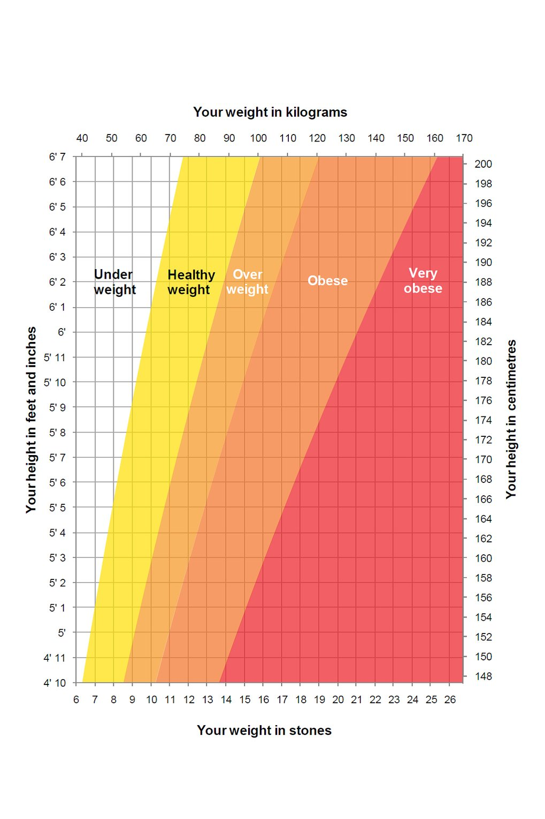

Appendix 18.
Ethics Form
APPLICATION FOR ETHICAL APPROVAL

In order for research to result in benefit and minimise risk of harm, it must be conducted ethically. A researcher may not be covered by the University’s insurance if ethical approval has not been obtained prior to commencement.

The University follows the OECD Frascati manual definition of research activity: “creative work undertaken on a systematic basis in order to increase the stock of knowledge, including knowledge of man, culture and society, and the use of this stock of knowledge to devise new applications”. As such this covers activities undertaken by members of staff, postgraduate research students, and both taught postgraduate and undergraduate students working on dissertations/projects.

The individual undertaking the research activity is known as the “principal researcher”.

Ethical approval is not required for routine audits, performance reviews, quality assurance studies, testing within normal educational requirements, and literary or artistic criticism.

Please read the notes for guidance before completing ALL sections of the form.

This form must be completed and approved prior to undertaking any research activity. Please see Checklist for details of process for different categories of application.

SECTION A: About You (Principal Researcher)

Full Name: |  |  | Robert Shaw
Tick all boxes which apply:
Member of staff: | ☐ | Student: |  | ☒ | Honorary research fellow: | ☐

Faculty/School/Centre: | School of Sport, Health and Outdoor Education
Campus: | Carmarthen
E-mail address: | 1701251@student.uwtsd.ac.uk
Contact Telephone Number: | 07479868998
For students:
Student Number: | 1701251 | Undergraduate | ☒
Programme of Study: | Sports Science | Taught Postgraduate | ☐
Director of Studies/Supervisor: | Geraint Forster | Research | ☐

SECTION B: Approval for Research Activity

Has the research activity received approval in principle?  (please check the Guidance Notes as to the appropriate approval process for different levels of research by different categories of individual) |  | YES | ☒ | NO | ☐
 |  |  |  | Date
If Yes, please indicate source of approval (and date where known): | Research Degrees Committee |  | ☐
 | Faculty Research Committee |  | ☐
 | Dissertation supervisor |  | ☒ | 28/01/20
Approval in principle must be obtained from the relevant source prior to seeking ethical approval.

SECTION C: External Ethical Guidance Materials

Please list the core ethical guidance documents that have been referred to during the completion of this form (including any discipline-specific codes of research ethics, and also any specific ethical guidance relating to the proposed methodology). Please tick to confirm that your research proposal adheres to these codes and guidelines.
University of Wales, Trinity Saint David Ethics Website | ☒
CrossFit, Certificate-Courses, Level-1, Code of Conduct | ☒
BASES, code of conduct, https://www.bases.org.uk/imgs/bases_code_of_conduct872.pdf | ☒

SECTION D: External Collaborative Research Activity

Does the research activity involve collaborators outside of the University? |  | YES | ☐ | NO | ☒
If Yes, please provide the name of the external organisation and name and contact details for the main contact person:
Institution
Contact person name
Contact person e-mail address

Where research activity is carried out in collaboration with an external organisation
Does this organisation have its own ethics approval system? | YES | ☐ | NO | ☒
If Yes, please attach a copy of any final approval (or interim approval) from the organisation

SECTION E: Details of Research Activity

Indicative title: | CrossFit relationship to UK governments physical guidelines
Proposed start date: | 03/02/2020 | Proposed end date: | 24/04/2020
Purpose of research activity (including aims and objectives)
Outline the purpose, aims and objectives of the research activity, including key research questions. Show briefly how existing research has informed the proposed activity and explain what the research activity will add and how it addresses an area of importance. (Maximum 300 words)
The aim of this study is to compare Functional fitness training (CrossFit) to current UK fitness guidelines for adults 19-64 years old. Each week, adults should accumulate at least 150 minutes of moderate intensity activity or 75 minutes of vigorous intensity activity or a combination of both moderate and vigorous activity. Adult’s should also do weight bearing exercises at least twice a week to build strength and reduce atrophy and muscle loss due to age, (Gov.uk 9th Jan 2020 & 19th Sep 2020).

Having athletes who have participated in functional fitness or/and CrossFit based training for 3 months or more and have no current or previous injury within the last 6 months wear heart rate monitors while participating in a 1-hour CrossFit training session and monitor intensity and time spent in each aerobic training zone and to monitor is the session is aerobic or anaerobically based comparing results gathered to UK fitness guidelines to see if 1 CrossFit session can be classified as moderate or vigorous activity and a weight bearing exercise based session.

If the results show that one high intensity functional fitness-based session is equivalent to 60 minutes of vigorous and moderate intensity and a weight bearing training session, those individuals who are short on time to train or those who prefer not to can reach current guidelines in an easier method and a shorter duration.

Proposed methods
Provide a brief summary of all the methods that may be used in the research activity, making it clear what specific techniques may be used. If methods other than those listed in this section are deemed appropriate later, additional ethical approval for those methods will be needed. (Maximum 600 words)
An athlete from CrossFit will be the main subject of the study conducting a pilot study of their results gathered from 2 maximal effort tests.

The athlete will participate in a V02 max test. The athlete may stop at any point during testing. The athlete will cycle at a pre established rpm for 3 minutes, every 3 minutes the resistance will be increased by 1. Until the athlete can’t maintain the rpm they are required to. 2-3 minutes the athletes will be required to wear a nose clip and place a mouthpiece in, the expired air will be collected in a Douglas air bag.

The athlete will participate in a V02 max test, based off aerobic exercises, thrusters and pull ups. The athlete may stop at any point during testing. The athlete will conduct 3 minutes of each selected functional fitness exercise. 2-3 minutes the athlete will wear a nose clip and mouthpiece and air samples will be collected. The athlete will then move onto the second exercise and complete the same method.

The athlete will complete each exercise 3 times, each time progressively getting harder.
Movement 1, thrusters. 0-3 minutes light weight, 3-6 minutes moderate weight, 6-9 minutes heavy weight.
Movement 2 pull ups. 0-3 minutes banded assistive, 3-6 minutes body weight, 6-9 minutes weighted pull ups.

Athletes at CrossFit Carmarthen will be asked to wear a Polar Team Pro heart rate monitor and height, weight and age to be recorded to create profiles of the athletes to monitor heart rate and time spent in each heart rate zone during a 1-hour training period.

Location of research activity
Identify all locations where research activity will take place.
UWTSD, SHOE facility, Lab
CrossFit Carmarthen Gym

(this box should expand as you type)
Research activity outside of the UK
If research activity will take place overseas, you are responsible for ensuring that local ethical considerations are complied with and that the relevant permissions are sought. Specify any local guidelines (e.g. from local professional associations/learned societies/universities) that exist and whether these involve any ethical stipulations beyond those usual in the UK (provide details of any licenses or permissions required). Also specify whether there are any specific ethical issues raised by the local context in which the research activity is taking place, for example, particular cultural sensitivities or vulnerabilities of participants.
N/A

(this box should expand as you type)

SECTION F: Scope of Research Activity

Will the research activity include: | YES | NO
Use of a questionnaire or similar research instrument? | ☐ | ☒
Use of interviews? | ☐ | ☒
Use of diaries? | ☐ | ☒
Participant observation with their knowledge? | ☒ | ☐
Participant observation without their knowledge? | ☐ | ☒
Use of video or audio recording? | ☐ | ☒
Access to personal or confidential information without the participants’ specific consent? | ☐ | ☒
Administration of any questions, test stimuli, presentation that may be experienced as physically, mentally or emotionally harmful / offensive? | ☒ | ☐
Performance of any acts which may cause embarrassment or affect self-esteem? | ☐ | ☒
Investigation of participants involved in illegal activities? | ☐ | ☒
Use of procedures that involve deception? | ☐ | ☒
Administration of any substance, agent or placebo? | ☐ | ☒
Working with live vertebrate animals? | ☐ | ☒
Other primary data collection methods, please explain in this box | ☐ | ☐

If NO to every question, then the research activity is (ethically) low risk and may be exempt from some of the following sections (please refer to Guidance Notes).

If YES to any question, then no research activity should be undertaken until full ethical approval has been obtained.

SECTION G: Intended Participants

Who are the intended participants: | YES | NO
Students or staff at the University? | ☐ | ☒
Adults (over the age of 18 and competent to give consent)? | ☒ | ☐
Vulnerable adults? | ☐ | ☒
Children under 18? | ☐ | ☒
Prisoners? | ☐ | ☒
Young offenders? | ☐ | ☒
Those who could be considered to have a particularly dependent relationship with the investigator or a gatekeeper? | ☐ | ☒
People engaged in illegal activities? | ☐ | ☒
Others (please identify): | ☐ | ☒

Participant numbers and source
Provide an estimate of the expected number of participants. How will you identify participants and how will they be recruited?
Participants will be current members of CrossFit Carmarthen, with at least 3 months of weight training and CrossFit training. Familiar with functional fitness movement patterns. Participants will be recruited via verbal dialog in a gym-based environment and will be informed/advertised via social media platform (Facebook and Instagram). Estimated participants numbers are 20 male and females. Participant numbers may very due to personal reasons, however speaking to potential participants, it will be spoken of the importance to attend both training sessions if possible.

this box should expand as you type)

Information for participants: | YES | NO | N/A
Will you describe the main research procedures to participants in advance, so that they are informed about what to expect? | ☒ | ☐ | ☐
Will you tell participants that their participation is voluntary? | ☒ | ☐ | ☐
Will you obtain written consent for participation? | ☒ | ☐ | ☐
Will you explain to participants that refusal to participate in the research will not affect their treatment or education (if relevant)? | ☒ | ☐ | ☐
If the research is observational, will you ask participants for their consent to being observed? | ☒ | ☐ | ☐
Will you tell participants that they may withdraw from the research at any time and for any reason? | ☒ | ☐ | ☐
With questionnaires, will you give participants the option of omitting questions they do not want to answer? | ☐ | ☐ | ☒
Will you tell participants that their data will be treated with full confidentiality and that, if published, it will not be identifiable as theirs? | ☒ | ☐ | ☐
Will you debrief participants at the end of their participation, in a way appropriate to the type of research undertaken? | ☒ | ☐ | ☐
If NO to any of above questions, please give an explanation
No Questionnaires are in use.

(this box should expand as you type)

Information for participants: | YES | NO | N/A
Will participants be paid? | ☐ | ☒ | ☐
Is specialist electrical or other equipment to be used with participants? | ☒ | ☐ | ☐
Are there any financial or other interests to the investigator or University arising from this study? | ☐ | ☒ | ☐
Will the research activity involve deliberately misleading participants in any way, or the partial or full concealment of the specific study aims? | ☐ | ☒ | ☐
If YES to any question, please provide full details
Polar Team Pro heart rate monitors are to be worn during 2x functional fitness training sessions.
Polar Team Pro heart rate monitors are to be worn during 2x aerobic and anaerobic maximal testing.
Watt bike pro will be used for Vo2 aerobic max testing.
Pull up bar and dumbbells for anaerobic Vo2 max testing.
Douglas bag used to collect 60 second air samples from the Vo2 testing.
Stopwatch, to monitor time.
Mouthpiece & valve to create a seal to collect a full 60 second air sample.
Nose-clip to stop the athlete breathing through their nose during 60 second air sample collection.
Servomex gas analyser, to analyse the samples collected.
Dry gas meter, to analyse the samples collected.
Borg RPE scale, to monitor athlete intensity.

(this box should expand as you type)

SECTION H: Anticipated Risks

Outline any anticipated risks that may adversely affect any of the participants, the researchers and/or the University, and the steps that will be taken to address them.

If you have completed a full risk assessment (for example as required by a laboratory, or external research collaborator) you may append that to this form.

Full risk assessment completed and appended?

Yes ☐
No ☒

Risks to participants
For example: emotional distress, financial disclosure, physical harm, transfer of personal data, sensitive organisational information
DOMs: Delayed onset muscle soreness, participants might develop DOM’s depending on the CrossFit session. An appropriate warm up and cool down will be conducted to reduce risk of DOM’s and injury. A coach will be present at all time to ensure correct and safe technique is used.

HR monitors: participants will be wearing a HR monitor for 1-hour periods. They must ensure not to hit it off any bars, weight or other equipment that may cause it to press into the sternum causing physical harm. Extra caution and constant reminders will be used to reduce risk of injury.

Emotional distress: due to the volume and intensity of training participants may feel emotional distress. To mitigate the risk support if needed and participants may stop at any time if they need to.

Physical harm: under fatigue if technique fails participants may drop the weight, let go of the pull up bar, they may fall or knock the participant causing physical harm. Coaches are present to reduce load and intensity id participants fail to meet standards. Coach’s are present to teach participants how to bail or drop weights in a safe manor.

Transfer of personal data: personal data when transferred will always be kept on the testers. Laptop will be in a secure bag, paper documents will be in a folder in a secure bag. The bag will always be with the tester, when left alone it will be locked inside an office inside a locked house.

Sensitive information: will be confidential between tester and participant only, no sharing of data or information will be passed on at any time. Data will be stored safely in a locked office which the tester alone has keys to.

High-intensity exercise using cycle ergometer (Wingate): the participant may feel sick dizzy and lightheaded, they may feel fatigue and muscle soreness, a correct warm up and cool down will be used to reduce muscle soreness, appropriate time to rest and fluids after testing will be given by choice. Technique will be demonstrated to the participant prior and will be enforced during testing.

Maximal aerobic test (VO2max/peak): the participant may feel sick dizzy and lightheaded, they may feel fatigue and muscle soreness, a correct warm up and cool down will be used to reduce muscle soreness, appropriate time to rest and fluids after testing will be given by choice. Technique will be demonstrated to the participant prior and will be enforced during testing.

Prolonged exercise: the participant may feel sick dizzy and lightheaded, they may feel fatigue and muscle soreness, a correct warm up and cool down will be used to reduce muscle soreness, appropriate time to rest and fluids after testing will be given by choice. Technique will be demonstrated to the participant prior and will be enforced during testing.

Blood pressure: will be taken from the pilot study participant, the procedure will be explained to them however if they do not follow procedure, circulation may be restricted. The procedure will be explained, and they may stop at any time if they so choose.

Sterilisation procedures: all equipment will be cleaned with appropriate cleaning products and rinsed clear after cleaning and before use to ensure no chemicals are left on the equipment.

Strength testing (External Resistance): the participant may feel sick dizzy and lightheaded, they may feel fatigue and muscle soreness, a correct warm up and cool down will be used to reduce muscle soreness, appropriate time to rest and fluids after testing will be given by choice. Technique will be demonstrated to the participant prior and will be enforced during testing.

Body composition: participant from the pilot study will be asked to conduct a body composition on a Tanita and height and weight recorded. This data will only be shared between the participant and tester. The data will be stored in a file in a locked room and not shared with external parties.

(this box should expand as you type)
If research activity may include sensitive, embarrassing or upsetting topics (e.g. sexual activity, drug use) or issues likely to disclose information requiring further action (e.g. criminal activity), give details of the procedures to deal with these issues, including any support/advice (e.g. helpline numbers) to be offered to participants. Note that where applicable, consent procedures should make it clear that if something potentially or actually illegal is discovered in the course of a project, it may need to be disclosed to the proper authorities
N/A

(this box should expand as you type)
Risks to investigator
For example: personal safety, physical harm, emotional distress, risk of accusation of harm/impropriety, conflict of interest
Risk to investigator physical harm, during testing the investigator must ensure a safe distance from participants when lifting weight or conducting movements to mitigate the risk of objects falling or been dropped on the investigator or collations between participants and investigator.

Risk to investigator credibility, during testing a witness should be present for submaximal testing, and during height, weight and age gathering at the CrossFit gym to ensure no false claims are made towards the investigator.

(this box should expand as you type)
University/institutional risks
For example: adverse publicity, financial loss, data protection
Risk to University, the investigator will take appropriate actions to act in a professional and polite manor to all participants, the investigator will always have a 3rd party member, lab tech/ CrossFit coach present when conducting all testing and if any information is required from participants.

There will be no adverse risk to the university or finical loss sue to all participants been volunteers.
There will be no risk to data protection as data protection act 1998 will be followed through out testing.

(this box should expand as you type)
Adverse outcomes
List measures put in place to limit any adverse effects or outcomes of research activity where appropriate. Include any emergency protocols.
Weather: due to rain and flooding, all exercise and testing will be stopped and be re-arranged at a later date.

(this box should expand as you type)

Disclosure and Barring Service
If the research activity involves children or vulnerable adults, a Disclosure and Barring Service (DBS) certificate must be obtained before any contact with such participants. | YES | NO | N/A
Has a DBS certificate been obtained? | ☒ | ☐ | ☐

SECTION I: Feedback, Consent and Confidentiality

Feedback
What feedback will be provided to participants, how will this be done and when?
No feedback will be given unless the participants request it prior.

Informed consent
Describe the arrangements to inform potential participants, before providing consent, of what is involved in participating. Describe the arrangements for participants to provide full consent before data collection begins. If gaining consent in this way is inappropriate, explain how consent will be obtained and recorded.
Consent will be acquired via a consent form, written. All participants will be informed of what is expected and if they wish to stop, they may. Participants will also complete a PAR-Q to screen for any risk that may cause injury, hard or show they have been injured in the last 6 months.

Each session will be explained to participants, that height weight and age is required to create a profile on polar team pro, they need to wear a HR monitor for the full duration and once cooled down they may remove it.

Sub maximal testing, the participant will be informed of the standard of which they must maintain during both aerobic and anaerobic maximal testing, apparatus used will be presented to the participants to allow them to try it and become comfortable with the equipment.

Confidentiality / Anonymity
Set out how anonymity of participants and confidentiality will be ensured in any outputs. If anonymity is not being offered, explain why this is the case.
Participants data will be recorded down with names, however only testers will know the identity and results of those individuals, records will only show N (number of participants that took part). No names or specific data will be presented or shared from this study.

(this box should expand as you type)

SECTION J: Data Protection and Storage

In completing this section refer to the University’s Research Data Management Policy and the extensive resources on the University’s Research Data Management web pages (http://uwtsd.ac.uk/library/research-data-management/).
 | YES | NO
Does the research activity involve personal data (as defined by the Data Protection Act)?  “personal data” means data which relate to a living individual who can be identified—  (a) from those data, or  (b) from those data and other information which is in the possession of, or is likely to come into the possession of, the data controller, and includes any expression of opinion about the individual and any indication of the intentions of the data controller or any other person in respect of the individual. | ☒ | ☐
If YES, provide a description of the data and explain why this data needs to be collected:
Age, Height and Weight will collected from the participants for the polar team and for mean and average scores.

(this box should expand as you type)
Does it involve sensitive personal data (as defined by the Data Protection Act)?  “Sensitive personal data” means personal data consisting of information as to –  (a) the racial or ethnic origin of the data subject,  (b) his political opinions,  (c ) his religious beliefs or other beliefs of a similar nature,  (d) whether he is a member of a trade union (within the meaning of the Trade Union and Labour Relations (Consolidation) Act 1992),  (e) his physical or mental health or condition,  (f) his sexual life,  (g) the commission or alleged commission by him of any offence, or  (h) any proceedings for any offence committed or alleged to have been committed by him, the disposal of such proceedings or the sentence of any court in such proceedings. | ☒ | ☐
If YES, provide a description of the data and explain why this data needs to be collected:
Physical data will be collected from all participants from 2x 1 hour training sessions.

(this box should expand as you type)

Will the research activity involve storing personal data on one of the following: | YES | NO
Manual files (i.e. in paper form)? | ☒ | ☐
University computers? | ☒ | ☐
Private company computers? | ☒ | ☐
Home or other personal computers? | ☐ | ☒
Laptop computers/ CDs/ Portable disk-drives/ memory sticks? | ☒ | ☐
“Cloud” storage or websites? | ☐ | ☒
Other – specify: | ☐ | ☒
For all stored data, explain the measures in place to ensure data confidentiality, including details of password protection, encryption and anonymisation:
All paper copies of data will be stored in a file in a locked draw in a private room which will be locked when the main researcher of the study is not present. Laptop and personal PC are in a study, this is locked when not in use. University tablet will be used to collect data, the data will be transferred straight to a private PC then wiped clear of all sensitive data. Laptop and PC have passwords on and will follow data protection act.

Will the research activity involve any of the following activities: | YES | NO
Electronic transfer of data in any form? | ☒ | ☐
Sharing of data with others at the University? | ☐ | ☒
Sharing of data with other organisations? | ☐ | ☒
Export of data outside the European Union or importing of data from outside the UK? | ☐ | ☒
Use of personal addresses, postcodes, faxes, emails or telephone numbers? | ☐ | ☒
Publication of data that might allow identification of individuals? | ☐ | ☒
Use of data management system? | ☐ | ☒
Data archiving? | ☐ | ☒
If YES to any question, please provide full details, explaining how this will be conducted in accordance with the Data Protection Act (and/or any international equivalent):
Transfer will be from tablet to a private PC. Once transferred the data will be wiped from the public tablet.

List all who will have access to the data generated by the research activity:
Robert Shaw (investigator)
Dissertation supervisor
Moderator
External examiner

List who will have control of, and act as custodian(s) for, data generated by the research activity:
Robert Shaw (investigator)

(this box should expand as you type)
Give details of data storage arrangements, including where data will be stored, how long for, and in what form. Will data be archived – if so how and if not why not.
Paper form will be stored in a file in a locked draw in a locked study.
Electronic data will be stored on a file on a password protected PC in a locked study.

(this box should expand as you type)

SECTION K: Declaration

The information which I have provided is correct and complete to the best of my knowledge. I have attempted to identify any risks and issues related to the research activity and acknowledge my obligations and the rights of the participants.

In submitting this application I hereby confirm that I undertake to ensure that the above named research activity will meet the University’s Research Ethics and Integrity Code of Practice
Signature of applicant: |  | Date:

For students:
Director of Studies/Supervisor: | Geraint Forster
Signature:
Date:

For staff:
Head of School/Assistant Dean:
Signature:
Date:

Checklist: Please complete the checklist below to ensure that you have completed the form according to the guidelines and attached any required documentation:
☒ | I have read the guidance notes supplied before completing the form.
☒ | I have completed ALL RELEVANT sections of the form in full.
☒ | I confirm that the research activity has received approval in principle
☒ | I have attached a copy of final/interim approval from external organisation (where appropriate)
☐ | I have attached a full risk assessment (and have NOT completed Section H of this form) (where appropriate)
☒ | I understand that it is my responsibility to ensure that the above named research activity will meet the University’s Research Ethics and Integrity Code of Practice.
☒ | I understand that before commencing data collection all documents aimed at respondents (including information sheets, consent forms, questionnaires, interview schedules etc.) must be confirmed by the DoS/Supervisor, module tutor or Head of School.

RESEARCH STUDENTS AND STAFF ONLY
All communications relating to this application during its processing must be in writing and emailed to pgresearch@uwtsd.ac.uk , with the title ‘Ethical Approval’ followed by your name.
You will be informed of the outcome of your claim by email; therefore it is important that you check your University and personal email accounts regularly.

STUDENTS ON UNDERGRADUATE OR TAUGHT MASTERS PROGRAMMES should submit this form (and receive the outcome) via systems explained to you by the supervisor/module leader.

This form is available electronically from the Academic Office web pages: http://www.uwtsd.ac.uk/academic-office/

Application Process

All staff research projects and all research students must submit the Ethical Approval Form to the University Ethics Committee via the Academic Office (pgresearch@uwtsd.ac.uk). Staff research directly in relation to personal study for taught undergraduate or Masters programmes should be submitted via the Faculty procedures explained below.

Taught masters and taught undergraduate research Ethical Approval Forms are considered within Faculties. Faculties will provide details of the specific processes for this. Where the Ethical issues within any single ethical application are of particular concern the Faculty will refer these to the University Ethics Committee. Any student activity that involves the collection of primary data needs to undergo Ethical approval, this includes assignment work as well as dissertations.

Notes for guidance in completion of this form

Section A: About You
Please complete all relevant sections

Section B: Approval for research activity
Research proposals must be approved in principle before applying for Ethical Approval. The proposal approval only becomes final when the ethical approval is received.

The process for proposal approval varies according the individual and programme of study:
- Research students, by application on form PG1 to the Research Degrees Committee
- Taught students by review of research proposal within Faculties (Faculties provide specific details of these processes)
- Staff, by agreement by the Head of School/Assistant Dean

Section C: External Ethical Guidance materials
Many discipline areas are required to operate with the discipline specific codes of research ethics (for example health, psychology, education etc.), any such codes must be listed and you must tick to confirm that you have consulted with these.

Section D: External Collaborative Research Activity
Provide details of the external collaborative partners, where appropriate you might want to submit a copy of the external collaboration agreement with the Ethical Approval Form. If the partner requires the research to be subject to its own internal Ethical approval process then please provide details of that process and a copy of any final (or interim) approvals received from the organisation.

Section E: Details of Research Activity
Remember that the individuals reviewing this Ethical Approval Form may not have seen your research proposal, and also may not be experts in the specific area of your research. The information provided should therefore be jargon free and clearly stated.
Indicative Title: please use the same title as used on the research proposal.
Purpose: the Ethical approval process will want to ensure that the methods you propose are adequate and appropriate to address the research aims and objectives. Excessive additional data collection can be seen as unethical.
Proposed Methods: the Ethical approval process seeks to ensure that you understand the methods that are intended, and that the implementation of those methods will be appropriate and without unnecessary impact on respondents. Please be specific.
Location: this needs to mention geographical location and also local situation (for example, within Local Authority Offices in Cardiff, using a private room but close to other individuals). If you are collecting data within an organisational setting then you need to explain the permissions that you have obtained to do this.
Research Activity outside of the UK: please complete this section in detail, and note any guidance you have received. Also describe your own familiarity (or not) with the location that you will be utilising.

Section F: Scope of Research Activity
Please tick ALL of the research activities that might be undertaken. If any additional types of activity are intended then please add an extra box and describe these.
If you have answered no to all questions in F then sections G and J do not need to be completed. Section H should be considered, and may be completed. Signatures are still required in section K.

Section G: Intended Participants
Please tick all categories that might apply.
Numbers & Source: if you are using a series of different methods or research activities please list numbers for each stage/phase. Be clear about how you will find respondents. Will you use intermediaries, and if so how? How will you ensure compliance with your sampling strategy?
Information for participants: all participants should be appropriately informed about the research, what is expected of them and what will happen to the information that they provide. The Ethical review process does not ask to see this documentation, but requires this to be reviewed and approved by the Director of Studies in the case of research students, the supervisor/module tutor in relation to students on taught programmes and the Head of School/Assistant Dean in relation to staff research.

Section H: Anticipate Risks
All research carries some level of risk. The answers you provide to questions in this section will be reviewed to ensure that you have an appropriate understanding of the type of risks involved and how you can mitigate against these risks. If you have completed a full risk assessment, as required for example for laboratory work, field work, clinical tests, diving operations, or by a collaborative partner, you may append that to this form. In that case, please tick the box indicating this has been provided. You will not then be required to complete Section H.
Risk to participants Think very carefully about how your actions/questions/discussions might affect the people you are involving as participants. You might identify the risk as small but it would still be a risk. Many types of question have the potential to make respondents less content with their life / job; you need to recognise and try to ameliorate any such effects
If these are business owners, time with you may reduce profit.
In some locations physical risk is very real to both participants and yourself, please consider this.
Risk to you, the researcher Think about where you will meet people, if there are any dangers involved in the location. If you are meeting people as individuals think about using a public place. In general do not visit people in their own homes or remote locations. If you are talking to individuals about certain issues think about how their responses might affect you emotionally. What about the risk of collecting insufficient data?
Risk to the University When undertaking your research, you are acting as a member of the University (student or staff). Professionalism is important, so it is important to be well organised and well prepared. Punctuality, clarity etc. are all part of this. What will you do to ensure this? You must ensure you do not harm the good name of the University in any way and do nothing to undermine the reputation of the research it conducts and sponsors. Upholding high standards of conduct and integrity are vital in this regard. You must also conduct the research in such a way to minimise the potential for claims of negligence made against the University, its researchers and any collaborating individual or organisation. In this respect you should always comply with ethical, legal and professional frameworks, obligations and standards as required by statutory and regulatory authorities, as well as the university’s Research Integrity and Ethics Code of Practice. Research misconduct in this respect can take many forms, including:
- fabrication: making up results or other outputs (eg, artefacts) and presenting them as if they were real
- falsification: manipulating research processes or changing or omitting data without good cause
- plagiarism: using other people’s material without giving proper credit
- failure to meet ethical, legal and professional obligations: for example failure to declare competing interests; misrepresentation of involvement or authorship; misrepresentation of interests; breach of confidentiality; lack of informed consent; misuse of personal data; and abuse of research subjects or material
- improper dealing with allegations of misconduct: failing to address possible infringements such as attempts to cover up misconduct and reprisals against whistle-blowers

Adverse Outcomes. Think carefully about the possibilities, and cover here

Section I: Feedback, Consent and Confidentiality
Feedback to participants: outline your approach. Will interview transcripts be shared with respondents to check accuracy? Will summaries of questionnaire analysis be made available to respondents in some way? Will an overview report be provided? How and when?
Informed consent: Draft letter / e-mail / or heading (or footer) section of questionnaire must be approved by DoS/supervisor (if research student), supervisor/module tutor if taught student, or Head of School / Assistant Dean if a member of staff.
Confidentiality/Anonymity. Explain clearly how you will ensure confidentiality and anonymity.

Section J: Data Protection and Storage
Before completing this section it is necessary to read the University’s Research Data Management information. The questions that follow are designed to ensure compliance with the Data Protection Act as well as established research protocols.

Many research activities will involve electronic transfer of data and use of data management systems in the summarisation and analysis of data. You will need to explain these in relation to compliance with the Data Protection Act.
Think carefully about who will have access to your data, this will include supervisors and examiners. Also that a thesis will be made available via the University library and the British Library system. If you are seeking an access bar for a period of time after completion then mention it here. If you will provide a copy of your findings, or intend to give a presentation, to a facilitating/ supporting/accessing organisation then explain that in this section. But also think about the general principle of data sharing, as explained in the Research Data Management information.
In terms of storage of data please ensure security, and also mitigate against loss of data.

Section K: Declaration
Ensure the appropriate countersignatures have been provided
Look carefully at the checklist and ensure that you comply with and tick all that are relevant to your research.

