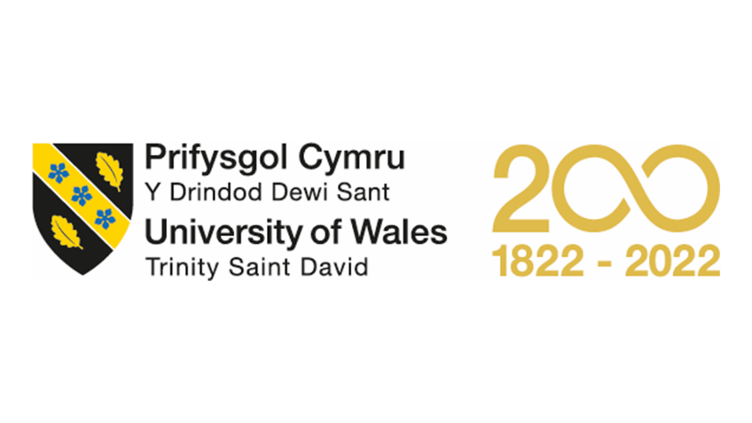

Assignment Title: Individual Report; Component 1

Module Name: Introduction to Modern Workplace

Module Code: LCBB 4003

Program of Study: BA Business Management

Student Name: Hamdan Ahmad

Student ID #: 2208436

Lecturer Name: Dr Uju Ugochukwu

Table of Contents
Introduction 3
Organizational back ground: 4
Management Styles and its Impact on Employee Behavior in Tesco PLC: 5
Management and Leadership Theories 6
Conclusion: 8
References 9

Introduction
Management is an essential component of any organization, playing a critical role in shaping the behavior of employees and ultimately determining the success of the organization. The management style employed by leaders has a profound impact on the culture, productivity, and overall performance of the organization. With globalization and the ever-changing business environment, the importance of management has increased manifold, and effective management has become a key determinant of organizational success.
In this report, I will explore how management styles shape the behavior of employees in a selected organization in the UK and the impact that managerial styles can have on the success of that organization. I will use management and leadership theories to support my argument and provide relevant examples.
The organization that I have chosen for this essay is Tesco PLC, a multinational grocery and general merchandise retailer. Tesco is one of the largest retailers in the world, operating in 12 countries with over 6,800 stores and employing more than 440,000 people. The organization has a highly decentralized structure, with each country's operations being run by a local management team, reporting to the headquarters in the UK.
Tesco's management style has evolved over the years, with the organization's former CEO, Terry Leahy, being credited with introducing a customer-centric approach to management. Leahy believed in empowering employees and giving them a sense of ownership and responsibility, thereby increasing their motivation and engagement levels. He also encouraged collaboration and open communication, creating a culture of transparency and trust.
This approach is consistent with the transformational leadership theory, which emphasizes the leader's ability to inspire and motivate employees to achieve their full potential. Transformational leaders like Leahy focus on developing their employees' skills, providing them with challenging tasks and opportunities for growth, and fostering a sense of ownership and pride in their work.
Under Leahy's leadership, Tesco achieved unprecedented success, becoming the market leader in the UK and expanding its operations globally. However, with the change in leadership and increasing competition, the organization faced challenges in maintaining its market position.
The current CEO, Dave Lewis, has adopted a more authoritarian management style, with a focus on streamlining operations, cutting costs, and increasing efficiency. Lewis has implemented several cost-cutting measures, including reducing employee benefits and restructuring the organization's operations.
This approach is consistent with the transactional leadership theory, which emphasizes the use of rewards and punishments to motivate employees. Transactional leaders like Lewis focus on achieving goals and meeting targets, using performance metrics and incentives to incentivize employees to achieve their targets.
While Lewis's approach has been successful in achieving short-term goals and improving efficiency, it has also led to a decline in employee morale and engagement levels. The reduction in employee benefits and the restructuring of operations have created a sense of insecurity and mistrust among employees, leading to increased turnover rates and decreased productivity.
So, the management style adopted by leaders has a profound impact on the behavior of employees and ultimately determines the success of the organization. Transformational leaders like Terry Leahy focus on inspiring and motivating employees, creating a culture of collaboration and trust, and providing opportunities for growth and development. On the other hand, transactional leaders like Dave Lewis focus on achieving short-term goals and improving efficiency, using rewards and punishments to incentivize employees. While both approaches have their benefits and drawbacks, a balanced approach that combines elements of both transformational and transactional leadership is essential for long-term success.

Organizational back ground:
Tesco PLC is a leading multinational grocery and general merchandise retailer based in the United Kingdom. The company operates in various regions across the globe, including Europe, Asia, and North America. It is one of the largest retailers in the world, with over 6,500 stores and more than 450,000 employees worldwide.
The company was founded in 1919 by Jack Cohen and has since grown to become a global brand. Its success is largely attributed to its innovative business strategies, such as its "Every Little Helps" campaign, which focuses on providing high-quality products at affordable prices while prioritizing customer satisfaction. This approach has helped Tesco to establish a loyal customer base and maintain a competitive edge in the retail industry.
In recent years, Tesco has faced several challenges, including increased competition from online retailers and economic uncertainty caused by Brexit. However, the company has remained resilient by implementing strategic measures to adapt to changing market conditions.
One of Tesco's key strengths is its diverse product offering, which includes groceries, clothing, and household goods. The company also offers a range of services, such as banking and insurance, which have contributed to its success.
Tesco has also been recognized for its commitment to sustainability and social responsibility. The company has implemented several initiatives aimed at reducing its environmental impact, such as reducing waste and emissions. Tesco has also supported various community projects, including food banks and education programs.
In terms of its organizational structure, Tesco operates as a hierarchical structure with clear lines of authority and defined roles and responsibilities. The company is led by a board of directors, with the CEO responsible for overall strategic direction and day-to-day management.
Overall, Tesco PLC is a leading multinational retailer with a strong reputation for providing high-quality products and services. Its success is driven by its innovative business strategies, diverse product offering, and commitment to sustainability and social responsibility. Despite facing several challenges in recent years, Tesco remains a resilient and competitive player in the retail industry.

Management Styles and its Impact on Employee Behavior in Tesco PLC:
Management styles refer to the various ways in which managers lead and guide their subordinates in an organization. Different styles can impact the behavior of employees, and in turn, affect the success of the organization. Tesco PLC, a multinational grocery and general merchandise retailer in the UK, employs several management styles to ensure the efficient functioning of its operations and the motivation of its workforce.
Tesco's management styles include autocratic, democratic, and transformational. The company's leaders employ the autocratic style, where they make decisions without the input of subordinates, in emergencies or situations that require urgent action. This style is useful in critical circumstances where immediate action is required, such as during natural disasters or unforeseen events.
In contrast, the democratic style involves the input of subordinates in decision-making processes. Tesco's management team employs this style to foster creativity and innovation among employees, especially in areas where teamwork is necessary. For instance, the company's managers allow their employees to participate in the decision-making process of the company's CSR activities. This inclusion makes the employees feel valued and motivated, which leads to increased job satisfaction and better overall performance.
The transformational management style is the third approach used by Tesco's leaders. Transformational leaders inspire and motivate their followers to achieve a common goal by encouraging them to take ownership of their work and focus on their strengths. This style involves mentoring and coaching subordinates, with the aim of building trust and loyalty. Tesco's transformational leaders empower their employees by delegating responsibilities and holding them accountable, which leads to higher levels of employee engagement and job satisfaction.
The impact of management styles on the behavior of employees in Tesco is evident. For instance, the use of the democratic style fosters a culture of inclusivity, where employees are encouraged to share their opinions and ideas. This approach leads to increased collaboration and teamwork, which translates to better performance and improved results. Additionally, the transformational style of management has been beneficial to the company, as it leads to higher levels of employee engagement and job satisfaction, which results in lower employee turnover rates.
Furthermore, Tesco's management styles have contributed significantly to the company's success. For instance, the company's democratic approach to management has helped it to develop innovative products and services that cater to the diverse needs of its customers. The transformational approach to leadership has also played a crucial role in the company's success, as it has helped to create a positive work environment that motivates employees to give their best. Overall, Tesco's management styles have helped the company to maintain its position as a leading player in the grocery and general merchandise retail industry in the UK.
So, Tesco's use of various management styles demonstrates the impact that managerial approaches can have on employee behavior and the success of an organization. The company's management team has effectively utilized the autocratic, democratic, and transformational styles to create a positive work environment that fosters innovation, collaboration, and employee engagement. This has, in turn, contributed to the company's success as a leading player in the grocery and general merchandise retail industry in the UK.

Management and Leadership Theories
Tesco PLC is a multinational grocery and general merchandise retailer headquartered in the UK. The company operates in several countries across the world and has a workforce of over 450,000 employees. Tesco PLC is known for its innovative management and leadership style, which has enabled it to remain competitive in the retail industry.
Management and leadership theories are crucial in shaping organizational culture and management practices. The success of Tesco PLC can be attributed to its effective application of management and leadership theories in its operations. The company has adopted various management styles that have shaped its organizational culture and management practices.
The transformational leadership style is one of the management and leadership theories that have been adopted by Tesco PLC. This style is characterized by leaders who inspire and motivate employees to achieve their goals. Tesco PLC has been able to inspire its employees by setting high-performance standards and recognizing and rewarding excellent performance. This has created a sense of purpose among employees, leading to improved productivity and a positive work environment.
Tesco PLC has also adopted a participative management style, which involves involving employees in decision-making processes. This style has allowed employees to feel valued and respected, resulting in a motivated workforce. The company has implemented an open-door policy, where employees can freely share their ideas and suggestions with their managers. This has resulted in the development of innovative ideas, leading to improved products and services.
The company has also adopted a contingency management approach, where management practices are tailored to suit specific situations. This approach has allowed Tesco PLC to remain flexible and adaptable to changes in the retail industry. For example, the company has implemented online shopping platforms, mobile applications, and self-service checkouts, among other innovative solutions.
Tesco PLC has also adopted a task-oriented management style, where managers focus on achieving specific goals and objectives. This style has allowed the company to remain focused on its mission and objectives, leading to improved performance and productivity. The company has implemented performance management systems that measure employee performance against specific targets. This has led to improved employee motivation and productivity.
So, Tesco PLC's success can be attributed to its effective application of management and leadership theories in its operations. The company has adopted various management styles, including transformational leadership, participative management, contingency management, and task-oriented management, to shape its organizational culture and management practices. These management styles have created a positive work environment, motivated employees, and enabled the company to remain competitive in the retail industry.

Conclusion:
Tesco PLC, a multinational grocery and general merchandise retailer of the UK, is a prime example of how effective management styles can lead to the success of an organization. The company has undergone significant changes in recent years, including the introduction of new management strategies, which have resulted in a positive impact on the company's performance.
Tesco's management has adopted a transformational leadership style, which encourages and motivates employees to perform at their best. This style of leadership emphasizes the importance of communication and collaboration, which has resulted in improved employee engagement, increased job satisfaction, and productivity.
Moreover, Tesco's management has also implemented a flexible management style that allows employees to work in a way that suits those best, resulting in a better work-life balance. This approach has not only improved employee morale, but it has also reduced employee turnover, saving the company time and money on recruitment and training costs.
Furthermore, Tesco's management has also adopted an autocratic management style in situations that require quick decision-making and implementation, such as during the pandemic. This style of management has helped the company respond rapidly to changing circumstances and ensure the safety of its employees and customers.
In the end, Tesco's success can be attributed to its management's ability to adopt different management styles, depending on the situation. The company's adoption of transformational, flexible, and autocratic management styles has resulted in a positive impact on employee behavior, productivity, and the overall success of the organization. By using management and leadership theories to back up the argument or discussions, it is evident that effective management styles play a crucial role in the success of an organization.

References
Armstrong, M., (2007) A handbook of human resource management practice. s.l.:Kogan Page Publishers.
Bass, B, M., (2008). The Bass handbook of leadership: Theory, research, and managerial applications. s.l.:Simon and Schuster.
Conger, n.d. The Practice of Leadership: Developing the Next Generation of Leaders.. 2013: John Wiley & Sons.
D. & J., (2009) 'Positive managerial behavior: An impact on employee attitudes and performance.' Journal of Management. 35(2), pp. 307-328.
Goleman, D., (2004) 'What makes a leader?' Harvard Business Review. 82(1), pp. 82-91.
Hersey, P. &. B., (2007) Management of organizational behavior: Utilizing human resources. 9th ed. s.l.:Prentice Hall.
Yukl, G. A., (2013) Leadership in organizations. (8th ed.). ed. s.l.:Pearson.

