THE GLOBAL BUSINESS ENVIRONMENT
Student name :Daniela Elena Petrescu
Student number :1814733
Academic Essay

On

“Electric vehicles in Europe: gearing up for a new phase?”

Introduction
Every business has to maintain the equilibrium among different elements of the business environment while developing its business model by considering environmental factors (Morrison, 2016). Car and automotive industries are highly influenced by the increasing demand for the electric car and the environut forces such as innovative technology and environmental safety is the main concern in this sector now. Like most of the car manufacturer, Volvo has marked this as a historic change in the business environment to electrify the future car and to end the use of fossil fuel which emits CO₂ in the atmosphere. Europe has already passed the initial critical phase to adopt the mobility of electric cars and now emphasise on the importance of this powertrain which ensures environmental safety and fulfils the needs of future demand. This essay aims to asses the environmental forces of the car industry and how the industry has changed in the last decade with the response to the needs. Besides, this assignment will also identify the new emerging business opportunities along with manufacturing and selling cars and automotive.

“Electric vehicles in Europe: gearing up for a new phase?”
The global business environment is the environment of different countries where different factors directly or indirectly influence the decision-making process of the home business. There are some major forces in this environment including rapid technological innovation, the evolution of money and trade paradox (Johnson et al., 2017). All these forces have a tremendous impact on the car industry where car manufacturer seeks newer from innovation and implement environment-friendly technology.
The automotive industry and car manufacturer have observed a significant appeal for the sake of electric vehicle all over Europe. According to the leading car marketer Volvo, an ICE or Internal Combustion Engine can be replaced with EV to bring mobility in this sector where all vehicle will be power by electric motors to run them. After the invention of ICE, the main concern of all stakeholders is to create an electrified car market which will pave a way to this new chapter (Kley, Lerch and Dallinger, 2018). The major forces that form the environmental structure of the car industry can be identified by using PESTLE analysis as it explains all the factor of the external environment along with internal changes. The PESTLE analysis is given below to determine the major forces in the car industry of Europe market:
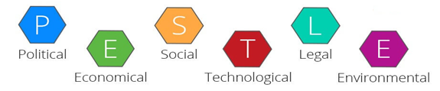
The political environment has some serious impact on the electric vehicle of Europe as the government of the UK and other developed countries such as German and Sweden has taken strict rule and regulations for environment safety. The use of petroleum and gasoline highly emit CO₂ and other dangerous chemical and impact on the bio-diversity. So, the electric powertrain gets the priority as its environment-friendly (Morrison, 2016). The regional government including Scotland, Ireland, Netherlands, Wales and London impact on business planning with their ideologies and policies.
The economy is another major force of business environment where taxation rules are set as progressive or regressive based on the economic condition. As the Electric power is global demand and can be reproduced using the natural source, the government allow the manufacturer to get some financial investment and facilities in this sector. The manufacturer of the electric car easily controls their internal factor to satisfy their stakeholder and increase the sale which contributes to the national economy (Schlesinger, 2014). Volvo is determined to serve more electric powertrain as the demand is rising and the customers are interested in this industry which increase economic growth.
Social forces are the belief and culture of the people living in a specific society or in a specific market where people are interested in their specific range of product or service. The European Union is one kind of market or society where member countries are well developed and aware of technological impact on their life (Schuetzle and Glaze, 2018). Most people of the European countries are aware of the environmental problem which increases the demands of the electric vehicle rather than conventional vehicles. The low pollution levels and the interest to the latest technology are the main concern of them which undoubtedly create a future of EV industry in Europe.
Technological innovation and implications are the keys to move forward to the electrifying the core system of the modern vehicle. The companies are installing a solar charging station in a different area to make their car get their power when they ran out of battery. The momentum to use EV are increasing from both the customer and the manufacturer as the technology is getting cheaper day by day (Kassi and Kapoor, 2015). Automotive industries are trying to utilise the natural sources such as air and sunlight to avail the recharge power which reduces the fuel cost and ensure environmental safety. So, technological evolution is highly affecting to change the powertrain of the automotive industry.
Legal forces mean the existing laws and regulation to certain business which affect the business operation on the specific region. There are acts regarding human rights, employees benefit and environment safety which has to maintain by the automotive industry to keep the impact nominal. The electric vehicle should depend on the natural sources rather than fossil fuel generator to reduce the negative impact. Otherwise, the industry won’t get any legal future (Westney, 2011).
Environmental forces are mainly those factors which impact on the environment and business organisation are liable for those impacts (Toensmeler, 2011). As the electric vehicles have fewer emissions and positive impact on the environmental, the impact of this industry is limited and consumer are preferred these cars instead of conventional ones. To avoid an adverse impact on global warming, the industry must consider not to use fossil fuel to generate its electricity.
All these main forces from up the shape of the environment for the electric car industry where the manufacturers, government and other stakeholders are interlinked to support the operation in business sectors (Worthington, Britton and Thompson, 2018). The structure of the electric vehicle industry has developed in the last few years and it is getting cheaper day by day as the technological innovation occurs rapidly.
The growth of electric mobility is increasing as the initial phase has already reached significant success in Europe. In the last few years, Volvo has developed many electric components according to their plan and now ready to step forward with its electric powertrain to implement in vehicles. The company has already announced that it will bring the Internal Combustion Engine to the core of the vehicle and electrify all its components to deliver full mobility support in electric vehicles from 2019 which has already begun. In addition to it, Tesla has developed power-efficient cars and heavy truck and started imported to many European countries (Helmers and Marx, 2017).
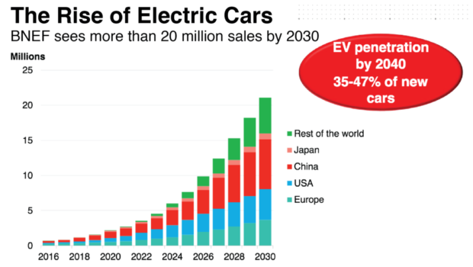
According to the previous report of McKinsey & Company back in 2016, the future of the electric vehicle was full of potential and bright future. It was estimated that the EV penetration in the future market will be more than £20 million by 2040 where 35-47% will be new cars. The present result of this estimation is far greater as the customers are already enjoying these cars and looking forward to implementing electric motors in all types of public transports too. The contribution of Europe market in the global economy is more than 25% in the rise of electric cars as most of the popular car manufacturer is in Europe (McKinsey & Company, 2019). The future of electric vehicle can be found if we analyse these key reasons given below:
Rapid Technological Evolution: Many car manufacturers are successful in making high-density efficient battery which increases the potentials of Electric vehicle. These innovative EVs and powertrain in automotive industries are also reducing price which increases the affordability.
Emerging market and Evolution of Money: Money becomes flexible in the transaction by creating virtual value where any company can create its own cryptocurrency in this modern ear (Morrison, 2016). This allows the stakeholder from a foreign country to easily participate and make a transaction which influences in EV industries to expand in merging market.
Globalisation and Trade Paradox: The whole world now seems smaller and anyone can find anything using the internet (Westney, 2011). The electric components are easy to import and export under the international market and manufacturer utilise their products with the touch of technology. The trade is now beyond the national border and anyone can enjoy the latest invention from any corner of the world as the trade paradox is eliminated in the global business environment.
Environmental safety: The demand for an electric vehicle is increasing due to global warming issue where electric vehicle uses electric motors and manufacture build their solar charging station to recharge the batteries of EVs. It does not emit any dangerous elements like CO₂ in the atmosphere and help the environment reduce global warming where fossil fuel burn generates a tremendous emission (Schlesinger, 2014).
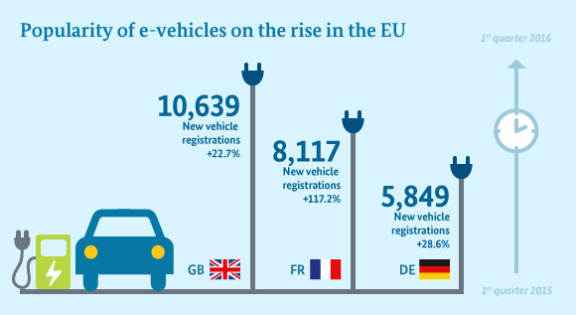
All these reasons are highlighted by the environment analyst and people are aware of environmental pollution. Hence, the adverse the product which is not environment-friendly is rejected by the customer and eliminates the development of those conventional cars. Although the sales figure of EV is not big enough, the growth of support of government and stakeholders are increasing towards Electric vehicles. The emerging market for electric vehicles is increasing in Europe as the demand is increasing according to the situation (Schuetzle and Glaze, 2018).

Electric vehicles have enormous opportunities in future automotive market where car manufacturers of Europe can identify their opportunities to assess and utilise them to maximise the market share. Though German, Netherlands and Sweden have started selling Battery Electric Vehicles (BEVs) since 2013, the sales amount was very small in the last few years. Recently these countries started manufacturing electric cars and the demands for these EVs are increasing worldwide (Schlesinger, 2014). Norway has reached 12% sales of EVs last years and started designing their Electric Truck which will penetrate in the heavy vehicle market very soon. As the mutual support from both government and customers are increasing for the EV industry, it will go beyond the hype of electric cars and achieve its maturity in the automotive industry within the next few years. But the opportunities for Electric Vehicles are not limited within the production and selling only, there are a number of new and emerging business opportunities inf this sector. Porter’s five forces framework is used to identify the opportunities along with rival competitions and other barriers in this automotive industry:
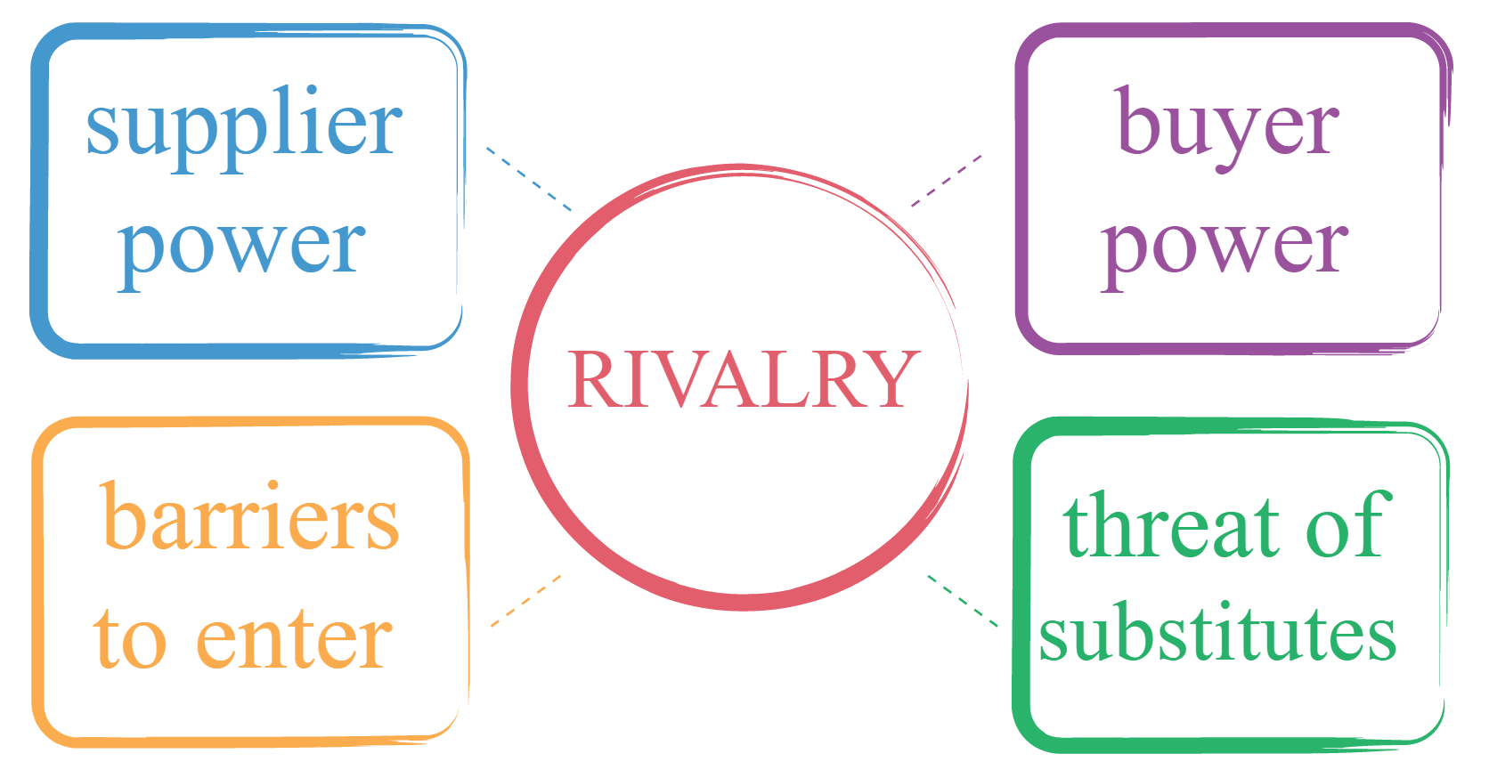
The first force is customer bargaining power where the potential customers engage themselves in pricing to determine a selling price. As the electric vehicle industry has several manufacturers in Europe, the customer will bargain if there are any options allowed for them (Helmers and Marx, 2017). The pricing of electric vehicles is generally lower compared to conventional vehicles as the government put off a certain amount of money to produce and buy the vehicle without paying any tax.
The second force is the bargaining power of suppliers where EV manufacturer will demand their price and present the advantages of their vehicles (Johnson et al., 2017). This power is weak and there is less benefit for the industry as they have to maintain some formal procedure for pricing their vehicles. In this part, suppliers of the electric component such as battery and Internal Combustion Engine will be countable too. There are some opportunities for the supplier like selling their components.
The third power is the market entrance where the company need a huge amount of investment to enter the vehicle market. As the initial investment and long-term cost are huge, the possibilities of the market entrance are low (Kassi and Kapoor, 2015). This creates s opportunities for the existing manufacturer to produce more components and do a monopoly business in the market.
The force of substitute product in the car market is low to mid as there is very less manufacture in this field. The latest innovative automotive is adopted to buy the least of the company and doing there developing their business to attract the customer (Kassi and Kapoor, 2015). But the other manufacture may invest in this sector which slightly increases the risk. There are some both opportunities and disadvantages for the customer in the electric vehicle industry.
The completive rivalry in the electric vehicle is very high as the technology is becoming more affordable and every manufacture started developing their own electric vehicle unit which opens up more options for the customer to choose their brand. For example, Tesla is started building recharge station using solar power which may let the other competitors including Volvo do the same and increase the coemption in the electric vehicle industry (Morrison, 2016).
The analysis of porters five force has shown the competitive situation along with some opportunities in the automotive market. The marketing executive and production unit of electric vehicle industries can show some new and emerging business opportunities to attract them for investing in this sector which is explained below:
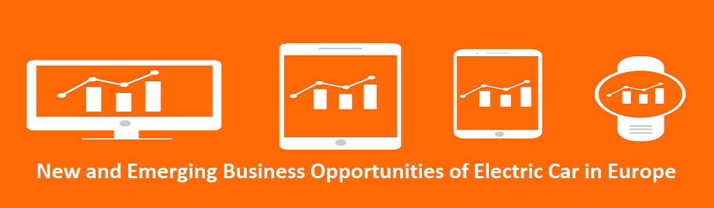
Electric car servicing garage: The structure of the electric car is different from internal combustion engine where electric batteries and motors servicing and replacement is necessary which will create another business opportunity in a different area and improve the global economy. These new opportunities will create some employment and remove social barriers along with increasing the skills for the country (Kley, Lerch and Dallinger, 2018).
EV charging station and management: The EV industries also recreate opportunities to install the charging station where the customer will be easily getting their electric car charged. These stations will need skilled people to serve the management of this station where the training centre can be built to train them. This will create another level of business opportunity for every station.
Electric Car Rental service: As the electric car is environment-friendly and emits less pollution to the air, Electric car rent station can be established. This will attract more customer to try electric vehicle for less cost as this technology are more efficient than convention cars.
Online shop for electric Spare parts: This is a great opportunity to start an online shop where different types of electric components will be available for electric cars. The car manufacturer can use Amazon or any other online service to sell their spare part or make their own online website to sell these components from where the customer will get things very easily (Schlesinger, 2014).
Solar Charging Installation Centre: Solar charging selling and installation is another great opportunity for this EV industries. The demand for solar power is high as the fossil fuels burning generates global warming (Schuetzle and Glaze, 2018). This can be used to charge the electric car and customer will love to get the station installed and charge their cars for free.
Moreover, the electric vehicle not only creates these new opportunities but also delivers some emerging business facilities. As the European countries already launched these electric vehicles and planning for mobilising the whole transport system to be electrified, there are huge business opportunities for the industries. If the marketing executive can present these opportunities, the stakeholders and investor will come forward to this EV industries to make a future proof business model and contribute to the economy of Europe (Toensmeler, 2011).
The success of electric vehicle may eliminate the business model of conventional powertrain such as ICE if enough electric power is generated from nature. Thousands of people who are working on the current garage or workshop may lose their job as those will be unusable in the long run business. The petroleum industry may fall down due and some countries may lose their huge portion of GDP from the fuel sector (Worthington, Britton and Thompson, 2018). Moreover, the whole conventional automotive industry will fall down if the electric car finds its ultimate future. So, to avoid these critical issues, the government of the country should seek an alternative source of energy and recreate their human skill by proving proper training which will help them face these critical issues.

Conclusion
The continuous improvement of technological evaluation bringing the efficient system for electric vehicle and reduce the dependency from the traditional combustions engine which uses fossil fuels to power the vehicle. The innovative electric vehicle is developed and entered into the market in the last few years. The necessity of electric car is increasing as global warming is becoming a global environmental issue. So, the car manufacturer of European countries highly concerned about these industries to bring more efficient and effective technology which will bring mobility to this sector and reduce the usage of fossil fuel from the transportation system. But the middle east countries have to look forward to an alternative source of their primary income as the conventional power train is decreasing its necessity (Schlesinger, 2014). This essay has addressed the primary forces of the EV industry and potential opportunities in this sector along with the critical issue of conventional powertrain which is interlinked with the automotive industry.

References
- Helmers, E. and Marx, P. (2017). Electric Vehicles: technical characteristics and environmental impacts. Environmental Sciences Europe, 24(1).
- Johnson, G., Whittington, R., Scholes, K., Angwin, D. and Regner, P. (2017). Exploring Strategy: Text and Cases. 11th ed. London Education: Pearson.
- Kassi, T. and Kapoor, R. (2015). Technological innovation strategies in the EVs industries. International Journal of Business Innovation and Research, 4(5), p.391.
- Kley, F., Lerch, C. and Dallinger, D. (2018). New business models for electric cars: New and Emerging business opportunities. Energy Policy, 39(6), pp.3392-3403.
- McKinsey & Company. (2019). McKinsey & Company. [online] Available at: https://www.mckinsey.com/ [Accessed 5 Aug. 2019].
- Morrison, J. (2016). The Global Business Environment Challenges and Responsibilities. 4th ed. Palgrave.
- Schlesinger, B. (2014). Electric Vehicles: Electric Vehicles May Reduce Oil Imports. Natural Gas & Electricity, 30(8), pp.18-22.
- Schuetzle, D. and Glaze, W. (2018). The automotive industry and the global environment. 9th ed. Warrendale, Pa.: Society of Automotive Engineers, Inc.
- Toensmeler, P. (2011). The EVs Industry Trends: Emerging Opportunities. Electric Engineering, 67(5), pp.10-16.
- Westney, D. (2011). Global strategy and global business environment: changing models of the global business environment. Global Strategy Journal, 1(3-4), pp.377-381.
- Worthington, I., Britton, C. and Thompson, E. (2018). The business environment. 11th ed. Harlow: Pearson.

