Hamza Omar Sbeitan
Student I.D. p143571
Dissertation Proposal
Keywords:
- Counter ideology (One man’s terrorist is another man’s freedom fighter.)
- Perspective
- Media

How does the media control our perception of who is a terrorist and how does this affect the status of the Palestinian People?

Context
The primary focus of my proposed dissertation is the media’s ability to influence and to some extent, control our perception of who is a terrorist. Special focus will be on the Palestinian people, who for the past 7 decades have suffered the ‘stigma’ of being classified as ‘terrorists’ by the state of Israel. The state of Israel uses the media to perpetuate this idea, and many Israeli citizens have grown up with the notion that all Palestinians are terrorists, simply because they exist. The dissertation will also address how the media can be biased even in its use of images. Photojournalism will be examined to determine its role in the situation.
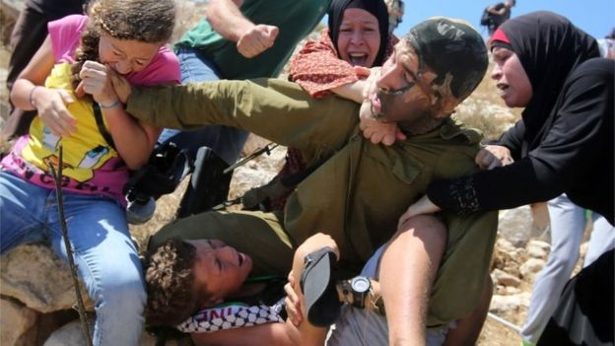
First keyword – Counter- ideology
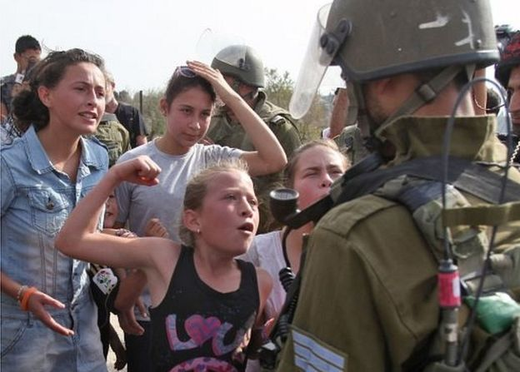

Image 1 (Knell 2018) Image 2 (Knell 2018)

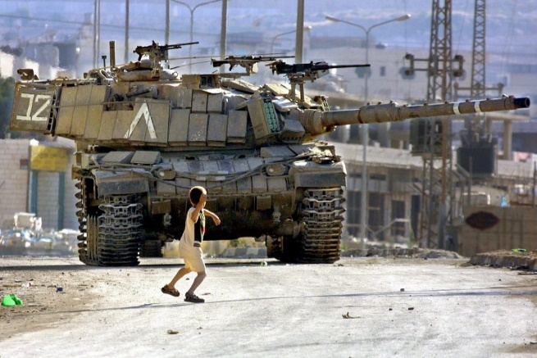
Image 3 (reddit.com n.d)

The first keyword, to be explored in my dissertation is counter-ideology; it will be examined in the context of ‘One man’s terrorist is another man’s freedom fighter’. A brief history of the Palestinian/Israeli conflict will be given for the purpose of context only, using the biography of King Hussein of Jordan, ‘The Lion of Jordan’ by Avi Shreim. Avi Shreim is a Fellow of St Antony's College and a Professor of International Relations at the University of Oxford. I will use this source to provide an Israeli perspective of the Palestinian/Israeli conflict in order to avoid bias, since being of Palestinian heritage, I wish to avoid bias.

Reference will be made to the images of Ahed Tamimi (Images 1 + 2), the 17-year-old Palestinian girl who was jailed by the Israeli army because she slapped an Israeli soldier who was outside her house. Reference will also be made to the young Palestinian boy seen throwing a rock at an Israeli tank (Image 3). The discussion about these images will be to determine whether these are images of ‘terrorists’ or ‘freedom fighters’. A brief background for each image will be presented in order to understand the context of the photograph. (The images will be referred to again in the section on the second keyword – perception).

The main focus of this section will be discussing counter-ideology in the context of ‘One man’s terrorist is another man’s freedom fighter’ with the main resource being referred to, the paper by Professor Boaz Ganor, ‘Defining Terrorism – Is One Man’s Terrorist Another Man’s Freedom Fighter?’ This paper has been chosen because it is written by an Israeli Professor; “Prof. Boaz is the Dean and the Ronald Lauder Chair for Counter-Terrorism at the Lauder School of Government, Diplomacy & Strategy, as well as the Founder and Executive Director of the International Institute for Counter-Terrorism (ICT), at the Interdisciplinary Center (IDC), Herzliya, Israel.” (create.usc n.d.)

I believe it is a good idea to use Professor Ganor as the main ‘thinker’ in this section of my dissertation, since it will provide a balanced argument when determining how representatives of the Palestinian people, (Palestinian Liberation Organization – PLO, Palestinian Liberation Front, PLF and Hamas) are viewed by the Israeli government and many others, as terrorist groups. While Professor Ganor stresses that it is very difficult to give one, clear definition of terrorism, I will be using the words of the Israeli professor himself, to build a case against the Israeli government, that can, according to some of the various definitions for terrorism put forward by the professor, be considered a ‘terrorist’ group.

The section will also discuss the difference between a ‘terrorist’ and a freedom fighter,
using Dr. Jerome Slater’s paper for the Middle East Policy Council, ‘Terrorism and the Israeli-Palestinian Conflict’. “Dr. Slater is professor emeritus of political science and a university research scholar at the State University of New York at Buffalo.” (mepc.org n.d.) The paper by Dr. Slater will help in determining the difference between a ‘terrorist’ and a ‘freedom fighter’. The paper discusses ‘just cause’ stating that, “the Palestinians have the right (just cause) to freedom, independence and an end to Israeli occupation and repression.” (Slater n.d)

I will also refer briefly to the book by Susan Sontag, ‘Regarding the Pain of Others’ in this section, particularly chapters 5 and 7, which discuss the relationship between the camera and its subject and a reminder to readers of what it means to view images of cruelty, respectively. The same book and writer will be focused on in depth in the next 2 sections of my dissertation.

By the end of this section I hope to conclude that the Palestinian people are often dealt with harshly in terms of ‘one man’s terrorist is another man’s freedom fighter’ and that when classifying the actions of people like Ahed Tamimi, the context of the action is often overlooked.

Second key word – Perception

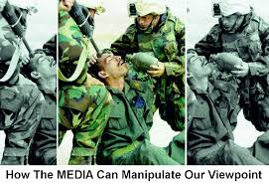

Image 4. (while-you-were-sleeping.com 2014)

This section of my dissertation will include a reference to image 4, to demonstrate how images are presented to us in a way that influences how we perceive a situation. We know that to understand a situation we need to ‘see’ the full picture. We cannot gain a clear understanding of any situation by looking at just one side of the ‘picture’. Image 4 demonstrates the potential for the media to control our perception of any given situation, by manipulating images to reflect what they want us to ‘see’. The full image allows for understanding of the situation, however, the image, when viewed from just one side can present 2 very conflicting ideas. Reference will also be made to images 2 and 3, to discuss the focus of each image and how they may be perceived.
The main source of reference for this section will be Susan Sontag’s book, ‘Regarding the Pain of Others’ and the writer herself will be used as the key – thinker. Susan Sontag, who died in December, 2004 was an American writer, filmmaker, and political activist. I will be relying heavily on chapters 2 and 3 from the book in this section, to build on the argument that the media influences how we perceive situations. Chapter 2 discusses how we perceive images of atrocities that occur far away. Sontag states that mass media has the ability to bring such images right into our homes, but without showing the complexity of the event in question. She points out that the meaning of a photograph is based on how it is perceived by the viewer. (Sontag 2003)
In Chapter 3, Sontag points out that a photograph’s meaning is understood through context and experience. In the absence of context, the viewer will interpret the image from their own perspective.
In her book, Sontag looks into the way war is perceived, while taking into account contributory factors such as culture, status and gender. She argues that imagery of war is open to interpretation and manipulation. She argues that war imagery is open to both interpretation and manipulation. (Sontag 2003)
Sontag believes that the meaning of a photo is based on interpretation, which may be formed of ignorance. She argues that, “Images make events seem "real" to viewers, even as they seem "unreal" in their similarity to art. Images, however, have impeccable veracity to the human mind, representing as they do the basis of empirical truth. Sontag reminds the reader, however, that images are first filtered through image-takers.” (bookrags.com n.d.) This argument backs up what I am trying to prove through my dissertation and will be expanded upon.
I will also refer briefly to an online article, The Fifth Estate – Citizenship Journalism, to explain Image 4. This online article will be referred to again in the next section of my dissertation.
By the end of this section of my dissertation, I hope to establish that it is crucial to understand the context of an image before formulating any opinions.

Third key-word: Media
The final key-word for my dissertation is – Media. In this section I will be examining the role of the media in the context of my research question. I will be looking into the moral role of the media and discussing the responsibility of the media when presenting images. I will be talking about the different forms of media and how the media today, has the ability to deliver ‘the news’ as it is happening.
I will also be looking into the issue of ‘freedom of the press’ to establish again, that with freedom comes responsibility. Too often, bias is involved when reporting news and I will be looking at how this affects the Palestinian people. I will try to establish if bias is involved in western media’s portrayal of the Palestinian/Israeli conflict and work back to the source of the bias. I will examine if there is any truth to the rumour that the media is mostly owned by Jews.
I will touch briefly on the article ‘The Fifth Estate-Citizenship Journalism’ to establish an American (western) view on the role of the media.
The main focus of this section will be chapter 8 of Susan Sontag’s book, Regarding the Pain of Others, which deals with the media. In chapter 8, Sontag examines the way that the media guides (influences) public opinion, particularly in its choice of what it covers. Sontag will also be focused on as the key-thinker for this section
I will give examples of how the media has influenced people’s perception of events in the past, with particular focus on the case of Menachem Begin. Menachem Begin was elected as the 6th Prime Minister of Israel in 1977 and was welcomed as the country’s leader in all western countries. However, in the 1940’s, the same Menachem Begin was the leader of the Zionist militant group, the ‘Irgun’ - and considered as a ‘terrorist’. He was on the ‘most wanted’ list in Palestine and the British MI5 offered a 10,000 Pound reward – dead or alive, for the capture of Begin. This information will be included to show how the media can play a role in ‘white-washing’ a situation.
By the end of this section, I hope to have established the role of the media in presenting news and connect to how the media has the ability to influence our perception of situations.
Contextualization
The subject of the plight of the Palestinian people is very personal to me since I am of Palestinian descent. It has always struck me that the Palestinians do not appear to get a ‘fair deal’ when it comes to the media. I don’t want bias to creep into my dissertation, but through my dissertation paper, I will examine whether there is a link between media reporting of the Palestinians and media ownership, i.e. whether the media is owned by a Jewish majority.
Obviously, as a Palestinian, I find it difficult to accept that the Palestinians are ‘terrorists’ for fighting for their basic rights, when they are living under occupation. However, for the purpose of my dissertation, I will abide by the consensus of opinion of what constitutes a ‘terrorist’, when discussing the Palestinians, to establish whether Palestinians are ‘freedom fighters of terrorists (counter-ideology)
Ultimately, my dissertation will explore the role of the media in propagating the belief (of some people) that Palestinians are terrorists.
I realize that I need to do a lot more reading for my dissertation to be able to ‘stand’ as a comprehensive research on the subject of the media’s control of how we perceive situations. However, since the subject is very personal to me, I fully intend to read a plethora of texts on the subject in order to help me be prepared for my dissertation next year.

References
Books
Shlaim A, (2008) Lion of Jordan. The Life of King Hussein in War and Peace,

Sontag S, (2003) Regarding the Pain of Others, New York, Farrar, Straus and Giroux

Articles
Ganor B, (2010) Defining Terrorism – Is One Man’s Terrorist Another Man’s Freedom Fighter? (online) Available at: https://www.ict.org.il/Article/1123/Defining-Terrorism-Is-One-Mans-Terrorist-Another-Mans-Freedom-Fighter#gsc.tab=0: (Accessed on 01/05/2019)

Slater J, (n.d) Terrorism and the Israeli-Palestinian Conflict, Volume XXll, Number 3: (online): Available at: https://www.mepc.org/terrorism-and-israeli-palestinian-conflict: (Accessed on 01/05/2019)

While-you-were-sleeping-com (2014) The Fifth Estate – Citizenship Journalism Available at: https://while-you-were-sleeping.com/2014/12/07/the-fifth-estate-citizenship-journalism: (Accessed on 03/05/2019)

News reports
Knell Y, (2018) Ahed Tamimi: Spotlight turns on Palestinian viral slap video teen, (online): Available at: https://www.bbc.com/news/world-middle-east-42612666: (Accessed on 10/05/2019)

Websites
Bookrags.com (n.d) http://www.bookrags.com/studyguide-regarding-the-pain-of-others/#gsc.tab=0 (Accessed on 13/05/2019)
Create.usc (n.d) https://create.usc.edu/boaz-ganor (online) Accessed on 01/05/2019

Reddit.com(n.d)https://www.reddit.com/r/pics/comments/6onu5m/palestinian_child_throwing_a_rock_at_an_israeli: (Accessed on 01/05/2019)

