Material Science / Structural Appreciation, Science & Materials – Joel Williams 1708430

This paper attempts to review the Unite d’habitation of Marseille a concrete building in France and the 122 Leadenhall a steel building located in London. The paper will discuss the design planning, construction and potential impact in sustainability at the build. The paper will also discuss the durability, climate resistance and likely impact of the frames materials original production process to the environment of both structures. Finally, the ease of assembly and the potential ease of its adaption to different building shapes and use within the life cycle of the building.
The Unite d’habitation of Marseille is home to 337 apartments, a hotel and a rooftop terrace and was designed by Le Corbusier. Due to the mass destruction during world war II, people needed housing immediately and so the Unite d’habitation was constructed. The building was designed 56 meters high,140 meters long and 24 meters wide. The building is based on one block and raised on free standing pillars. This allows for the whole ground space to be allocated for gardens and leisure with the reinforced concrete structure acting like a shelf over the top. The building was designed to allow great permeability at ground level to be a communication space between the exterior and interior. During the design planning, it was decided that interlocking two apartments to the central access corridor meant more living space. The top two floors were designed to be shopping streets and the rooftop space was allocated for a leisure complex. Le Corbusier formed his buildings such as the Unite d’habitation sculpturally, generously coloured with tapestries and paintings became an important part to the architecture. He designed the building to not only provide accommodation but a place for people to relax.
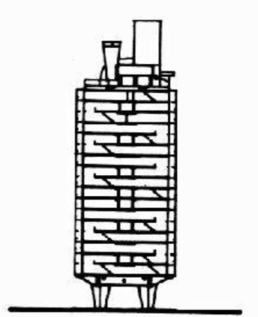
(Andrew Kroll, 2010)

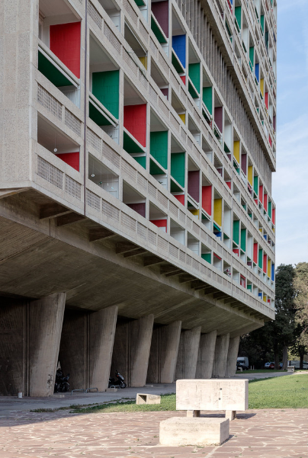 (Andrew Kroll, 2010)

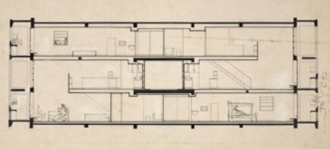
Apartment Section Photo (Amy Frearson. 2014)

The building is constructed of reinforced concrete with a visible coating and glass. During the construction, Le Corbusier originally planned to use steel for the Unite, however beton brut concrete was used due to the low cost of the material. The precast concrete was manufactured offsite and then delivered and slotted into place being used for the walls and balconies. Beton brut concrete was used as an insitu concrete for the exterior and the creamy white concrete came from the pale limestone aggregates used from the local town. A large panel system was used for most of the precast concrete and once assembled would resist gravity load. When the horizontal roof and floor panels are joined together either as one way or two way, they would then act as diaphragms that would transfer the lateral loads to the walls (Sitapatel, 2016). Each apartment inside the building consists of two floors and an internal staircase. The living room is the height of both floors, 4.8 metres with a large floor to ceiling window of 3.66 x 4.8 metres giving full view of the picturesque scenery outside (Sitapatel, 2016).
Reinforced concrete is a sustainable material, however does need service inspections and repairs overtime. Concrete defects include heavy weathering and spalling, with some of the worse defects being water to the heart of the steel reinforcement and fractures. To maintain the concrete over a long period, defects need to be located and repaired. If these defects are not located and repaired, then overtime the defect will deteriorate and fail potentially causing collapse to the building. With 337 apartments and shops requiring heating and hot water, this brings a negative effect on the building being sustainable for the future. 72% of domestic emissions arise from space heating and the provision of hot water (Design Buildings. 2018).
Reinforced concrete is one of the strongest materials used compared to other building materials. Being strong makes it durable and allows the material to last for many years providing it has been mixed correctly. Reinforced concrete is the primary material used in the construction of the Unite d’habitation meaning the building is able to withstanding wear, damage and pressure. Drastic changes in weather such as high winds will not affect the building due to the strength of the material, however if water gains access through the concrete to the steel reinforcement the concrete will be weakened. Wood, metal, and many other materials can’t handle the same temperatures as reinforced concrete without catching fire or deteriorating making it fire resistant material (MERLO CONSTRUCTION, 2017).
Concrete is made up of around 12% cement and 80% aggregate by mass. The production of cement alone in the makeup of concrete adds a considerable amount of carbon dioxide into the atmosphere. Materials such as clay, limestone and coal causes huge deforestation of trees. The mining, processing, and transport operations involving such large quantities of aggregate consume considerable amounts of energy, and adversely affects the ecology of forested areas and riverbeds (Mehta, 2001). The production of concrete uses a huge amount of water, however other chemicals and materials are also added to the mix needing a large input of energy. The main source of energy for the production are fossil fuels which have a negative effect on the environment causing global warming. Although the creamy white concrete came from the pale limestone aggregates used from the local town, decreasing some of the transportation time. Due to the size of the building and the amount of concrete needed for the construction the materials original production would have had a negative impact on the environment due to the amount of energy and fossil fuels needed to be used.
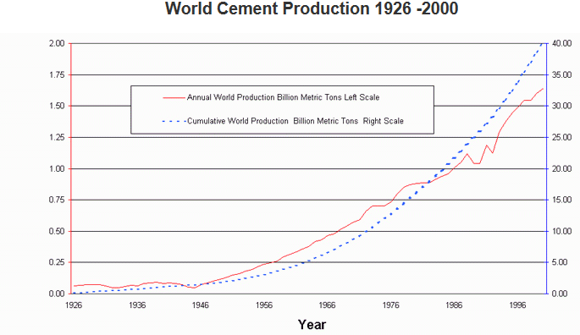
(GreenSpec, 2019)

Construction of the building began in year 1951 and was planned to be finished just a year after construction began. Unfortunately, due to lack of money being effected from world war II, the building took five years before the construction was completed. Even though the time schedule did not go as planned, no problems arose during the construction as the concrete simply slotted into place. What makes this building unique to other buildings is the flat roof design having a leisure complex and the internal shops and educational facilities inside the building. Changing the building in future times would be difficult. The strict grid, framed by thick sound-proofed walls, means that reconfiguring layouts is largely impossible, but the designers can entirely restyle the space (Amy Frearson, 2014). Changing the shape of the building would result in a huge amount of work and money with possible having to replace the old building completely and designing a new building using different materials.
The Leadenhall building is a 225m tall steel frame building located in city of London and was designed by Rodgers Stirk Harbour and Partners. The main feature of the Leadenhall is its distinctive tapering shape, angled at 10 degrees in order to protect the sight of the nearby St Paul’s Cathedral dome (Design Build Network. (n.d).). The building was designed using multidimensional building information modelling (BIM), The virtual construction approach allowed the client to visualise the building before construction and the solutions needed for the planning permission and any problems discovered. During the design, it was planned that the ground level of the building would be used as a public area and while the south side would be containing the mega frame, the north core would be home to the building services.
The construction of the Leadenhall hall started in the year 2011 and came to completion in 2014. Majority of the components had to be prefabricated offsite and then delivered, due to the construction site being based in London meaning limited space for the works. A 32-ton crane was used, along with two brand new cranes built especially for the project to move a total 18000 tons of steel used for the building. Engineers used BIM as it gave detailed information on every component used during each step of the build. Unlike most tall buildings which use a concrete core to provide stability, the Leadenhall uses a steel mega frame. It is divided into eight sections, each 28 meters high and comprising seven floors (Laing O’Rourke, 2016). The steel beams and columns were connected using nodes while almost 3000 mega bolts connected all the steel components together. Each floor to ceiling has a height of 2.75 meters which was achieved within every 4-meter-high office story. This consisted of 150mm concrete slab laid over 700mm steel beams and the floor raised to 150mm. The building was predicted to move towards the north so had to be constructed off the vertical known as active alignment – tensioning the steel beams along the sloping face to pull the structure back to the vertical (Laing O’Rourke, 2016).

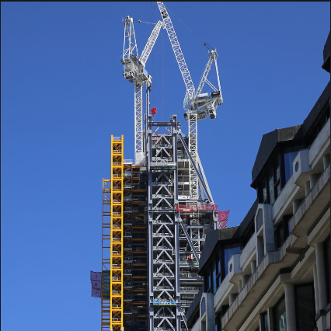
(Vandoorn, 2013)

The Leadenhall building uses a triple glass layer with the outer layer being separate from the inner layer of double-glazing by a cavity containing blinds that
respond to the sun’s movement. This helps keep the office space comfortably cool while having vents every seventeen floors meaning no need for artificial cooling. The building has been built to be sustainable for the future by using energy efficient lighting, reducing waste through design including prefabrication where possible and reducing carbon emission by 35% under building regulations.
Steel is a material which corrodes overtime and is effected by fire more so than other materials by bending and causing displacement to the steel element. However, the Leadenhall steelwork is corrosion and fire protected giving the building the ability to withstand this damage. In external areas, epoxy intumescent coatings are employed for durability (SteelConstruction.org,2017) and the nuts and bolts have been preserved by placing cast intumescent caps over the ends of the mega frame.
More than 80% of the elements had been prefabricated off site, such as the mega frame. The mega frame used was made in Scotland, Northern Ireland and Northern England. Using external manufactures means the building process is more accurate, safer and less wasteful. This method has a positive effect on the environment reducing waste sent to landfills. London is a very busy city occupied with around 8 million people so building a tall building is a difficult task. The majority of the work on the Leadenhall building had to be completed during the night, giving little disruption to the public as possible. Getting the various elements to the site using vehicles such as lorries has a negative effect on the environment. These negative effects come from exhausts emitting a wide range of gases causing acid rain and global warming. Using steel over concrete as the primary element used for the building is better for the environment as it needs less energy, produces less waste and air pollution.

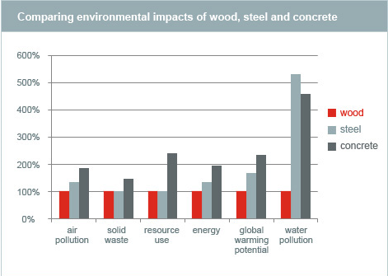
(Canfor, 2017)

Building information modelling (BIM) made the assembly of the frame less time consuming and more accurate. Using this technology meant engineers and builders had accurate information and measurements of how to construct the building which in turn lowered the risk of mistakes and problems that could arise. However, the construction on the Leadenhall building didn’t come without its problems. During the construction two bolts snapped leaving debris falling to the ground and another tethering away. The reason for the replacement was that they were suspected of suffering from “hydrogen embrittlement”, a process that lowers the ductility of fasteners (David Rodgers, 2015). Another problem arose by the building reflecting light from its south facing concave facade, causing damage to nearby cars and shops. Solving the problem meant having to cover the glass with non-reflective film to prevent any further damage being causes. While a crane was lifting a steel beam up into place, the beam smashed a neighboring window of the Leadenhall building. Fortunately, no injuries occurred during this incident and the damaged window was replaced. The nickname of the 225m tall building is known as the Cheese Grater due to its slanting profile. This slanting profile gives the 122 Leadenhall building its definitive feature, with majority of buildings taking a rectangular form. Future adaptation to the building will be difficult due to the protective view of St Paul’s Cathedral. Further planning permission will be required for any adaptations to the building and won’t come without a high cost.

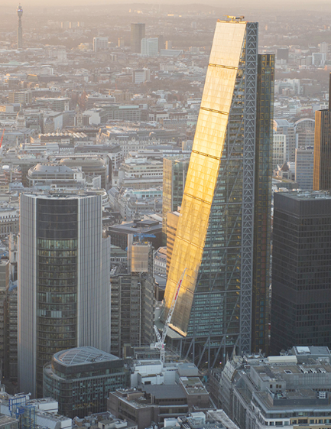
(The Leadenhall Building City of London, 2015)

References.
Unite d'habitation of Marseille - Data, Photos & Plans. 2019. Unite d’habitation of Marseille. [ONLINE] Available at: https://en.wikiarquitectura.com/building/unite-dhabitation-of-marseille/. [Accessed 3 January 2019].
Sitapatel, (2016). Unite D'Habitation of Marseille. Available: https://sitapatel.weebly.com/materials-and-structure/unite-dhabitation-of-marseille. Last accessed 04/01/19.
Andrew Kroll, (2010), Greatbuildings.com [ONLINE]. Available at: https://www.archdaily.com/85971/ad-classics-unite-d-habitation-le-corbusier/5037e7be28ba0d599b0003ad-ad-classics-unite-d-habitation-le-corbusier-section [Accessed 4 January 2019].
Sitapatel, (2016). Unite D'Habitation of Marseille. Available: https://sitapatel.weebly.com/materials-and-structure/unite-dhabitation-of-marseille. Last accessed 04/01/19
Design Buildings. 2018. Sustainability in building design and construction. [ONLINE] Available at: https://www.designingbuildings.co.uk/wiki/Sustainability_in_building_design_and_construction. [Accessed 4 January 2019].
MERLO CONSTRUCTION. 2017. Advantages and Disadvantages of Reinforced Concrete. [ONLINE] Available at: https://www.merloconstructionmi.com/advantages-disadvantages-reinforced-concrete/. [Accessed 4 January 2019].
MEHTA, P., 2001. Reducing the Environmental Impact of Concrete. 1st ed. Farmington Hills: Concrete International. P.,62.
GreenSpec, (2019), World Cement Production [ONLINE]. Available at: http://www.greenspec.co.uk/building-design/environmental-impacts-of-concrete/ [Accessed 6 January 2019].
Amy Frearson. 2014. Brutalist buildings: Unité d'Habitation, Marseille by Le Corbusier. [ONLINE] Available at: https://www.dezeen.com/2014/09/15/le-corbusier-unite-d-habitation-cite-radieuse-marseille-brutalist-architecture/. [Accessed 5 January 2019].
Design Build Network. (n.d). The Leadenhall Building, London. [ONLINE] Available at: https://www.designbuild-network.com/projects/-the-leadenhall-building-london-uk/. [Accessed 5 January 2019].
LAING O'ROURKE. 2016. The Leadenhall Building. London. UK. [ONLINE] Available at: http://www.laingorourke.com/our-projects/all-projects/the-leadenhall-building.aspx. [Accessed 5 January 2019].
Vandoorn, (2013), Vandoorn Tower Crane [ONLINE]. Available at: https://vandoorntcc.co.uk/project/leadenhall-building-london/ [Accessed 6 January 2019].
SteelConstruction.org. 2017. The Leadenhall Building, London. [ONLINE] Available at: https://www.steelconstruction.org/design-awards/2017/award/the-leadenhall-building-london/. [Accessed 6 January 2019].
Canfor, (2017), Comparing environmental impacts of wood, steel and concrete [ONLINE]. Available at: https://www.canfor.com/responsibility/why-wood/comparing-wood-and-non-renewable-materials [Accessed 6 January 2019].
David Rodgers. 2015. Global Construction Review. [ONLINE] Available at: http://www.globalconstructionreview.com/news/fear-failure-why-bolts-londons-che8es8e8gr8a8t8er/. [Accessed 6 January 2019].
The Leadenhall Building City of London, (2015), The Leadenhall Building [ONLINE]. Available at: https://www.theleadenhallbuilding.com/galleries/air/ [Accessed 6 January 2019].

