ACBA5000/ACBA5007

Modern and traditional construction

Case study

Liam Morgan 1806324

Deadline: 09/1/2020

Word count: 2329

Table of Contents
Introduction 3
Excavation to be carried out 3
Equipment Needed for Project 4
Backhoes 4
Dump Trucks 4
Pumps and Dewatering Equipment 4
Multi-Purpose Excavator 4
Sheet Piling Equipment 5
Crane 5
Welding 5
Ventilation 5
Site Layout 5
Basement Construction 6
Façade 7
Conclusion 8
References 9
Appendix 11
Appendix 1 11
Appendix 2 11
Appendix 3 12
Appendix 4 13
Appendix 5 14
Appendix 6 15
Bibliography 16

Introduction
This assignment will act as a report on the construction of a 20-storey high-rise building with a three-floor basement carpark to be constructed underneath. It will cover:
- The Excavation process and give description of the site layout that will be used to carry out the construction.
- The type of retaining wall needed for the project due to the high-water table and location near the sea with high risk of floods. It will cover the foundations needed for the building.
- Appropriate drainage required from temporary to permanent.
- The report will also give details of the equipment needed to complete this project and techniques that will be used.

Excavation to be carried out
For the excavation it has been decided that a top-down method will be used in the construction of basement car park. This will allow for works to begin on the superstructure whilst works for the substructure take place simultaneously. This method was successfully used on the imperial gate travel lodge hotel, Cardiff (Yandzio Bsc et al., 2001). Due to the high-water content there needs to be a watertight retaining wall made before excavating takes place. The choice was made that Larssen sheet piles will be used as a permeant retaining wall. This was due to a number of reasons.
- Cost
- Sustainability.
- Lower Risk.
- The success of other sheet pile retaining wall systems (Wong and Poh, 1999).
Before being delivered onsite the sheet piles will be coated and have sealant barriers already applied to them. These can become damaged through transport and off-loading. So, visual checks should be made before installation continues. This reduces the risk of problem later during the construction process. Before excavation begins the site will be cleared. All safety measures put in place before the installation of the sheet piles start. The site will be marked out to ensure correct and clear positioning. Due to the high boulder clay content, an impact hammer attached to the excavator will be used to hammer the sheet piles down to the required depth (Chudley and Greeno, 2016). whilst keeping vertical. This will be done using single Larssen sections and they will interlock with each other. In the event of an obstruction, then it may be necessary to drill down using the auger to help with the removal of the obstruction and making the sheet piles easier to insert and vertical (Ivor King 2017). This process will continue with the sheet piles interlocking until they have been completely installed. Once this process is completed, excavations can then begin for the first part of the basement. During the excavating it may be possible that temporary drainage will be needed, therefore pumps will be set up temporally to allow for removal for any unwanted water. This should be minimal due to the sheet piling. Due to the top down construction method the excavation will be an on-going objective however calculations to work out the amount of soil that is to be removed have been done and the excavated amount will be 10,350m³ (Zhitov, 2018) See appendix for calculations (1) This will be disposed away from site in an appropriate way. This will be done using two dumpers and an excavator these calculations can be seen in appendix. (2)

Equipment Needed for Project

Backhoes
These are small tractor like machines. They are ideal for basement construction due to the ability to go into confined small spaces.

Dump Trucks
Two dumper trucks with a 30m³ capacity will be used to remove excavation material from site. They are also used to carry materials to and from site. Using the three dumper trucks will allow the excavator to be operating continually.

Pumps and Dewatering Equipment
Due to the high-water table pumps and dewatering, equipment may be needed for temporary purposes. As a permanent solution a chamber will be placed at the basement slab behind the internal wall this will then take any water to a sump pump chamber to be pumped into the nearest drainage system.

Multi-Purpose Excavator
These are used for trenches, foundations, material handling open pit mining they also have the ability to use different attachments like a pile driver, auger, hydraulic claws, cutters and breakers. For this project a crawler excavator will be used these range between 19-24 ton these are commonly used in commercial construction due to their power and reach capabilities while their hydraulic system allows them to handle different attachments as previously stated (Lovely, 2018).

Sheet Piling Equipment
There are different types of sheet piling equipment from viratory hammers, impact hammers, hydraulic presses. The uses depend on the soil and obstructions. Vibrations can affect near buildings and roads so these factors must be taken into account. For these sheet piles we will be using impact hammer due to the clay content. This can be fitted to the excavator using the crane to lift it in place.

Crane
Is used to move heavy things around the site it also helps with installing beams, sheet piles, and façade. It is vital piece of equipment on this project. A tower crane is the choice for this project, this is because of the ability to reach 70 meters and has a lifting power of 18 metric tonne. It also has great stability (Civil today, 2020).

Welding
Welding Equipment will be needed to weld the interlocks of the sheet piling making it watertight. It will also be used in welding all kinds of materials together throughout the project.

Ventilation
During the excavation and top down construction, ventilation will be vital due to the fact that it will be underground and there will be dust, plant, welding and spraying, These are very dangerous so making sure the right ventilation and dust removal is supplied is extremely important and using the BS 6164:2011 Health and Safety in tunnelling in the construction industry (British Tunnelling, 2018) will allow the appropriate ventilation system to be put in place.

Site Layout
There will be hoarding set up around the site perimeter to provide protection for the public. It will be gated with a Gates man appointed to control access and ensure deliveries and plant vehicles do not pose a risk to the public. There will also be welfare facilities provided these will be maintained and kept to a high standard. All materials will be kept away from excavation and stored in a correct and safe place (CITB, 2017). There will be offices close to the gate to minimise the risk for visitors. All walkways will have barriers to keep plant and operatives separate. The crane will be placed away from the main area and where there is no obstruction around, for example electric cables. No unauthorised personnel will be allowed access to the site or excavation. Correct signage will be place around the site. The construction (Design and management) regulations 2015 will be adhered to at all times throughout the project (Legislation, 2015). For drawing see Appendix (3)

Basement Construction
Once all the sheet piles are in place providing a permanent retaining wall. Excavation under the roof slab will commence. Struts will then be installed to support the retaining walls. The roof slab will be made to give access to the below levels. Using plunge piles installation method these will be placed at the locations of the internal columns of the structure. Using an auger drill 1.2 diameter, reinforce concrete pile will be created. Then the concrete will be tremie and steel column’s plunged into wet concrete. This then creates a steel Column and reinforced pile foundation this is continued for all the rest of the basement columns down to the basement final slab (Eng, Mimare and Biddle Bsc, 2001). Due to the seaside location of the site and the high-water table, making the basement watertight is essential. Construction into the basement continues and the face of the sheet pile walls become available. Welding on the interlock of every sheet will be made by sealing them and giving watertight protection making sure it up to BS 8102:2009 protection of below ground structures against water from the ground (Thenbs 2015). As progress is made going deeper into the ground it will need to be well ventilated and will need dust extractors put in place to make sure it follows the regulations previously mentioned. Before the final reinforced concrete slab is made, a water and vapour proof membrane is put down to stop water penetrating up through the basement slab. Once the slab is made, it will be connected to the steel sheet by welding a steel plate between the sheet and the base creating a water bar. Hydraulic sealant is then placed on top to provide extra waterproofing. There will be a water channel made for any water that may come through the external wall and this will then be taken to a sump pump that will pump the water up to the nearest drainage system. The channel will be hidden behind the internal wall and will be a permanent fixture through the life span of the building. See details in appendix (4) There will be an accesses point for the sump pump so access can be granted for maintenance and inspection works to be carried out. Once the retaining walls have all been placed and the slabs formed an interior wall will be formed with the required drainage to allow the water to gain entry to the channels. Fire escapes will also be put in place, these will be in accordance with the building regulations Part B. The ramps will be kept within in a 5% slope. There will be two entry points put in place to make it a one-way system. The lighting will be put in following the British standards BS 5489-1:2013 design of road lighting.

Façade
A façade is very important part of the building as it gives protection against the natural elements i.e. rain, wind, cold and heat. They have been designed for many years with this function in mind. In these modern times we now rely on facades to have other functions. Some of these are to allow acceptable lighting, Control of solar gain, insulation for sound, thermal material and ventilation. There are many different materials used in the making of a façade all with their advantages and disadvantages. For this project it has been decided that a glass unitized curtain wall system will be used for this building. There where many reasons for this choice these are some of them
- The curtain wall does not carry the load of the of the structure it simply transfers horizontal loads induced by wind and gravity to the floors or columns of the building (Barrington, 2011).
- It allows natural lighting into the building this is a great benefit for human comfort levels.
- Curtain walls last longer in general due to their protective shield.
- It reduces building sway giving a better structural stability (Alexander, 2017).
- Slowing the speed of fire and stopping it going between floors this is great for high rise buildings where the risk is high.
- Double layered toughed vision glass and between the layers of glass there will be filled with gas this will help with the reduction of heat loss.
There will be better thermal efficiency of the building this will lower operation cost. Due to the majority of the work is carried out in a factory, the opening vents and infill panels have already been built into the units saving more labour time on site. Apart from the reasons listed, Other benefits such as the appearance of the building. If protected from the UV rays the buildings appearance won’t fade like other materials. This will allow the façade to look clean and new for a longer time (glassonweb, 2016). The unitized curtain wall system will be made in panels in the factory and will have to be installed using the crane. For the installation of the curtain walls, brackets are bolted to the structural frame. See appendix (5). The panels will then be lifted with the crane dropped into position leaving a gap for movement within the bracket. This is due to the curtain wall is likely to move due to wind and thermal changes. This movement will differ from the structure, so the curtain wall needs to be able to have the slight gap in the bracket to accommodate this movement (brown and Vigener, 2016). There are drainage holes placed at the bottom of each cavity this will allow water to escape through. Smaller holes are then placed at the top. This will allow air to pass through removing any excess water. For corner of facade detail see appendix. (6)

Conclusion
Having looked at so many different options that were available to use and the different techniques, the materials and process listed are the best sustainability and durability for this project. Most of the materials used will be recyclable, meaning the buildings end of life cycle can be reused for future projects. The top down method was chosen due to the success of many projects within the area. When it came to be choosing a retaining wall, steel sheet piles provide the best answer due to their ability to prevent water from entering the basement and can also be made lightweight. They are also 100% reusable, unlike a diagram wall and there is less risk involved with sheet piling compared to the other options. The pile raft foundation was chosen due to the clay soil and the size of the structure. The façade was chosen for the following positive reasons and to meet expected sustainability requirements:
- Protection from water and air moisture
- Natural lighting
- Maintenance
- Operational cost
- Thermal
- sustainability
- Durability
- Comfortability
- Cost effective
- On site or off-site manufacturing.
It is due to these that a curtain wall would be most beneficial to the project, as well as begin aesthetically pleasing and would give the building a modern and contemporary look.

References
Alexander, R. (2017). Advantages of Curtain Walls | Tom Brown Inc. [online] Tom Brown Inc. Available at: http://tombrowninc.com/blog/advantages-curtain-walls/ [Accessed 14 Jan. 2020].
Barrington, kathrine (2011). Advantages and Disadvantages of Curtain Walls | Hunker. [online] Hunker. Available at: https://www.hunker.com/12594703/advantages-and-disadvantages-of-curtain-walls [Accessed 13 Jan. 2020].
Best Practice Guidance Type B Waterproofing Systems. (2014). [online] Available at: https://www.property-care.org/wp-content/uploads/2014/12/Type-B-Guidance-FINAL2-09.16.pdf [Accessed 13 Jan. 2020].
Britishtunnelling.org.uk. (2018). The British Tunnelling Society. [online] Available at: https://www.britishtunnelling.org.uk/?sitecontentid=10AFAFD7-4FE0-48D9-9F23-D6D97C4F803D [Accessed 14 Jan. 2020].
brown, M. and Vigener, N. (2016). Curtain Walls | WBDG - Whole Building Design Guide. [online] Wbdg.org. Available at: https://www.wbdg.org/guides-specifications/building-envelope-design-guide/fenestration-systems/curtain-walls [Accessed 14 Jan. 2020].
Chudley, R. and Greeno, R. (2016). Building Construction Hanbook. 11th ed. USA and Canada: Routledge.
Citb.co.uk. (2017). CDM Regulations. [online] Available at: https://www.citb.co.uk/about-citb/partnerships-and-initiatives/construction-design-and-management-cdm-regulations/cdm-regulations/ [Accessed 14 Jan. 2020].
Civiltoday.com. (2020). Different Types of Cranes with Pros and Cons - Civil Engineering. [online] Available at: https://civiltoday.com/construction/construction-equipment/136-types-of-cranes [Accessed 14 Jan. 2020].
Eng, M., Mimare, C. and Biddle Bsc, A. (2001). Steel Intensive Basements. [online] The Steel Construction Institute. Available at: https://www.steelconstruction.info/images/1/15/SCI_P275.pdf.
glassonweb.com. (2016). How to Prevent UV Fading. [online] Available at: https://www.glassonweb.com/article/how-prevent-uv-fading [Accessed 14 Jan. 2020].
Ivor King - The Piling People. (2017). Ivor King Sheet Piling. [online] Available at: https://www.ivorking.co.uk/vibro-driving-solutions/ [Accessed 14 Jan. 2020].
Legislation.gov.uk. (2015). The Construction (Design and Management) Regulations 2015. [online] Available at: http://www.legislation.gov.uk/uksi/2015/51/regulation/22/made [Accessed 6 Jan. 2020].
Lovely, L. (2018). Compact Excavators and Their Advantages. [online] Grading and Excavating. Available at: https://www.gxcontractor.com/equipment/article/13034357/compact-excavators-and-their-advantages [Accessed 14 Jan. 2020].
Thenbs.com. (2015). REP PG 5 Piling in “Boulder Clay” and other glacial tills, CIRIA - Publication Index | NBS. [online] Available at: https://www.thenbs.com/PublicationIndex/documents/details?Pub=CIRIA&DocID=200593 [Accessed 12 Jan. 2020].
Wong, I.H. and Poh, T.Y. (1999). Comparison of retaining walls for basement construction in stiff clays. Tunnelling and Underground Space Technology, [online] 14(4), pp.461–468. Available at: https://www-sciencedirect-com.ezproxy.uwtsd.ac.uk/science/article/pii/S0886779800000080 [Accessed 12 Jan. 2020].
Yandzio Bsc, E., Eng, M., Mimare, C. and Biddle Bsc, A. (2001). Steel Intensive Basements. [online] Available at: https://www.steelconstruction.info/images/1/15/SCI_P275.pdf.
Zhitov, D. (2018). Pit excavation. [online] Zhitov.ru. Available at: http://www.zhitov.ru/en/ditch/ [Accessed 14 Jan. 2020].

Appendix

Appendix 1
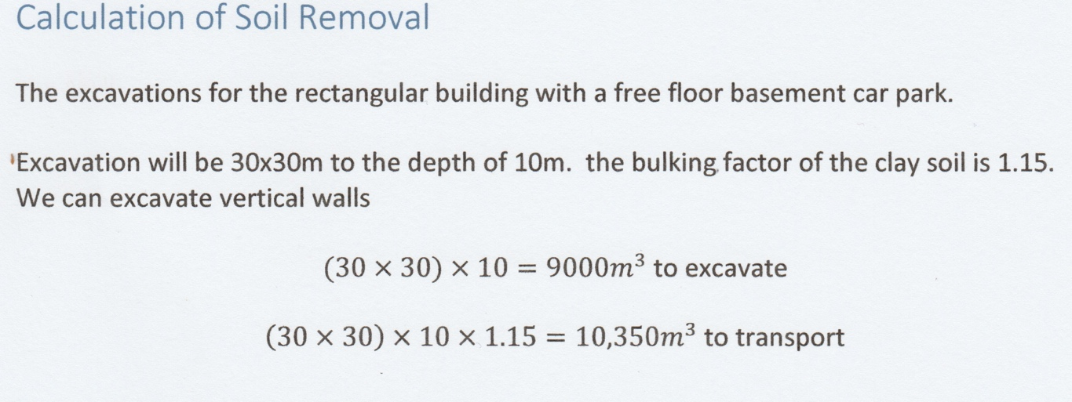

Morgan, L. (2020) Calulation od Soil Removal. [Word Processor].

Appendix 2
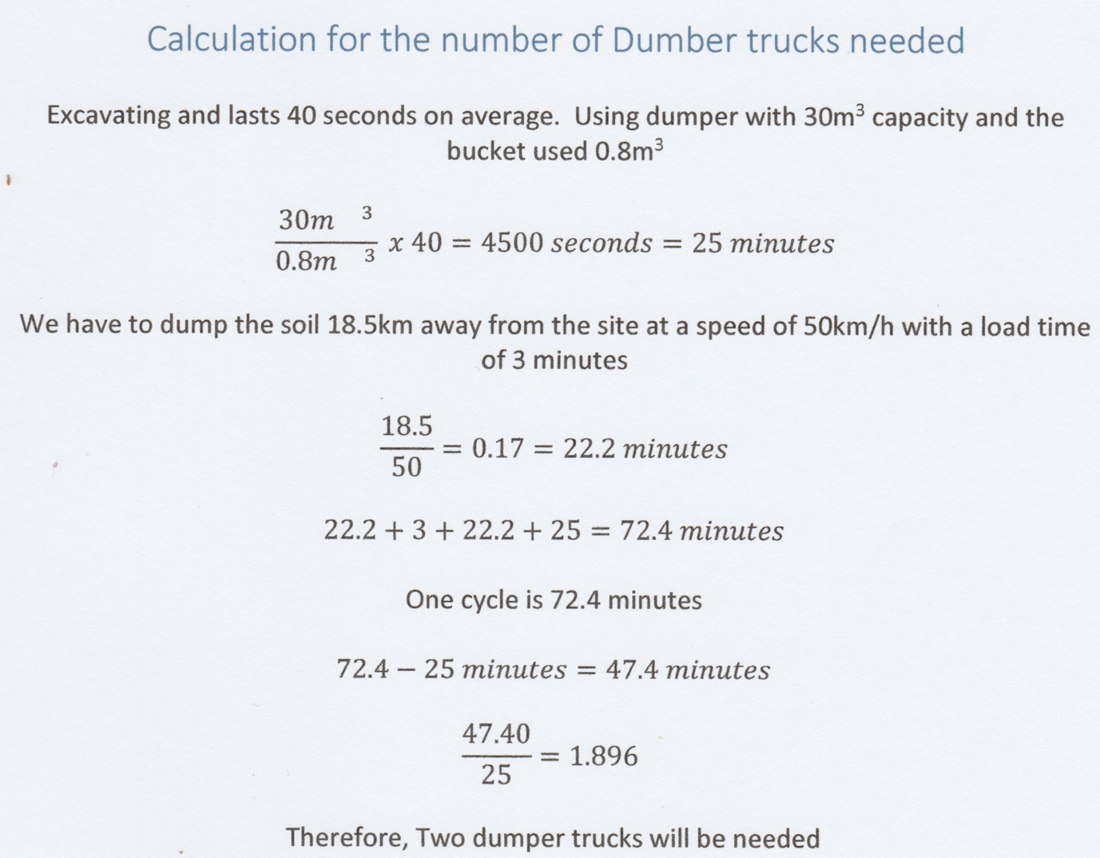

Morgan, L. (2020) Calculation of Dumper Trucks. [Word Processor].

Appendix 3

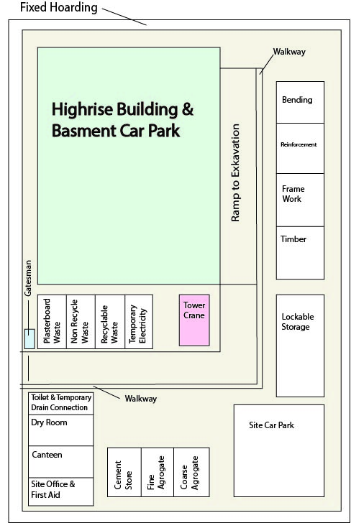

Morgan, L. (2020) Sit Map. [Graphic Illustration].

Appendix 4

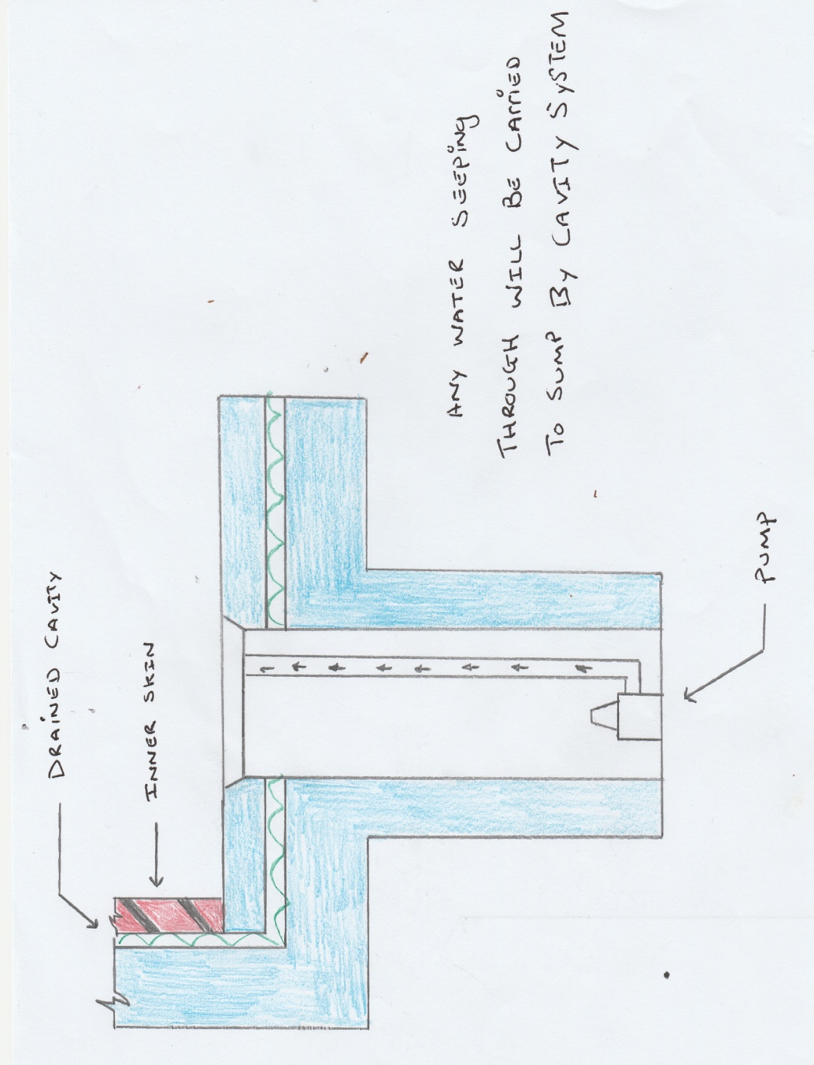

Morgan, L. (2020) Drainage. [Hand generated cross section].

Appendix 5

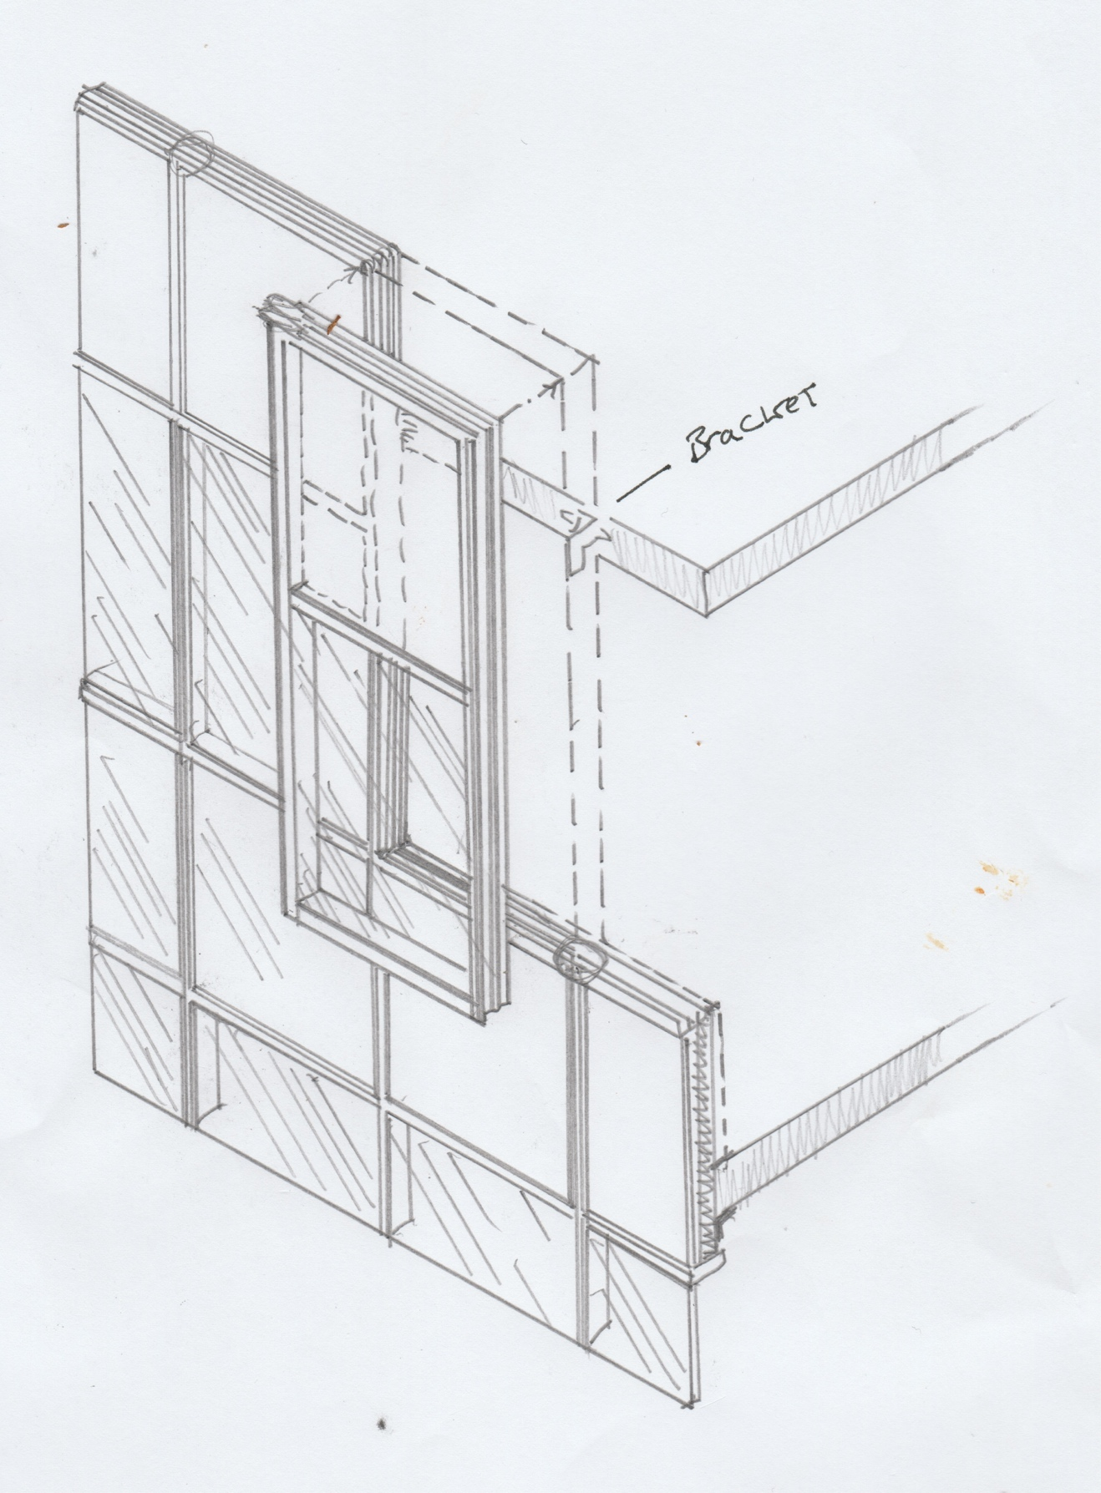

Morgan, L. (2020) Curtain wall panels. [Hand generated Illustration].

Appendix 6

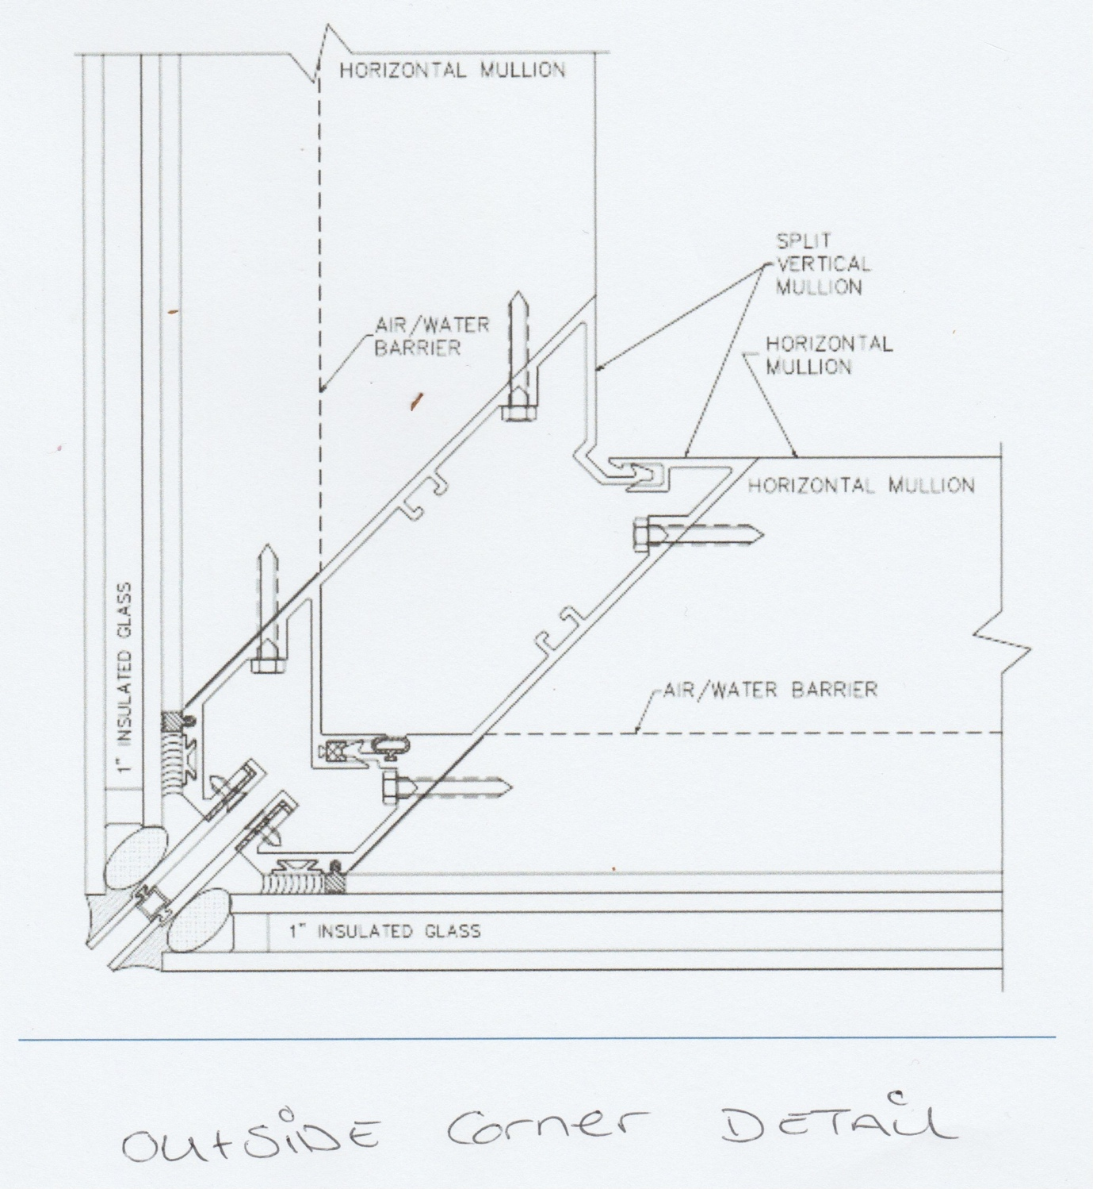
Morgan, L. (2020) Outside corner detail. [Illustration].

Bibliography

ACCESS & EGRESS FOR EXCAVATIONS. (n.d.). [online] Available at: http://toolboxtalks.coffeecup.com/PDF/Excavations.pdf [Accessed 6 Jan. 2020].
ArcelorMittal Sheet Piling ArcelorMittal Sheet Piling Guide Book for The Netherlands -2018 Underground car parks. (n.d.). [online] Available at: http://spundwand.arcelormittal.com/uploads/files/AMCRPS_Underground_Car_Parks_Guide_Book_web.pdf [Accessed 10 Jan. 2020a].
ArcelorMittal Sheet Piling ArcelorMittal Sheet Piling Guide Book for The Netherlands -2018 Underground car parks. (n.d.). [online] Available at: http://spundwand.arcelormittal.com/uploads/files/AMCRPS_Underground_Car_Parks_Guide_Book_web.pdf [Accessed 10 Jan. 2020b].
Ben-Nail, S. and Sief, A. (n.d.). Comparison of Different Facades for High-rise Buildings in Hot and Cold Climates in terms of Material Usage. [online] Available at: https://pdfs.semanticscholar.org/8f57/437c3a70e19353a299e664716bfb7c8a9958.pdf [Accessed 13 Jan. 2020].
Best Practice Guidance Type B Waterproofing Systems. (2014). [online] Available at: https://www.property-care.org/wp-content/uploads/2014/12/Type-B-Guidance-FINAL2-09.16.pdf [Accessed 13 Jan. 2020].
BP U.S. Pipelines and Logistics (USPL) Excavation Safety Manual. (n.d.). [online] Available at: https://www.bp.com/content/dam/bp/country-sites/en_us/united-states/home/documents/products-and-services/pipelines/contractor-information/uspl/excavation-policy.pdf [Accessed 11 Jan. 2020].
CODE OF PRACTICE 2 0 0 5. (n.d.). [online] Available at: https://www.commerce.wa.gov.au/sites/default/files/atoms/files/code_excavation.pdf [Accessed 11 Jan. 2020].
Construction Phase Plan (CDM 2015). (n.d.). [online] Available at: https://www.hse.gov.uk/pubns/cis80.pdf.
CWCT CURTAIN WALL INSTALLATION HANDBOOK. (n.d.). [online] Available at: https://www.cwct.co.uk/construction/installation%20guide/INST-ALL.pdf.
EUROPEAN FEDERATION OF FOUNDATION CONTRACTORS Guide to Tremie Concrete for Deep Foundations. (n.d.). [online] Available at: https://www.fps.org.uk/content/uploads/2018/06/EFFC_DFI_Tremie_Concrete_Guide_2nd-Edition_2018_Final_rev1_01-07-18.pdf [Accessed 14 Jan. 2020].
EXCAVATION and BASEMENT CONSTRUCTION. (n.d.). [online] Available at: http://personal.cityu.edu.hk/bswmwong/contents/ebook/construction_technology/2e.pdf [Accessed 30 Oct. 2019].
Excavation FAQs (2018). Excavation FAQs. [online] Health and Safety Authority. Available at: https://www.hsa.ie/eng/Your_Industry/Construction/Construction_FAQ’s/Excavations/ [Accessed 6 Jan. 2020].
Excavation Operations. (2009). [online] Available at: https://www.usbr.gov/ssle/safety/RSHS/sec22.pdf [Accessed 6 Jan. 2020].
Glazing -safety in relation to impact, opening and cleaning N1 Protection against impact N2 Manifestation of glazing N3 Safe opening and closing of windows, skylights and ventilators N4 Safe access for cleaning windows etc. (n.d.). [online] Available at: https://gov.wales/sites/default/files/publications/2019-05/building-regulations-guidance-part-n-glazing-safety.pdf [Accessed 14 Jan. 2020].
Google Books. (2010). Estimating Excavation. [online] Available at: https://books.google.co.uk/books?id=BxSjyYKWn0wC&pg=PA175&lpg=PA175&dq=excavation+ramp+location&source=bl&ots=0Azkdob3sj&sig=ACfU3U3-xo0A45YMlBPhO55WOLHgHtazKA&hl=en&sa=X&ved=2ahUKEwiGzsWRl-_mAhUJZcAKHaV9CykQ6AEwGHoECAoQAQ#v=onepage&q=excavation%20ramp%20location&f=false [Accessed 6 Jan. 2020].
HASpod (2013). Excavations And The 1.2m Rule. [online] Haspod.com. Available at: https://www.haspod.com/blog/construction/excavations-and-the-1-2-m-rule [Accessed 6 Jan. 2020].
https://www.facebook.com/FPrimeC.Solutions (2016). Why and When to Use Concrete Piles? | FPrimeC Solutions. [online] FPrimeC Solutions. Available at: https://www.fprimec.com/concrete-piles/ [Accessed 12 Jan. 2020].
https://www.howstuffworks.com/about-author.htm (2000). How Tower Cranes Work. [online] HowStuffWorks. Available at: https://science.howstuffworks.com/transport/engines-equipment/tower-crane.htm [Accessed 14 Jan. 2020].
info@aisolutions.co.uk (2015a). Excavation - Hazard Related Topics - Safety Matters (Health & Safety Community). [online] Aisolutions.co.uk. Available at: https://www.aisolutions.co.uk/Community/Knowledge/Topic/68/1004/Excavation [Accessed 6 Jan. 2020].
info@aisolutions.co.uk (2015b). Excavation - Hazard Related Topics - Safety Matters (Health & Safety Community). [online] Aisolutions.co.uk. Available at: https://www.aisolutions.co.uk/Community/Knowledge/Topic/68/1004/Excavation [Accessed 6 Jan. 2020].
info@aisolutions.co.uk (2015c). Excavation - Hazard Related Topics - Safety Matters (Health & Safety Community). [online] Aisolutions.co.uk. Available at: https://www.aisolutions.co.uk/Community/Knowledge/Topic/68/1004/Excavation [Accessed 6 Jan. 2020].
Installation Guide Synthetic Sheet Piling. (n.d.). [online] Available at: http://nilex.com/sites/default/files/Nilex-Sheet-Piling-Install-Guide.pdf [Accessed 14 Jan. 2020].
Introduction to Excavation Safety. (n.d.). [online] Available at: http://www.bhsea.org.uk/Introduction%20to%20Excavation%20Safety.pdf [Accessed 6 Jan. 2020].
NASSPA Best Practices Sheet Piling Installation Guide. (n.d.). [online] Available at: https://s3.amazonaws.com/isheetpile/downloads/NASSPAinstallationguide.pdf [Accessed 12 Jan. 2020].
Nhbc.co.uk. (2020). 404 | NHBC. [online] Available at: http://www.nhbc.co.uk/NHBCPublications/LiteratureLibrary/Technical/TechnicalExtra/filedownload [Accessed 14 Jan. 2020].
Packman, B. (2014a). METHOD STATEMENT DOCUMENT NO. 2 BASEMENT EXCAVATION AT 28-29 HANS PLACE LONDON SW1X 0JY PREPARED BY. [online] Available at: https://www.rbkc.gov.uk/idoxWAM/doc/Other-1276256.pdf?extension=.pdf&id=1276256&location=Volume2&contentType=application/pdf&pageCount=1 [Accessed 6 Jan. 2020].
Packman, B. (2014b). METHOD STATEMENT DOCUMENT NO. 2 BASEMENT EXCAVATION AT 28-29 HANS PLACE LONDON SW1X 0JY PREPARED BY. [online] Available at: https://www.rbkc.gov.uk/idoxWAM/doc/Other-1276256.pdf?extension=.pdf&id=1276256&location=Volume2&contentType=application/pdf&pageCount=1 [Accessed 6 Jan. 2020].
Packman, B. (2014c). METHOD STATEMENT DOCUMENT NO. 2 BASEMENT EXCAVATION AT 28-29 HANS PLACE LONDON SW1X 0JY PREPARED BY. [online] Available at: https://www.rbkc.gov.uk/idoxWAM/doc/Other-1276256.pdf?extension=.pdf&id=1276256&location=Volume2&contentType=application/pdf&pageCount=1 [Accessed 6 Jan. 2020].
Piling Handbook 9th edition. (n.d.). [online] Available at: https://sheetpiling.arcelormittal.com/wp-content/uploads/2018/03/AMCRPS_Piling_-Handbook_9th_web-3.pdf [Accessed 14 Jan. 2020].
Preventing accidents in excavations. (n.d.). [online] Available at: https://www.hse.gov.uk/construction/lwit/assets/downloads/excavations.pdf [Accessed 6 Jan. 2020].
Qin, Z., Chen, L., Song, C. and Sun, L. (2017). Field Tests to Investigate the Penetration Rate of Piles Driven by Vibratory Installation. Shock and Vibration, [online] 2017, pp.1–10. Available at: https://www.hindawi.com/journals/sv/2017/7236956/ [Accessed 14 Jan. 2020].
Sciencedirect.com. (2012a). Excavation Method - an overview | ScienceDirect Topics. [online] Available at: https://www.sciencedirect.com/topics/engineering/excavation-method [Accessed 6 Jan. 2020].
Sciencedirect.com. (2012b). Excavation Method - an overview | ScienceDirect Topics. [online] Available at: https://www.sciencedirect.com/topics/engineering/excavation-method [Accessed 6 Jan. 2020].
soilsmatter2011 (2015a). What type of soil is good for a foundation for buildings or houses? [online] Soils Matter, Get the Scoop! Available at: https://soilsmatter.wordpress.com/2015/05/01/what-type-of-soil-is-good-for-a-foundation-for-buildings-or-houses/ [Accessed 12 Jan. 2020].
soilsmatter2011 (2015b). What type of soil is good for a foundation for buildings or houses? [online] Soils Matter, Get the Scoop! Available at: https://soilsmatter.wordpress.com/2015/05/01/what-type-of-soil-is-good-for-a-foundation-for-buildings-or-houses/ [Accessed 12 Jan. 2020].
Steel Piling Group. (2017a). Basements - Steel Piling Group. [online] Available at: https://www.steelpilinggroup.org/steel-piling-overview/common-uses-for-steel-piling-products/basements/ [Accessed 6 Jan. 2020].
Steel Piling Group. (2017b). Sheet Piles - Steel Piling Group. [online] Available at: https://www.steelpilinggroup.org/steel-piling-overview/sheet-piles/ [Accessed 14 Jan. 2020].
Strength and structure of boulder clays (lodgement till) with reference to the scale of the proposed construction. (2015). Icevirtuallibrary.com. [online] Available at: https://www.icevirtuallibrary.com/doi/abs/10.1680/ecsmge.60678.vol6.544 [Accessed 12 Jan. 2020].
TECHNIQUE SHEET. (n.d.). [online] Available at: https://www.balfourbeatty.com/media/29550/plunge-columns.pdf [Accessed 15 Jan. 2020].
The Delivery Hub health, safety and environment Raising the bar 1 Plant and equipment. (2013). [online] Available at: https://assets.publishing.service.gov.uk/government/uploads/system/uploads/attachment_data/file/798330/RtB_1_Plant_and_Equipment_Apr_19.pdf [Accessed 14 Jan. 2020].
Thenbs.com. (2015). BS 8102:2009 Code of practice for protection of below ground structures against water from the ground, British Standards Institution - Publication Index | NBS. [online] Available at: https://www.thenbs.com/PublicationIndex/documents/details?Pub=BSI&DocID=291234 [Accessed 14 Jan. 2020].
THS Concepts (2019). THS Concepts LTD. [online] THS Concepts - Land & Architectural Surveying. Available at: https://www.ths-concepts.co.uk/earthwork-bulking-volume-calculator/ [Accessed 12 Jan. 2020].
VGC Group. (2018). Excavations - VGC Group. [online] Available at: https://vgcgroup.co.uk/staff/staying-safe-well/some-safety-hazards-in-construction/excavations/ [Accessed 6 Jan. 2020].
‌

