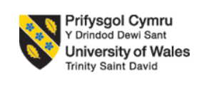

Module code: LCBB6004

STRATEGIC MANAGEMENT and SUSTAINABILITY

Student’s Name: Valentina Simona Duroiu
Student’s ID: 2021942
Executive summary
The following report has highlighted the strategic management of Volkswagen which has recently faced a backlash and huge loss due to its emissions-cheating devices. However, the company has taken a new initiative to produce more eco-friendly products. The report has shed light on the strategies it has taken to overcome the situation over the past five years. Moreover, the challenges along with the importance of resources it has been using to mitigate the barriers. Lastly, suggestions have also been recommended to the company so it can improve its strategies accordingly.

Table of Contents
Introduction 4
Company Background 5
Discussion on the key business strategies of Volkswagen over the past five years 6
SWOT Analysis 6
PESTLE Analysis 7
Competitor’s Analysis - Porter’s Five Force Model 8
Identifying the case study business's assets and capacities during the last five years 10
Defining Strategy 12
Analysing Volkwagon’s alignment to the recent business strategies 12
Evaluate with evidence how VW has tried to become more competitive while taking into consideration sustainability and the environment 14
Recommendations on how further sustainability practices can help the organisation develop future competitive advantages 17
Conclusion 19
References 20
Appendix 22

Introduction
The following report will cover the concept of strategic management and sustainability in order to explore plans for Volkswagen. However, the leading brand has recently faced a scandal over the software installation of emissions-cheating devices in its vehicles. First and foremost, the prominent business strategies of VW will be mentioned that it has undertaken over the past five years. Afterwards, an analysis will be done on the resources that the company has been using over the past five years related to its business strategies. Thereafter, the discourse will evaluate the challenges that the ventures faced while implementing a sustainable approach to fight against environmental issues like climate change. Lastly, a list of recommendations will be attached to the report to provide guidance to Volkswagen for the development of the company.

Company Background
German carmaker Volkswagen was established in 1937 and has its corporate headquarters there. One of the top automakers in the world, it creates a variety of cars, from the affordable to the opulent. The corporation, which is well-known for vehicles like the Beetle and Golf and owns companies like Audi, Porsche, and Lamborghini, is present all over the world. Volkswagen has had both success and failure, including problems involving the emissions. In recent years, it has actively shifted towards electric and environmentally friendly mobility options.

Discussion on the key business strategies of Volkswagen over the past five years

SWOT Analysis
Strength
Volkswagen is one of the leading automotive manufacturers that has an extended market across the globe including Europe. Additionally, the company owns different kinds of popular car brands like Audi, Porsche and Skoda that cater to every kind of consumer satisfaction. As the enterprise has global recognition, it possesses immense capital and for sustainability, it has been developing advanced forces like electrification, software-defined products and autonomous driving (volkswagen-newsroom, 2023).
Weakness
However, in 2015, due to the Dieselgate scandal, Volkswagen faced a significant setback since then. Moreover, the company has been going through huge losses due to litigation in many countries and the brand has been paying fines, compensation, civil, settlements and buyback schemes. Over €30bn has already been paid by the enterprise for which the revenue rate has fallen drastically. The company’s financials have also been drained due to the investment in Research and development which is also essential.
Opportunity
With the growing economic status, it can invest more in enhancing innovation to fight against climate change. Moreover, with the increasing popularity of sustainability, Volkswagen can utilise the chance to commercialise its business by undertaking new initiatives that support the cause. However, with its global popularity, the brand can penetrate the global market and exercise its competitive advantages. Furthermore, it can take the initiative to introduce new models to enhance the overall share of all-electric cars up to 70%.
Threats
With the growing automotive industry, the competition has also been growing rapidly which has posed a greater threat to Volkswagen. Moreover, especially after the pandemic, the global economy has been fluctuating that resulting in major disruption in the company’s compliance cost and affecting the over-sale of the products.

PESTLE Analysis

Political Factors
Volkswagen has access to the major markets both in the United States and the United Kingdom. However, the political alliances between Germany and other European countries have become doubtful regarding trade regulations. The United States has been changing its policies on taxes and tariffs on products that are imported from Germany. The changes in tax rates, tariffs and protocols can affect the financial viability and additional charges can be imposed on the venture.
Economic factors
Day by day, people are keener today to buy more gadgets and electronics which has given rise to so many automotive companies. Alongside this, people also want sustainable products that are eco-friendly and fight against climate change. Penetrating the small markets and making emphasis on the preferences of local people can be beneficial for the development revenue. Apart from that, selling expensive models in the wealthier market can also help to uplift the finance of Volkswagen (Friesendorf et al., 2021).
Societal factors
Volkswagen is one of the most esteemed brands that own various brands like Audi, Porsche and Buggati which are immensely popular brands. However, the company also owns brands like Seat or Skoda that are comparatively less popular or demanding. With the presence of competitors like BMW or Tesla, it can be quite challenging for the company to sell fewer appealing models. On the other hand, people are also opting for car services like Uber for comfort and sustainability. With this shift from the sociocultural perception of owning a car, Volkswagen can lose its customer base if they do not introduce something more worthy to replaceable.
Technological factors
However, the venture has decided to accelerate its pace of innovation to stand out from its competitors. Thus, it has been developing electrification, software-defined products and autonomous driving by implementing modern technology. This approach has led them to introduce safe and self-reliable driving cars to provide ultimate comfort to their consumers.
Legal factors
Cars made between 2009 and 2015 by Volkswagen incorporated software that was subjected to emission cheating software. However, it could not meet the legal standards after it was launched in the market for consumer use. Numerous legal actions were taken against the company for which Volkswagen had to pay tens of billions of dollars fines and damages.
Environmental factors
After the Diesel gate scandal that led Volkswagen to its downfall, the company has undertaken strategies to implement sustainable approaches to fight against climate change. Volkswagen has already successfully been producing battery-powered electric cars along with the development of hydrogen fuel cells (Jellinghaus, 2022).

Competitor’s Analysis - Porter’s Five Force Model
The bargaining power of buyers
The bargaining power of buyers is comparatively lower than other companies as the price of Volkswagen products and cars is highly expensive. Moreover, the company also facilitates premium or exclusive products for the customers who possess the premium membership. The variety of products has enabled the company to attain the trust and loyalty of the consumers and the power to control the pricing strategies (volkswagen-group, 2023).
Bargaining power of suppliers
The bargaining power of the suppliers is also low as they produce parts in a limited number. due to this uniqueness, the products are so distinctive from other brands. However, the suppliers are thus highly reliant on the automakers. Volkswagen is very specific about the suppliers they are working with thereby it can buy products at the lowest prices possible.
Threats of New Competitors
There are many challenges in the automobile industry that new companies face while entering the market. Hence, the threat from them remains low as starting a new automobile venture requires high capital and strong distribution channels.
Threats from the substitute products
The threats from the substitute products are medium for the respective company as the price of fuel accelerates. This is the reason most people are opting for public transportation and cycling for convenience ((Merwitz, 2020).
The Rivalry of Existing Players
Competition in the existing market is always high, especially for Volkswagen which enables the company to invest more in innovation. Due to this competitiveness, the company is likely to exit the wealthier markets if they fail to meet the requirements and desires fo modern customers (Bobek and Kodric, 2021).

Identifying the case study business's assets and capacities during the last five years
Volkswagen has demonstrated a range of assets and skills during the last five years that have aided in its development and success. These are a few significant arguments supported by data:
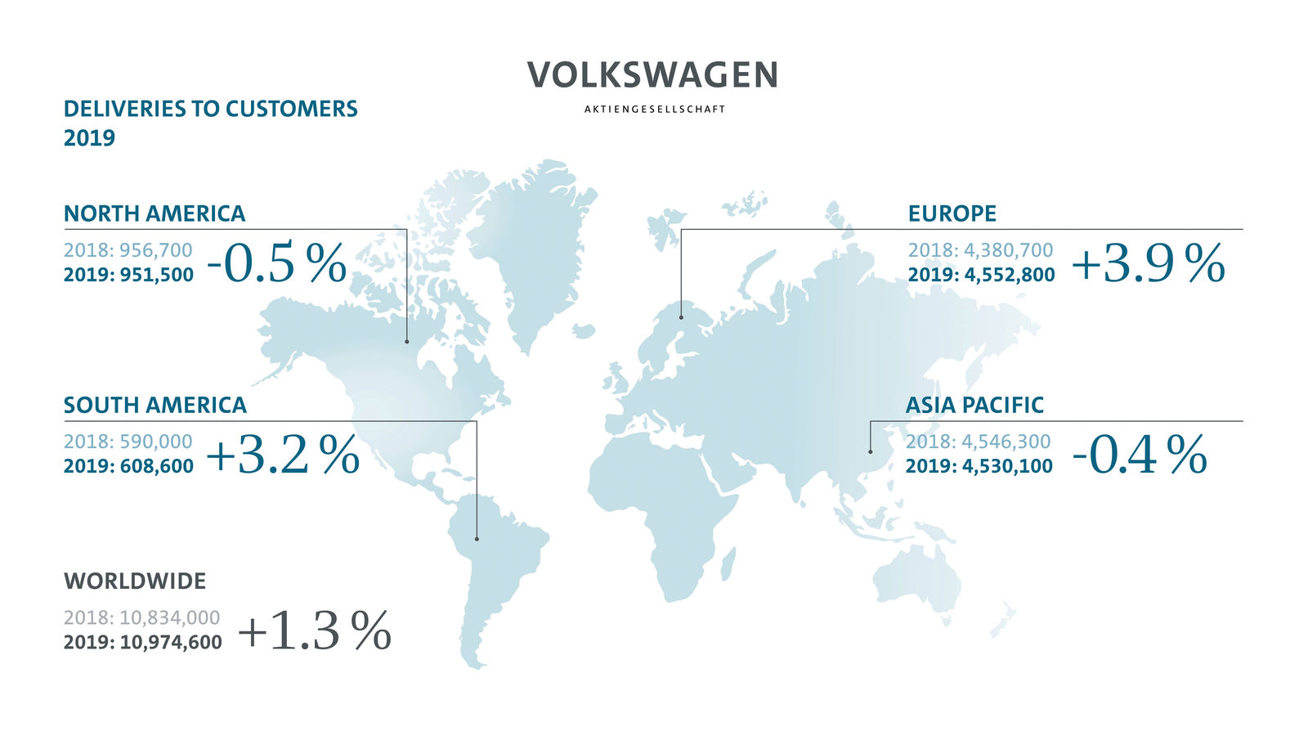
Figure: Global Presence of Volkswagen
Source: (volkswagen, 2022)
Strong Global Presence: Volkswagen has kept a solid reputation around the world, with factories and sales networks spread throughout several nations, notably China, the United States, and Europe. For Volkswagen, China has been a key market, where the firm has experienced consistent growth for a long period.
Diversified Brand Portfolio: Volkswagen is the owner of several well-known car brands, including Audi, Porsche, and SEAT. In 2020, the Volkswagen Group said it shipped almost 9.3 million vehicles worldwide.
Technological developments: The business has made significant investments in the development of EV technologies. For example, Volkswagen's drive towards electric vehicles including the ID.3 as well as ID.4 vehicles has gained a lot of popularity (Schmitt, 2018).
Financial Stability: Volkswagen has demonstrated resilience in its financial success despite difficulties like the Diesel gate scandal. The Volkswagen Group projected a solid net revenue and a sizable liquidity position in 2020 despite the COVID-19 epidemic.
Research and development: For maintaining its position as a leader in automotive technology, Volkswagen has constantly made R&D investments. Providing a case study of their R&D-driven improvements in sustainable mobility solutions, their creation for the Modular Electric Drive Kit (MEB) system resulted in the ID.4 electric SUV. The business's emphasis on innovation is shown in the self-driving features as well as the connected car technologies it has developed (Schmitt, 2018).

Defining Strategy
According to Richard Whittington's book "Exploring Strategy," strategy includes the purposeful actions and judgments an organization makes to accomplish its long-term objectives in the face of changing surroundings. It entails developing a distinctive position, selecting resources, and adjusting to changes while coordinating internal skills with outside chances to gain competitive advantage.

Analysing Volkwagon’s alignment to the recent business strategies
Volkswagen has a long history of placing a high priority on engineering, manufacturing, and brand identification. For the sake of achieving its objectives, the corporation has over the years coordinated these crucial assets with its business strategies.
Product portfolio: Volkswagen has purposefully varied its product line to appeal to a range of market categories, from normal cars to luxury automobiles. Volkswagen has created a number of technologically innovative goods, such as the electric SUV ID.4 that features sophisticated battery control for a longer range. Another illustration is their Car-Net technology, which enables smartphone apps for remote car monitoring and control. Volkswagen's dedication to incorporating technology into their products is demonstrated by these advancements. (Jacobs, and Kalbers, 2019).
Technological Innovation: Due in large part to the emergence of electric cars and autonomous driving, the automotive sector has been undergoing fast change. Recognising this trend, Volkswagen made major investments in research and development to create electric and hybrid cars that have a long-term aim of environmentally friendly transportation.
Market Positioning: VW has carefully established its company as a brand that emphasises excellence, dependability, and innovation. The brand image of the organisation is in line with its commercial strategy to draw in a wide client base and foster consumer trust and loyalty.
Strategic Agreements: To gain access to new markets, share information, and improve its skills, Volkswagen has forged strategic alliances and collaborations with other manufacturers and technology companies. For example, Volkswagen and Ford's collaboration intends to create commercial vehicles together and to invest in autonomous and electric innovations which they have accomplished in the recent years(Jacobs, and Kalbers, 2019)

Evaluate with evidence how VW has tried to become more competitive while taking into consideration sustainability and the environment
Volkswagen’s CSR and Sustainability
The CSR and sustainability statement from Volkswagen demonstrates their dedication to responsibility for the environment and society. The report stated took initiatives to lower carbon emissions through expenditures in renewable energy sources, electric vehicle development, and manufacturing. In order to guarantee moral behaviour and ethical material procurement, they place a strong emphasis on partnerships with suppliers. The business also displays its efforts to encourage inclusiveness and diversity among its employees. Volkswagen's involvement in community improvement initiatives and support for health and education initiatives also demonstrate their commitment to societal well-being (Leggett, 2018).
Company’s Implementation of Sustainability
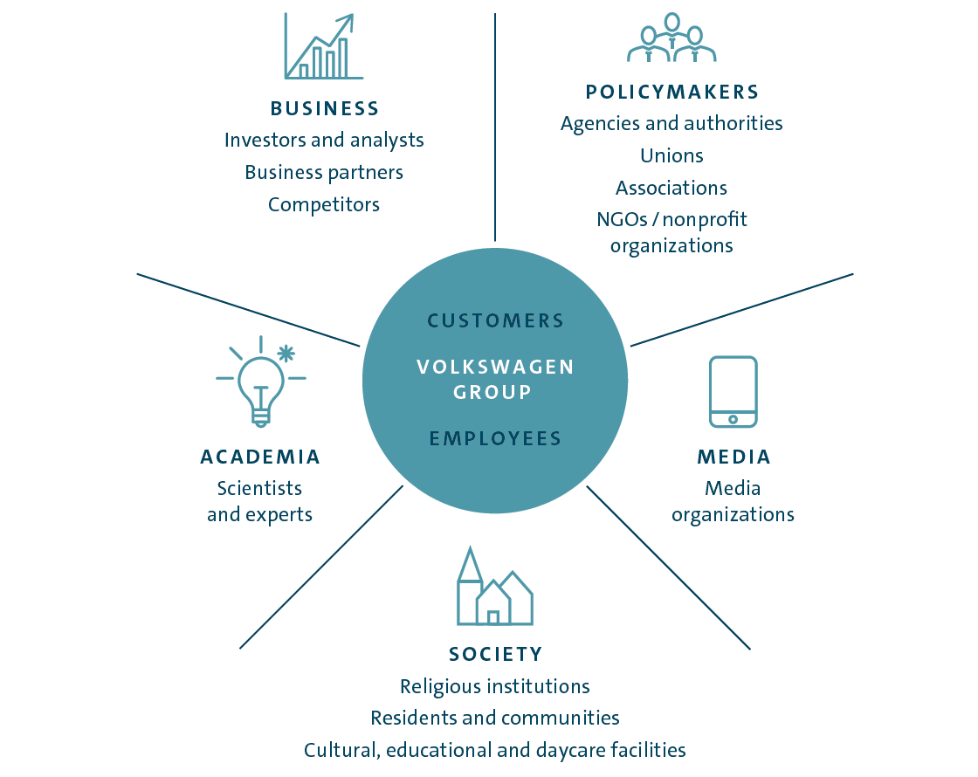

Figure: Business strategies of Volkswagen
Source: (Wissuwa, and Durach, 2023).
One of the biggest automakers in the world, Volkswagen, has made enormous efforts to increase its competitiveness while simultaneously taking sustainability and the natural world into account. The corporation has previously faced difficulties, like the diesel emissions crisis, which forced them to review their business practices (Leggett, 2018) The disaster motivated them to put more of their emphasis on sustainable and environmentally friendly activities. Following are some salient details and examples demonstrating Volkswagen's initiatives in this strategy:
Use of E- Mobility:
Volkswagen has made significant investments in electric vehicle (EV) technologies to lessen its carbon impact. Under their ID series, they debuted its ID.3, an entirely electric hatchback, and ID.4, a battery-powered SUV, in 2020. Volkswagen plans to invest over €35 billion in e-mobility by 2025 to dominate the EV industry. This action shows their dedication to lowering emissions of greenhouse gases and switching to cleaner forms of transportation.
Use of MEB Platform:
Volkswagen created the Modular Electric Drive Matrix architecture, which is only intended for use with electric vehicles. This framework enables them to effectively produce a variety of electric vehicles, lowering production costs and increasing consumer access to EVs. In line with its environmental objectives, the MEB platform additionally endorses the use of recyclable and renewable resources in the manufacture of vehicles (Conrad, and Holtbrügge, 2021).
Charging Infrastructure: Volkswagen continues to be actively working with public and commercial organisations to create reliable charging infrastructure to assist the widespread use of electric vehicles. For example, the business collaborated with several partners in 2019 to launch the Ionity charging infrastructure in Europe, to construct 400 ultra-fast charging points beside key thoroughfares. This programme intends to reduce "range anxiety" for consumers of electric vehicles as well as promote long-distance emission-free travel (Vallino et al., 2021).
Sustainable manufacturing:
Volkswagen has pledged to make all of its manufacturing facilities carbon-neutral. They have put in place several steps, such as using sources of clean energy and adopting energy-efficient production techniques. For instance, through these initiatives, their Zwickau, Germany factory in Germany, which manufactures the ID.3, became the first Volkswagen location to attain carbon-neutral status (volkswagenag, 2020).
Use of proper materials:
The business has been investigating and incorporating sustainable materials throughout its vehicle designs. For example, Volkswagen debuted the ID.3 with recycled-material seats. Additionally, they have been working hard to develop and use bio-based materials for automobile interior parts, minimising the negative environmental effects of the life cycle of their vehicles.
Green Logistics:
Volkswagen has used green logistics techniques in addition to manufacturing and car development. This entails streamlining travel routes to cut down on fuel use and carbon dioxide emissions, in addition to investigating other environmentally friendly transport options including rail and waterways.
Initiatives for a Circular Economy:
Volkswagen is attempting to create a model for a circular economy that emphasises recycling and waste reduction. They want to prolong the lifespan of what they sell and salvage useful elements from outdated automobiles. By reducing resource usage and waste production, this strategy adheres to sustainability standards (Conrad, and Holtbrügge, 2021).

Recommendations on how further sustainability practices can help the organisation develop future competitive advantages
Sustainability refers to the complete management of environmental, and social practices that bring out a long-term impact at the local and global level. The Volkswagen Group has been following various sustainable measures with proper strategic investments for the management of the business for a considerable period. As a notable automaker, Volkswagen can use sustainability initiatives to strengthen its market position and establish itself as an innovative and ethical business.
Increased use of E- Mobility:
Businesses must invest extensively in the creation and development of electric cars (EVs) and related technology to embrace electric mobility. It is recommended that Volkswagen can lessen its environmental impact by abiding with increasing emission laws, and gain an advantage in the expanding EV market by switching to electric transportation which in turn will help the society at large.
Renewable source of energy integration:
Integrating renewable energy sources to meet a sizable amount of your energy needs, like solar, wind, or hydroelectricity. It is recommended Volkswagen can lessen its environmental effect and show that it is genuinely committed to sustainability by reducing its dependency on energy from petroleum for production and operations.
Transparency in the Supply Chain:
Encouraging supply chain openness by working with suppliers to uphold sustainability standards will help the business to increase its business standards. Businesses must be sure that supplies are sourced ethically, and encourage vendors to cut back on water use, waste production, and carbon footprint. An open and ethical supply chain can increase consumer confidence and draw in customers who care about the environment (Hąbek, 2022).
Manage sustainability:
It is recommended that investing in proper Resources will develop cutting-edge environmentally friendly innovations. These innovations will include light-weight materials, energy-efficient parts, and improved battery technology, to create sustainability. These developments can set Volkswagen apart from rivals, lower operational costs, and offer an ongoing edge in the market which will be beneficial in future.

Conclusion
Volkswagen has worked hard to increase its competitiveness while putting sustainability and the environment first. Volkswagen is putting itself in a leading position in the automobile industry's transition to a more environmentally friendly future by implementing sustainable practices. Implementing sustainability in their business operations will give a positive setback to the company and improve its competitive advantages. Environmental-conscious customers will be attracted towards these strategies and thus the brand will experience a positive success in future. Thus, the report has analysed the key business strategies of Volkswagen by understanding its strengths, weakness which in turn will bring opportunities and threats. The five forces analysis along with a PESTLE tool has been used to analyse the framework of these strategies implemented by the business. Further, the sustainable practices of the company have been highlighted in this report and relevant details and recommendations for further improvements have been highlighted in this report.

References
Bobek, V. and Kodrič, B., (2021). COMPETITIVENESS ANALYSIS OF EUROPEAN AUTOMOTIVE INDUSTRY.
Conrad, M. and Holtbrügge, D., (2021). Antecedents of corporate misconduct: A linguistic content analysis of decoupling tendencies in sustainability reporting. Business Ethics, the Environment & Responsibility, 30(4), pp.538-550.
Friesendorf, C., Uedelhoven, L., Friesendorf, C. and Uedelhoven, L., (2021). Macro-Environment of Mobility. Mobility in Germany: Digital Transformation, Megatrends and the Evolution of New Business Models, pp.11-17.
Hąbek, P., Lavios, J.J. and Krupah, E., (2022). How car producers are driving toward sustainable supplier development. Production Engineering Archives, 28(3), pp.268-278.
Holtbrügge, D. and Conrad, M., (2020). Decoupling in CSR reports: A linguistic content analysis of the Volkswagen Dieselgate scandal. International Studies of Management & Organization, 50(3), pp.253-270.
Jacobs, D. and Kalbers, L.P., (2019). The Volkswagen diesel emissions scandal and accountability. The CPA Journal, 89(7), pp.16-21.
Jellinghaus, M.Y., (2022). Analyzing the case of Volkswagen and the transition to electric vehicles in 2020-sustainability of electric vehicles (Doctoral dissertation).
Leggett, T., (2018). How VW tried to cover up the emissions scandal. [Online]
Available at: https://www.bbc.com/news/business-44005844 [Accessed 24 July 2023].
Merwitz, O.C., (2020). Analysis of the current after sales market for Volkswagen Commercial Vehicles and future trends in Finland.
Schmitt, B., (2018). Volkswagen's Brand Strategy: Finally, Something That Makes Some Sense. [Online]
Available at: https://www.forbes.com/sites/stevenehrlich/2023/07/18/making-a-move-on-ethereum/?sh=6eae983330bb [Accessed 24 July 2023].
Vallino, E., Ridolfi, L. and Laio, F., (2021). Trade of economically and physically scarce virtual water in the global food network. Scientific Reports, 11(1), p.22806.
volkswagenag, (2020). The future on hand. [Online]
Available at: https://annualreport2020.volkswagenag.com/group-management-report/sustainable-value-enhancement/sustainability.html [Accessed 24 July 2023].
volkswagen-group, (2023). History. [Online] Available at: https://www.volkswagen-group.com/en/history-15914 [Accessed 20 July 2023].
volkswagen-newsroom, (2023). Strategy. [Online] Available at: https://www.volkswagen-newsroom.com/en/strategy-3912 [Accessed 20 July 2023].
Wissuwa, F. and Durach, C.F., (2023). Turning German automotive supply chains into sponsors for sustainability. Production Planning & Control, 34(2), pp.159-172.
Leggett, T., (2018). How VW tried to cover up the emissions scandal. [Online] Available at: https://www.bbc.com/news/business-44005844 [Accessed 24 july 2023].
volkswagen, (2022). Volkswagen Group records higher deliveries in 2019. [Online] Available at: https://www.volkswagen-newsroom.com/en/press-releases/volkswagen-group-records-higher-deliveries-in-2019-5723 [Accessed 24 July 2023].

Appendix
SWOT analysis

Strengths | Weaknesses
As the enterprise has global recognition, Volkswagen possesses immense capital and for sustainability. Moreover, it has been developing advanced forces like electrification, software-defined products and autonomous driving. | However, in 2015, due to the Dieselgate scandal, Volkswagen faced a significant setback since then. Over €30bn has already been paid by the enterprise as fine for which the revenue rate has fallen drastically.
Opportunities | Threats
However, with its global popularity, the brand can penetrate the global market and exercise its competitive advantages. Furthermore, it can take the initiative to introduce new models to enhance the overall share of all-electric cars up to 70%. | Especially after the pandemic, the global economy has been fluctuating that resulting in major disruption in the company’s compliance cost and affecting the over-sale of the products.

Pestle Analysis

Political | The political alliances between Germany and other European countries have become doubtful regarding trade regulations. The United States has been changing its policies on taxes and tariffs on products that are imported from Germany.
Economic | Penetrating the small markets and making emphasis on the preferences of local people can be beneficial for the development revenue. Apart from that, selling expensive models in the wealthier market can also help to uplift the finance of Volkswagen
Social | With the presence of competitors like BMW or Tesla, it can be quite challenging for the company to sell fewer appealing models. On the other hand, people are also opting for car services like Uber for comfort and sustainability.
Technological | Volkswagen has been developing electrification, software-defined products and autonomous driving by implementing modern technology. This approach has led them to introduce safe and self-reliable driving cars to provide ultimate comfort to their consumers.
Environmental | Volkswagen has already successfully been producing battery-powered electric cars along with the development of hydrogen fuel cells.
Legal | Cars made between 2009 and 2015 by Volkswagen incorporated software that was subjected to emission cheating software. Numerous legal actions were taken against the company for which Volkswagen had to pay tens of billions of dollars fines and damages.

