Module Title: Introduction to Health and Social Care
Student name: Aqsa Ejaz
Student ID: 2507265
Assignment Title: Portfolio – Two Task
Lecture’s Name: Daniel Harune
Module code: LCHS4003

Current Functions of the Community Mental Health Services
Today, CMHS operate within a combined care system, involving CMHTs, crisis resolution/home treatment teams, early intervention in psychosis and recovery services. The Community Mental Health Framework for Adults and Older Adults prioritises improved access, reduced waiting times and strengthens the collaboration between health and social care sectors (NHS England, 2019). Digital inventions such as, online therapy and telephone support, have expanded reach and accessibility.
Service establishments with voluntary housing and social care partners support holistic care planning. Evidence suggests while the Community Mental Health Team models vary locally leading to gaps in assessing some service outcomes, highlighting the need for consistent research and evidence-based intervention models (Malone, 2007).

Brief History of Community Mental Health Services
Mental health care in the UK is largely centred on the psychiatric centres historically. This led to long term isolations and poor quality of life. In the middle of 20th century, a change took place which challenged this approach – it was driven by increased recognition of patients’ human rights and community inclusion (Tuner, 2015).
The Mental Health Act 1959 hugely restored care towards the community by ordering local follow ups and collaborations with other professional services. This reduced the reliance on asylums. Thereafter, policy reforms including Care in the Community (1980s-1990s), looked to replace the long stays in the hospitals which was organised under the NHS and Community Care Act 1990 (Department of Health, 1990). These shifts laid down the groundwork for modern multidisciplinary community care, highlighting accessibility, social integration and recovery.
Explanation of the service
Community Mental Health Services in the UK give assessments, treatments and continuous support for the people suffering in the community. They prepare people for independent living and recovery whilst also reducing the need of admissions in hospitals. This helps people with conditions like depression, anxiety disorders, bipolar disorder, schizophrenia and personality disorders (NHS England, 2022). Multidisciplinary teams who work diversly include psychiatrists, community mental health nurses, psychologists, social workers, occupational therapists and support workers.
Services are often gained access via GP or hospital referrals but in some local areas, an increasingly through self-referrals is also available. The care model stresses the fact that person centred planning and shared decision making is important. Community Mental Health Teams focus on the deliverance of managed psychosocial support, rehabilitation and crisis management to allow the recovery to take place in the community (Chew-Graham et al. 2007).
Community Mental Health Services in the UK
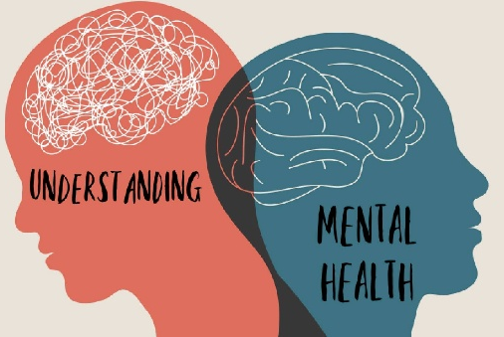
Figure 1: Rates of probable mental health disorders among children and young people have increased significantly since 2017 (The King’s Fund, 2023).

Challenges Facing Community Mental Health Services
Increased Demand and Workforce Shortages
Demand for mental health care is growing rapidly, with adult referrals and service contacts increasing year-on-year (CQC, 2025). This surge has been intensified by the COVID-19 pandemic and rising levels of psychological distress.
Workforce shortages present a major challenge. UK mental health services experience higher staff turnover and vacancy rates than other NHS sectors, contributing to longer waiting times and lowered quality of care (Long et al., 2023). Reports indicate substantial rota gaps, burnout, and stress among mental health professionals, exacerbated by insufficient retention strategies and growing workloads.

Funding and Inequality of Access
Mental health services have historically received less funding than physical health services, despite increased societal need. Analysis suggests increasing referrals are not matched with sustainable funding and workforce capacity, creating service bottlenecks and inequalities. Inequalities in access are also observed across socioeconomic groups, with systematic reviews showing disparities in service engagement among marginalised populations.

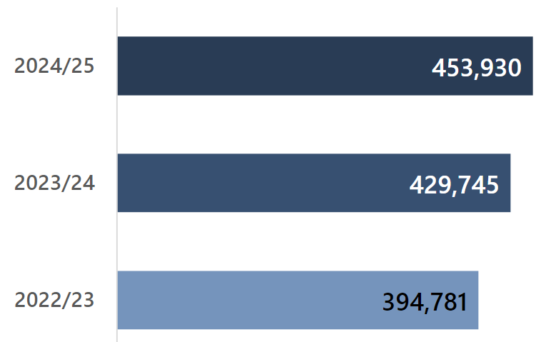
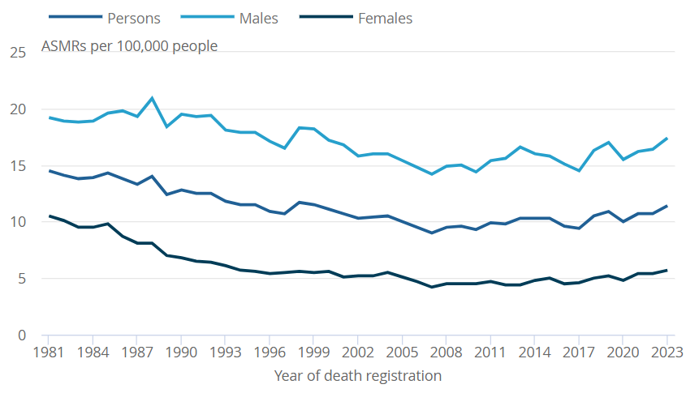
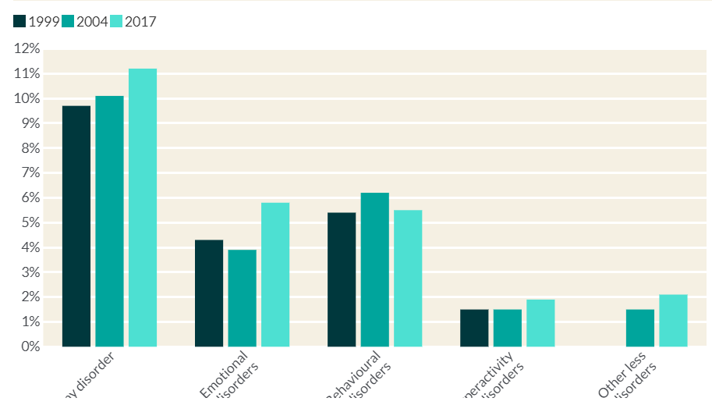
Figure 2: CQC reports rising demand for secondary mental health services and highlights access delays, supported by figures in the State of Care access section (CQC, 2025).

Figure 3: ONS charts show the suicide rate in England and Wales increased in 2023 and provide demographic breakdowns (ONS, 2024).

Task 2:
Introduction — What Dental Services Are
Dental services are healthcare support that keeps your teeth, gums and mouth healthy. They help prevent and treat problems like cavities (holes in teeth), gum disease and pain. Looking after oral health matters because bad dental health can cause pain when eating, infection, difficulty speaking, and affect general health and confidence. For example, many adults in England report pain that prevents eating or makes them feel self-conscious about their teeth’s look, which harms quality of life (Department of Health and Social Care, 2025).
Dentists and other mouth-care workers also give advice on brushing, diet and preventing problems in the first place — because avoiding tooth decay and gum disease is usually better than fixing them later. Dental services today mix old knowledge with modern ideas to help people stay healthy and confident.

Historical Origins — Where Dentistry Came From
Humans have tried to treat dental problems for thousands of years. Archaeological evidence shows people drilled into teeth as far back as 7000 BC, and ancient cultures used early tools to clean their teeth and control pain — showing oral care is very old (Dr Cheraghian, 2024).
One of the biggest advances happened in the 1700s with Pierre Fauchard, known as the Father of Modern Dentistry. In 1723 he published the first complete dental textbook, The Surgeon Dentist, which explained how to care for teeth, how decay worked, and ways to treat cavities and tooth loss. He also suggested fillings and recognised the role of sugar acids in decay — ideas that are still part of dental care today (American Dental Education Association, 2026).
Fauchard’s work helped dentistry grow from simple tools and guesswork into a professional field using systematic knowledge and clinical practice.

How Dental Services Work Today
Modern dental care includes regular check-ups, cleaning, fillings, crowns, braces, tooth removal, and sometimes surgery. Dentists work with dental hygienists and therapists to prevent disease, teach good habits, and treat problems early.
In England, dental care is offered through the National Health Service (NHS) and private practices. Many people still rely on the NHS, but access has been shrinking — for example, only about 40 % of adults saw an NHS dentist in the two years to 2024, down from before the pandemic, because many NHS practices aren’t taking new patients and workforce shortages persist (Healthwatch, 2023).
Studies show that cost and availability affect how often people visit a dentist. Around a third of adults say the cost of care changed their treatment, and some only see a dentist when they have trouble rather than for a check-up (Department of Health and Social Care, 2025).
Technology also changes services — digital scans, 3D printing and improved materials make treatments faster, more accurate and often more comfortable for patients.

Why Dental Care Matters for Life
Good oral health affects everyday life. People who have toothache may find it hard to eat or sleep, and those with missing or damaged teeth may feel self-conscious. In the UK, surveys show almost 47 % of adults had some oral impact — like pain, difficulty eating or feeling embarrassed — in the last year (Department of Health and Social Care, 2025).
Poor dental health doesn’t just hurt the mouth — it can impact nutrition, social interaction, work and wellbeing. Regular check-ups help dentists find problems early when they are easier to treat, avoid pain, and support healthy eating and confidence.
Public dental programmes — especially in schools or community centres — reduce inequalities by giving more people access to preventative care and advice. Without this, groups in poorer areas show higher disease rates and more untreated decay because they go less often and have worse access (Department of Health and Social Care, 2025) .

Conclusion — Dentistry’s Role Today
Dentistry has evolved from ancient tools and treatments into a full modern healthcare profession that aims to prevent, find and treat oral health problems. It improves overall health, comfort, appearance and confidence.
In places like England, dental services try to reach everyone through the NHS. However, access issues and workforce challenges mean many people now turn to private care or wait longer than recommended for treatment. Better funding, prevention programmes and easier access to check-ups would help lower disease rates and improve quality of life.
Supporting strong dental services — from early education to modern treatments and accessible NHS care — helps people stay comfortable, confident and healthy throughout life.
Reference
Chew-Graham, C., Slade, M., Montana, C. et al. (2007). A qualitative study of referral to community mental health teams in the UK: exploring the rhetoric and the reality. BMC Health Services Research, 7(117). Available at: https://doi.org/10.1186/1472-6963-7-117 (Accessed: 5th February 2026).
Department of Health (1990). The NHS and Community Care Act 1990. London: HMSO. Available at: https:// www.legislation.gov.uk/ukpga/1990/19/contents
(Accessed: 5th February 2026).
Malone, D. (2007). Community mental health teams (CMHTs) for people with … PMC, 2007. Available at: https://pmc.ncbi.nlm.nih.gov/articles/PMC4171962/ (Accessed: 5th February 2026).
Turner, J. (2015). The History of Mental Health Services in Modern England. PMC, 2015. Available at: https://pmc.ncbi.nlm.nih.gov/articles/PMC4595954/ (Accessed: 5th February 2026).
Long, J. et al. (2023). Realist synthesis of factors affecting retention of staff in UK …. BMJ Open. Available at: https://bmjopen.bmj.com/content/13/5/e070953 (Accessed: 5th February 2026).
NHS England (2019). The Community Mental Health Framework for Adults and Older Adults. Available at: https://www.england.nhs.uk (Accessed: 5th February 2026).
NHS England (2022). Mental health services overview. Available at: https://www.nhs.uk (Accessed: 5th February 2026).
CQC (2025). Mental health: state of care report 2024–25. Available at: https://www.cqc.org.uk/publications/major-report/state-care/2024-2025/access/mh (Accessed: 5th February 2026).
The King’s Fund (2023). Mental Health 360: Prevalence. Available at: https://www.kingsfund.org.uk/insight-and-analysis/long-reads/mental-health-360-prevalence (Accessed: 5th February 2026).
Care Quality Commission (2025). State of care 2024/25: Access to mental health care. Available at: https://www.cqc.org.uk/publications/major-report/state-care/2024-2025/access/mh (Accessed: 5th February 2026).
Office for National Statistics (2024). Suicides in England and Wales: 2023 registrations. Available at: https://www.ons.gov.uk/peoplepopulationandcommunity/birthsdeathsandmarriages/deaths/bulletins/suicidesintheunitedkingdom/2023 (Accessed: 5th February 2026).
American Dental Education Association (2026). History of Dentistry. Available at: https://www.adea.org/godental/discover-dentistry/history-and-data/history-of-dentistry (Accessed: 5th February 2026).
Department of Health and Social Care (2025). Adult Oral Health Survey 2023 – report summary. Available at: https://www.gov.uk/government/statistics/adult-oral-health-survey-2023/report-summary (Accessed: 5th February 2026).
Department of Health and Social Care (2025). Adult Oral Health Survey 2021 findings. Available at: https://www.gov.uk/government/statistics/adult-oral-health-survey-2021/adult-oral-health-survey-2021-report-summary (Accessed: 5th February 2026).
Dr Cheraghian (2024). History of Dentistry – Ancient to Modern Era. Available at: https://drcheraghian.com/wp-content/uploads/2024/08/History_of_dentistry_from_Ancient_to_Mod.pdf (Accessed: 5th February 2026).

Healthwatch (2023) Annual NHS Dental Statistics England – response summary. Available at: https://www.healthwatch.co.uk/news/2023-08-24/annual-nhs-dental-statistics-england-our-response (Accessed: February 2026).

