Contemporary Themes in the Hotel and Hospitality Sector

BMIH6001

Conference Presentation

Kobirul Islam
2130690
Ben Ka Po Chong

I confirm that I have not used any AI tools in the research and creation of this assignment. I confirm that I have not presented any AI generated materials as my own work. I confirm I have copies of my drafts, notes, and other resources I used, which I may be asked to provide in evidence.

Slide 1: Cover page
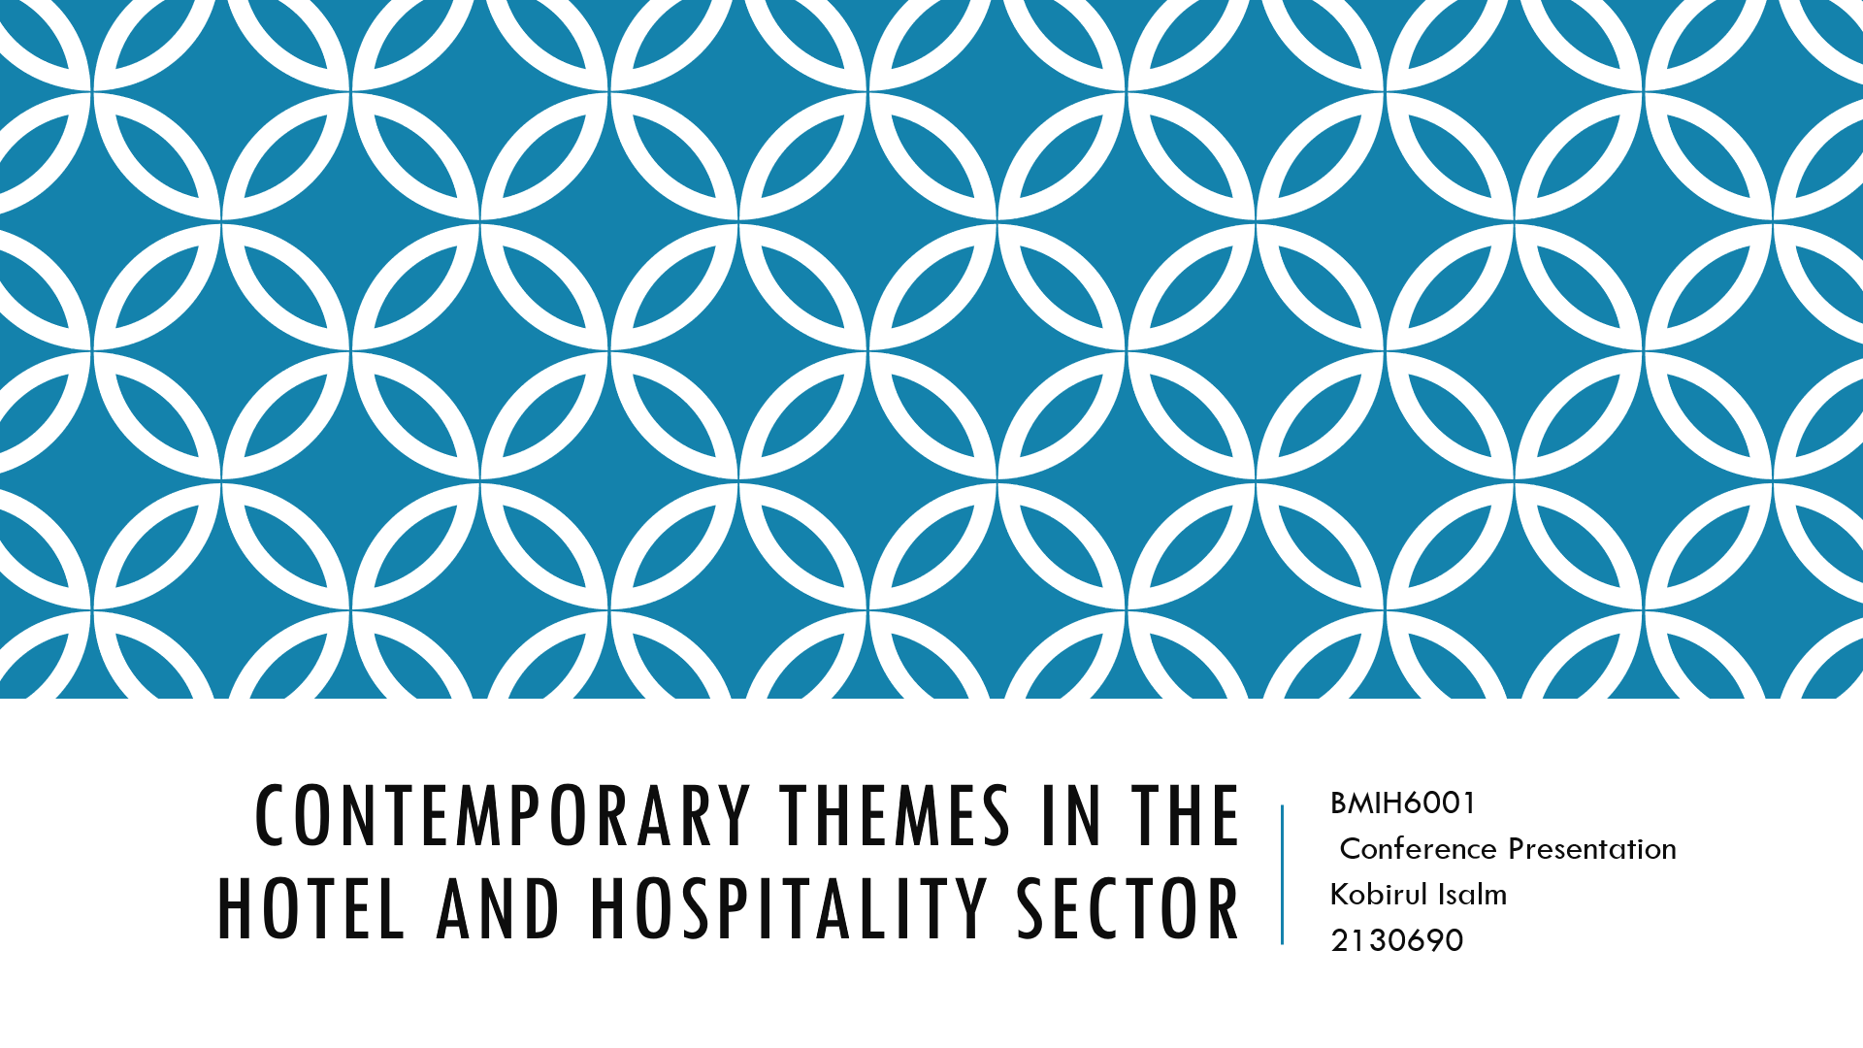

Slide 2: Introduction
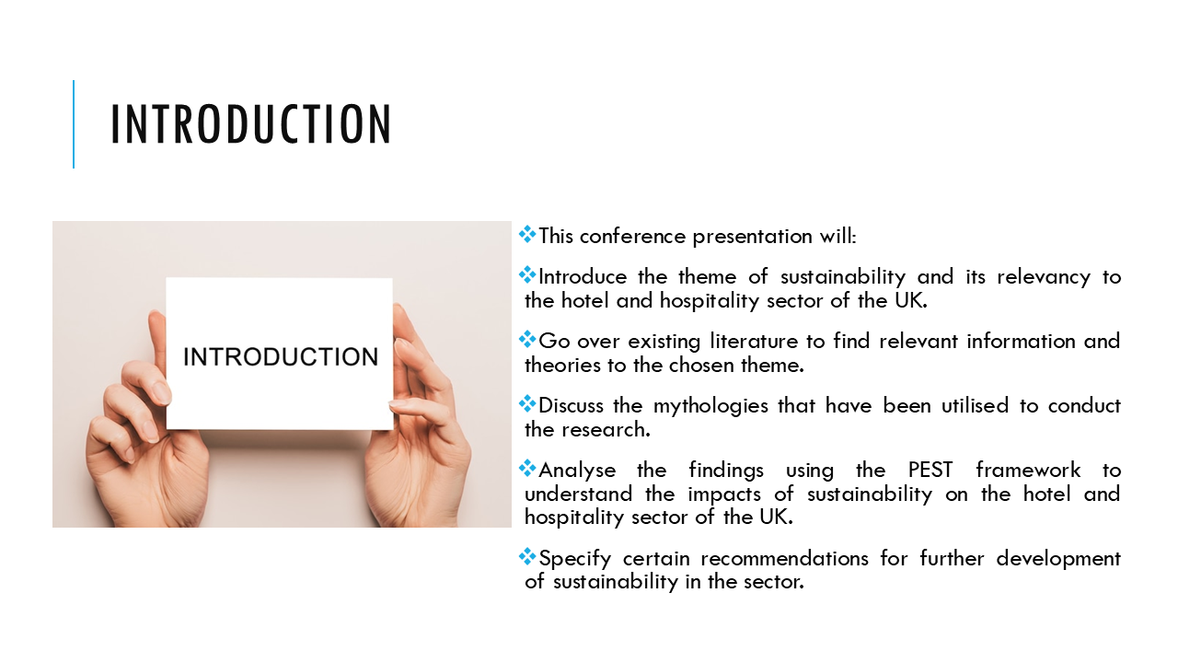

Slide 3: Literature Review
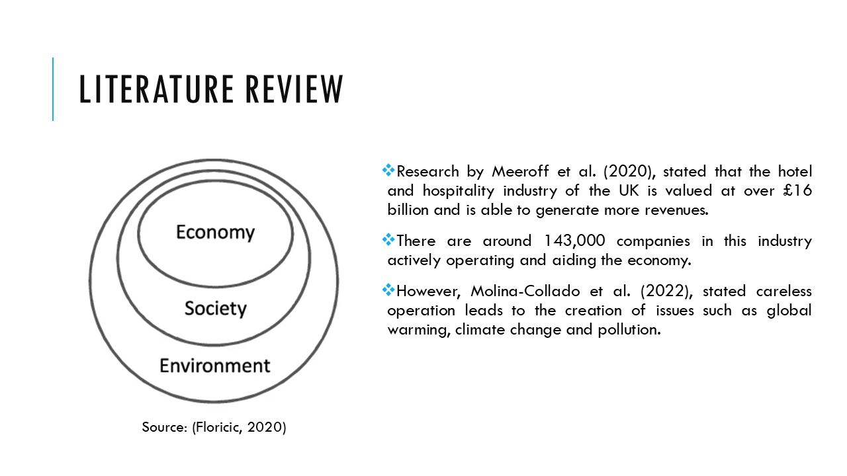

Slide 4: Literature Review (Cont.)
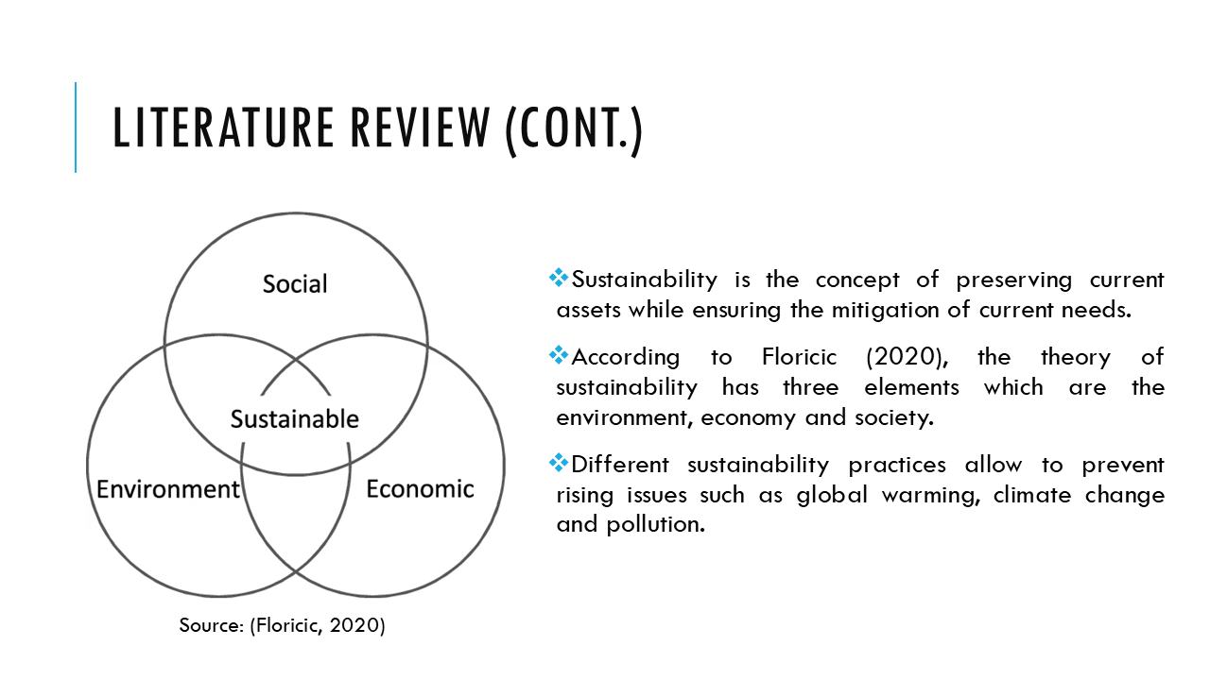

Slide 5: Literature Review (Cont.)
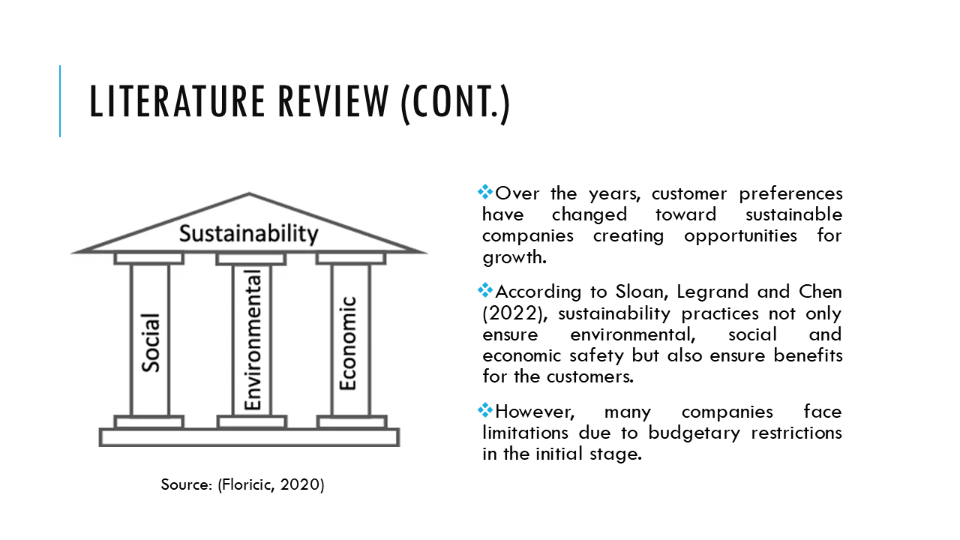

Slide 6: Methodology
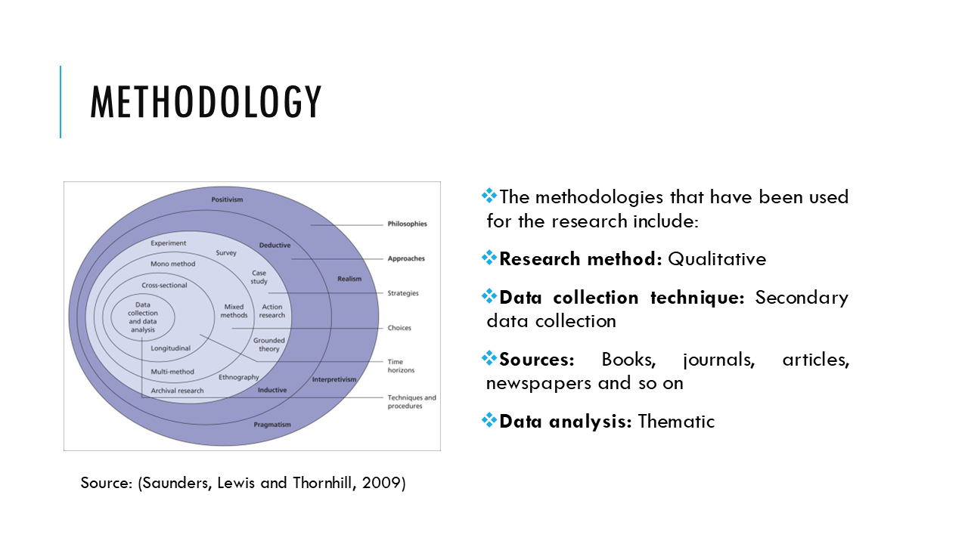

.

Slide 7: Theme Impact Analysis
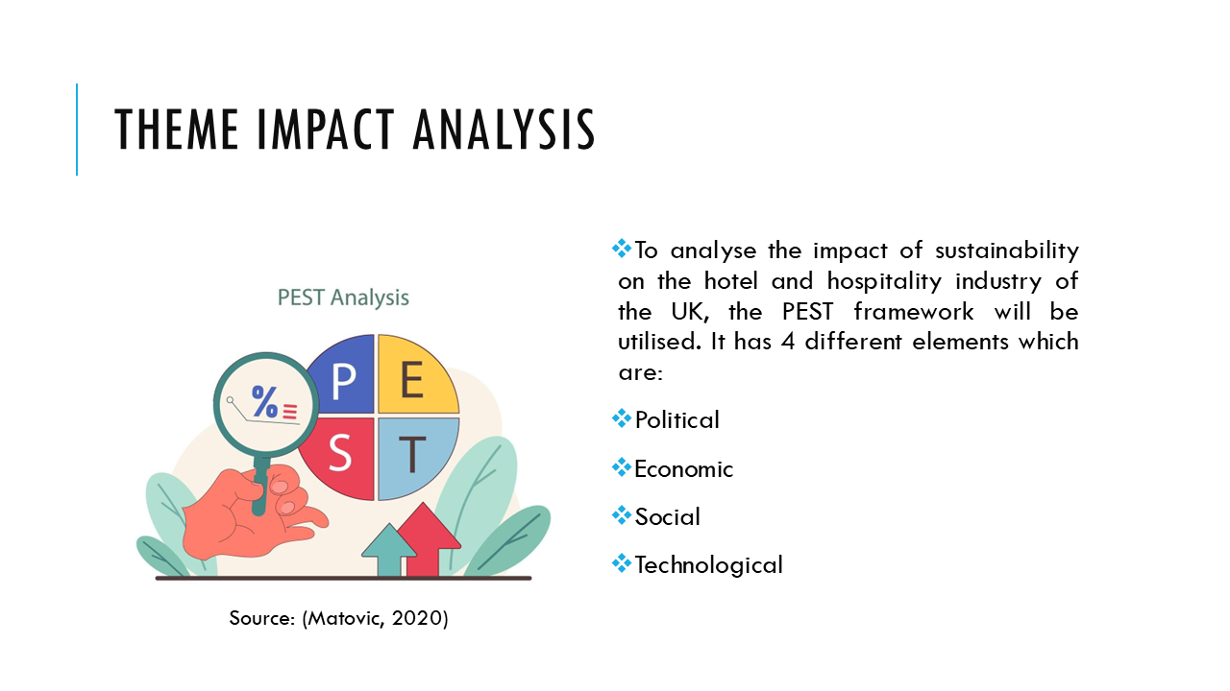

Slide 8: Theme Impact Analysis (Cont.)
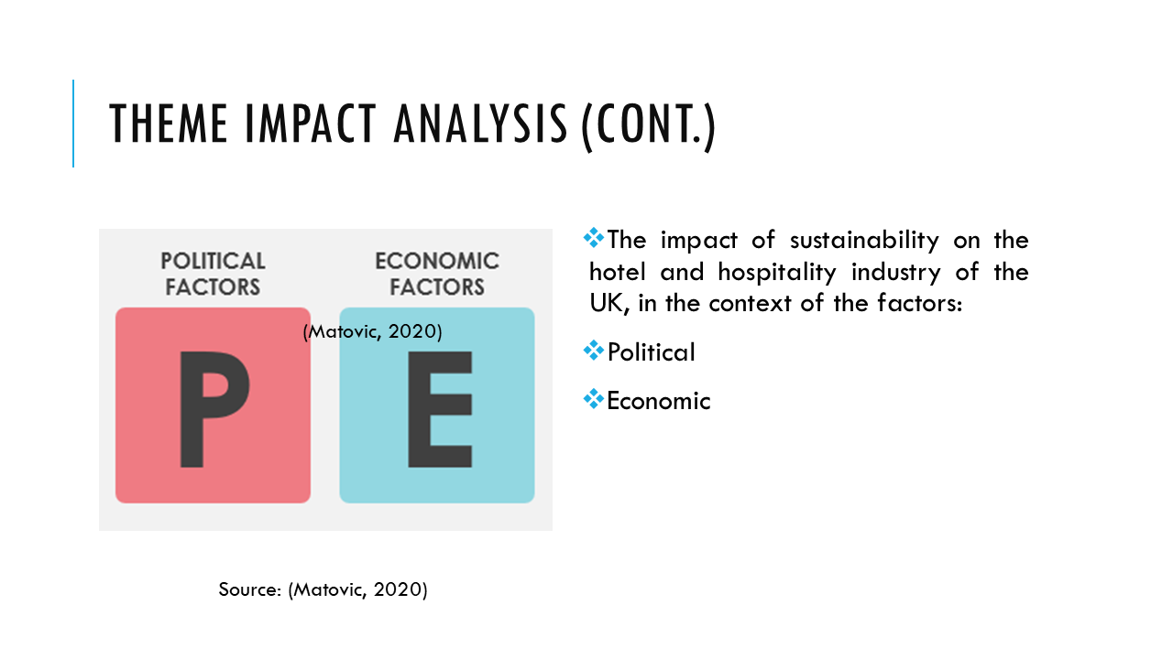

Slide 9: Theme Impact Analysis (Cont.)
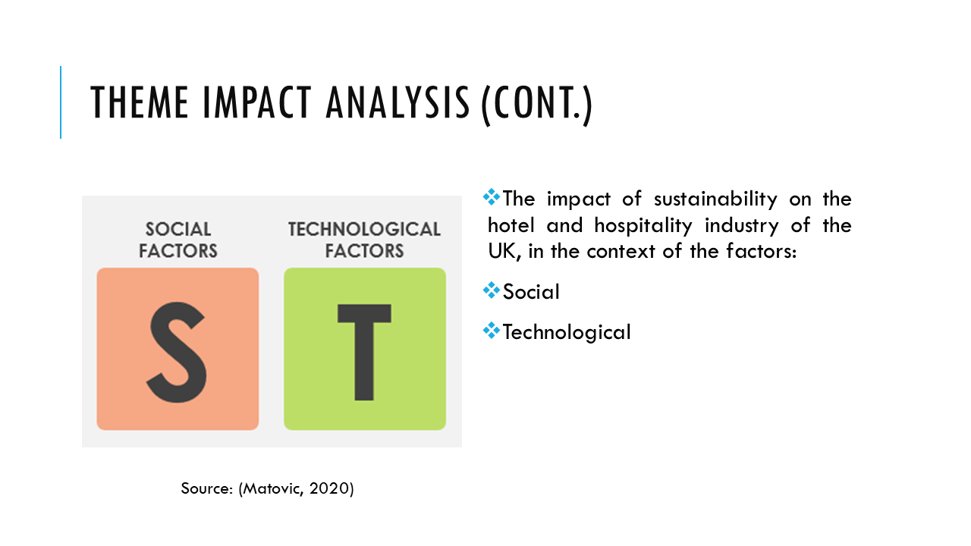

Slide 10: Recommendations
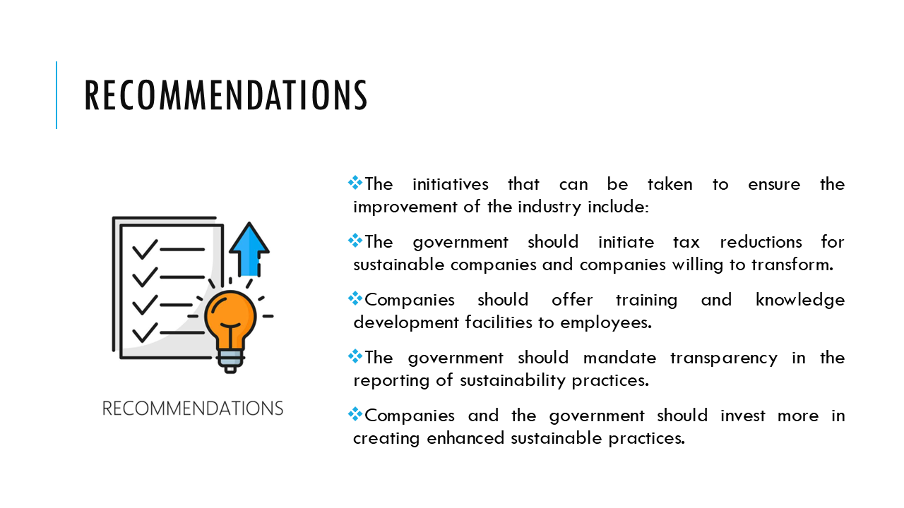

Slide 11: Conclusion
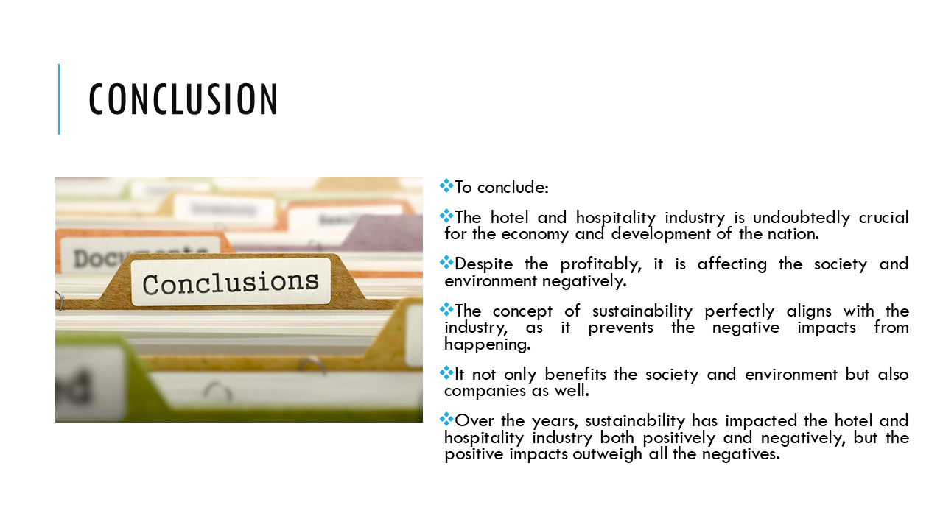

Slide 12: Reference List


