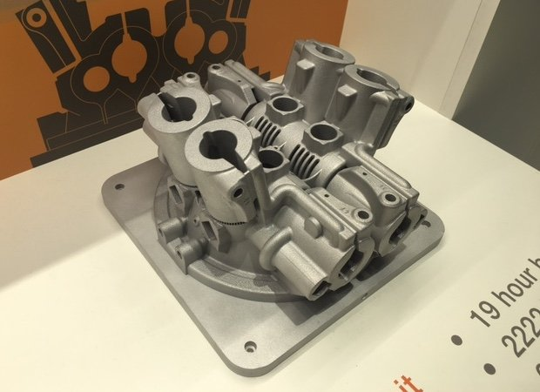
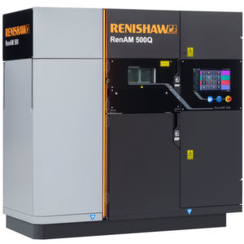

ACMA5009
Group Project

Pipe Cutting Jig
Ben Shears

Contents Page:
- Abstract
- Introduction
- Initial Gantt Chart
- Evaluation of planning techniques
- Critical Path Analysis
- Design Brief
- Feasibility study
- Lewin’s force field matrix analysis
- Initial ideas
- Evaluation of ideas
- Matrix Analysis
- Product Design Specification
- How was my PDS influenced
- Comparison of PDS to BS7373
- Importance of the PDS to the Final Design
- Legislation and regulations
- Trial Investigation into current method
- Research
- Costings
- Savings
- Final Gantt Chart
- Initial CAD design
- Development Ideas
- Final CAD design
- Machining engineering drawings
- Manufacture of project
- Cost of Project
- Evaluation of Project
- Seniors Comments
- Acknowledgement
- Referencing
- Appendix

Abstract:
This report is about a project undertook for the purpose of an improvement for the AM500 metal additive manufacturing production line. To save on cost of quality and scrap, it was decided that a pipe cutting jig needed to be designed to solve the issues of badly cut pipes impacting on the machines cost to manufacture. The issue was plastic PVC pipes were either being cut to the incorrect length causing them to be stretched or not fit at all. The other problem was the finish of cut, due to it causing the pipes not to seal in pneumatic fittings within the machine correctly. The current method was reviewed and trialled and automated pipe cutting machines were priced but they proved to be too expensive. The findings showed that each pipe took an average time of 2 minutes to cut. If that was halved which I believe it easily could be, then the cost of rework/scrap that would be saved is estimated at around £6800 a year. After presenting the finding to the senior engineer, a budget of £650 was allocated to the project to resolve the issue and start saving. My timescale for this project was from January 2021 to May 2021. The total spend ended up at approximately £600 out of the £650 budget which will be made back in under two months of production. In-house machining was used to save costs. I had great feedback from my Senior and the project was successful.

Introduction:
This report details a project suitable and beneficial for my department within Renishaw. The department called ADG (Assembly Development Group) are responsible for introducing new assembly products from design to the production world. They deal with setting up the production process and improving them as much as possible before handing them over to Renishaw’s current products team. Will George, a Process Development Engineer assisted the project.
The timescale for this project was 15 weeks, due to the length of the semester and deadline set by UWTSD. The spend budget for this project was as low as possible while still achieving good accuracy, quality and for the end product to be as cost effective as it possibly could be. The benchmark figure of £650 was allocated to me. Another main aim for this project was for it to be as ergonomical as possible. For the jig to be able to be used on the production line it must go through strict health and safety tests and comply with all regulations, including CE marking where necessary.

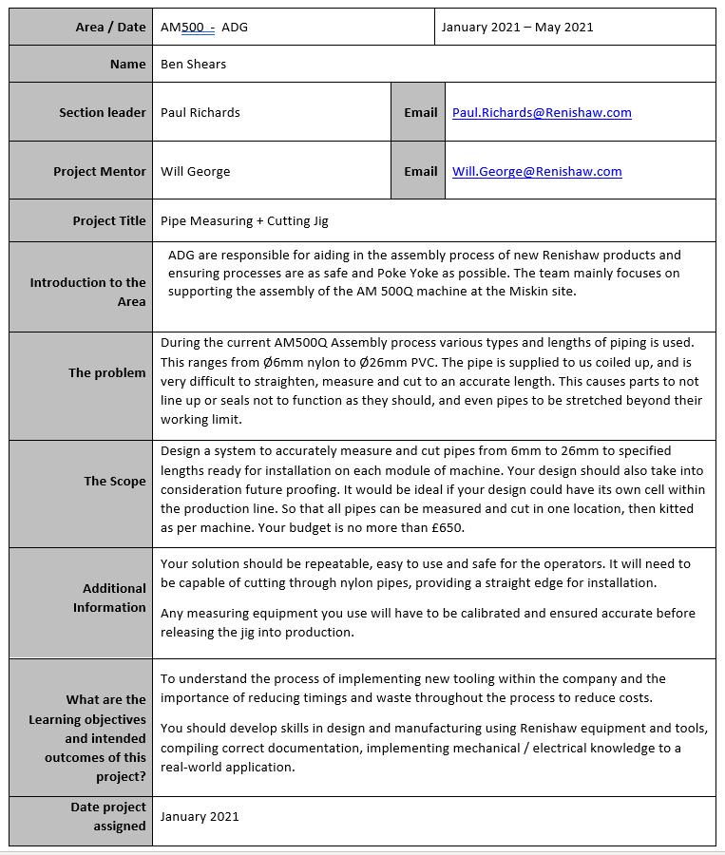
Design Brief:

Feasibility Study:
Financially:
The budget for this project is £650 and it is planned to pay for itself in less than 2 months. The jig also plans to save around £7000 a year by halving the cutting time and improving the quality of cut to reduce the cost of quality.
Ethically:
It is ethically correct to build this jig as it is going to reduce plastic waste (Incorrectly cut pipes) coming from the production line, it also isn’t harming the environment by giving off any fumes etc. It is likely to be powered by 24V so it will use little power, however we do have solar panels covering the roof of the factory to make us more carbon neutral.
Sustainability:
The jig will most definitely be made mainly from a soft metal, probably Aluminium so that it is strong and sustainable. The jig will be kept indoors at average temperature so will not be affected by the weather and will be expected to last 15 years as a minimum. The rubber on the rollers will wear and require maintenance checks but the rollers themselves will last as long as the jig and so will the electrical components providing they are not faulty or come in contact with liquid.
Maintenance:
The only maintenance that the jig will require would be minimal, such as simple visual checks of the condition of the rubber coated rollers to ensure they are intact before use. Every other component will be dealt with upon breakdown.
Summary:
I believe that this project is really needed on the AM500 Production line and I think when designed and implemented correctly it will pay for itself in a matter of months and save the company a small fortune in material and in manual rework hours. I plan for this jig to be in production for at least the next 15 years. In that time it would have paid for itself over and over again and would have saved at lot of money.
For the jig to be able to last for the next 15 years as a minimum then it will need to be robust and strong, made from some kind of soft metal such as Aluminium. I am not planning to sell the jig although for it to be placed on the production line it will need to be put through lots of legal legislation paperwork such as Risk Assessment, PUWER and CE Marking.

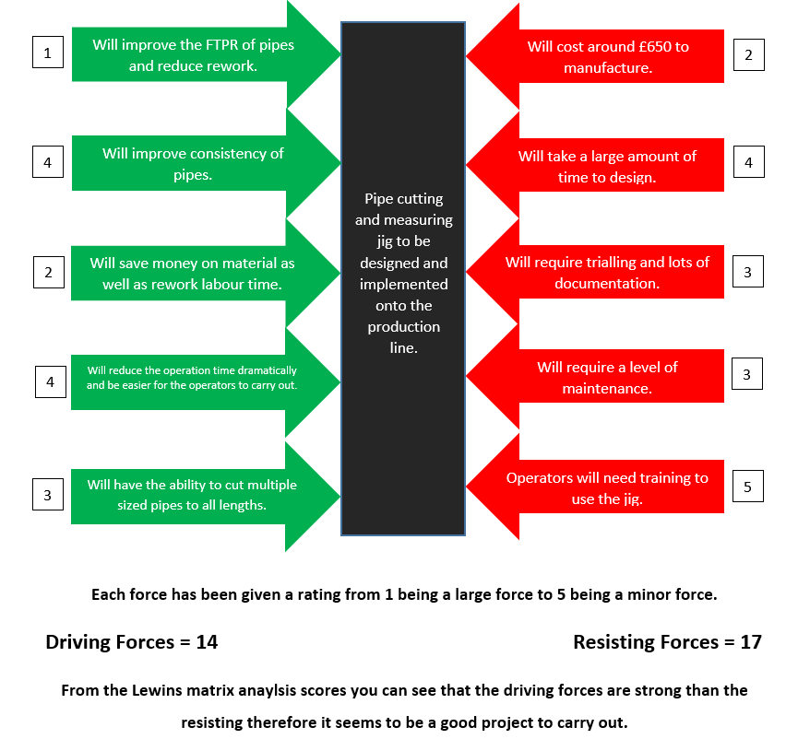
Lewin’s force field analysis matrix:

Initial Gantt Chart:
Figure 7a
Above in Figure 7a you can see the initial project Gantt Chart created on Excel and used to plan and stay on track. I inputted the project requirements and rough dates down the left hand side, then the Gantt Chart which you can visualise appears on the right to help you stay on track.

Evaluation of planning technique:
I chose this method of planning as I have used it on previous projects and it has proven to be successful, it is also a very simple package to use and ammend further down the line. My other option was to use a list or table format on word. With a list or table format it is very hard to visualize where you are with your project and if you are still on track. For this reason I chose to go with a Gantt Chart on Microsoft Excel as it had proven effective before. If I had done this project again, I would have been more realistic with planning the gantt chart out and would have left breaks for bank holidays etc. as I did struggle to keep up with my Initial Gantt Chart.

CPA:
CPA stands for Critical Path Anaylsis and it has been used since around the 1950’s. It’s a project management technique that requires you mapping out every task/meeting you require for project completion. You also need to set a timescale along side each of these tasks and decide on what order the tasks are going to be tackled and if they are dependant on other tasks or not. A CPA sets realistic deadlines for project tasks to track your projects progress, it calculates these times from the data that has been inserted and sets realistic deadlines for project tasks to track your projects progress throughout.
In basic terms:
- CPA is a project planning technique that focuses on identifying tasks that are dependent on other tasks for quicker completion.
- The tasks dependencies are key to realistic deadlines and timely completion.
- CPA is commonly used in industry, especially ones that carry out highly complex projects.
How to use CPA:
CPA detects all of the critical and noncritical tasks involved in a project and notes if the task is dependent on any other tasks. It then tells you the amount of spare time you have with each task so that you can still achieve your deadline effectively. The project must be monitored continuously updated like all planning methods, this ensures every task is on track and no further adjustments need to be made. The timeline of a CPA is usually displayed as a Gantt chart.
(Kopp, 2019)

Initial ideas -
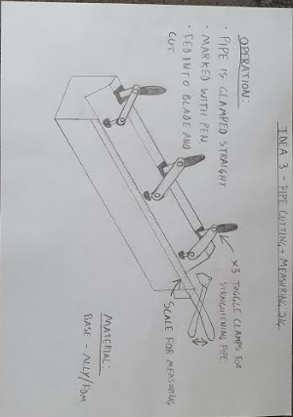
Figure 9a
This is a basic concept that encompasses an off the shelf pipe cutting tool. The operator would clamp the pipe down to the long V-shaped block with the end of the pipe against the blade, they would then mark the pipe with a pen, unclamp the pipe and move the pen mark to the blade and reclamp. The pipe cutters can then be squeezed giving the pipe a nice clean cut.
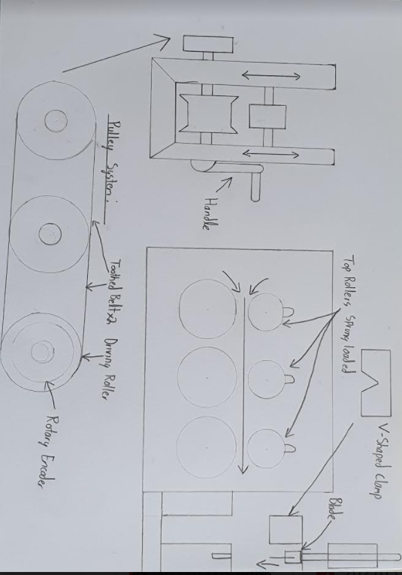
Figure 10a
This concept is a bit more complex and more expensive but will reduce the operator’s actions considerably and speed up the process. The pipe would be fed through the 6 roller system with the top rollers being sprung straightening the pipe. A datum cut would then be performed by pulling down on the press which has been modified to have clamps and a blade. The rotary encoder would then need to be zeroed and you can feed the correct length pipe through using the handle and checking the encoders readout. The rotary encoder reads CW and CCW movement so if the operator was to go longer than needed then they could rewind it and perform the cut.

Evaluation of ideas –

Idea 1 (Figure 9A):
Good points:
- Will reduce operation time minimally.
- Low Tech so less maintenance needed.
- Proven cutting method.
- Wont need CE Marking.
Bad points:
- Requires a lot of actions for the operator to carry out.
- Nothing stopping operator making a measuring mistake.
- Not Poke a Yoke.
- Large jig.
- Heavy jig.
- Not overly accurate.

Idea 2 (Figure 10a):
Good Points:
- Highly accurate.
- Small compact Jig.
- Repeatable.
- Will produce a better cut than current method.
Bad Points:
- Expensive.
- High tech.
- Due to the press being adapted with a blade this causes a big safety risk so the jig will require guarding.
- Will need CE Marking.

Matrix Analysis
I chose to go with a matrix analysis rather than a Pugh Chart as although there are pipe cutting jigs in the market, most are highly automated and highly expensive so I didn’t think it would be fair to mark my jig off one of those machines due to my budget being £650.
 | Idea 1: | Idea 2:
Ease of manufacture | 2 | 5
Health and Safety | 5 | 3
Lifespan | 4 | 5
Cost | 4 | 3
Saving | 3 | 4
Maintenance | 4 | 4
Total - | 21 | 24
Table 12a
Key:
5 – Excellent
4 – Very Good
3 – Good
2 – Poor
1 – Very Poor
Looking at my matrix analysis (Figure 12a) I can see that the best choice for me to pick judging on the total score would be idea 2. This would be the sensible choice as it would save the company the most money due to its minimal operations, and also its reliability in comparison to Idea 1. I could also future proof this idea so it to be used on a larger variety of pipes for future products.
Document Title:
Pipe Cutting Jig - Specification - T-00044
Summary / Scope:
This jig will assist the operators in all the cells of the AM500 production line to cut all different types of pipe to the correct length accurately, with a good quality and square cut. Before they had a problem cutting the pipes square and to the correct length due to the pipe being bent and being supplied in coils. This will save the production line time and money as I am hoping to at least half the cutting time by taking manual measuring and marking out of the equation.

Assembly Definition
The assembly which is going to be cut, will be all the different types of pipe, ranging from 6mm Nylon to 26mm PVC.

Assembly Function
These pipes are used on the 500ML machine for the argon gas in and around the machine and are also used for recirculating metal powder around the machine which is used as filament to 3D print.

Specification
Key:
E = Essential D = Desirable
= Specification point met
= Specification point requires testing (The spec may be met by design but requires testing)
= Specification point has not been met
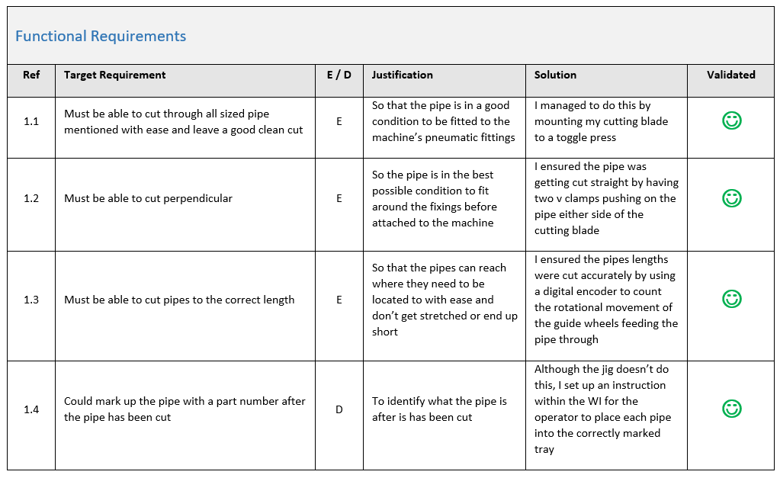
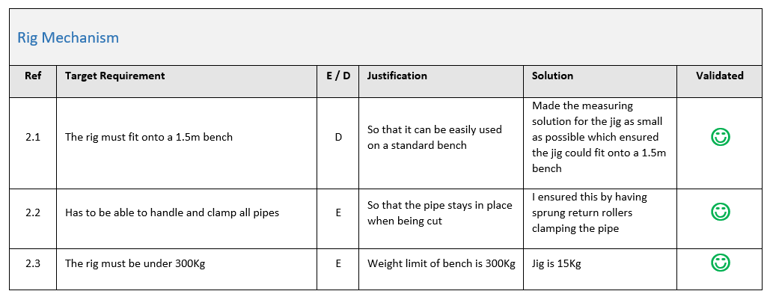
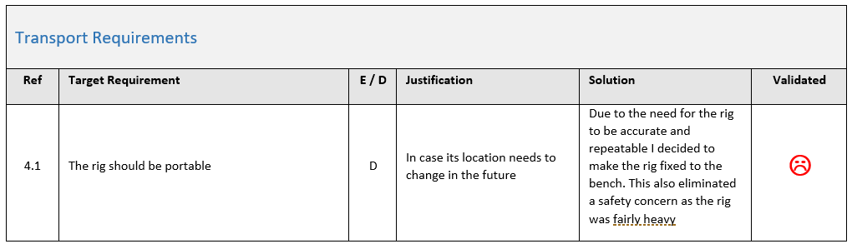
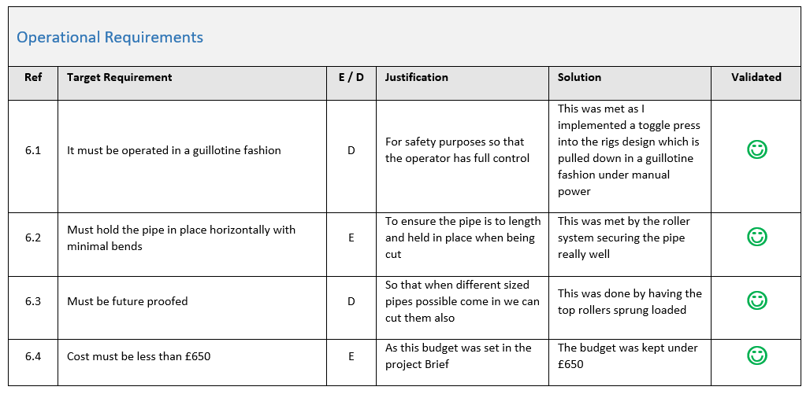
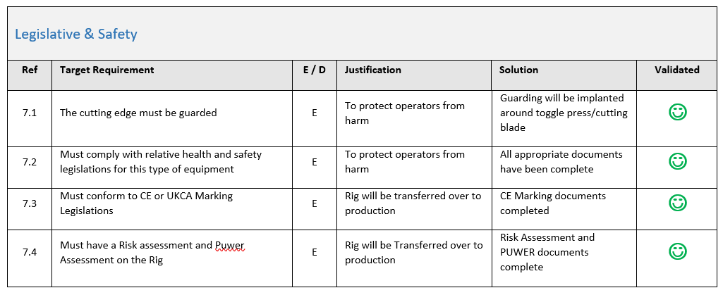
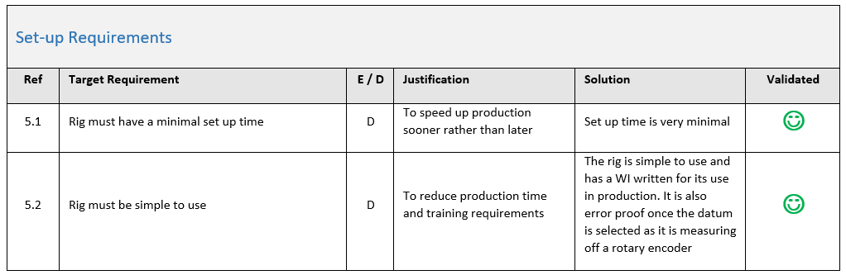
How was my PDS influenced by the Brief:
There were a number of aspects in my brief that influenced my product design specification such as the fact that the pipe cutting and measuring jig had to be adaptable for all sized plastic pipes cut on the AM500 3D Printer production line. Another one would have been the budget of £650 stated in the Brief.
Comparison of PDS to BS7373 Industry Standard Version:
I believe the content to meet the industry standard BS7373 is there although the format and layout is slightly different. The formatting is down to me using Renishaw’s standard template, by the company having a template it prevents us forgetting sections of the product design specification and also it is more professional for external people such as customers to constantly see the same template no matter the job requirement. The compliance group of Renishaw designed this product design specification and it complies with all necessary EU documentation including BS7373. The document template was last updated in 2018.
Importance of the PDS to the Final Design:
The PDS has a massive effect on the final design as the PDS is what constrains the aspects of the project such as weight, size, strength, function etc. An example would be in my design specification I mentioned the budget of my project was no more than £650 and I kept my final design below that. Another example would be the cutting fashion of the jig, stated in the PDS it should be a guillotine fashion cut where you pull down a large lever, this was achieved by having the blade mounted to the toggle press. Certain aspects within my PDS were essential and some were desirable. To give you an example one of the jigs desirable transportation specs was for the jig to be portable but in the last stages of the project it was decided that it was best to keep the jig fixed in case of damage and so we can monitor it easily and it can be stationed next to a power source.

Legislation and regulations:
This is a more detailed view at the strict health and safety legislation that jigs and fixtures that are going to be released from development into production need to go through:
Every jig needs a Risk Assessment and PUWER document of its own. If the jig has any of the below then it needs to go through a CE marking process:
- Voltage going through it (No matter how small)
- Pneumatics or hydraulics
- Explosive or highly flammable components
- Handling parts that go into the medical industry
- Safety jigs/fixtures that keep people from harm
What the documents are:
Risk Assessment – The Risk Assessment is a document to ensure you have thought about and documented all possible risks from as little as sharp edges to crushing points or shock risks on your jig/fixture. If a risk is identified for example “Sharp Edges” then you must do what you think is necessary to try to reduce the risk such as putting a radius on the edge. You must then score the likelihood of someone getting hurt after the action has been taken so how commonly it would affect the operator along with the severity it would inflict on someone. You must then add your scores up and come to terms with whether it is expectable, if not then you need to redesign of the jig. When complete the Risk assessment needs to be signed by a manager.
PUWER – Provision and Use of Work Equipment Regulation. This document is there to make working life safer for everyone using and coming into contact with machinery and equipment, including employers, employees, contractors, suppliers, and anyone else who might use or have access to machinery in the workplace. The regulations aim to ensure that all equipment is:
- Suitable for its intended purpose.
- Regularly maintained to ensure safety.
- Only used by people who have received adequate training.
- Inspected by a competent worker.

CE Marking – The CE Mark is a symbol that must be attached to most products before they can be sold on the European market. The symbol shows that a product: Meets the necessary European product directives. Meets all the required performance and safety standards. However, Jigs and fixtures on production lines within Europe also need CE marking to safeguard operators from dangerous accidents. Some basic jigs don’t require CE marking but all electrical jigs and jigs that move under pneumatic/hydraulic power require this.

The CE marking process:
At Renishaw we have our own CE marking template that we use. We fill out the basics such as weight, size, voltage etc. then send it off along with the jigs Risk Assessment and PUWER document to Renishaw Compliance Team. They then arrange a meet with the jigs designer and walk through the process before awarding the jig with a CE Mark or stating the things that need to be done or changed to be able to pass the Jig/Fixture.

Trial to investigate the current manual cutting method:

To see how accurate the manual cutting method with pipe cutters and a measuring tape and marker was, I asked 3 operators to manually cut 4 types of pipe to a given length as they normally would do, and for them to try their best to get it as accurate and as close to the length as possible.

Pipe Diameter: | Method: | Length given: | Length cut to 1st time: | Length cut to 2nd time: | Length cut to 3rd time:
6mm Nylon | Pipe cutters and tape measure | 600mm | 605mm | 594mm | 608mm
10mm Nylon | Pipe cutters and tape measure | 475mm | 473mm | 476mm | 479mm
19mm PVC | Pipe cutters and tape measure | 650mm | 660mm | 645mm | 662mm
26mm PVC | Pipe cutters and tape measure | 930mm | 949mm | 922mm | 935mm
Table 19a
As my results show in Table 19a, these methods aren’t the most accurate. The operators cut the 26mm PVC around 19mm too long at one point. On the other hand, the nylon pipes were cut better with plus or minus 8mm. Even so, there is still room for improvement.
I think the reason for the problem is related to the fact it is so hard to straighten due to it being stored in reels. Therefore, when you want to straighten it to measure and mark, it proves difficult causing errors to be made. The longer the length of pipe the larger the error margin due to the difficulty of measuring a bend pipe.

Research
Pipe cutting tools:
I researched pipe cutters to see what designs were on the market. Most cutters on RS Components which is a large vendor for Renishaw seemed to be identical to each other just different brands, colours and handles etc.
There seemed to be three main design variations across them all:
- A scissor type motion cutter with only one blade, the other side had a v shaped female connector groove cut into it for quality of cut purposes.
- G Clamp motion where the blade is pushed into the pipe on a thread.
- The other cutter worked by being spun around the pipe, but looked mainly for metal piping rather than PVC.
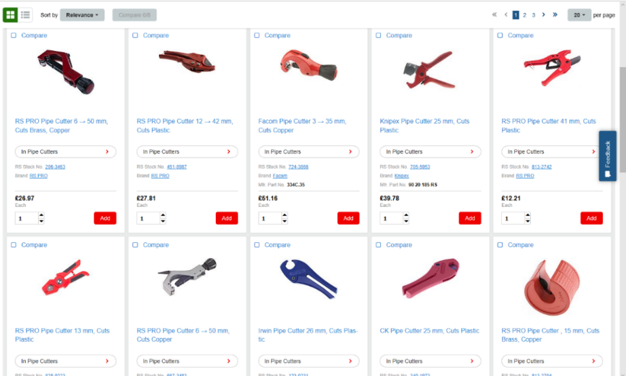
They all seemed to be priced fairly similar and seem to be equally rated.
(RS Components, 2021)
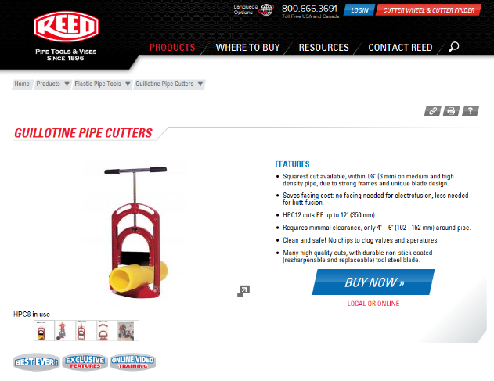
I looked into a guillotine styled system on a thread as shown in the photo below, I liked the idea and was thinking I could adapt it so the blade is actioned by a toggle press and not a thread, this would speed the cutting process up, although I would need to take safety measures and maybe install a guard around it.
(Reed Engineering, 2021)
I also briefly looked into automated machinery like the machines below:
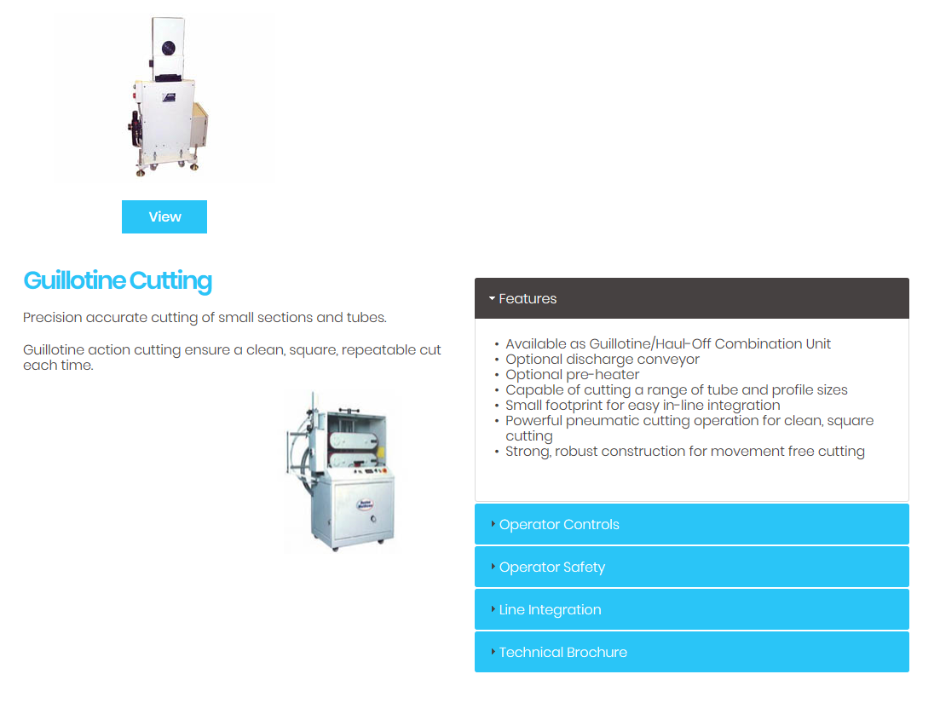
(Boston Matthews, 2021)
These proved to be way above the budget set in the brief, but I thought it was worth looking into to get some more ideas of their mechanisms and processes.

Work Holding Methods:
One of my initial thoughts was toggle clamps along the base or channel to hold the pipe down where it starts to bend. The pipe would then be held between the bed which I could make V shaped.
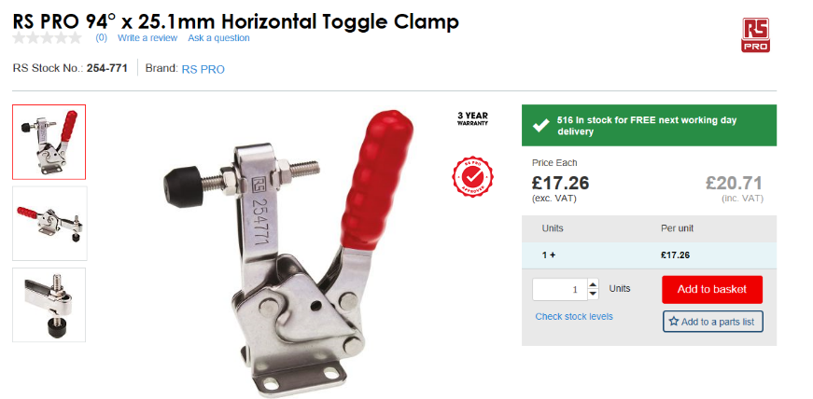
Toggle clamp from RS:
(RS Components, 2021)
Basic G Clamp:
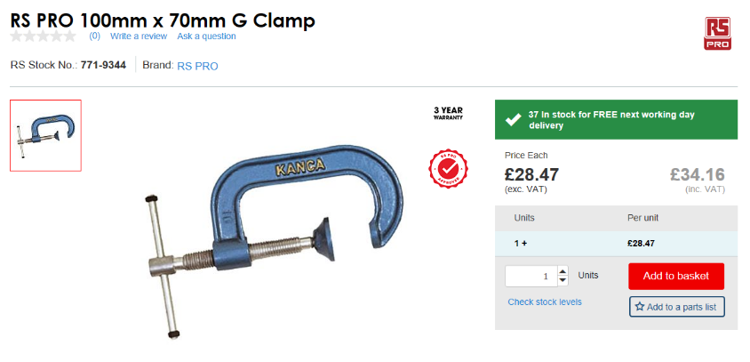
(RS Components, 2021)
Bit too bulky for this project and time consuming to operate.

Presses:
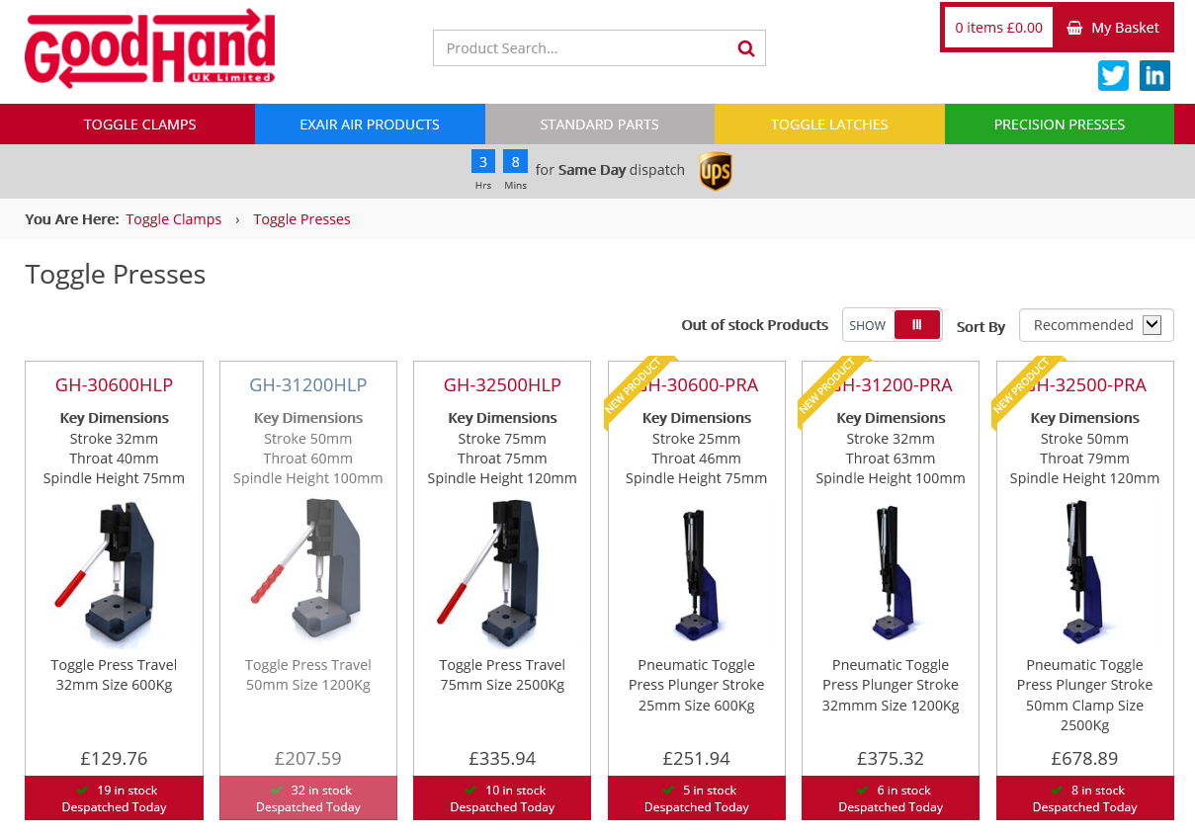
(GoodHand, 2021)
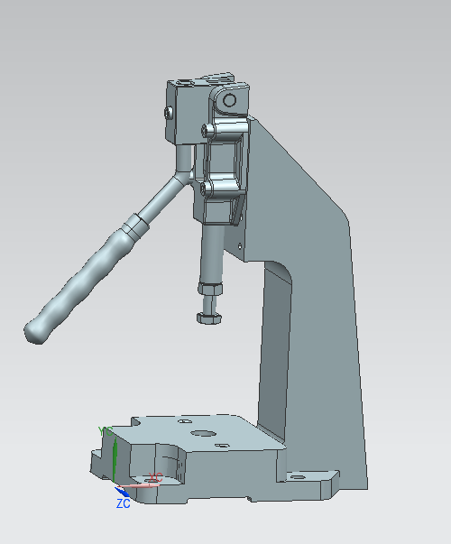
I was able to obtain a CAD model to see which press was the best suited for the project.
I quoted Schmidt one of the leading press companies around the world. They quoted a suitable press at the cost of £701.
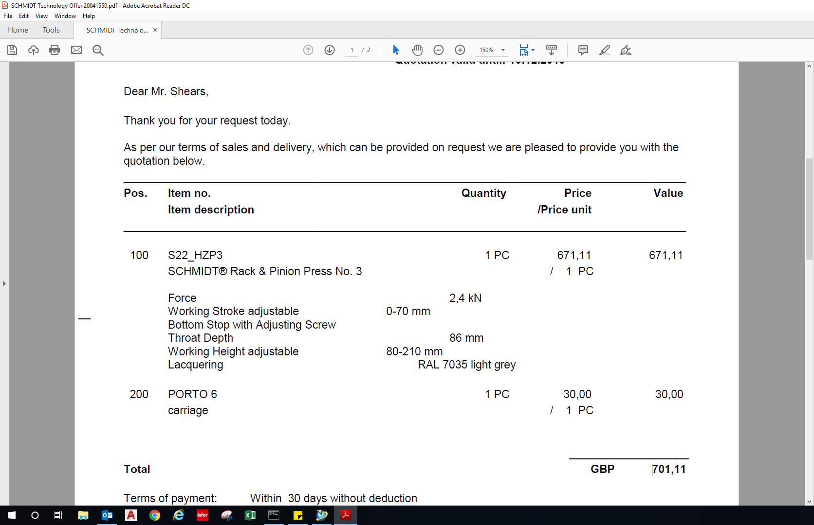
Quote obtained by Schmidt

How much badly cut pipes have cost us in time and money over a year:

From January 2020 to January 2021 according to the logged faults spreadsheet the technicians have had 21 different occurrences which were caused my badly cut pipes.

By the terms badly cut pipes, this could mean any of the below:
Not a square cut (Angled or pointed)
Not a smooth finish edge (Rough and jagged edge)
Incorrect length (Therefore can’t reach or can’t be bent to fit)

Any of the above cause leaks to occur which slows production down as the commissioning tec’s jobs become harder. Therefore, this is a problem.

The total number of hours spent on these 21 occurrences according to the commissioning faults spreadsheet is 28 Hours.

The cost of quality for this would be £111 over the year.
The cost of an operator’s time for this would be £2355.08 over the year.

How much time and money it takes for pipes to be cut by the operator over a year:

(Timings for pipe to be found, cut to size, and material returned back on shelf. Based on the pipe being stored at the back of cell)

10mm Nylon pipe: 2 Minute
12.5mm Blue/Red pipe: 1 Minute 58 Seconds
19mm Blue/Red pipe: 2 Minute 03 Seconds
26mm Clear pipe: 1 Minute 50 Seconds

The Average time for a pipe to be cut and prepared for fitment is roughly 2 Minutes.

There are 59 different length and diameter pipes that need to be cut to build the AM500Q Machine.
Therefore, the time spent cutting pipes ranges upwards of 1 hour and 58 minutes per machine.
The hourly rate of labour including all the heating costs and floorspace for the RenAM assembly line is £84.11.
If production were to produce 2 machines a week the annual cost for operators to cut pipes themselves would be £8747.44 a year.
I am hoping to reduce the average pipe cut to under a minute with my jigs.
This will hopefully make an annual saving of £4373.72.

Total Saving of £6839.80

Amended Gantt Chart:

Figure 26a
See my amended Gantt Chart above in Figure 26a. I needed to make some alterations to ensure my final Gantt Chart was a true reflection of my project so far. Personally, I found Excel really user friendly for planning techniques.

Initial design –
My initial design was a long v shaped block with toggle clamps along the v shaped channel and a scale along the side of the block. This was simply to measure the pipe, the cutting method would stay the same.
The operation would have been, you slide the pipe in then clamp all the toggle clamps down to straight pipe then mark the pipe with reference to the scale. You would then remove the pipe and cut it using a pipe cutter tool.
Developed CAD concepts –
Points I picked up on that needed thinking about:
Straightening the pipe – When using the initial concept, it was hard to keep the pipe straight.
Measuring the pipe accurately – Measuring the pipe accurately proved difficult in my initial concept and there was a huge risk for operator error.
Cutting the pipe – I wanted to eliminate the possibility of not cutting the pipe square with the pipe cutting tool.

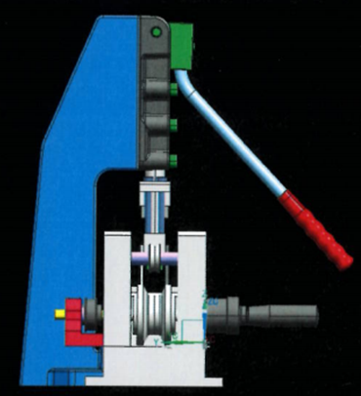
Final design –

To the left in Figures 28a, 28b and 28c you can see my final design. I designed this using Siemens NX. Work placed me on a 1 week CAD course to be trained up on the software, I have had previous CAD experience so picked it up pretty quickly.

Figure 28a
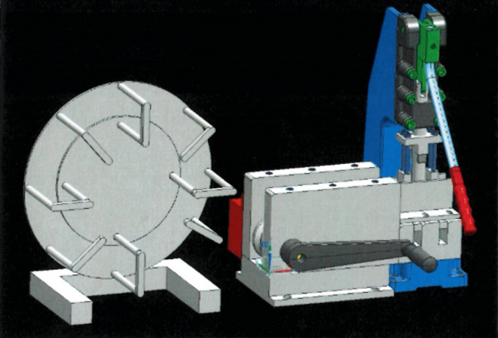

I am now going to explain briefly how the jig works:
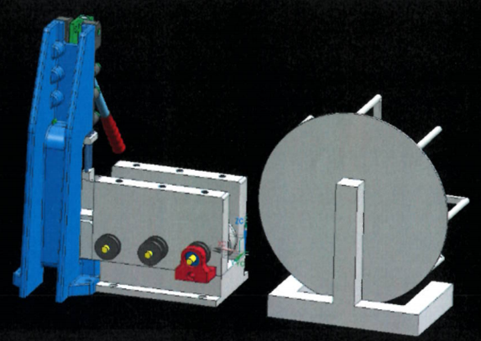
My jig consists of a sprung roller pathway where there are three large bottom rollers with three small top sprung rollers. The pipe is fed through the rollers with a crank handle which turns pulleys connected by timing belts at the back of jig driving all three bottom rollers feeding the pipe through into the jig. Once the pipe reaches the datum cutting edge which is the blade. The counter driven by the rotary encoder is zeroed and the pipe is driven through to the correct length. The blade which is attached to a toggle press fixed to the bench along with the jig is then pulled down which cuts the pipe with force. You can continue to cut various length pipes without zeroing the counter as the press has a proxy sensor attached to it so it zeros every cut.
Figure 28b

Figure 28c
Calculations for a pulley system with timing belts:

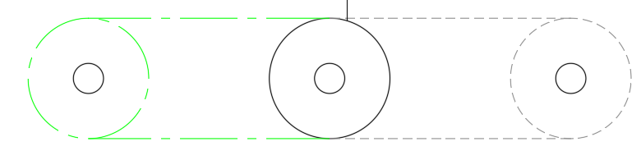
Figure 29a
Outer circumference of Pulley: 3.142 x 31 (Diameter) = 97mm
97 + 160 = 257mm
The belts will need to be 257mm long each.

I worked out by trial and error on a scrap piece of metal by milling holes accurately that the correct distance that each pulley should be from one another for the timing belts purchased to tension correctly would be 160mm.

Some of my machining engineering drawings and materials used:
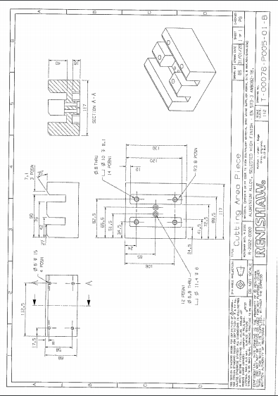
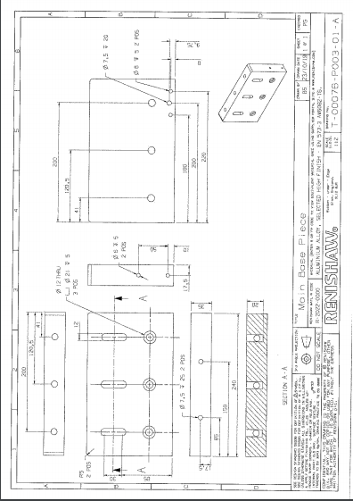
For me to manufacture my jig I had to design each part and create an engineering drawing with the correct dimensions then send the drawings to small batch within Renishaw. The lead time was around 4/5 weeks.
Figure 30a
Figure 30c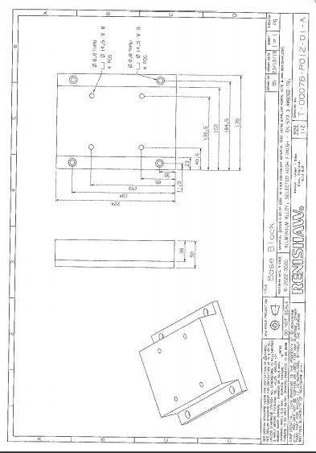
Materials:
All machined parts including the rollers were made from Aluminium so that is was cheap and easy to machine as well as being sustainable, long lasting and robust.
Figure 30c
Manufacture of project:
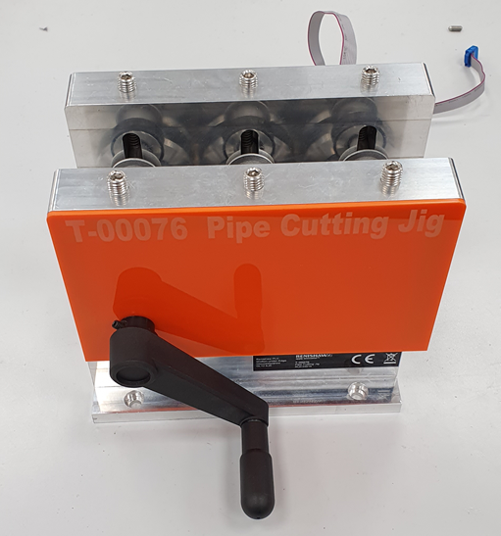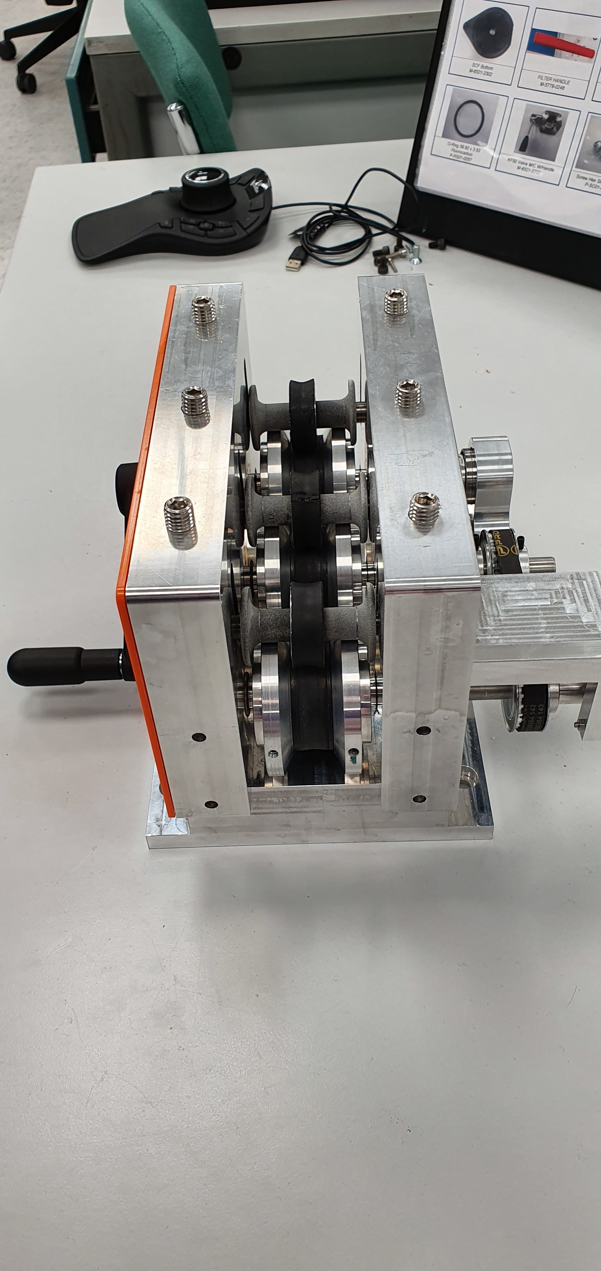
Figure 31a Figure 31b
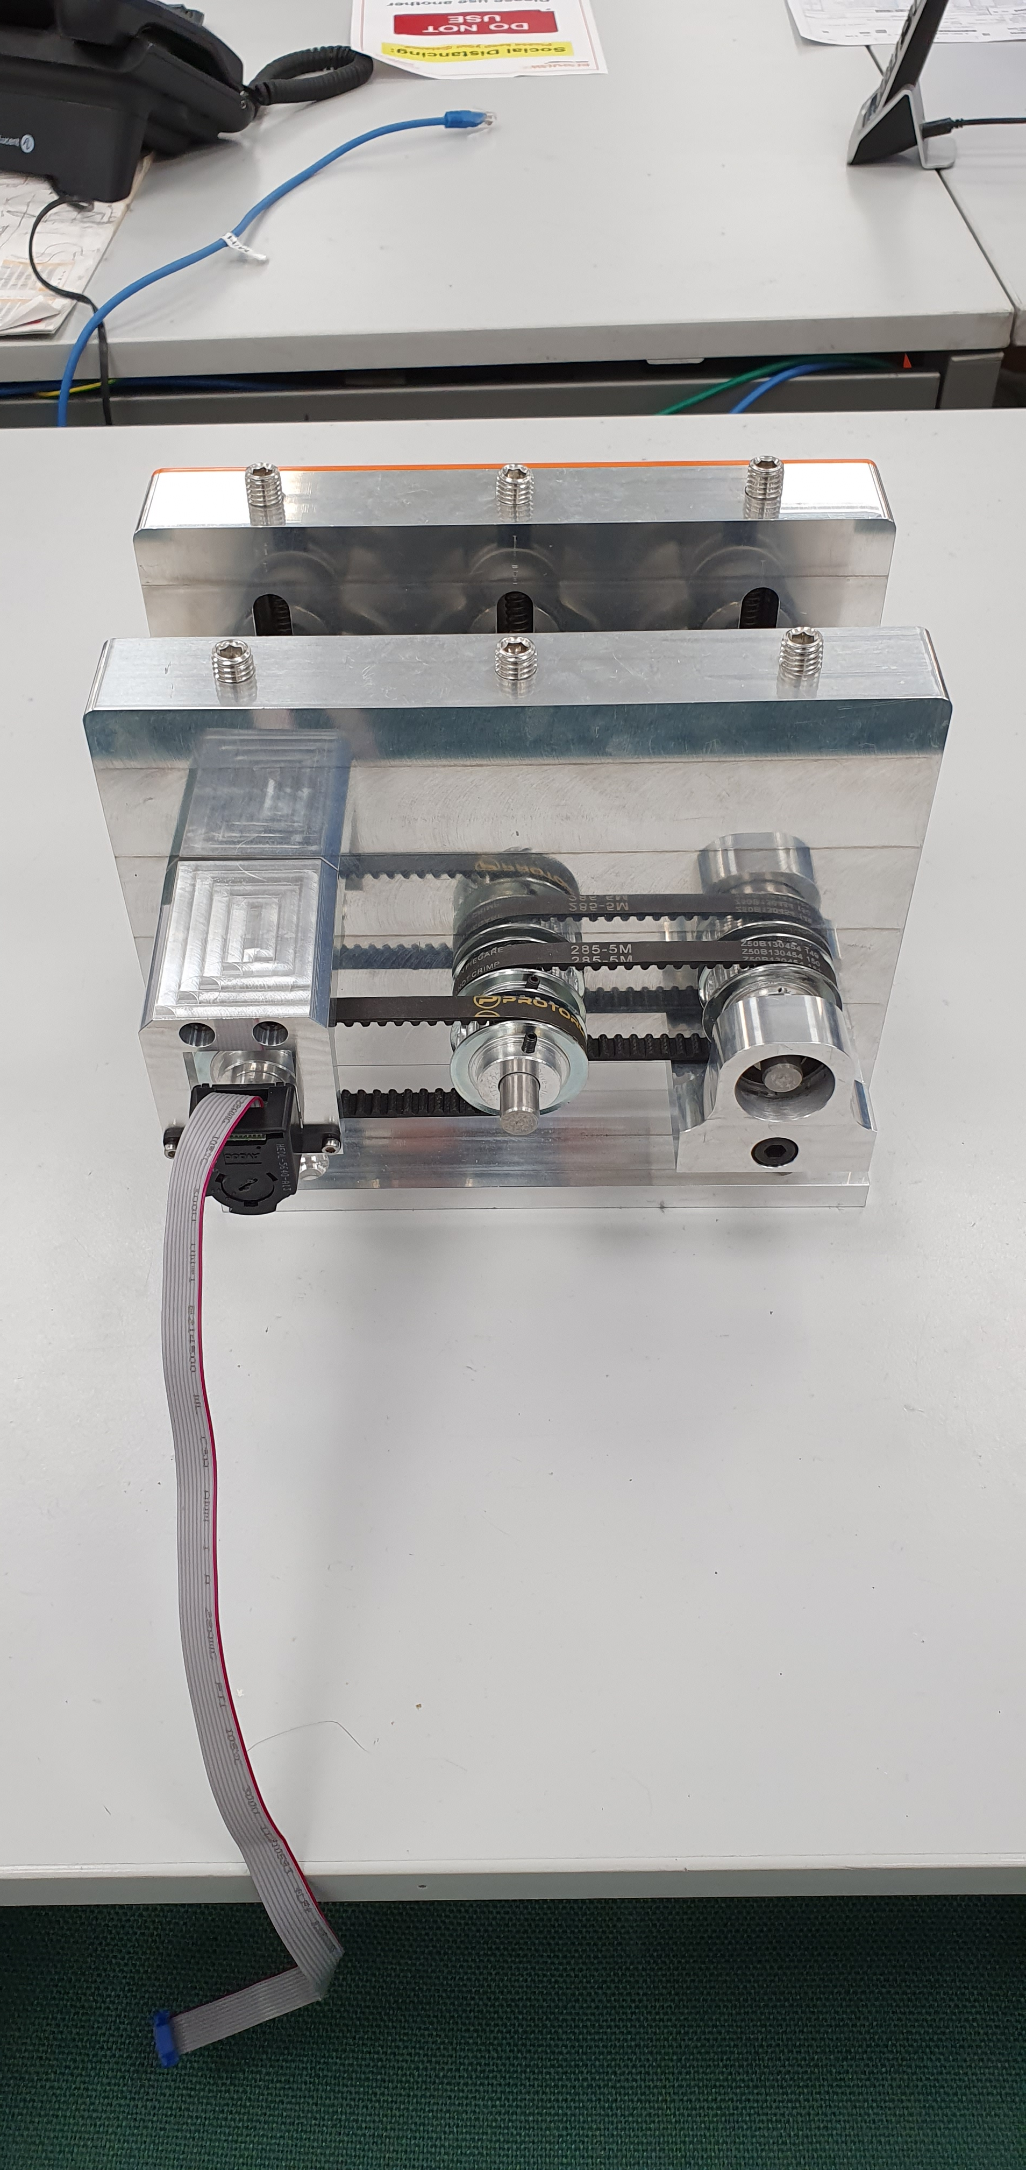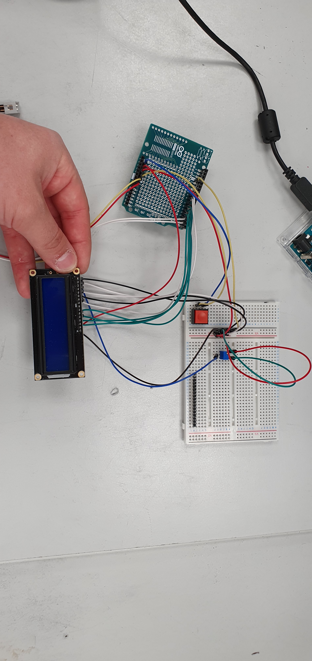
Figure 31c Figure 31d
Above in Figures 31a, 31b, 31c and 31d you can see some images of the project and how the project is coming along. In the bottom right image you can see the LCD read out screen which is going to be programmed using an Arduino UNO board and mounted to the jig to read out the length of pipe.
How the jig is assembled:
The top and bottom rollers both have bearings within them and slide onto a 8mm Aluminium Rod which then locates tightly into either side piece of the jig. Once the rods holding the rollers are secure you can then mount the side pieces onto the base block to keep everything together, this is done by x4 M8 bolts fastening from underneath. The cutting area is then placed on top of the bed of the press bought and is secured by four dowels into the side pieces.

Evaluation of my Project:

Planning:
I feel like my planning was to a good standard in this project. I immediately started off with an Initial Gantt Chart which helped me see what needed to be done. I then converted this into a list or contents page. Then one by one I completed each section from the contents page. When I got around the half way point I updated my Gantt Chart to suit. My diary also helped me update this accurately as I had been keeping a record and date of what I had been doing and when.
Time Keeping:
Although I had a Gantt Chart I did wander off this plan slightly, this is why I kept a diary and made an updated Gantt Chart. I think the main reason for me not sticking to the Gantt Chart was not having enough time to collect data and things I needed in work such as photos. Also it was difficult to get hold of the engineers to discuss ideas as they were always very busy.
Research:
My research was very thorough. I trailed and tested a lot of different aspects such as the pipe feeding/holding method, the cutting method, and also small things such as the distance each pulley needs to be for the belt to be tensioned correctly. Overall I was pleased with the research carried out and was confident with my findings of what makes a good cut.
Design:
Looking back at my initial designs they wouldn’t have worked, although my final and developed idea wouldn’t have grown the way it did if it wasn’t for them. I am pleased with the way my final design has ended up and the fact it has incorporated bearings and pulleys on the CAD model. Along with the model of the press.
Manufacturing:
When it came to manufacturing when all the components and parts had arrived at work. Mostly everything went smoothly although we did have a problem with the friction/grip of the Aluminium rollers and getting the rotary encoder to read correctly.
Quality of designed product:
I believe the quality of the finished product is great and believe people would actually buy my design for their production lines.

Up to date costings:
The project has cost around £300 for all the machined components and purchased parts. The press cost £250. The budget for the project was around £650. Therefore, I will be completing the project very close to the budget set with a £50 buffer to spend on critical spares. However, this jig will pay for itself in a matter of months.

Comments from my Senior Engineer:
“Ben has taken a big project on board in hope of solving a long lasting issue on the production line and I think so far he has done an fantastic job and is on track to solving the issue. I have been monitoring him throughout this project and I am pleased with all the design changes and advice he has taken on board. I think Ben has learnt a lot from this project such as limits and fits, the use of inner and outer bearings. I think the part Ben didn’t do so well was mapping everything out more realistically at the start on his Gantt and possibly sending off for parts separately rather than in bulk so he could finish the build faster.” – Senior Process Development Engineer (ADG Miskin)

I am pleased with Pauls comment above and I agree on the improvements I could have made by ordering in bulk and possibly planning better. I also agree that I have learnt a lot from this project as I have been working alongside experienced engineers and haven’t been afraid to ask them questions throughout the course of my project. The other thing I would change about my project is the length of time it took me to complete, although I had delivery time taking a big impact towards to end of the project at the build stage I feel like I could have completed the research and design stage a little faster instead of prioritising other small tasks.

Acknowledgement:
I would like to thank Paul Richards, Will George and Jack Brooks for their involvement in this project, they have helped me throughout and provided some good ideas and methods which I have taken on board. This is the first group project I have carried out and I feel like we worked really well together.

Works Cited
Boston Matthews, 2021. Boston Matthews. [Online]
Available at: https://www.bostonmatthews.com/tube-cutters/
GoodHand, 2021. GoodHand. [Online]
Available at: https://www.goodhanduk.co.uk/Catalogue/Toggle-Clamps/Toggle-Presses
Kopp, C., 2019. Investopedia - Critical Path Analysis (CPA). [Online]
Available at: https://www.investopedia.com/terms/c/critical-path-analysis-cpa.asp
Reed Engineering, 2021. Reed Engineering. [Online]
Available at: https://www.reedmfgco.com/en/products/plastic-pipe-tools/guillotine-pipe-cutters/
RS Components, 2021. RS Components. [Online]
Available at: https://uk.rs-online.com/web/c/hand-tools/pliers-cutters/pipe-cutters/?searchTerm=pipe%20cutters
RS Components, 2021. RS Components. [Online]
Available at: https://uk.rs-online.com/web/p/door-latches/0254771/?relevancy-data=7365617263685F636173636164655F6F726465723D31267365617263685F696E746572666163655F6E616D653D4931384E525353746F636B4E756D626572267365617263685F6C616E67756167655F757365643D656E267365617263685
RS Components, 2021. RS Components. [Online]
Available at: https://uk.rs-online.com/web/p/clamps/7719344/?relevancy-data=7365617263685F636173636164655F6F726465723D31267365617263685F696E746572666163655F6E616D653D4931384E525353746F636B4E756D626572267365617263685F6C616E67756167655F757365643D656E267365617263685F6D617

Front cover images all from Renishaw internal drive and owned by Renishaw.
All other Figures are my own Drawings/Files/Charts.



