DATA ANALYSIS AND WRITE UP:
DATA ANALYSIS:
Completing my research via quantitative means has allowed me to gather a collection of results from the public as well as internally via the police in order to gain their perspectives on consensus and conflict perspective theory viewpoints.
Before starting this task, I completed four objectives of my research which were the focal point as to why I am conducting this research and created my questionnaire based on the objectives and hypothesis of these. My research objectives and hypothesis were:
“
- Understand sociological theories and how the public’s opinion correlates to theoretical viewpoints to evidence the theory.

Hypothesis:
- I believe through the use of targeted questions and research, I will be able to combine literature research and questions to gather viewpoints from several participants and if their answers combined correlate to one specific theory or if it is a mixture of consensus and conflict.

- Understand public’s perception of policing and if it correlates to one specific perspective theory or if it is dis-jointed and a mixture of multiple.

Hypothesis:
- I hypothesise that the majority of my responses will only fixate on the question asked and not the overarching theory. I therefore believe that participants of my research will agree with multiple viewpoints from both conflict and consensus theory and not fixate on one such theory giving me a mixture of results.

- To research both in the police, and within the public to gather viewpoints from both sides to understand if there is any bias based upon the job role and exposure to frontline response.

Hypothesis:
- I speculate that there will be bias from participants within the police due to the exposure they have to certain jobs and incidents which they will attend. Due to being exposed to response policing and possibly becoming “used to” dealing with crime, it may create a more cynical response to questions.

- To conclude with working strategies and ideas of what works and what doesn’t within the police and suggest change based upon the perceptions of the public.

Hypothesis:
- I will look to conduct this once my research has been collected. I suspect that the public’s opinion will reflect a more consensus theory perspective in wishing for more police visible in communities for a positive reflection that crime is being managed and will thus suggest this.
“

The questionnaire was created utilising a free online tool which had limitations to its usage. Unfortunately, it only allowed for the use of 10 questions to be asked in the survey and also limited the type of questions I could ask. For example, it did not allow me to create questions which could provide an open answer which participants could answer in a text box to give a more qualitative answer. This limited the questions I was able to ask.
Research Findings:
As shown below, the majority of my participants were external to the police and from the public. This will allow me to factor in bias from those respondents internal to the police but have a majority of respondents without bias fixated to their answers.
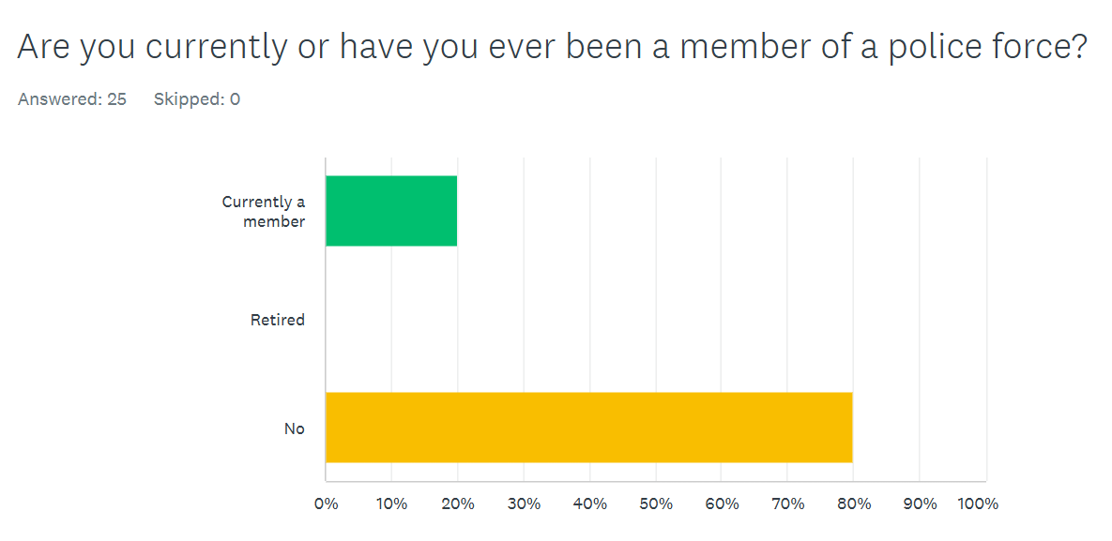

This question contains both key factors from both theories such as conflicts “connecting via conflict and response” comparatively to consensus’ theory focal point of the police connecting via community and consensus with one another. As seen below, 88% of respondents agree that the police connect with the public more via conflict and response to incidents rather than community engagement.
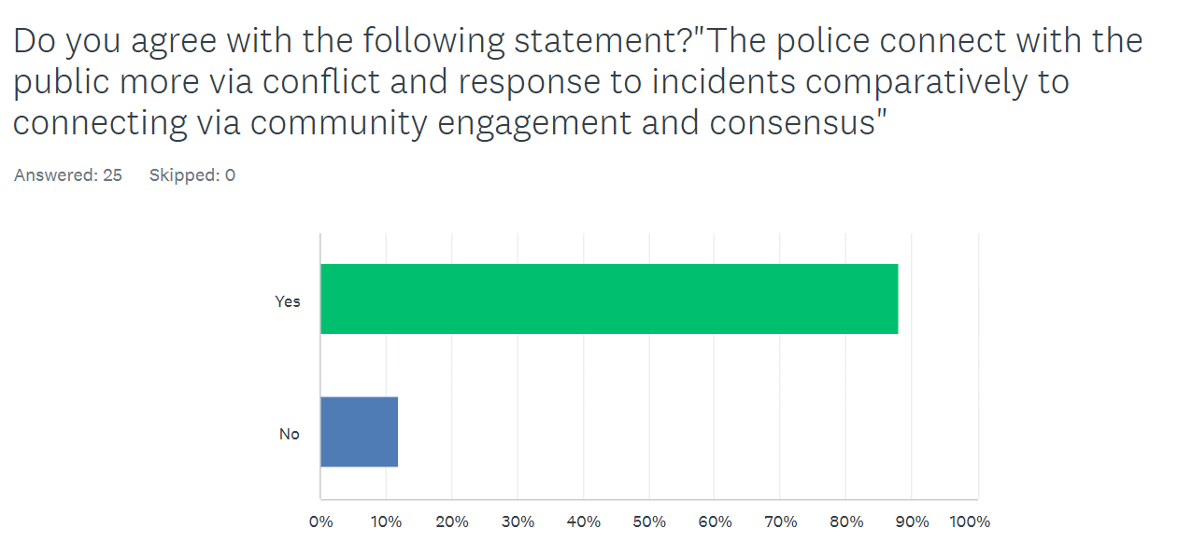
Following the previous question, this question was focused on the 2011 study from Richard Murphey (Murphey, 2011) relating to tax fraud and its main contributor. The below graph demonstrates that the public’s opinion on tax fraud is predominantly fixated on benefit fraud and tax eversion. Despite 72% of respondents being split evenly between tax eversion ad benefit fraud, this graph could highlight the trend that benefit fraud is broadcasted more as a predominant issue by media and government and therefore, evidencing Murphey’s and William Chambliss’ (Chambliss, 1978) viewpoint in conflict theory that there is “Selective Law Enforcement” and the public agree with this.
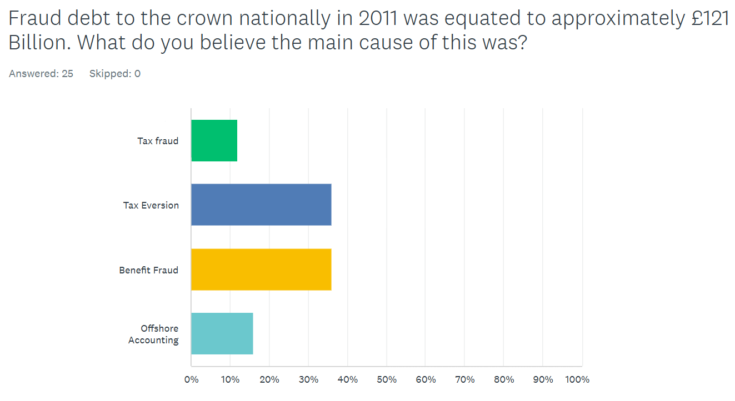
My fourth question was aimed from the IPSOS study of 4709 persons in Britain about the police’ effectiveness at tackling online crime such as fraud, hacking and sextortion. Despite one respondent skipping the answer, 70% of respondents believe the police being inept at dealing with this crime and do not feel safe from it. This further bolsters the viewpoint conflict theorists are presenting of Selective Law Enforcement.
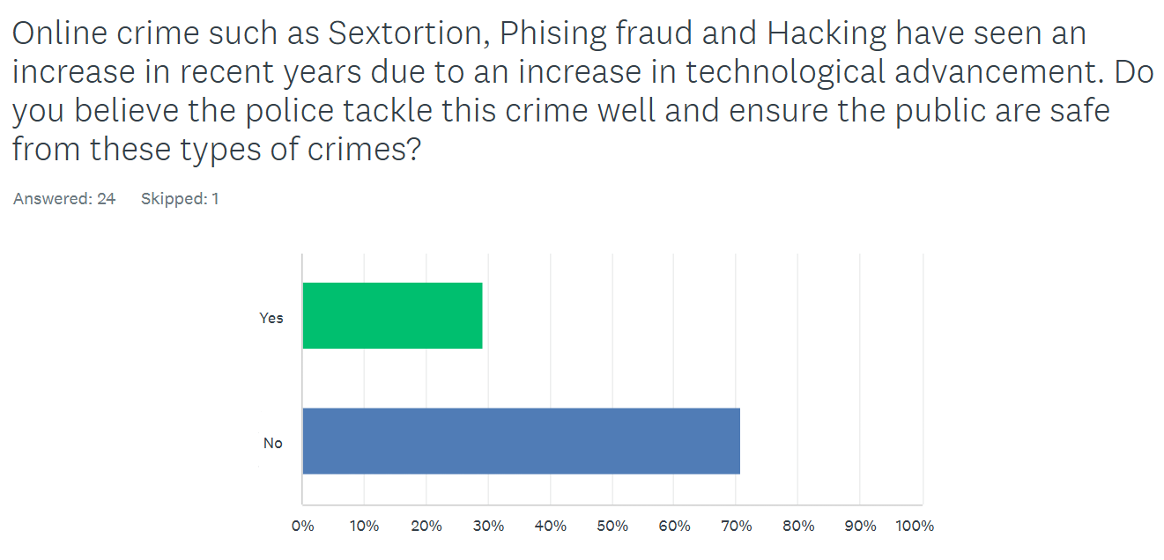

64% of respondents agreed with the below question of policing and prosecution being classist. This highlights the conflict (Marxist) theory point of bias law enforcement based on the factor of class and further the public’s agreement with conflict theorists.
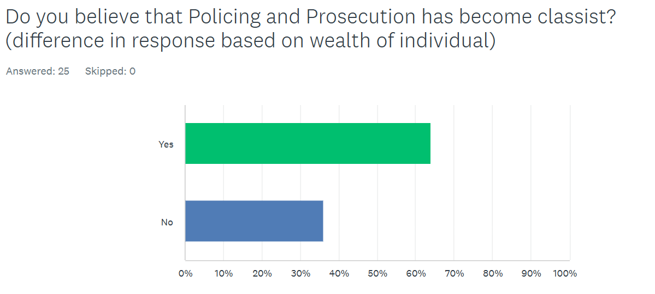

The questions from here focused on consensus theory viewpoints in order to ask an even number of questions on both theories. The below question shows that a policing presence is welcomed in the community with 72% of respondents evidencing an agreement with this consensus theory viewpoint.
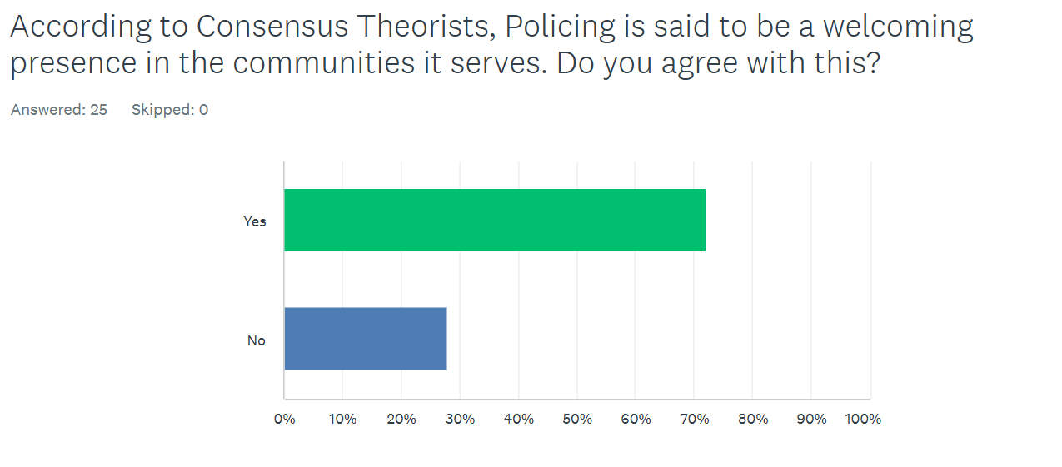

With consensus theorists arguing from the Peelian principles which state that the police’s legitimacy comes from consent from the public. Utilising the report from Fielding (Fielding, 2005) which stated that the public were more concerned with fairness in law enforcement comparatively to effectiveness I wished to evidence this in my own research to see if the public’s opinion is truly reflected in this. As below, the results are almost a 50/50 split with a very small majority for fairness. These results do disprove Fielding’s report slightly, as it shows that it is not a stark majority of the public who agree with the sentiment that fairness is more important than effectiveness.
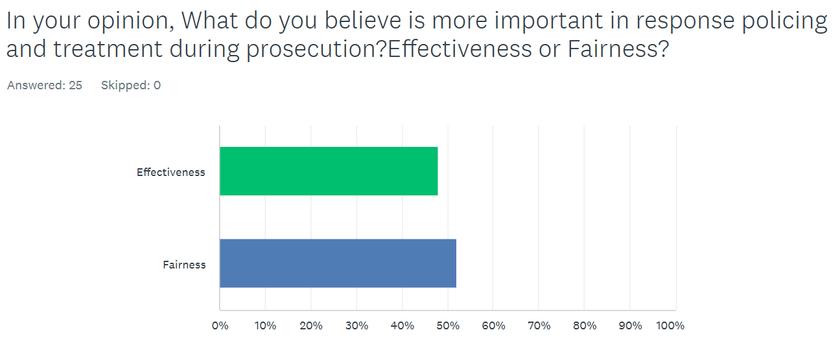
The following question was aimed to gather initial opinions and opinions heard of the police and their ranking of positive or negative. This graph presents the mixture of results gathered from this question with the majority of participants stating it was both “Somewhat Positive” and “Somewhat Negative”. This was to highlight the correlation in consensus theorist viewpoints that the public’s opinion on the police effect the function of the police as theorised by Peyton (Peyton, 2019). This graph therefore, shows according to Peyton’s theory that the police is therefore ineffective because the opinions of the police are mostly “somewhat negative” to “very negative”.

Following the previous question, Peyton’s Theory (Peyton, 2019) was also asked in this question and whether the public agreed with the below statement. As such, the public disagreed with the theory presented by Peyton with a majority of respondents (44%) stating they disagreed or strongly disagreed with the statement made by Peyton. This could theorise that the majority of respondents are in agreeance with conflict theory sentiments and ideologies.
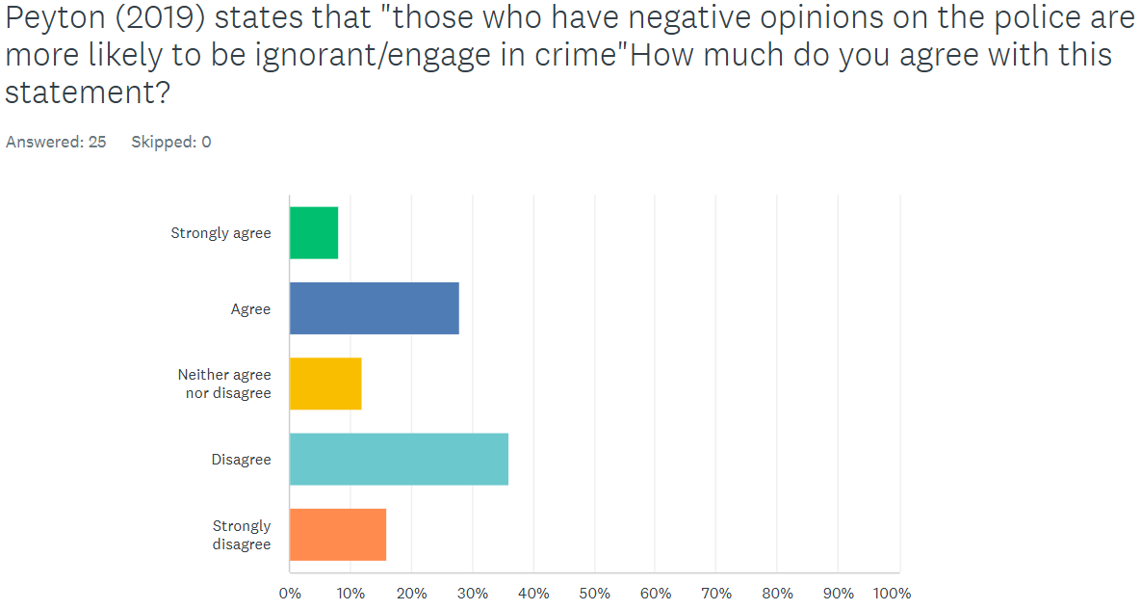

The final question in the survey was to ask whether they agreed with conflict or consensus theory or if they agreed with both. A small text box was utilised as an “other” box so the respondents could justify their answers. The overarching themes of conflict and consensus were included in the question. The majority of respondents have therefore answered they agreed with Conflict theory more (52%).
Similarly, 3 respondents stated they agreed with both for several reasons. One respondent believed that society began as a consensus and community, however, has overtime developed to be more conflicting. A second respondent stated that “Law/rules are predominantly made for and by the upper-class white male” but also believe that societal changing events such as the suffragettes and the case of Stephen Lawrence push for societal change”. It can therefore be derived that from this respondent’s answer that they believe consensus and societal change comes from events and protests from the majority whilst also agreeing with sentiments from Marxist and feminist theories that class and gender are predominant factors of unfair law enforcement. This respondent was also not a member of a police force and therefore, has no bias attached to their answer.



