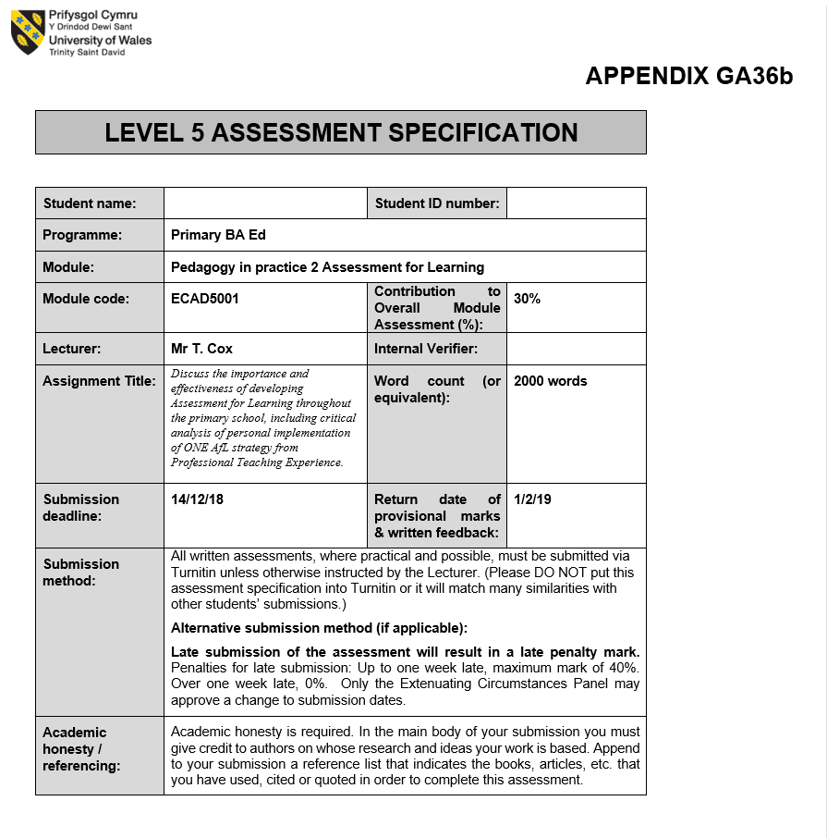

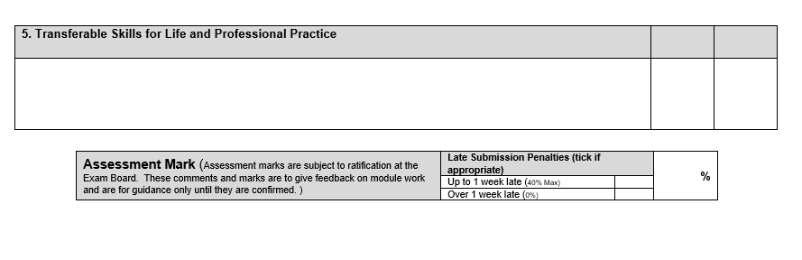
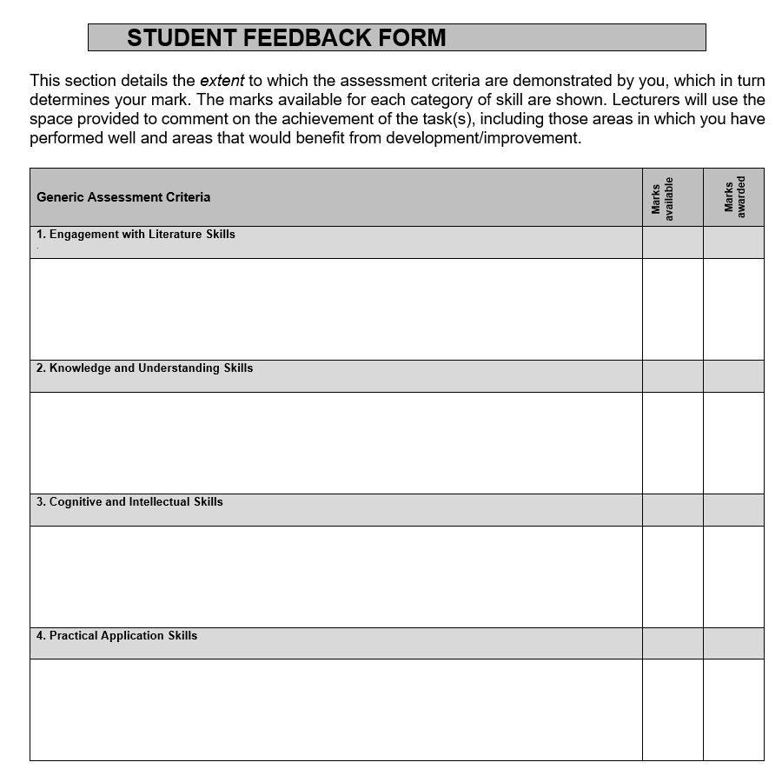

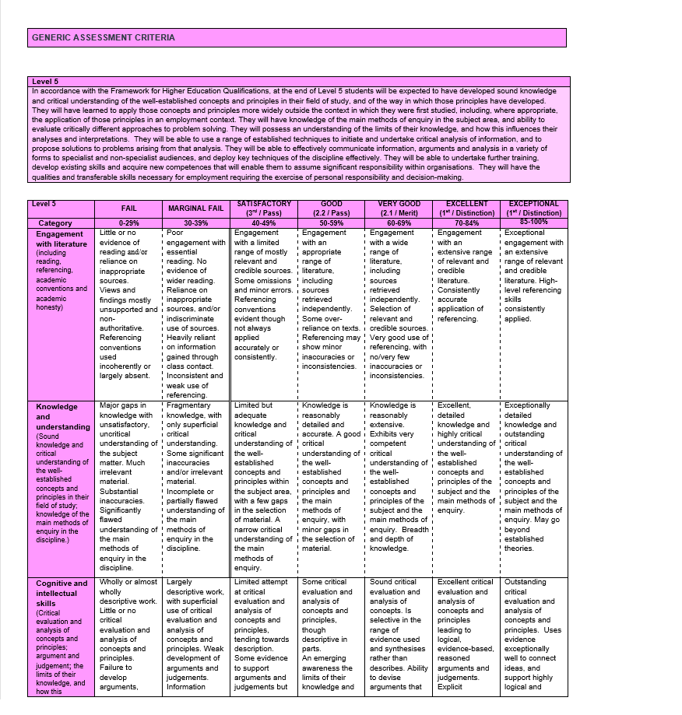

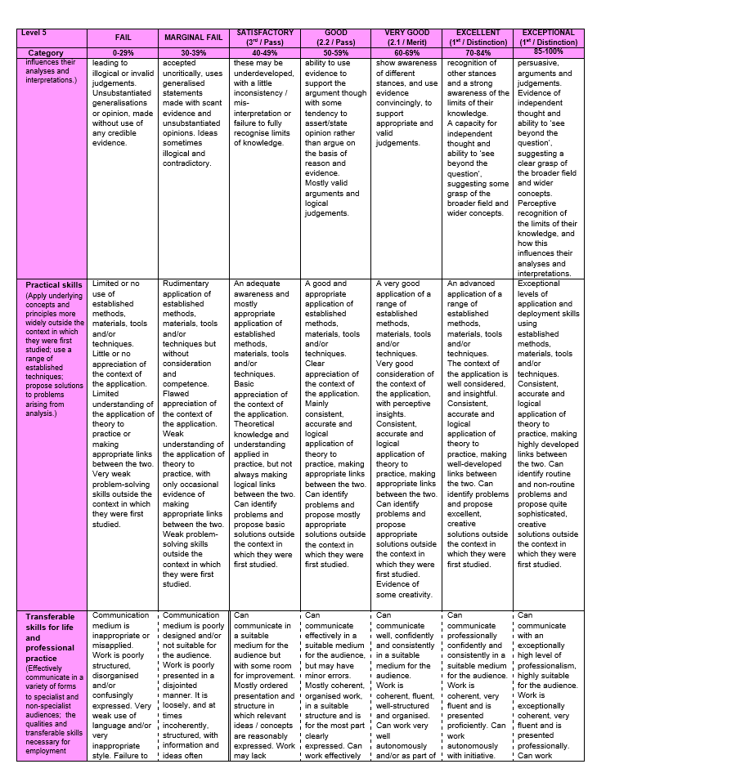

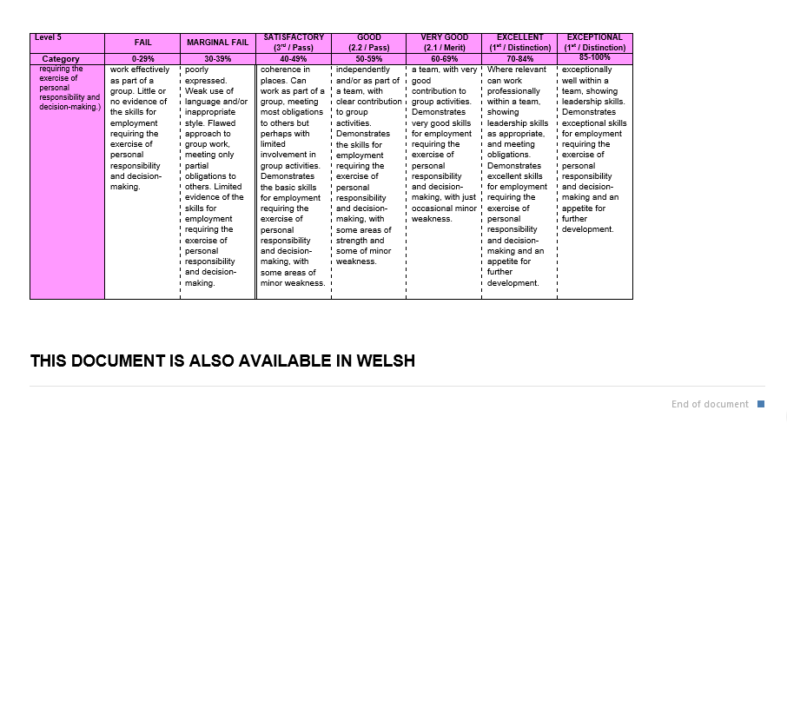

Discuss the importance and effectiveness of developing Assessment for Learning throughout the primary school, including critical analysis of personal implementation of ONE AfL strategy from Professional Teaching Experience.

Gardner (2012) and Black et al (2003) both suggest how assessment for the sake of assessment is not beneficial to anyone, whereas assessment for the learner is worthwhile. Assessment for Learning (AfL) is a method which heavily links teaching, learning and assessment to one another. It uses feedback in a constructive way to improve students’ performance and should allow the children to become actively involved in their own learning. Research carried out by Wiliam (2009) shows how well planned and valuable AfL can add 8 extra months of learning time to the lower and higher attaining learners. This shows how important it is as it empowers learners to have ownership of their own learning and provides them with the tools to reflect on what they have learnt. Furthermore, AfL involves both the teacher and student knowing where they are currently in their understanding and learning, it then requires the teacher to see where the child needs to go in order to move the pupils on in a way that will challenge them, and lastly the teacher needs to know how to get them to achieve their learning goals. Additionally, Hattie (2012) states how AfL is helpful not only for the pupils but for the teacher, as feedback from the children can help to improve teaching in future lessons. The standard of learning is dependent on the standard of assessment that is carried out in the classroom. Broadfoot (1996) argues that assessment is the most influential tool when it comes to education. On the other hand, Steinberg (1996) argues that if students do not come to school with a passion or interest to learn then no amount of change in classroom organisation or school training will work. Considering both these points, it is understood that although AfL is proven to improve standards, if children arrive at school with no motivation to learn then no amount of training or change will impact that child, showing that the learning is based upon the well-being of the child.

AfL is also known as formative assessment as it is a continuous process used by teachers and students to improve learning, whereas summative assessment is the process which occurs at the end of the learning to see what the children have learnt, it is also known as assessment of learning. When AfL is carried out effectively it can improve children’s abilities to reach targets and help to develop their determination. AfL can also improve pupil’s confidence as the feedback given to the children will be task-specific and will focus on that individual’s needs. Sadler (1998) suggests that formative assessment is an assessment process that is used precisely to give feedback on work to boost learning. Black and William (1998) suggest that when the assessment is formative it becomes a fundamental element of the teaching and learning procedure, and the information gathered from the assessment should also be used to change the way in which the teaching is delivered to meet the pupils learning needs and enhance learning. However, Black et al (2003) and Rowe (2000) both suggest how assessment can be used for a number of reasons, one being to provide statistics for league tables which increases the need for accountability. However, stated in recommendation 68 in Successful Futures, children’s performance in schools should no longer be reported to the Welsh Government on a ‘school-by-school basis but should monitor performance in key aspects of the curriculum through annual testing on a sampling basis’ (Donaldson, 2015, p.119).

Hattie (2012) states how some teachers have the expectation of all their pupils to reach the success criteria and with this being said this would mean that these teachers would believe that intelligence can be changed rather than fixed. However, Dweck (2006) has provided evidence that a fixed or growth mindset shows that this might not be the case. Dweck shows how people with a growth mindset want to challenge themselves, and understand that their abilities can be developed, whereas someone with a fixed mindset has the perspective that their intelligence is fixed and cannot be developed.

Weeden, Winter and Broadfoot (2004) suggest that bringing in an AfL strategy to a classroom isva time consuming process. This can cause apprehension for teachers and pupils as the fear of change may lead them to think that it may not be beneficial in the long run (Wiliam, 2012). If a negative environment is created where there is fear of failure children will become scared of being wrong, a safe environment needs to be created where children are resilient and not afraid to be ‘wrong.’ The environment also needs to encourage pupils become independent and in control of their own learning. As stated by Claxton (1998) children will need to know what they should be expected to do when they do not know what to do.

The strategy in this discussion will be the use of traffic lights. This strategy requires the children to honestly mark their own work based upon what they think they can or cannot do and have or have not understood. The children are provided with a table with a list of the success criteria, a column for ‘self’ and ‘teacher’. The children are expected to colour the criteria in green if they have fully understood, red if they did not understand and need help and orange if they were unsure. Black and Wiliam (1998) suggests there are four elements when it comes to AFL, those being: questioning, feedback, sharing criteria and self and peer assessment. The strand in which the traffic light strategy sits would be self and peer assessment, although this is strongly linked to sharing the learning intention. Hattie (2008), the Assessment Reform Group (1999), and Welsh Assembly Government (2017) all agree that pupil self-assessment is one of the highest aspects of raising learning standards.

This strategy supports a humanist approach. A humanist believes that personal growth and emotional needs are the highest of values. Holt (1964) talks about how teachers need to meet the emotional needs of learners, and produce an environment which does not create a fear of failure and rejection. Having reviewed these points, AfL seems to go against the humanist approach, as assessment can lead to giving children labels and therefore not focusing on the child as a whole. Assessment can focus mainly on problematic areas, however ‘assessment doesn’t have to be problem focused – it can also be growth orientated’ (Friedman and Macdonald, 2006, p. 517). Hence, when assessment is planned focusing on a child’s growth, the view of the child as a whole thus through a humanistic approach removes the fear of assessment being statistic focused.

Pollard (2014) argues that when it comes to marking the teacher should focus more on the developments needed for the learner rather than the marks which will be given to the child. This statement suggests that self-assessment encourages children to assess their own work and therefore removing the element of judgement from other class members. It also enables teachers to amend their plans and gives an indication of children’s feelings. However, this strategy was carried out in a reception class where the children didn’t have much of an understanding of why they were colouring the criteria in green, red, or orange and the children’s age ranged from 4-5 years old and couldn’t read but were expected to mark themselves on what they could or couldn’t do. Bertram and Pascal (2002) talk about how formal assessments used on 3-4 year olds could possibly be damaging to children in the future. Black (2003) and Sadler (2013) both argue that for children to self-evaluate in a constructive way the child must have a concise understanding of the learning goal, and be provided with the vocabulary in order to ask relevant questions. Hence, expecting children of such a young age to carry out such tasks is highly demanding and unrealistic.

Lastly, some recommendations that could be made to this strategy will be as follows. As this strategy was carried out in a reception class the children were too young to understand the concept of the traffic light system. The children were expected to colour in the criteria without actually knowing what they were colouring it for. Therefore, although AfL was being carried out, the children did not have a clear understanding of why they were doing so. The strategy should be explained each and every time the pupils were expected to colour in the criteria therefore building up their understanding over and over again. This strategy needs to be constantly modelled for children this young so it therefore becomes a normal classroom routine. Griggs (2015) states how teachers should model correct behaviour in order for the children to follow desired instructions. The teacher needs to make the strategy clear to all the children so when they are expected to self-mark they know exactly what they are doing. For AfL to be effective it must be something that is consistent with the rest of the school and for AfL to be a valuable process the pupils and teachers must be committed to the approach.

Laevers (2012) discusses the process within the child, where the approach to the activity e.g. the space, the interaction of the child etc. comes first, then leads on to the process which includes the two strands of well-being and involvement, resulting in the outcome. This literature suggests that the outcome of the activities is dependent on their level of well-being in the class and their interaction with other pupils. Considering this piece of writing, it may be useful to use the traffic light strategy in a different way with a reception class. Rather than getting the children to self-mark their work at first, instead get them to traffic light their involvement and their well-being within an activity. The teacher can then carry on with the colouring of the success criteria from the activity in red, green or amber and explaining to the children as they do so. Friedman and Macdonald (2006) suggest how assessment can be less about statistics and more about the child’s participation in an activity as a whole following a humanist approach. Dweck (2014) supports this by stating that children should be praised on their effort, strategies and perseverance to create children who are resilient, rather than focusing on praising their intelligence. After considering these points, well-being involves the process of developing children’s inner strength, and their self-confidence which are all aspects that are involved in effective AfL. By starting with self-assessing their well-being using the traffic light system will eventually lead on to pupils being honest when self-marking their pieces of work in the future. Arguably, Holt (2009) describes many children use techniques throughout their schooling to get themselves out of learning because they are scared of humiliation, by using this technique of self-assessing their well-being before their learning will hopefully create an environment where the children are not afraid to be wrong. Montessori settings use what is known as Learning Journey Profiles, where observations are noted, reflections, and pictures of the children and their work showing the children’s progress (Montessori Schools Association, 2012) again focusing on the personal development of the children rather than their statistics.

In a key stage 2 setting the traffic light strategy could again focus on their well-being at the end of an activity where they can express their feelings. The table of the traffic light strategy with columns named ‘self’ and ‘teacher’, will further include another column with the title ‘peer’, this way their work is being checked by a number of sources. Black and Wiliam (1998, p.10) describe peer assessment as ‘uniquely valuable’ as children may accept a comment made by their friend/peer, which they may not take seriously from the class teacher. Therefore, in view of this having a ‘peer’ column may improve the pupil’s ability to learn. Additionally, when being carried out in a key stage 2 setting the teacher can use the marks from the traffic light strategy and pair up greens with ambers to help with understanding and therefore giving the teacher a chance to concentrate on those who have marked themselves as red.

In conclusion, AfL is a powerful process that can either improve learning or limit it, depending on how it is delivered. Estyn (2018) states AfL is an important tool that works progressively across the whole school. Experiences that come with assessment stay with pupils for life, and can possibly affect their future learning, ‘emotional charge is part of the character of assessment information’ (Reineke, 1998, p.7). AfL has some limitations but overall provides many reasons as to why it is a successful tool. O’Donnell (2013) suggests children may be affected negatively and shaped depending on their classroom environment. This suggests that it is the teacher’s responsibility to create an environment which does not feel safe and secure will therefore restrain children’s learning. An environment should be created with the encouragement of a growth mindset from a young age (Dweck, 2006). Black and Wiliam (1998, p.9) state how children are ‘reliable and honest’ when it comes to assessment and if an environment is created where they feel comfortable and confident they will in turn be able to flourish.

Reference List

Assessment Reform Group (1999) Assessment for Learning: Beyond the Black Box. Cambridge: Cambridge University Press.

Bertram, T. and Pascal, C. (2002) Early Years Education: An International Perspective. London: QCA

Black, P. and Wiliam, D. (1998). Inside the Black Box. London: GL Assessment.

Black, P. et al. (2003). Assessment for learning. Berkshire: Open University Press.

Broadfoot, P. (1996) ‘Assessment and learning: Power or Partnership?’ In H. Goldstein and T. Lewis. ‘Assessment: Problems, developments and statistical issues.’ Chichester: John Wiley & Sons Ltd.

Claxton, G. (1998) Mastering Uncertainty: The New Science of Lifelong Learning. University of Bristol Mimeo.

Donaldson, G. (2015) Successful Futures. Crown copyright. Available at:
https://gov.wales/docs/dcells/publications/150317-successful-futures-en.pdf
(Accessed: 9th December 2018)

Dweck, C. (2006) Mindset. New York: Random House.

Dweck, C. (2014) The Power of Believing That You Can Improve. [Video] Available at:
https://www.ted.com/talks/carol_dweck_the_power_of_believing_that_you_can_improve/transcript?language=en
(Accessed: 7th December 2018)

Estyn (2018) Improving Teaching. Cardiff: Crown Copyright. Available at:
https://www.estyn.llyw.cymru/sites/default/files/documents/Improving%20teaching.pdf
(Accessed 12th December 2018)

Friedman, H. and Macdonald, D. (2006) Humanistic Testing and Assessment. SAGE Publications Ltd.
Available at:
https://journals.sagepub.com/doi/pdf/10.1177/0022167806290210
(Accessed: 12th December 2018)

Gardner, H. (2012) Assessment and Learning 2nd Edition. London: SAGE Publications Ltd.

Griggs, R (2015) Becoming an Outstanding Primary School Teacher 2nd Edition. London and New York: Routledge.

Hattie, J (2008) Visible Learning. Abingdon: Routledge.

Hattie, J. (2012) Visible Learning for Teachers: Maximizing Impact on Learning. London and New York: Routledge.

Holt, J (1964) How children fail. New York: Pitman Publishing Company.

Holt, J. (2009). How Children Learn. New York: Da Capo Press.

Laevers, F. (ed) (2012) Well-being and Involvement in Care Settings. A Processoriented Self-evaluation Instrument. Available at:
www.kindengezin.be/img/sicsziko-manual.pdf
(Accessed: 8th December 2018)

Montessori Schools Association (2012) Guide to the Early Years Foundation Stage in Montessori Settings. London: Montessori Schools Association.

O’Donnell, M. (2013). Maria Montessori a Critical Introduction to Key Themes and Debates. London/New York: Bloomsbury,

Pollard, A. (2014) Reflective Teaching in Schools. London: Bloomsbury.

Reineke, R. A (1998) Challenging the Mind, Touching the Heart: Best Assessment Practices, Thousand Oaks, CA: Corwin Oaks.

Rowe, K. (2000) Assessment, League Tables and School Effectiveness: Consider the Issues and ‘Let’s Get Real!’ Journal of Educational Enquiry. Volume 1, Issue 1. Available at:
https://ojs.unisa.edu.au/index.php/EDEQ/article/viewFile/572/442
(Accessed: 11th December 2018)

Sadler, D. R. (1998). Formative Assessment: revisiting the territory, in Assessment in Education: Principles, Policy & Practice. Volume 5, Issue 1. Available at: https://www.tandfonline.com/doi/pdf/10.1080/0969595980050104?needAccess=true
(Accessed: 10th December 2018)

Sadler, D. R. (2013) ‘Opening up feedback: Teaching learners to see’. In Merry, S., Price, M., Carless, D., and Taras, M. ‘Reconceptualising Feedback in Higher Education: developing dialogue with students.’ London: Routledge.

Steinberg, R. (1996) Beyond the Classroom: Why School Reform Has Failed and What Parents Need to Do. New York: Touchstone.

Weeden, P., Winter, J. and Broadfoot, P. (2004). Assessment: what's in it for schools?. London: RoutledgeFalmer.

Welsh Assembly Government (2017) Written Statement - Assessment for Learning Available at:

https://gov.wales/about/cabinet/cabinetstatements/2017/assforlearning/?lang=en

(Accessed: 10th December 2018)

Wiliam, D. (2009) Assessment for Learning: Why, What, and How? London: Institute of Education.

Wiliam, D. (2012) The Classroom Experiment (Ep.1). [Video] Available at:

https://www.youtube.com/watch?v=J25d9aC1GZA
(Accessed: 12th December 2018)

