Assignment 2: Sustainability Waste and Recycle in Hilton Hotel and Hospitality
Presentation
Contemporary Themes BMIH6001
Lecture: Giulia Chifari
Student name: Mahin Sultana (2022862)
Date: Friday 13th November 2023



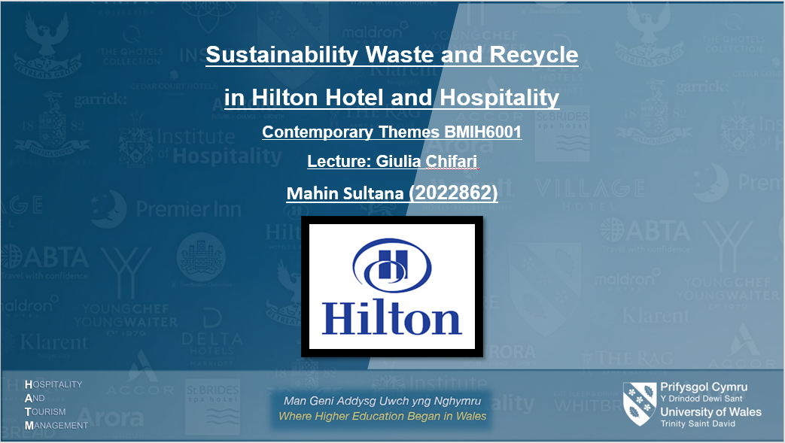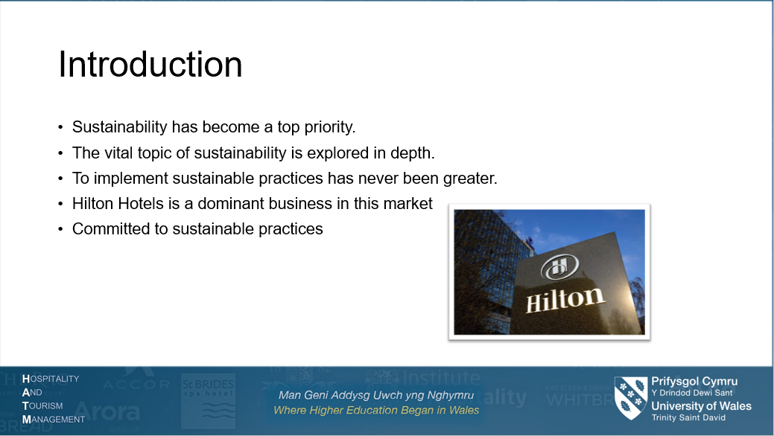
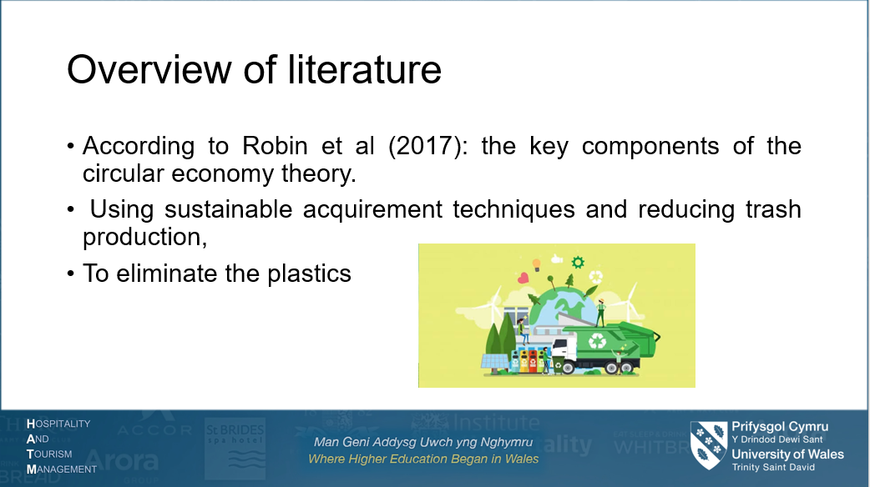
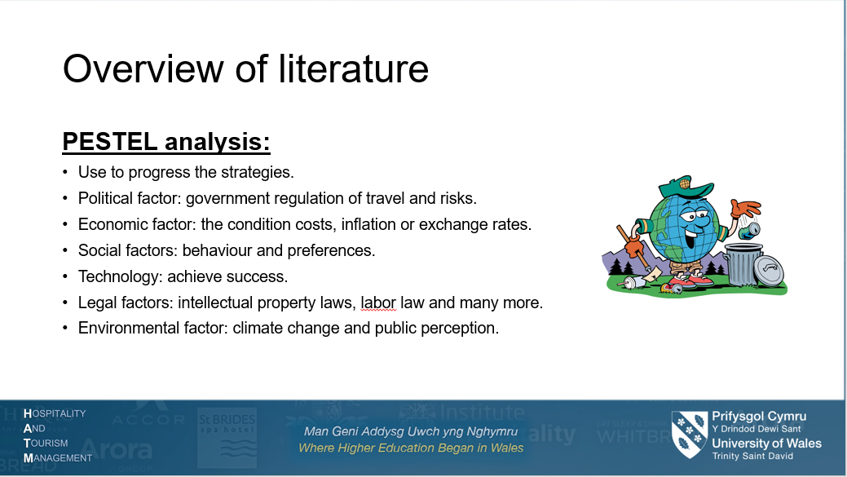
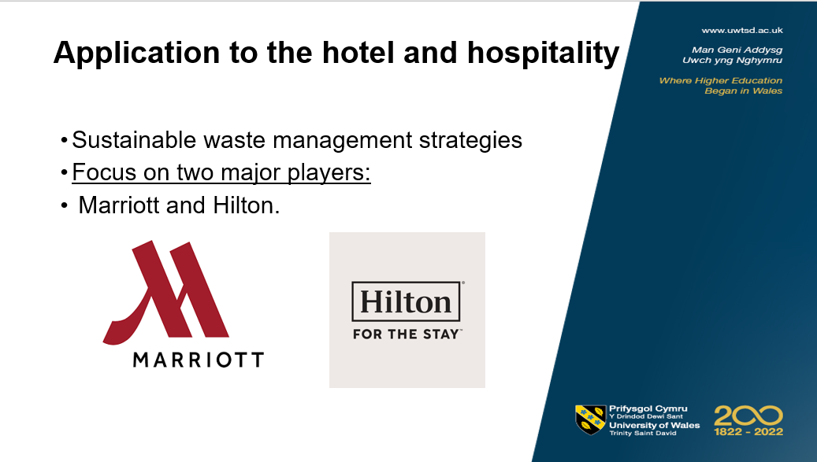
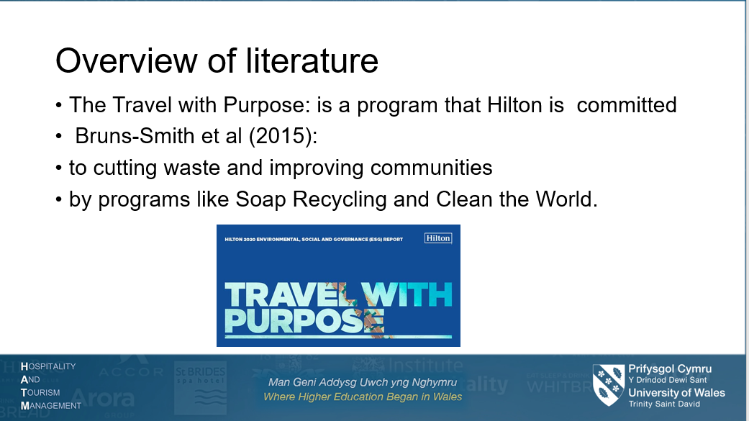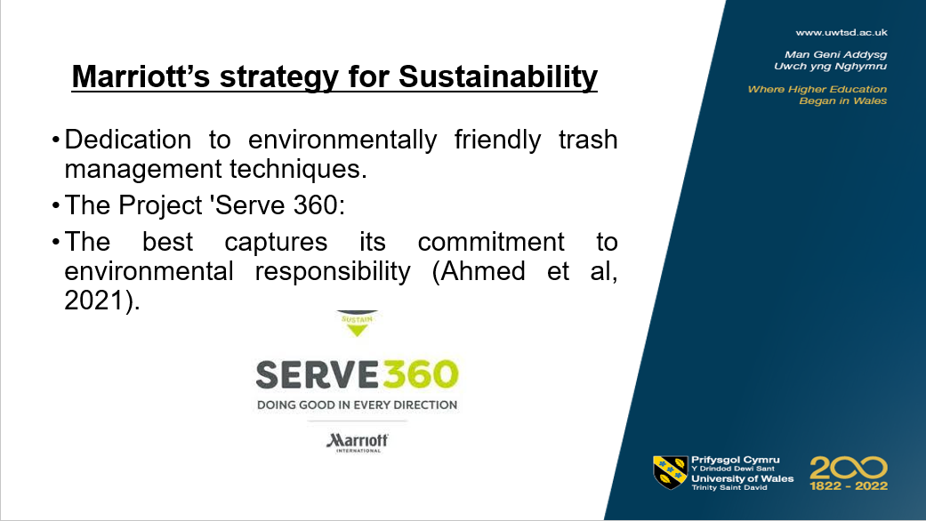
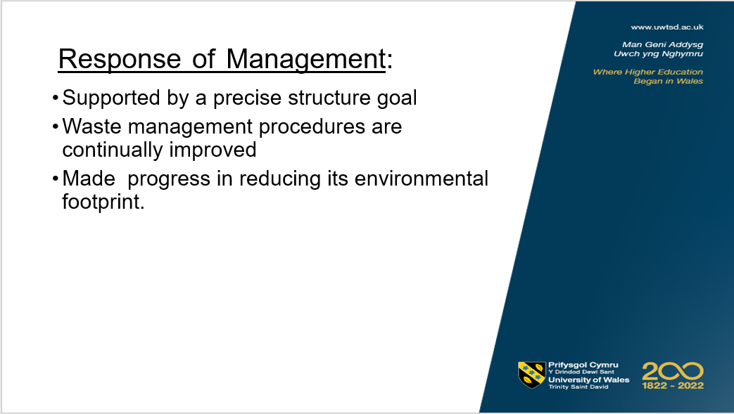
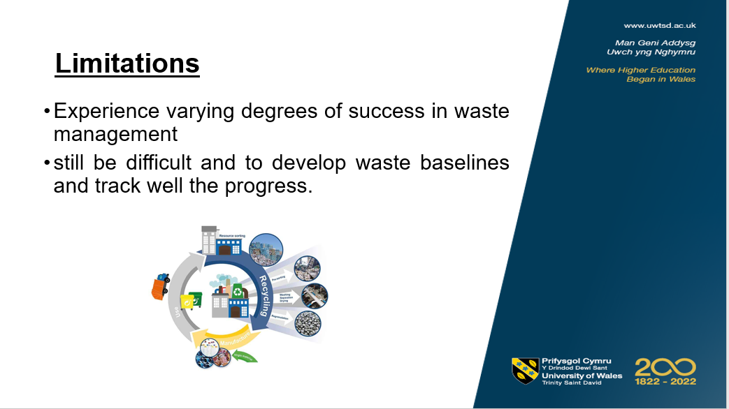
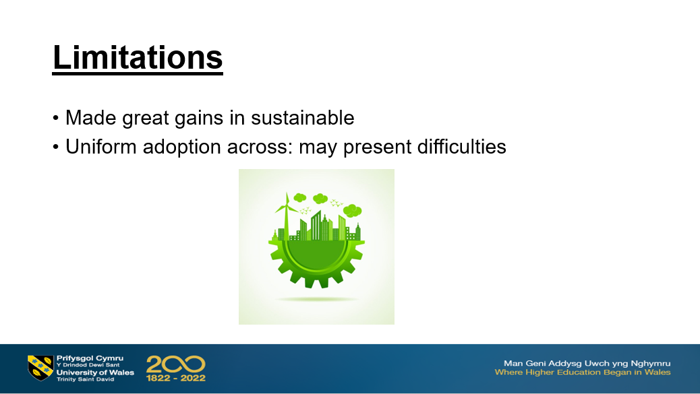
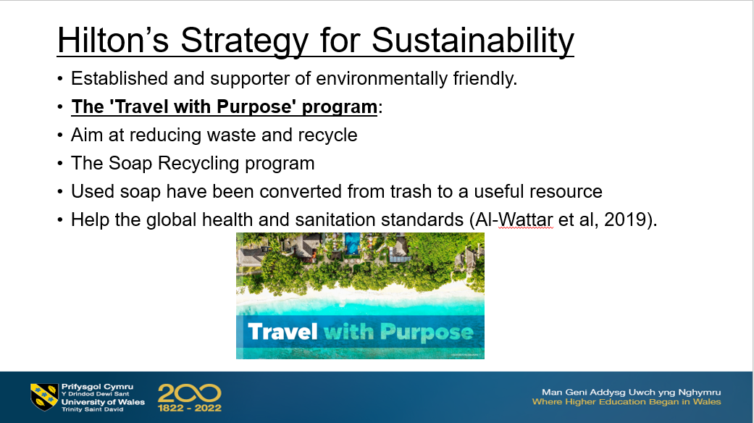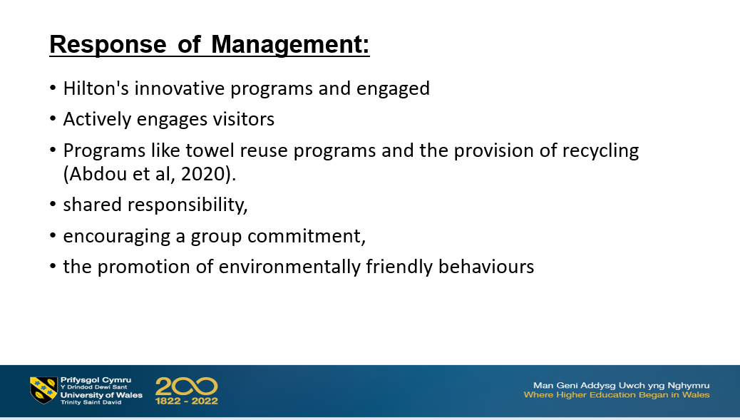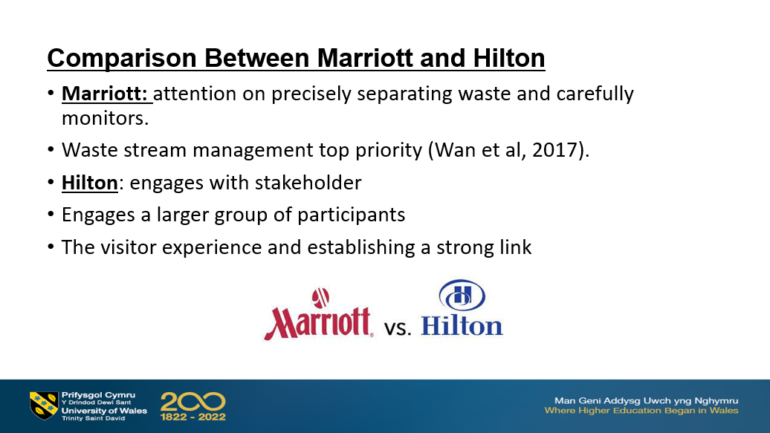
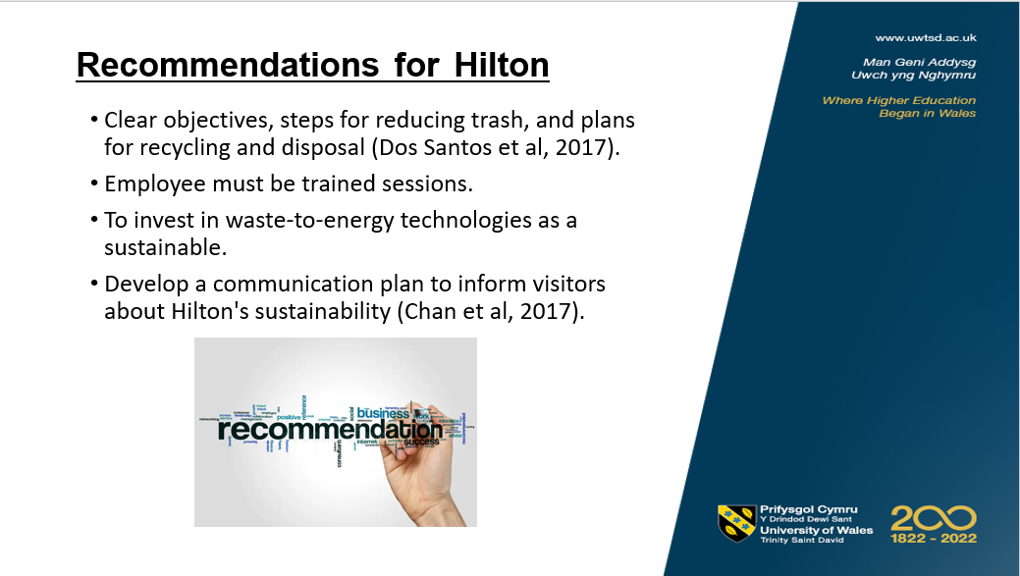
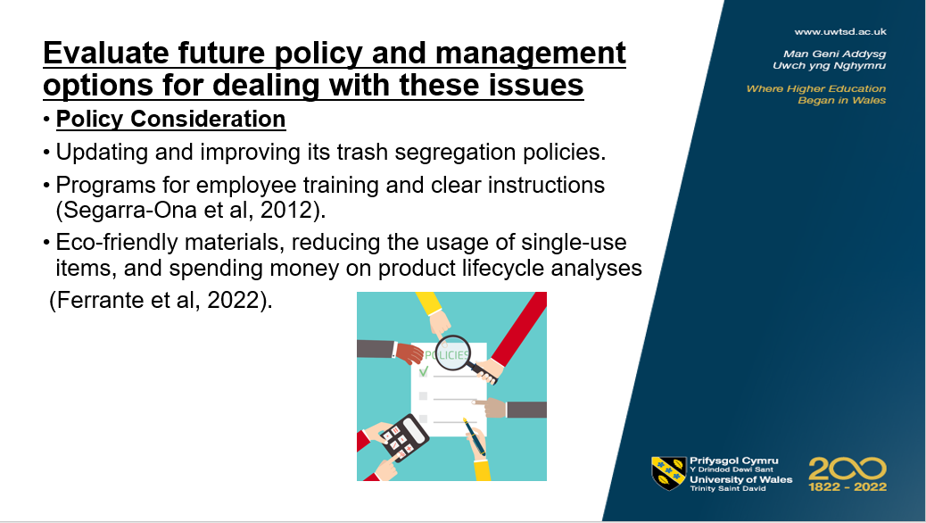



References

Abdou, A.H., Hassan, T.H. and El Dief, M.M., (2020). ‘A description of green hotel practices and their role in achieving sustainable development'. Sustainability. 12(22), p.9624.

Ahmed, M., Guo, Q., Qureshi, M.A., Raza, S.A., Khan, K.A. and Salam, J., (2021). ‘Do green HR practices enhance green motivation and proactive environmental management maturity in hotel industry?’. International Journal of Hospitality Management, 94, p.102852.

Al-Wattar, Y.M.A., Almagtome, A.H. and Al-Shafeay, K.M., (2019). ‘The role of integrating hotel sustainability reporting practices into an Accounting Information System to enhance Hotel Financial Performance: Evidence from Iraq’. African Journal of Hospitality, Tourism and Leisure, 8(5), pp.1-16.

Bruns-Smith, A., Choy, V., Chong, H. and Verma, R., (2015). ‘Environmental sustainability in the hospitality industry: Best practices, guest participation, and customer satisfaction’.

Chan, E.S., Hon, A.H., Okumus, F. and Chan, W., (2017). ‘An empirical study of environmental practices and employee ecological behavior in the hotel industry’. Journal of Hospitality & Tourism Research, 41(5), pp.585-608.

Dos Santos, R.A., Méxas, M.P. and Meiriño, M.J., (2017). ‘Sustainability and hotel business: criteria for holistic, integrated and participative development’. Journal of cleaner production, 142, pp.217-224.

Discounted cash flow, (2023). PESTEL Analysis of Hilton Worldwide Holdings Inc (HLT). Available at: https://dcf.fm/blogs/blog/hlt-pestel-analysis

Ettinger, A., Grabner-Kräuter, S. and Terlutter, R., (2018). ‘Online CSR communication in the hotel industry: Evidence from small hotels’. International Journal of Hospitality Management, 68, pp.94-104.

Ferrante and Maria, (2022). ‘Sustainability: Drives Packaging Innovations: Driven by consumer demands for more eco-friendly products and manufacturers' goals to cut costs by reducing material and energy usage, sustainability is a notable trend in the packaging industry, including end-of-line packaging’. 194 (1), p.20.

Hilton, (2023) ‘Travel with Purpose’. Available at: https://esg.hilton.com/

Hilton, (2023). ‘Our Journey Toward 2030’. Available at: https://esg.hilton.com/2030-goals/

Marriott, (2023) ‘Sustain responsible operations’. Available at: https://serve360.marriott.com/sustain/
Marriott, (2022), ‘Serve 360 Report: Environmental, social and governance Progress’. Available at: http://serve360.marriott.com/wp-content/uploads/2022/10/Marriott-2022-Serve-360-ESG-Report-accessible_F.pdf

Robin, C.F., Pedroche, M.S.C. and Astorga, P.S., (2017). ‘Revisiting green practices in the hotel industry: A comparison between mature and emerging destinations’. Journal of cleaner production, 140, pp.1415-1428.

Segarra-Ona, M.D.V., Peiró-Signes, A., Verma, R. and Miret-Pastor, L., (2012). ‘Does environmental certification help the economic performance of hotels? Evidence from the Spanish hotel industry’. Cornell Hospitality Quarterly, 53(3), pp.242-256.

Wan, Y.K.P., Chan, S.H.J. and Huang, H.L.W., (2017). ‘Environmental awareness, initiatives and performance in the hotel industry of Macau’. Tourism Review, 72(1), pp.87-103.

