

Name: OLUWATOYIN RUTH SALU
Student ID: 2508698
Module Code: LCHS4003
Module: INTRODUCTION TO HEALTH AND SOCIAL CARE
Lecturer: Dr Ayazullah Safi

SUBMITTED ON: 21 February 2026

TABLE OF CONTENTS

TABLE OF CONTENTS 2
Residential Care Home Poster 3
ESSAY 7
AMBULANCE SERVICES 7
Introduction: 7
Origin of Ambulance Services: 7
Historical Context and Development: 8
Critical Evaluation of how it functions: 9
Ambulance Service significance in enhancing the quality of life of service users: 9
Conclusion: 10
REFERENCES 11

Residential Care Home Poster

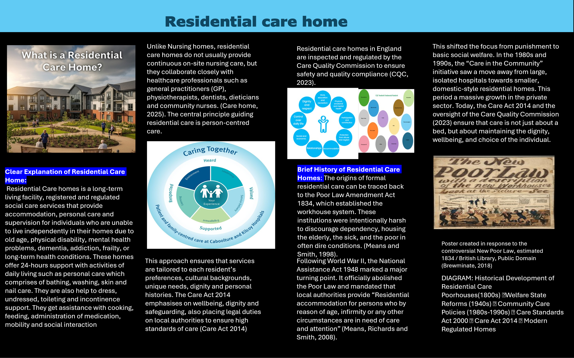







ESSAY

AMBULANCE SERVICES

Introduction:
Ambulance services is a vital component of modern healthcare system, providing urgent medical care, which serves as the critical bridge between an emergency incident and definitive hospital care. Ambulance also performs Emergency Medical Services (EMS) which is called pre-hospital treatment, while the patient is being transported to the hospital. Over time, ambulance services have advanced from the initial transport arrangements into highly skilled, technological advanced emergency care systems. This essay will explore the origins of ambulance services, examines the historical factors that shaped its development, evaluates how ambulance service functions today, and discusses its significance in enhancing the quality of life of service users.

Origin of Ambulance Services:
The origin of ambulance services can be traced back to military medicine. Early forms of organised causality transport were used during wars to remove injured soldiers from battlefields. One of the earliest document systems emerged in the 11th century with the Knights of St. John, who provided care and transportation for injured Crusaders. (Stem Ems, 2025). However, the modern concept of an ambulance service began in the late 18th century precisely 1792, when Dominique Jean Larrey, a French military surgeon, introduced “flying ambulances” during the Napoleonic War to rapidly evacuate wounded soldiers for treatment, having seeing men die for lack of timely care. (Skandalakis et al., 2006). In civilian life, ambulance services initially functioned as simple transport systems rather than providers of medical care. During the 19th century, horse-drawn ambulance was introduced in cities such as London and New York to convey injured individual to hospitals. Fast forward to mid-20th century, the UK introduced 999 emergency numbers in 1937. The modern, comprehensive national ambulance service was established in 1948 as part of the NHS.


Historical Context and Development:
The earliest structured ambulance systems developed in response to war during the Napoleonic Wars created “flying ambulance” and later during the Crimean war (1853-1856), Florence Nightingale improved sanitation and hospital organisation, influencing structured emergency care system. (Science Museum, 2018). The development of ambulance services was strongly influenced by urbanisation, industrialisation, and public health reform. Rapid population growth in cities during the industrial revolution led to increased workplace accidents, infectious diseases, and traffic-related injuries, highlighting the need for organised emergency response systems. In the UK, the formalisation of ambulance services gained momentum in the 20th century, particularly following the establishment of the National Health Service in 1948.The creation of the NHS ensured that ambulance service became publicly funded and universally accessible, making a significant shift from voluntary and charitable provision (EMSUK Learning, 2023). Advancement in medical knowledge, radio communication, and vehicle design further transformed ambulance into mobile treatment units rather than mere transport vehicles. According to Chamberlain (2018), paramedic roles in the 1970 represented a critical milestone, enabling advanced life-saving interventions such as defibrillation, airway management, and drug administration to be delivered at the scene.
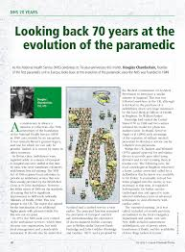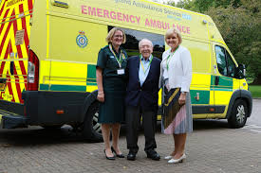

Critical Evaluation of how it functions:
Today’s ambulance services are no longer simple patient transporters; they are integral parts of the healthcare system. In the UK, ambulance services are provided by multiple NHS trusts covering geographic regions and are key pillars of urgent and emergency care. They deliver emergency medical services free at the point of use, responding to 999 and 112 calls, sometimes to NHS 111 where urgent advice is needed. Modern services are categorised into Basic Life Support (BLS) and Advance Life Support (ALS). Critically evaluating the current system reveals a transition towards “See and Treat” models. Rather than taking every patient to a hospital, paramedic now use advanced diagnostics-such as 12-lead ECGs and point-of-care testing-to refer patients community care or discharge them at the scene. While this reduces the burden on overcrowded Emergency Departments, it places immense psychological and clinical pressure on frontline staff, who must make high-stakes decisions in non-clinical environments. (AACE, 2025).

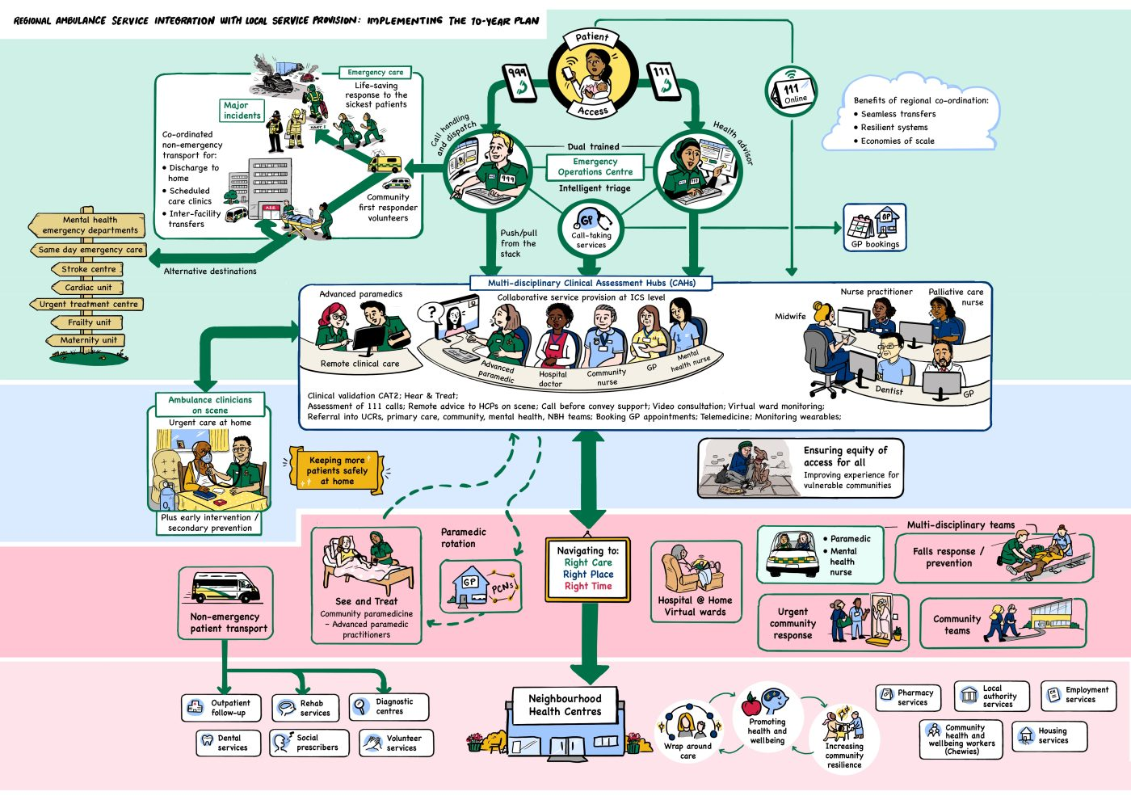

Ambulance Service significance in enhancing the quality of life of service users:
Ambulance service plays a crucial role in enhancing the quality of life (QoL) of service users by providing rapid, skilled pre-hospital care and ensuing timely access to appropriate treatment. Early intervention in life-threatening conditions such as cardiac arrest, stroke, trauma and sepsis reduces mortality and long-term disability, thereby preserving independence and functional ability (World Health Organization (WHO), 2023). In England, ambulance services increasingly operate as mobile healthcare providers, delivering assessment, treatment, and referral at the scene, which can prevent unnecessary hospital admissions and support patients to remain safely at home (National Audit Office (NAO), 2017). This “right care, right place” approach improves patient experience, reduces distress, and minimises disruption to family life (NHS England, 2023). However, system pressures such as delayed hospital handovers may negatively affect outcomes and patient safety, highlighting the importance of whole-system urgent and emergency care reform (Care Quality Commission (CQC), 2023. Overall, effective ambulance services contribute significantly to survival, recovery, reassurance and continuity of care-key determinants of improved quality of life.

Conclusion:
In conclusion, ambulance services have evolved significantly from their military origins into sophisticated, patient-centred emergency care systems. Historical developments such as urbanisation, medical advancements and the establishment of the NHS have shaped their current form. Despite contemporary challenges, ambulance services remain essential in improving health outcomes and enhancing the quality of life for service users delivering timely, compassionate, and effective care.

REFERENCES
Association of Ambulance Chief Executives (2025) Ambulance sector response to the Fit for the Future 10-year health plan. Available at: https://aace.org.uk/wp-content/uploads/2025/09/AACE-response-to-10YP-Sept-2025.pdf (Accessed: 12 February 2026)
Care Quality Commission (2023) The state of health care and adult social care in England 2022/23. Available at: https://www.cqc.org.uk/publications/major-report/state-care/2022-2023 (Accessed: 14 February 2026)
Chamberlain, D. (2018) ‘Looking back 70 years at the evolution of the paramedic’, Journal of Paramedic Practice. Available at: https://www.paramedicpractice.com/content/opinion/looking-back-70-years-at-the-evolution-of-the-paramedic ( Accessed: 12 February 2026)
EMSUK Learning (2023) History of UK ambulance services. Available at: https://www.emsuklearning.co.uk/history-of-uk-ambulance-service (Accessed: 12 February 2026)
National Audit Office (2017) NHS Ambulance Service. HC 972. London: National Audit Office. Available at: https://www.nao.org.uk/wp-content/uploads/2017/01/NHS-Ambulance-Services.pdf#:~:text=This%20report%20reviews%20the%20progress,Committee%20of%20Public%20Accounts. (Accessed: 13 February 2026)
NHS England (2023) Delivery plan for recovering urgent and emergency care services. London: NHS England. Available at: https://www.england.nhs.uk/publication/delivery-plan-for-recovering-urgent-and-emergency-care-services/ (Accessed: 13 February 2026)
Science Museum (2018) Florence Nightingale: The pioneer statistician. Available at: https://www.sciencemuseum.org.uk/objects-and-stories/florence-nightingale-pioneer-statistician#:~:text=Florence%20Nightingale%20and%20her%20team%20came%20to,than%20as%20a%20result%20of%20battlefield%20wounds. (Accessed: 12 February 2026)
Skandalakis, P.N., Lainas, P., Zoras, O., Skandalakis, J.E. and Mirilas,, P. (2006) ‘To afford the wounded speedy assistance: Dominique Jean Larrey and Napoleon’. World Journal of Surgery, 30(8), pp. 1392 – 1399. doi: 10.1007/s00268-005-0436-8. Available at: https://onlinelibrary.wiley.com/doi/10.1007/s00268-005-0436-8. (Accessed: 6 February 2026)
Stem EMS (2025) AMBULANCE HISTORY: A journey between England and America. Available at: https://www.stem.it/en/il-mondo-del-soccorso/ambulance-history-a-journey-between-england-and-america/#:~:text=Origins%20of%20ambulance%20history%20date,fast%20and%20efficient%20patient%20transport. (Accessed: 6 February 2026)
World Health Organization (2023) WHO’S response to health emergencies: annual report 2023. Geneva: World Health Organization. Available at: https://www.who.int/publications/i/item/9789240097452 (Accessed: 13 February 2026)

