Paul Newman 1805494
Paul_newman37@yahoo.co.uk
Carlene Campbell

COFFEECAPUIUS
ACCA4018

Table of Contents
2 Table of Figures 2
3 Introduction 3
3.1 A look at public/private entries Systems and Safety 4
4 Mobile Device Management Software for staff (BYOT) 5
5 Mobile Device Management (MDM) 6
5.1 SSL (Secure Sockets Layer) 6
5.2 SSH (Secure Shell) 7
5.3 A Network with cloud 7
5.4 Recommendations 10
5.5 Personal Note 10
6 Bibliography 11
7 Recommend a policy for a CoffeeCapulus using a cloud system. 11
Introduction 12
Information Security Policies (ISP) 12
Responsibilities of Staff Members 13
Monitoring and access of the companies Network 14
Regarding Personal Devise 15
BYOD and Data Protection 15
Rights and Responsibilities 16
Penalties and Misuse 16

- Table of Figures
Figure 1: Cloud network pt1 7
Figure 2: Cloud network pt2 8
Figure 3: The First attempt at network 8
Figure 4: Switch ONE 8
Figure 5: Router ONE 9
Figure 6: Cloud 9
Figure 7: COFFEECAL 9

Introduction
This report will look at how Cyber security systems and principles are designed to safeguard websites and web-applications from attackers seeking to disrupt, delay, alter or redirect the flow of data. These attackers vary in target, motive, levels of Americanism organization, and technical capabilities, requiring public and private organizations to adopt ever-increasing measures to prevent cyber-attacks. We will look at how a company can operate safely while giving its patrons free Wi-Fi.

A look at public/private entries Systems and Safety
Private enterprises use cyber Hyphenate cyber-security and online data protection to help prevent lost revenues, harm to brand-reputation, and potential fines or legal liabilities. [1]
Governments maintain cyber hyphenate measures to protect the integrity of critical infrastructure for financial systems, public health, science, and safety institutions, and defence, aerospace, and intelligence agencies. [1]
Most private/public entities defend their web-based technology by using hyphenate security in data centres, such as network firewalls, hardened routers and WAF (Web Application Firewall) these devices help provide a good layer of wed defence, but not as a sole means of defence they have some problems such as:-
- These devices inspect and filter incoming traffic, and can easily become a performance chokepoint, at a single point of failure for cyber attackers to target.
- As they are inside the data centre, these devices cannot protect against attacks that look to block the internet lines that link the data centre to telecom carriers.
Three ministries and a State Administration Bureau have joined to issue a new set of measures/rules to regulate the operations of business entities to provide internet access services, including internet cafes. defined in the measures as places of business that provide internet access services to the public through computers linked up with the internet. The measures state that: -

- Provincial level telecommunications authorities will be responsible for approving the setting up of internet cafes and for supervising the quality of their services, while the administration for industry and commerce will grant their business licence. [2]
- Public security authorities will examine whether internet cafes follow current internet security rules. [2]
- Culture authorities will assess whether the games provided by the cafes contain pornography, violence, and other prohibited material. Previous regulations prohibited any form of computer games, while the new measures only prohibit them from providing computer games containing pornography, gambling, violent and superstitious materials [2].

Mobile Device Management Software for staff (BYOT)
Workers often like to use their own laptops, smartphones, and tablets to take to work and use for their business. Although staff find their own devise easier to use as they are customed to the person, so they can work more efficiently. It makes carrying just their own devise easier rather then carrying both personal and business devise It can be cost effective for the business as they do not have to buy a lot of machines and program licensing.
Businesses must make sure that there is adequate security for these devises to
make sure the data is safe guarded not only for outside hackers but to safeguard the devise from theft, lose and damage. The other factors that can go wrong are: -

Have less control and visibility of a user's personal devices.
Easier deliberate data loss (copying data from work app to personal).
Higher accidental data loss (device backups containing work data, users sharing their device with family).
Weak security causing malicious exploitation of devices as a result of wrong configuration (no data encryption leading to data extraction).
Additional exposure of devices to threats as a result of being used in a family setting where sharing devices or passwords with others.
Personal devise already has virus and can upload to business systems.

Mobile Device Management (MDM)
Most Mobile Device Management solutions provide business with security for the mobile apps, network’s and data used by the mobile device including the device itself are managed by an business IT department with a single mobile device software product.
Some MDM solutions combine mobile security and expense management in a single product. you can normally expect mobile device management software to contain some or all the following: -
- Management.
- Support of mobile applications.
- Mobile policy management.
- Inventory management.
- Security management.
- Telecom service management.

SSL (Secure Sockets Layer)
SSL is the standard security technology for establishing an encrypted link between a hyphenate webserver and a browser. This link ensures that all data passed between the web server and browser remain private. [3]
When a user enters a website, they can be intercepted by a hacker on any unsecure website. This information could be anything from details on a bank transaction, to high-level information you enter to register for an offer. The interception is often referred to as a (man-in-the-middle attack) The attack can happen in a number of ways, but the most commonly used is when a hacker places a small, undetected listening program on the server hosting a website. That program waits in the background until a visitor starts typing information on the website, and it will activate to start capturing the information and then send it back to the hacker. [3]
When you visit a website that is encrypted with SSL, your browser will form a connection with the webserver, look at the SSL certificate, and then bind together your browser and the server. This binding connection is secure so that no one besides you and the website you are submitting the information can see or access what you type into your browser. [3]

SSH (Secure Shell)
SSH (Secure Shell) is a remote administration protocol that allows users to control and modify their remote servers over the Internet. The service was created as a secure replacement for the unencrypted Telnet and uses cryptographic techniques to make sure that all communication to and from the remote server happens in an encrypted safe manner. It provides a way to authenticate a remote user, transferring information/data from the client to the host, and relaying the output back again safely.

A Network with cloud

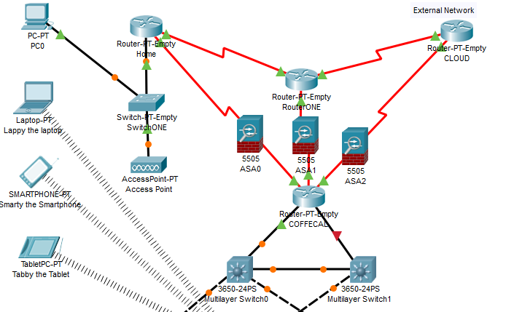
Figure 1: Cloud network pt1
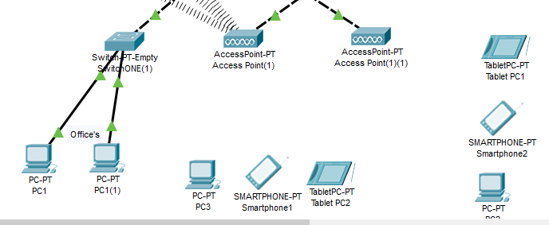
Figure 2: Cloud network pt2
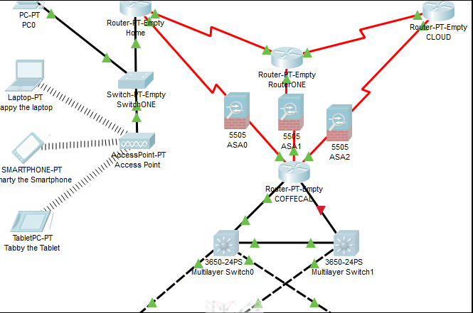
Figure 3: The First attempt at network
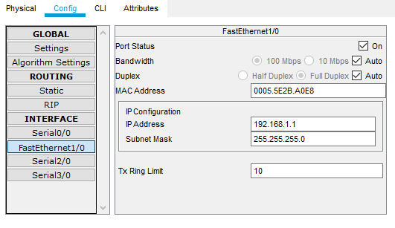
Figure 4: Switch ONE
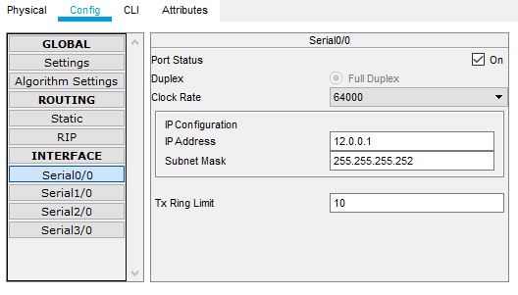
Figure 5: Router ONE
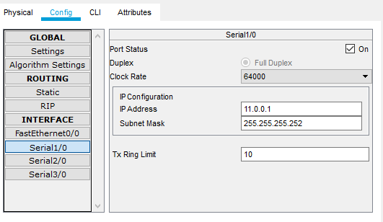

Figure 6: Cloud
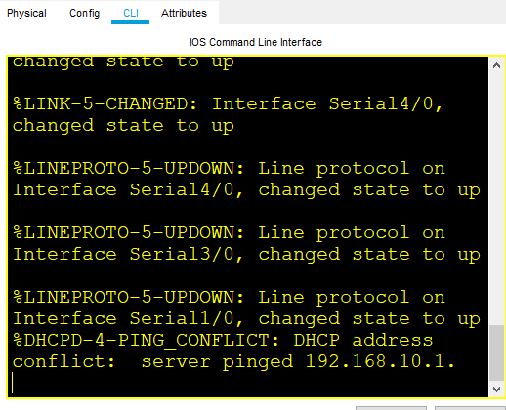
Figure 7: COFFEECAL

Recommendations
Any public access points should take security steps to work with its customers to protect a user's safety and security. These steps should be deleting settings on log-out after each user, regular deletion of all content on hard drives and clear warnings to users of the risks they are exposing themselves to, and there are simple ways of helping their customers to understand the risks of using these open systems. That it is the individual and the employer who are likely to find themselves in trouble with the ICO (Information Commissioner) for failing to take correct and adequate steps to protect data, as fines in excess of £100,000 for data security breaches often happens.
Entities need to understand their obligation to protect data does not end once it is outside their internal systems nor does it become the sole risk and responsibility of the individual who removes it. [4]
NHS Surrey fined £200,000 on 12 July 2013 after the patient records of 900 adults and 2,000 children were found on a second-hand computer purchased from an online auction site. The sensitive information was inadvertently left on the computer and sold by a data destruction company employed by NHS Surrey to wipe and destroy out-of-date computer equipment. [4]

Personal Note

In Figures 1-3 I was unable to finish the network and I struggled a lot with this I would just like to say I am sorry for not being able to complete this task correctly. As a further point I had a windows update problem last week, where it wiped not only all my work on my laptop but my flash drive that was connected, It wiped all my book marks and history, I had to use a back up copy I had on my mobile Hard drive so I have lost a few reference point’s that I had used. David Williams can confirm this.

Bibliography

[1] | “akamai,” [Online]. Available: https://www.googleadservices.com/pagead/aclk?sa=L&ai=DChcSEwjDvMqm1sToAhXJtO0KHUHTAxkYABADGgJkZw&ohost=www.google.com&cid=CAESQOD2b7-29D4xoGUfQcp64eXUGly4_L9hLSZJzSCLzCcNxHu5mfE3K9YVB9vokdV8l3_o4WfHur7157g_1DMUAnA&sig=AOD64_2HFPFQuzxle5ia039mSNpk4G6iRg&q=. [Accessed 31 March 2020].
[2] | uk.practicallaw.thomsonreuters.com, Legal update: archive, thomson reuters, 2020.
[3] | “hubspot,” [Online]. Available: https://blog.hubspot.com/marketing/what-is-ssl. [Accessed 6 April 2020].
[4] | “computer weekly,” TechTarget, 2000 - 2020,. [Online]. Available: https://www.computerweekly.com/. [Accessed 31 March 2020].

Recommend a policy for a CoffeeCapulus using a cloud system.

CoffeeCapulus
Bring Your Own Device (BYOD) and The Use of Computing Facilities, Resources and Security Policy

This document will contain: -
The outlines and acceptable measures to using your own device whilst accessing systems, services, data, facilities, resources, and security of CoffeeCapulus.

Introduction
CoffeeCapulus understands the benefits that can be created by allowing staff to use their own devices while working at home or at work. these devices may include laptops, smart phones. This is known as Bring Your Own Device or BYOD. We are dedicated to helping and support our staff in this endeavour and ensuring that there is few technical restrictions and problems as possible, on accessing BYOD. The use of these devices to create information and data can creates issues that need to be acknowledged in the area of security. CoffeeCapulus must sure it contains control of its data and information that it is responsible for regardless of the ownership of the device that is used to carry out the job and must protect its intellectual property.

Information Security Policies (ISP)
All CoffeeCapulus policies apply to staff that are using BYOD and Information Security related policies.
- The Company Policy on the Use of Computing Facilities and Resources.
- Protection of Information Held on Mobile Devices and Encryption Policy.
- Anti-Virus Policy.
- Data Protection Policy.
CoffeeCapulus computing facilities should be used legally, ethical, and appropriate to The Company s business objectives, and not to hinder others. This policy sets out the conditions of the company’s IT facilities.

Responsibilities of Staff Members
Staff who use of BYOD will take responsibility for their own device and actions:-
- Familiarise their device and its security features. And the safety of CoffeeCapulus information (as well as their own).
- Add and support the correct security features.
- Ensure that the device is not used for any other purpose that would compromise The Company Policy on the Use of Computing Facilities.
- The Company IT support staff will always do there best to help their fellow colleagues wherever possible.
- The Organisation will not take responsibility for supporting devices it does not provide.
Any Staff using BYOD will take all reasonable for the following actions:-
- Prevent theft and loss of data/information.
- Will keep all information confidential.
- Will Keep the integrity of data and information at home or on site.
- Take responsibility for all software they download onto their device(s).

Any Staff using BYOD will: -
- Set up their own passwords, passkeys, or passcodes.
- Set up remote wipe facilities if the device is lost or stolen.
- Encrypt documents or devices.
- Not to hold any information that is of importance, personal and confidential, and of commercial value.
- Where it is essential that information belonging to the company is held on a personal device(s) it should be deleted as soon as it is no longer required, including information within emails.
- Report the loss of any device containing the company’s data.
- Be aware of any Data Protection issues.
- Report any security breach immediately to IT department
- Ensure that none of the information is left on any of the personal device(s). The device is disposed of, sold or transferred or sold to a third party.

The Use of Computing Facilities and Resources

All computing facilities and resources administered by the company, on or off site this includes used by staff and clients and visitors of the company or by other person(s) permitted to use these facilities. Any user authorised by the company using any kind of computer hardware or software, for any purpose, at the company and/or connecting and authenticated to Company’s network from any location. if the devise is their own or a third party’s and is connected to the company’s network is required to abide by the terms of this policy. All equipment owned by the Company’s is covered, even at a remote location.

Monitoring and access of the companies Network
The Company will not monitor the content of personal devices, But the Company does reserve the right to:-
- Check and log data/information and traffic transferred between the device(s) and the company’s systems.
- Deny access to a device from either the wired or wireless networks.
If needed some circumstances there is no other choice you can (with permission) store certain types of information, like staff or financial records on a personal device, you must seek permission from the correct staff member(s).
The company may need to check and monitor the device that is used to check that no miss use of the information is being committed and may compromise your personal data and information.
All staff members are required to conduct work-related, online activity in line with the Company’s Computer related use, this may result in the companies regulations and the requirement may apply the same to using your own devices that are used for the company.
Computing facilities are provided for authorised users only, for the purpose use in connection with the running of day to day operations of CoffeeCapulus. The Computing facilities may be used for a limited time use for personal use if it does not cause problems with the company or makes it legally liable.

Regarding Personal Devise
CoffeeCapulus will takes no responsibility for the following: -
- Supporting,
- Maintaining
- Repairing
- Insuring
- Loss or damage
Of Employee personal devices.
When possible, the company will support and help all devices, but the staff have the responsibility to learn how and manage the device(s) correctly within the context of the company’s policy. Help and advice is available on request from the IT department.

BYOD and Data Protection
CoffeeCapulus will process personal data and information, to identify the living individuals in accordance with the Data Protection Act 1998.
Sensitive personal data that relates to the user, BYOD recognises that there are risks in using personal device(s) to hold personal data. So, staff must follow the guidance in the company’s polies when using BYOD to process personal data.
A breach of the Data Protection Act can lead to CoffeeCapulus being fined up to £200,000. Any member of staff found to have deliberately breached the Act will be subject to disciplinary action, or even a criminal prosecution.

Rights and Responsibilities
All users that use CoffeeCapulus Computing Facilities are under the Policy of CoffeeCapulus and the Resources as soon as they access CoffeeCapulus products.
- All Users will be held responsible for all activity on computing facilities.
- Accordingly, it is forbidden for a user to allow any other person to access to their user ID or password.
- Any security issue when using computing facilities, it should be reported to the IT department.
- CoffeeCapulus will not permit the use of its computer facilities or resources for the access to illegal sites or data.

Penalties and Misuse
Any Breache of this company’s policy by any member of staff will be dealt with the correct disciplinary procedures and staff, if any form of illegal behaviour will be reported to the police or other appropriate authority. They may also be personally liable for their actions under civil law.
- When a staff member at CoffeeCapulus or other authorised user(s) will have their use of computing facilities immediately suspended, during their investigation by the correct member of staff.
- The said staff member may be summonsed for reimbursement or court costs for that loss on revenue

marking criteria and Student FEEDBACK

This section details the assessment criteria. The extent to which these are demonstrated by you determines your mark. The marks available for each criterion are shown. Lecturers will use the space provided to comment on the achievement of the task(s), including those areas in which you have performed well and areas that would benefit from development/improvement.

Common Assessment Criteria Applied (Assignment 1) | Marks available | Marks  awarded
1. Engagement with Literature Skills
Extent of research and/or own reading, selection of credible sources, application of appropriate referencing conventions.
Demonstrates poor engagement with literature skills with an over-reliance on reference source material. Please note that you are required to use reference sources to help you write about research topics in your own words and not just copy and paste from the reference sources as also evidenced by your high Turnitin score. Please note that the University considers this to be an academic misconduct, known as over-reliance on reference materials, see more here: https://www.uwtsd.ac.uk/media/uwtsd-website/content-assets/documents/academic-office/aqh-chapters/chapters---en/Academic-Misconduct-Policy.pdf. (Grade mark: 0.00%) | 15 | 0
2. Knowledge and Understanding Skills
Extent of knowledge and understanding of concepts and underlying principles associated with the discipline.
Demonstrates poor engagement with literature skills with an over-reliance on reference source material. Please note that you are required to use reference sources to help you write about research topics in your own words and not just copy and paste from the reference sources as also evidenced by your high Turnitin score. Please note that the University considers this to be an academic misconduct, known as over-reliance on reference materials, see more here: https://www.uwtsd.ac.uk/media/uwtsd-website/content-assets/documents/academic-office/aqh-chapters/chapters---en/Academic-Misconduct-Policy.pdf. (Grade mark: 0.00%) (Grade mark: ) | 15 | 0
3. Cognitive and Intellectual Skills
Analysis, evaluation and synthesis; logic, argument and judgement; analytical reflection; organisation of ideas and evidence
This report has a high turnitin score and is sent to the unfair practice coordinator (Grade mark: 0.00%) | 40 | 0
4. Practical Application Skills
Deployment of methods, materials, tools and techniques; application of concepts; formulation of innovative and creative solutions to solve problems.
Did not submit a design (Grade mark: 0.00%) | 20 | 0
5. Transferable Skills for Life and Professional Practice
Attributes in professional practice: individual and collaborative working; deployment of appropriate media; presentation and organisation.
Demonstrates poor engagement with literature skills with an over-reliance on reference source material. Please note that you are required to use reference sources to help you write about research topics in your own words and not just copy and paste from the reference sources as also evidenced by your high Turnitin score. Please note that the University considers this to be an academic misconduct, known as over-reliance on reference materials, see more here: https://www.uwtsd.ac.uk/media/uwtsd-website/content-assets/documents/academic-office/aqh-chapters/chapters---en/Academic-Misconduct-Policy.pdf. (Grade mark: 0.00%) (Grade mark: ) | 10 | 0

Assignment Mark (Assessment marks are subject to ratification at the Exam Board. These comments and marks are to give feedback on module work and are for guidance only until they are confirmed. ) | Late Submission Penalties (tick if appropriate) |  | 0%
 | Up to four weeks late |  | 0%
 | First Attempt? |  | 0%

