Marketing Management Assessment
Volkswagen Needs to Embrace New Marketing



April 2023

Marketing Management Assessment (BMMB7012)
Wenlong Wang 2218783
Content words:3,296

Table of Contents

Executive Summary 3
1.Introduction 4

2. Macro and Micro Environment of the Organisation .................................................4
2.1 PESTELAnalysis .....................................................................................................5
2.2 SWOT Analysis........................................................................................................6
3.Target Markets.............................................................................................................8
3.1 The Segmentation Targeting and Positioning (STP) marketing strategy .................8
3.1.1 Market segmentation strategy........................................................................,,.....9
3.1.2 Target market strategy .....................................................................................10
3.1.3 Market positioning strategy.................................................................................10
3.2.Markting MIX........................................................................................................10
4. Key Channels of Marketing.....................................................................................11
5. Success of the Marketing Strategy...........................................................................12
6.Conclusion.................................................................................................................12
7.Recommendations 13
References 14

Executive Summary

The global automobile market has entered the era of stock cars in economically developed regions. Thus, if Volkswagen wants to survive and develop in such a volatile market, it must change traditional, non-digital means and embrace digital marketing. While embracing digital marketing strategies, Volkswagen will encounter many problems changing its organizational culture and strategy. This report analyzes how the company can apply the "1 global data label construction" approach to attain accuracy, build member operation systems for automobile enterprises to realize long-term value, and establish a private domain marketing construction, which will act as the content operation as the king. These three principles can further improve sales.

- Introduction
Volkswagen Group, a leading German carmaker, was founded in 1937 to produce a low-priced “people’s car.”
Today, the company operates plants worldwide and owns twelve brands. Volkswagen offers cutting-edge solutions for future issues such as e-mobility and digitalization, with the goal of making mobility sustainable for future generations.
By 2050, the entire group will be CO2-neutral, and over 70 new all-electric car models will launch by 2028. Volkswagen is currently investing €33 billion in the world's largest e-offensive to sell more than 1 million electric cars per year worldwide in the coming years.

- Macro and Micro Environment of the Organisation
The global automobile market has been disrupted by the COVID-19 pandemic and changes in consumer behavior, Yang and Dong (2022) underline that from the two dimensions of quantity and quality, sales lead in the automotive industry are facing degradation, and traditional non-digital means are difficult to cope with. Secondly, the profit margin of auto enterprises is shrinking due to the rising cost of single-car marketing when auto prices are generally rising. Finally, with the widespread popularity of the mobile Internet, the automotive marketing ecology has quietly changed.
One of the advantages of automobile enterprises is the ability to rely on content that conforms to brand value and effective contact matrices to manage target customers effectively. However, it is challenging for car enterprises accustomed to operating in the public domain to change their marketing strategies significantly(Hassan, 2019). Overall, the automobile industry is undergoing a digital transformation, and car enterprises need to adapt their marketing strategies to meet changing consumer needs, which includes adopting decentralized models and providing digital experiences that meet customers' increasing expectations. Automobile enterprises need to build digital experiences that provide an integrated, seamless experience.(Allen et al. 2021) This requires car sellers to address the challenges of acquiring and retaining new users by using a decentralized model that provides flexibility, active access, high controllability, low comprehensive cost, and more accuracy.
In the next ten years, the global automotive industry will witness four major trends: the market's globalization, the industry's digitalization, the emergence of technical products, and lightened brands (Rekha & Gayatri, 2017). The overall marketing of the automobile industry will start from the three dimensions of market, mode, and product to reduce marketing costs.
Trend 1: In the era of stock competition, cost reduction in marketing becomes the king
In terms of market dimension, it can be seen from the sales volume and market share of China's passenger car brands in 2020 that the country's passenger car market has entered the mature stage. The "stock market" attribute of automobile market is still established, which also determines that cost reduction will become the main theme of automobile enterprises in marketing.
Trend 2: Operating user data and mining long tail value
The change in model dimension, automobile product attribute, and business model of automobile enterprises promote the formation of a long-term bond between automobile enterprises and customers. The enterprises and customers are interdependent and need more effective customer information to drive automobile R&D and marketing promotion (Janßen & Küçükay, 2021). Therefore, user long-tail value mining based on user data operation will become an important source of value for vehicle enterprises in the next stage.
Trend 3: Product supports marketing, and marketing defines products
Hannah (2018) notes that in the digital marketing era, intelligence has transformed cars into intelligent mobile terminals, giving them more user contacts to support the landing and implementation of marketing means. On the other hand, marketing will also redefine products. With the profound, timely, and comprehensive consumer insights digital marketing provides, intelligent cars will be redefined, and a two-way pipeline between marketing and products will be established. The two will eventually be integrated into an integral whole.
2.1 PESTEL Analysis
Political Factors
Volkswagen is impacted by escalating trade wars and conflicts between countries, as well as Brexit, which can lead to declines in the stock market and trade disruptions.
Economic Factors
Consumer demand, global economic development, and local market exchange rates influence Volkswagen’s product launches and production decisions.
Social Factors
Volkswagen adapts its marketing and products to different cultural values and orientations across countries to match local social and cultural environments.
Technological Factors
Volkswagen invests in digital technology to improve driving experiences and explore new customer segments, such as autonomous driving technology.
Environmental Factors
Volkswagen contributes to sustainable development and promotes new energy vehicles to address environmental concerns.
Legal Factors
Volkswagen faces legal challenges as a multinational enterprise, and must improve core product technology, quality management, and legal awareness to avoid issues.
2.2 SWOT Analysis
Internal Advantage
Volkswagen has a very high brand awareness and is more well-known than other car manufacturers, which often leads many consumers to have a higher sense of trust and recognition towards Volkswagen. In terms of product classification, Volkswagen has a wide range of product categories that can meet the needs of various customers.
In terms of manufacturing process, Volkswagen has a more efficient and high quality production process, this makes the cars manufactured by Volkswagen of better quality and more durable. Volkswagen has also launched many innovative products through extensive research and development. For example, electric vehicles, smart cars and other products, which make them a leading position in the global automotive industry (Bekker, H, 2019).
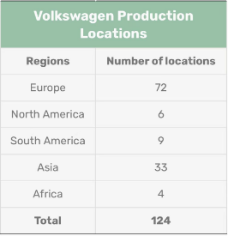
Source : Pixabay
Internal Disadvantage
The disadvantages of Volkswagen are mainly reflected in two aspects. On the one hand, the production cost of Volkswagen is relatively high because Volkswagen has very high requirements for quality. This limits its competitiveness and company's growth potential in some emerging markets. Compared to other models with lower costs, the internationalization of the Volkswagen is slow. On the other hand, although the Volkswagen automotive brand is renowned worldwide, it has not established strong brand loyalty. This means that Volkswagen needs to put more effort into its operations to attract consumers and maintain their loyalty.
External Opportunities
After the COVID-19 pandemic, the demand for cars in emerging markets is increasing, which provides a huge growth opportunity for Volkswagen. These markets can also help Volkswagen increase its global market share. As people pay more and more attention to sustainable development of the environment, the research and development technology of new energy vehicles is also changing rapidly. The constantly updated science and technology have laid a solid foundation for the development of automotive technology. The external R&D environment of Volkswagen has also become better and better, providing the company with the opportunity to launch more high-end and innovative products.
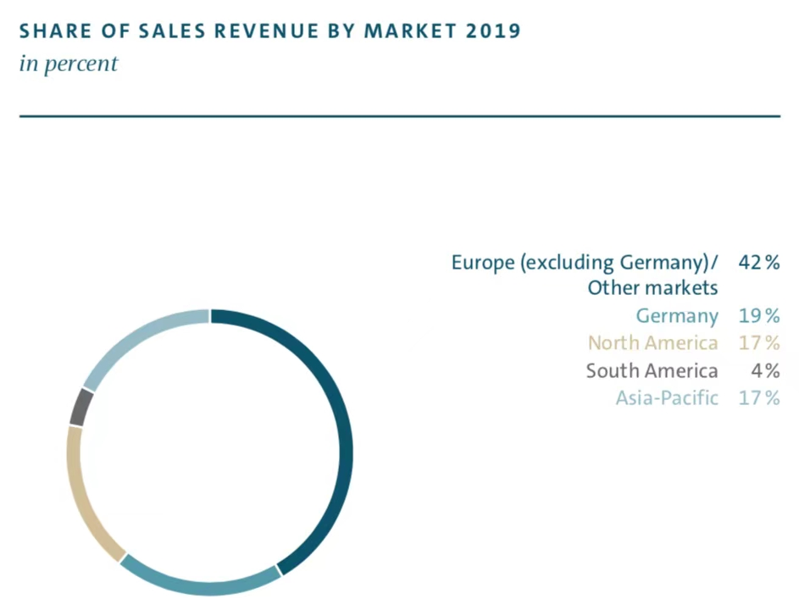
Source : Volswagen Annual Report 2019
External threats
With the world economy entering an uncertain development trend, the automotive market has experienced intense competition, and Volkswagen must maintain a competitive advantage in terms of global, brand, product characteristics, and price. This is very unfavorable for the Volkswagen brand, which focuses on quality. Secondly, there have been uncertainties in the political situation in individual regions of the world, with many countries and regions experiencing highly uncertain political environments, such as Russia, Brazil, India, and others. This may lead to some market risks and the threat of policy changes, directly leading to a decrease in sales revenue or an impact on production. Thirdly, global inflation has not spared the automotive industry, and the cost of automotive raw materials has also increased significantly. However, companies still need to maintain quality, innovation, and sustainability. In this situation, Volkswagen will face the threat of rising costs in all aspects.
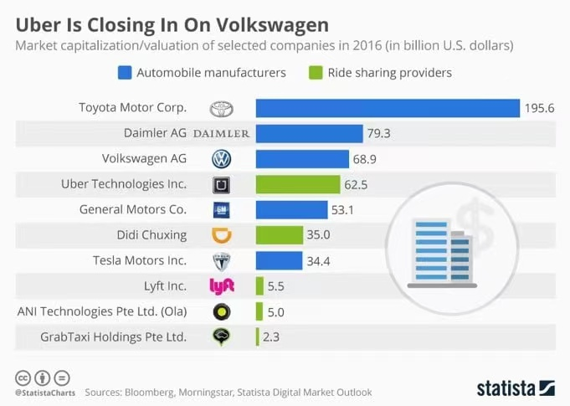(Source:Statista)
3. Target Markets
3.1 The Segmentation Targeting and Positioning (STP) marketing strategy
Teena and Deepak (2014) observe that modern marketing methods attach great importance to STP marketing. With increased production and competition in the automobile industry, high-priced and low-frequency consumer goods and consumers' choices of automobiles are growing. This emergency has generated diverse demands in the market. Enterprises can only position some target customers as potential consumers based on divergent and dynamic consumer needs. Instead, they should focus on advantageous resources to select the most attractive and effective part of the market for the enterprise. Based on their market objectives, they can formulate effective marketing strategies that anchor their products uniquely and attractively. In this regard, the company's image and position can help it secure a fee position in the competitive market (Statkevych & Shapoval, 2020). Using the STP approach, Volkswagen has tailored its marketing approach in the following manner:
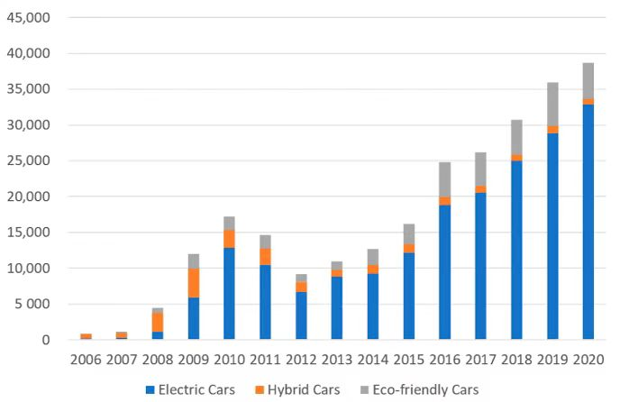
3.1.1 Market segmentation strategy
Segmentation by geographical factors
Volkswagen has divided the international market into four parts. It operates 45 automobile manufacturing plants in eleven countries in Europe and seven countries in the Americas, Asia, and Africa to supply automobile products.
Segmentation by economic dynamics
Volkswagen actively sets up franchises to explore overseas markets. For example, in Mexico, the company mainly produces products that meet the needs of the North American market. It also produces low-price models for export to many Latin American countries.
Segmentation by income factors
The Volkswagen brand group includes Volkswagen buses, Skoda (Koda), Bentley, and Bugatti. Each brand has its logo and operates independently. Its products range from super economical compact models to luxury cars to "high, medium, and low" grades under the Audi, Volkswagen, and Skoda brands corresponding to people of different income levels.
Segmentation by psycho-social factors
For instance, Audi's market positioning is to meet the upper class's pursuit of taste and spiritual sublimation and enjoy the symbolic meaning of the brand. (David, 2015).
Segmentation by behavioral factors
Volkswagen has divided consumers into cool car groups and wait-and-see groups according to their driving factors for buying cars. The cool car group is crazy about cars. They have a clear attitude and personality: active thinking, advocating freedom, and always leading the trend in the forefront of the city. Their demand for cars is dynamic appearance and powerful functions (Jiraporn & Sujitra, 2019). The wait-and-see group is often more interested in cars' practical value and long-term durability.

3.1.2 Target market strategy
Regarding vehicle segmentation, the Audi Q1 first attracted everyone's attention to this market segment because its higher pricing obtained rich initial profits. After the market recognized the products, Volkswagen launched small cars on the same platform to increase its market share. Simultaneously, the company consolidated the consumers' recognition of the products in this market segment to make more profits. Also, Volkswagen launched the Skoda brand as a "cheap version" of Audi, which helped it enhance its market stranglehold.
Volkswagen's market strategy is divided into three levels: high, middle, and low, corresponding to Audi, Volkswagen, and Skoda. Audi first tested the response of the market segment with the Audi Q1 model when developing the market and then launched small cars on the same platform to expand its market share.

3.1.3 Market positioning strategy
Positioning based on the type of consumer
Different groups of consumers with different consumption habits focus on different models. Some value cost performance, while others have a higher choice weight for appearance or brand popularity. Especially in luxury cars, it may be suicidal to preach the cost performance of cars.
Position yourself as a competitor
Martin Winterkorn, president of Volkswagen Automotive, told the German media that he no longer regarded Toyota as the most worrying competitor but pays more attention to the challenges from Hyundai since the Korean currency exchange rate handed Hyundai Motors an export advantage. The high quality of Hyundai Motor also won the respect of Volkswagen Motor (Hye Hwa & Su, 2018).
Position by product
In German, the term "Volkswagen" means "national car." Volkswagen is mainly positioned as a low-end model that is easy for consumers to popularize. During World War II, the Beetle became the first national car launched by Volkswagen. Since then, Volkswagen has launched another national car – The golf. Up to now, golf has had a great advantage in the market share in Germany, becoming the king of national cars in Germany and even Europe.

3.2 Marketing MIX
The marketing mix in Volkswagen marketing strategy can be explained as follows:
Product Strategy:
Volkswagen offers several vehicles in different countries. The company has invested more than $80 billion for developing electric cars. Its top selling and most popular models are results of the product strategy in the marketing mix of Volkswagen. Depending on the level of localization, features, comfort, size, seating capacity, options, engine configurations and power several different trims and variants are offered (Aditya. S, 2021).
Price Strategy:
Pricing strategy in the marketing mix of Volkswagen is mostly based on competition, segment, demand, features offered in the car and the geography being served. With 34,500 vehicles sold every day, Volkswagen prices its products competitively for certain developing nations and slightly more expensively for economies where it is seen as a brand which can command a higher premium. Volkswagen banks on its higher quality as a measure for its slightly expensive prices. Spares too are priced on the expensive side.
Place and distribution strategy:
Volkswagen is available in almost all parts of the world. Assembly lines and manufacturing facilities are located in several regions of the world. Volkswagen chooses suitable countries such as India or China, for example, builds a new plant to help increase the level of localisation and make cars cheaper. Volkswagen has a truly international presence and does a good job of distributing for the countries in which it operates.
Promotion & Advertising Strategy:
Volkswagen has always been forceful with its ad campaigns. As a part of its marketing mix promotion strategy, Volkswagen has used 360 branding to promote not only the parent company, but all its cars individually. ‘Higher quality’ is as a trait of all of its car and most of its promotions in developing countries advertised the same. Aggressive promotional activities using social media networks and online platforms including Twitter, Facebook, You Tube and Instagram help Volkswagen remain at the top of the promotional game as competitors are increasingly heading into online space. Volkswagen also engages with other prominent brands globally via sponsored events.

4.Key Channels of Marketing
However, in the era of rapid development of the internet, the model of diversified marketing has gradually been welcomed and recognized. The operating model of Volkswagen 4S stores can no longer adapt to and meet the needs of consumers in the new era. Instead, it is necessary to learn from other industry marketing models, combine the advantages of the internet and oneself to carry out diversified marketing, increase marketing channels, promote high-quality development of marketing strategies, and achieve the goal of economic sharing. Therefore, when optimizing marketing strategies, Volkswagen can optimize channel marketing strategies from three aspects: direct sales, partnerships, and rental sales.
Firstly, as of now, Tesla has started to adopt a direct sales model for marketing. Tesla has established an offline experience store, where consumers can choose to test drive the store according to their location. They can place orders on online platforms based on their favorite car models. For later maintenance, insurance and other issues, they can follow the database to obtain the fastest and most convenient services. Volkswagen can replicate their marketing channels (Gazdik, T. 2020).
Secondly, Volkswagen can also carry out marketing work by adopting a partnership system between manufacturers and distributors, breaking the previous production first, then sales model, and adopting a production while sales system to save inventory costs.
Thirdly, in the context of the popularity of the sharing economy, the shared bicycle travel method has been recognized by the majority of consumers. Therefore, Volkswagen can optimize its marketing strategy by implementing a sharing model, specifically by increasing consumer recognition through leasing.

5. Success of the Marketing Strategy
In order to successfully implement the new marketing strategy, the marketing system can be further optimized in the process of implementing the strategy through the following aspects:
Firstly, there are differences in cultural characteristics, consumption characteristics, and income levels among different regions and markets, so the promotion strategy chosen should also be targeted and effective. We can learn from the marketing strategies of the e-commerce industry and hire well-known anchors to promote through the creation of shopping festivals, enhancing the breadth and depth of promotions.
Secondly, in recent years, co creation culture has become popular in the automotive industry. Automobile manufacturers encourage user participation throughout the entire process, and can provide suggestions based on needs. At the same time, cross-border integration at the sales end is becoming increasingly normalized (Hanley, S. 2020).
At the same time, the company should note that the various service functions behind traditional 4S stores have not disappeared. They are continuously restructuring and evolving to become more diverse and efficient, exploring and expanding on the three key points of "channels, scenarios, and driving forces".

6.Conclusion
Due to the impact of the COVID-19 pandemic and the large sales of previous models in the international market, the industrial scale's growth has dipped immensely. Also, in addition to technological innovation to increase product iteration, the privatization of sales is imperative. As a result of the rapid development of the Internet and the need for enterprises to reduce costs in the future, digital marketing of automobile enterprises will become the main marketing direction and revenue source of all automobile enterprises. Therefore, Volkswagen must pay more attention to collecting digital customer information and completing more accurate digital portraits.

- Recommendations
Construction of Global Data Labels to Facilitate Accurate Access
The company should construct a multi-dimensional crowd tag to facilitate its comprehension of the market demands (Vellequette, 2021). Using consumption power can refer to RFM and other models, label and classify them based on user groups' consumption preference and consumption capacity, and design private domain operation plans and sales service plans accordingly (Zhang & Wang, 2022).
Product feature word-of-mouth description
Through the product attribute label, Volkswagen can build an industry automobile commodity library, comprehensively and deeply understand the attribute characteristics of each automobile, and form an industry-leading and comprehensive product attribute label. Using a model word-of-mouth label can introduce the owner's users' perceptions and views on the commercial models and form a brand awareness/word-of-mouth label. After further classification and subdivision, a more concrete and perceptible value tag system can be formed (BeachBoard & BeachBoard, 2014).
Build the operation system of car enterprise members to realize long-term value
The core success factor of the member operation lies in meeting users' needs and realizing the value of the car enterprise (Kurt, 2020). Although in the early stage of operation, the car enterprises may need to incline more to the needs of users, that is, appropriately sacrifice financial benefits to meet the demands of more users, in the later stage of private domain operation, the two sides can gradually achieve an organic balance.
Private domain marketing construction and content operation
According to the Yiou Think Tank model, growth in sales of China's passengers will plummet in the next five years. Since emotion is the back door of consumers' brains, they are exposed to more stimulating information, resulting in the increasing threshold of consumers' emotions. If car companies want to increase their trading volume, they must start with consumers' emotions(Beukes & Gerhard van Wyk, 2016).Add new functions, significantly upgrade performance, or first find a traffic star as the spokesperson (Mohammad & Arash, 2020) are marketing actions that help further capture user sentiment and improve user conversion efficiency.

References
Allen Franklin, Haas Marlene D., Nowak Eric &Tengulov Angel. (2021). Market efficiency and limits to arbitrage: Evidence from the Volkswagen short squeeze. Journal of Financial Economics (1).
Almoatazbillah S. Hassan.(2019).Evaluating the Marketing Communication Strategy of Volkswagen in Post-Crisis Period: Application of Image Repair Theory. International Journal of Marketing Studies (2). doi:10.5539/ijms.v11n2p87.
Bagga Teena & Gupta Deepak. (2014). Internet Marketing by Automobile Industry: Special Reference of Indian Counterparts. International Journal of Computer Applications (6). doi:10.5120/17009-7219.
Boienko O.,Statkevych K. & Shapoval A..(2020).Development of Promotion Policy of Hybrid Technology of Cars as an Element of Social-Ethical Marketing. Modern Economics(1). doi:10.31521/modecon.v19(2020)-04.
Barkholz, David.(2015).Hyundai, VW add dealer website options. Automotive News(6660).
Boonying Jiraporn &Chantana Sujitra.(2019).Distribution Marketing Strategy of Goods from Manufacturers to the Consumer in the Auto Parts Industry in Thailand. The Social Sciences(9). doi:10.36478/sscience.2019.335.340.
Byun Young si,Joo Hye Hwa & Park Yeon Su.(2018).Effect of Experiential Marketing on Automotive User Interface: User Experience of Eco-Driving and Welcome System. Design Convergence Study(4). doi:10.31678/sdc.71.3.
Chris Beukes & Gerhard van Wyk.(2016).An Investigation of the Marketing Performance Measurement Practices in Hatfield Volkswagen Group. African Journal of Business Management(6).
Chuhui Yang & Botao Dong. (2022).The Internationalization Strategy of Volkswagen in Entering China..(eds.)Proceedings of 3rd International Symposium on Frontiers of Economics and Management Science (FEMS 2022)(pp.698-703).
Dahiya Rekha &Gayatri.(2017).Investigating Indian Car Buyers’ Decision to Use Digital Marketing Communication: An Empirical Application of Decomposed TPB. Vision: The Journal of Business Perspective(4). doi:10.1177/0972262917733175.
Eneizan, Bilal Mohammad, Abd Wahab ... &Tareq Fayeq.(2016).Effects of Green Marketing Strategies on Sales Volume of Green Cars. Singaporean Journal of Business, Economics and Management Studies(3).
Grober, F., Janßen, A. and Küçükay, F. (2021) “Customer-focussed automatic test course design,” FISITA World Congress 2021 - Technical Programme [Preprint]. Available at: https://doi.org/10.46720/f2020-dgt-007.
Hannah Lutz.(2018).Chase Auto unifies marketing, direct lending. Automotive News(6855).
Larry P. Vellequette.(2021).Why VW went all-in on 'Voltswagen' ruse. Automotive News(6980).
Liu, Y., Zhang, Q., Fan, Z. P., You, T. H., & Wang, L. X. (2018). Maintenance spare parts demand forecasting for automobile 4S shop considering weather data. IEEE Transactions on Fuzzy Systems, 27(5), 943-955.
Ma, C., Zhang, J., & Wang, J. (2022, June). Research on Management Improvement of Visual Marketing Intelligence System in Automobile 4S Shop. In 2021 6th International Conference on Intelligent Transportation Engineering (ICITE 2021) (pp. 630-639). Singapore: Springer Nature Singapore.
Martine Robinson BeachBoard & John C. BeachBoard.(2014).To Outsource Web Development or Not: A Small Automotive Company Considers Search Engine Marketing. Journal of Information Technology Education: Discussion Cases (JITE: DC).
Mikayla Easley. (2022). Manufacturer Marketing New-Look Humvees to U.S. Allies. National Defense (825).
Moeser Kurt. (2020).Auto-Identities. Marketing, Consumption and Product Images of the Automobile after the Boom. VSWG-VIERTELJAHRSCHRIFT FUR SOZIAL-UND WIRTSCHAFTSGESCHICHTE(4).
Morrison, L. (2006). Visual business intelligence can drive performance improvement. Journal of Medical Marketing, 6(2), 119-125. doi:10.1016/J.JFINECO.2021.05.015.
Wolfgang H. Schulz & Bettina Arnegger. (2021).The Volkswagen fraud in the context of economic theory. International Journal of Management Practice(6). doi:10.1504/IJMP.2021.118936.
Olena Lozhachevska & Ruslan Hryhorenko.(2018).ANALYSIS OF MARKETING ACTIVITY AND COMMUNICATION POLICY OF CAR SERVICE ENTERPRISES OF UKRAINE. Economic Analysis(28(3)). doi:10.35774/econa2018.03.170.
Shafiee Majid Mohammad & Shahin Arash.(2020).How Can Green Marketing Lead to Customer Trust and Green Intention Evidences from Automobile Industry. International Journal of Business Excellence(1). doi:10.1504/ijbex.2020.10025827.
Shauli Chaudhuri,CEO & Hoojook.(2014).A New Paradigm in Automotive Marketing. Automotive Industries.
Szillat Patrick & Betov Alexander.(2015).Marketing to multicultural audiences - Ethnic marketing for Turks in the German automotive and telecommunications industries. International Journal of Business and Management(2). doi:10.20472/bm.2015.3.2.006.
Vince Bond Jr..(2020).Automotive marketing shifts amid uncertainty. Automotive News(6926).
Xiong, K. (2020, August). Research on Innovation of Automobile Marketing Mode Based on Big Data Marketing. In 2020 International Conference on Big Data and Social Sciences (ICBDSS) (pp. 72-75). IEEE.
Aditya Shastri.(2021).Comprehensive Marketing Mix of Volkwagen - All 4Ps Included The Digital School (9-10-2021).
Bekker, H. (2019). 2019 Global: Volkswagen Produced Fifth Million Tiguan. Best Car Brands (25-01-2021)
Gazdik, T. (2020). Volkswagen Launches Community-Driven Promise. Media Post (05-04-2020)
Hanley, S. (2020). Volkswagen Pivots Away From SEAT For Low-Cost EV As Chinese Market Cools. CleanTechnica (04-04-2020)

