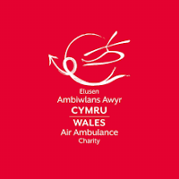
Welsh Air Ambulance Project


By Chris Bikos
224 Words
We chose the Welsh Air Ambulance Charity Organisation as our group project. The Wales Air Ambulance provides advanced life-saving medical care to individuals in Wales around the clock. They are the only air ambulance organisation located in and committed to the people of Wales, and they rely solely on philanthropic donations.
We've decided to call it the "Welsh Air Ambulance" initiative, and our sponsor will be Hannah Bartlett, Supporter Engagement Manager at Wales Air Ambulance. We have chosen to hold a charity walk event in which we will sell Air Ambulance T-shirts, and cupcakes with logos and conclude with a raffle prize in which the winner will win a day at the spa. The goal is to raise £2,000.
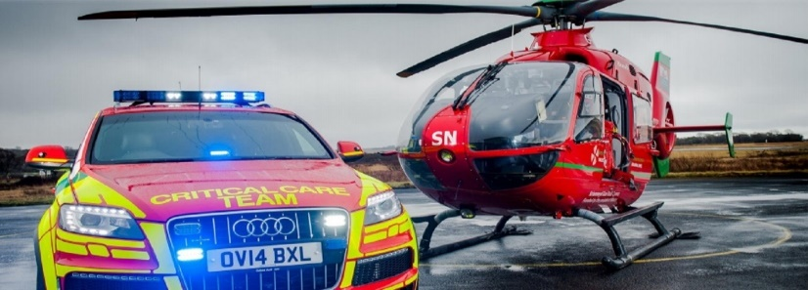

My role in the team….
When I completed the Belbin Questionnaire, I identified as a Coordinator and a Teamworker, but I ended up being the Team Leader. Belbin Team Roles has limitations that can reduce its usefulness in team analysis. Teams and organisations should use it as one of numerous tools for team growth while remaining cognizant of its limitations and tailoring their approach to their team's individual needs and context.
“There are several other factors that are a part of a person’s makeup, including personality. The Belbin Report is not a psychometric instrument, and therefore does not measure personality attributes” (Belbin North America, 2023).
Reference List
The limitations of Belbin (2023) Belbin North America. Available at: https://belbinnorthamerica.com/the-limitations-of-belbin/ (Accessed: May 22, 2024).

