Page 1.
Portfolio.
Cover Image
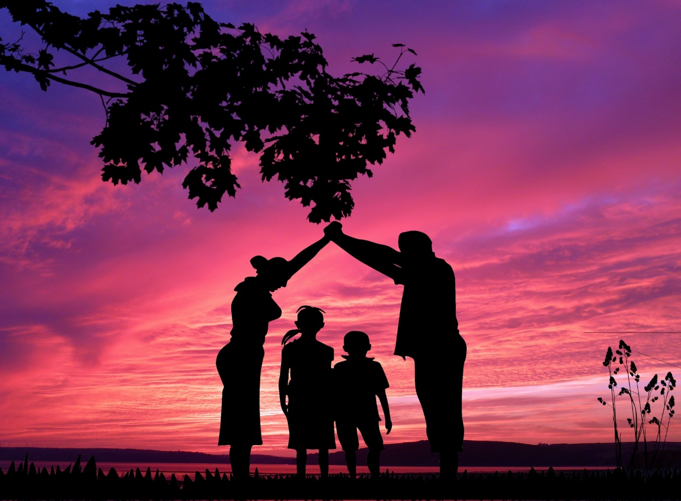
(Familydomainpictures, no date)
By Natalie Bevan
Student Number: 1906137
Assessment Number: 2

Page 2.
Contents page:
Page 1-Front cover
Page 2- contents page
Page 3/4-Introduction
Page 5/6/7-Image 1
Page 8/9-Image 2
Page 10-Conclusion
Page 11-Reference list
Page 12-Image Reference list

Page 3
Social media plays a large role in lots of people’s daily life and can affect their mental health. Human beings are social animals and being socially connected to others has its positives and negatives. On a positive note according to Mehta (2022) being socially connected to others can help to reduce stress, anxiety, depression, increase self-worth, provide comfort and happiness and prevent loneliness. The negative impact of social media can cause emotional and mental health problems, feelings of sadness, dissatisfaction, frustration, loneliness and isolated. Social media is used not just by individuals but also by large companies who use these platforms to influence the viewer into buying their idea/product/service. Hedau (2020) explains how using platforms like Facebook, Twitter and Instagram allows the influencer to target millions and possibly billions of people at once. In the description of their book Cipresso, Riva and Wiederhold (2016) explain how using social media and individual can invent their own personal identity and have full control of how it is viewed by others, including using photographs and videos of how they want to be viewed by others and on many occasions these images can be tweaked to make an individual or their child or home or pet look better to the viewer.
The concept of family has also changed dramatically over the decades. Brewer (2005, p.1) explains in her book ‘how children in sixteenth century England had a very different way of life that they have now she goes onto explain that custody as we know it now didn’t exist at one point in time, children over the age of seven could be married, children could make a will at the age of four’, they were basically only useful to their parents if they had money or could marry into money and it was only in 1889 when the first act of parliament was passed to prevent cruelty to children by their parents that children became better looked after by their parents. In chapter four of what was commonly known as The Children’s Charter (Prevention of Cruelty to, and Protection of, Children Act 1889) included legislation which made it illegal for any parent/guardian to illtreat or neglect a child in their home. The legislation even included a proposed fine to anyone who could be proved to be involved in the death of a child by payment. To compare how children were once treated by their parents and how they are treated now the difference is vast. Without the creation of a parliament and the passing of laws it is difficult to know if children would still be treated like this in the 21st century. The power and popularity
Page 4
of social media has also changed how children are treated as more and more of people’s digital lives are viewed and commented on by others. Many individuals try to portray the perfect image to their social friends and followers even if the image is not the case.

Page 5
Image 1.

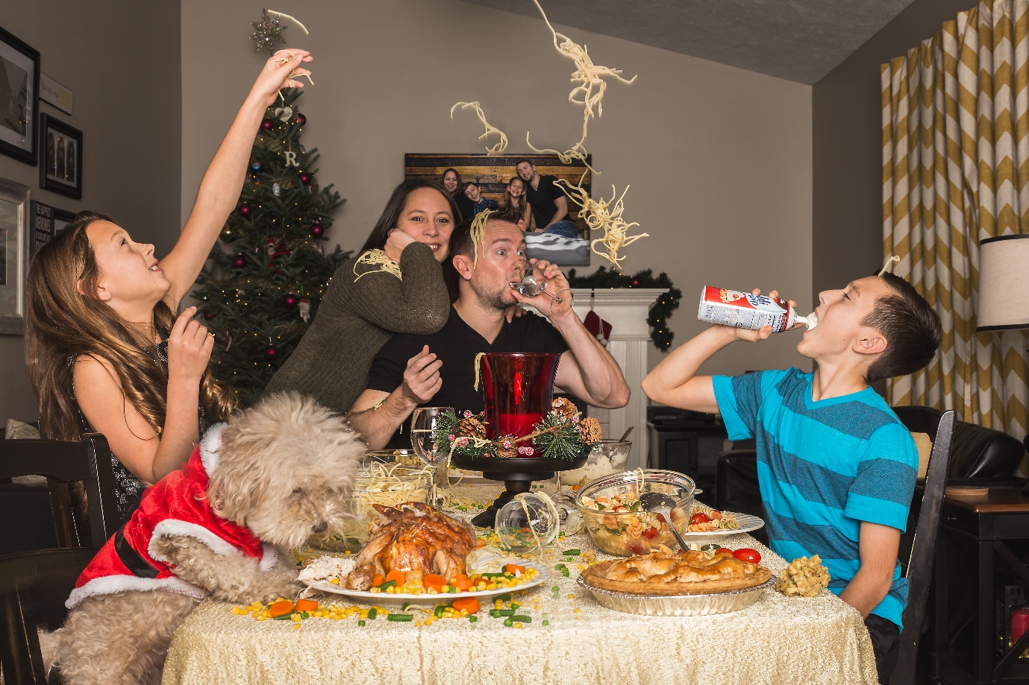 (Bing, no date)

Page 6
The social media image above illustrates two parents of opposite sex and two children of opposite sex enjoying Christmas Dinner with their pet at the table. The image portrays that both adults may be drinking alcohol as there are filled wine glasses on the table although it cannot prove that they are consuming alcohol, it may even be water in the glasses which is all families can afford to drink on Christmas day. The young girl in the image is throwing spaghetti in the air and over her assumed parents and brother, the young boy in the image is pouring
whipped cream into his mouth straight from the can. There is a dog at the table, and it could be assumed from this image that the dog is eating the food that is on the table. This image shows a messy table with glasses knocked over. The image does not portray a traditional Christmas dinner in the United Kingdom, spaghetti could be viewed as a strange accompaniment to turkey and to some viewers the food on this table could be viewed as poor quality. The individuals in this image are not dressed smartly, their dress is quite casual. The amount of food on the table is plentiful but the table itself is quite small.
This social media image could be viewed as a breath of fresh air to some households, as it depicts what is normal for some families. Families who do not expect their children to sit perfectly at the table, on their bottoms for example and no elbows on the table, which can be seen by some as poor manners. The spaghetti on the table could suggest that this is a favourite of the children’s and is being served to ensure they are going to eat the meal. The dog being at the table may be a relief to some viewing this image as many families treat animals in quite the same way as they treat their children and allow their dogs to share the human food and to sleep in the human bed. This image could shock some viewers as this is not how they would let their children or pet behave at the dinner table or anywhere else in the home. The image could be trying to influence individuals to show more of their actual life and what happens in it rather than the perfectly staged photos that most individuals share on their social media with all members of the family in matching Christmas pyjamas, perfectly posed in front of the nicest are of their home without a pet hair in sight.

Page 7
Hill (2005, p.82), says that ‘parents set boundaries of how children should behave but there will be times when the children push these boundaries’. It is unlikely that these children have been brought up to behave like this at the dinner table but as it is a special occasion maybe boundaries have been lowered. This image could portray to anyone who views it, that children are not always well behaved and do not always follow rules and instructions. This image also shows that the family pet does not always conform to rule and regulation either. To a family who have children and pets who don’t always do and act as they have been taught, this image could portray to the viewer that they are not alone in these matters and make them feel better about their situation. This image could also portray a lack of obedience by the children and the dog and be viewed as disrespectful and disobedient behaviour. This image could be viewed as the exact opposite of how some families would conform to eat their Christmas dinner together, throwing food around and allowing a pet to eat off plates would be seen as repulsive to some individuals especially individuals who might suffers from conditions like obsessive compulsive disorder. This image could influence an individual or family into thinking that these behaviours at a dinner table by both the children and the dog are normal and acceptable. The image could also be viewed as it is ok to serve spaghetti on a Christmas dinner as the children like it and this could be regarded by some as ‘letting the children have their own way’ or being ‘spoilt’.

Page 8

Image 2.
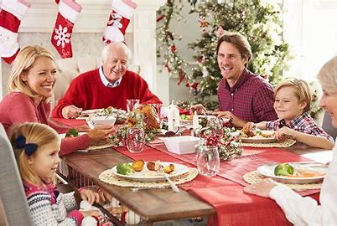
(Bing, no date)
Families in the 21st century can look very different to how they did years ago. Times have changed and the idea of the nuclear family could be offensive to single parents, divorced/separated parents, parents of the same sex and parents who adopt children of a different ethnicity to themselves. In her book Howe (2012, p. 4) explains ‘the varied reproductive technologies available today and how divorce rates can impact the nuclear family as individuals remarry which can result in step children, adoption is a very popular way to have a child if you cannot give birth to one for whatever reason, surrogacy is also a very popular way of someone having a baby that they cannot have naturally’.
The social media image above shows six people sitting at a dinner table enjoying their Christmas dinner. A viewer could assume that there is a mum and dad of the same sex, their two children of opposite sex and two grandparents present. The image shows all six members of the table smiling. This image shows a rather large table which does not appear to have a lot of food on it, although the food could be viewed as of quite good quality, all of the drinking glasses appear to be empty and the table looks clean and quite sparse. All of the males in this image are wearing shirts which portrays this meeting as a formal one which could mean that perhaps it is not a regular occurrence and so special effort has been made to impress the other
Page 9
family members. This image being viewed by a single parent could make them feel envious of what appears to be a ‘perfect’ Christmas dinner shared with a partner. Adult viewers may have not ever had a partner they could share such an intermate dinner with, viewers could have lost a partner which would make this image difficult to look at, The image could also be quite depressing for adults who no longer have their parents alive to share Christmas dinner with and a child viewing this image could compare it to their life also depending on who is present at their table at Christmas. Some viewers of this image might be influenced into inviting their parents over for Christmas dinner or buying a bigger kitchen table for the occasion.
This social media image portrays a family enjoying each others company, all members of the image appear to be enjoying themselves. The image is selling a perfect family photo of the perfect family Christmas dinner. Many viewers who see this image will probably compare their Christmas Dinner to this, some may want to copy and try to bring this image to life at their own Christmas Table. This image could affect an individual’s mental health if they are aware that their family Christmas is not going to look anything like this. The loss of a loved one, divorce or ill health are just some of the reasons that adults may not be able to spend Christmas with their loved ones. From a child’s perspective viewing this image when their parents have separated could cause anxiety or depression. Some relationship breakdowns are not amicable and depending on who the child resides with can result in them losing contact with members of the family of the parent they do not reside with. A survey carried out by the BBC and reported about by Horton (2014) had found that four million people in the United Kingdom would have spent Christmas Day alone in 2014. As a result of the Coronavirus pandemic this number would have probably risen to much higher numbers over the last two years. The individuals experiencing this and viewing either of these images could be left feeling lonely or depressed. These images would also make difficult viewing for a homeless person, not having a roof over their heads, not having clean dry clothes, not having the warmth that a home provides, not having a family to spend time with and not having any food on Christmas day and could result in negative mental health such as feelings of loss, loneliness and inadequacy.

Page 10
Campling (2005, p.74) states in her book that “Childhood is experienced differentially through social class” this is being portrayed here if both the images are to be compared. Both images have used the idea of the nuclear family which could now be seen as outdated. Both images have used slender actors and image two has barely any food on the table which could be trying to influence viewers who are larger than these actors that if you only have this much food on the table, they could be slender also. Everything in is the second image is made to appear more expensive and more formal than the first image. Looking at these images from a micro perspective of how individuals are socially constructed to behave around each other it would be interesting to see if image one would look the same if the family had visitors around or were having their dinner in someone else’s home. Both of the images portray a family getting together for a family dinner and both images show that the families are enjoying each other, but the difference between the two images shows a difference in social class, it could be assumed when comparing these images that one family has more money than the other. Social media influencing can make individuals feel inadequate compared to the images they are shown on social media which can result in mental health and well-being issues for the individuals seeing these images. Social media images are often viewed by teenagers and younger children too and some of the images that they view can influence them into wanting to make changes to their appearance which can be the start of a very addictive process when it concerns body image changes. On the other hand there may be individuals who view these images as something they would like to strive towards in their future, it may give the viewer hope and the confidence they need to achieve their future dreams.

Page 11
Reference List
Brewer, H. (2005) By Birth or Consent: Children, Law, and the Anglo-American Revolution in Authority. Virginia: University of North Carolina Press.
Campling, J. (2005) Families in Society: Boundaries and Relationships. Bristol: Bristol University Press.
Cipresso, P., Riva, G. and Weiderhold, B, K. (2016) The Psychology of social networking vol 2: identity and relationships in online communities. Warsaw: De Gruyter Open Poland.
Hedau, S. (2020) Influence of social media. Available at: Social Media Influence On The World | Power of Social Media (softspacesolutions.com) (Accessed: 5 December 2022).
Hill, M. (2005) Families in Society: Boundaries and Relationships. Bristol: Bristol University Press.
Horton, H. (2014) 4 MILLION of you will spend Christmas alone- why and what can we do about it? Available at: 4 MILLION of you will spend Christmas alone- why and what can we do about it? - Mirror Online (Accessed: 5 December 2022).
Howe, T.R. (2012) Marriages and families in the 21st Century: a bioecolgical. Sussex: Wiley-Blackwell Publishing.

Mehta, N. (2022) Why Social Media Is Bad For Depression? 6 Signs Social Media Is Affecting Your Mental Health. Available at: Why Social Media Is Bad For Depression? 6 Signs Social Media Is Affecting Your Mental Health - Dr. Neha Mehta (drnehamehta.com) (Accessed: 5 December 2022).

Prevention of Cruelty to, and Protection of, Children Act 1889, c. 44. Available at: Prevention of Cruelty to, and Protection of, Children Act 1889 (legislation.gov.uk) (Accessed: 5 December 2022).

Page 12
Image reference list:
Cover Image. Family Domain Pictures (No date) Available at: familie-002.jpg (1920×1415) (publicdomainpictures.net) (Accessed: 5 December 2022).
Image 1. Bing. (No date) Available at: Bing (Accessed: 5 December 2022).
Image 2. Bing. (No date) Available at: perfect christmas family dinner family - Bing images (Accessed: 5 December 2022).

