Abstract:

This article begins by discussing fundamental concepts of data security, including core principles and international standards such as ISO 27001 and ITIL. It then applies these principles to an information security plan in the context of NG Company, covering legal compliance, security policies, risk assessment, security administration frameworks, emergency preparedness, safeguarding mechanisms, and service commitment agreements. The article emphasizes the importance of compliance with data protection regulations, continuous monitoring, and risk assessment to adapt to evolving threats. This article provides NG Company with a guide to enhancing data security and information management practices, ensuring the confidentiality, integrity, and availability of information, and aligning with industry standards.

Intorduction
Data security has consistently been a major issue in information technology[1], highlighting the critical importance of protecting information from unauthorized access, data breaches, and cyber attacks. In the digital age, where vast amounts of sensitive data are stored and transmitted across networks, the integrity, confidentiality, and availability of this data are paramount. Data security encompasses a range of practices and technologies designed to safeguard data from corruption and unauthorized access. This includes the implementation of strong encryption methods, robust access control mechanisms, and regular security audits. Additionally, awareness and training are essential in mitigating human error, often a significant vulnerability in data security. As cyber threats evolve, so too must the strategies and tools employed to protect sensitive information, making data security a dynamic and ever-present challenge in the field of information technology.

Security Framework and Model Research
In the realm of data security, three fundamental requirements must be met: (1) secrecy or confidentiality refers to the protection of data against unauthorized disclosure[2]; (2) Integrity, which involves guarding against unauthorized and improper alterations of data; and (3) Availability, which focuses on averting and recovering from both hardware and software malfunctions, as well as from intentional actions that render the database system inaccessible.
Also, In the field of data security, introducing international standards is crucial for establishing the most suitable information security system for an organization's structure. These standards provide guidance to organizations on how to better manage and protect information. Some of the international standards related to information security management include ISO 27001 and ITIL (Information Technology Infrastructure Library).

ISO 27001 is an international standard that focuses on establishing and maintaining an Information Security Management System (ISMS). This standard first appeared in 1995 under the name BS-7799 and was further revised in 2005 ISO 27001 is a standard that defines a set of principles about the implementation of an appropriate information security management system [3]. This standard focuses on the Information Security Management Systems (ISMS) standard to ensure integrity, availability, and confidentiality [4].
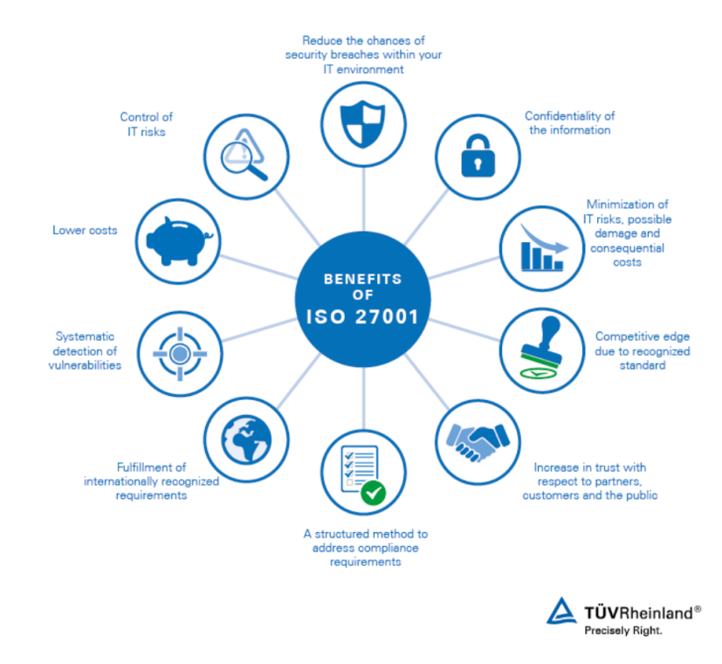
Figure1. The Advantages of Implementing ISO 27001 Standards

As shown in Figure 1, this chart provides an overview of the many benefits of implementing the ISO 27001 standard. The figure illustrates the advantages of this standard through eight key points, NG's extensive online presence makes it susceptible to various cyber threats. Implementing systematic vulnerability detection as per ISO 27001 can help NG proactively identify and mitigate these risks. For example, regular vulnerability assessments can uncover weaknesses in its web platforms and social media interfaces, ensuring timely patching before exploitation.

The Information Technology Infrastructure Library (ITIL) is a framework developed by the UK’s Office of Government Commerce (OGC) [5] ,that outlines best practices for Information and Communication Technology (ICT) service management.The ITIL
framework is now administrated by the Office of Government Commerce and its best
practice processes are supported by the British Standards Institute’s BS 15000 Standard for IT Service Management[6]. Its purpose is to promote effective IT service management. Implementing ITIL is believed to bring many benefits, including improved risk management, cost-effectiveness, reduced service disruptions, improved business productivity and efficiency, and enhanced customer and user experiences.
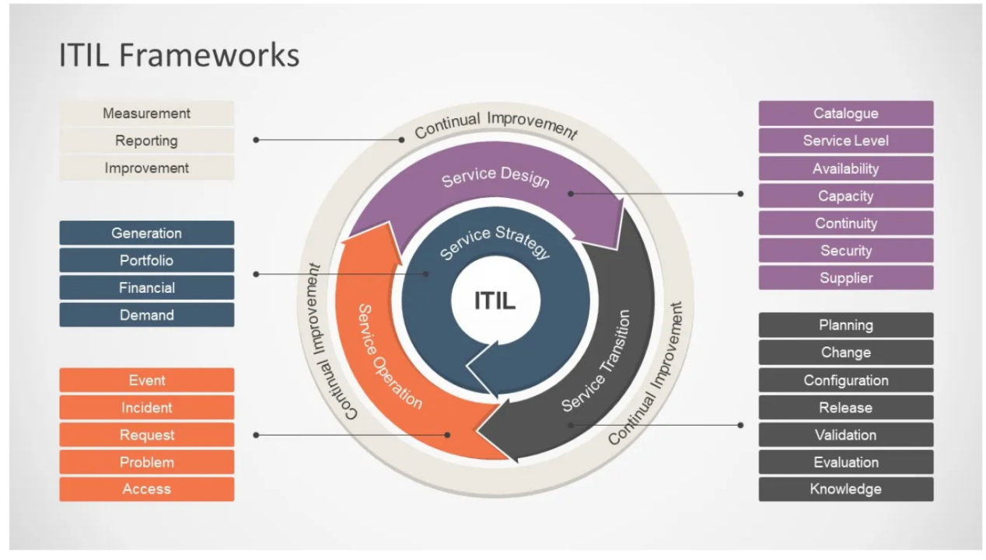
Figure 2. ITIL framework

Figure 2 illustrates the structure and components of the ITIL framework. ITIL (Information Technology Infrastructure Library) is a widely recognized collection of best practices for IT service management. The core of the figure represents a cycle divided into five main stages, representing the lifecycle of IT services: service strategy, service design, service transition, service operation, and continual service improvement. For NG, this means establishing clear guidelines on personal device usage, access control, and data handling, reducing the current disarray in their security policies.

Data Security Plan for NG Company
In the following sections, we will discuss and apply the researched methods to design an information security plan for the NG company mentioned in the case study, addressing the following aspects:Compliance (Laws and Ethics), Security Policies,Risk Management
Security Management Models and Practices, Contingency Planning,Protection Mechanisms,Service Level Agreement.This approach aims to meet the needs of the company for information system security, governance, and compliance.

- compliance ( law and ethical)
Ethics and law both influence data security. Law sets specific rules and penalties, while ethics is based on societal consensus and personal beliefs, which meant teaching philosophical reflection about critical and analytical action[7].

NG must comply with data protection laws like GDPR to ensure principles like data minimization, fairness, accuracy, transparency, and confidentiality, considering its international operations. The reason GDPR can ensure these principles is because GDPR gives consumers a high degree of control[8]. GDPR emphasizes the principle of data minimization, requiring organizations to only process personal data that is necessary to achieve their processing purposes. Secondly, it mandates that data processing must be fair and transparent, ensuring data subjects are aware of how their data is being used. GDPR's establishment encompasses a comprehensive compliance regulatory framework, including strict penalty mechanisms, to ensure organizations take their obligations seriously.

NG could conduct Data Protection Impact Assessments (DPIA) to assess privacy risks, as required by GDPR, ensuring transparency in data processing.
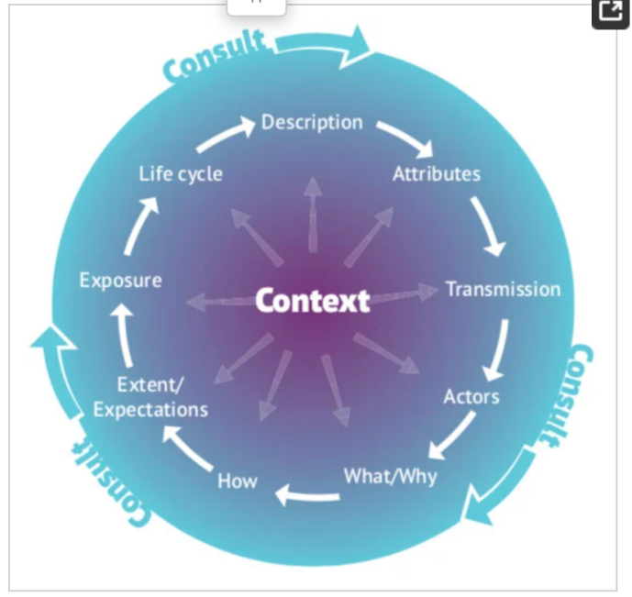
Figure3.Data Protection Impact Assessment (DPIA) Data Wheel

The DPIA Framework was created as part of a GDPR implementation study[9], Figure3 illustrates DPIA principles for NG. To apply DPIA, NG NG should commence by mapping out how data flows through its cloud services and wireless network. Then, Assess Risks: Identify potential risks to personal data, considering the vast amount of customer information handled.Mitigate Risks: Develop strategies to mitigate identified risks, such as encrypting data transfers and strengthening access controls.Document and Review: Document the DPIA process and outcomes, reviewing it regularly, especially when introducing new technologies or processes.

(2)Governance and Strategic Planning for Security

To develop its "Governance and Strategic Planning for Security," NG company can closely follow the framework and methods provided in the course materials. This process will involve multiple stages, including establishing a governance structure, strategic planning, implementation planning, and the use of the Security Systems Development Lifecycle (SecSDLC) model. Here are the specific steps and applications.

NG company should first establish its information security governance structure, identifying key stakeholders such as senior management, and information security professionals like The Chief Information Security Officer (CISO), who is responsible for developing, managing, and operationalizing the information security strategy, as well as conducting information security audits and risk assessments[10]. Next, they should develop an information security vision and mission statement that aligns with overall business objectives, emphasizing the importance of protecting customer data and intellectual property, and aspiring to be a leader in the information security field within the industry.
NG company can formulate its strategic planning for information security, defining long-term organizational objectives, resource allocation, and strategies to achieve these objectives. The plan will include strategies such as enhancing employee security awareness, investing in advanced security technologies, and conducting regular security audits, as well as setting specific and quantifiable goals.

Security Program Implementation Planning. NG company's CIO and CISO must convert strategic planning into specific information security plans, deciding on a bottom-up (grassroots effort) or top-down (senior management support) implementation approach. If the top-down approach is selected, senior management will lead in reinforcing the organization's information security responsibilities and practices.

Application of the SecSDLC Model Finally, NG company needs to apply the Security Systems Development Lifecycle (SecSDLC) model to execute its information security plan. The SecSDLC model consists of several stages, including investigation, analysis, design, implementation, and maintenance. For instance, in the investigation stage, the company will assess the current security posture and potential risks. In the analysis stage, necessary security measures will be identified. The design stage will involve developing specific implementation plans for these measures. The implementation stage will deploy security measures, and in the maintenance stage, the company will continuously monitor and update security measures to address new threats and challenges.

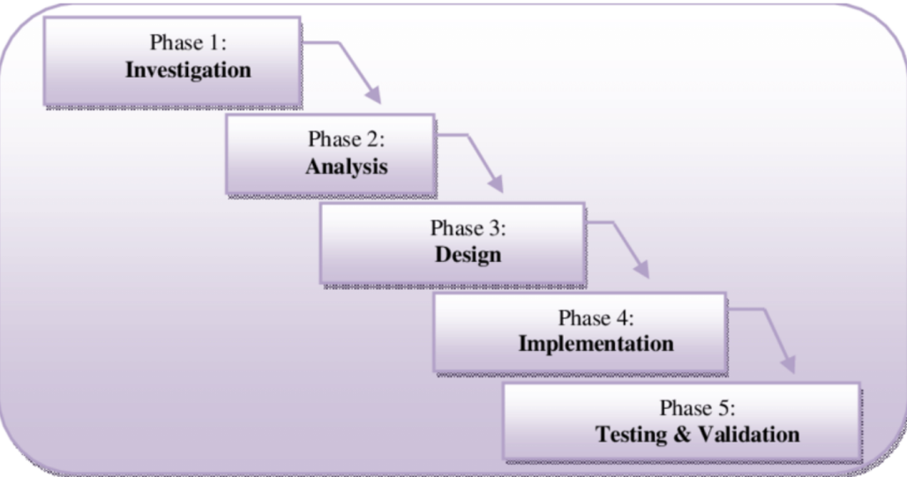
Figure4. Secure System Development Life Cycle (SecSDLC)[11]

The Secure System Development Life Cycle (SecSDLC) is an approach that integrates security considerations from the very beginning of system development. It consists of five phases: Investigation (assessing project feasibility and security requirements), Analysis (in-depth analysis of system requirements and risk identification), Design (architecting system architecture and security controls as foundational elements), Implementation (building the system and implementing security specifications from the design phase), and Testing & Validation (rigorous testing to verify the effectiveness of security measures). SecSDLC ensures that security is embedded throughout the entire development process, helping create systems that are inherently secure by design. NG company can systematically progress through each phase, ensuring that security considerations are integrated into every step of its system development.

By following these detailed steps, NG company can establish a comprehensive "Governance and Strategic Planning for Security," ensuring that its information security management aligns with business objectives and effectively addresses security challenges.

3.Development and Implementation of Security Policies
To establish a robust information security policy at NG Company, four key methods are employed: engaging management in formulating policy that emphasizes reduced risk and compliance; developing distinct types of policies (EISP, ISSP, SysSP) through a thorough risk assessment and management approval process; ensuring effective policy implementation and comprehension among all employees, with formal consent to adhere; and maintaining the relevance of the policies through regular review and updates, allowing for anonymous employee feedback. These measures are designed to align with the company's goals and ensure a secure and compliant organizational environment.

4.Execution of Risk Management
Data-security risk management is becoming an increasingly important process in modern businesses[15]. Therefore, risk management is a core concept in information security, aiming to assist organizations in effectively handling and reducing risks associated with information asset security. This process involves 1. Asset Valuation: Estimating the financial value of information assets, considering costs related to design, development, maintenance, protection, and potential losses. 2. Single Loss Expectancy (SLE): Calculating expected losses from specific attacks, factoring in asset value and potential loss percentages. 3. Annualized Rate of Occurrence (ARO): Estimating the likelihood of specific types of attacks occurring within a defined timeframe. 4. Annual Loss Expectancy (ALE): The overall potential loss for each risk is determined by multiplying SLE and ARO or Risk will be calculated using the following formula, documented by ISACA:Risk=Likelihood∗Impact[16]. 5. Cost-Benefit Analysis (CBA): Evaluating whether the benefits of control measures outweigh the costs, helping organizations make informed risk management decisions.

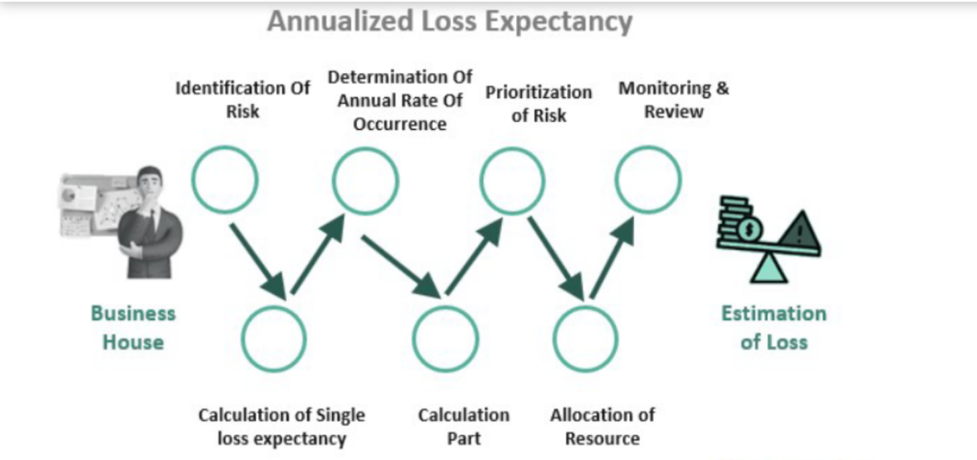
Figure5.ALE

Tailored to NG's business context, it's crucial to ensure that each protection mechanism directly addresses the specific threats the company encounters. For instance, robust authentication and access control are vital for securing wireless networks, particularly within NG's extensive global network. Additionally, advanced data encryption is essential to safeguard customer data stored in the cloud. These customized approaches and associations are instrumental in helping NG effectively tackle its distinctive business challenges and threats.

5.Security Management Models and Practices

NG Company's security management model and practices revolve around its organizational structure and specific requirements. For large organizations, security management typically involves multiple specialized teams, while smaller organizations may be handled by a few experts. Core practices include risk assessment, system testing, policy development, legal compliance assessment, incident response, planning, and monitoring. Information security is usually under the purview of the IT department but is gradually transitioning to an independent department to better balance the needs of different stakeholders. Additionally, security education, training, awareness programs, and effective project management implementation are crucial. NG Company also relies on professional certifications such as CISSP and CISM to define the skills and knowledge requirements for information security roles, ensuring the professionalism and effectiveness of security practices.

NG Company can adopt a variety of mature security management models to enhance its information security strategy. Firstly, utilizing the ISO/IEC 27000 series standards provides a comprehensive framework for an Information Security Management System (ISMS),WhichThe main purpose of an ISMS is to provide executive level management with confidence that the security of corporate information is properly managed as required by executive management and/or regulatory requirements[18]. Concurrently, incorporating the Special Publications of NIST, like SP 800-53, helps in designing tailored security controls. NIST (National Institute of Standards and Technology) is a U.S. government agency that develops and promotes standards and guidelines for various industries, including cybersecurity. SP 800-53 is one of NIST's Special Publications, providing security controls and recommendations for federal information systems. Additionally, the integration of the COBIT 5 framework control framework focuses on IT governance and internal controls. COBIT, currently in its fifth edition, is a good-practice framework for the enterprise governance of IT[19]. NG Company should also implement an information security governance framework, ensuring clear responsibilities from top-level management to general staff. Moreover, adopting access control strategies such as the Bell-LaPadula and Biba models enhances confidentiality and data integrity.
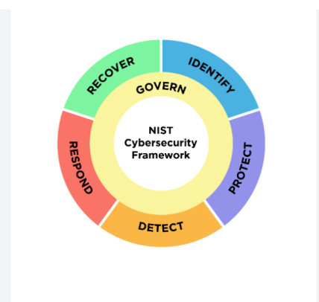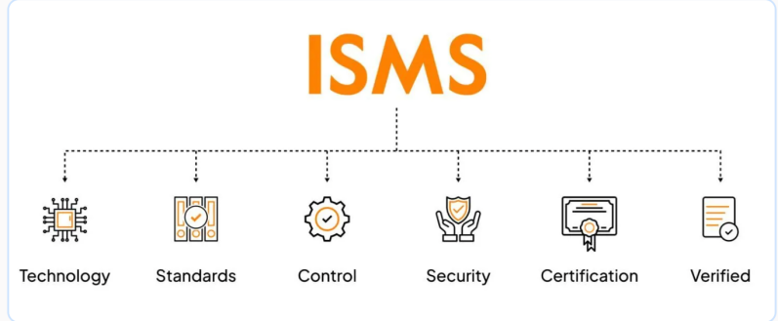
Figure 6. NIST Framework Figure 7. The beneifts of ISMS]

6.Development of Contingency Planning
To elaborate NG Company's emergency plan in detail, incorporating professional terminology, the plan includes: Business Impact Analysis (BIA): Business impact analysis (BIA) is an important process that probes into business processes to determine and list critical processes that are vital to keep the business going[17].Conduct a BIA to identify and assess the potential impact of various risk events, such as natural disasters, technical failures, or security vulnerabilities, on NG Company's critical business operations, ensuring prioritized protection and recovery. Critical Resource Identification: Identify key resources required to sustain critical business processes, including personnel, technology, data, and facilities, and evaluate each resource's impact on business continuity. Recovery Time Objective (RTO) and Recovery Point Objective (RPO): RTO(Recovery Time Objective) and RPO(Recovery Point Objective) is the most critical two metrics in disaster recovery planning[13]. RTO represents the maximum allowable recovery time after an interruption, while RPO defines the acceptable timeframe for data loss. Emergency Response Plan: Develop emergency response plans tailored to different types of risk events to ensure swift and effective business recovery. Continuous Monitoring and Early Warning Systems: Implement continuous monitoring mechanisms to detect potential threats and abnormal activities, ensuring timely response. Regular Testing and Assessment: Conduct periodic tests and assessments of the emergency plan to ensure its effectiveness and make timely updates.

Through these steps, NG Company can ensure its emergency plan is adequately prepared to address various potential risks, safeguarding business continuity and data security.

7.Deployment of Protection Mechanisms
NG Company can enhance its network security through various measures, including the deployment of firewalls and proxy firewalls to prevent unauthorized access and cyber attacks. These devices assist in filtering network traffic and monitoring potential intrusion attempts. Additionally, the company can utilize Intrusion Detection and Prevention Systems (IDPS) such as Cisco Firepower to monitor network traffic and system activities, Cisco got rated a “high effectiveness against signature-based threats”[14]. NG Company should also regularly use scanning and analysis tools like Qualys to check for vulnerabilities in its systems and network. Implementing Network Access Control (NAC) is crucial for managing and controlling access to network resources, ensuring that only authorized users and devices can access critical assets.

To effectively protect its information assets and respond to evolving threats, NG Company needs to adopt a comprehensive security management approach. This includes the integrated use of firewalls, IDPS, scanning and analysis tools, and network access control technologies to build a robust defense system. To maintain the effectiveness of this defense, the company must continuously monitor, update, and train its staff on network and information system security, ensuring a swift adaptation and response to emerging threats.

7.Clearly specified Service Level Agreements
A Service Level Agreement (SLA) is typically an agreement between a customer and a provider to receive a particular service[20]. Service Level Agreements (SLAs) include key parameters like response time, bandwidth, storage, reliability, and cost, which providers must monitor and maintain to prevent SLA breaches. SLAs aid in adapting to dynamic environments and diverse resources. To ensure that NG Company's information security management is both effective and compliant with industry standards, the following measures can be applied in the clear stipulation of Service Level Agreements (SLA)
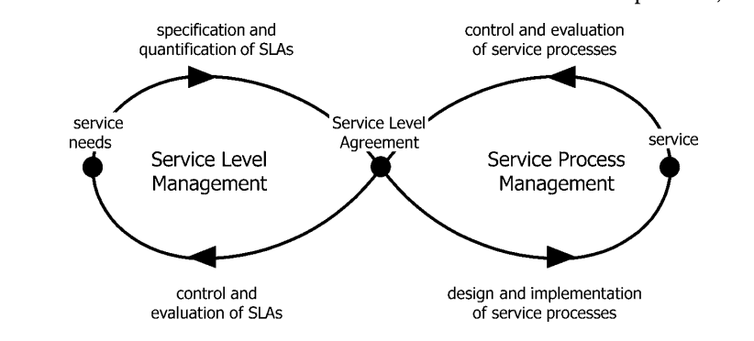
Figure 8.The Service Management Lemniscate[21].

Clarification of Security Service Standards: The SLA signed with third-party service providers should clearly include specific security service standards. These standards should detail the required security measures, such as encryption protocols, data access controls, risk assessment procedures, etc.

ITIL-based Service Management: The SLA should incorporate service management practices based on ITIL (Information Technology Infrastructure Library). This means that the definition and monitoring of service quality will be based on the ITIL framework, ensuring standardized processes and best practices in service management.

Setting Monitoring Metrics: Specific monitoring metrics should be defined in the SLA, which can quantitatively assess the performance of service providers. For example, metrics regarding system availability, response time, fault repair time, etc., can be set.

Regular Review and Update: To adapt to the constantly changing technology and threat environment, the SLA should be regularly reviewed and updated. This includes re-evaluating security standards and monitoring metrics to ensure they still meet NG Company's needs and industry best practices.

Compliance and Industry Standards: Ensure that all terms in the SLA comply with relevant laws, regulations, and industry standards. This may involve collaboration with legal advisors and industry experts to ensure comprehensive compliance.

Employee Training and Awareness: Regularly train NG Company's employees to ensure they understand the contents of the SLA and their practical application in daily operations.

Through these measures, NG Company can ensure that its information security management not only follows industry best practices but also effectively addresses the increasingly complex challenges of information security.
Summarization and Review
This document provides NG Company with a detailed overview of data security, emphasizing compliance with data protection laws, monitoring, and risk assessment. It discusses data security principles, standards like ISO 27001 and ITIL, and applies them to NG's security plan covering legal compliance, policies, risk management, and service agreements. However, it lacks practical case studies, might need updates to reflect latest data security trends, doesn't sufficiently stress employee training and security awareness, and needs more detailed strategies for new threats like APTs and zero-day attacks. Future improvements should focus on these areas to enhance NG's data security management against complex threats.

- Sun Y, Zhang J, Xiong Y, et al. Data security and privacy in cloud computing[J]. International Journal of Distributed Sensor Networks, 2014, 10(7): 190903.
- Bertino E, Sandhu R. Database security-concepts, approaches, and challenges[J]. IEEE Transactions on Dependable and secure computing, 2005, 2(1): 2-19.
- Hsu C, Wang T, Lu A. The impact of ISO 27001 certification on firm performance[C]//2016 49th Hawaii International Conference on System Sciences (HICSS). IEEE, 2016: 4842-4848.
- Talib M A, Khelifi A, Ugurlu T. Using ISO 27001 in teaching information security[C]//IECON 2012-38th Annual Conference on IEEE Industrial Electronics Society. IEEE, 2012: 3149-3153.
- Potgieter B C, Botha J H, Lew C. Evidence that use of the ITIL framework is effective[C]//18th Annual conference of the national advisory committee on computing qualifications, Tauranga, NZ. 2005.
- Cater-Steel A, Tan W G. Implementation of IT Infrastructure Library (ITIL) in Australia: Progress and success factors[C]//2005 IT Governance International Conference. Auckland University of Technology, 2005: 39-52.
- Karale A. The challenges of IoT addressing security, ethics, privacy, and laws[J]. Internet of Things, 2021, 15: 100420.
- Li H, Yu L, He W. The impact of GDPR on global technology development[J]. Journal of Global Information Technology Management, 2019, 22(1): 1-6.
- Henriksen-Bulmer J, Faily S, Jeary S. DPIA in context: applying dpia to assess privacy risks of cyber physical systems[J]. Future internet, 2020, 12(5): 93.
- Monzelo P, Nunes S. The Role of the Chief Information Security Officer (CISO) in Organizations[J]. 2019.
- Daud M I. Secure software development model: A guide for secure software life cycle[C]//Proceedings of the international MultiConference of Engineers and Computer Scientists. 2010, 1: 17-19.
- Framework B E. The National Institute of Standards and Technology (NIST)[J]. 2015.
- S. Suguna and A. Suhasini, "Overview of data backup and disaster recovery in cloud", International Conference on Information Communication and Embedded Systems (ICICES2014), vol. 978, pp. 1-7, February 2014.
- Next Generation Firewall Capabilites Assessment (2015). Retrieved from SwishData: http://www.swishdata.com/downloads/Next-Generation-Firewall-Capabilities-Assessmet.
- Jerman-Blazic B. A quantitative model for information-security risk management[J]. Engineering management journal, 2013, 25(2): 25.
- Information Systems Audit and Control Association (ISACA)-ISACA Journal, vol. 4, 2014.
- Sikdar P. Alternate approaches to business impact analysis[J]. Information Security Journal: A Global Perspective, 2011, 20(3): 128-134.
- Broderick J S. ISMS, security standards and security regulations[J]. information security technical report, 2006, 11(1): 26-31.
- De Haes S, Van Grembergen W, Debreceny R S. COBIT 5 and enterprise governance of information technology: Building blocks and research opportunities[J]. Journal of Information Systems, 2013, 27(1): 307-324.
- Swain A K, Garza V R. Key factors in achieving Service Level Agreements (SLA) for Information Technology (IT) incident resolution[J]. Information Systems Frontiers, 2023, 25(2): 819-834.
- Trienekens J J M, Bouman J J, Van Der Zwan M. Specification of service level agreements: Problems, principles and practices[J]. Software Quality Journal, 2004, 12: 43-57.

