Gendered Suffering: The Segregation and undeniable suffering of women as a result of the Holocaust

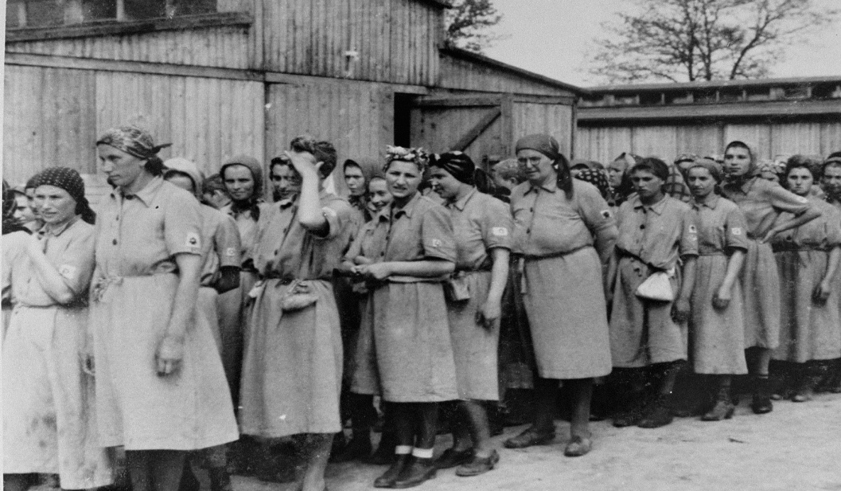
Picture 1 Jewish women at Auschwitz-Birkenau Collections Search - United StatesHolocaust Memorial Museum. Accessed 1st February 2025

The term Genocide was originally conceptualised and utilised by Raphael Lemkin a Polish Jewish jurist in 1944, who used the term to describe the results and actions of the Nazis in the World War II and has been used as a template for similar atrocities following. Using the combination of the Greek word ‘Genos’ meaning race or tribe and the Latin word ‘cide’ meaning killing(Simon, no date). Its meaning is used to describe acts of de liberate and systematic destruction of a racial, political or cultural group. In most cases Mental and physical harm is inflicted and projected onto such individuals often by recreating an environment where such individuals are denied their cultural heritage and the ability to exercise their rights in their natural state. Often in history children were targeted in the process of genocide and were transferred to other cultures in the hope of their indoctrination and so stamping out any future continuation of their original way of life, further measures were also made to prevent future births from members that were able to conceive. It is summarised that Genocide and war go hand in hand, more so that war in fact creates both a smoke screen and the suitable environments with which to begin a Genocide regime. In 1996 Professor Dr Gregory H Stanton the founding president of Genocide Watch created a model on which is used to identify and explain the signs and processes linked within genocide, these are called the Eight Stages of Genocide, later expanding it to ten. These showcase the negative and progressiveness of possible human brutality. Although there have been unlimited attempts of Genocide littered throughout history, perhaps none are so well documented and on such a vast scale as that of the Holocaust, widely due to its effect on many cultures at the time. With the use of photography and video capture which was still in its infancy the story of the holocaust has remained well documented and been used in educational programmes and thanks to the Nuremberg trials of 1945-1946 has been used as the pre-curser to other Genocide war crime cases although the term Genocide only appear in the indictment of the German war criminals at the time(Simon, no date). In this piece I will be examining how deeply women were affected by the Holocaust during their times concentration camps and post the end of the war while reflecting on some of the categories that create genocide. This will include accounts of women prisoners who were encamped in Ravensbruck and Auschwitz and an comparable account of a female SS guard who was in charge of selection, training and tortured such women.

It is seen visually within war that men are treated differently than women and that the role of the masculine is to protect the nation which is represented as the feminine as she is the creator of life, that if he fails in his task he would be emasculated and feminised(Gender and the Violence(s) of War and Armed Conἀict: More Dangerous to Be a Woman? - external_content.pdf, no date a). In the midst of Nazi policies lay a race hygiene ideology called the Rassenschande law which inhibited racial defilement with Germans and jews segregating them into Aryans and non- Aryans and saw the Jewish woman’s body as an object of danger, where other cultures believed in the genocidal aim of contaminating the bloodline by the production of ethically mixed children(Gender and the Violence(s) of War and Armed Conἀict: More Dangerous to Be a Woman? - external_content.pdf, no date b) Acts of sexual violence has been utilised In the art of warfare worldwide intended to punish, intimidate and destroy communities(gender et al., 2020). Absence of the Rassenschande laws was clear in the concentration camps as rape was commonly used as a form of initiation for SS soldiers and Sadistic rape was encouraged to offer soldiers a way to reinstate a level of internal power and boost an individual’s esteem(Gender and the Violence(s) of War and Armed Conἀict: More Dangerous to Be a Woman? - external_content.pdf, no date b). At the beginning of the war Jewish women were led to believe that the Germans were civilized and that men were the only ones at risk, so women did not have the need to deport or hide(Women in the Holocaust, no date). However, it soon become apparent that women were then to be targeted and sent to the concentration camps, and in 1938 the first all women concentration camp of Ravensbruck was created with 900 women were transferred from the Lichtenburg camp. On July 1943 in Theresienstadt compulsory abortions order was issued in July 1943, where a Jewish women who gave birth to a child was automatically sent to Auschwitz with her child and husband(Women in the Holocaust, no date). Women arriving at the concentration camps would undergo a form of defeminising with the implementing of stripping down and shaving their bodies including their heads to expose their naked bodies for examination. With the lack of supplies and limited resources to wash many women would feel shame and humiliation as they were unable to hide their menstrual cycles although this would provide a deterrent from being sexually assaulted it also led to levels of anxiety (Femininity in Concentration Camps, no date). Many women due to lack of nutrition and large amounts of weight loss would experience times with no menstruation which transmuted in these women a fear of their future beyond the camps as lack of fertility meant no children for them in the future.

In the time of the Holocaust there were more than a thousand concentration camps erected during 1933 and 1945, designed to house a varied range of prisoners from political people to Jews, French resistance to name a few, with many then progressing to become forced labour camps and extermination camps. In these camps German authorities assigned women into forced labour with such poor conditions that they weren’t expected to survive. Roma and Jewish women were specifically targeted for experimentation and sterilization with pregnant Jews submitted to forced abortions, while Polish and Soviet women were forced to give birth in makeshift nurseries where the infants would perish. Within these camps the Germans established brothels using the inmates for the pleasure of the soldiers(Women during the Holocaust, no date). An estimated 34,140 women and girls were trafficked and subject to sexual terror by the Third Reich during their rule with Heinrich Himmler overseeing the integral parts of what would later be known as rape camps, to where he would send homosexual prisoners in an attempt to cure them(Center, no date). Classification of the individuals or groups were commonplace and lead to an internal divide between individuals based on ethnicity, religion and such groupings, creating an environment where there became a them and us scenario. Symbolization was used to identify individual groups for the reason of their incarceration by assigning distinguishing markers on their prison clothes, in the case of Dachau which was first established in March 22nd 1933 originally to house men, but in later would house women from August 1944 began with a prototype of identification of inmates that would later be adapted as the regimes progressed(Holocaust Encyclopedia, no date), this follows stage 2 of the genocide act. Pregnancy within a concentration camp would lead to a death sentence and if women were visibly pregnant or was pregnant with a small child they would be selected for execution which mey be referenced to stage 4 and 7 of the stages of genocide. It was probable that some pregnant women would avoid detection and in these cases women would give birth in secret and poison be administered to the newborn upon birth to save the life of the mother(Women in the Holocaust, no date).

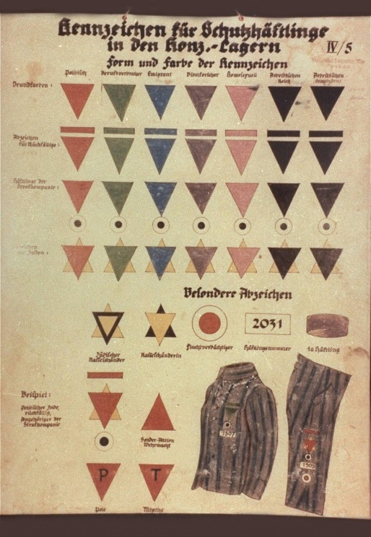
Picture 2 Dachau identification of prisoners Holocaust Encyclopedia | United States Holocaust Memorial Museum Accessed 6th February 2025

Ravensbruck was the largest and the first all women concentration camp and was established in 1938 for order of SS leader Heinrich Himmler. From 1939 it held 900 women increasing to 10,000 by the end of 1942(Ravensbrück, no date) Amongst the captured and enslaved were women of varying ages, cultures, religion and countries, including Catholic nuns, French resistance, English reconnaissance, Czech journalists as well as Jewish, polish, Romani and children. Due to overcrowding and poor sanitary conditions a Typhus epidemic engulfed the camp leading to isolation of prisoners deemed too weak to work under a Euthanasia programme, this led to 1600 prisoners being killed. Karl Gebhart utilised this camp to conduct experiments where he would select the strongest women to test the effectiveness of sulfanilamide, this would involve breaking and removing bones and inserting various objects such as wood and cloth to cause infection. These women were labelled as Rabbits and would although suffer extreme suffering would hold a strong level of compassion in the eyes of the other prisoner. A secret group within the camp was created to smuggle food into them and who in turn with the help of prisoners would document their mutilated bodies and smuggle messages, such is the case of Krysia Czyz who wrote a letter using her urine(Ravensbrück, no date). Towards the end of their ordeal regular prisoners would aid in hiding the r Female prisoners were controlled 3500 by female guards. Female SS guards known as Aufseherinnen were assigned to female prisoners, they received minimal training and were selected for their diverse backgrounds. Although they were not seen as officially members of the ss but were seen as employees. Women at these times had less physical or political power and so in many cases due to the prowess of these roles became fixated on the symbol of authority that they projected, which in turn influenced them to become worse than the male SS soldiers and attracted women with sadistic tendencies. Torture was commonplace and held in bunkers, more commonly was the use a wooden structure designed to that the prisoner was bent over and thrashed which was authorised by Himmler. One such guard Dorothea Binz was instated at Ravensbruck at the age of 19 and came from a middle class family in Forsterei Dusterlake in an attempt to better her circumstance which she did by several promotions leading into 1942 where she assisted in selecting women for the ongoing experiments, by 1944 she was given the role of chief overseer and trained new female guards by indoctrination in the finer points of malicious pleasure(Dorothea Binz, no date). She would target the weaker women and set dogs on them and kept the prisoners cold and hungry and forcing inmates to have sexual relations with her and becoming aroused while watching women being beaten. After years of court hearings, she was finally sent to hang in 2nd May 1947, after her attempt to commit suicide.

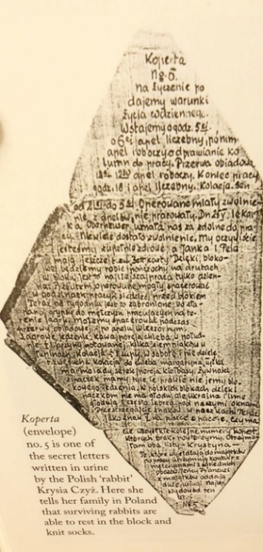
Picture 3 Secret letter written in Urine by Krysia Czyz "The Rabbits of Ravensbrück" - Exhibits - The Other ‘Othered’: Bodily Rhetoric and the Women of Ravensbrück Concentration Camp - Student Digital Gallery - BGSU University Libraries. Accessed 4th February 2024

Elise Rivet joined the Notre-Dame de la Compassion sisters in Lyon France in the year 1913 at the age of 22 and was better known as Sister Elizabeth, and eventually rose to the order of Mother Superior During her time, she became devoted to work on educating poor girls in need, later aiding the French resistance by hiding weapons and jews disguising them as nuns, with the blessing of Cardinal Gerlier The Gestapo finally apprehended her on March 25 1944 sending her to Ravensbruck where she supported prisoners both emotionally and spiritually for the next year until March 30 1945 where she finally offered to trade in her life for that of a mother who was condemned to be gassed, which was 2 weeks before the war was declared over(The Heroic Nun Who Gave Her Life for a Mother, 2017). She was later honoured in 1961 by the government of France in a Heroes of the Resistance postage stamp and her legacy has been used to aspire others of the importance of the power of faith, love and the strength of the human spirit.

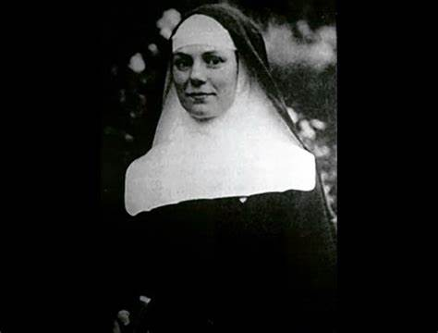
Picture 4 Elise Rivet The Heroic Nun Who Gave Her Life for a Mother| National Catholic Register. Accessed 6th February 2025
Corrie ten Boom was born 15 April 1892 in Haarlem, Netherlands and was one of 4 children. Living above her father’s watch shop she started learning the trade and organising the finances to later qualify as the first licensed woman watch maker in 1922. Her family were Calvinist Christian in the Dutch Reformed Church who believed in serving their society and that Jews were precious to God, that all people were created equal. Her efforts in the war grew from gathering stolen ration cards to harbouring jews in her home and on 28th February 1944 her and her family were arrested and put on trial where she continued to speak for the rights of those with mental disease which were dismissed by the Nazis and her then being transferred to Ravensbrück, where she continued to preach the lords work and contribute to prisoners converting to Christianity. She remained a devote Christian writer and a public speaker and setup a rehabilitation centre in Boemendaal for concentration camp survivors until 1950(Corrie ten Boom: Biography, Holocaust Activist, The Hiding Place, no date).

Ruth Cohen was born Renee Friedman transferred to Auschwitz-Birkenau at the age of 14 with her family in May 1944. On arrival she was segregated from her family to be reunited with her sister and father upon liberation and to later venture to America for the hope of better perspectives. She was uninformed of the death chambers and the crematorium until later which she was informed her mother, brother and cousins had been victims of. At the age of 80 she attended a tour of the camp with the Holocaust Memorial Museum she volunteers at and is momentarily affected by the memories bringing on feelings of heart irregularity, leading to a resistance to walking thru the gas chamber reminiscing how it had taken away her whole world. She recalls how she lived in a room of 12 people sleeping on just wooden planks and how she felt sleeping next to her sister saved her life. She remains a key advocate to educate people on the dangers of repeating history broadcasting her belief that Antisemitism and Racism are on the rise and her concerns that nobody is remembering the dangers of such actions with the results of the Holocaust as a template(Kirsch, 1738472400).

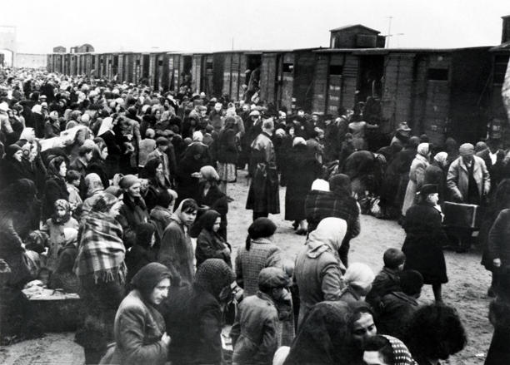
Jewish people disembark from a train as they arrive at Auschwitz-Birkenau in German-occupied Poland in 1944.. Auschwitz survivor returns to brave a harrowing past . Accessed 4th February 2024

Although the Holocaust was cantered more around the Jews rather than just women, it is apparent that all groups of women of different nationalities and ages in the concentration camps suffered heinous acts of abuse under the Nazi regime, countless of which did not survive. Such was the degree of violence that that Holocaust survivors favoured not disclosing their ordeals of sexual violence from WWII from the difficulty in remembering accounts and emotions from the past as well as a level of shame(Stein, 2009). That there is a pattern of mental illness followed on from survivors to their children which can result in the subjection of the siblings to exhibit concentration camp syndrome and in some instances be the subject to emotional and physical abuse(Dashorst et al., 2019). In the case of women, it is apparent that they are twice as likely to develop PTSD due to the extent of the sexual violence they were exposed to and being under obligation to not disclose the degrees of violence as at the time it was seen as taboo. Women repeatedly underwent vast attacks at their femininity with emotional and physical abuse, as the caregiver and protector role diminished as they were torn away from their children and families. In Auschwitz June 1944 due to the Nazi protocol to separate healthy women to work from their children many mothers faced the ordeal of staying with their children to be killed or bidding farewell to their children, with this ordeal within 6 months 600 mothers chose to stay with their children and be gassed with them, leading to increased amount of Jewish women’s death due to their feeling of devotion and responsibility (Women in the Holocaust, no date). Women were clinging on to the hope of liberation resulting in a growing solace and hope by forming a type of camp-sister organisation coined Lagerschwestern, which focused around sharing recipes, building moral and forming support mechanisms. Within the relationships there was created a powerful psychological effect as it reflected a commitment to live and was unique to women(Women in the Holocaust, no date). For the women who were liberated and survived few have documented their experiences and have found solace in their religion, practising peace and forgiveness to those that did them harm, have given credit to those women that supported, had forfeited their lives for others and the compassion and strength the women found themselves surrounded in. Some women belief in testifying to their survival and teaching their stories in hope for a better future.

Bibliography

Center, K.H. (no date) ‘The Concentration Camps - Inside the Nazi System of Incarceration and Genocide Part 4B’.
Corrie ten Boom: Biography, Holocaust Activist, The Hiding Place (no date). Available at: https://www.biography.com/activists/corrie-ten-boom (Accessed: 7 February 2025).
Dashorst, P. et al. (2019) ‘Intergenerational consequences of the Holocaust on offspring mental health: a systematic review of associated factors and mechanisms’, European Journal of Psychotraumatology, 10(1), p. 1654065. Available at: https://doi.org/10.1080/20008198.2019.1654065.
Dorothea Binz (no date) The Holocaust, through their eyes... Available at: http://theholocaustthroughtheireyes.weebly.com/dorothea-binz.html (Accessed: 6 February 2025).
Femininity in Concentration Camps (no date). Available at: https://digitalgallery.bgsu.edu/student/exhibits/show/eng-6800--convincing-women--19/femininity-and-dehumanization- (Accessed: 7 February 2025).
gender, A.M.A. has been involved with the O. since early 2020 S. is currently a S.C. writing as part of the E.D.S. recently completed a masters degree in I.R. where she focused on the analyses of et al. (2020) ‘Sexual Violence As A Weapon Of War’, The Organization for World Peace, 1 May. Available at: https://theowp.org/reports/sexual-violence-as-a-weapon-of-war/ (Accessed: 4 February 2025).
Gender and the Violence(s) of War and Armed Conἀict: More Dangerous to Be a Woman? - external_content.pdf (no date a). Available at: https://library.oapen.org/viewer/web/viewer.html?file=/bitstream/handle/20.500.12657/43770/external_content.pdf?sequence=1&isAllowed=y (Accessed: 21 January 2025).
Gender and the Violence(s) of War and Armed Conἀict: More Dangerous to Be a Woman? - external_content.pdf (no date b). Available at: https://library.oapen.org/viewer/web/viewer.html?file=/bitstream/handle/20.500.12657/43770/external_content.pdf?sequence=1&isAllowed=y (Accessed: 3 February 2025).
Holocaust Encyclopedia (no date). Available at: https://encyclopedia.ushmm.org/en (Accessed: 6 February 2025).
Kirsch, J. (1738472400) Auschwitz survivor returns to brave a harrowing past. Available at: https://www.msn.com/en-us/news/world/auschwitz-survivor-returns-to-brave-a-harrowing-past/ar-AA1ygb7Y?ocid=BingNewsSerp (Accessed: 5 February 2025).
Ravensbrück (no date). Available at: https://encyclopedia.ushmm.org/content/en/article/ravensbrueck (Accessed: 4 February 2025).
Simon, T.W. (no date) ‘Defining Genocide’.
Stein, A. (2009) ‘“As Far as They Knew I Came from France”: Stigma, Passing, and Not Speaking about the Holocaust’, Symbolic Interaction, 32(1), pp. 44–60. Available at: https://doi.org/10.1525/si.2009.32.1.44.
The Heroic Nun Who Gave Her Life for a Mother (2017) NCR. Available at: https://www.ncregister.com/blog/the-heroic-nun-who-gave-her-life-for-a-mother (Accessed: 28 January 2025).
Women during the Holocaust (no date). Available at: https://encyclopedia.ushmm.org/content/en/article/women-during-the-holocaust (Accessed: 3 February 2025).
Women in the Holocaust (no date) Jewish Women’s Archive. Available at: https://jwa.org/encyclopedia/article/women-in-holocaust (Accessed: 6 February 2025).

https://youtu.be/TisxvqIWdXg?si=t_WKR3Y4wYuobhK5
https://youtu.be/TisxvqIWdXg?si=t_WKR3Y4wYuobhK5

https://youtu.be/6SYN82l6Ves?si=SeFE0wruL6RebTb4

