MARKETING MANAGEMENT, ASSESSMENT 2

MARKETING MANAGEMENT- LCMB7001

NAME : MUHAMMED SHEBIL PALLIMALIL
STUDENT NUMBER : 2130892
LECTURER : Tushara Balendran
COURSE : MBA General management
SUBMISSION DATE : 12/09/2022
TITLE : Marketing Assignment 2

TABLE OF CONTENTS

INTRODUCTION ............................................................................................ 3
PESTEL ANALYSIS ........................................................................................ 3
PORTER’S 5 FORCE MODEL ........................................................................ 5
SWOT ANALYSIS .......................................................................................... 6
STP ANALYSIS ................................................................................................ 8
MARKETING MIX ........................................................................................... 8
RECOMMENTATIONS .................................................................................... 9
CONCLUSION ..................................................................................................11
REFERENCES ..................................................................................................11

INTRODUCTION
For every business, there are numerous factors that affect its operations. In this study, we considered macro and micro environmental factors that affect the business of Nike. By analyzing the position of the company, we recommend strategies for its product life cycle.
Nike's mission and vision
Nike Inc an American sportswear company was founded by Bill Bowerman who is a track and field coach and Phil Knight at the University of Oregon. They were first known as Blue Ribbon Sports. The company started as a distributor for Onitsuka Tiger a Japanese shoemaker (Nike, 2022). The mission of Nike is to bring innovation to athletes by inspiring them through their products. Its vision is to produce goods that help every athlete to give their best and make Nike distinct from their competitors.

MACRO ENVIRONMENT ANALYSIS
PESTLE Analysis
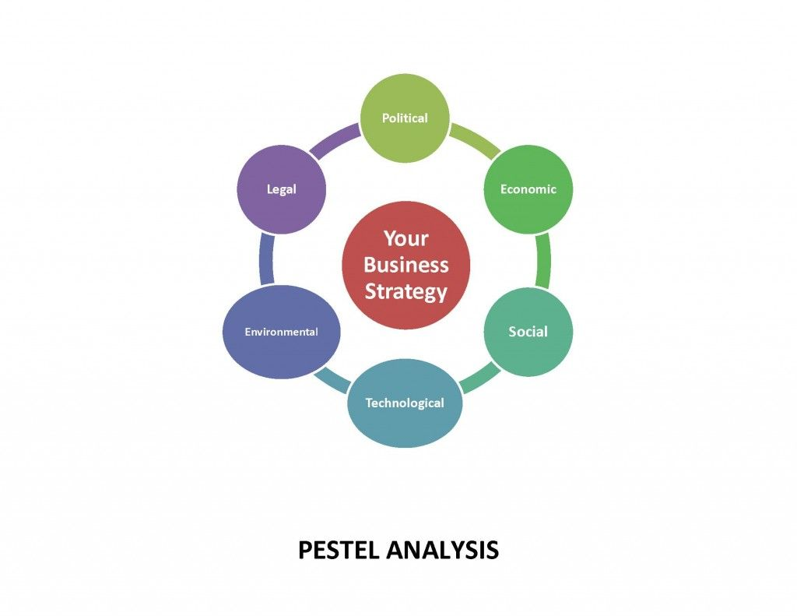
Source:(Alanzi, 2018)

POLITICAL FACTORS
In 2019, Nike was able to generate a revenue of 41% through various policies that are generated by the government, especially in the US. The company mainly manufactures its products in China and Vietnam. In 2019 due to US-China trade tension, the US government increased the tariff on goods and services that are exported from China. For this, Americans have to pay an extra $7 billion a year.
ECONOMIC FACTORS
Economic factors include all the factors effecting the economy. Due to the arrival of the pandemic, there was a job loss and a fall in income which leads to a fall in sales by 12%. Nike adopted a strategy of cost reduction for this the company reduced its workforce by 5%. This enabled Nike to survive even during periods of crisis.
SOCIAL FACTORS
Through social factors, the company will be able to analyze the behaviour of its customers. Nike, as a multinational company, know what its customer wants and they are aware of the changes that are taking place in the economy. To get attention from the public, Nike launched Dream Crazy in 2018 which became controversial and a backlash from certain customers.
TECHNOLOGICAL FACTORS
Technology is one of the factors that affect the operation of a business. Technology is very important for a company like Nike whose sales are mainly focused on e-commerce sites. Technology is also important for the company’s product design and development. Nike is a brand that brings innovative products to the market that are developed in its own lab and research Centre. The latest innovation from Nike is Nike fit, which is a combination of artificial intelligence and computer vision.
ENVIRONMENTAL FACTOR
Environmental factors play a significant role as the operation of the company will be affected if it has any negative impact on the environment in which it operates. Nike has tried to reduce the emission of carbon dioxide and also, take actions to reduce the waste products that are generated by the company and also, the company reduced the pollution emitted from the factory. Now the company use only renewable source of energy and reduces shipping emissions.
LEGAL FACTORS
Legal factors consider the laws and regulations of the industry. Nike has several legal issues that affect the company. The company has failed to provide good working conditions for its employees and for this, the company was taken to court. Also, cases against Nike was filed by Skechers for copying their design.

Source: (Shtal et al., 2018;Guerguis, 2018;Rowland, 2017).
Through a proper PESTEL analysis, we were able to scan the environment, by analyzing ongoing business trends and various factors that lead to the success of the organization. As PESTEL is a tool for environmental analysis we were able to analyze the macro factors affecting the business of Nike. All other macro factors of PESTEL except legal factors look satisfactory for the company.
PORTER’S Five Force Model
The threat of new entrants | The threat of new entrants  It is difficult for new rivals to outcompete Nike Inc. because of the high expense of brand management. Nike's extensive global manufacturing and distribution infrastructure gives it a strategic advantage over new competitors. The lower cost of the company's operations further restricts the ability of new competitors to change the business environment. Thus, the threat of new entrants is minimal for this product.
Threat of substitutes | Since Nike is a brand with significant R&D investment, there is no chance that a competitor will take its place. But the rise in counterfeit items that resemble real shoes is one element that affects Nike. Recent enhancements in the features provided by pirated goods have resulted in the development of a new threat to the product. However, when it comes to Nike, the danger of alternatives is a weak one.
Bargaining power of  customers | Customers of Nike have a direct influence on the company's success. Due to the limited comparing the benefits, consumers also have the choice to buy other products instead of Nike. Each consumer's small size, however, decreases the impact they have on the company. Customers, therefore, have some negotiation power.
Bargaining power of suppliers | Because there are so many suppliers, Nike is less affected by the decisions made by each one. The number and size of suppliers support a reasonable level of supplier control. However, the negotiating power of suppliers is weak.
Competitive rivalry | It is considerably more challenging for Nike to enhance growth due to high competition. Rival companies like Adidas, Puma, and others are making large investments in their marketing activities, which makes it challenging for the Nike to stand out in the industry. Although there aren't many direct rivals for Nike, the competition is fierce. Therefore, rivalry among competitors is a powerful force in this context.

Source: (Nike Inc., 2020;ROWLAND, 2017;Innovalor, 2018)

MICRO ENVIRONMENT ANALYSIS
SWOT Analysis
STRENGTH | WEAKNESS
• Strong distribution channel  • Low production cost  • Extensive client base  • Best R&D staff  • Great brand recognition and  value | • Limited diversification  • High prices
OPPORTUNITIES | THREAT
• Innovative products  • Emerging markets  • Merges with Metaverse | • High competition  • Counterfeit products  • Marketing Budget Pressure
Source:(Nike, 2021)
Nike have the major strength of strong distribution channels, and the lower production cost for these shoes also provides an advantage to the company. These are basketball shoes that have a vast client base, and since Nike has the best research and development teams to make improvements, this benefits the further improvements of Nike products. The shoes are popular as Nike has high brand awareness and value. Speaking of weaknesses, Nike do not have vast area of diversification. High prices for these shoes are another major weakness. As for opportunities, Nike have the advantage of a greater innovative team. Nike could also expand into emerging markets, and Nike's recent merger with Metaverse could turn out to be an opportunity. The main threat to Nike is its high competition from other brands and also the pirated fake products that look identical. Since the other rival brands are largely investing in promotional activities, Nike faces huge pressure regarding the same.
Advantages and disadvantages of SWOT analysis
SWOT analysis has numerous advantages, including its straightforward structure, which enables it to be implemented for any business in any sector. It can also be applied to a diverse range of scenarios and initiatives. Leaders do not require costly operating systems or a specialist to guide them through the method. Swot analysis does not require any special training or skills.
SWOT analysis have disadvantages as well. It is only as good as the information it contains. This will imply the creator's preconceptions and experiences. A SWOT analysis focuses on broad ideas instead of precise terms. The data supplied after the analysis does not contain references or anything else of the sort. In other words, it ought to be understood more or less ignorantly, and it is intuitive that not everybody will consider this point.

SEGMENTATION, TARGETING ANF POSITIONING (STP) ANALYSIS
Market Segmentation
There are three types of segmentation that the company follows the first one is Demographics segmentation where Nike segments its user based on age and gender it has a wide range of products that can be used by people under the age group of 15 -55. According to psychographics and behavioral segmentation, Nike tries to understand the need of its customer and the trend that take place in the purchasing habit of the customers. The last one is geographic segmentation Nike was its users all around the world, especially in the US, Africa, Europe, etc. (Mahdi and Abbas, 2015).
Targeting
Nike has a niche market where the company focuses on athletes or persons who are active in sports. Nike helps its target customers to get their products customized with personal signatures from famous personalities like Michael Jordan (Wells, 2021).
Market Positioning
Nike has a good position in the mind of its customers. It has a product line that can satisfy the needs of their customer and as per the slogan just doing it has made the customer more confident and inspired to buy its products. Because of the quality of products that are offered by the company it can create a reputation for the brand at the same time improve its image in the mind of its users (Ali, 2017).
MARKETING MIX
Product
Nike has a wide range of product line includes shoes, sport equipment’s, apparel etc. Currently Nike offers light weight cricket shoes which attracts customers towards their products (Bhasin, 2021).
Price
Their pricing is based on target customers as the premium segment. The company uses a cost-based pricing strategy as its customers are from a niche market where the customers are capable of purchasing the products of Nike (Mehta, 2022).

Place
Nike products are available in all Nike stores across the world. It also has manufacturing concerns in different parts of Asia at the same time they offer customer support services in different parts (Gregory, 2020).
Promotion
Nike uses various promotional tools to create awareness about its product. Their major promotional tool is advertisements that they use celebrities to promote their products (Shastri, 2020).
RECOMMENDATIONS
Ansoff Matrix

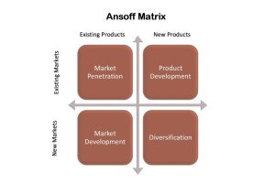
Source: Bizzledizzle, 2016
Nike emphasizes the development of creative and distinctive shoe designs. Nike uses market penetration method of pricing where same products are sold at same market with differentiated price. Nike also extends cost leadership strategy for market penetration. Nike expanded its market by entering into different markets around the world. Nike lacks diversification as they are designed particularly as athletic brand.

Product Life Cycle

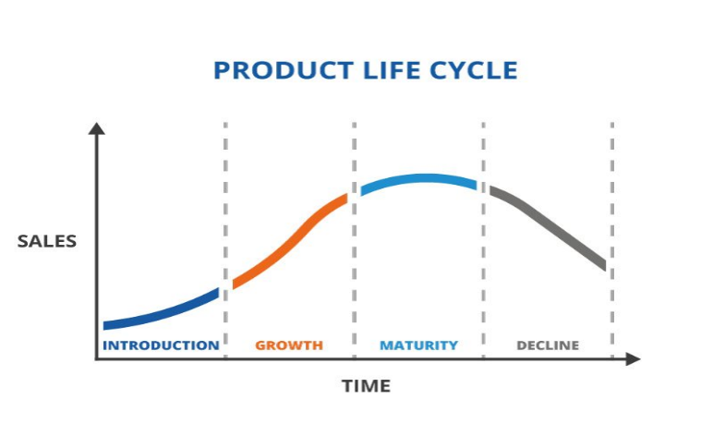
Source: (TWI Global, 2022)
Introduction stage: BRS was the original name of Nike. Nike's first television advertisement demonstrated how successfully their running shoes could be used for running. Their "just do it" tagline is so inspirational, and their swoosh logo is instantly recognizable. Nike chose to use a pricing approach called penetration. They did this to support the early sales, which helped them gain a sizable market share (Nike Inc., 2020).
Growth stage: As more people began purchasing the sneakers, the firm gradually raised the price. The shoes grew in popularity with a large client base. Following a makeover, the sneakers sold out almost immediately.
Maturity stage: Nike is one of the largest shoe makers in the world. People continue to purchase the product despite the increased price. The advancements in Nike were maintained. The business prioritized comfort over new styles.
Decline stage: Nike is still in their stages of Maturity. Since the company is always developing new concepts and enhancements for this product, the decline is currently not that substantial. Nike is currently in their maturity stage. Increased penetration, extended use, and global market expansion are the recommended strategies for the product at this stage.
1. Increased Penetration strategy
The reduction in sales was mainly because of the high price of the Nike products. Nike could adopt a penetration strategy at this mature stage to significantly increase its proportion of market-wide sales. It could often reduce costs as a result of the increasing sales volume, which raises its profit margin.
2. Extended Use strategy
To extend its market share, Nike can adopt an expansion strategy, by finding new consumers make changes to the existing products. By using this expansion strategy, the company will be able to keep its position in the maturity phase (Durmaz, Ilhan and Ilhan, 2015).
3. Global Expansion strategy
By adopting a global expansion strategy, the company will be able to expand its market to other foreign countries. This helps Nike to reduce their risk. Through expansion strategy, the company will be able to create diverse customer strengths and also improves its brand image.
CONCLUSION
The sneakers and activewear called Nike are made by the American company Nik Nike is an American multinational company that creates, develops, produces, markets, and sells shoes, clothes, accessories, and services on a global scale. This paper illustrates an environment analysis of the market that combines an examination of the microenvironment using SWOT, STP, and marketing mix and PESTEL and force analysis with consideration of the major external impacting factors. Recommendations are given based on the stage of Nike’s product life cycle.
REFERENCES:
Alanzi, S. (2018) ‘Pestle Analysis Introduction September’, 15(2), pp. 1–23.
Ali, S.Z. (2017) ‘Nike ’ s Segmentation Targeting Positioning Marketing Strategy’, pp. 1–13.
Bhasin, H. (2021) ‘What is Boundary Spanning ? Importance of Effective Boundary Spanning’, pp. 1–10.
Durmaz, Y., Ilhan, A. and Ilhan, A. (2015) ‘A Theoretical Approach to Purpose and Type of Strategy’, International Journal of Business and Management, 10(4). Available at: https://doi.org/10.5539/ijbm.v10n4p210.
Gregory, L. (2020) ‘Nike Inc .’ s Marketing Mix ( 4Ps / Product , Place , Promotion , Price ) – An Analysis Nike ’ s Products ( Product Mix ) Place / Distribution in Nike ’ s Marketing Mix’, pp. 1–5.
Guerguis, A. (2018) ‘Nike’s Marketing Mix and pestl analysis in Vietnam’.
Hitt, M.A., Li, D. and Xu, K. (2016) ‘International strategy: From local to global and beyond’, Journal of World Business, 51(1), pp. 58–73. Available at: https://doi.org/10.1016/j.jwb.2015.08.016.
Innovalor (2018) ‘Porter ’ s Five Forces’, pp. 1–10. Available at: https://s3.amazonaws.com/coursera-uploads/peerreview/asSgiHyvEeWpcQ7HugVD8Q/3e4af1d7318d042dcff3ab654396083a/Porter-5-Forces--Payment-Industry.pdf.
Mahdi, H.A.A. and Abbas, M. (2015) ‘A Comparative Analysis of Strategies and Business Models of Nike , Inc . and Adidas Group with special reference to Competitive Advantage in the context of a Dynamic and Competitive Environment’, 6(3), pp. 167–177.
Mehta, R. (2022) ‘India ’ s best selling and most preferred footwear brand with products ranging from sandals Nike Marketing Mix ( 4Ps ) and Marketing Strategy The Product in the Nike Marketing Mix Strategy’, pp. 1–9.
Nike (2022) ‘ACG for Kids’.
Nike, I. (2021) ‘Annual Report’, Annual report pursuant to section 13 or 15(D) of the securirty
12

exchange act of 1934 for the FISCAL year ended May 31, 2021, p. 102. Available at: https://investors.nike.com/investors/news-events-and-reports/default.aspx.
Nike Inc. (2020) ‘ANNUAL REPORT ON FORM 10-K for Fiscal Year 2020.’, p. 103. Available at: https://s1.q4cdn.com/806093406/files/doc_downloads/2021/NKE-FY20-10K.pdf.
nikejordansblog (2016) SWOT Analysis SWOT ANALYSIS.
Rowland, C. (2017) ‘Nike Inc. PESTLE/PESTLE A nalysis and Recommendations’.
ROWLAND, C. (2017) Overview : Nike ’ s Five Forces Analysis Competitive Rivalry or Competition with Nike Inc . ( Strong Force ) Bargaining Power of Nike ’ s Customers / Buyers ( Moderate.
Shastri, A. (2020) ‘Researched Marketing Mix of Nike - All 4Ps Included | IIDE’, pp. 1–9.
Shtal, T. et al. (2018) ‘Methods of analysis of the external environment of business activities’.
Wells, T. (2021) ‘Positioning Segmentation and Targeting in Marketing: Nike’s Success Story’, pp. 1–18.

