Module Title: International Meetings Management BMIH6007
Assignment Title: Planning and Delivering an International Meeting/Event

Student Name: Zomir Hussain Khan
Student ID: 2209207
Lecturer’s Name: Kathryn Flynn

Acknowledgement
I confirm that I have not used any AI tools in the research and creation of this assignment. I confirm that I have not presented in any AI-generated materials as my own work. I confirm I have copies of my draft notes and other resources I used, which I may be asked to provide in evidence.
Student Name: Zomir Hussain khan
Student ID: 2209207

Introduction
The DEI Tech Summit 2024 represents a globally important event that facilitates significant talks about industrial diversity and inclusive leadership development. The event selection occurred because organisations increasingly require workplace DEI initiatives to drive innovation and improve employee well-being while promoting equality (Bowdin et al., 2023). The summit provides global leaders with a space to unite HR professionals with industry leaders, DEI advocates and policy influencers to exchange critical DEI insights as well as best practices and strategic approaches for a diverse talent pool and international market. The Hilton Hotel in New York City serves as the event venue because it provides physical and virtual attendance options to reach a wide range of participants (González-Granadillo, González-Zarzosa, & Diaz, 2021). The diverse business landscape and international connexons of this city create perfect conditions to host this essential summit which enables professionals from different sectors to exchange ideas about advancing DEI initiatives.
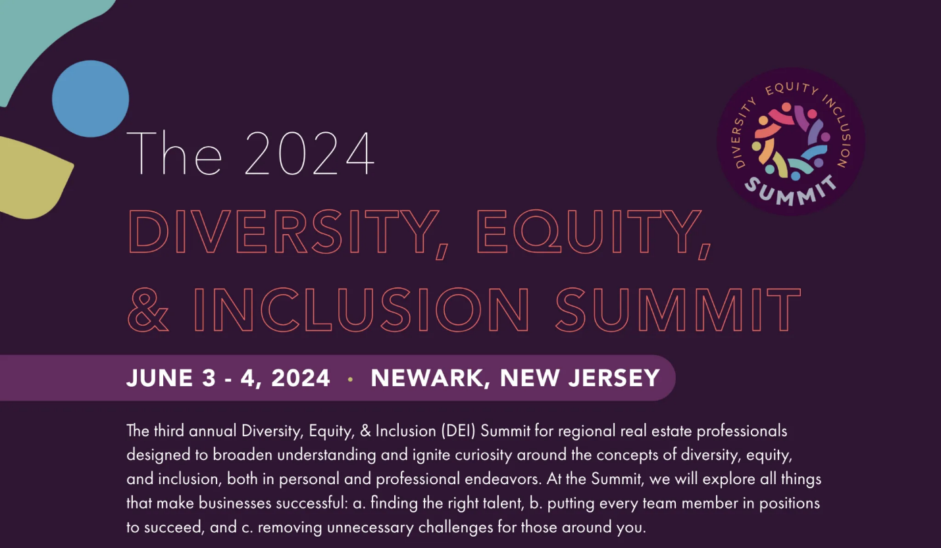
Figure 1. Event Cover photo (DEI Tech, 2024)

Event Cycle

The Event Cycle delivers a structured approach for event planning activities from development to administration and execution with corresponding procedures needed for post-event support. The Event Cycle contains four main phases which include initiation followed by planning then execution and evaluation (Ziakas, 2021). The event planning process includes multiple stages that enable stakeholders to handle time requirements, resource distribution, and risk management to achieve successful outcomes. The phases of the Event Cycle require specific tasks and considerations that must be revisited for necessary adjustments and improvements because these elements depend on each other. The Event Cycle serves as a complete framework that follows project management principles to guarantee the successful delivery of high-quality executed events.
The Event Cycle will guide the organisation and execution of the Diversity Equity and Inclusion (DEI) Summit 2024 through the following stages to deliver a seamless and impactful event.
- Initiation: During the initiation stage the DEI summit's objectives are established alongside defining its purpose and determining essential stakeholders for involvement. The gathering of information about DEI trends industry requirements and target audience needs ensures the summit delivers meaningful content (Lachance et al., 2022). The summit will focus on “Fostering Inclusion in the Workplace and Beyond” as its main theme while defining the essential messages that need to be conveyed.
- Planning: The event planning portion requires complete system development for handling logistical needs with budget oversight, marketing approaches, and content development processes. Event planning activities like finding the Hilton Hotel in New York City as a venue obtaining speakers and sponsors and designing scheduling and promotional tactics will be managed in this period. Events achieve measurable and achievable goals through proper implementation of the SMART objective’s framework during this phase (Richards & Jarman, 2021). As part of the planning phase, the team will evaluate possible risks that can affect the event such as speaker absences or logistical obstacles while developing preventative measures.
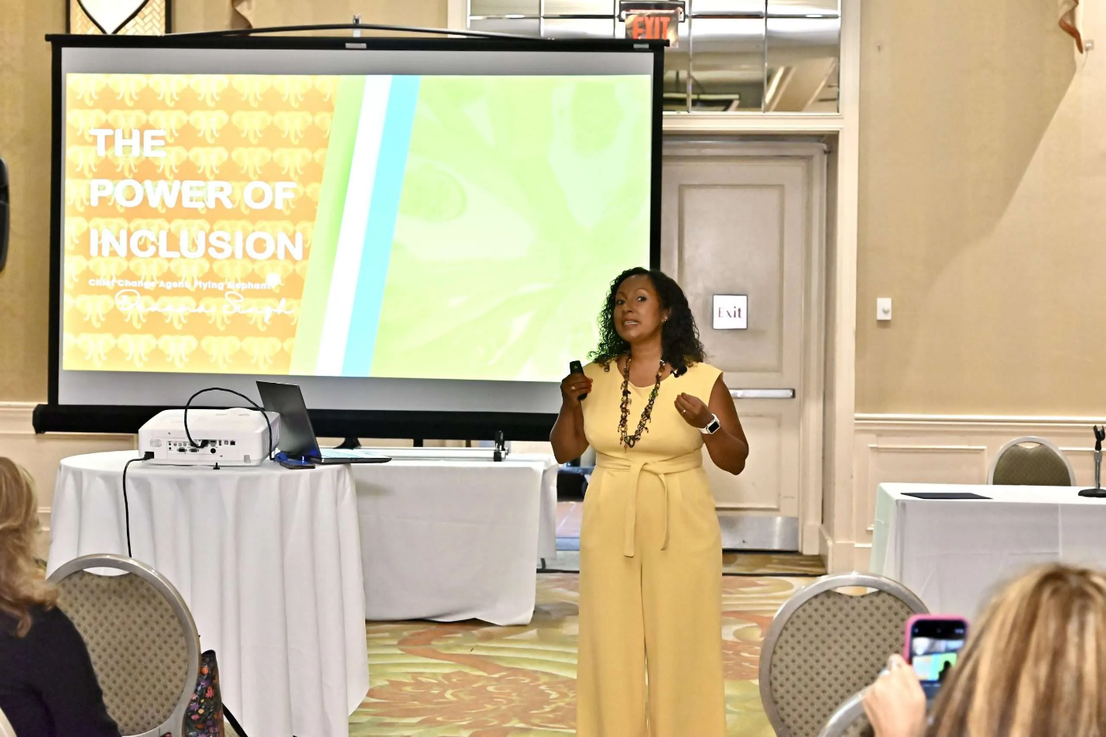
Figure 2. Event discussion (DEI Tech, 2024)

- Execution: The execution phase includes all on-the-day activities that implement previously developed plans. Event organisers must verify that all speakers and attendees along with necessary resources are properly arranged. The technical team will establish setup procedures for both physical and virtual participation to maintain continuous communication and interaction across the entire day (Bauer et al., 2021). The team will perform immediate adjustments to handle unexpected problems which will help maintain event continuity.
- Evaluation: The evaluation process must take place following the event to determine its achievement and its resulting impact. The evaluation process will collect feedback through surveys and interviews with participants stakeholders and speakers. The evaluation process will analyse how well the event met its DEI goals while measuring audience participation and operational performance (Seyitoğlu & Costa, 2024). The acquired knowledge will help future DEI summits develop an enhanced planning process through improved methods.

Event Concept

The Diversity Equity and Inclusion (DEI) Summit 2024 will deliver an engaging informative and impactful experience to all delegates and guests throughout the entire day. The planned activities at the event will support productive dialogue while providing platforms to learn cooperatively and establish meaningful connections that produce specific findings concerning DEI strategies (Hadiwiyanti, Suryanto, & Safitri, 2022). The event will organise multiple essential sessions that will help participants understand DEI concepts while sharing effective practices and creating workplace transformation.
The event will begin with a welcoming speech from the summit organiser which will establish the main goals and set the direction for the day. A recognized expert in diversity and inclusion will deliver an extensive opening speech about the contemporary diversity equity and inclusion conditions in organisations together with their corresponding obstacles (Liu-Lastres & Cahyanto, 2023). Leaders from multiple industries will deliver panel discussions that present their corporate experiences along with challenges and solutions for organizational inclusion. The programme will explore both unconscious bias elimination and leadership development for inclusivity.
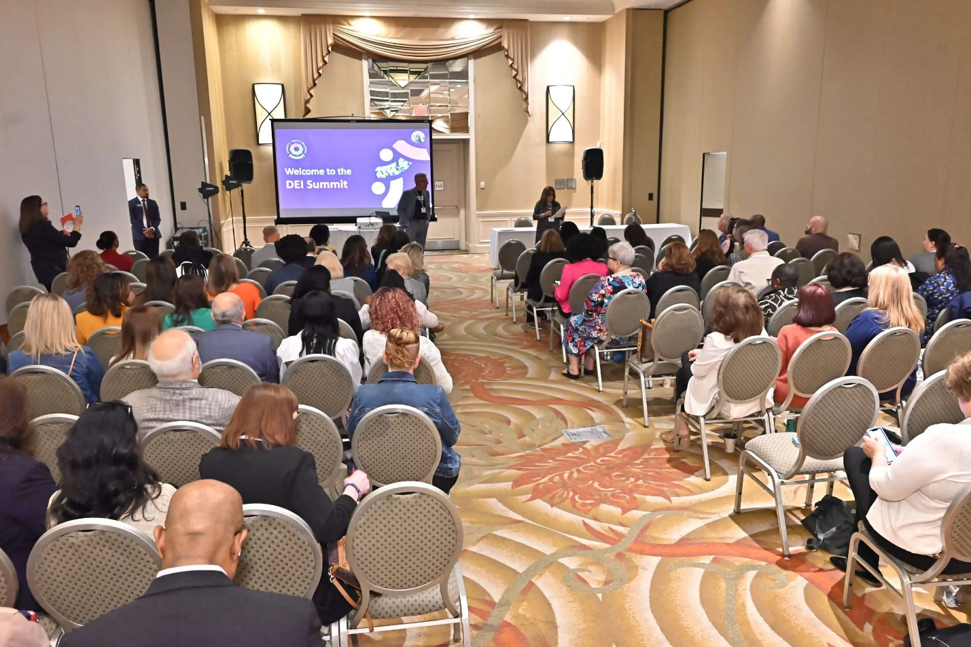
Figure 3. Event conference (DEI Tech, 2024)

The event will continue with interactive workshops that allow participants to join after the panel discussions conclude. The workshops will teach attendees practical methods to execute DEI strategies through training programmes for unconscious bias and inclusive hiring procedures (Richards & Jarman, 2021). Participants will gain practical learning experience through interactive workshops that enable mutual exchange of real-world experiences.
The event includes networking sessions that enable delegates to meet professionals with similar interests while building important business connections. Informal networking and thought reflection about the conference sessions will happen during the designated lunch break.
The afternoon part of the summit features company presentations that demonstrate how organisations successfully execute DEI initiatives within their operations. The event will finish with a Q&A session that lets participants interact with speakers and panelists to exchange thoughts about essential learnings.

Aim and Objectives

The main objective of the Diversity Equity and Inclusion (DEI) Summit 2024 serves to unite industry professionals with policymakers and DEI advocates for knowledge exchange and challenge assessment and strategy development for workplace inclusivity across all sectors (Berbekova, Uysal, & Assaf, 2021).
The Diversity, Equity, and Inclusion Summit will achieve the following SMART objectives:
- Specific: The event will reach its specific goal by attracting 300 physical participants and 500 digital participants from multiple industries who will discuss DEI approaches and practices throughout the summit.
- Measurable: The event will achieve its goal when post-event surveys show that 85% of delegates gained a better understanding of DEI initiatives and implementation strategies.
- Achievable: The event will succeed through the achievement of five prominent industry keynote speakers and three corporate sponsors before the scheduled date.
- Relevant: The event will focus on presenting industry requirements for practical DEI solutions by addressing bias problems and leadership development and inclusivity challenges.
- Time-Bound: The objectives must be accomplished during the 12 months before the event date through proper scheduling of speaker bookings and sponsor acquisition.

Event Management

The logistics behind the success of hosting the DEI Summit 2024 will never depend on just those skills but rather the right distribution of time and expertise across the media planning and buyers’ team to facilitate market gradients through top-tier campaigns. Handling daily logistical elements, planning strategically, and executing digital marketing efforts to maximize attendance would take an entire team of professionals, so it is beneficial to have these systems in place.
Operational expertise is essential for the actual functioning of the summit, including venue and scheduling as well as technical support (Draper, Liu, & Young, 2021). To successfully carry out these elements, an experienced event coordinator will need to ensure that speakers are aligned with vendor seating arrangements (something that should be decided in advance) and that catering services are coordinated with AV tech setups. The tech crew would be responsible for combining both virtual and physical aspects, this involves incorporating the livestream of the event and the facilitation of real-time Q&A sessions for all convincing remote attendees. You are also working on-site at the event to manage registration, respond to questions from attendees, and troubleshoot any last-minute technical or logistical challenges encountered throughout the course of the summit.
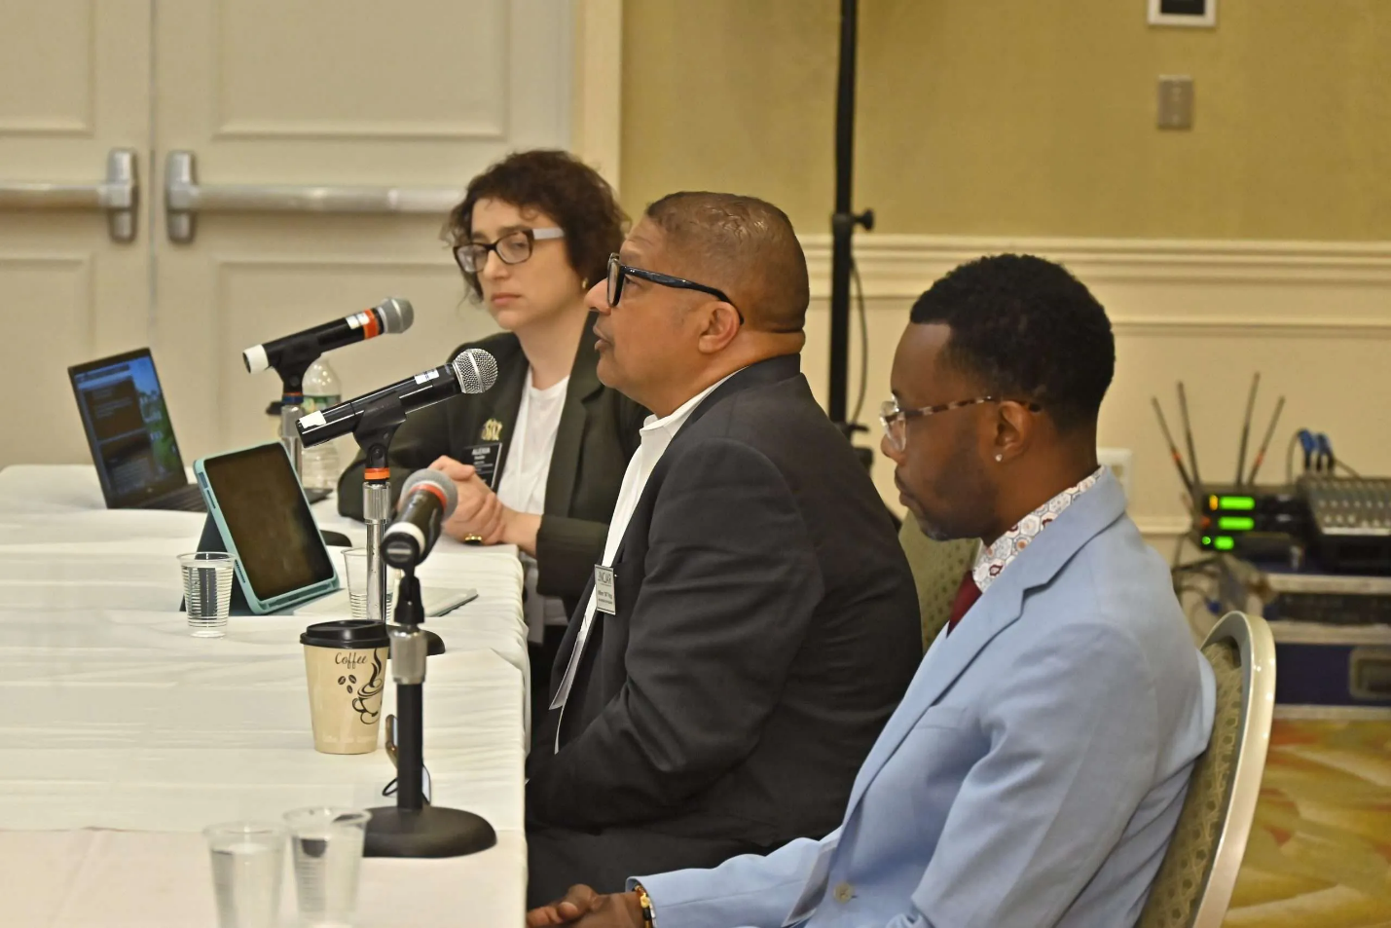
Figure 4. Event speakers (DEI Tech, 2024)
An event planning framework is a great tool for framing the timeline of the summit. A detailed project roadmap includes determining speakers, obtaining sponsors, writing programs, creating marketing materials, and testing hardware and software before launching the event. It will be the project manager's leadership that plays a central role in developing plans to properly organize and monitor all components that are in motion (Estanyol, 2022), knowing that we have deadlines to meet but making productivity and operational excellence the imperative of the day. Managing the budget is an additional dilemma, demanding meticulous allotment of funds to accommodate venue bookings, speaker fees, catering, and promotion costs. Assigning responsibilities to the right employees according to time and understanding the required support to prepare in advance is significantly determined by the efficient distribution of resources during the event.
Wavelength, one of an effective digital marketing strategy is crucial to reaching the summit’s target audience and driving attendees to the event. Social Media Campaign We will use LinkedIn, Twitter, and Instagram to accrete interest, apply content, sponsored ads, and influencers to drive views. Moreover, the summit will use targeted email marketing campaigns to reach out to potential attendees with key information about the event, including registration deadlines and personalized updates (Jain, Ajmera, & Davim, 2022). Sponsorships and partnerships with business partners will also help reach their audience and be able to reach more potential customers and increase credibility through the networks of their partners.

EMBOOK Model Application in DEI Tech Summit 2024
The EMBOOK Model, which focuses on Engagement, Motivation, Brand alignment, Optimization, Operations, and Knowledge management, provides a structured approach to executing the DEI Summit 2024 successfully.
- Engagement – Meaningful interactions with stakeholders, attendees, and sponsors are key. Using an interactive website, live Q&A sessions and dedicated networking lounges in the venue and virtual space, this will be possible. The summit will also include breakout sessions and workshops to encourage deeper engagement among participants.
- Motivation – Developing good incentive programs to drive attendance and attendance is required. This is with an early bird registration period and discounts for both registration and certification as an attendee, as well as a new recognition program for high-impact contributors (think: panelists and sponsors). In addition, gamification techniques like interactive polls and virtual leaderboards will be included.
- Brand Alignment – Branding around the summit will be outward-facing and highlight the summit’s commitment to diversity, equity, and inclusion—all ways in which the marketing efforts and the partners we choose align with our values. Aligning logos and messaging on all platforms will bolster the summit’s unifying mission and create an immediately recognisable identity.
- Optimisation – Event outreach and operational efficacy will be optimised using data analytics. Data will be analysed Live to improve future marketing campaigns and attendee experience, this includes social media insights, email open rates and participant feedback. Moreover, in this trend, AI technologies can drive chatbots and automated registration systems to make things easier and to create fewer administrative tasks.
- Operations — You will have a strong operational strategy to deliver. This includes implementing event management software for scheduling, tracking and managing tasks. A plan for contingencies will be developed to deal with last-minute problems that might arise, such as speaker cancellations or technical failures. RFID-based access control is a great way to enhance security at events while also providing a better experience for attendees ensuring seamless check-ins and access to various zones of the event.
- Knowledge Management: Best practices, feedback from attendees, and recordings of sessions will all be documented to improve future summits. You are also going to create a report of that event which will have information about key performance indicators (KPIs) as well as audience demographics and engagement metrics, which you can use in your strategic planning for future events.
The goal is to ensure operational excellence while creating a meaningful engagement for all stakeholders through the application of the EMBOOK Model during the planning and execution of DEI Summit 2024. Tactical planning ensures the summit stays true to its mission, while also maximizing efficiency, engagement, and long-term value.
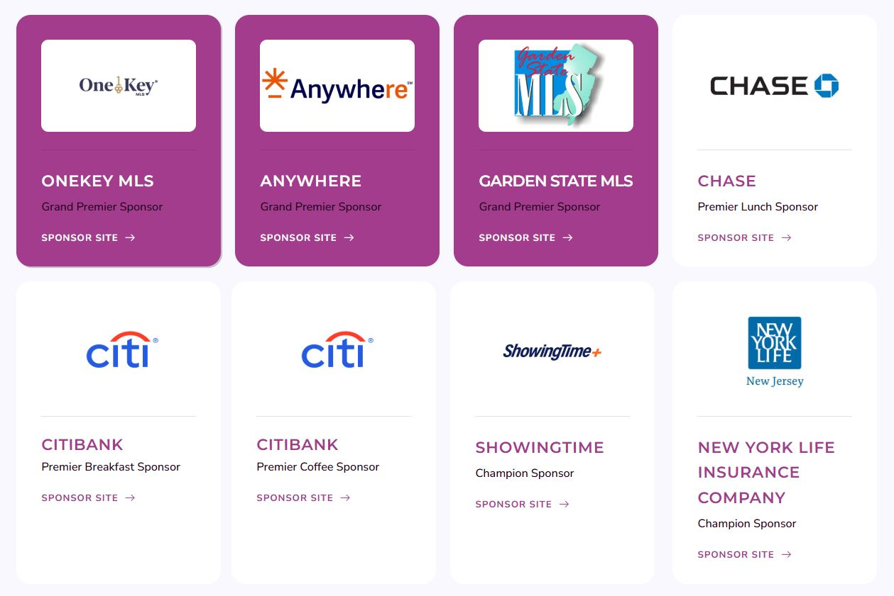
Figure 5. Event sponsors (DEI Tech, 2024)

Event Budget

Expenses
Expense Category | Estimated Cost (USD)
Venue Rental | $50,000
Speaker Fees | $20,000
Marketing | $15,000
Catering | $10,000
Staff Salaries | $10,000
AV & Technology Setup | $8,000
Security & Logistics | $5,000
Miscellaneous | $5,000
Total Cost | $118,000

Revenue Sources
Ticket Sales: $100,000 from 500 in-person attendees ($200 each).
Virtual Access Fees: $50,000 from 1000 remote attendees ($50 each).
Sponsorships: Estimated at $50,000.
Projected Profit: $90,000

The expenses cover the following areas:
Operational Activities
Successfully executing an event requires operational skills as the key element. The Hilton Hotel needs to optimise its venue management by adjusting capacity and layout to support both physical attendees and virtual participants. Before each session change event coordinators need to organise error-free transitions by conducting regular checks to ensure that both streaming and real-time technical equipment function correctly (Huang & Fan, 2021). Logistics management includes handling catering provision along with seating distribution and audience movement patterns. The event requires technical support to resolve streaming problems and recording issues and technical faults which will maintain continuous attendance for both physical and virtual participants.
Planning Activities
The first step of successful planning involves creating a detailed schedule for each phase of the event (O'Toole, 2010). The development of a comprehensive planning schedule by event planners must cover speaker verification as well as the final stage of organising both the program sequence and session structure. Project management expertise will be essential for meeting deadlines by coordinating between speakers’ delegates and sponsors (Chui et al., 2023). Budget management stands to be a vital planning activity because the event demands precise monitoring of financial inflows and outflows including venue rental expenses marketing costs speaker fees and catering expenses. A detailed plan for staffing requirements will guarantee the successful execution of the event. The team structure requires a detailed definition of responsibilities while registration staff and breakout session support teams need to be established.
Marketing Activities
The DEI Summit marketing approach will use digital platforms to expand its audience reach. The target audience will receive relevant content and event reminders through LinkedIn Twitter and Instagram social media platforms. Email will serve as a vital marketing channel because it enables specific messages to reach potential participants sponsors and beneficiaries (Hussien et al., 2021). Wider network promotion of the event can be achieved through strategic partnerships with industry leaders and influencers. The marketing team requires additional resources to develop websites and create promotional materials and content creation teams. Through the marketing team's work, the organisation will make advertisements using banners, videos, and email campaigns to attract ticket buyers and sponsors.

Industry Trends

The Diversity Equity and Inclusion (DEI) Summit 2024 operates within the framework of multiple dominant trends and issues affecting the meetings and events industry. Knowledge of these trends enables proper alignment between the summit's structure and current industry criteria and meeting participant demands.
The new trend consists of combining both in-person participation with virtual components in event execution (Vivek et al., 2021). Hybrid events provide flexibility as well as broad reach because they support audiences of different types. Event organisers believe hybrid events are essential to their plans according to survey results and predict a substantial rise in hybrid events during the next few years.
Participants look for customised event encounters that suit their personal preferences during events. Event organisers leverage AI combined with analytics tools to develop customised content along with networking possibilities which results in enhanced attendee satisfaction and engagement (Ji et al., 2021). The significance of having individualised experiences for participants within events has become key according to this evolving trend.
Event planning gets influenced more and more by environmental consciousness which leads towards sustainability. Event organisers now use sustainable practices that include venue selection based on its environmental impact and waste management methods and accepting alternative methods of transportation. The industry demonstrates expanding dedication toward environmental responsibility through this trend.
Event planning now gives increasing attention to implementing Diversity Equity and Inclusion (DEI) principles in its process (Hong, Liang, & Yang, 2023). Accessibility requirements apply together with the promotion of diverse speakers and topics alongside inclusive environmental development. The DEI Summit 2024 approaches these important elements when it aligns with current trends.
The event industry experiences a transformative impact through technological progress involving AI as well as AR and VR solutions. Event technologies improve audience reach by creating virtual environments while improving all operational elements of management. Attendees receive innovative interactive experiences by implementing these technological solutions.

Hybrid events cater to those Audience Segments who prefer interacting face-to-face and those who crave the virtual convenience. The segmentation allows organisers to cater to groups with specialised needs, preferences, and shared behaviors, effectively making events accessible to all (Getz & Page, 2024). Beyond the pandemic, participants have become more interested in curated outings that reflect individual interests. Event organisers have been using AI and analytics tools to facilitate the personalisation of content and networking opportunities, which is anticipated to enhance attendees' satisfaction and engagement (Ji et al., 2021). This is an application of the Product element of the 4Ps of Marketing. With personalized experiences needed, organisers can augment the Value proposition ensuring people can meet their individual needs while also making repeat attendance at one event or another more likely. Another trend that is growing in event planning is environmental awareness. Sustainability has always been a top priority, with event organisers optimising venue selection based on their carbon footprint and adopting sustainable practices from waste management to transportation methods. Related to the Place of 4Ps — Events businesses are motivated to choose sustainable venues as part of their brand ethos and corporate responsibility. The growing commitment of the industry to sustainability is reflected in sustainability-oriented consumer demand. Additionally, there is a larger focus on Diversity, Equity, and Inclusion (DEI) standards in the event industry. These principles encompass more than simply speaking your audience's language or making sure all attendees can access your event. By doing so, organisers are able to promote their own diversity and inclusivity through targeted marketing campaigns along the Promotion approach of 4Ps, thus garnering support from various segments of the event attendees such as participants and vendors (Hong, Liang, & Yang, 2023). This resonates well with modern event-goers, who appreciate inclusive spaces. AI, AR, and VR have also delivered immersive experiences for participants; all parts of a new technology transforming the industry. These technologies improve operational efficiency and offer novel interaction opportunities (Getz, 2023). They are a move toward utilising Process and Physical Evidence as part of the 4Ps, as event technology has become essential in producing memorable attendee experiences with seamless logistics.
Operational content also includes, for example, detailed itineraries, health and safety protocols and contingency plans. This ensures the event’s smooth functioning while safeguarding stakeholders’ health and safety, especially in hybrid or large-scale events. Contingency plans cover potential problems, such as a tech glitch or a sudden spike or drop in attendees, that could threaten the event's smooth execution. Operational strategies complement and enhance the attendee experience, from the fluid execution of a virtual platform to the interplay of in-person event elements.

Situational Consideration

The planning of the Diversity Equity and Inclusion (DEI) Summit 2024 requires a thorough examination of external situational elements and cultural aspects that will affect its success. The success of the summit depends on these essential factors to create meaningful connections with diverse audiences and meet international industry standards. A SWOT analysis provides organisations with a framework to understand and control their internal and external factors.
Strengths: The summit demonstrates strength through its dedication to DEI because this topic has become increasingly vital for modern global workplaces. The event stands out as a leading authority in DEI by focusing on inclusive leadership, diverse hiring practices and equity creation (Husain et al., 2021). Through its hybrid delivery method, the event ensures a wider reach of content since it provides options for people from diverse geographic setups who lack the time or financial means to access in-person events. The combination of physical and virtual attendance fits well with modern industry needs to enhance adaptability and online participation.
Weakness: Several important limitations need attention. The cost of hybrid event hosting becomes substantial because organisations need to invest in advanced technology systems that enable virtual features including live streaming and interactive tools (Huang & Fan, 2021). A sophisticated system must exist to handle cultural considerations especially since the audience brings diverse cultural elements from across the world. An event's content requires customisation to prevent discrimination against any section of participants while maintaining respectful voluntary participation from every demographic.
Opportunities: The summit should create partnerships with influential organisations and corporate sponsors who share its DEI-focused mission to maximise opportunities. Partnerships between organisations give access to monetary support as well as extend the dissemination of ideas (Estanyol, 2022). The integration of emerging technology reservoirs comprising virtual reality alongside artificial intelligence enables imaginative ways to deliver interactive educational sessions that boost attendee participation. Emerging technologies would enhance both the accessibility and immersive qualities of the summit to uphold the organisation's dedication to innovation.

Threat: The summit encounters multiple challenges that require immediate attention. Economic instability leads organisations to reduce their sponsorship support and attendance numbers because they become more careful about budgeting decisions (Vivek et al., 2021). Planners are exposed to cultural missteps in the planning process because they do not grasp diverse cultural expectations, especially when catering to a globally diverse audience. Incorrect portrayals or failure to include specific groups may result in a damaged reputation together with impaired effectiveness for the event (O'Toole, 2000).
Event organisers who perform a detailed SWOT analysis will successfully handle upcoming challenges while leveraging their summit's advantages and possibilities. Strategic planning establishes that DEI Summit 2024 will be culturally rich while remaining both financially achievable and impactful for its delivery of inclusion and equity messages.

Conclusion

Diversity, Equity, and Inclusion (DEI) Tech Summit 2024 will deliver a strategic event that focuses on meaningful dialogues and inclusive action for workplaces through its planned approach. The summit's strategic planning process which combines industry analysis with operational design and cultural understanding will produce meaningful sessions that address current organisational and professional requirements in DEI work. The event will generate an inclusive engaging experience for international participants through strategic technology implementation and collaborative partnerships alongside a hybrid meeting format. This event follows the increasing market need for DEI initiatives which guarantees enduring value and influence.

References
Allen, J., Harris, R., & Jago, L. (2022). Festival & special event management. John Wiley & Sons.
Bauer, D., Leverty, J. T., Schmit, J., & Sydnor, J. (2021). INTRODUCTION: Symposium on insure-tech, digitalization, and big-data techniques in risk management and insurance. The Journal of Risk and Insurance, 88(3), 525-528.
Berbekova, A., Uysal, M., & Assaf, A. G. (2021). A thematic analysis of crisis management in tourism: A theoretical perspective. Tourism Management, 86, 104342.
Bowdin, G. A., Allen, J., Harris, R., Jago, L., O'toole, W., & McDonnell, I. (2023). Events management. Routledge.
Chui, M., Issler, M., Roberts, R., & Yee, L. (2023). Technology trends outlook 2023.
Draper, J., Liu, Y., & Young, L. (2021, October). Research methods, data collection, and data analysis in meetings, expositions, events, and conventions journals. In Journal of Convention & Event Tourism (Vol. 22, No. 5, pp. 429-447). Routledge.
Estanyol, E. (2022). Traditional festivals and COVID-19: Event management and digitalization in times of physical distancing. Event Management, 26(3), 647-659.
Getz, D. (2023). Thoughts on resilience and innovation in events today. Event Management, 27(4), 637.
Getz, D., & Page, S. J. (2024). Event studies: Theory and management for planned events. Taylor & Francis.
González-Granadillo, G., González-Zarzosa, S., & Diaz, R. (2021). Security information and event management (SIEM): analysis, trends, and usage in critical infrastructures. Sensors, 21(14), 4759.
Hadiwiyanti, R., Suryanto, T. L. M., & Safitri, E. M. (2022, October). Evaluation of Campus Event Management Information System Using System Usability Scale Method. In 2022 IEEE 8th Information Technology International Seminar (ITIS) (pp. 350-353). IEEE.
Hong, J., Liang, F., & Yang, H. (2023). Research progress, trends and prospects of big data technology for new energy power and energy storage system. Energy Reviews, 100036.
Huang, W., & Fan, Z. (2021). Innovation and Coordination a SWOT Analysis of Artificial Intelligence Industry in Guangdong Province. In E3S Web of Conferences (Vol. 235, p. 03050). EDP Sciences.
Husain, I., Ozpineci, B., Islam, M. S., Gurpinar, E., Su, G. J., Yu, W., ... & Sahu, R. (2021). Electric drive technology trends, challenges, and opportunities for future electric vehicles. Proceedings of the IEEE, 109(6), 1039-1059.
Hussien, H. M., Yasin, S. M., Udzir, N. I., Ninggal, M. I. H., & Salman, S. (2021). Blockchain technology in the healthcare industry: Trends and opportunities. Journal of Industrial Information Integration, 22, 100217.
Jain, V., Ajmera, P., & Davim, J. P. (2022). SWOT analysis of Industry 4.0 variables using AHP methodology and structural equation modelling. Benchmarking: An International Journal, 29(7), 2147-2176.
Ji, B., Wang, Y., Song, K., Li, C., Wen, H., Menon, V. G., & Mumtaz, S. (2021). A survey of computational intelligence for 6G: Key technologies, applications and trends. IEEE Transactions on Industrial Informatics, 17(10), 7145-7154.
Lachance, E. L., Thompson, A., Bakhsh, J. T., & Parent, M. M. (2022). Examining Changes in Sport Event Volunteers' Motivation, Satisfaction, Commitment, Sense of Community: Evidence from a Preevent–Postevent Design. Event Management, 26(8), 1727-1743.
Liu-Lastres, B., & Cahyanto, I. P. (2023). Are we always ready? Examining event professionals approaches to risk and crisis management and resilience. Tourism management perspectives, 46, 101073.
O'Toole, W. (2010). Events feasibility and development. Routledge.
O'Toole, W. J. (2000). Towards the integration of event management best practice by the project management process. Events beyond 2000: Setting the agenda, 86.
Richards, G., & Jarman, D. (2021). Events as platforms, networks, and communities. Event Management, 25(1), 1-7.
Seyitoğlu, F., & Costa, C. (2024). A systematic review of scenario planning studies in tourism and hospitality research. Journal of Policy Research in Tourism, Leisure and Events, 16(4), 731-748.
Tzanakakis, K., & Tzanakakis, K. (2021). Risk Assessment Techniques. Managing Risks in the Railway System: A Practice-Oriented Guide, 113-146.
Vivek, C. M., Ramkumar, P., Srividhya, P. K., & Sivasubramanian, M. (2021). Recent strategies and trends in implanting of renewable energy sources for sustainability–A review. Materials Today: Proceedings, 46, 8204-8208.
Ziakas, V. (2021). Event portfolio management: An emerging transdisciplinary field of theory and praxis. Tourism Management, 83, 104233.

